Name: Theresa Reynolds

Student number: 1912751

Module Title and Code: Changemakers: Creativity and Value Creation

Assignment Title: E-Portfolio Evidence of Learning

Lecture name: Dr Azora Hurd

Introduction
Within this assignment I will be covering Task 3 by producing a flyer and an elevator pitch and in Task 4 I will be producing a conference poster that will advertise my project idea of what I am trying to achieve and details of how people can get involved. The flyer and poster will advertise my idea and will aim to draw the attention of the wider public of any age, sex and diversity.
Task 3 Create a 2minute elevator style pitch of your idea and a supporting flyer. The pitch should be written in a format that enable you to present it to and audience. Your flyer can be produced using PowerPoint. The flyer should be double sided A5 or trifold and be designed to engaged potential contributors/buyers of the benefits of your idea.

What is an elevator pitch?
Using an elevator pitch to get my message across is a very good way to make a good impression and getting the interest and attention of my audience in 2 minutes. According to Blench (2020) an elevator pitch is talking about an idea that you have and only allowed a certain time limit to get your message across.

What is a Flyer
When creating a flyer, it is important that you state the main information about your idea so that it is clear, easy to read and understand. According to MBE Australia (2020) a flyer is a type of paper that is used to advertise event, promote a business and the services that they offer and to recruit people. This paper is unfolded 2-sided sheet that contains a simple message that is easy to understand.

Pitch
Hello, my name is Theresa, today I will be discussing a project that I am running on dementia awareness. Well before I start on my idea I will first discuss how I started out. This idea came about when I decided to become an entrepreneur and open my own care company and being a carer for 4 years has given me more insight on people with dementia. I then decided to look into this in more depth and through my company I have decided that I would like to run a charity event that raises awareness of dementia, which is aim at individuals of all ages, sex and diversity. However, to go about doing this I did not want it to be just an event that people come to and get loaded with all this information, I wanted it to be a fun event that even people who are suffering from dementia can be involved in through a budding up system. I then decided to do this through a netball charitable tournament because of the passion I have for netball and do play the game. What I want to achieve is to educate people that dementia can affect people of the age 40s and 50s which is called Young Onset Dementia (YOD). According to Draper and Withall (2016) YOD is define as any symptoms that is dementia related that started before the age 65. Another research shows that YOD is starting to be recognised more frequently as a clinical and social problem and that the rates of this is going up and estimated that between 67 to 81 per 100,00 patients with YOD is in the United Kingdom alone (Sampson et al., 2004). Any donations that are raised will be used to set up a supporting system that would be available for anyone who needs more information or even dementia sufferers. Thank you for listening to me today and is open for any questions and hope to see you all at our event.

Flyer
Dementia Awareness

Love playing or watching netball?
Come along to our annual charity netball tournament that will be raising awareness of dementia in 40s and 50s age range and even the elderly.

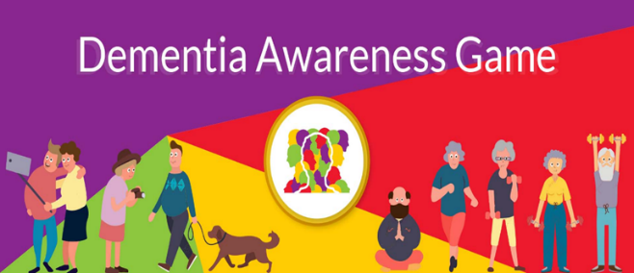

Be Involved

Fund raising
This will also be a fund raiser event so that support can be given to a dementia person through a buddying up system or other form of support.
Dementia sufferers are welcome
Make Donations
Entre with a team to participate

For more information contact us at Cloudnine Care via:
Email: 1912751@student.uwtsd.ac.uk
Telephone: 07944355755
On our social media platforms:


Knowledge is Power & Can be Fun
Be in the know some people will link dementia to only elderly people but in fact many people below the age of 65 does suffer dementia.

Date and Time:
20th July 2023 @ 9am
Taken place @ West Bromwich Centre

Task 4: Create a conference poster showcasing your project. Your poster should refer to the learning covered in Unit Four of the module. A list of references should be included with the poster. Consider your audience when designing the poster and the kind od messages you wish to portray to promote your idea. You can include some of the messages and images used in the flyer in task 3 so long as you focus on generating a conference poster which will promote your idea to encourage individuals to attend.

What is a Conference Poster?
According to Calbraith (2020) a conference poster requires thorough and systematic preparation and the person who is preparing it needs to make the message that they need to send out to be very clear and know what the aim of the poster is. The conference poster must be visible appealing, precise and straight to the point.

Before having some knowledge about dementia, I was one of the people who whenever hear the term dementia automatically think of elderly and frail people. The good thing about having dementia awareness is knowing that different types of dementia exist and that it affects people as young as 40s. If someone is suffering from dementia or someone knows a person who is, but they are only in their 50s, this may cause worry and fear because they are not fully equip with the knowledge of dementia and therefore don’t know how to recognise it. According to WHO and ADI (2012) campaigns that raises awareness of dementia can include increasing knowledge and understanding of dementia, reducing the discriminatory and stigma that dementia sufferers face and also recognising early signs and symptoms to help diagnosis it.


Conference Poster
Knowledge is Power


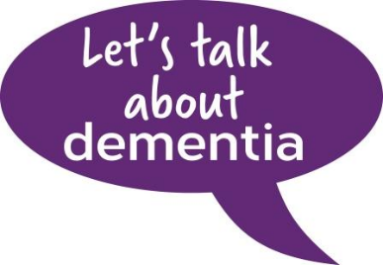

Be Aware
Of

(AbbotsCare, 2020)

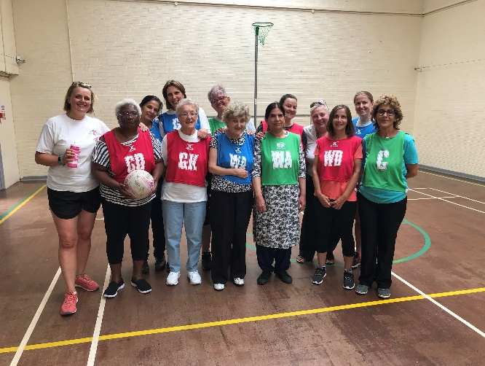
Young onset
Dementia

(GetOutGetactive, 2019)

Come along and get in the know and donate to this cause through our charitable netball event on 20th July

This conference poster illustrates my idea of bringing forth dementia awareness in a fun way. The term that is use ‘knowledge is power’ refers to arming yourself with the knowledge of dementia so that you are equip with the right information.
References
- Abbots Care (2020) Our latest news and published articles [image]. Available at: https://www.abbotscare.com/blog/ (Accessed: 15 March 2021).

- Blench, J. (2020) What Is an Elevator Pitch and How Do You Write One? [blog]. 14 Oct. Available at: https://www.act.com/blog/gb/elevator-pitch/ (Accessed: 19 March 2021).

- Calbraith, D. (2020) ‘How to develop and present a conference poster’, Nursing Standard, 36(9), pp. 46-50. DOI: 10.7748/ns.2020.e11468

- Draper, B. and Withall, A. (2016) ‘Young onset dementia’, Internal Medicine Journal, 46(7), pp.779-786. DOI: 10.1111/imj.13099

- Focus Games (2019) Dementia Awareness Game [image]. Available at: https://www.dementiagame.com/ (Accessed: 8 February 2021).

- Get out Get Active (2019) Who says it’s not netball if players can’t run and jump? [image]. Available at: http://www.getoutgetactive.co.uk/news/387-who-says-its-not-netball-if-players-cant-run-and-jump (Accessed: 15 March 2021).

- Grate, R. (2019) 100 Fundraising Ideas: How to Effectively Raise More Money [image]. Available at: https://www.eventbrite.co.uk/blog/fundraising-ideas-ds00/ (Accessed: 8 February 2021).

- Mailboxes Etc Australia (2020) What is a Flyer? Available at: https://www.mbe.com.au/what-is-a-flyer/ (Accessed: 19 March 2021).

- Sampson, E.L., Warren, J.D. and Rossor, M.N. (2004) ‘Young onset dementia’, Postgraduate Medical Journal, 80(941), pp.125-139. DOI: 10.1136/pgmj.2003.011171

- World Health Organisation and Alzheimer's Disease International (WHO & ADI) (2012) Dementia: A public health priority. Available at: http://www.who.int/mental_health/publications/dementia_report_2012/en/ (Accessed: 20 March 2021).

