

Assignment Title: Assessment component: Financial performance and management
Programme: Master of Business Administration
Module: Financial Management
Module code: LCMB7002
Student Id:2430810

Student Name: Jigarkumar prajapati

Lecturer: Dr Shengfeng Mei

Word count : 5471

Term - 1

TABLE OF CONTENTS

1. Introduction 3
2. Financial Health Check 3
2.1 Ratio analysis of General Electronics for last five years 3
3. Working Capital Management Analysis 12
3.1 Cash operating cycle 12
3.2 Suggestions of strategies for improving liquidity through working capital reforms 13
3.3 Short-term financing options vs long-term financing options 14
4. Strategic Financial Restructuring Plan 1200 15
4.1 Options available for financial restructuring 15
4.2 Impact on shareholder value, debt structure, and operational flexibility 18
4.3 International and ethical considerations 19
5. Investment Appraisal and Capital Budgeting 20
5.1 Assessment of Project A, B and C using PBP, ARR, NPV, PI, and IRR 20
5.2 Final investment recommendations 22
6. Conclusion 22
References 23
Appendices 29
Appendix 1: Ratio analysis 29
Appendix 2: Calculation of Altman Z score model 30
Appendix 3: Cash conversion cycle 31
Appendix 4: Payback periods 31
Appendix 5: Accounting rate of return 33
Appendix 6: NPV and PI 34
Appendix 7: IRR 36

1. Introduction
Financial analysis, investment appraisal, and capital budgeting are three core elements that can highlight a business’s financial stability and this also indicates the future growth opportunities. This report aims to execute an in-depth financial analysis of General Electronics. In this context, the first part of this report involves the evaluation of General Electronics where financial ratio analysis is done to explore the financial trends, strengths and threats for this company. Along with this, application of corporate failure prediction models can aid in assessing default risk. The second part of this report encompasses working capital management analysis to assess the cash operating cycle and based on this strategies will be suggested for upgrading liquidity using working capital reforms. Furthermore, an analysis is done in this section to make a comparison between General Electronics’s short-term vs long-term financing options. The third part of this report will discuss the suitable financial restructuring options for General Electronics along with a discussion regarding its impact on different aspects like shareholder value, debt structure, and operational flexibility. This discussion also includes the analysis of international and ethical considerations for financial restructuring. In the last section of this report, PBP, ARR, NPV, PI, and IRR will be used to recommend the most viable project among three proposed investment projects considering the company's financial performance and project risk characteristics.

2. Financial Health Check

2.1 Ratio analysis of General Electronics for last five years
Financial ratios are like metrics which depict a company’s financial situation and can reveal what financial strength, opportunities or threats a company has. According to Santoso and Supatmi (2021), a financial ratio is used to make comparisons between one financial data with other financial data in a financial report that are related to each other. This comparison helps in making a conclusion regarding a company’s financial situation. Thus, use of ratio analysis for General Electronics in this report can reveal this company’s financial health. In the context of General Electronics’s financial health analysis, profitability, liquidity, efficiency, gearing, investment, cash flow ratios are used so that financial trends, strength and existing threats can be assessed.
Profitability ratio analysis
For assessing the profitability situation of General Electronics, it is determined that gross profit ratio and net profit ratio are two best metrics. Gross profit ratio showcases how much gross profit a company has earned in the context of net sales value it gained. Net profit ratio highlights the % of net profit a company gains on the basis of net sales value (Heliani et al. 2023). As per the ratio analysis calculation, the gross profit ratio of General Electronics in 2024 was 28.87 a slight increase from the past five years. Thus, it can be stated that this company’s gross profit making ability increased at a minor level which is overall a positive sign for the business. On the other hand, the net profit ratio of General Electronics started declining from 2021 and reached at -6.09. That means this company’s ability to make net profit in the context of net sales decreased [Refer to Appendix 1]. From 2021 to 2024, a downward trend has been noticed in the context of net sales and net profit. It has been noticed that from 2023 this company struggled with net loss and as a result net profit ratio also resulted negative. Negative net profit ratio and slow growth of gross profit margin is a signal of a company’s poor profitability health (Widiasmara, 2022). Therefore, it can be inferred that the profitability situation or the profit generating ability of General Electronics is low and the net loss is like a financial threat for the company in upcoming years.
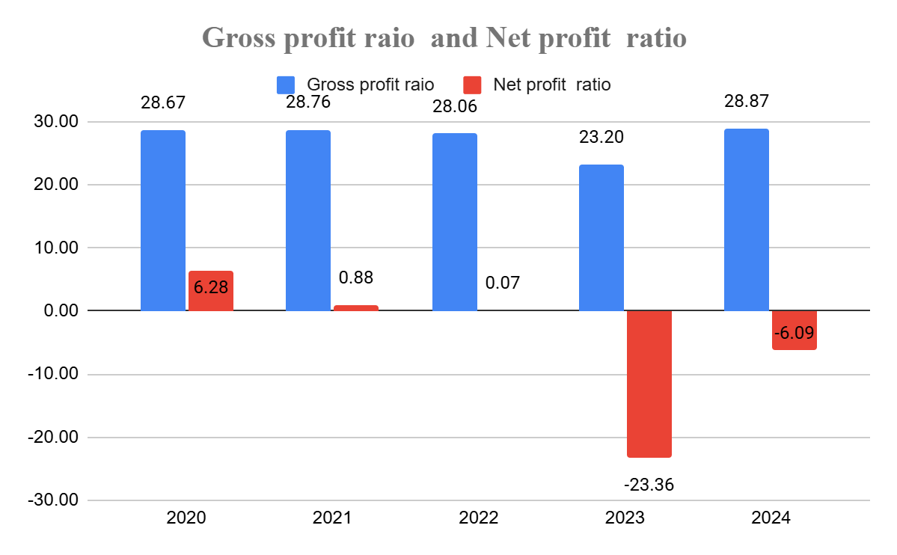
Illustration 1: Profitability ratios
(Source: Self-developed)

Liquidity ratio analysis
Liquidity ratios such as current and quick ratio are used in financial analysis to evaluate whether a business has sufficient short-term assets to cover short-term liabilities. Blessing and Sakouvogui (2023), liquidity ratios are elementary for a company aiming to determine its’ ability to meet its short-term obligations. Hence, the current and quick ratio is computed for General Electronics to assess this company’s potential for addressing short-term obligations using short-term assets. Ratio calculation for the last five years shows that there is a declining trend in current ratio as it reached 1.53 in 2024 from 1.82 in 2020 [Refer to Appendix 1]. Declining current ratio informs that a company’s ability to pay off current liabilities is decreased which ultimately is a threat factor for business (Gunawan, 2023). Then, it is easy to claim that this company's financial capacity of covering current liabilities by the use of current assets is minimised and it is a sign of poor liquidity position. The same trend is also noticed for quick ratio analysis. It has been seen that this company’s quick ratio was at 1.15 in 2020 and in 2024 it dropped to 1.03 dramatically [Refer to Appendix 1]. Quick ratio informs how much financially stable a company is in the context of paying off current liabilities consuming current assets without inventory (Hasidi et al. 2024). Hence, it is transparent that General Electronics has not sufficient current assets to cover current liabilities. Moreover, it has been seen that in the last five years, the value of current assets decreased and this is the reason behind the poor liquidity performance.
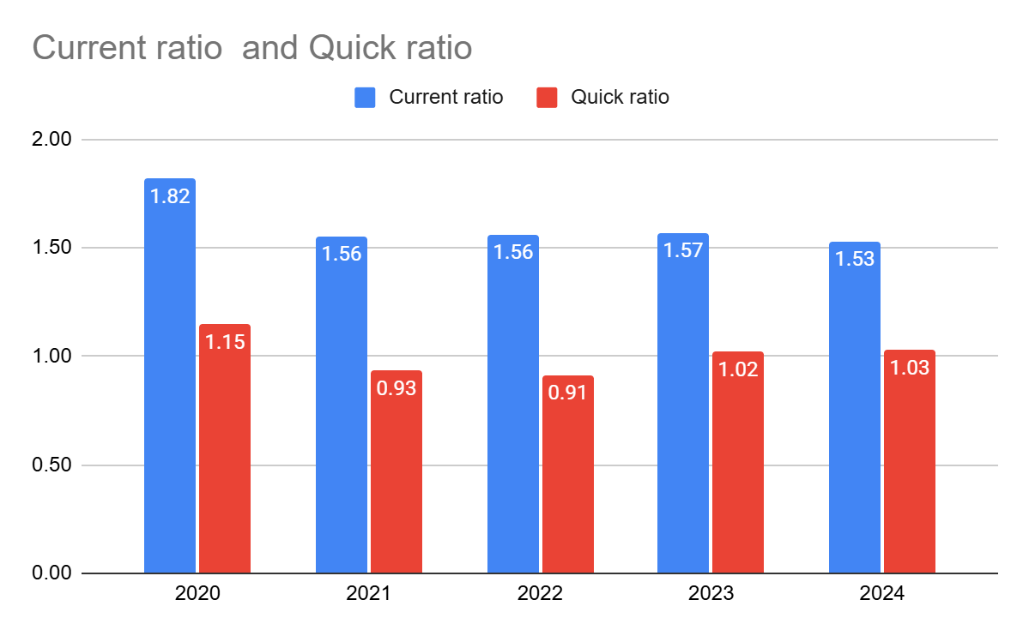
Illustration 2: Liquidity ratios
(Source: Self-developed)
Efficiency ratio analysis
Efficiency ratio is another metric used in financial analysis to judge the potential of a company in the context of resource utilisation. Efficiency ratio showcases the comparison between the expenses incurred for resources, capital and assets with regard to revenues earned, generally what type of return on revenue or profit a business can share with the amount it spends on resources to run business. (Corporate Finance Institute, 2024). In the context of evaluating General Electronics’s efficiency, assets turnover and inventory turnover ratios are applied here. Ratio calculation highlights that inventory turnover dropped to 3.35 in 2024 while in 2020 it was 3.34. Furthermore, it has been seen that inventory turnover dropped significantly in 2022 and 2023 at 2.84 and 2.83 [Refer to Appendix 1]. Overall, the declining trend has been noticed in inventory turnover ratio. Inventory turnover ratio is defined as an effective indicator of how potential a company has in managing and selling its inventory within a fiscal period (Kwak, 2019). Hence, it can be stated that declined inventory turnover ratio indicates General Electronics’s poor performance in the context of inventory management. Furthermore, a declined trend has also been noticed in assets turnover ratio as this minimised to 1.16 in 2024 from 1.20 [Refer to Appendix 1]. Assets turnover ratios reveal how well a business can manage its assets and when it goes higher it shows a company’s robust potential in managing assets (Tissen and Sneidere, 2019). It has a significant impact on the profit growth (Utami, 2017). Therefore, it has been realized that the capability of managing assets or generating revenue from assets minimised and that worsening efficiency performance will be a threat for the company.
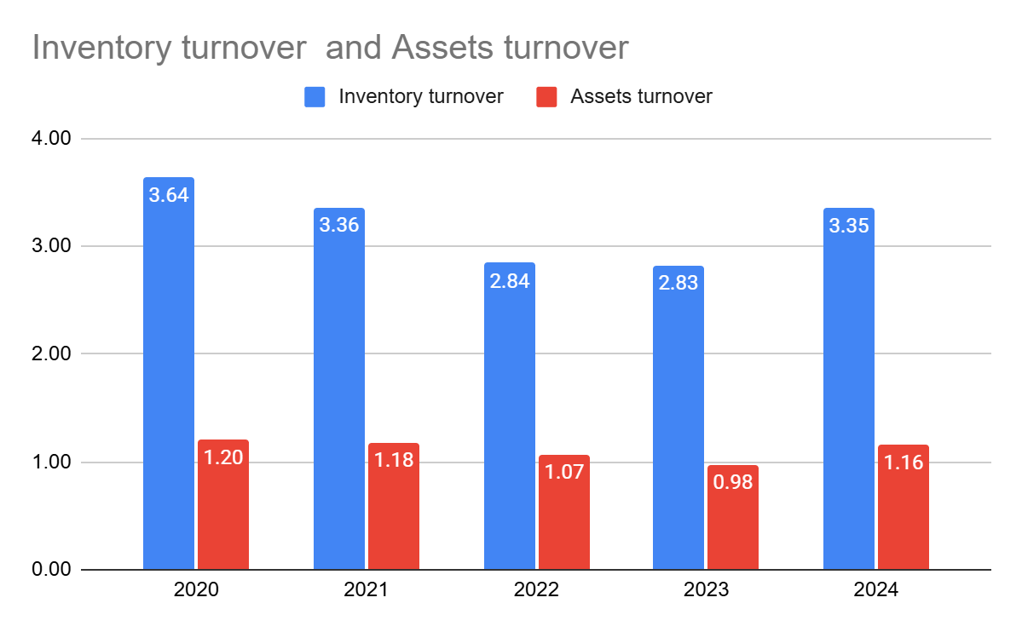
Illustration 3: Efficiency ratio
(Source: Self-developed)
Gearing ratio analysis
Gearing ratio is computed here to analyse the General Electronics’s leverage position and to assess whether the company is dependent on debt or equity for financing the company (Tulung et al. 2024). Debt to Equity is the chosen gearing ratio in this context. As per the analysis, it is revealed that this company’s debt to equity ratio increased to 1.11 in 2024 from 0.99 in 2023 and 0.63 in 2020 [Refer to Appendix 1]. As the increase in debt to equity ratio implies that a company is highly dependent on debt in place of equity for financing; it can be stated that upwarding debt to equity ratio is a signal for financial burden.
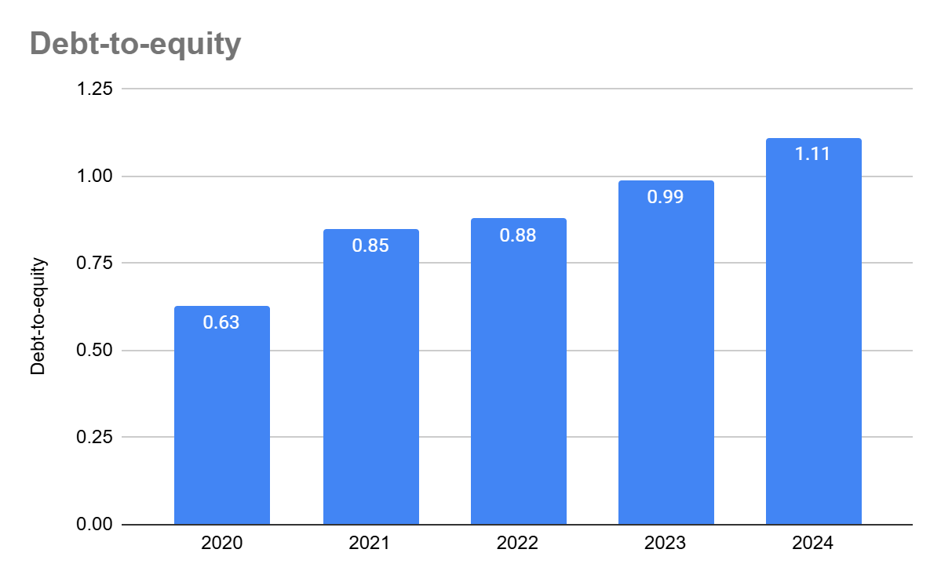
Illustration 4: Gearing ratio
(Source: Self-developed)
Investment ratio analysis
Earnings per share is chosen here as an investment ratio. Articulated by Bustani et al. (2021), this ratio informs how much profit or the return a company makes for each outstanding share and this reflects shareholders’s earnings strength and their value. From 2021, the EPS of this company started falling and in 2023 and 2024 it reached negative value -7.64 and -1.85 accordingly [Refer to Appendix 1]. This means, General Electronics is in a critical situation because it is not able to generate any profit for the shareholders. As a result of that situation, this company has to suffer for equity financing in the next few years as the shareholders' confidence level will drop after seeing the negative return trend in the last few years.
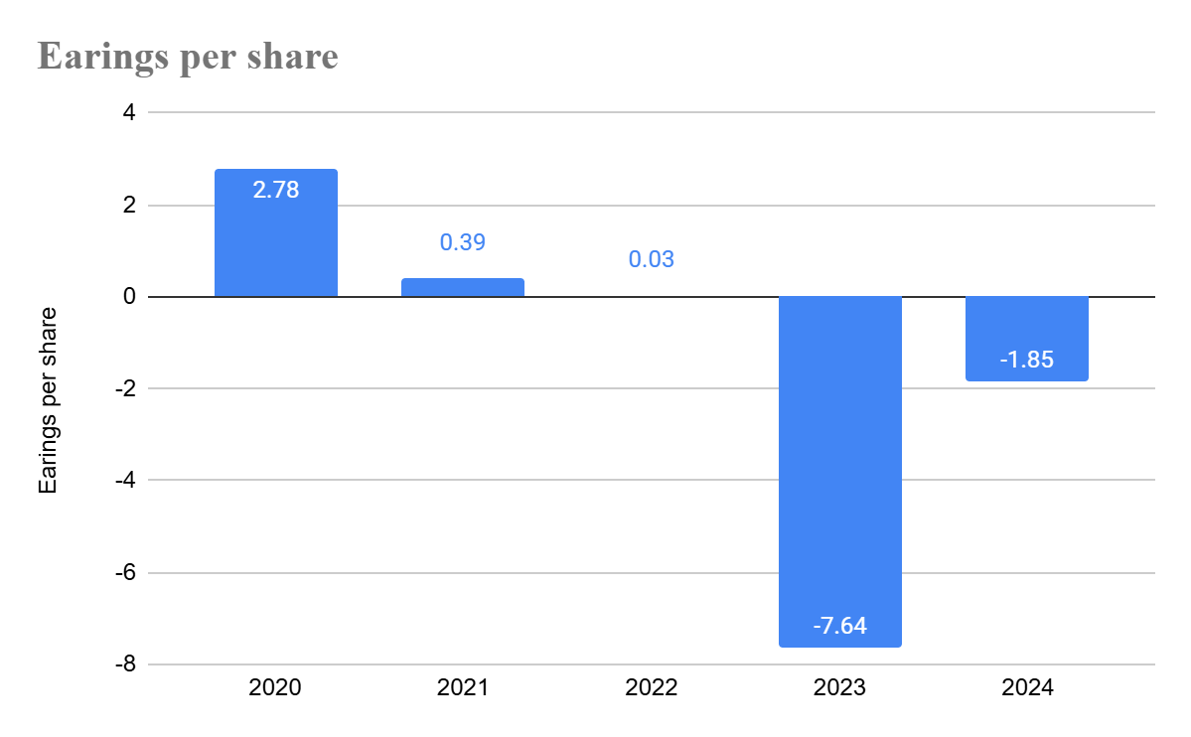
Illustration 5: Investment ratio
(Source: Self-developed)
Cash ratio analysis
The cash ratio informs whether an enterprise's liquid cash value is sufficient to cover short-term liabilities (Zuliyana et al. 2023). Therefore, use of this ratio can reveal how well the General Electronics can address its short-term debt except depending on inventory or receivables. Cash ratio analysis for General Electronics indicates a downward trend where it is clearly noticeable that in 2024 it declined to 0.17 from 0.32 in 2017 [Refer to Appendix 1]. Based on this trend, it is viable to claim that General Electronics had insufficient cash to pay short-term liabilities at urgent situations and this will be a burden for the business. Reduction of liquid cash value and similarly increase of short-term debt is liable for this worse financial situation.
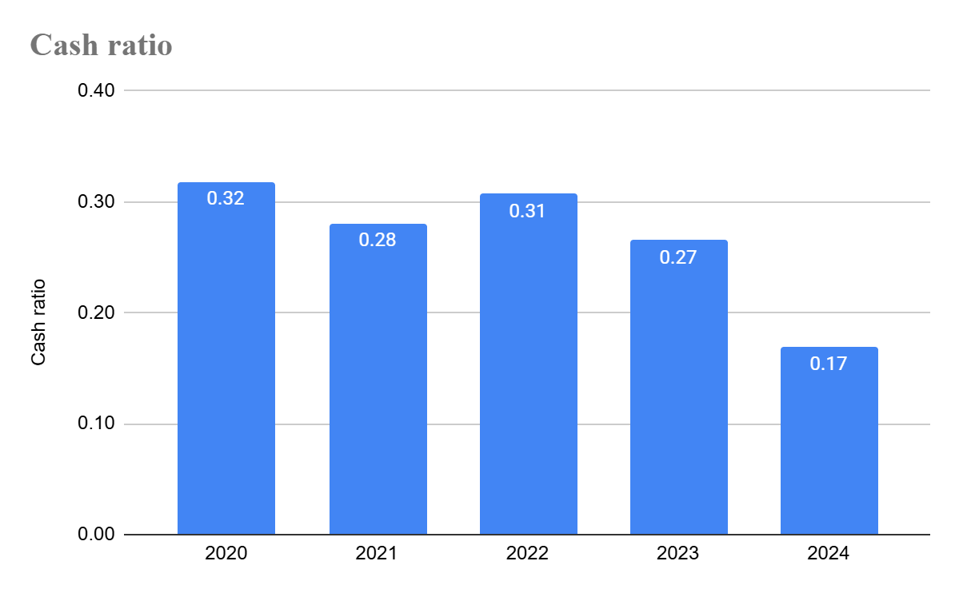
Illustration 6: Cash ratio
(Source: Self-developed)
2.2 Corporate failure prediction models
Altman Z score model is one such model applied for the purpose of estimating the probability of a business going bankrupt. Using five ratios, Altman (1968) has used multiple discriminant analysis (MDA) for the motive of evaluating the chance of failure of business and this technique model is highly recognised to make a forecast on financial distress of companies (Cındık and Armutlulu, 2021). For General Electronics, this model is applied here for the same purpose.
Formula:
Zeta (ζ) = 1.2A + 1.4B + 3.3C + 0.6D + 1.0E
A is the Working Capital/Total Assets ratio
A= 0.260
B is the Retained Earnings/Total Assets ratio
B= 0.644
C is the Earnings Before Interest and Tax/Total Assets ratio
C= -0.05
D is the Market Value of Equity/Total Liabilities ratio
D= 0.899
E is the Total Sales/Total Assets ratio
E = 1.22
Therefore, Zeta (ζ) = 2.81 [Calculations are placed in Appendix 2]
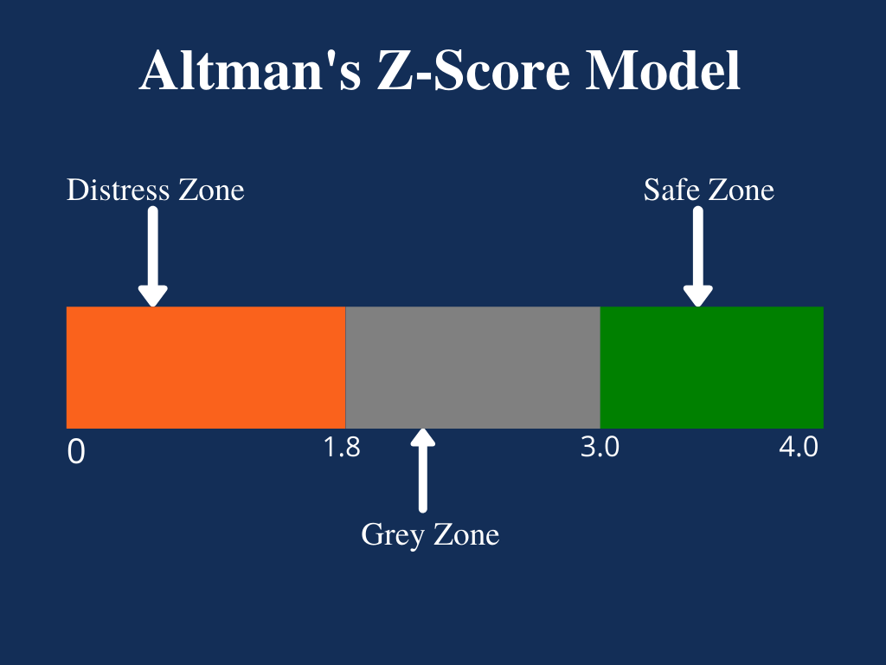
Figure 1: Different zones of Altman Z score model
(Source: Corporate Finance Institute, n.d. a)
As the Z score value of General electronics is below 2.90; it can be concluded that the company is in the grey zone in place of a safe zone and this shows the probability of higher level of financial risk. This altman z score result overall illustrates this company's possible chance of financial distress and it will result in uncertain financial stability (Mattio, 2024; Asif, 2024; ). Furthermore, this results in solvency problems when adverse conditions will come.

3. Working Capital Management Analysis

3.1 Cash operating cycle
The purpose of computing the cash operating cycle (CCC) is to assess and quantify both risk and rewards associated with the General Electronics’s liquidity management. As stated by Asman et al. (2022), CCC is beneficial for assessing the duration a business takes to transform resources into cash from the time resources are bought up to when it is traded while the debts are reimbursed.
CCC = DIO + DSO – DPO (Akpadaka and Edeh, 2024)
As per the calculation, it has been seen that General electronics’s CCC is at 112,133,154, and 130 in 2021,2022, 2023, and 2024 accordingly [Refer to Appendix 3]. Thus, it can be stated that this company has a high and volatile CCC. This increasing CCC value indicates that this company is taking extensive time to transform its resources into cash (Akpadaka and Edeh, 2024). It is also a noticeable fact that the days taking for this conversion is increasing yearly which signals lower working capital efficiency and elevated liquidity risk.
In the context of Days inventory outstanding (DIO), it has been expanded to 129 days in 2023 while in 2021 it was 109 days. This result showcased General Electronics’s low inventory turnover with a risk of overstocking (Zaher and Illescas, 2022). In 2024, it dropped again to 109 days which signals General Electronics's better inventory management. Overall, the volatile DIO indicates a risk for the company.
For Days Sales Outstanding (DSO), it increased to 105 days in 2024 from 78 days in 2021. This result means that this company delayed the collection of receivables and this specified the company’s inferior credit control that negatively impacted cash inflows (Ceylan, 2021). On the other hand, Days Payable Outstanding (DPO) for this company seemed somewhat the same up to 2023 (75 days in 2021, 77 in 2022, 73 in 2023). However, in 2024, DPO dramatically surged to 84 days. Therefore, it is the signal that General Electronics is consuming prolonged time for paying dues of suppliers which means a liquidity pressure (Ngo, and Van Nguyen, 2022).

3.2 Suggestions of strategies for improving liquidity through working capital reforms
Based on the CCC analysis, some issues have been found for General Electronics like weak working capital management, delayed cash inflows, as well as high liquidity risk. Based on these some recommendations are illustrated below-
Recommendation 1:
As the DSO is seen as increasing and this can impact both profit and CCC; it should be changed with immediate actions. This company has a necessity of implying a strong receivables and credit control mechanisms. As the upwarding DSO is delaying cash inflow and lowering credit assessment; it is creating a liquidity risk. When a business has a strategic receivable management; its cash flow stability can be improved along with the reduction of working capital lock-in (Ramli et al. 2025). Therefore, it is advised that updation of credit terms with customers, implementation of customer credit scoring facility and offering discounts for early payments of sale will help General Electronics to minimise the DSO. In addition to this approach, continuous supervision of ageing receivables will sort out the bad debt risks and these overall enable a good cash conversion cycle.
Recommendation 2:
An extreme level of volatility has been noticed for DIO. It increased to 129 days meaning there is inconsistent inventory control along with the possible risk of overstocking. Even though, in 2024, it minimised in 2024; General Electronics has to emphasis on how to stabilise inventory turnover. It can be suggested that the company can use any inventory management softwares like SAP, ZOHO, Katana to maintain and trace inventory flow. Along with this, implementation of First in First out (FIFO), just-in-time (JIT) practices, and periodic inventory audits can help to stabilize inventory management of General Electronics (Manohar and Appaiah, 20217). In line with the opinion of Niaz (2022), it can be recommended that integration of data analytics for inventory planning not only benefit in enhancing accuracy but also help in minimising obsolete stock. This will further serve as a strategic action for the prevention of excessive capital being held in inventory.

Recommendation 3:
DPO of General Electronics has also been seen as increased in 2024 indicating issues of delayed payments to suppliers and liquidity pressure. It is a fact that delay for supplier’s payments is good for improving cash flow temporarily but excessive delays is a threat for companies as it hamper supplier trust and disrupt supply chains (Jean, 2024). Therefore, this company is advised to modify structured payment terms with key suppliers so that payments periods can be extended. Furthermore, automated payment facilities will be a way to mitigate this matter.
Recommendation 4:
Cash flow forecasting is advisable for the company so that burdens on General Electronics’ operating cash flows can be removed. Nosov et al. (2021), stated that forecast of future cash flow is the solution for minimizing cash flow deficit. It will further help in predicting liquidity gaps and enabling operational cash allocations. Moreover, short-term cash management practices will be a superior solution for enhancing visibility over inflows and outflows.

3.3 Short-term financing options vs long-term financing options
General Electronics has two scope one is short-term financing and another is long-term financing for the growth. This company can choose some short-term financing options like business line of credit, receivable financing and commercial papers (Corporate Finance Institute, n.d. b). It has been seen that this company already has £36,960m lines of credit and £323,354m of assets. Therefore, the company has the scope for expanding revolving credit limits based on its established credit history. It will offer both flexibility and can enable quick access of funds for the company in accordance with high CCC. Furthermore, receivable financing can be a good option as the company already holds the accounts receivable worth £114,182m. In this case, increasing DSO showed that this company delayed payment collection and this created receivables financing a justifiable short-term solution. Hence, factoring or discounting receivables can be beneficial for accelerating cash inflows unless elevating traditional debt. As receivable value consistently exceeds £110,000m; it offers strong collateral. This can be justifiable for upgrading liquidity along with the mitigation of inefficiencies indicated in CCC analysis.
From the consolidated balance sheet, it has been seen that the company reduced its value of total liabilities to £170,249m in 2024 while in 2022 it increased to £235,757m. This financial trend is evidence of General Electronic’s reduced leverage and strong financial stability. Furthermore, this company’s equity worth £153,105m is proof of strong investor backing. Based on this financial stability, it can be stated that the company has good creditworthiness and it holds the capacity to get long-term financing. It is also a validated fact that long-term financing from corporate bonds or long-term bank term loans can enable General Electronics to match funding maturity with long-term assets like property, plant, and equipment of £34,207m and intangible assets worth £24,038m. Hence, this approach can minimise liquidity pressure of short-term borrowings.
Overall, the comparison between short-term and long-term financing reveals that this company should go with long-term financing as there is a scope of funding with some long-term assets. For instance, long-term bonds can decrease the dependency on volatile credit lines worth £36,960m and this can minimise some refinancing risk for supporting sustainable financial growth.

4. Strategic Financial Restructuring Plan 1200

4.1 Options available for financial restructuring
There are several options available for General Electronics’ financial restructuring like equity injections, factoring accounts receivables. In the context of financial restructuring of a company, an equity injection is a situation in which fresh or present investors invest new cash into a company by acquiring common or preferred shares for the purpose of offering much-needed capital (Xiong et al. 2023). This helps a company to improve liquidity, pay-off debts so that the business can be stabilised. Factoring accounts receivables, on the other hand, specified as a process of trading outstanding invoices to a third party factor at a discount in exchange for receiving instant cash. This strategy enables fast working capital unless taking traditional loans and shifts the collection to the factor (Onuoha, 2021). This strategy is highly suitable when a company aims for financial restructuring as it helps in cash flow stabilization and ease the way of addressing short term commitments when the scope of traditional financing is limited.
As per the balance sheet, this company owns £323,354m assets and £153,105m equity which solidify it’s financial situation. Still, this company is struggling with declined cash and cash equivalents which dropped to £26,783m in 2024 and that situation shows its’ liquidity pressures. Therefore, this company can introduce £20,000m new equity shares as equity injection strategy. This new equity share value has been seen as moderate compared to paid-in capital worth £344,697m. This is the reason why the new equity injection can help this company to enhance liquidity and there will be no such issue of diluting a huge portion of ownership (Megginson and Fotak, 2021). This new invested capital will further help General Electronics to minimise its dependence on short-term credit lines of £36,960m and sustain working capital requirements arising from a high CCC. Even so, it is a fact that EPS has a chance to minimise at a lower rate for the short term because shares outstanding is already increased; liquidity position will be better along with low interest expenses. It is also expected that equity injection can help in maximising profitability and EPS in the long-term.
Stage | Equity Base (£m) | Net Earnings (£m) | EPS Impact
Present (2024) | 153,105 | 100% | Base EPS
Short Term (Post £20,000m Issue) | 173,105 | 100% | ↓ ~11–13% dilution
Future (Post-Restructuring) | 173,105 | +10–15% earnings | EPS improves beyond base
Table 1: Probable impact on EPS due to equity injection
(Source: Self-developed)
On the other hand, General Electronics can choose factoring accounts receivable for the financial restructuring as the balance sheet shows its high accounts receivable value of £114,182m in the last year. This particular current asset holds 47% of total current assets value (£242,494m) of the company. According to the above DSO calculation, it has been noticed that the company has an issue of delayed payment collection that increased the liquidity pressure. Hence, this company can factor 22% of accounts receivable which is approx £25,000m. If the company goes with this option there some benefits will be created like immediate cash flow unless raising the balance sheet debt value. Furthermore, the company can minimise its reliance on short-term credit lines.
Particulars | Option 1: Equity Injection | Option 2: Factoring Accounts Receivable
Proposed invested value | £20,000m | £25,000m (22% of accounts receivables)
Balance Sheet Basis | - Equity worth £153,105m  - Assets worth £323,354m  - Low cash and cash equivalents worth £26,783m | - Accounts receivable worth £114,182m which is approx 47% of current assets
Purpose | - To assure long-term liquidity | - To improve liquidity with immediate action
Impact on liquidity | - Increase of cash and cash equivalents | - Instant availability of cash inflow
Impact on debt | - Minimisation of dependance on short-term credit lines | - No change in balance-sheet debt
Ownership control | - Minor dilution because of moderate equity issue | - No ownership dilution
Short-term EPS Impact | - Low EPS dilution because of increased shares | - Marginal EPS reduction for the factoring fees
Long-term EPS Impact | - EPS growth from lower interest cost and higher profitability | - EPS recovery through improved cash flow
Strategic Suitability | - Long-term financial stability as well as expansion | - Short-term cash flow stabilisation
Risk Profile | - Low–moderate (controlled dilution) | - Low (asset-backed, off-balance-sheet)
Table 2: Comparisons of two recommendations
(Source: Self-developed)

4.2 Impact on shareholder value, debt structure, and operational flexibility
Shareholder value
Shareholder value will be impacted positively in both ways either it is equity injection or receivables factoring. It has been seen that equity injection worth £20,000m can result in short-term EPS dilution still, this impact is not for long-term as the company already owns massive equity valued £153,105m and paid-in capital of £344,697m. It is the fact that issuance of equity at moderate level while a company plans for restructuring increases long-term shareholder value through the upgradation of financial resilience and deduction of distress risk (Fahdil et al. 2024). According to Barnabas and Oloyede (2024), when a company’s liquidity improves it helps in reducing interest expenses from short-term borrowings and sustaining the profit growth. On the other side, factoring receivables approach will not impact ownership model but it support for cash flows. This overall helps to boost investor confidence.
Debt structure
Both strategies are crucial for establishing a strong debt structure. In the context of equity injection, it will increase the business capital for the long-term and that can help in minimising the pressures of short-term credit lines. As a result of this, leverage will be improved while the risk associated with refinancing can be addressed. This fact is supported by the opinion of Serrasqueiro et al. (2025), where it has been claimed that minimisation of short-term debt dependence makes a company financially more stable. Furthemore, the strategy of factoring accounts receivable will create a scope of increasing liquidity where balance-sheet debts will be the same as earlier. This will create a scope for increasing borrowing capacity for future investments. Moreover, the decline of total liabilities in 2024 will help General Electronics in establishing a strong debt profile and a strategic financial mix.

Operational flexibility
Al-Shammari and Al-Yahya (2021), stated that a strong liquidity position of a company results in enhanced operational flexibility. In line with this opinion, it can be claimed that implementation of any of two approaches can help General Electronics in improving operational flexibility. For this company, equity injection can offer long-term funding for business operations which can address the issues in operations impacted through high CCC. This approach can enable on-time supplier payments, streamlined production with cash availability. Besides that, factoring receivables can help this company to access immediate cash for mitigating delays in customer payments which the DSO results shows. Overall, these two strategies can upgrade responsiveness to market changes along with reducing operational disruptions.

4.3 International and ethical considerations
General Electronics should have to determine some international and ethical factors before adapting equity injection and receivables factoring as financial restructuring approaches. In the context of equity financing, there will be no such matter of tax-deductible interest expenses unlike debt. Equity financing never generates any tax-deductible interest expenses so that it can maximise General Electronics’s effective tax burden across jurisdictions with diverse corporate tax regimes. In the context of accounts receivables factoring in the global market can raise some matters like withholding tax and transfer-pricing complexities while the cross-border trades will be performed (OECD, 2022).
Furthermore, this company has to consider current risk as one of the main concerns because new equity value and the factoring accounts receivables value may be received from foreign countries. In this case, volatility of exchange rate can highly impact the cash inflows through factored receivables and dilute the real value of injected equity. If these values are not properly hedged then it will create several complexities (Alfaro et al. 2024). Besides that, the UK's consistent inflationary pressures will be accountable for increased operating costs and this can minimise purchasing power (Commons Library, n.d). Thus, it is vital to establish efficient liquidity management for assuring real returns on equity.
Equity injection is necessary for strengthening long-term stability as it never shifts risk to suppliers or employees. On the other hand, aggressive receivables factoring can generate financial burdens on customers that can hamper long-term relationships. Overall, there should be an existence of ethical financial management for enabling transparent disclosure, fair credit practices, and corporate reputation.

5. Investment Appraisal and Capital Budgeting

5.1 Assessment of Project A, B and C using PBP, ARR, NPV, PI, and IRR
Payback period
Payback period is one of those investment appraisal techniques that help an investor or company in measuring the potential of any investment. Cotter (2023), articulated that payback period technique tells about length of time an investment or project can take to cover the initial cost funded in a project. As per the calculation, it has been seen that Project A, Project B, and Project C have payback periods of 3 years 4 months, 5 years, and 3 years 6 months accordingly. This means, if the company chooses Project A where £40 million investment is required; total of 3 years 4 months duration will be consumed to recover this invested capital. If the company opt for Project B, a total of 5 years it will take to recover the initial investment of £30m. Furthermore, choosing project C for investment, 3 years 6 months required to retrieve the £50 million investment. Imteaz et al. (2021) mentioned that lower the payback period of an investment; the faster the recovery of the initial capital. This benefits in reduction of investment risk and upgrade liquidity position. Hence, from a comparative view on the basis of payback period, it can be illustrated that investment in project A and C is much better than B as these two two projects are able to recover the investment early.
Accounting Rate of Return (ARR)
ARR is considered as an efficient technique of capital budgeting indicating an annual percentage based on which investor can realise the probable profitability. It is computed using average capital cost and average net income and then it is compared with the benchmark profit percentage to assess whether an investment will satisfy the needs of investors. As per the view of Usodan et al. (n.d), ARR is the assessment of an investment’s performance regarding its average accounting profits in place of cash inflow. In the context of Project A, ARR is computed at 27% which means investing in this segment has a possibility of getting approx. 27% average annual return of £40 million investment. This shows that this investment is viable as this has a scope generating higher profitability. For Project B, ARR is 20%. Hence, it can be stated that the company can get 20% average annual return from Project B for a total of £40 million investment. This results signals that funding in Project B can make moderate profitability with minimal financial stability. Furthermore, it has been noticed that the ARR of Project C is 30%. Thus, it is crystal clear to state that capitalising Project C will result in a 30% average annual return in exchange for £50 million investment. Comparatively, another fact revealed that Project C is better for investment than A and B because it can offer maximised return using investment properly.
Net Present Value (NPV)
NPV the calculation of difference between the PV of cash inflows and the PV of cash outflows within a particular period. As stated by Chauhan and Tomar (n.d), positive NPV means an investment is able to produce more cash compared to initial investment and choosing this type of investment is always a viable choice. NPV of Project A, Project B and Project C are £1.31million, -£7.27million, and £4.20 million. Thus, it can be stated that Project C is the viable choice for investment because it has higher NPV than Project B and A. Besides, Project C should totally be ignored as it can result in loss in future.
Profitability Index (PI)
PI is defined as a crucial tool which calculates the ratio of PV of future cash flows and initial investments for the purpose of ranking different projects or investments decisions (Sokolov, 2024). According to computation, Project A has PI of 1.03, Project has 0.76 and Project C has 1.08. Conforming this PI index, it can be stated that Project C should be on the 1st rank, then Project A and lastly Project C. Both A and C are able to generate a good return.
Internal Rate of Return (IRR)
IRR is a valuable tool for investment appraisal inform about the anticipated annual rate of growth of an investment. “The IRR is the discount rate that makes the NPV of an investment equal to zero” (Chauhan and Tomar, n.d). When an investment’s IRR surpasses the expected rate of return, therefore, that investment is determined as acceptable. As per the calculation, IRR of Project A, B and C are 11.33%, 0% and 13%. Hence, it can be claimed that both A and C are feasible for General Electronics compared to B. Here, the negative IRR of Project B indicates that his investment has no scope to generate good return.

5.2 Final investment recommendations
Assuming capital rationing (maximum of £60 million), it can be stated that the company should go with Project C. Considering the results of NPV (£4.20 million), PBP (3 years 6 months), ARR (30%), IRR (13%), PI (1.08), it is confirmed that Project C can generate better return and can recover initial investment within a short-period. Hence, this project is more efficient than A and B in the context of value creation. It is further noticed that cash inflow of this project is increasing since the 1st year which confirms its financial feasibility. It has been seen that the company has negative profitability (net profit margin -6.09 in 2024) and low liquidity. Therefore, a constrained financial environment situation can be a barrier for this investment in Project C. Hence, it is recommended to emphasise on value creation, quick cash recovery, and lower risk exposure for a good cash flow prospect. Furthermore, it has been seen that this company requires a long-term return in place of short-term and the Project C investment will be suitable as it can address the shortage of cash and cash equivalents.

6. Conclusion
Conclusively, it can be reported that General Electronics has some financial issues like negative profit margin, decreasing liquidity, and higher dependence on debt which should be addressed through financial restructuring approaches. These overall create a financial threat for the long-term run. Hence, this company should make a choice of long-term investments like equity injection, factoring receivables and the investment on Project C will also create some scope of managing cash and cash equivalents accordingly.

References
Akpadaka, O. and Edeh, P.O., 2024. Impact of Cash Conversion Cycle and Financial Stability on Firm Value. Journal Of Accounting AND Financial Management, 10, pp.123-141. https://www.researchgate.net/profile/Ovbe-Akpadaka/publication/383262033_Impact_of_Cash_Conversion_Cycle_and_Financial_Stability_on_Firm_Value/links/66c4c856ccd355055fe1342b/Impact-of-Cash-Conversion-Cycle-and-Financial-Stability-on-Firm-Value.pdf
Al-Shammari, A.A.A.J. and Al-Yahya, I.H.A., 2021. Financial Flexibility, Cash holdings and liquidity: An Empirical Study. Turkish Journal of Computer and Mathematics Education, 12(7), pp.3364-3380. https://search.proquest.com/openview/81b1dafda8f934f6aadac6cc1223ab59/1?pq-origsite=gscholar&cbl=2045096
Alfaro, L., Calani, M. and Varela, L., 2024. Firms, currency hedging, and financial derivatives. In Handbook of Financial Integration (pp. 340-370). Edward Elgar Publishing. https://www.aeaweb.org/conference/2023/program/paper/9HK8f99r
Altman, E. I., 1968. Financial ratios, discriminant analysis and the prediction of corporate bankruptcy. The journal of finance, 23(4), 589-609.
Asif, M., Tiwari, S., Saxena, A., Chaturvedi, S. and Bhardwaj, S., 2024. A Study of Altman Z-Score Bankruptcy Model for Assessing Bankruptcy Risk of National Stock Exchange-Listed Companies. Proceedings on Engineering Sciences, 6(2), pp.789-806. https://pesjournal.net/journal/v6-n2/36.pdf
Asman, F.N., Fernandez, D., Jamaludin, N.A., Omar Zaki, H. and Ghazali, A.W., 2022. Cash conversion cycle and firm’s performance. International Journal of Academic Research in Business and Social Sciences, 12(11), pp.2682-2692. https://www.academia.edu/download/106769993/cash-conversion-cycle-and-firms-performance.pdf
Barnabas, B. and Oloyede, J., 2024. Cash Flow Optimization: Strategies for Enhancing Short-Term Liquidity. Available at SSRN 5004465. https://papers.ssrn.com/sol3/Delivery.cfm?abstractid=5004465
Blessing, H. and Sakouvogui, G., 2023. Impact of liquidity and solvency ratios on financial performance: a comprehensive analysis. Indonesia Auditing Research Journal, 12(3), pp.102-115. http://journals.iarn.or.id/index.php/ARJ/article/download/208/141
Bustani, B., Kurniaty, K. and Widyanti, R., 2021. The effect of earning per share, price to book value, dividend payout ratio, and net profit margin on the stock price in Indonesia stock exchange. Jurnal Maksipreneur: Manajemen, Koperasi, Dan Entrepreneurship, 11(1), pp.1-18. https://ejournal.up45.ac.id/index.php/maksipreneur/article/download/810/641
Ceylan, I.E., 2021. Does cash conversion cycle affect firm profitability? Evidence from the listed small and medium-sized enterprises. Eskişehir Osmangazi Üniversitesi İktisadi ve İdari Bilimler Dergisi, 16(1), pp.110-123.https://dergipark.org.tr/en/download/article-file/1488568
Chauhan, A. and Tomar, P.S., Time Value of Money and Investment Appraisal. MEDIA EDUCATION AND NATIONAL EDUATIONAL POLICY, p.749. https://mis.itmuniversity.ac.in/ssr/C3/Volume%208.pdf#page=761
Commons Library, n.d. Inflation in the UK: Economic indicators. [Online] Available at: https://commonslibrary.parliament.uk/research-briefings/sn02792/ [Accessed on: 11-12-2025]
Corporate Finance Institute, 2024. Efficiency ratios. [Online] Available at: https://corporatefinanceinstitute.com/resources/accounting/efficiency-ratios/ [Accessed on: 14-11-2025]
Corporate Finance Institute, n.d a. Altman’s Z-Score Model. [Online] Available at: https://corporatefinanceinstitute.com/resources/commercial-lending/altmans-z-score-model/ [Accessed on: 8-12-2025]
Corporate Finance Institute, n.d b. Short Term Loan. [Online] Available at: https://corporatefinanceinstitute.com/resources/accounting/short-term-loan/ [Accessed on: 9-12-2025]
Cotter, E., 2023. Net Present Value and Payback Period: An Analysis. https://scholarworks.wmich.edu/cgi/viewcontent.cgi?article=4808&context=honors_theses
Cındık, Z. and Armutlulu, I.H., 2021. A revision of Altman Z-Score model and a comparative analysis of Turkish companies’ financial distress prediction. National Accounting Review, 3(2), pp.237-255. https://www.aimspress.com/aimspress-data/nar/2021/2/PDF/NAR-03-02-012.pdf
Fahdil, H.N., Abdulkarim, M.A., Mohamed, J. and Allah, E.A.M.M., 2024. Corporate bankruptcy and financial restructuring. Journal of Ecohumanism, 3(5), pp.234-248. https://digitalrepo.alnoor.edu.iq/files/original/3cdc203e00fa792b33bd70addcb34b9d07745539.pdf
Gunawan, E., 2023. Liquidity Ratio Analysis in Financing Short Term Liabilities. International Journal of Health, Economics, and Social Sciences (IJHESS), 5(2), pp.157-162. https://jurnal.unismuhpalu.ac.id/index.php/IJHESS/article/download/3611/2789
Hasidi, M.H., Baheri, J. and Hajar, K.I., 2024. Financial performance evaluation using profitability and liquidity ratio analysis. https://jurnal.ibik.ac.id/index.php/jimkes/article/download/2742/1966
Heliani, E.M., Fadhilah, S.H. and Gumelar, T.M., 2023. Analysis of the Effect of debt to equity ratio, current ratio, total asset turnover, net profit margin & gross profit margin on profit growth. Adv. Econ. Bus. Manag. Res, 2(4), pp.34-47. https://www.atlantis-press.com/article/125990504.pdf
Imteaz, M.A., Bayatvarkeshi, M. and Karim, M.R., 2021. Developing generalised equation for the calculation of payback period for rainwater harvesting systems. Sustainability, 13(8), p.4266.https://www.mdpi.com/2071-1050/13/8/4266
Jean, G., 2024. Impact of Digital Payment Systems on Supplier Coordination and Financial Performance in E-supply Chains. https://www.researchgate.net/profile/Guillaume-Jean-6/publication/384832570_Impact_of_Digital_Payment_Systems_on_Supplier_Coordination_and_Financial_Performance_in_E-supply_Chains/links/6708dc03e3c0600c7c9b720a/Impact-of-Digital-Payment-Systems-on-Supplier-Coordination-and-Financial-Performance-in-E-supply-Chains.pdf
Kwak, J.K., 2019. Analysis of inventory turnover as a performance measure in manufacturing industry. Processes, 7(10), p.760. https://www.mdpi.com/2227-9717/7/10/760
Manohar, H.M. and Appaiah, S., 2017. Stabilization of FIFO system and Inventory Management. International Research Journal of Engineering and Technology, 4(6), pp.5631-5638. https://www.academia.edu/download/53797516/IRJET-V4I6512.pdf
Mattio, F., 2024. Altman Z-Score Indicators (Doctoral dissertation, Politecnico di Torino). https://webthesis.biblio.polito.it/secure/31425/1/tesi.pdf
Megginson, W. and Fotak, V., 2021. Government equity investments in coronavirus bailouts: Why, how, when?. Journal of Law, Finance, and Accounting, 6(1), pp.1-49. https://papers.ssrn.com/sol3/Delivery.cfm?abstractid=3561282
Ngo, D.N.P. and Van Nguyen, C., 2022. Effect Of Working Capital Management On The Performance Of Listed Firms In Emerging Markets: Evidence In Vietnam. Webology, 19(2). https://www.researchgate.net/profile/Cong-Nguyen-10/publication/360439510_Effect_Of_Working_Capital_Management_On_The_Performance_Of_Listed_Firms_In_Emerging_Markets_Evidence_In_Vietnam/links/62fee2bbeb7b135a0e461100/Effect-Of-Working-Capital-Management-On-The-Performance-Of-Listed-Firms-In-Emerging-Markets-Evidence-In-Vietnam.pdf
Niaz, M., 2022. Revolutionizing inventory planning: Harnessing digital supply data through digitization to optimize storage efficiency pre-and post-pandemic. BULLET: Jurnal Multidisiplin Ilmu, 1(03), p.592273. https://www.researchgate.net/profile/Moazam_Niaz/publication/374998906_BULLET_Jurnal_Multidisiplin_Ilmu_Revolutionizing_Inventory_Planning_Harnessing_Digital_Supply_Data_through_Digitization_to_Optimize_Storage_Efficiency_Pre-and_Post-Pandemic/links/653a959d5d51a8012b7165df/BULLET-Jurnal-Multidisiplin-Ilmu-Revolutionizing-Inventory-Planning-Harnessing-Digital-Supply-Data-through-Digitization-to-Optimize-Storage-Efficiency-Pre-and-Post-Pandemic.pdf
Nosov, A., Tagirova, O., Fedotova, M. and Novichkova, O., 2021. Forecasting as a way to reduce the risks of a cash flow deficit in agricultural organizations. https://managementjournal.usamv.ro/pdf/vol.21_2/Art50.pdf
OECD, 2022. OECD Transfer Pricing Guidelines for Multinational Enterprises and Tax Administrations 2022. [Online] Available at: https://www.oecd.org/en/publications/2022/01/oecd-transfer-pricing-guidelines-for-multinational-enterprises-and-tax-administrations-2022_57104b3a.html
Onuoha, N.C., 2021. Legal and Regulatory Considerations in Promoting Factoring as an Alternative Trade Financing Tool in Nigeria (Master's thesis, University of Pretoria (South Africa)). https://repository.up.ac.za/bitstream/handle/2263/82858/Onuoha_Legal_2021.pdf?sequence=1
Ramli, M., Dangkeng, A., Wijaya, H. and Sudirman, N., 2025. Working Capital Efficiency Assistance for Food and Beverage Vendors. Masterpiace Journal Society Service Insight, 1(2), pp.130-139. https://jurnal.amertainstitute.com/index.php/masterpiace/article/download/455/560
Santoso, T.G. and Supatmi, S., 2021. Financial Ratio Analysis to Assess Financial Performance of the Hotel Industry. International Journal of Social Science and Business, 5(3), pp.346-353. https://ejournal.undiksha.ac.id/index.php/IJSSB/article/download/37003/20667
Serrasqueiro, Z., Sardo, F., Neves, E. and Morais, F., 2025. SME rebalancing short-term and long-term debt ratios: the role of financial distress costs. International Journal of Accounting & Information Management, 33(1), pp.169-186. https://www.emerald.com/insight/content/doi/10.1108/IJAIM-02-2023-0034/full/html
Sokolov, M.V., 2024. NPV, IRR, PI, PP, and DPP: A unified view. Journal of Mathematical Economics, 114, p.102992.https://arxiv.org/pdf/2302.02875
Tissen, M. and Sneidere, R., 2019. Turnover ratios and profitability ratios calculation methods: the book or average value. https://dspace.lu.lv/dspace/bitstream/handle/7/54149/Tissen_M_Sneidere_R_NC_2019.pdf?sequence=1
Tulung, J.E., Sondakh, J.J., Wangke, S.J.C. and Posumah, R.F.K., 2024. EFFECTS OF CAPITAL RATIO, QUALITY OF RECEIVABLES, LIQUIDITY, AND GEARING RATIO ON PROFITABILITY: A STUDY FINANCIAL INSTITUTIONS’GOVERNANCE. Journal of Governance and Regulation/Volume, 13(3). https://virtusinterpress.org/IMG/pdf/jgrv13i3art4.pdf
Usodan, A.K.M., Jalal, F.D.H., Bandera, A.D. and Usman-Macadaag, O.M., Making the Right Choice: A Literature-Based Analysis on Investment Appraisal. International Research Journal of Economics and Management Studies IRJEMS, 4(11). https://irjems.org/Volume-4-Issue-11/IRJEMS-V4I11P113.pdf
Utami, W.B., 2017. Analysis of current ratio changes effect, asset ratio debt, total asset turnover, return on asset, and price earning ratio in predictinggrowth income by considering corporate size in the company joined In LQ45 Index Year 2013-2016. International Journal of Economics, Business and Accounting Research (IJEBAR), 1(01). https://jurnal.stie-aas.ac.id/index.php/IJEBAR/article/download/253/180
Widiasmara, A., Kusherawati, A., Cahyaningati, R. and Paramita, R.W.D., 2022. The Effect of Current Ratio, Debt to Equity Ratio, Return On Assets, and Net Profit Margin on Profit Growth. Assets: Jurnal Ilmiah Ilmu Akuntansi, Keuangan Dan Pajak, 6(1), pp.8-15. https://pdfs.semanticscholar.org/aa04/03048865d1266d764dda6c89cb67d7971c39.pdf
Xiong, H., Liu, T. and Wang, Z., 2023. Financial effect of long-term policy equity injection: evidence from special construction funds in China. Applied Economics, 55(19), pp.2129-2145.
Zaher, H. and Illescas, G.M., 2022. The Cash Conversion Cycle: A Systematic Literature Review. Economic and Social Development: Book of Proceedings, pp.18-35. https://www.researchgate.net/profile/Ana-Markuz/publication/367203897_PROJECT_MANAGER'S_SOCIAL_RESPONSIBILITY_ENSURING_WORK-LIFE_BALANCE_AND_EQUAL_OPPORTUNITY_IN_PROJECT/links/63c7f2a0e922c50e99a376bb/PROJECT-MANAGERS-SOCIAL-RESPONSIBILITY-ENSURING-WORK-LIFE-BALANCE-AND-EQUAL-OPPORTUNITY-IN-PROJECT.pdf#page=23
Zuliyana, S., Karyatun, S. and Digdowiseiso, K., 2023. Analisis Cash Ratio, Debt to Equity Ratio, and Sales Growth on Company Value for Food and Beverage Companies During the 2015-2021 Period. Jurnal Syntax Admiration, 4(4), pp.739-748. https://www.jurnalsyntaxadmiration.com/index.php/jurnal/article/download/906/1305

Appendices

Appendix 1: Ratio analysis
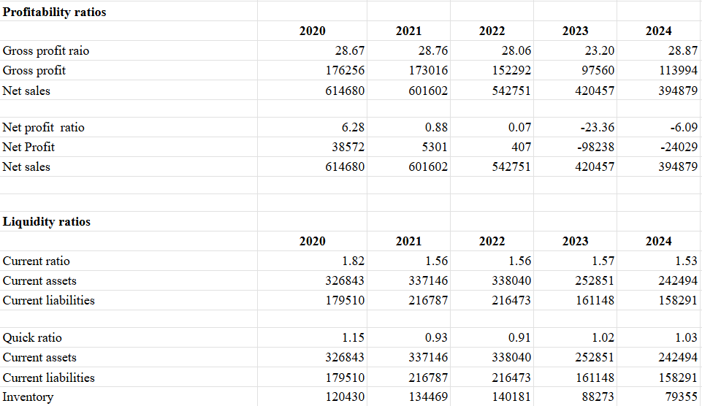
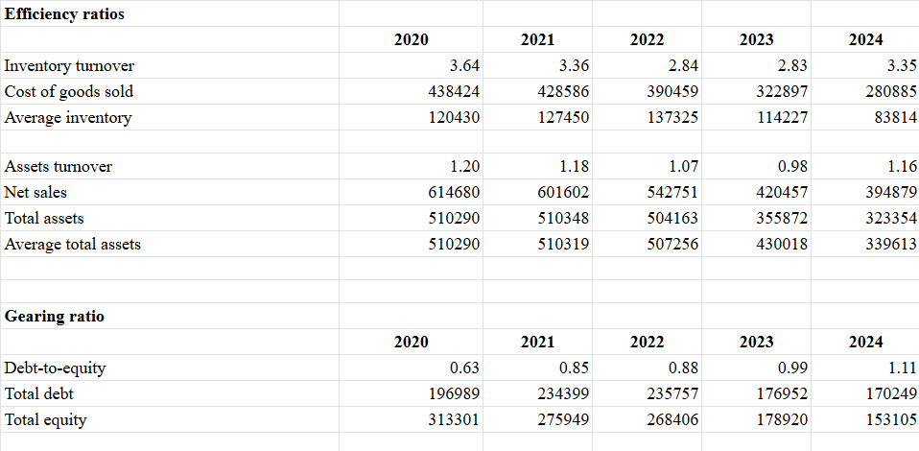
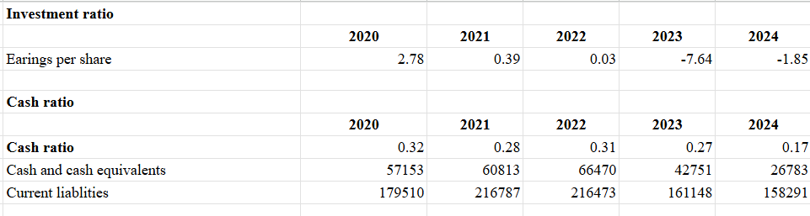

Appendix 2: Calculation of Altman Z score model
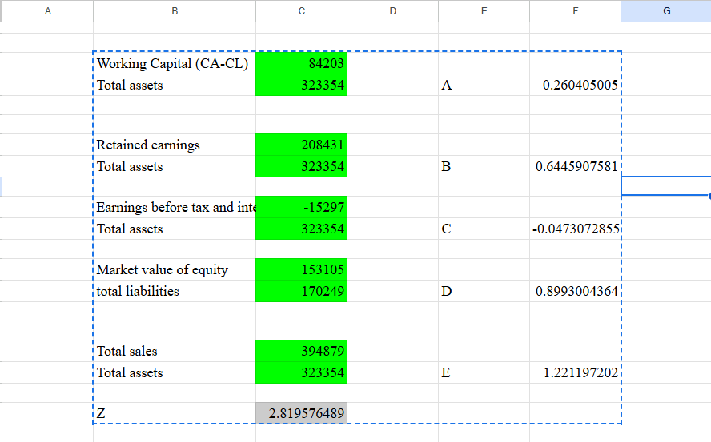

Appendix 3: Cash conversion cycle
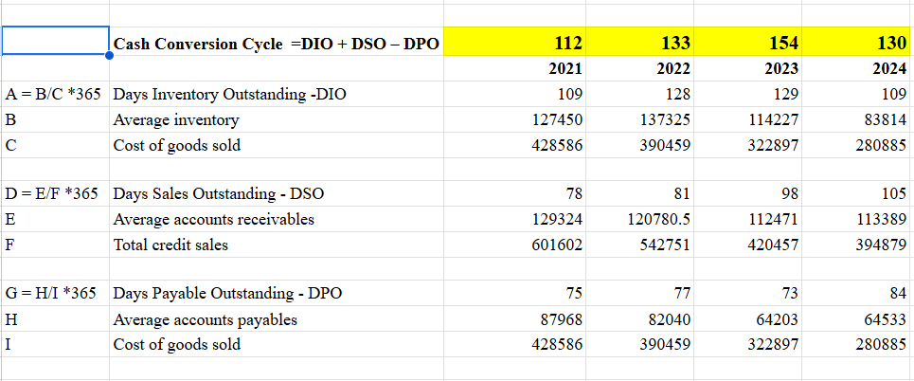

Appendix 4: Payback periods
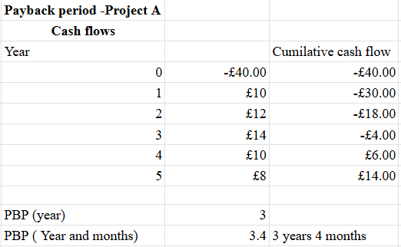
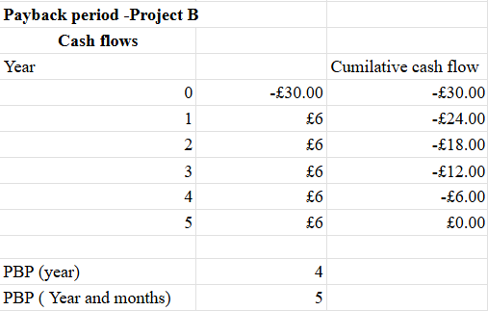
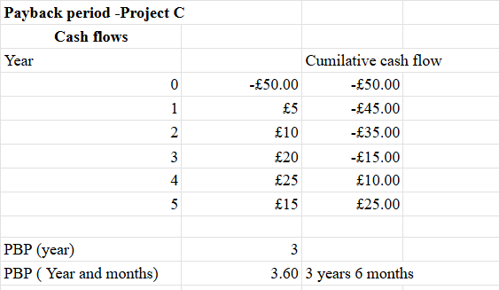

Appendix 5: Accounting rate of return
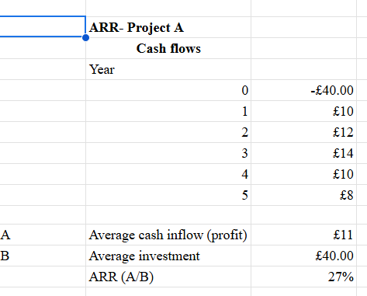
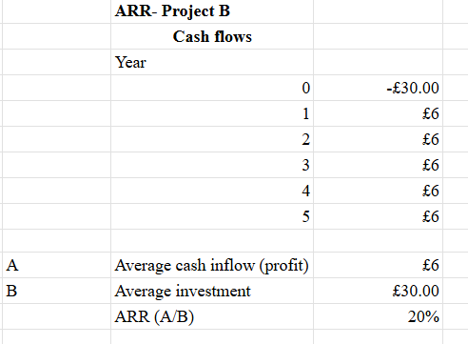
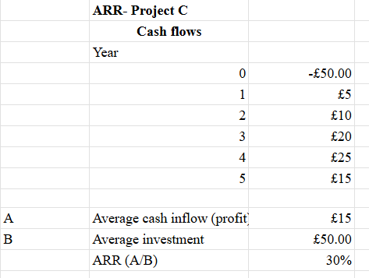

Appendix 6: NPV and PI
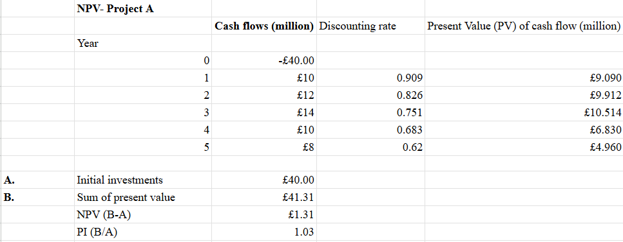

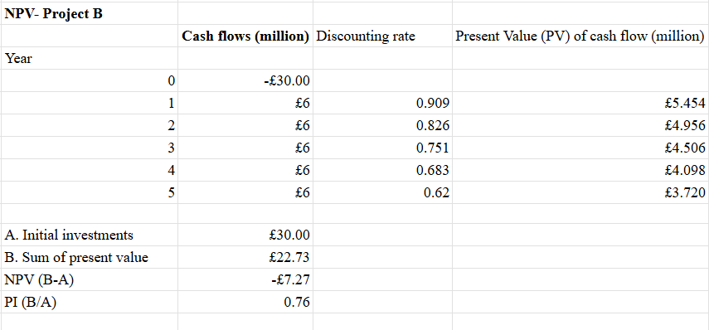
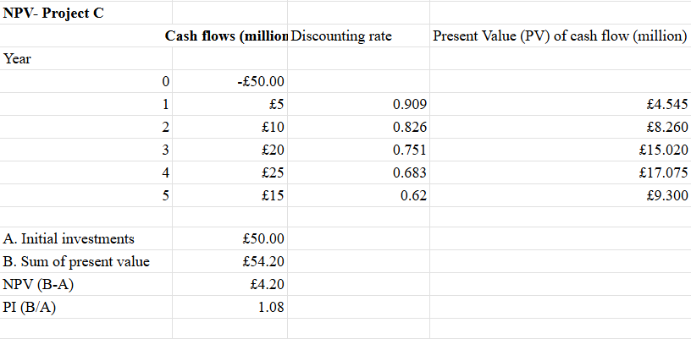

Appendix 7: IRR


