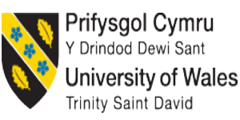

Foreign Languages and Cultural Awareness

Intercultural Competence Report

Student Name: Mashuda Begum
Student ID: 2119256
Lecturer Name: Heidi prosser

Executive Summary
As the Assistant General Manager of Diversity Hotel & Spa, tasked with overseeing the expansion of our 5-star UK-based hotel chain into France, I present this report on intercultural competence and leadership in preparation for the General Manager's visit to our new establishment in France. This report leverages the GLOBE Project's cultural and leadership study to analyse France's cultural nuances, focusing on practices and values crucial for the success of our hotel in this new market. This report also compares the culture of these two countries, with a focus on understanding cultural intelligence which can provide a seamless experience to new customers and staff of Diversity Hotel & Spa in France.

Contents
Executive Summary 1
Introduction 3
Main Body 4
Cultural Overview 4
GLOBE Project/Country analysis using Hofstede’s cultural dimension 5
Cultural Dimensions 6
Conclusion 7
Recommendation 8
References 9

Introduction
As the Assistant General Manager of the Diversity Hotel & Spa, this report is to provide insights into the cultural aspects of France and offer recommendations for the upcoming training session in the new hotel (Hampden-Turner, 2020). The report focuses on intercultural competence and leadership, drawing on Hofstede’s cultural dimension model, GLOBE Project culture, and leadership study.

Main Body

Cultural Overview
As Diversity Hotel & Spa is expanding its business to France which has a completely different culture from the UK, it is very important to understand French culture and customs for successful integration in the French market. In France, people place a high value on politeness and formality in daily interactions. French people expect common courtesies such as saying “Bonjour” and "Au revoir", titles such as "Monsieur" and "Madame", and a handshake in a more formal situation. Politeness is also a cornerstone of social interactions in the UK however, French people are requiring more formalities (Hong and Muniz, 2022). They focus on appreciation for eloquence where facial expressions and body language matter a lot in conveying meaning. The French people highly value their language, literature, and culture which is quite different from the UK. The employees in the UK value work-life balance, with a standard workweek, however, in a new location the hotel needs new employees who would be more or less French people having different cultural preferences related to work-life or people from the UK who need to deal with French clients. Managers need to be aware of these cultural differences to ensure employee productivity which includes emphasizing a balanced approach to life, longer lunch breaks, and enjoyment of leisure and enjoyment of culinary delights. The 35-hour workweek is a symbol a proof of the balance between work and personal life they maintain (Sochor, 2020). Besides, France is internationally renowned for its culinary excellence with an emphasis on fresh, high-quality ingredients. Dining etiquette is formal in Franch, with multiple courses and a leisurely pace where wine is an integral part of meals, and wine knowledge is considered a mark of sophistication.

GLOBE Project/Country analysis using Hofstede’s cultural dimension
Hofstede's cultural dimensions offer valuable insights into understanding the cultural dimension and customs of France that can help to analyse France's cultural and leadership aspects necessary for the successful operation of the new hotel (Hofstede, 1984). Below is the output for France
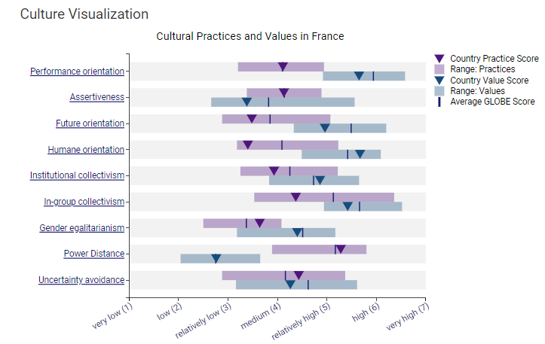
France has a relatively low power distance orientation which makes decision-making collaborative and may translate into a preference for a consultative and participative work style (GLOBE, 2023). As for uncertainty avoidance, France exhibits a moderate level indicating respect for rules and procedures along with a willingness to adapt to ambiguity and change. The score on Societal Collectivism (Collectivism 1) shows individualism which indicates France emphasizes personal achievement and autonomy. However, in societal aspects, there remains an emphasis on collectivism, requiring leaders to strike a delicate balance between individual objectives and fostering unity within the team. The fourth dimension is Collectivism II which refers to In-Group Collectivism, France his relatively higher score. It indicates that French places importance on loyalty and strong in-group relationships which need to be fostered by managers by establishing a sense of camaraderie within teams, emphasizing collaboration and mutual support. In the case of Gender Egalitarianism, France people generally support gender equality which may influence practices that promote diversity, inclusivity, and equal opportunities for both genders in managing a sound workplace (Diamantis et al., 2016). Lastly, with a medium score on Assertiveness Fresh people are moderately assertive, confrontational, and aggressive in their relationships with others which may require leaders to adopt a balanced approach to assertiveness.
Figure 1: Result of GLOBE Project for France (Own)

Cultural Dimensions
Cultural intelligence and sensitivity are paramount for hotel personnel to attract diverse customer groups, effective communication, build trust and rapport with guests, enhance team collaboration among employees from diverse culture groups to enhance team collaboration, handle any unexpected situation and crisis, gain competitive advantage over rivals, and finally for avoiding any legal consequences (Abramson, 2018). Through effective communication a culturally intelligent staff can meet these expectations of guests ensuring guests feel valued and understood, leading to increased customer satisfaction and loyalty. Therefore, culturally intelligent staff can contribute to positive guest experiences, effective communication, and a harmonious workplace, all of which are essential for the long-term success and sustainability of Diversity Hotel & Spa in an increasingly globalised and diverse business landscape. Through training programs and continuous emphasis on cultural knowledge, Diversity Hotel & Spa can build such a workforce to ensure new hotels in France have a positive cultural environment that please all guests and staff.

Conclusion
Fostering intercultural competence and leadership is vital for the success of Diversity Hotel & Spa's expansion into France. By recognising and adapting to the cultural dynamics of the new location, the hotel can ensure a better and culturally enriched experience for both guests and staff (Held, 2007). For dealing with diverse customer groups and diverse staff from different cultures, knowledge about cultural differences can be very efficient and effective. It will help Diversity Hotel & Spa to establish a brand reputation and to satisfy customers and staff at the same time.

Recommendation
- Implement comprehensive cross-cultural training programs to enhance awareness and understanding of diverse cultural dimensions, ensuring effective communication and service (Earley and Ang, 2015)
- Establish mechanisms for continuous learning about cultural trends and changes to ensure connectivity to evolving cultural dynamics
- Maintain a high level of cultural dynamics among leaders and managers
- Offer language training programs to staff (Middleton, 2019)
- Tailor marketing strategies to resonate with the cultural values of France
- Select employees who are culturally intelligent and have great communication skills
- Make Hired employees aware of France's culture, customs, and language

References
Abramson, N. a. M. R., (2018). Managing Cultural Differences: Global Leadership for the 21st Century.. 10th ed. Abingdon: Routledge.
Diamantis, D., Knowles, T. and El-Mourhabi, J.B. (2016) The Globalization of Tourism and Hospitality.: A strategic perspective. International Thomson Publs.
Earley, P.C. and Ang, S. (2015) Cultural intelligence: Individual interactions across cultures. Stanford: Stanford University Press.
GLOBE, (2023). The GLOBE Studies.. [Online] Available at: https://globeproject.com/about?page_id=intro#globe2020_intro [Accessed 14 Nov. 2023].
Hong, J. and Muniz, J. (2022) ‘Cross-cultural knowledge management’, Cross-cultural Knowledge Management, pp. 20–40. doi:10.4324/9781003112136-2.
Hampden-Turner, C. a. T. F., (2020). Riding the Waves of Culture.. 4th ed. London: John Murray Press.
Held, D. a. M. A., (2007). Globalization/Anti-Globalization: Beyond the Great Divide.. 2nd ed. Cambridge: Polity press.
Hofstede, G., (1984). National cultures and corporate cultures, in L. A. Samovar and R. E. Porter (eds) Communication between Cultures.. s.l.:s.n.
Middleton, J. (2019) Cultural intelligence: The competitive edge for leaders crossing boundaries. London: Bloomsbury Business.
Sochor, J. (2020) ‘Comparison of selected attributes in cultural dimensions as defined by Hofstede and the Globe Project’, The 20th International Joint Conference: Central and Eastern Europe in the Changing Business Environment [Preprint]. doi:10.18267/pr.2020.cer.2395.24.

