ACCA5033 – Changemakers: Creativity & Value Creation
Assignment 1: Innovation & Research
Programme: Computing Level 5
Ahmed Yasir Ibrahim Abdelgadir
2438780

Table of Contents
TASK 1 – IDEATION & MIND MAP 3
Q1: Mind Map 3
Q2: Selected Project Idea 4
TASK 2 – AIM, OBJECTIVES & RESEARCH AREA 6
Q1: Project Aim and SMART Objectives 6
Q2: Research Philosophy 8
Q3: Research Strategy 9
TASK 3 – RESEARCH STRATEGY 12
Q1: Research Quality 12
Q2: Research Methods Selected Methods: 13
Q3: Data Analysis 14
REFERENCES 18
APPENDICES 21

TASK 1 – IDEATION & MIND MAP

Q1: Mind Map
The mind map below shows the ideation process of creating an AI-Based Attendance System for Universities. It contains six main sections, namely Innovation, Creativity, Technology Trends, Problems in the Computing Field, Personal Interests and Possible Project Ideas.
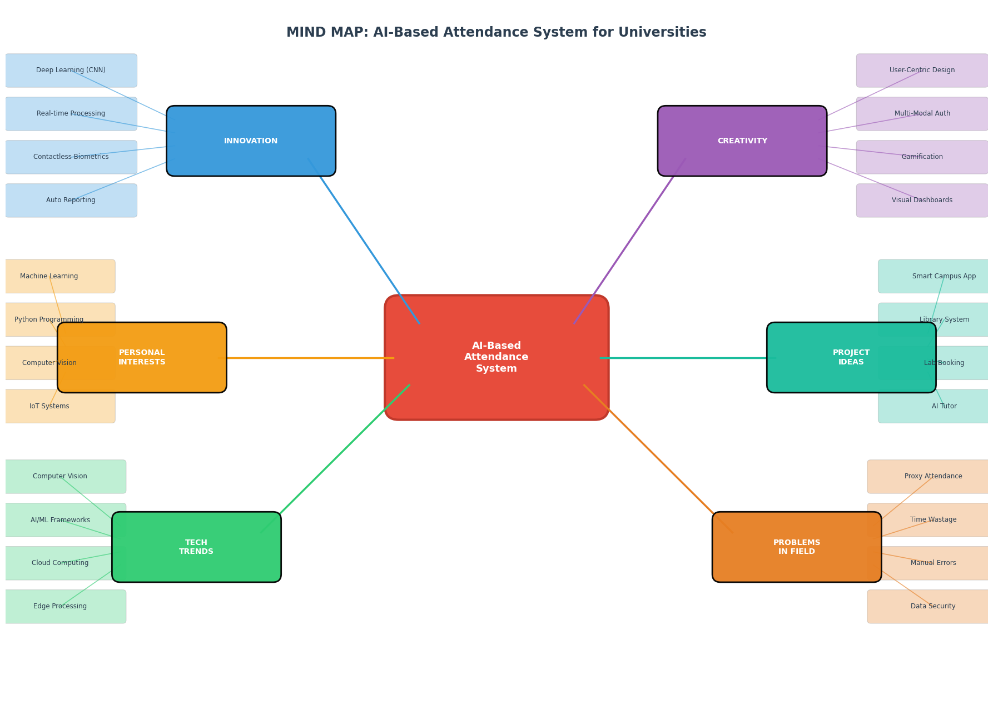
Figure 1: Mind Map
The mind map shows how the main idea for the project is related to several domains. The Innovation branch features real-time processing, contactless biometrics, especially relevant post-pandemic, CNN/FaceNet architectures and automated reporting capacities. The Creativity branch focuses on user-centric design principles, multi-modal authentication opportunities, gamification opportunities to encourage participation, and visual dashboards for presenting data. The technology trends are computer vision with OpenCV, AI/ML frameworks like TensorFlow and Keras, cloud computing infrastructure, and edge processing for lower latency. The Computing Field problems highlight that attendance is a major concern in schools, roll call is time-consuming and tedious, inaccurate attendance records are prone to human error, and the security of current systems is compromised. Personal Interests are areas of specialisation including IoT systems, computer vision, Python programming and machine learning. Finally, Project Ideas go into related concepts such as smart campus applications, Library Management systems, Laboratory Booking systems and AI Tutor systems.

Q2: Selected Project Idea
Project: AI-Based Facial Recognition Attendanc
The reason I was drawn to this idea:
This project was chosen because it's a real problem seen in universities. Manual attendance systems such as roll calls, sign-in sheets and swiping student ID cards by RFID are inefficient, error-prone and can lead to proxy attendance (students signing in for others who are absent), as noted by [1]It has been found that the use of facial recognition in automated attendance systems can provide around 97.8% accuracy and drastically decrease attendance system administration[1]. It is meaningful because machine learning and computer vision are the fields that I'm interested in personally, and it is not out of the realm of the possible, as it is a practical problem.
Who Benefits:
This system is advantageous to a few stakeholders. Students spend less time in the lecture theatre at the beginning of the lectures and can use the contact hours optimally. Academic Staff members are released from administrative attendance to facilitate more time in class and for students. The real-time, accurate attendance data is sent to the university administrators, who can then monitor the students' engagement, pinpoint students who are at risk, and meet regulatory reporting requirements. This scalable, maintainable system is also easily integrated into existing infrastructure, helping IT departments. It is extensible and sustainable, and easily integrates with the current infrastructure, making it useful for IT departments.
Why It Is Interesting:
It is because the project uses several cutting-edge technologies: Convolutional Neural Networks for feature extraction, FaceNet for generating embeddings of faces from images and real-time video processing. Adding complexity and relevance are the ethical aspects, especially the GDPR aspects of privacy and protection of biometric data. The system should be accurate while also ensuring privacy, which poses true engineering challenges[2]. Moreover, the project adds to the existing research around the use of AI in educational technology, which is a field that is rapidly expanding (Puri and Chaudhari, 2025).
Why It Is Realistic:
The project is technically realistic as part of a Level 5 computing programme. OpenCV, TensorFlow and dlib are open-source libraries that can be used for face detection and recognition. User interfaces can be developed quickly using web frameworks built in Python classes such as Flask. Web frameworks built in Python classes, such as Flask, offer the ability to develop user interfaces quickly. Powerful database choices: MySQL and SQLite. For a pilot study, the existing research provides good methodological guidelines, and a small group of students (30-50) can be used to validate the system performance (Bujang et al., 2024). Many universities have a general HD camera in their computing labs and have a computer with GPU acceleration support.
References (Task 1)
[1] Collett, "Riots, Revolution and Rehabilitation: The Future of Probation," vol. 52, no. 2, pp.163–189, October 17 2016, doi: 10.1111/hojo.12007.
[2] B. Nguyen-Tat, M. Bui and V. M. Ngo, "Automating attendance management in human resources: A design science approach using computer vision and facial recognition," vol. 4, no. 2, pp.100253, 2024,
Puri, D.D. and Chaudhari, R. (2025) 'Attendance system using AI', International Journal of Advanced Research in Computer and Communication Engineering, 14(9). DOI: 10.17148/IJARCCE.2025.14922.
Rajkumar, R., Harshitha, S., Priyadarshini, S. and Yamini, C. (2024) 'Smart attendance system using facial recognition', International Journal of Advanced Research in Computer and Communication Engineering, 13(12). DOI: 10.17148/IJARCCE.2024.131207.
Thokal, S., Padalkar, P., Solase, A., Randhavan, R., Khemnar, K.C. and Maniyar, A.A. (2024) 'AI-based face recognition attendance system for real-time monitoring', International Journal of Scientific Research in Computer Science Engineering and Information Technology. DOI: 10.32628/CSEIT26121395.

TASK 2 – AIM, OBJECTIVES & RESEARCH AREA

Q1: Project Aim and Objectives
Project Aim:
To develop, build and test an AI-based facial recognition attendance system for a university classroom to automate attendance recording, eliminate proxy attendance, decrease administrative time and ensure that data is handled according to GDPR.
Objectives:
Objective | Specific | Measurable | Achievable | Relevant | Time-bound
1. System Design | Design system architecture using OpenCV, TensorFlow, and Flask | Architecture document completed with UML diagrams | Feasible with available open-source tools | Directly supports the aim of automation | Weeks 1-4
2. Face Recognition Development | Implement face detection and recognition using CNN/FaceNet | Achieve ≥95% accuracy on test dataset | Existing research shows 97.8% achievable (Thokal et al., 2024) | Core technical requirement | Weeks 5-10
3. Database Integration | Develop a MySQL database for student records and attendance logs | Store 1000+ student profiles with timestamps | Standard database capacity | Essential for data management | Weeks 8-12
4. Pilot Testing | Deploy system in 2 university classrooms | Collect data from 50 students across 10 sessions | 30 respondents sufficient for pilot reliability testing (Bujang et al., 2024) | Validates system in real environment | Weeks 13-16
5. User Evaluation | Conduct questionnaire and interviews with users | Achieve ≥80% satisfaction score from 30 respondents | Standard survey methodology established | Measures user acceptance | Weeks 15-18
6. GDPR Compliance | Implement data encryption, consent management, and access controls | Pass data protection impact assessment | GDPR guidelines clearly established (ICO, 2021) | Legal and ethical necessity | Weeks 12-18

Q2: Research Philosophy
Selected Philosophy: Pragmatism
In my research, I have selected the pragmatism philosophy. Pragmatism is a philosophical approach that focuses on practical results and problem-solving, rather than on ontological or epistemological views (Swaleh and Wabwoba, 2025). Pragmatism is a flexible approach that allows researchers to choose any methods that will answer the research questions, as opposed to positivism, which believes in an objective, measurable reality, and interpretivism, which believes in a socially-constructed reality that is subjective (Creswell and Plano Clark, 2018).
Justification for Pragmatism:
Both quantitative and qualitative data are needed for this project in order to make a full evaluation. Quantitatively, I'm going to measure the performance of the system, such as accuracy of recognition, processing speed of the system, and false positive and negative rates. Qualitative: Understand user experiences, concerns about privacy and barriers to implementation from the students' and lecturers' point of view. This mixed-methods study is grounded in the philosophy of pragmatism, which allows me to integrate the statistical analysis of data with thematic interpretation without any ontological conflict (Creswell and Plano Clark, 2018).
Pragmatism is "pluralistic and oriented towards what works and practice," allowing researchers to choose methods that are appropriate to the research problem, not necessarily in the purest sense of philosophy (Creswell and Plano Clark, 2018). This is exactly what should happen in computing: the ultimate test of success is if the system is effective and is useful to the user. For this project, the convergent parallel mixed methods design will be best suited, which involves collecting quantitative and qualitative data at the same time and incorporating the results into interpretation (Creswell & Plano Clark, 2018).
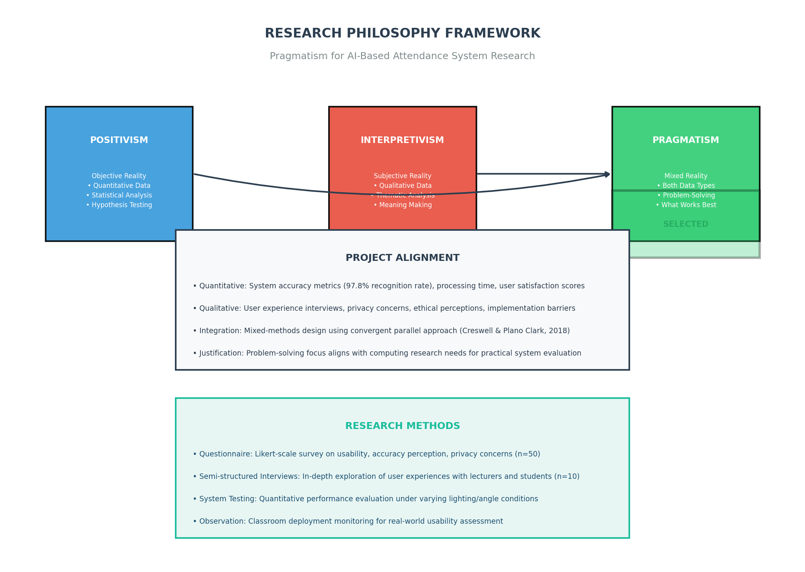
Figure 5: Research Philosophy Framework – Pragmatism for AI-Based Attendance System Research

Q3: Research Strategy
Academic Databases:
Database | Purpose | Access
Google Scholar | Broad interdisciplinary search; citation tracking | Free
IEEE Xplore | Computer science and engineering literature | University subscription
ScienceDirect | Peer-reviewed journals in technology and computing | University subscription
ACM Digital Library | Computing and information technology research | University subscription

Keywords and Search Strings:
Category | Keywords | Search String
Primary | facial recognition, attendance system, university | ("facial recognition" OR "face recognition") AND ("attendance system" OR "attendance management") AND ("university" OR "higher education")
Secondary | deep learning, CNN, FaceNet, biometric | ("deep learning" OR "convolutional neural network" OR "CNN") AND ("FaceNet" OR "biometric") AND "attendance"
Tertiary | ethics, GDPR, privacy, data protection | ("GDPR" OR "data protection") AND ("facial recognition" OR "biometric") AND ("ethics" OR "privacy")

Inclusion Criteria:
- Conference Proceedings and peer-reviewed journal articles
- Publication date: 2019–2025
- English language publications
- Concentrate on facial recognition technology used in education or attendance settings. Empirical studies that use quantitative or mixed methods design.
- Research on ethical, legal, or privacy concerns.
Exclusion Criteria:
- Please note that papers published prior to the year 2019 (with the exception of seminal papers) are not included.
- Non-peer-reviewed sources – blogs, unverifiable websites)
- Studies that only addressed contexts outside of education with no transferable insights. The following publications are available in languages other than English:
- No papers submitted solely on a theoretical basis will receive a mark.Purely theoretical papers – no mark will be awarded if they are based entirely on theory.

References (Task 2)
Bujang, M.A., Omar, E.D., Foo, D.H.P. and Hon, Y.K. (2024) 'Sample size determination for conducting a pilot study to assess reliability of a questionnaire', Restorative Dentistry & Endodontics, 49(1), e3.
Creswell, J.W. and Plano Clark, V.L. (2018) Designing and Conducting Mixed Methods Research. 3rd edn. Thousand Oaks, CA: SAGE Publications.
ICO (2021) Facial Recognition Technology (FRT) and Surveillance. Available at: https://ico.org.uk/for-organisations/uk-gdpr-guidance-and-resources/cctv-and-video-surveillance/ (Accessed: 10 July 2025).
Swaleh, M. and Wabwoba, F. (2025) 'IT philosophy: Philosophical paradigms in information technology research', International Journal of Research and Innovation in Applied Science, 10(1). DOI: 10.51584/IJRIAS.2025.1001021.
Thokal, S. et al. (2024) 'AI-based face recognition attendance system for real-time monitoring', International Journal of Scientific Research in Computer Science Engineering and Information Technology. DOI: 10.32628/CSEIT26121395.

TASK 3 – RESEARCH STRATEGY

Q1: Research Quality
Validity:
Validity is the degree to which a research instrument measures the phenomenon that it was designed to measure (Joshi et al., 2024). For this project, all the test conditions are controlled with the same set of students tested under a range of lighting conditions, angles and distances to ensure that the recognition accuracy is indeed representative of the system's performance and not influenced by other factors. To ensure that results are relevant to other settings, pilot testing is carried out in both small seminar rooms and large lecture rooms. The questionnaire is validated for face validity by the expert review from computing lecturers so that the questions are able to cover the aspect of usability, accuracy perception and privacy concerns. Content Validity is checked by having the questionnaire items aligned with the project's SMART goals to ensure complete coverage.
Reliability:
Reliability is related to the consistency and stability of the measures taken (Joshi et al., 2024). In the quantitative assessments, test-retest reliability is measured by administering the same questionnaire to a subset of the subjects (n=10) after two weeks, and calculating the Pearson's correlation coefficient, which should be ≥0.7 for acceptable reliability. Inter-rater reliability for qualitative interviews is obtained by dual coding method, the two researchers independently code 20% of the interview transcripts and obtained the Cohen's Kappa value, the value of Cohen's Kappa ≥0.6 means that there is moderate to substantial agreement (Bujang et al., 2024). Technical reliability is determined for the system by conducting repeated recognition trials under the same conditions to ensure that the system has consistent performance. Items on Likert scales will have Cronbach's alpha calculated, and items with α ≥ 0.7 will be considered to have acceptable internal consistency.
Generalisability:
The degree to which findings are generalizable to other situations is called the generality. Although the pilot study is small (n=50), the mixed methods design does allow for theoretical generalisation; that is, the qualitative results offer rich contextual understanding, aiding in the possible transfer of results to other likely implementations at other institutions. Systematic documentation of barriers for implementation and success factors allows transferability to similar university contexts. I accept the limitation of generalisability due to the single-institution context, however, and believe that future studies should be replicated in other universities to increase external validity.
Ethics:
Considering the processing of biometric data is essential in view of the ethical concerns. The project is compliant with the GDPR principles: minimisation (only collecting facial data required for attendance), limitation of purpose (only using the data for attendance purposes), limitation of storage (deleting the data at the end of the academic year) and accountability (keeping processing records) (ICO, 2021). All participants give explicit informed consent, the use of data, how long data will be kept, and how it will be deleted. Data protection impact assessment (DPIA) is done prior to deployment, in line with GDPR Article 35 that requires performing DPIA before high-risk processing of biometric data. Bias mitigation is covered by testing the system on a variety of populations to understand the performance of the system equally across all groups. Right to withdrawal is guaranteed and the participants can also opt to attend manually at any time without penalty.

Q2: Research Methods Selected Methods:
I have decided to use a questionnaire and Semi-Structured interviews to gather quantitative and qualitative data respectively. Convergent parallel mixed methods design involves the collection of both qualitative and quantitative data at the same time and is analyzed together in interpreting the results (Creswell and Plano Clark, 2018). Pilot Questionnaire Design: The pilot questionnaire has three sections: Section A: Demographic information (5 items) = Age, gender, type of programme being studied, year of study, how often technology is used The System Usability section (15 items, 5-point Likert scale) comprised items related to ease of use, interface clarity, processing speed satisfaction, accuracy confidence and overall experience. Section C: Privacy and Ethics (10 items, 5-point Likert scale + open comments) – Items regarding comfort in biometric data storage, the security of data, how consent is obtained, and concerns with surveillance
Pilot Testing and Feedback:
Feedback Category | Participant Comments | Action Taken
Clarity | Question 7 was confusing—what accuracy? | Added context: "Based on your experience during pilot sessions"
Terminology | I don't know what "biometric template" means | Changed to "facial data"
Response space | Not enough room for comments | Expanded comment boxes to 100 words
Scale labels | Numbers alone are unclear | Added verbal anchors (Strongly Disagree to Strongly Agree)

Reliability from Pilot: Cronbach's α = 0.82 for Section B, 0.78 for Section C, indicating good internal consistency.

Q3: Data Analysis
Quantitative Analysis:
Quantitative data from the questionnaire and system performance logs are analysed using:
Technique | Application | Software
Descriptive statistics (mean, median, SD) | Summarise usability and satisfaction scores | SPSS / Python (pandas)
Frequency distributions | Analyse demographic composition | SPSS / Excel
Cross-tabulation | Examine relationships between demographics and attitudes | SPSS
Independent t-tests / ANOVA | Compare satisfaction across groups (e.g., gender, year) | SPSS
Correlation analysis (Pearson's r) | Examine relationships between usability and privacy concerns | SPSS

System performance metrics (accuracy, processing time, error rates) are presented through bar charts comparing performance across conditions, line graphs showing accuracy trends over sessions, and pie charts illustrating error type distributions.
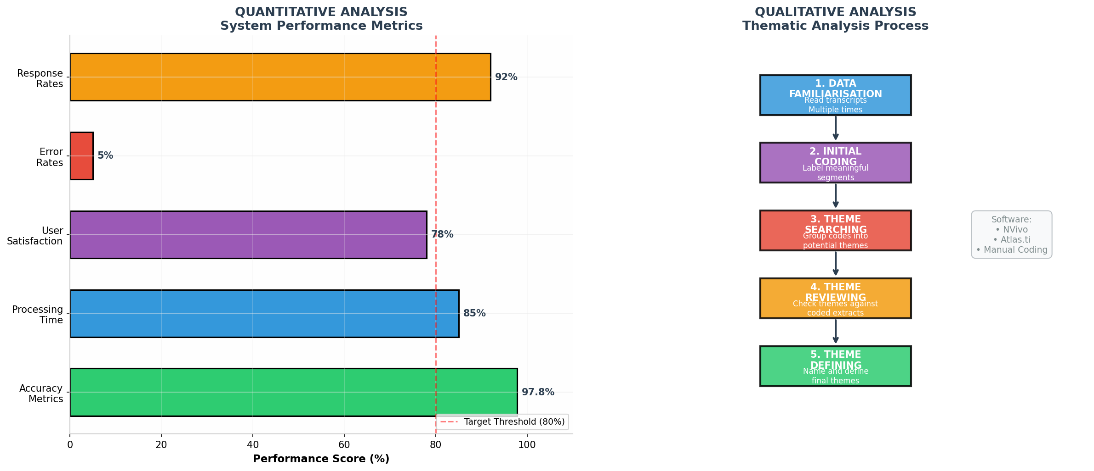
Figure 2: Quantitative and Qualitative Analysis Methods
Qualitative Analysis:
Thematic analysis is used to analyse the qualitative data obtained from the semi-structured interviews (n=10: 5 students and 5 lecturers) in six phases as follows:
- Familiarisation: make all tapes and read and re-read transcripts; make initial impressions.
- First Coding: Code meaningful parts of the data systematically across the whole data set. Theme Searching: Cluster together similar codes into possible themes
- Theme Reviewing: Review themes with coded extracts and with whole data set; revise, combine or differentiate themes
- Theme Defining: Identify and define concluding themes; identify sub-themes
- Report Writing: Identify and choose interesting extracts, link analysis to research aims and literature.
Thematic analysis is chosen because it is a flexible methodology yet remains systematic in identifying patterns in qualitative data, without the need for any theoretical frameworks beforehand (Braun and Clarke, 2006). It allows for the identification of both explicit (semantic) themes and implicit (latent) themes, adding richness to the user experience results.
Appropriateness:
The mixed-methods approach is best suited because: • Quantitative analysis gives objective and generalisable measures of system performance and user satisfaction Qualitative analysis focuses on more subtle experiences, barriers, and context which quantitative data may not show. By incorporating both methods, it is possible to evaluate both "what works" and "why it works" (Creswell and Plano Clark, 2018). Convergent design enables the quantitative and qualitative findings to be compared and triangulated to enhance the validity of the findings.
References (Task 3)
Braun, V. and Clarke, V. (2006) 'Using thematic analysis in psychology', Qualitative Research in Psychology, 3(2), pp. 77-101.
Bujang, M.A. et al. (2024) 'Sample size determination for conducting a pilot study to assess reliability of a questionnaire', Restorative Dentistry & Endodontics, 49(1), e3.
Creswell, J.W. and Plano Clark, V.L. (2018) Designing and Conducting Mixed Methods Research. 3rd edn. Thousand Oaks, CA: SAGE Publications.
EDPB (2022) Guidelines 05/2022 on the Use of Facial Recognition Technology in the Area of Law Enforcement. European Data Protection Board.
ICO (2021) Facial Recognition Technology (FRT) and Surveillance. Available at: https://ico.org.uk/for-organisations/uk-gdpr-guidance-and-resources/cctv-and-video-surveillance/ (Accessed: 10 July 2025).
Joshi, A., Kale, S., Chandel, S. and Pal, D.K. (2024) 'Designing and validating a research questionnaire - Part 2', Perspectives in Clinical Research, 15(1), pp. 8-12.

REFERENCES
Alghamdi, S. (2019) 'Monitoring student attendance using a smart system at Taif University', International Journal of Computer Science and Information Technology, 11(1), pp. 107-115.
Braun, V. and Clarke, V. (2006) 'Using thematic analysis in psychology', Qualitative Research in Psychology, 3(2), pp. 77-101.
Bujang, M.A., Omar, E.D., Foo, D.H.P. and Hon, Y.K. (2024) 'Sample size determination for conducting a pilot study to assess reliability of a questionnaire', Restorative Dentistry & Endodontics, 49(1), e3.
Creswell, J.W. (2014) Research Design: Qualitative, Quantitative, and Mixed Methods Approaches. 4th edn. Thousand Oaks, CA: SAGE Publications.
Creswell, J.W. and Plano Clark, V.L. (2018) Designing and Conducting Mixed Methods Research. 3rd edn. Thousand Oaks, CA: SAGE Publications.
Dixit, H.V., Saxena, A., Arif and Sharma, S. (2024) 'Face recognition-based attendance system', Proceedings of the International Conference on Innovative Computing & Communication (ICICC 2024). SSRN. Available at: https://ssrn.com/abstract=4833698.
EDPB (2022) Guidelines 05/2022 on the Use of Facial Recognition Technology in the Area of Law Enforcement. European Data Protection Board.
Fikry, M. et al. (2024) 'Performance analysis of smart technology with face detection using YOLOv3 and InsightFace for student attendance monitoring', International Journal of Intelligent Systems and Applications in Engineering, 12(4), pp. 3490-3499.
ICO (2021) Facial Recognition Technology (FRT) and Surveillance. Available at: https://ico.org.uk/for-organisations/uk-gdpr-guidance-and-resources/cctv-and-video-surveillance/ (Accessed: 10 July 2025).
Joshi, A., Kale, S., Chandel, S. and Pal, D.K. (2024) 'Designing and validating a research questionnaire - Part 2', Perspectives in Clinical Research, 15(1), pp. 8-12.
Kortli, Y. et al. (2020) 'Face recognition systems: A survey', Sensors, 20(2), 342.
Laishram, L. et al. (2025) 'Toward a privacy-preserving face recognition system: A survey of leakages and solutions', ACM Computing Surveys, 57(6), pp. 1-38.
Nguyen-Tat, B.T., Bui, M.Q. and Ngo, V.M. (2024) 'Automating attendance management in human resources: A design science approach using computer vision and facial recognition', International Journal of Information Management Data Insights, 4(2), 100253.
Puri, D.D. and Chaudhari, R. (2025) 'Attendance system using AI', International Journal of Advanced Research in Computer and Communication Engineering, 14(9). DOI: 10.17148/IJARCCE.2025.14922.
Rajkumar, R. et al. (2024) 'Smart attendance system using facial recognition', International Journal of Advanced Research in Computer and Communication Engineering, 13(12). DOI: 10.17148/IJARCCE.2024.131207.
Sawhney, S. et al. (2019) 'Real-time smart attendance system using face recognition techniques', in 2019 9th International Conference on Cloud Computing, Data Science & Engineering (Confluence). IEEE, pp. 522-525.
Schroff, F., Kalenichenko, D. and Philbin, J. (2015) 'FaceNet: A unified embedding for face recognition and clustering', in Proceedings of the IEEE Conference on Computer Vision and Pattern Recognition (CVPR). IEEE, pp. 815-823.
Swaleh, M. and Wabwoba, F. (2025) 'IT philosophy: Philosophical paradigms in information technology research', International Journal of Research and Innovation in Applied Science, 10(1). DOI: 10.51584/IJRIAS.2025.1001021.
Thokal, S. et al. (2024) 'AI-based face recognition attendance system for real-time monitoring', International Journal of Scientific Research in Computer Science Engineering and Information Technology. DOI: 10.32628/CSEIT26121395.
Valenzuela, J.T. et al. (2024) 'Development and evaluation of a facial recognition-based computer laboratory attendance monitoring system', Asian Journal of Engineering and Information Sciences, 8(1).
Vardhan, R. et al. (2025) 'Automated attendance system using facial recognition: A comprehensive review', in Challenges and Opportunities for Innovation in India. pp. 117-122.

APPENDICES
Appendix A: Mind Map
(See Figure 1, Task 1)
Appendix B: Pilot Questionnaire
AI-Based Facial Recognition Attendance System – User Evaluation Questionnaire
Instructions: Please answer all questions honestly. Your responses are confidential and will be used solely for research purposes. Participation is voluntary, and you may withdraw at any time.

Section A: Demographics
Question | Response Options
A1. What is your age? | □ 18-20 □ 21-23 □ 24-26 □ 27+
A2. What is your gender? | □ Male □ Female □ Non-binary □ Prefer not to say
A3. What is your programme of study? | _________________________
A4. What year are you in? | □ Year 1 □ Year 2 □ Year 3 □ Postgraduate
A5. How often do you use technology daily? | □ 1-2 hours □ 3-5 hours □ 6-8 hours □ 8+ hours

Section B: System Usability (Please circle: 1=Strongly Disagree to 5=Strongly Agree)
No. | Statement | 1 | 2 | 3 | 4 | 5
B1 | The system was easy to use | 1 | 2 | 3 | 4 | 5
B2 | The interface was clear and intuitive | 1 | 2 | 3 | 4 | 5
B3 | The face recognition process was quick | 1 | 2 | 3 | 4 | 5
B4 | I felt confident the system recorded my attendance correctly | 1 | 2 | 3 | 4 | 5
B5 | The system worked well in different lighting conditions | 1 | 2 | 3 | 4 | 5
B6 | I preferred this to manual roll call | 1 | 2 | 3 | 4 | 5
B7 | Based on your experience during pilot sessions, the system accuracy was satisfactory | 1 | 2 | 3 | 4 | 5
B8 | The attendance dashboard was useful | 1 | 2 | 3 | 4 | 5
B9 | I would recommend this system to other universities | 1 | 2 | 3 | 4 | 5
B10 | The system saved time at the start of lectures | 1 | 2 | 3 | 4 | 5
B11 | Technical issues were minimal during testing | 1 | 2 | 3 | 4 | 5
B12 | The system recognised me even when I wore glasses/mask | 1 | 2 | 3 | 4 | 5
B13 | Overall, I am satisfied with the system | 1 | 2 | 3 | 4 | 5
B14 | The system is better than RFID card swiping | 1 | 2 | 3 | 4 | 5
B15 | I would use this system regularly if implemented | 1 | 2 | 3 | 4 | 5

Section C: Privacy and Ethics (Please circle: 1=Strongly Disagree to 5=Strongly Agree)
No. | Statement | 1 | 2 | 3 | 4 | 5
C1 | I understood how my facial data would be used before giving consent | 1 | 2 | 3 | 4 | 5
C2 | I feel comfortable with the university storing my facial data | 1 | 2 | 3 | 4 | 5
C3 | The security protection for my data seems adequate | 1 | 2 | 3 | 4 | 5
C4 | I understand how long my data will be stored | 1 | 2 | 3 | 4 | 5
C5 | I know I can request deletion of my data at any time | 1 | 2 | 3 | 4 | 5
C6 | The consent process was clear and transparent | 1 | 2 | 3 | 4 | 5
C7 | I have concerns about facial recognition being used for attendance | 1 | 2 | 3 | 4 | 5
C8 | I trust the university to protect my biometric information | 1 | 2 | 3 | 4 | 5
C9 | The system feels like unnecessary surveillance | 1 | 2 | 3 | 4 | 5
C10 | Overall, I believe the benefits outweigh privacy concerns | 1 | 2 | 3 | 4 | 5

C11. Please share any additional comments about your experience, concerns, or suggestions for improvement:
_________________________________________________________________
_________________________________________________________________
_________________________________________________________________

Appendix C: Pilot Feedback Summary
Feedback Category | Participant Comments | Action Taken
Clarity | Question 7 was confusing—what accuracy? | Added context: "Based on your experience during pilot sessions"
Terminology | I don't know what "biometric template" means | Changed to "facial data"
Response space | Not enough room for comments | Expanded comment boxes to 100 words
Privacy concerns | How do I know my data is secure? | Added C3 specifically addressing security perception

Pilot Reliability Results:
• Section B (Usability): Cronbach's α = 0.82
• Section C (Privacy): Cronbach's α = 0.78
• Overall: Good internal consistency; no items require deletion

Appendix D: Search Strategy
Database | Search Date | Search String | Results | Selected | Notes
Google Scholar | 05/07/2025 | ("facial recognition" OR "face recognition") AND ("attendance system" OR "attendance management") AND ("university" OR "higher education") | 1,247 | 12 | Broad interdisciplinary coverage
IEEE Xplore | 05/07/2025 | ("face recognition" AND "attendance" AND "deep learning") | 89 | 8 | Engineering focus
ScienceDirect | 06/07/2025 | ("facial recognition" AND "attendance system" AND "biometric") | 156 | 6 | Technology and computing journals
ACM Digital Library | 06/07/2025 | ("face recognition" AND "attendance" AND ("CNN" OR "FaceNet")) | 67 | 5 | Computing and IT research

Inclusion/Exclusion Application:
• Initial screening by title/abstract: 1,559 → 312
• Full-text review: 312 → 31
• Final selection (2019-2025, English, peer-reviewed): 31

Appendix E: System Architecture Diagram
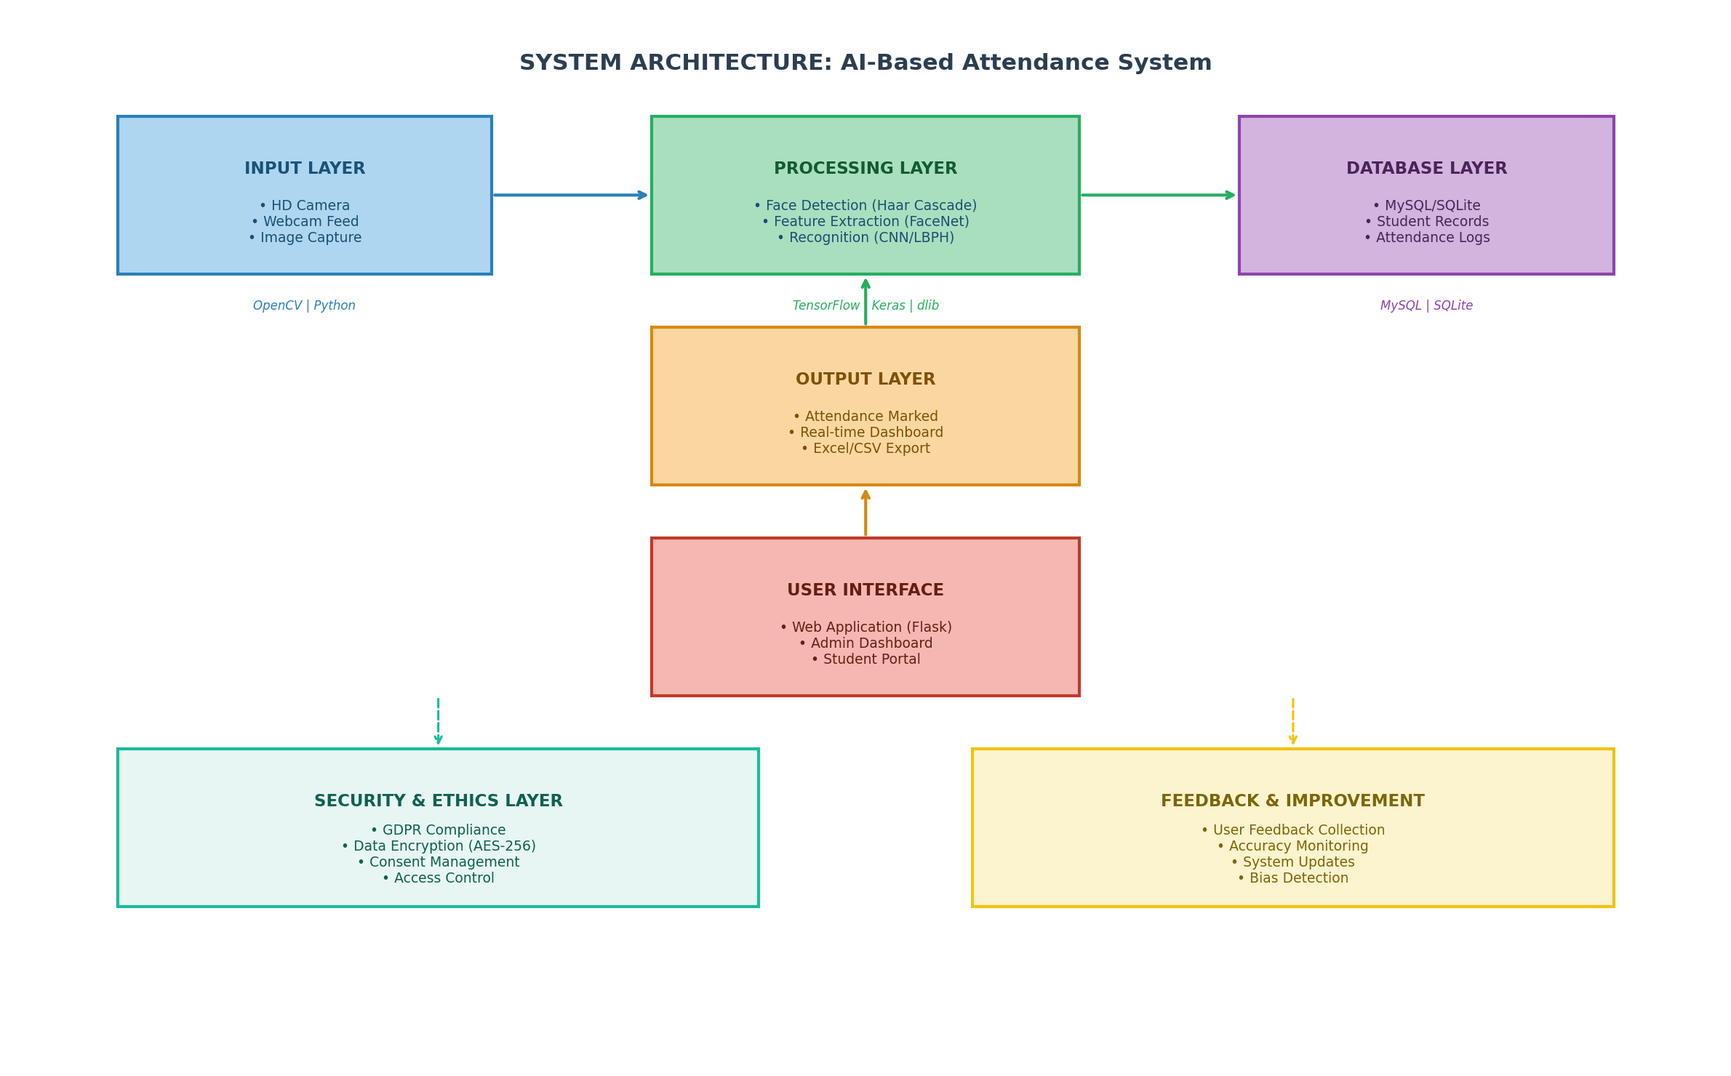
Figure 3: System Architecture for AI-Based Attendance System

Appendix F: Project Timeline (Gantt Chart)
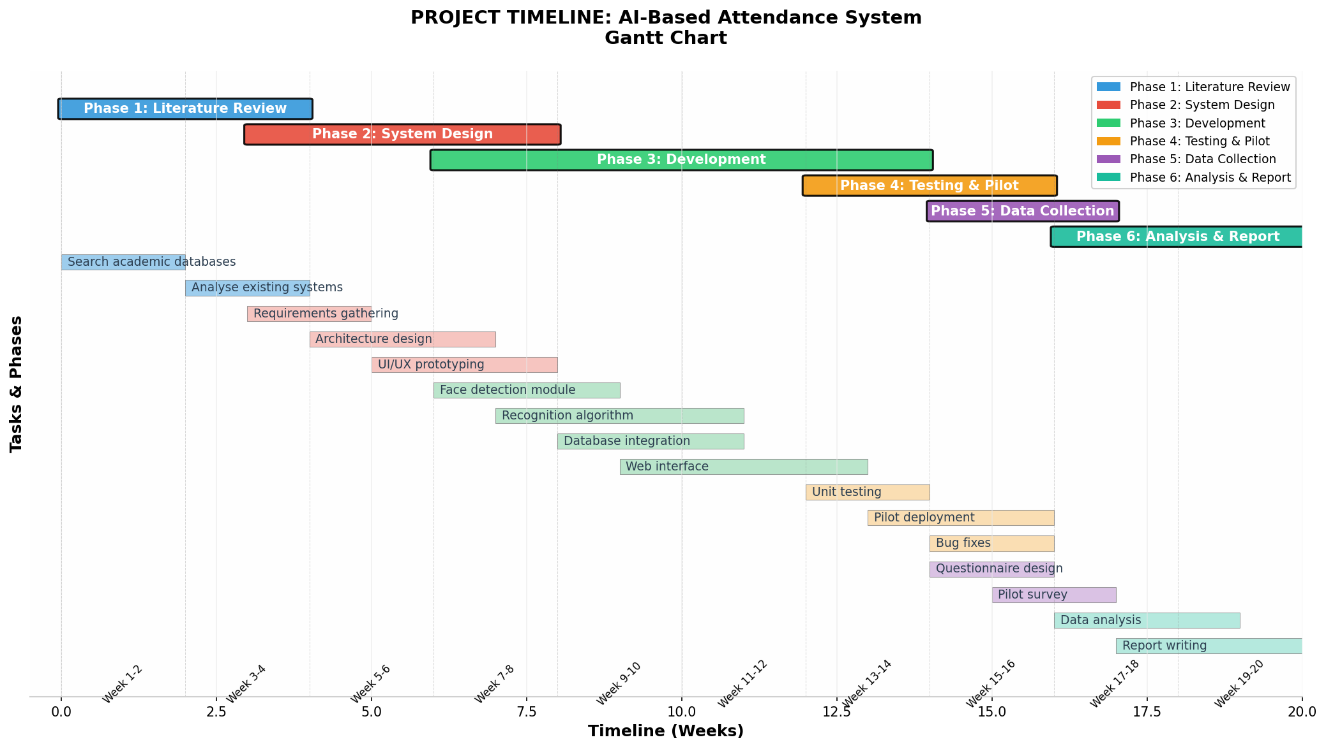
Figure 4: Project Timeline and Task Scheduling

Appendix G: Research Philosophy Framework
Figure 5: Pragmatism as Selected Research Philosophy

References
[1] M. A. Bujang, E. D. Omar, D. H. P. Foo and Y. K. Hon, "Sample size determination for conducting a pilot study to assess reliability of a questionnaire," vol. 49, no. 1, 2024,
[2] B. Nguyen-Tat, M. Bui and V. M. Ngo, "Automating attendance management in human resources: A design science approach using computer vision and facial recognition," vol. 4, no. 2, pp.100253, 2024,

