Coaching and Mentoring Skills for the Workplace
BMSW6105_LON

SUDENT NAME: ALINA COCIRLEA
STUDENT NUMBER: 2123036
LECTURER NAME: NISHI RAMSURRUN

Table of Contents
Introduction 3
Critical Evaluation of the Purpose of Coaching and Mentoring in the Workplace 3
Top 10 Coaching Skills: Importance and Practical Application 5
Critical Analysis of the Specific Coaching Model 7
Reflection on Practical 1: Coaching Session 8
Reflection on Practical 2: Mentoring Session 9
References 12
APPENDIX 1: 14
APPENDIX 2- Action Plan 15

Introduction
The following reflective report focuses on the goals and feedback in peer coaching and mentoring of the BMSW6105 module. In analysing sessions I have facilitated regarding learning outcomes, difficulty experienced, and improvement, I will employ Gibbs's Reflective Cycle, a mode of reflection. This framework is exactly what I needed it may serve as a guide that allows a subject to describe each session, assess its efficiency, and generate an action plan against the evaluation.
Coaching is a solution-focused, goal-oriented process for helping people actualize intended objectives. Mentoring, on the other hand, tends to be more long-term focused, being more concerned with the development of the individual self. While both approaches contain some common aspects, coaching is usually process or work-focused, and a mentor deals with more extensive productive subject areas. This distinction guided my work so that I could use methods that would suit the goals of each session.
Skills for coaching and mentoring are listening, understanding, and using positive questions. However, creating a favourable environment of trust that facilitates confidence and openness is critical, especially in the achieving of better results. This report will describe the use of these skills, and other theories involved in the process such as The GROW model for coaching and the Johari Window for mentoring and assess the extent to which they fulfil the purpose of having meaningful development within a workplace environment.

Critical Evaluation of the Purpose of Coaching and Mentoring in the Workplace
Today, coaching and mentoring are two different processes that play different roles in the learning of employees and the development of organizations. Coaching is the process of using one’s expert advice to help a person or a team meet a performance target often in skill development or increased performance (Whitmore, 2017). On the other hand; Mentoring promotes individual development by providing career and personal guidance in the long term in conjunction with gaining information from the mentor (Garvey et al, 2021). These processes can exist side by side in the workplace that is through training and development programs we can create a learning organization and support workplace learning.
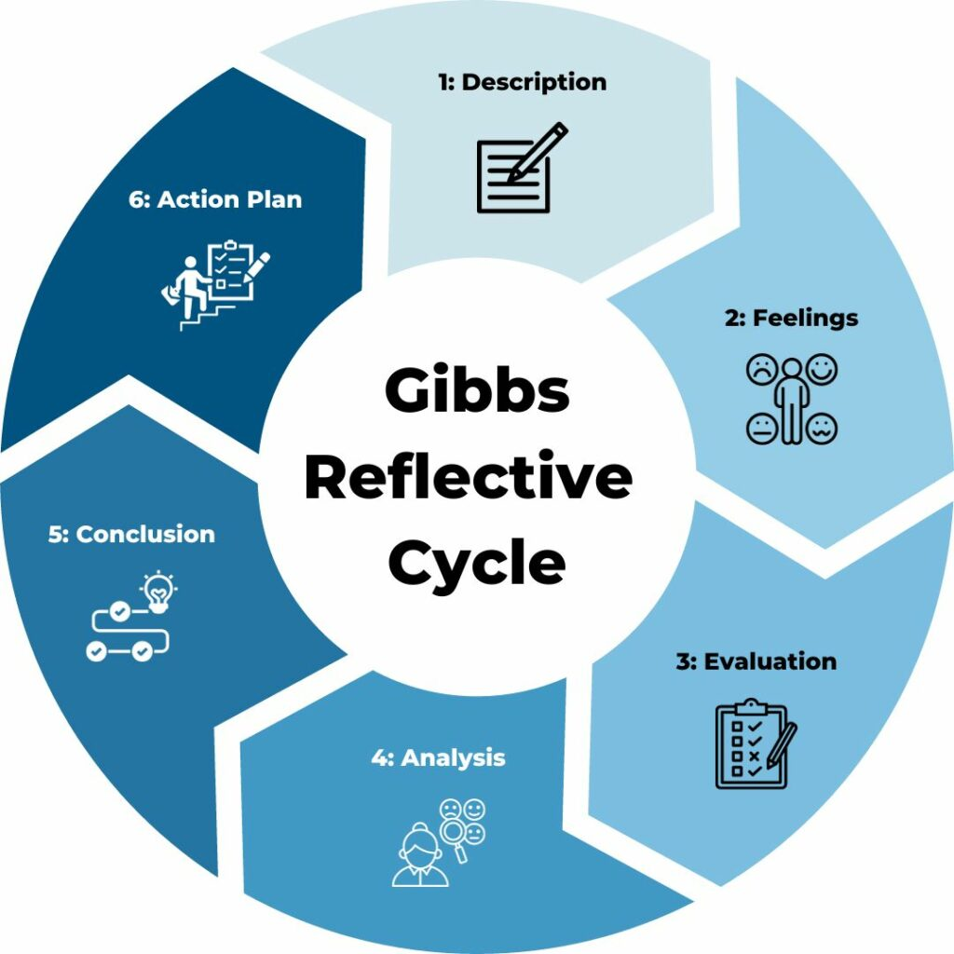
Figure 1: Diagram of Gibbs Reflective Cycle
Coaching is most useful in situations where fast skill development is needed motivation must be raised or people have to be prepared for certain positions (Jones et al., 2016). If targets are placed as structured and short-term, then the skill that needs improvement or the behavioural change that needs to occur could be the focus of the coaching. On the other hand, mentoring is a more comprehensive type of training and aims at the person and his/her perception (Cox and Chappell 2014). While the major difference between a sponsor and a coach is that the former gives advice and assists the coachee in overcoming career development issues, the role might best be characterized as less directive and more supportive than coaching.
It is well understood that coaching and mentoring subordinates have several advantages. Research evidence proving the importance of the practice in employees’ performances, motivation, and capacity for development exists (Theeboom et al., 2014). Mentoring on the other hand is correlated with higher levels of job satisfaction, enhanced commitment at work, and enhanced quality of psychological well-being (Garvey et al., 2021). Jones et al, also note that mentoring relationships lead to increased organization identification and helps to decrease the levels of turnover amongst employees.
Despite all the advantages that both processes provide they have their shortcomings. Coaching tends to be utilitarian and ‘skin deep’, and may not meet career development needs, which means that it may not fully address long-term aspirations. Mentoring on the other hand takes a relatively longer time in which the effectiveness may be dampened (Drake, 2018). It can also be done in a way that coaching and mentoring complement each other thus way meeting both the short and the long-term goals.
The modern world’s fluid business environment only highlights the value of such activities. For instance, organizations that experience change regularly enjoy the benefits of coaching since it prepares the employee to handle new responsibilities when he or she has been reassigned (Cameron & Green, 2019). Mentoring leads to high levels of support, and trust and this is important when there is change especially to retain the employees.

Top 10 Coaching Skills: Importance and Practical Application
Effective coaching requires a set of well-defined skills that enable coaches to support their coachees in achieving goals, overcoming challenges, and fostering personal and professional growth. Below is a detailed explanation of the top 10 coaching skills and their importance, with examples of their practical application in coaching sessions:
Listening | Active listening is fundamental in coaching as it builds trust and ensures coachees feel understood and valued. It enables coaches to identify the underlying issues or motivations of the coachee. In a coaching session, a coach may listen attentively to a coachee. This shows understanding and creates an open environment. (Garvey, Stokes and Megginson, 2021).
Questioning | Asking insightful and open-ended questions encourages critical thinking and self-reflection. It helps coachees uncover solutions and explore perspectives they may not have considered. A coach might ask, “What would success look like for you in this situation?” This question encourages the coachee to visualize their goal and articulate it clearly.
Building Rapport | Establishing rapport creates trust and a safe space for open communication. This encourages open communication and collaboration. A coach might start with informal dialogue to ease tension and foster collaboration.
Empathizing | Demonstrating empathy helps the coachee feel supported and understood. It strengthens the coach-coachee relationship and creates a non-judgmental space for growth. For example, acknowledging their frustrations, such as “I understand how challenging this must feel,” demonstrates understanding.
Summarizing and Reflecting | Summarizing key points and reflecting on what has been discussed ensures clarity and alignment between the coach and coachee. It also reinforces learning (Drake, 2018). At the end of a session, the coach might say, “We have agreed to focus on improving your communication by practising presentations daily”.
Unlocking Limiting Beliefs | Helping coachees identify and overcome self-imposed barriers allows them to reach their full potential and achieve their goals. A coach might ask, “What evidence supports this belief?” to shift the focus to their strengths.
Staying Focused | Staying focused ensures that the coaching session remains productive and aligned with the coachee’s objectives. It prevents discussions from veering off-topic (Newman, 2022). If a discussion drifts, the coach might redirect with, “Let’s revisit our main goal for today.”
Being Non-Judgmental and Open-Minded | Maintaining an open and non-judgemental attitude creates a safe environment where coachees feel comfortable sharing their thoughts and challenges. When a coachee shares unconventional ideas, the coach explores these without criticism (Whitmore, 2017).
Giving Constructive Feedback | Providing actionable and constructive feedback helps coachees improve performance and gain clarity on areas of development. A coach might say, “Your ideas are strong; adding visuals could make your presentation more impactful.”
Resisting the Temptation to Tell | Coaching is about guiding, not instructing. Allowing coachees to discover solutions fosters independence and problem-solving skills (Newman, 2022). Instead of providing direct advice, a coach might ask, “What options do you think you have to address this challenge?”

Critical Analysis of the Specific Coaching Model
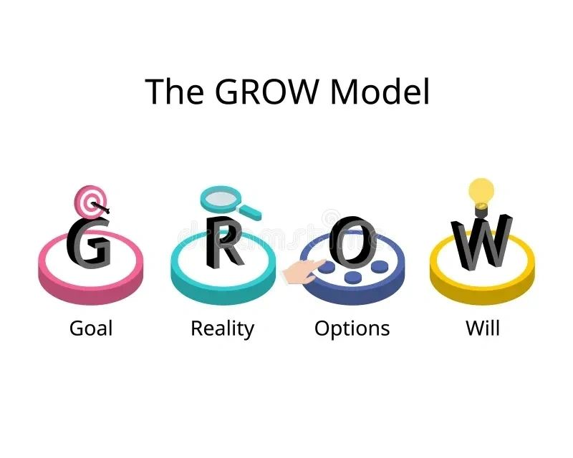
Figure 2: Diagram of the GROW Model

For the coaching session, I used the GROW model, developed by Whitmore (2017), a widely accepted framework that structures coaching conversations through four stages: We also have the following four-step process: Goal, Reality, Options, and Will. The elaborated model provides the opportunity for the construction of a purposeful but flexible conversation by the coaches, which in turn means that it results in more practical and efficient solutions when contrasted to a less ordered narrative (Newman, 2022).
In the Goal stage of the GROW model, the coachee is to establish the successful outcomes or targets that he or she ‘Wants’. Since the coachee has established a SMART goal which is Specific, Measurable, Achievable, Relevant and Time-bound the coachee clearly understands the direction (Whitmore, 2017). The Reality stage makes the coachee think of the present position as he or she looks for constraints to his/her ambitions. The Options phase is a generative stage where all possible solutions are presented to the coachee so that she or he is presented with all the options. The last component of the GROW Model is the Will phase, which concerns the coachee’s agreement to take action by following the laid plan (Panchal & Riddell, 2020).
The GROW model can be used to apply to any developmental situation due to the simple and precise framework it provides. A goal-oriented approach is effective because it serves as a way of enhancing performance and enhancing acquired skills which is highly desirable wherever specific objectives are to be met (Jones et al., 2016). Furthermore, it means that its stress on activity engulfs coachees and makes them personally liable for their actions, so commitment rises (Whitmore, 2017).
Nevertheless, the GROW model has been also distinguished by various weaknesses. Due to its concentration on the process, it might prevent the identification or examination of latent factors that often underlie the conflict and could easily twist the conflict into an unproductive direction (Drake, 2018). For instance, when I was doing the micro-teaching session myself, it was rather difficult to delve deeper into the concerns because of the model’s sequential format. According to Grant (2013), the GROW model is most beneficial in specific result-oriented settings which can cause issues in those settings that require a broader perspective like in development and personal issues.
Where there are calls for solutions that can provide easy-to-measure goals and objectives, then the GROW model is most appropriate. It may be less effective, for instance, in cases when there is an emphasis on psychological development or subsequent career choice, as the latter two fields are generally based on more extensive and uninterrupted discourses (Garvey et al., 2021).

Reflection on Practical 1: Coaching Session
According to Gibbs’ Reflective Cycle, I will analyse the given coaching session combined with the feedback I got to review what was done and assess my effectiveness.
During this session, I used the GROW model to help the coachee to reach his goal of enhancing time management skills. Following the feedback, I began by outlining the objective of the session and then asked questions incorporating the coachee’s agenda. Although the feedback given showed that my questions could have been more challenging this might have helped to prompt the coachee to go and think deeper. I engaged a lot of concern and time and focused on the coachee’s answer without interrupting him too much so that he could give the best way to respond to the questions. It brought my respondents’ attention to too much restraint and lack of criticism in my approach, which appeared to make participants more comfortable.
On thinking about the feedback, I felt confident that I was right about making the atmosphere safe and encouraging for the coachee. The comments from the participants of the conversation were positive – I was accused of active listening and of being patient – which helped to strengthen my belief in my efficiency as a listener and supportive friend. Nevertheless, getting to this point, I thought that it would have been advantageous to pose broader questions, as indicated in the suggestions.
The strengths that were pointed at in my form of coaching by the feedback included several thoughts. The coachee mentioned areas such as identification of his agenda and non-critical attitudes as some of the important strengths that need to be considered. Also, my usage of the GROW model created a coherent and targeted setting to help the coachee overcome the issues regarding time management. Of course, one of the weaknesses found in the feedback was that the depth of my questions was criticized. Although the questions that were asked were pertinent the elaboration of those questions could have assisted the coachee in critically evaluating the situation down to the degree he did not think of other issues and factors (Lightfoot, 2019)..
Using this feedback, it is possible to recommend that even though the methodology of the GROW model was helpful to the conversation, fixing such an approach laid the emphasis too rigid and did not allow for as much depth of discussion. Whitmore (2017) pointed out that the there is a structured approach is ideal for goal setting, and thereby, hinders general responsive conversations on personal issues. This response was best summed up by feedback that suggested that there should be structure but not to the extent that critical thinking could not be done sometimes more deeply.

Reflection on Practical 2: Mentoring Session
In the light of Gibbs’ Reflective Cycle, I will analyse the fact of mentoring and review it as regards the feedback received, which will allow me to improve my method.
Hence in this session, I decided to give feedback based on the Johari Window model to boost the self-perception of the mentee concerning interpersonal skills. According to the feedback I received, I stuck with the mentee’s roadmap well, as the whole session focused on time management, which was the mentee’s choice. Thanks to the structure of the Johari Window, I was able to focus on reporting my findings without adding judgment to them which preserved professionalism. It also provided feedback on me using active listening skills and being calm that created a positive atmosphere for the mentee to receive feedback.
I concluded from the practical lesson in that I received positive feedback pointing out that I was non-judgmental and centred my attention on the agenda of the mentee. I tried to be supportive and critical at the same time because I knew that remarking on a person’s interpersonal style can be somewhat personal. The feedback supported what I believe is important in creating a positive culture (Cameron and Green, 2019). But I was also cautious to some extent because I know that the Johari Window could sometimes be too intrusive for some people, which is not what I wanted for my mentees.
The reaction to the session also pointed out several strengths, as outlined below. It also benefited the session greatly that I remained emotionally neutral and followed the lead of the mentee. The mentee was receptive to the feedback and this was a major achievement of the process. However, one of the issues raised as a limitation in feedback was that the Johari Window model could not be appropriate for all the mentees (Till et al., 2021). Some people can easily feel uncomfortable with this way of feedback which could potentially reduce their willingness to give it freely. Some of this feedback was about the flexibility, needed for me to be sensitive to ways through which the mentees would feel supported.
Selecting feedback methods that are well appropriate to the comfort of the independent learning mentee, was the central message affirmed during this session. In subsequent meetings, I will check in with each mentee to determine if they are ready to receive critiques, for those who are very sensitive, I will use more reflective models such as the Narrative Coaching Models proposed by Drake (2018). This particular adaptation will ensure that the mentee feels more comfortable with the mentor so that the mentee will feel free to engage the mentor during subsequent sessions.

Conclusion
Therefore, this reflective report aims to share an understanding of the human resource coaching and mentoring approaches within the workplace environment. The GROW model is apt for use when serious structuring of goals is necessary, though its usage in line with introspective over-personal material proved certain limitations. The application of Johari Window was useful in providing constructive feedback; however, the feedback method has to be based on the employee feedback preference.
In applying the Gibbs Reflective Cycle, the following areas were noted as best practice; flexibility and paying attention to the preferences of the coachee and mentee. This reflection goes along with the understanding that coaching and mentoring different people might be different and will need different approaches. In the future, I proposed to use both structural models with fewer structures together with CBT to gain both superior levels of objective accomplishment as well as superior individual development.
All these will help me in my future professional practice incorporating approaches such as effective communication, listening, and being client-centred. It is my goal to strive to build the type of flexible coaching model that would address the demands of the contemporary labour market.

References
Cameron, E. and Green, M. (2019) Making Sense of Change Management: A Complete Guide to the Models, Tools and Techniques of Organizational Change. 5th ed. London: Kogan Page.
Cox, E., Bachkirova, T. and Clutterbuck, D. (eds.) (2014) The Complete Handbook of Coaching. 2nd ed. London: Sage.
Drake, D.B. (2018) Narrative Coaching: The Definitive Guide to Bringing New Stories to Life. Petaluma, CA: CNC Press.
Egan, G. (2013) The Skilled Helper: A Problem-Management and Opportunity-Development Approach to Helping. 10th ed. Belmont, CA: Brooks/Cole, Cengage Learning.
Garvey, B., Stokes, P. and Megginson, D. (2021) Coaching and Mentoring: Theory and Practice. 3rd ed. London: Sage.
Gibbs, G. (1988) Learning by Doing: A Guide to Teaching and Learning Methods. Oxford: Further Education Unit, Oxford Polytechnic.
Grant, A.M. (2013) ‘The Efficacy of Coaching’, in Passmore, J., Peterson, D.B. and Freire, T. (eds.) The Wiley-Blackwell Handbook of the Psychology of Coaching and Mentoring. Chichester: Wiley-Blackwell.
Grant, A.M. (2022) ‘Is it time to REGROW the GROW model? Issues related to teaching coaching session structures’, Coaching Practiced, pp. 29-40.
Jones, R.J., Woods, S.A. and Guillaume, Y.R.F. (2016) ‘The Effectiveness of Workplace Coaching: A Meta‐Analysis’, Journal of Occupational and Organizational Psychology, 89(2), pp. 249-277.
Lightfoot, I. (2019) ‘Insight events in coaching sessions’, International Journal of Evidence-Based Coaching & Mentoring, 17.
Newman, S. (2022) The Use of Coaching as a Model for Leadership Development.
Panchal, S. and Riddell, P. (2020) ‘The GROWS model: extending the GROW coaching model to support behavioural change’, The Coaching Psychologist, 16(2), pp. 12-25.
Till, K., Eisenmann, J., Emmonds, S., Jones, B., Mitchell, T., Cowburn, I., Tee, J., Holmes, N. and Lloyd, R.S. (2021) ‘A coaching session framework to facilitate long-term athletic development’, Strength & Conditioning Journal, 43(3), pp. 43-55.
Whitmore, J. (2017) Coaching for Performance: The Principles and Practice of Coaching and Leadership. 5th ed. London: Nicholas Brealey.

APPENDIX 1:

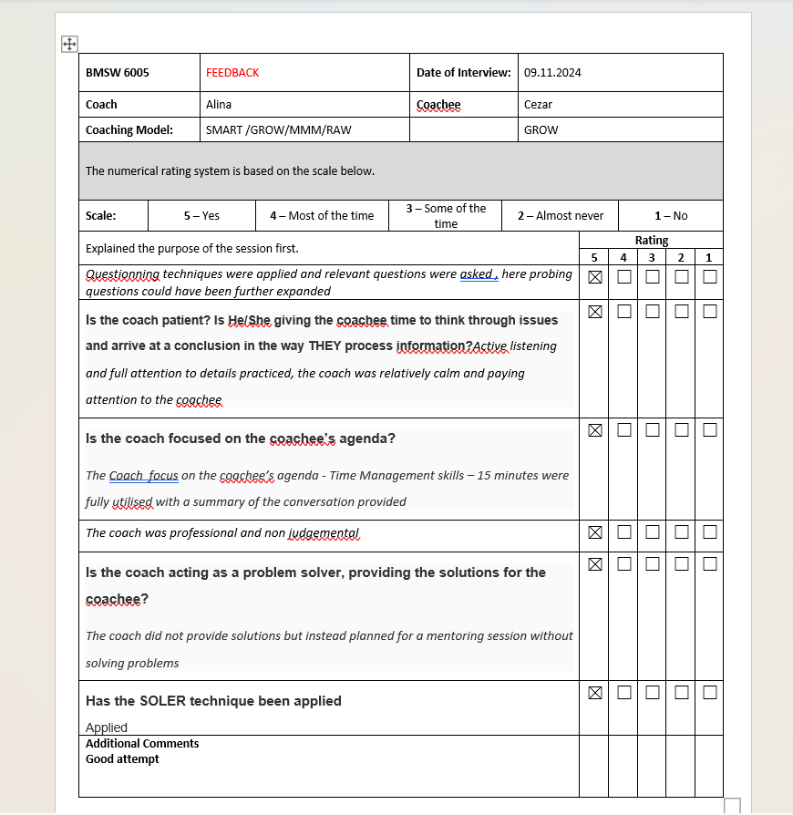

APPENDIX 2- Action Plan
Developmental Objective | Materials and Resources | Start Date | Completion Date | Implementation Plan | Evaluation Method
Enhancing Questioning Techniques | • Training on advanced questioning skills  • Coaching for Performance by Whitmore (2017) | Dec 15, 2024 | Jan 30, 2025 | • Attend webinars and workshops  • Practice in mock coaching sessions  • Seek peer feedback | • Feedback from coachees on the depth and effectiveness of questions used
Improving Empathy and Emotional Intelligence | • Emotional intelligence assessments (e.g., EQ-i 2.0)  • The Emotional Intelligence Quick Book by Bradberry | Dec 20, 2024 | Feb 15, 2025 | • Participate in emotional intelligence training  • Role-play scenarios  • Practice mindfulness | • Self-reflection and feedback on emotional responsiveness from coachees and peers
Mastering Flexibility in Coaching Models | • The Skilled Helper by Gerard Egan  • Peer-reviewed coaching journals | Jan 5, 2025 | Mar 15, 2025 | • Experiment with combining structured and flexible models  • Attend courses on integrative methods | • Monitor coachees’ satisfaction and outcomes using adapted coaching models
Developing Constructive Feedback Techniques | • Feedback frameworks (e.g., SBI model)  • Practice tools and exercises | Jan 10, 2025 | Feb 28, 2025 | • Use feedback models in sessions  • Review feedback effectiveness with coachees | • Conduct surveys to measure coachees' satisfaction with feedback delivery
Enhancing Active Listening Skills | • Active listening workshops and exercises  • You’re Not Listening by Kate Murphy | Dec 25, 2024 | Feb 10, 2025 | • Practice listening exercises (paraphrasing, summarizing)  • Record and review sessions | • Gather feedback from coachees on the quality of attentiveness

