
Problem-solving and Decision making

Keila Ribeiro
1917702
Lecturer: Gasso Wilson Mwaluseke
Module code: BMSW4004

Table of Contents
Introduction 3
Background of the company 3
The complex problem in the workplace including its scope and impact 4
Analyze the information on the identified problem 4
Problem-solving techniques 5
Decision making techniques 6
Plan for implementing the solution 7
Communication the plan to stakeholders 8
Appropriate monitoring and review techniques to ensure successful implementation of the solution 9
Conclusion 9
Adkar Model………………………………………………………………………………………………………………………………………….10
References 11

Introduction
The problem is usually related to the difference between the goals and performance of a particular organization. Many factors cause problems in the organization and lead to defects. Organizational problems are due to lack of communication, organizational structure flaws, and ambiguities in the chain of command (Baker, 2017). To get the best performance and results, it is important to quickly identify and resolve problems. If the problems of the organization are not resolved, they will slowly face and affect the entire organization. Problem-solving means finding solutions to difficult or complex problems. Companies need to analyze and solve problems. When solving the problem, resources will help to solve the problem. We always need to update information (Mayer, 2012). More and more information can make us smarter. This report is based on the workplace problem at Sainsbury. The main purpose of the report is to identify problems in the workplace and analyze information about the problems found. The report also explains how to solve problems and make decisions. The plan to implement these solutions is also discussed and communicated to stakeholders. The last session of this report discussed appropriate monitoring and review methods to ensure the successful implementation of the solution.

Background of the company
Sainsbury is one of the largest distributors in the UK, which can distribute and sell goods or services to customers through various channels. In the past two years, Sainsbury's has experienced difficult times. Lost the market share of competitors. After Tesco and Asda, Sainsbury is the third store in the UK. Sainsbury's has a market share of 16.73%, Tesco and Asda have 26.56% and 16.73%, respectively. Therefore, Sainsbury's must cover all aspects of the company. They won’t see any changes in the campaigns offered, and consumers will seamlessly transition from physical stores to online stores. Sainsbury's website creates opportunities to interact with consumers already in use. Consumers who shop in supermarkets that initially care about society are very sceptical. This website is used to express Sainsbury’s interest in important consumer issues (Corporate Watch, 2020).

The complex problem in the workplace including its scope and impact
At Sainsbury, there are a variety of workplace problems. Some of them lack training, lack of adequate risk control, poor service, violent incidents, cultural diversity, staff shortage and so on. In this report, we are only talking about the great problem that Sainsbury is facing. The biggest problem facing Sainsbury is the lack of staff in the company. Due to lack of capable and competent staff, services and performance decreased. The demand for Sainsbury workers is growing day by day, but bringing in workers cannot meet the demand. Due to dissatisfaction, many employees quit their jobs. Recruiting and retaining skilled workers has also been a difficult task for Sainsbury. With fewer employees at Sainsbury, customers will be severely affected. When there is a shortage of staff in Sainsbury, the client will not receive the proper services. This will harm customers as they do not get better service (El-Amir and Burt, 2008).

Analyze the information on the identified problem
Insufficient employees do not mean jokes in the company. In addition to unemployment and consistent productivity, unemployment can also be associated with an increase in the number of pensioners. A new generation of jobseekers consists of a small group of people, many of whom have a university degree. In general, the manufacturing industry does not have a high-quality industry. Unemployment increases the responsibilities and workload of existing employees, leads to mistakes and other activities, affects individual performance management and ultimately affects organizational performance. Due to staff shortages, customers cannot enter the company as soon as possible. As demand increases, the company will increase production. If there are not enough workers to complete the work on time, the company takes longer. This can lead to employees being frustrated by the tight budget and increased profits. The number of applicants in unemployment is very low. The employment department tries to find qualified candidates, perhaps with a high salary and attract qualified workers. Many companies need technical support, so competitions may be forced to hire people whose special skills are trained to complete the work required (Matemani, 2019).

Problem-solving techniques
The fishbone Diagram (Causes and effects of the problem)
The main causes and effects of this problem are (Mazer-Amirshahi and Fox, 2018):
Causes
1. Pay:
Sainsbury services are paid for very little. This is the main reason for the complaint. Many employees are looking for better opportunities.
2. Lack of growth and development
Opportunities for growth and development are the key to having good staff. If employees feel they have a problem, they can turn to another company in search of opportunities to improve their situation and profitability.
3. Lack of feedback and recognition
The Sainsbury protects feedback during the organization's operations. Because feedback is the first step in ensuring employee success, it will affect the success of employees who avoid this job. If employees are struggling, your honest feedback can help you manage and distribute your workload. If you ignore the comments or make inappropriate comments, the staff will feel embarrassed and frustrated and eventually give up.
4. Being overwork
During a financial crisis, a company needs employees to take on other responsibilities. They may need to let other employees take time off to increase their working hours or take a weekend break. However, demanded that employees choose between work and integrity and not always go smoothly. Instead, it helped increase sales because employees complained.
Effect
In the absence of employees, employees must work longer hours under extreme pressure, which can lead to fatigue, injury and job satisfaction (Poulston, 2017).
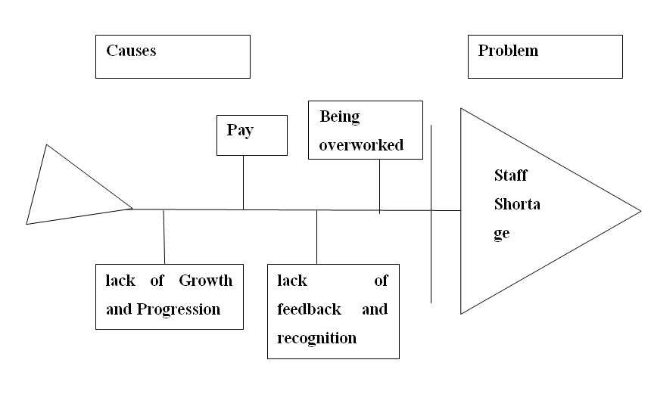

Decision making techniques
A decision is an action selected from two or more action routes. Decision-making can be called the process of identifying, analyzing and evaluating all available alternatives, from which the best option can be selected. In the case of simple matters and low investigation and evaluation costs, managers will choose more rational decisions when making business decisions. On the contrary, business managers cannot make reasonable decisions. Because people regard a rational solution as the best solution to a problem. In this case, managers usually have limited use of creativity (Yates and de Oliveira, 2016). It can be said that managers made mistakes without making correct judgments, and as a result, resources were wasted to find solutions to problems. A variety of techniques and tools can be used to make decisions. SWOT analysis is one of them. Sainsbury’s SWOT analysis is as follows (MBA Skool Team, 2020):
Strengths
- Largest supermarket chains in the UK
- Effective leadership team
- Innovative promotion strategies
- Wholesale and retail banking
- Right expansion moves
Weaknesses
- Brand switching
- Growing costs
- Low margins
Opportunities
- Growth in villages
Threats
- Increase competition
Understanding the strengths and weaknesses of the organization is essential for business. If the company plan to implement a new policy, improve the R&D investment process, or have a significant impact on the lives of businesses and individuals, it is worth doing a SWOT analysis. When performing a SWOT analysis, please seek help from other people in the organization or department. It attracts relevant and active stakeholders, and it is possible to provide a comprehensive rather than one-person view from all aspects. The company can find the connection between trends, patterns and upper limits. They can illuminate the square and find unprecedented opportunities.

Plan for implementing the solution
In order to reduce the shortage of personnel, the company will train more personnel as soon as possible. In order to solve the shortage of employees, we need to increase the capital budget so that we can hire a large number of employees. Existing employees should be encouraged to achieve job satisfaction and be loyal to the organization. Organizations should focus on training employees. Meeting and seminars should be organized on issues discussed by staff. Organizations must work with employees to develop personal training plans to deal with any changes related to the relevant industry.

Communication the plan to stakeholders
Communication is the process of transferring information, data, thoughts, opinions and ideas from one person to another or from one location to another through different media. The communication plan is linked to the transmission of messages to achieve the purpose of communication (Hoyt, Guilmett and Kochien, 2019). Communication is a key function of an organization to achieve its goals. In the Sainsbury company, they faced the staff shortage problem in the company. To improve this problem, the manager needs to communicate with their employees. For improving the staff shortage in the organization, the Sainsbury needs to develop the communication plan to stakeholders, which includes the following component, which is as follows (Backman, 2019):
Audience: To improve the workplace problems in the Sainsbury, initially it needs to spread this information to its employees. The main target audience for the communication plan at Sainsbury is the sales team, office team including accountant, administrative and support person and top-level manager.
Message: To minimize the workplace problem, the manager needs to provide the message that change in work structure and time schedule does not hamper on their paid or wages, it is only for the better of the organization and employees.
Time of communication: the message is delivered at the time of meeting to all the key stakeholders. The employees give their feedback about dissatisfaction and also needs to communicate with the employees.
The medium of communication: The managers should conduct the face to face communication to request them for the improvement policy for workplace problem.
A person responsible: The manager needs to make effective communication employees and also motivate them to contribute their best effort while performing the task in the company.

Appropriate monitoring and review techniques to ensure successful implementation of the solution
Sainsbury company needs to take the workplace problem seriously and create a comprehensive program that covers all workers. Specifically, the company needs to create a systematic workplace problem prevention aimed at reducing the workplace problem at the company. In order to reduce the shortage of personnel, the company will train more personnel as soon as possible. In order to solve the shortage of employees, we need to increase the capital budget so that we can hire a large number of employees. Existing employees should be encouraged to achieve job satisfaction and be loyal to the organization. Organizations should focus on training employees. Meeting and seminars should be organized on issues discussed by staff. Organizations must work with employees to develop personal training plans to deal with any changes related to the relevant industry. Solving the labour shortage can achieve three important goals. First, the company need to find new ways to hire employees across the industry. This should include the immigrant population as well as subcontractors, suppliers and the Internet. Second, individual businesses must retain employees by providing a combination of good wages, health benefits, bonus plans, training and retirement plans. Finally, renovation professionals need the support of the entire industry to redefine the perspective of construction workers and call for their renovation and construction careers to enter the next generation (Henkens, Remery, and Schippers, 2008).

Conclusion
Nothing works without any problems. Business organizations face many problems, solve them and continue their journey. Decision-making is important, as are problems and problem-solving. Decision-making activities are high-level activities mainly performed by top management. This is the process of choosing a suitable alternative from as many options as possible. Therefore, it is important to make effective decisions so that the company can easily solve problems that arise within the organization. This report is to identify problems in the workplace and analyze information about the identified problems. The report also explains how to solve problems and make decisions. The plan to implement these solutions is also discussed and communicated to stakeholders. It also describes appropriate monitoring and inspection methods to ensure the successful implementation of the solution.
A.M.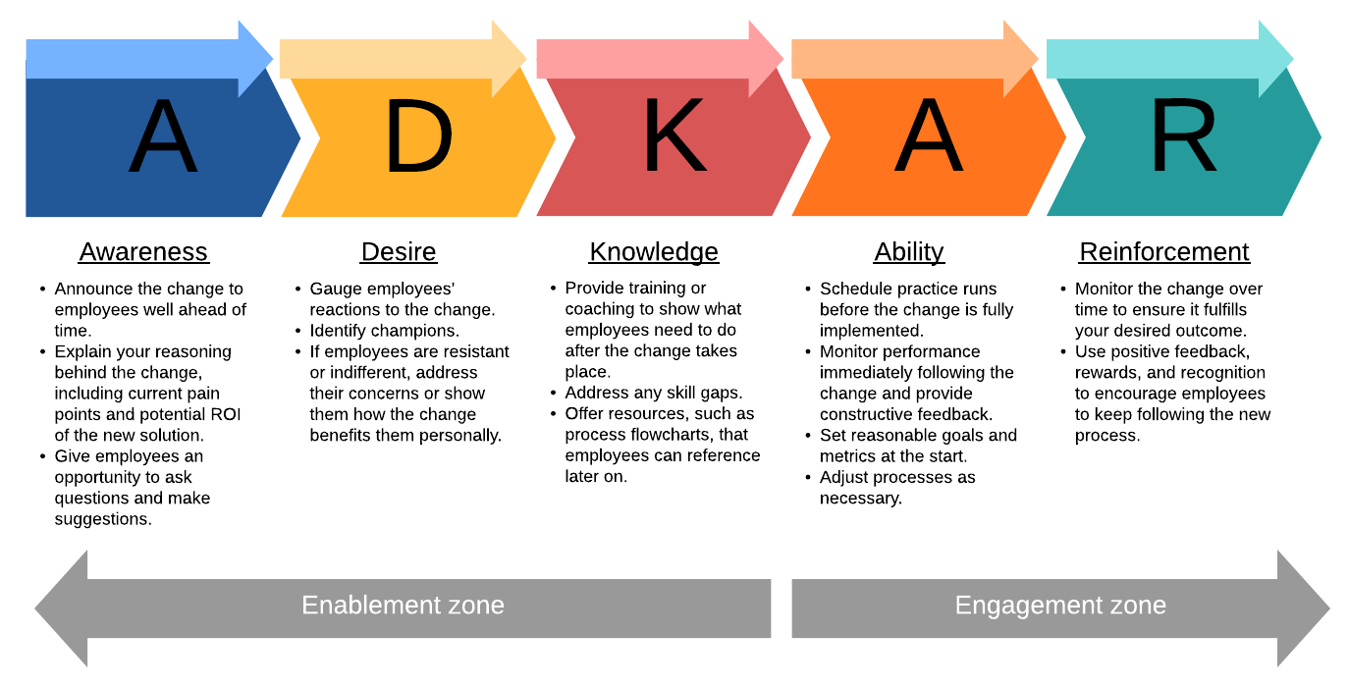

References
Baker, R., 2017. Problem-solving. In Agile UX Storytelling (pp.107-116). Apress, Berkeley, CA.
Mayer, M.W., 2012. Problem solving. Human and Machine Problem Solving, p. 39.
Corporate Watch, 2020. SAINSBURY'S COMPANY PROFILE. [Online] Available at: https://corporatewatch.org/sainsburys-company-profile/ [Accessed on 23 December 2020]
El‐Amir, A. and Burt, S., 2008. Sainsbury's in Egypt: the strange case of Dr Jekyll and Mr Hyde?. International Journal of Retail & Distribution Management
Mazer-Amirshahi, M. and Fox, E.R., 2018. Saline shortages—many causes, no simple solution. New England Journal of Medicine, 378(16), pp.1472-1474
Poulston, J., 2017. Staff shortages and turnover: Causes and solutions. Hospitality Insights, 1(1), pp.7-8.
MBA Skool Team, 2020. Sainsburys SWOT Analysis, Competitors, Segmentation, Target Market, Positioning & USP. [Online] Available at: https://www.mbaskool.com/brandguide/lifestyle-and-retail/2042-sainsburys.html [Accessed on 23 December 2020]
Hoyt, C., Guilmett, J.A. and Kochien, K., 2019. Communication, Collaboration & Productivity as Part of the Campus Communication Plan.
Backman, J., 2019. Marketing and communication plan, CASE: Riihisoft Oy, RIIHI DMA.
Henkens, K., Remery, C. and Schippers, J., 2008. Shortages in an ageing labour market: an analysis of employers' behaviour. The International Journal of Human Resource Management, 19(7), pp.1314-1329.

