Student number 2005002
Ways of Perceiving Module ADAD4019

Stalker from beyond, witness from within

Stalker from beyond, witness from within is an immersive, multi-disciplinary art exhibition that invites viewers to explore the complex relationship between self and surveillance in the digital age. Through a range of digital-based media, this exhibition delves into the paradoxical intersection of self-expression and constant observation. From interactive installations that challenge notions of privacy to photographs that examine the act of self-documentation, the featured artists, such as Hasan Elahi, Irene Fenara or Jeff Melmelstein, shed light on the complex ways in which we as individuals are subject to scrutiny of the world around us. Stalker from beyond, witness from within challenges viewers to contemplate the psychological, societal, and ethical implications of self-surveillance in a society dependent on digitisation.

The definition of the noun “surveillance’’ describes monitoring a person in regards to crime that has happened or is expected to happen (Cambridge English Dictionary, 4th Edition) However, the act of surveying goes beyond police stations and court rooms. Throughout history of humankind, people have monitored their own behaviours, traditions and emotions, and preserved them in diary entries, prose or poetry, and even visual art such as genre paintings. In modern society, individuals now have access to a wealth of tools and technologies for monitoring their habits, intake of food or even emotions, for the sake of self-care or even self-governance (Klauser, R Franscisco, 2014).

Nowadays, the art of self-surveillance is inherently inseparable from politics due to laws surrounding online privacy, right to access one’s personal data, as well as the opposition to imposed narratives or social standards. Artists who engage in self-surveillance such as self-portraiture use this practice to challenge traditional notions of identity, beauty, and control (Jones, Amelia 2002), and to shed light on important social and cultural issues such as privacy, surveillance, and the distribution of power. Jacques Rancière, a French philosopher, argued that art has the power to disrupt and re-define our perceptions of the politics (Rancière, 2012), and has inspired self-surveillance artists to challenge dominant systems of power and control.

Bangladesh-born artist Hasan Elahi uses self-surveillance as a response to government surveillance and racial profiling. Following the events of 9/11, the United States federal government increased the amount of security at the airports and allowed for online monitoring the terror suspects. Elahi, who states he was wrongfully placed on the FBI watchlist after arriving from the Netherlands, started his ongoing art project Tracking Transience, where he willingly shares a range of his private data, images and location on his website, which are easily accessible online. By choosing to participate in his own surveillance, Elahi challenges the power dynamics of surveillance systems, and asserts agency over his own identity.

Through their work, artists offer new insights into the ways in which power operates in contemporary society, and they push the boundaries of traditional art forms by using their own bodies and experiences as a means of creative expression. A great example of this is Jill Magid’s 2004 project Evidence locker, where she uses her own body and films herself through the “eyes” of Liverpool’s public surveillance system. Liverpool currently has one of the largest systems of public security camera in the whole of United Kingdom. The collected footage is not for public domain, unless an individual requests access via the Data Subject Request form. Magid’s work explores the relationship between individuals, institutions and one’s environment, while indirectly criticising the social and political implications of public surveillance.

Conversely, self-surveillance art can act as means of self-betterment and for the purposes of educating and comforting those around us. In an article Photography: Witness and Recorder of Humanity, Steichen (1958) notes that the photographer’s work is especialy powerful and meaningful because, in studying an object of their art, the artist helps others understand themselves. ‘’A proper study of mankind is man” (Pope, 1734)

By documenting their own behavior and experiences, artists who engage in self-surveillance are creating a documentary record of their own lives, as well as the social and cultural context in which they exist. This record can then be viewed and interpreted by others, allowing them to witness and gain insights into the artist's inner world and their perspective on the world around them. Moreover, self-surveillance art often involves a heightened sense of self-awareness and reflection on the self. In this sense, the artist is not only documenting their external actions, but also their internal thoughts and emotions, which can provide an intimate perspective on the human experience.

Stalker from beyond, witness from within exhibition explores the concept of self-surveillance through digital-based media such as video installations or photography. Every non-installation artwork is displayed on a monitor screen.

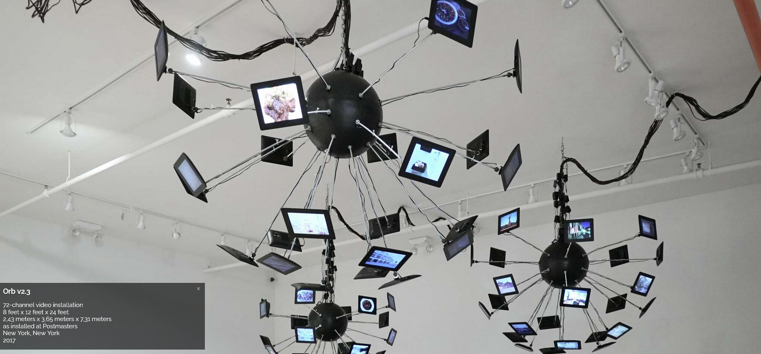
1. Elahi, Hasan Orb V2.3 (2017) video installation

Hasan Elahi is a Bangladeshi-American interdisciplinary artist who works with digital images and installations. After being mistakenly listed on an FBI watch list, he decided to make his life public by posting images of his surroundings, real time coordinates of his location and copies of every debit card transaction he makes. His work contains tens of thousands images, available for viewing on public domain.

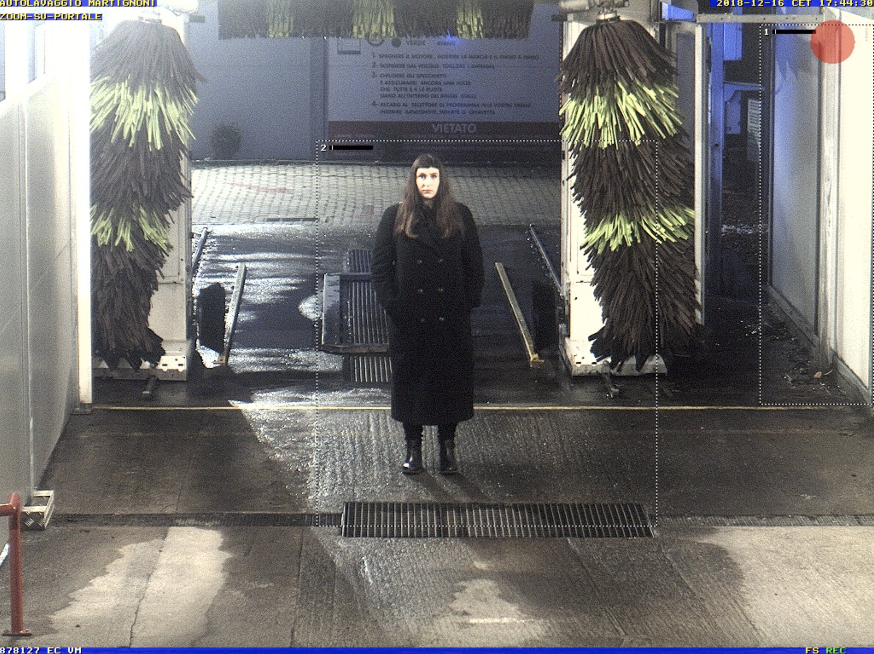
2. Fenara, Irene Self-portrait from surveillance camera (2018)

Irene Fenara is a visual artist whose practice focuses on capturing images via surveillance cameras. Her work explores concepts of control, privacy and identity and re-defining the relationship between the observer and the observed. Fenara “photographs” herself using the borrowed lenses of public surveillance cameras and saves the image before it gets lost in the continuous flow of data.

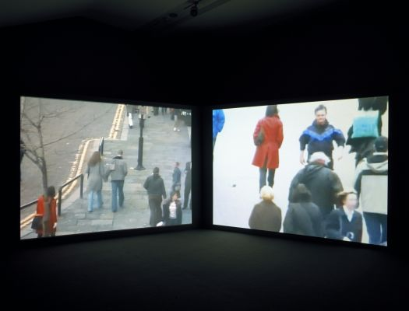

3. Magid, Jill – Stills from Evidence Locker (2004), shown on two large screens

Evidence Locker is a 2004 project filmed in Liverpool, England using the public surveillance system. During her 31 day stay in the city of Liverpool, Magid submitted Data Subject Request forms everyday to access this footage, and developed close contact with local police, who would film her posing or guide her through the city with her eyes closed.

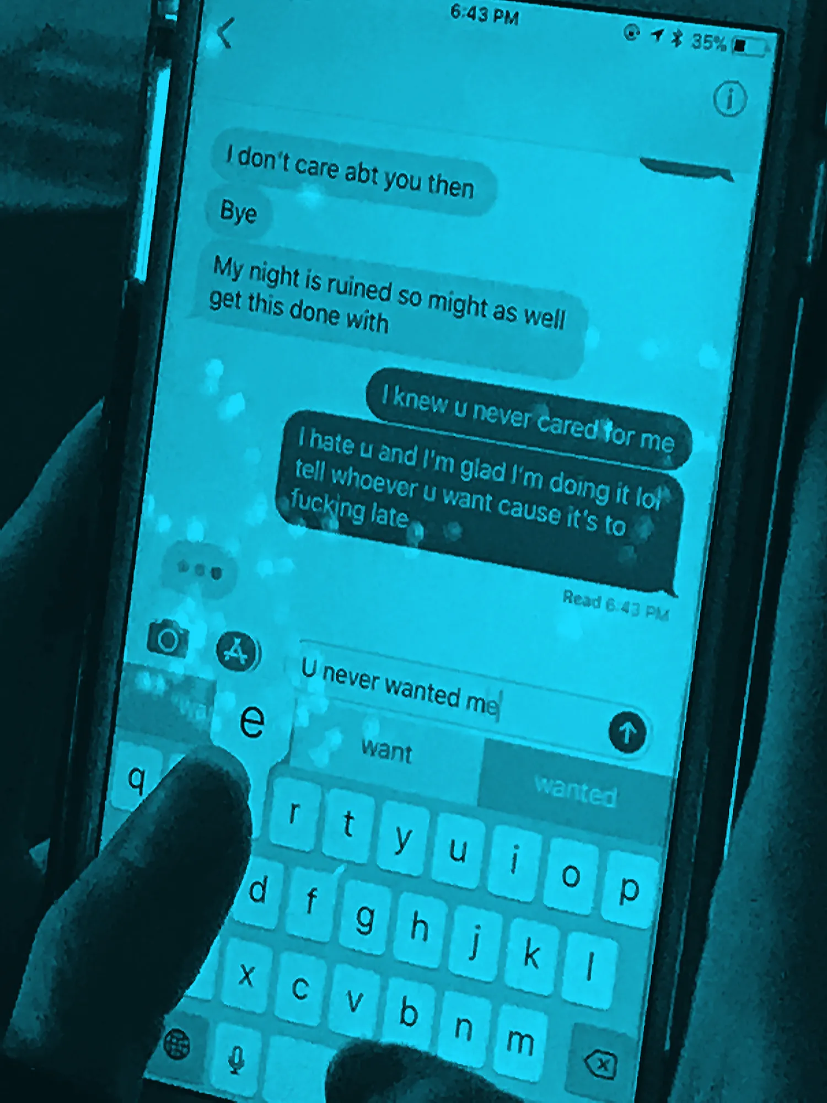

4. Mermelstein, Jeff #nyc, (2020)

Mermelstein’s 2020 book #nyc, is a collection of images of other people’s text conversations, shot exclusively on an iPhone. Mermelstein takes the viewer on a journey through New York, where he captures the every day conversations of others – confessions of love, break up texts, dinner plans, death and birth. Surveillance, in this sense, does not involve the self, but is rather an example of voyeuristic examination of others. The public is able to understand and closely relate to those text messages, as we have become a society dependent on mobile access to the Internet.

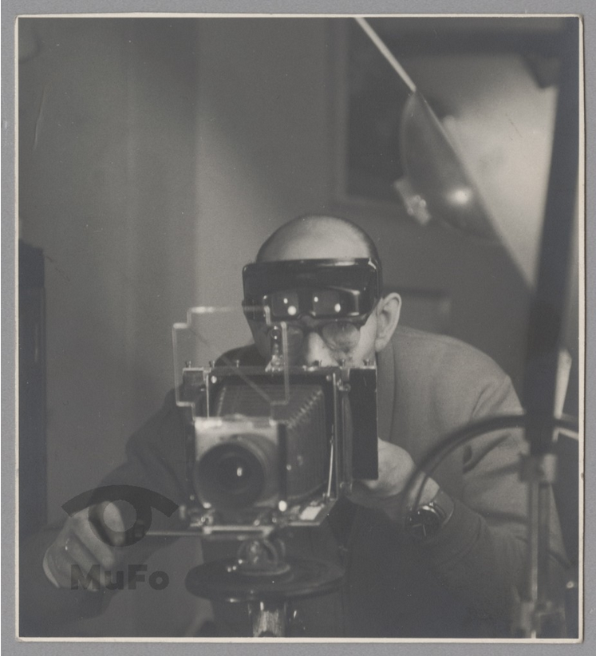

5. Rosner, Józef Self portait (1960)

Józef Rosner is a highly important figure in Polish photography. He was a co-founder of The Krakowian Photography Society and an owner of one of the earliest and most renowned photography aterlier in Krakow. As an artist, he believed that a portrait should be unaltered and showcase the subject’s emotional state, and he did not name people he photographed. This autopotrait shows Rosner taking what would today be called a selfie – an image of himself in a mirror’s reflection. He looks himself in the eyes and seems to be stating, almost playfully – “I know you see me, and I see you too”.

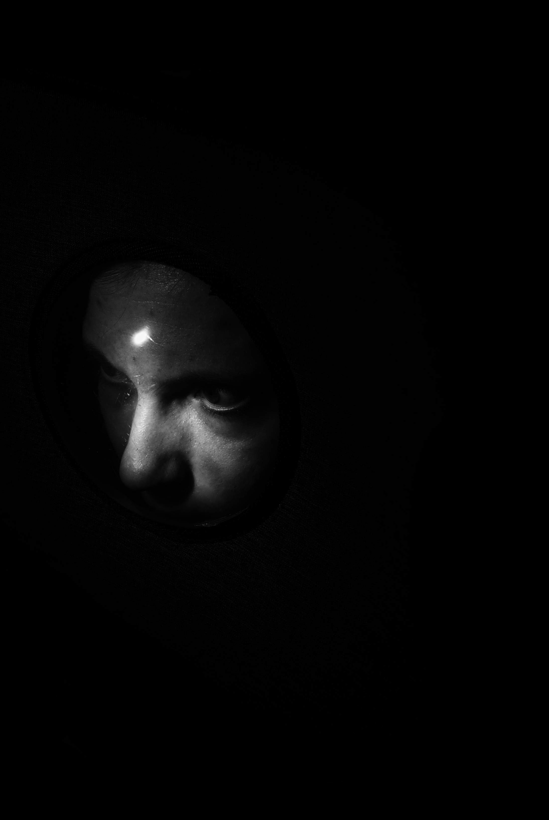

6. Bukreyeva, Lisa (2022) 2402. War diary

24 February 2022 marks the day when Russia invaded Eastern Ukraine and subsequently started a full-scale war in the region. Kyiv based artist Lisa Bukreyeva, in a series of portraits and dark, eerie images of broken glass, bullet shells and messy rooms, navigates her experience and emotions surrounding the invasion. Her diary quotes “My brother always says ‘let’s hope’. He’s fourteen. [..]But I’m not sure if this will end soon.”

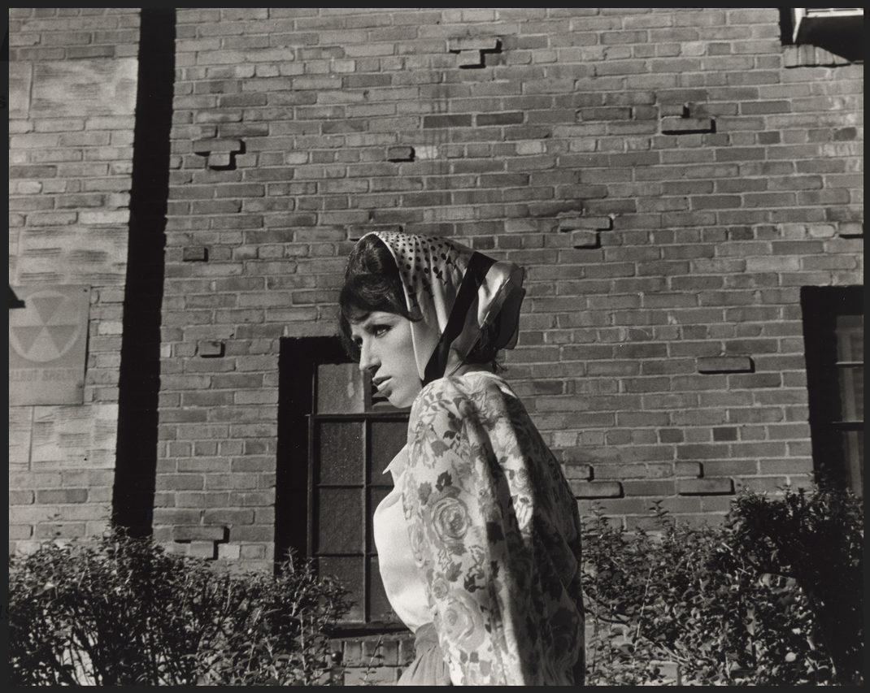

7. Sherman, Cindy (1979) Untitled Film Stills #19

Sherman’s Untitled Film Stills is a series of seventy black and white photographs in which the artist dresses herself and poses as stereotypical female film characters. This series is a conversation about the male gaze and potentially harmful potrayal of women in film. Although the photographs are not considered self-portraits, they can still be considered an example of self-surveillance, as Cindy Sherman carefully curates a certain, often stereotypical image of a woman, and challenges the societal constructs of femininity and identity.

Gallery plan:
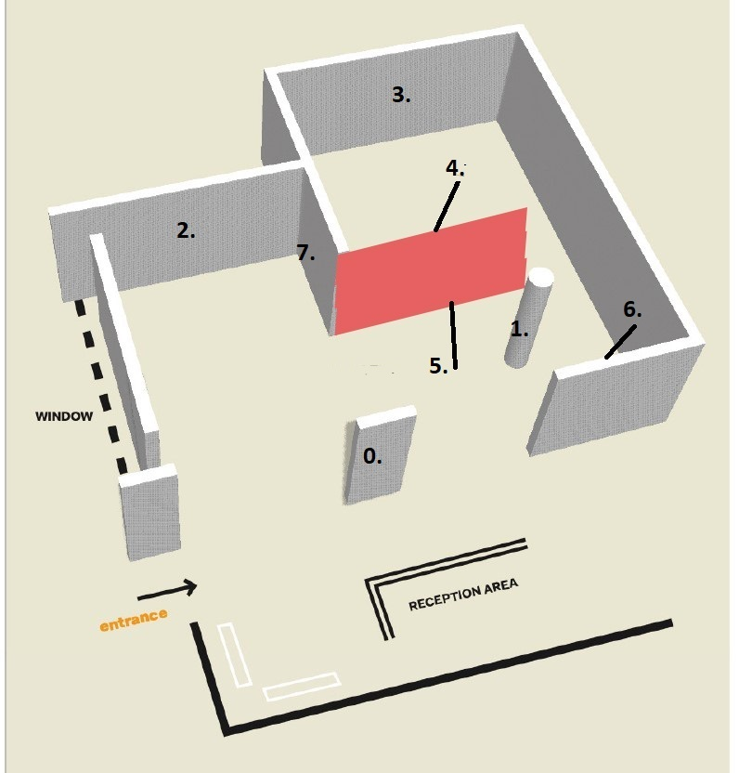

0. introduction to the exhibition on the reception side of the wall.
1. Elahi, Hasan Orb V2.3 installation
2. Fenara, Irene Self-portrait from surveillance camera
3. Magid, Jill Evidence locker video installation
4. Mermelstein, Jeff #nyc,
5. Rosner, Józef Self-portrait
6. Bukreyeva, Lisa 2402. War diary
7. Sherman, Cindy Untitled Film Still #19

Bibliography:
Cambridge University Press (2013) ‘Surveillance’ Cambridge Advanced Learner’s Dictionary 4th Edition [Available at: https://dictionary.cambridge.org/dictionary/english/surveillance ] (Accessed: May 17, 2023).

Klauser, R Francisco, Anders Albrechtslund (2014) ‘From self-tracking to smart urban infrastructures: towards an interdisciplinary research agenda on Big Data’, Surveillance and Society Vol.12 No.2. Available at https://doi.org/10.24908/ss.v12i2.4605 (Accessed 5 May 2023)

Jones, Amelia (2002) “The ‘Eternal Return’: Self‐Portrait Photography as a Technology of Embodiment.” Signs, vol. 27, no. 4, 2002, pp. 947–78. Available at https://doi.org/10.1086/339641 (Accessed 5 May 2023)

Pope, Alexander (1734) ‘An Essay on Man’ Eighteenth-Century Poetry Archive Available at https://www.eighteenthcenturypoetry.org/works/o3676-w0010.shtml (Accessed 9 May 2023)

Ray, Gene (2007) ‘This Way to Exit: On Julian Stallabrass’s Art Incorporated’, Third text, 21(4), pp. 387–395. Available at: https://doi.org/10.1080/09528820701433372 (Accessed 5 May 2023)
Rancière, Jacques and Rockhill, Gabriel (2021) The politics of aesthetics : the distribution of the sensible. Available at: https://doi.org/10.5040/9781350284913 (Accessed 5 May 2023)

Steichen, Edward. “Photography: Witness and Recorder of Humanity.” The Wisconsin Magazine of History, 1958, pp. 159–67. Available at http://www.jstor.org/stable/4633266 (Accessed 6 May 2023)

Table of contents:
1. Elahi, Hasan (2017) Orb V2.3, as installed at Postmasters, New York, 2017 [Available at http://elahi.wayne.edu/elahi_orb_postmasters.php ] (Accessed on 4 May 2023)

2. Fenara, Irene (2018) Self-portrait from surveillance camera [Available at https://www.irenefenara.com/self-portrait-from-surveillance-camera ] (Accessed on 26 April 2023)

3. Magid, Jill (2004) Evidence locker [As seen on http://www.jillmagid.com/projects/evidence-locker-2 ] (Accessed 4 May 2023)

4. Mermelstein, Jeff (2020) #nyc, [As seen on https://www.lensculture.com/articles/jeff-mermelstein-nyc ] (Accessed 3 May 2023)

5. Rosner, Józef (1960) Self-portrait [As shown in The Museum of Photography in Krakow, Poland [Available at https://zbiory.mufo.krakow.pl/card/mhf-35736-ii/ ] (Accessed 7 May 2023)

6. Bukreyeva, Lisa (2022) 2402. War diary [Available at https://bukreyeva.com/2402-War-Diary ] (Accessed 30 February 2023)

7. Sherman, Cindy (1978) ‘Untitled Film Still #19’ From Untitled Film Stills [Available at https://www.moma.org/collection/works/56606 ]

