LCMB7000 MBA Master of Business Administration Assessment 1 Human Resource Management (50%)

STUDENT NAME:
STUDENT ID:
PROFESSOR NAME: MOHAMED ASIM
MODULE TITLE:
MODULE CODE:

Table of Contents
Introduction 4
The current state of the UK labor market: 4
Internal Factors 5
Mismatched skills and talent shortages 5
Disruptive technologies and automation 5
Inequality in Wages 6
External factors: 7
Brexit impact: 7
Immigration Policies 7
Economic Uncertainty 8
Emerging changes in human resourcing strategies in the post covid, post-Brexit external environment 9
Hybrid work model and remote work strategies: 9
Flexibility: 9
Global talent acquisition: 10
Skill development and upskilling: 10
Addressing skill disparities: 10
Learning culture: 11
Diversity, equity, and inclusion 11
Addressing inequalities 11
Cultural competence 11
Talent acquisition and mobility 12
Brexit's effects 12
Electronic Onboarding 12
Well-being and mental health 12
Putting health first 12
Work-Life Balance 12
Conclusion 13
References: 14

Introduction
The labor market, a vital and dynamic part of every economy, shapes the employment landscape and organizational strategy. The labor market in the UK has seen substantial changes due to several internal and foreign events, including Brexit and the Covid-19 epidemic. This research aims to evaluate the UK labor market's present situation critically and examine how human resource management practices are changing in light of recent events surrounding Brexit and the Colombian Revolution (Bell, et al, 2020).

The current state of the UK labor market:
The labor market in the United Kingdom is a complicated, dynamic system essential to the nation’s economy. Internal and external forces have significantly impacted the UK labor market, causing noticeable changes and difficulties (Brell, et al, 2020).
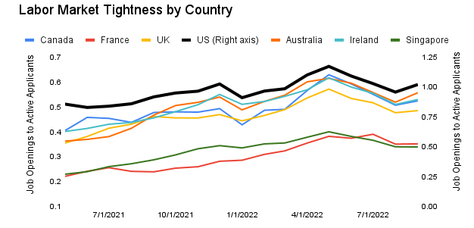
SOURCE:- https://economicgraph.linkedin.com/blog/linkedin-economic-outlook-state-of-the-labor-market-october-2022

Internal Factors

Mismatched skills and talent shortages
The need for alignment between the available talents and the needs of the labor market is one of the ongoing problems in the UK labor market. Some different areas, including technology, engineering, and healthcare, have seen this occurrence. Despite the nation's highly educated workforce, specific skills shortages still exist due to shifting technology and business practices. The difficulty of matching available skills with the constantly changing demands of the UK labor market highlights the complexity of contemporary employment dynamics. Despite the country's highly educated workforce, persistent skill gaps might arise due to the rapid speed of technological breakthroughs and changing business practices. This problem requires a complex strategy involving cooperation between politicians, industrial players, and educational institutions (Fana, et al, 2020). By bridging the gap between the capabilities of the workforce and the demands of the labor market, strategies like flexible and responsive education models targeted training programs, and ongoing upskilling efforts help ensure a more peaceful and prosperous economic future.

Disruptive technologies and automation
The nature of employment has changed due to automation and technological improvements. Automating routine and repetitive processes influences professions that need physical labor. The trend towards technologically demanding jobs necessitates a workforce with digital know-how and the flexibility to adjust to shifting platforms and technologies. Automation and technical improvements have a profoundly transformative effect on work. The potential of automation to free humans from repetitive and physically taxing jobs has improved efficiency but also sparked concerns about job displacement. At the same time, the growing number of occupations that need technology proficiency emphasizes the significance of digital expertise and agility. People and organizations must adopt a proactive approach to learning, upskilling, and cultivating the flexibility required to flourish in the changing job environment as technology transforms sectors and work processes (Malik, et al, 2021).

Inequality in Wages
The UK labor market continues to struggle with wage disparity. While the nation’s economy has expanded, not all employees have benefited equally. Pay stagnation is common in low-wage industries like retail and hospitality, increasing income inequality. A complex problem, pay inequality in the UK labor market affects several economic, social, and labor-related aspects (Lenhart, et al, 2019). The widening income inequality gap results from the unequal distribution of economic benefits and the frequency of pay stagnation in low-wage industries. A comprehensive strategy was encompassing legislative changes, programs for skill- and knowledge development, support for labor rights, and tactics to give employees more bargaining leverage is needed to address this problem. The UK may move towards a more just and inclusive economic environment for its residents by supporting a more equal labor market.
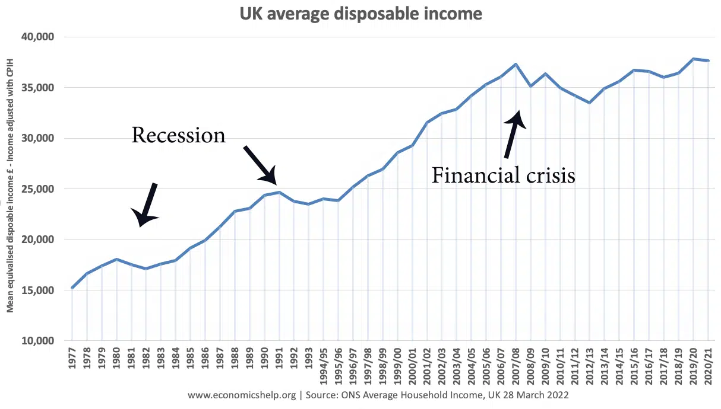

External factors:

Brexit impact:
The UK's decision to leave the European Union, known as Brexit, has significantly influenced the labor market. Changes in worker mobility result from the end of the free movement of persons between the UK and the EU. Before Brexit, many companies, especially those in the agricultural, healthcare, and hospitality industries, depended on a stable labor supply from EU nations. Businesses that hire foreign workers have faced difficulties as a result of the new immigration laws that were implemented after Brexit.
The multifaceted effects of Brexit on the UK labor market have changed the dynamics of worker mobility and labor supply. Industries that significantly rely on the free movement of people from the EU have been impacted by changes to immigration regulations. Agriculture, healthcare, and hospitality companies have needed help finding the workers they need. Creative solutions are required to address the issues brought on by the post-Brexit labor market environment, such as upskilling domestic employees and considering other labor sources.
Immigration Policies:
The UK government's new immigration policy has shifted to luring highly qualified professionals and laborers. The Points-Based System's implementation prioritizes talents, credentials, and income levels, making it more challenging for low-skilled migrants to enter the nation and find employment. Industries with significant seasonal labor demands, such as agriculture, have been impacted by this trend. The UK's intentional goal to recruit highly trained professionals while adopting stricter requirements for low-skilled migrants is reflected in its change to a points-based system in its immigration policy. The impact on sectors with seasonal labor needs, such as agriculture, highlights the difficulty of balancing economic conditions with immigration limits (Ginevicius, et al, 2020). To establish a labor market that promotes economic growth while adhering to the ideals of immigration policy, creative solutions, adaptation by impacted industries, and cooperation between the government, corporations, and other stakeholders are required.
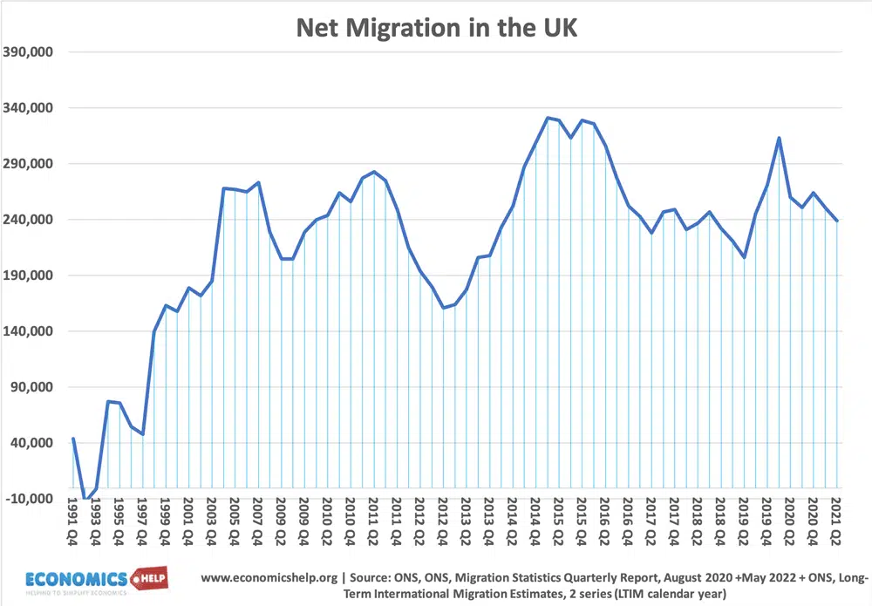
SOURCE: https://www.economicshelp.org/blog/6399/economics/impact-of-immigration-on-uk-economy/

Economic Uncertainty
Hiring decisions have been impacted by the economic unpredictability of the Covid-19 epidemic and Brexit. Businesses have experienced planning and financial stability issues, resulting in hiring freezes, layoffs, and shorter workweeks in several industries. Consumer purchasing habits have also been harmed by this uncertainty, which has hurt businesses that significantly rely on discretionary spending. The UK is currently experiencing a time of extreme economic unpredictability because of the interwoven difficulties of the Covid-19 epidemic and Brexit. An ever-changing environment has necessitated employment disruptions, such as hiring freezes, layoffs, and reduced workweeks. The effects of shifting consumer behavior have also been seen strongly in sectors dependent on discretionary expenditure. Both firms and politicians must be adaptable and resilient and take a strategic approach to get through this unpredictable period. The capacity to overcome these obstacles and regain stability ultimately depends on concerted efforts and proactive steps to boost economic development and consumer confidence (Litvinenko, et al, 2019).
The labor market in the UK is a dynamic, complex system that is affected by many internal and external influences. The current status of the labor market results from several factors, including skill mismatches, technology disruptions, pay inequality, Brexit-related changes, and economic uncertainty. Policymakers, companies, and educational institutions must work together to solve these issues as the UK navigates the post-Brexit and post-pandemic environment. This entails making investments in skill development, accepting technology advancements, and creating policies that support a flexible and resilient workforce capable of surviving in a labor market that is continuously changing.

Emerging changes in human resourcing strategies in the post covid, post-Brexit external environment
Human resource management (HRM) practices face new possibilities and difficulties due to the post-Covid and post-Brexit external environments. Organizations must adjust and develop their human resourcing strategies as they manage the intricacies of these two revolutionary events if they want to be competitive, adaptable, and responsive to the shifting environment. The Covid-19 epidemic and the fallout from Brexit are covered in depth in this part, along with the evolving changes in HRM tactics (Atar, et al, 2022).

Hybrid work model and remote work strategies:
The Covid-19 epidemic caused a seismic upheaval in the ways that work is done and the support for it. The typical office environment witnessed a quick shift that led to remote work's widespread acceptance. This change has altered workplace boundaries to accommodate the new paradigm and called for a rethinking of human resource management (HRM) tactics. These models allow workers to decide where they work, whether from home or an office, in a way that maximizes their efficiency and well-being. Hybrid work models allow employees to use the advantages of remote work while recognizing in-person cooperation's value (Garcia, et al, 2023).

Flexibility:
The Covid-19 epidemic altered the typical office setting and paved the way for the growing use of remote work. Organizations are adopting hybrid work arrangements that allow employees to choose between working from home and the office in the post-pandemic age. This trend necessitates deploying HRM strategies that support and enable remote work, assuring efficient communication technologies, remote collaboration platforms, and work-life balance-promoting policies.

Global talent acquisition:
To access a varied global talent pool, HR resourcing solutions are expanding as regional restrictions are removed. International hiring is becoming more popular among businesses to fill skill shortages, acquire specialized talent, and foster a diverse workforce that fosters innovation and creativity. Organizations use international recruiting to access a diversified global talent pool, significantly changing HR resourcing methods. Beyond filling skill gaps and gaining access to specialized knowledge, this strategy stimulates the development of a multicultural workforce that supports innovation, nurtures creativity, and places businesses at the forefront of their respective sectors. Adopting a global perspective in HR resourcing is not simply a choice in today's world of constant change and complexity; it is a strategic need that helps organizations to succeed in the challenging environment of the post-Covid, post-Brexit age.

Skill development and upskilling:

Addressing skill disparities:
The demand for a competent and certified workforce has become even more urgent due to the convergence of the Covid-19 pandemic and the transformational effects of Brexit. The need for individuals who can navigate new business environments, embrace technology innovations, and handle developing work requirements has reached unprecedented levels as organizations struggle with the numerous issues presented by these two events. In response, human resource (HR) resourcing plans have undergone a significant transformation, prioritizing efforts for skills development and upskilling at the top of their agendas. Following COVID-19 and Brexit, a greater need for a skilled workforce has prompted a change in HR resourcing tactics. Organizations are prioritizing skill development and upskilling initiatives to recognize the requirement for flexible, competent workers who can flourish in dynamic business contexts. This strategic strategy equips organizations to take advantage of opportunities, innovate, and maintain resilience in the ever-changing post-Covid, post-Brexit environment while addressing urgent concerns (Moradlou, et al, 2022).

Learning culture:
Today human resource (HR) plans now include nurturing employee development as a core component, particularly in light of seismic events like COVID-19 and Brexit. Establishing a culture of continuous learning is one of the essential ways that organizations are promoting employee development. HR practices developing to help employees on this journey since the capacity to adapt and pick up new skills has become crucial in this new era. HR practices have embraced a continuous learning culture to enable employee growth in the post-Covid, post-Brexit environment. The money spent on educational tools, programs, and mentorship initiatives demonstrates how important it is for organizations to have a staff that can adapt and learn new things. Organizations future-proof their workforce by allowing people to learn new skills and adjust to changing demands. They also foster a culture of innovation, continuous improvement, and professional development.

Diversity, equity, and inclusion

Addressing inequalities
The significance of diversity, equality, and inclusion (DEI) in the workplace is highlighted by the post-Covid and post-Brexit environments. HRM strategies need to prioritize structural injustices, do away with discrimination in hiring and promotion, and create an atmosphere where all employees may succeed (Krotz, et al, 2021).
Cultural competence:
Cultural competency is essential as the workforce becomes increasingly varied and scattered. Cross-cultural training, communication best practices, and programs that promote diversity must all be part of HRM plans.

Talent acquisition and mobility

Brexit's effects
The impact of Brexit on employee mobility has forced HRM practices to change to reflect the new immigration laws. Organizations are reviewing their approaches to international employment, considering skill shortages, visa limitations, and local and foreign talent proportion.

Electronic Onboarding
The spread of the epidemic hastened the implementation of virtual onboarding procedures. To guarantee that recruits are seamlessly integrated into the organization’s culture and systems, HRM strategies should emphasize improving and optimizing virtual onboarding experiences.

Well-being and mental health

Putting health first
The importance of employee well-being and mental health has been highlighted by the difficulties brought on by Brexit and the epidemic. Human resource management (HRM) tactics are changing to offer complete well-being programs, such as mental health assistance, wellness programs, and flexible work schedules considering individual requirements (McCann, et al, 2023).

Work-Life Balance
HRM strategies should promote work-life integration rather than just establishing work-life balance as remote work becomes more popular. Employees are given the freedom to balance work and personal obligations in a way that improves overall happiness, thanks to this strategy.
Human resource strategies must be rethought in light of the post-Covid and post-Brexit external environment. Organizations need to maintain their flexibility, toughness, and sensitivity to the changing demands of their workforce. HRM strategies can help organizations navigate the difficulties and take advantage of the opportunities presented by this transformative era by embracing hybrid work models, prioritizing skill development, fostering diversity and inclusion, improving talent acquisition techniques, and promoting well-being. Ultimately, these actions will position their organizations for long-term success in an uncertain world (Gupta, et al, 2023).

Conclusion
A dynamic interaction of internal and external influences has resulted in transformational changes in the UK labor market. The Covid-19 epidemic and Brexit both act as drivers to change organizational structures and job markets.
The necessity for alignment between labor skills and changing needs is highlighted by the persistence of skill mismatches and talent shortages domestically, notably in the technology, engineering, and healthcare industries. Traditional positions have been reshaped by automation and technology improvements, needing digital competency and flexibility.
Brexit has changed labor dynamics externally, affecting worker supply and movement. Industries that depend on foreign labor have been impacted by stricter immigration regulations, which has led to a change in HRM strategy. This and the pandemic's impact on the economy have caused hiring freezes, layoffs, and decreased work hours in several industries. As a result, HRM procedures are changing. Flexible hybrid work models provide workers with the option to pick their workplace. Initiatives for upskilling fill up skill shortages and encourage a culture of lifelong learning. International recruiting broadens the talent pool while prioritizing diversity, equity, and inclusion.
HRM strategies are crucial as organizations move through this environment. They encourage adaptability, creativity, and resilience, equipping businesses to prosper in the post-Covid and post-Brexit environment. HRM continues to be a compass in this transformation, helping organizations adapt to change and seize opportunities.

References:
Atar, E. and Baycar, H., 2022. UK’s Post-Brexit Strategy “Global Britain”. Great Power Politics in Greater Eurasia: Regional Alliances, Institutions, Projects, and Conflicts, p.117.
Bell, D.N. and Blanchflower, D.G., 2020. US and UK labour markets before and during the Covid-19 crash. National Institute Economic Review, 252, pp. R52-R69.
Brell, C., Dustmann, C. and Preston, I., 2020. The labour market integration of refugee migrants in high-income countries. Journal of Economic Perspectives, 34(1), pp.94-121.
Fana, M., Torrejón Pérez, S. and Fernández-Macías, E., 2020. Employment impact of Covid-19 crisis: from short term effects to long terms prospects. Journal of Industrial and Business Economics, 47, pp.391-410.
Garcia, M.J., 2023. Post-Brexit trade policy in the UK: placebo policy-making?. Journal of European Public Policy, pp.1-27.
Ginevicius, R., Kliestik, T., Stasiukynas, A. and Suhajda, K., 2020. The impact of national economic development on the shadow economy. Journal of Competitiveness, 12(4), p.39.
Gupta, R., Hasan, M.M., Islam, S.Z., Yasmin, T. and Uddin, J., 2023. Evaluating Brexit and COVID-19’s influence on the UK economy: A data analysis. Plos one, 18(6), p.e0287342.
Krotz, U. and Schramm, L., 2021. An old couple in a new setting: Franco-German leadership in the post-Brexit EU. Politics and governance, 9, pp.48-58.
Lenhart, O., 2019. The effects of health shocks on labor market outcomes: evidence from UK panel data. The European Journal of Health Economics, 20(1), pp.83-98.
Litvinenko, V.S. and Sergeev, I.B., 2019. Innovations as a Factor in the Development of the Natural Resources Sector. Studies on Russian Economic Development, 30, pp.637-645.
Malik, A. and Sanders, K., 2021. Managing human resources during a global crisis: A multilevel perspective. British Journal of Management, 32(4), pp.e1-e19.
McCann, P., Ortega-Argilés, R., Sevinc, D. and Cepeda-Zorrilla, M., 2023. Rebalancing UK regional and industrial policy post-Brexit and post-Covid-19: Lessons learned and priorities for the future. Regional Studies, 57(6), pp.1113-1125.
Moradlou, H., Fratocchi, L., Skipworth, H. and Ghadge, A., 2022. Post-Brexit back-shoring strategies: what UK manufacturing companies could learn from the past?. Production Planning & Control, 33(14), pp.1319-1336.

