

Assessment 1 – Reading Task Template
Upload your photo of your A3 in-class notes here:
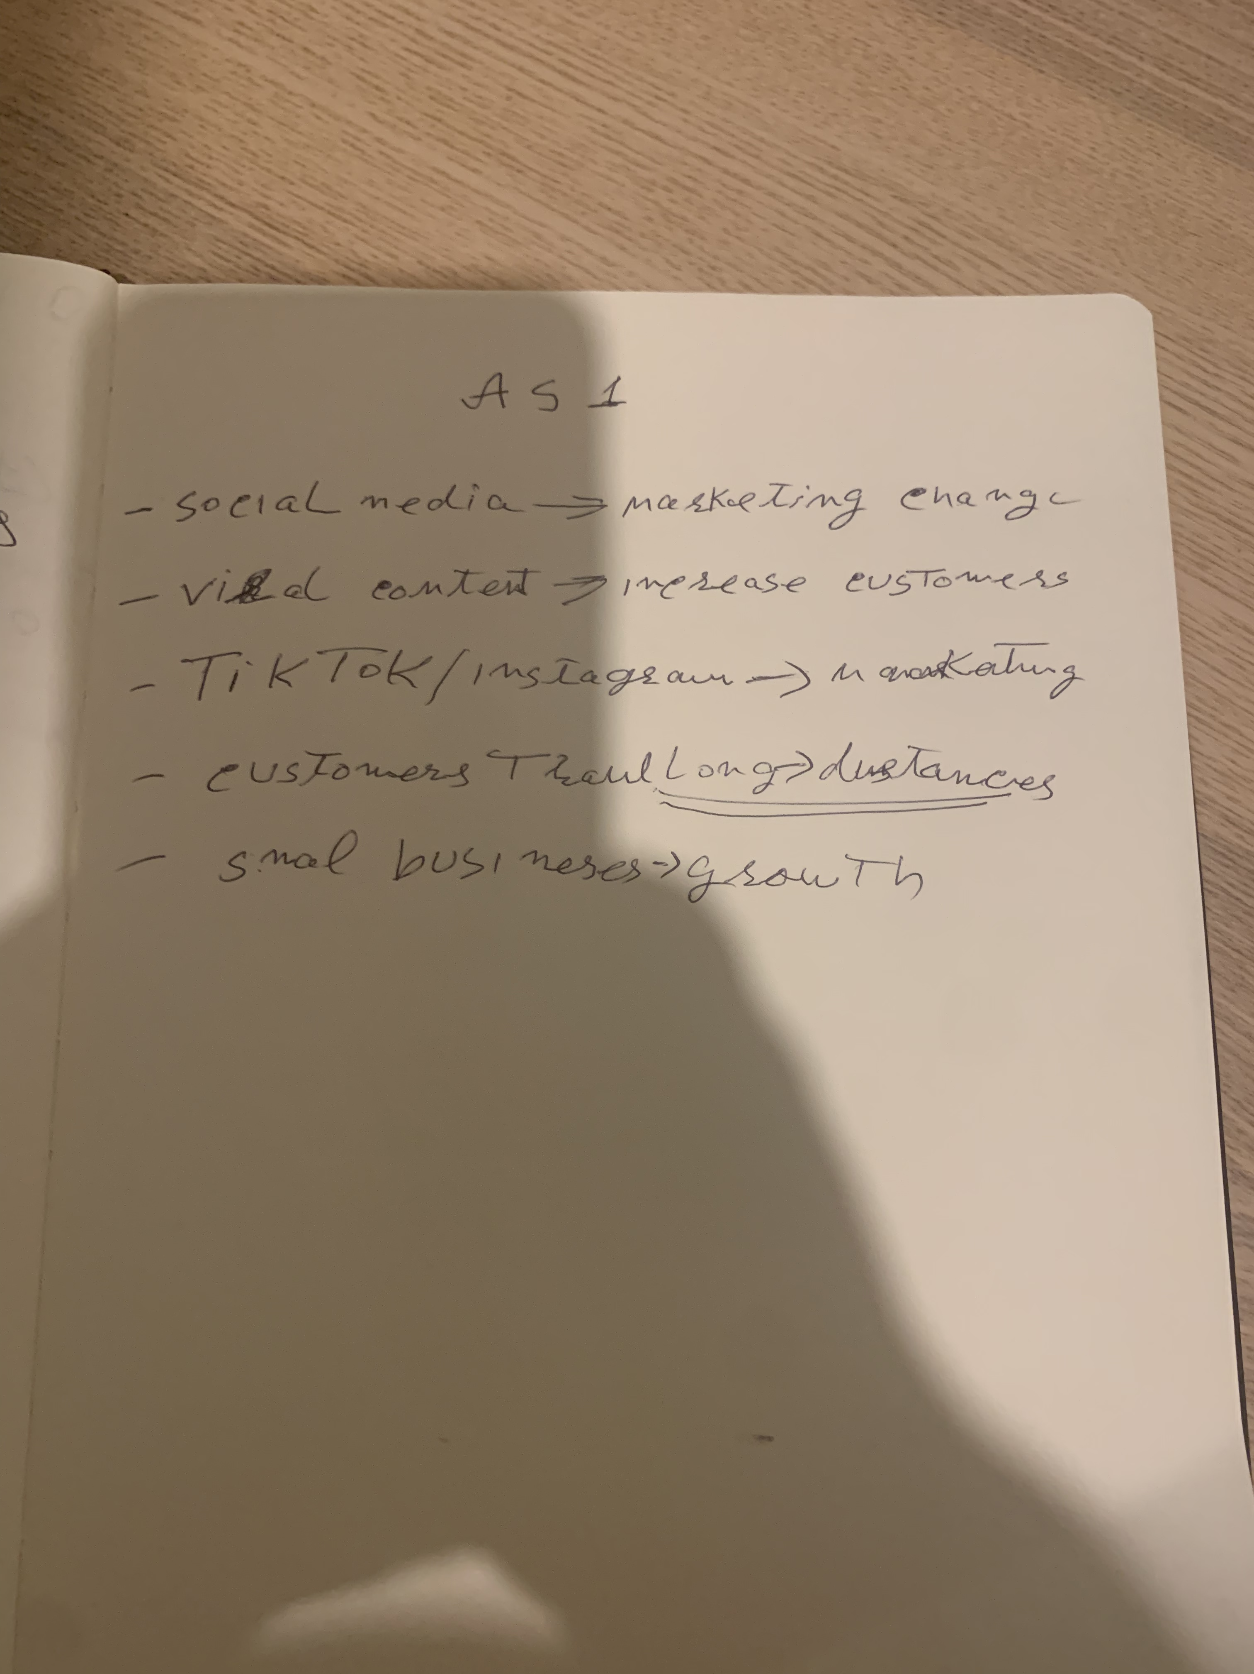

1. Answer these questions using the sentence starters below
a. What is the main idea of the text?
The main idea is that social media platforms have changed marketing by allowing businesses to grow rapidly through viral content and online engagement.
b. What are two key points?
One key point is that viral videos on platforms such as Tik Tok and Instagram can significantly increase business popularity and sales.
Another key point is that customers often travel long distances to visit businesses they discover through social media
c. What part of the text did you find most important? Why?
The most important part is the examples of small businesses gaining customers and increasing sales after going viral on social media, because it shows the real impact of social media on business success.
d. Was anything unclear or difficult to understand?
I was not sure about how social media could change consumer behaviour so rapidly.
e. How did your group help you understand the text better?
My group helped me by sharing different opinions and explaining the role of social media in changing marketing strategies
2. One sentence reflection
Question: What did you find challenging about this task?
The hardest part was selecting the key points from the text.

