

Student name: charlene ilangalal
Student ID:2134122
Module name: Independent Project
Module code:BMHP6020
Supervisor’s name: : Jolly Nwankwo

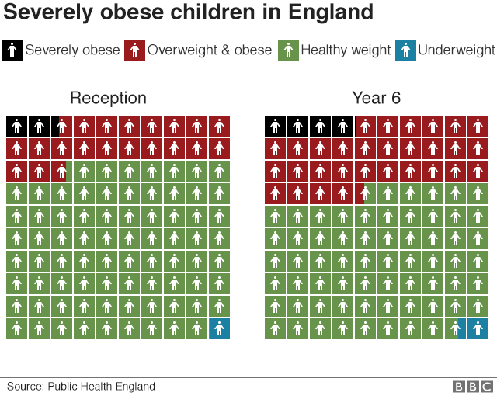 |  | Exploring the Impact of Obesity in Children in the United Kingdom  Aim: To examine the physical, psychological, and social impacts of obesity among children in the United Kingdom using a quantitative cross-sectional survey.  Data Collection Procedure  - Standardised data collection process: invitation, information sheet, consent/assent, Google Forms questionnaire, response export, and anonymised dataset creation.  - Data collection will take approximately three weeks.  - Duplicate responses will be identified using IP address and submission time.  - Incomplete responses will follow a predetermined missing-data protocol.  - All data handling will comply with GDPR and data minimisation principles. |  | 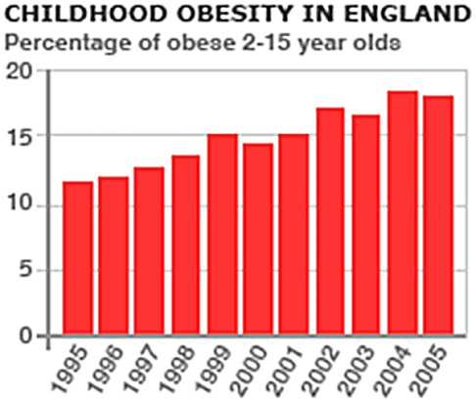
Methodological Limitations and Summary  - Self-report data: May be affected by recall bias and socially desirable responses.  - Cross-sectional design: Does not allow causal relationships to be established.  - Sample size and convenience sampling: May limit the generalisability of the findings.  - These limitations will be addressed through careful interpretation of the findings. |  |  |  | SPSS Data Analysis Plan  - Data will be analysed using IBM SPSS Statistics.  - Data will be cleaned through reverse coding, checking missing values, and coding/labelling variables.  - Frequencies and percentages will be used for categorical data.  - Means, medians, and measures of dispersion will be reported for ordinal data.  - Cross-tabulation and Chi-square tests will examine relationships between categorical variables.  - Spearman’s rank correlation will assess relationships between ordinal variables.  - An analysis-to-RQ matrix will guide the selection of statistical tests.  - Effect sizes will be reported where appropriate, distinguishing statistical significance from practical significance.  Ethical Considerations  - The study will follow UWTSD and BERA ethical guidelines.  - Informed consent and child assent (ages 10–16) will be obtained.  - Participation is voluntary, with the right to withdraw.  - Data will be collected anonymously and stored securely.  - Sensitive topics will be discussed using non-judgemental language.  - Participants may skip any question they do not wish to answer.  - Support services will be signposted in the participant information sheet.  - Safeguarding procedures will be followed for serious harm or abuse disclosures.

Data Collection
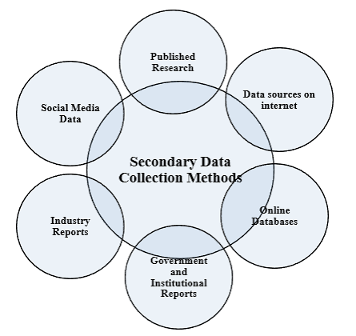

References
Bryman, A. (2016) Social Research Methods. 6th edn. Oxford: Oxford University Press.
Creswell, J.W. and Creswell, J.D. (2018) Research Design: Qualitative, Quantitative, and Mixed Methods Approaches. 5th edn. London: SAGE Publications.
Cobiac, L.J., Rogers, N.T., Adams, J., Cummins, S., Smith, R., Mytton, O. et al. (2024) 'Impact of the UK soft drinks industry levy on health and health inequalities in children and adolescents in England: an interrupted time series analysis and population health modelling study', PLoS Medicine, 21(3), e1004371. doi:10.1371/journal.pmed.1004371.
Field, A. (2018) Discovering Statistics Using IBM SPSS Statistics. 5th edn. London: SAGE Publications.

