

Student Name: Ayush Chandrakant Pagare

Student ID: 2428127

Module Name: International Marketing: Principles and Practices

Module Code: LCMB7026

Lecturer’s Name: Tushara Balendran (London)

Work Count: 5462

Term 2

Table of Content
INTRODUCTION 12
1.COMPANY BACKGROUND: Overview of the chosen brand and its operation in the chosen countries 12
1.1 Company Overview: BMW 12
1.2 Country A – BMW Operations in Germany 13
1.3 Country B – BMW Operations in USA 15
2. The Macroenvironment (PESTLE) Analysis of BMW 16
2.1 Political Factors 19
2.1.1 Germany 19
2.1.2 USA 20
2.2 Economic Factors 22
2.2.1 Germany 22
2.2.2 USA 23
2.2.3 GDP 24
2.2.4 Inflation Rate 25
2.3 Social Factors 26
2.3.1 Germany 26
2.3.2 USA 27
2.3.3 Germany: Changing Social Trends 28
2.3.4 USA: Changing Social Trends 30
2.3.5 Cultural Environment Analysis 31
2.3.5.1 Hofstede model 31
2.3.5.2 Advantages and Disadvantages of Hofstede’s Cultural Dimensions model 32
2.3.5.3 Hofstede Cultural Analysis 33
2.3.5.4. Similarities and Differences of cultural factors between Germany and the U.S. 34
2.3.5.5. Cultural Factors – Germany 35
2.3.5.6. Cultural Factors – United States 36
2.4 Technological Factors 37
2.4.1 Germany 38
2.4.2 USA 39
2.5 Legal Factors 40
2.5.1 Germany 40
2.5.2 USA 41
2.6 Environmental Factors 42
2.6.1 Germany 42
2.6.2 USA 43
2.7 Similarities and Differences in PESTLE Factors – Germany vs USA 45
3. Comparison of BMW’s STP Strategies in Country A (Germany) and Country B (USA) 46
3.1 Segmentation Strategies 47
3.1.1 VALS-2 Personality Types 47
3.1.2 Germany 48
3.1.3 USA 50
3.1.4 Market Segmentation – Germany vs USA 51
3.1.4.1 Geographic Segmentation 52
3.2 Targeting Strategies 54
3.2.1 Germany 54
3.2.2 USA 55
3.3 Positioning Strategies 56
3.3.1 Germany 58
3.3.2 USA 59
3.4 STP Comparation Germany vs USA 60
4. Comparison of Marketing Mix Strategies in Country A and Country B 60
4.1 Product Definition 61
4.1.1 Germany 61
4.1.2 USA 62
4.1.3 Product Variety, Depth & Width 63
4.1.3.1 Germany 63
4.1.3.2 USA 64
4.1.3.3 Main Differences Between Germany and the U.S. 65
4.1.4 Product Design 65
4.1.4.1 Germany 65
4.1.4.2 USA 66
4.1.5 Branding Strategies 67
4.1.5.1 Branding Strategies in Germany and the U.S. 67
4.1.5.2 Branding Strategy in Germany 67
4.1.5.3 Branding Strategy in the U.S. 68
4.1.5.4 Branding Strategies: Germany vs U.S. (BMW) 68
4.2 Price 69
4.2.1 Germany 69
4.2.2 USA 70
4.3 Place (Distribution) 71
4.3.1 Germany 71
4.3.2 USA 73
4.3.3 BMW Distribution Channels: Germany vs U.S. 74
4.3.4 Market Entry Methods 75
4.3.4.1 Market Entry Method Used: Wholly Owned Subsidiary (United States) 75
4.3.4.2 Why BMW Chose This Method 76
4.3.4.3 Advantages and Disadvantages of BMW’s Wholly Owned Subsidiary Entry Mode (U.S.) 76
4.4 Promotion 77
4.4.1 Germany 77
4.4.2 United States 78
4.4.3 BMW Promotion Strategy Evaluation – Germany vs USA 78
4.5 People 79
4.5.1 Germany 79
4.5.2 United States 80
4.6 Process 81
4.6.1 Germany 82
4.6.2 Customer Complaint Process Germany 82
4.6.3 USA 83
4.6.4 Customer Complaint Process United States 84
4.7. Physical Evidence Definition 85
4.7.1 Germany 85
4.7.2 USA 86
4.8 Similarities & Dissimilarities - BMW Germany vs USA (7Ps Comparison) 86
4.9 Evaluation of Marketing Strategies 88
4.91 Germany 88
4.9.2 USA 89
4.10 Profit and Sales 90
4.10.1 Germany 90
4.10.2 USA 91
4.11 Social Media Engagement 92
4.11.1 Germany 92
4.11.2 USA 93
4.12 Customer Reviews 94
4.12.1 Germany 94
4.12.2 USA 95
4.13 Key similarities and differences between Germany and the USA 96
5. Ethics of One Country (Germany) 97
6. Recommendations 99
6.1 Recommendations – Germany 99
6.2 Recommendations – United States 99
7. Conclusion 100
References 101
Appendix 108
Recommendations – Germany Action Plan 108
Recommendations – USA Action Plan 109

List of Tables
Table 1: Market Segmentation – Germany vs USA 52
Table 2: Comparative Insights of STP Germany vs. USA 60
Table 3: Branding Strategies: Germany vs U.S. (BMW) 69
Table 4: BMW Distribution Channels: Germany vs U.S. 74
Table 5: Advantages and Disadvantages of BMW’s Wholly Owned Subsidiary Entry Mode (U.S.) 76
Table 6: BMW Promotion Strategy Evaluation 78
Table 7: Similarities & Dissimilarities – BMW Germany vs USA (7Ps Comparison) 88
Table 8: Key similarities and differences between Germany and the USA 96
Table 9: Ethical vs Unethical Marketing Practices in Germany (Using STP / 7Ps) 98

List of Figures
Figure 1: BMW Logo 12
Figure 2: Dingolfing plant 14
Figure 3: Leipzig plant 14
Figure 4: Spartanburg plant 15
Figure 5: BMW of North America headquarter 16
Figure 6: PESTLE Analysis 16
Figure 7: PESTLE Definition 17
Figure 8: PESTLE Diagram 19
Figure 9: Political Factors 19
Figure 10: Germany’s Climate Targets and Emissions Pathways 20
Figure 11: US–EU Trade Tensions 21
Figure 12: Economic Factors 22
Figure 13: Germany Automotive Market Growth 23
Figure 14: U.S. Tariffs Pressure BMW 24
Figure 15: GDP 25
Figure 16: Inflation Rate 25
Figure 17: Social Factors 26
Figure 18: BMW’s Born Electric 27
Figure 19: Digital Personalisation Drives BMW USA 28
Figure 20: Germany: Changing Social Trends 28
Figure 21: BMW Neue Klasse Concept 30
Figure 22: USA: Changing Social Trends 30
Figure 23: Hofstede model 31
Figure 24: Hofstede Model 31
Figure 25: Hofstede Cultural Analysis Germany vs USA 33
Figure 26: BMW Governance Structure 34
Figure 27: Cultural Differences 35
Figure 28: German culture 36
Figure 29: U.S.A culture 37
Figure 30: Technological Factors 37
Figure 31: BMW Advanced Robotics Manufacturing 38
Figure 32: Human-Centred Mobility Innovation 39
Figure 33: Legal Factors 40
Figure 34: EU Green Deal Compliance 41
Figure 35: U.S.A legal compliance 42
Figure 36: Environmental Factors 42
Figure 37: BMW Global Battery Network 43
Figure 38: Circular Mobility, Lower Emissions USA 44
Figure 39: STP Strategies 46
Figure 40: VALS-2 Personality Types 47
Figure 41: BMW Electric Market Segmentation 49
Figure 42: EV Market Growth Trends 50
Figure 43: German Automotive Cluster Map 53
Figure 44: Differentiation and undifferentiation strategies 54
Figure 45: BMW Germany targeting strategy 55
Figure 46: BMW USA targeting strategy 56
Figure 47: Perceptual map definition 56
Figure 48: Perceptual map of BMW 57
Figure 49: BMW Brand Positioning Germany 58
Figure 50: BMW The Ultimate Driving Machine 59
Figure 51: 7P 60
Figure 52: Product Definition 61
Figure 53: BMW Germany EV Focus 61
Figure 54: BMW U.S. SUV Focus 62
Figure 55: Product Variety, Depth & Width Definition 63
Figure 56: BMW Group Brand Portfolio 63
Figure 57: BMW diversity within the SUV category 64
Figure 58: Product Design Definition 65
Figure 59: BMW German EV design features 66
Figure 60: BMW U.S. Design Focus 66
Figure 61: German Branding Innovation 68
Figure 62: Price Definition 69
Figure 63: BMW Value & Prestige Pricing 70
Figure 64: BMW Lease & Finance Offers USA 71
Figure 65: Place (Distribution) Definition 71
Figure 66: BMW Distribution in Germany 72
Figure 67: BMW Distribution in USA 73
Figure 68: Wholly Owned Subsidiary 75
Figure 69: Promotion Definition 77
Figure 70: Germany BMW promotional strategy 77
Figure 71: People Definition 79
Figure 72: BMW Employee Training Excellence Germany 80
Figure 73: BMW of Murrieta, Southern California Staff 81
Figure 74: Process Definition 81
Figure 75: Customer Complaint Process Germany 83
Figure 76: Customer Complaint Process USA 84
Figure 77: Physical Evidence Definition 85
Figure 78: German Showroom Aesthetics 86
Figure 79: BMW Welt 89
Figure 80: U.S. Performance Marketing 90
Figure 81: BMW Sales 91
Figure 82: Germany Social Media Engagement 92
Figure 83: BMW Social Media Strategy USA 93
Figure 84: BMW Germany Customer Reviews 95
Figure 85: BMW Germany Customer Reviews 95
Figure 86: Definitions of Ethics 97

INTRODUCTION
This report focuses on operations of BMW as a global premium automobile brand and examines the strategic approach of BMW in two main markets (Germany - Country A and USA - Country B). The study evaluates macroenvironment of BMW using PESTLE analysis, sociocultural influences, and segmentation, targeting, positioning (STP), marketing mix strategies and compares both countries. Through this analysis, the intended change in the report lays out the different ways in which BMW adapts its global brand identity to meet the different circumstances of the local market.

1.COMPANY BACKGROUND: Overview of the chosen brand and its operation in the chosen countries

1.1 Company Overview: BMW

Figure 1: BMW Logo
(Source: BMW Group, 2025)
Bayerische Motoren Werke AG (BMW Group) is a multinational company that operates on the principles of premium car and motorcycle industries and has its base headquarters in Munich, Germany. The company was founded in 1916 and it would no longer remain a humble airplane engine producer but one of the most innovated and eco-friendly and sustainable providers of mobility globally (BMW Group, 2025).
Vision
BMW's vision is to become the most successful and sustainable premium manufacturer for individual mobility, which includes a focus on developing a future of connected, digital, and emission-free vehicles.
(Source: BMW, 2025)
BMW corporate strategy is the direction of engineering excellence, introduction of new technologies, and customer-focused luxury mobility. Its worldwide businesses fall under three major brands namely BMW, mini, and Rolls-Royce that all accommodate the strategic focus of the company on the performance, luxury and heritage. At BMW, manufacturing plants are in over fifteen countries with sales subsidiary in over a hundred and forty countries (BMW Group, 2025). This large international footprint allows the organisation to fit into the local market environment and retain the main image of the German quality and precision.

1.2 Country A – BMW Operations in Germany
BMW's work in Germany represents an underlying part of the company's international success and its identity as a premium car maker. The company has its headquarters and major production centres in Munich, Dingolfing, Regensburg, Leipzig and Berlin, where it assembles just as much traditional combustion engine vehicles as next generation electric vehicles (BMW Group, 2025). These German plants serve as a central point for research, design and advanced engineering and thus strengthen Germany's important role in the global value chain of BMW.
The Munich facility is the headquarter of BMW and is the main plant, where the corporate headquarters, design studios, and production lines for the basic models of BMW are located. Dingolfing as a plant for car production hurts as the largest automotive plant in the European Union is a leading site for manufacture of electric vehicles and battery production and digitalised manufacturing processes (BMW Group, 2025). The Leipzig plant is a perfect example of sustainability, and it relies on renewable energy sources like wind and hydrogen, according to BMW's sustainability strategy as a whole (BMW Group Report, 2024).
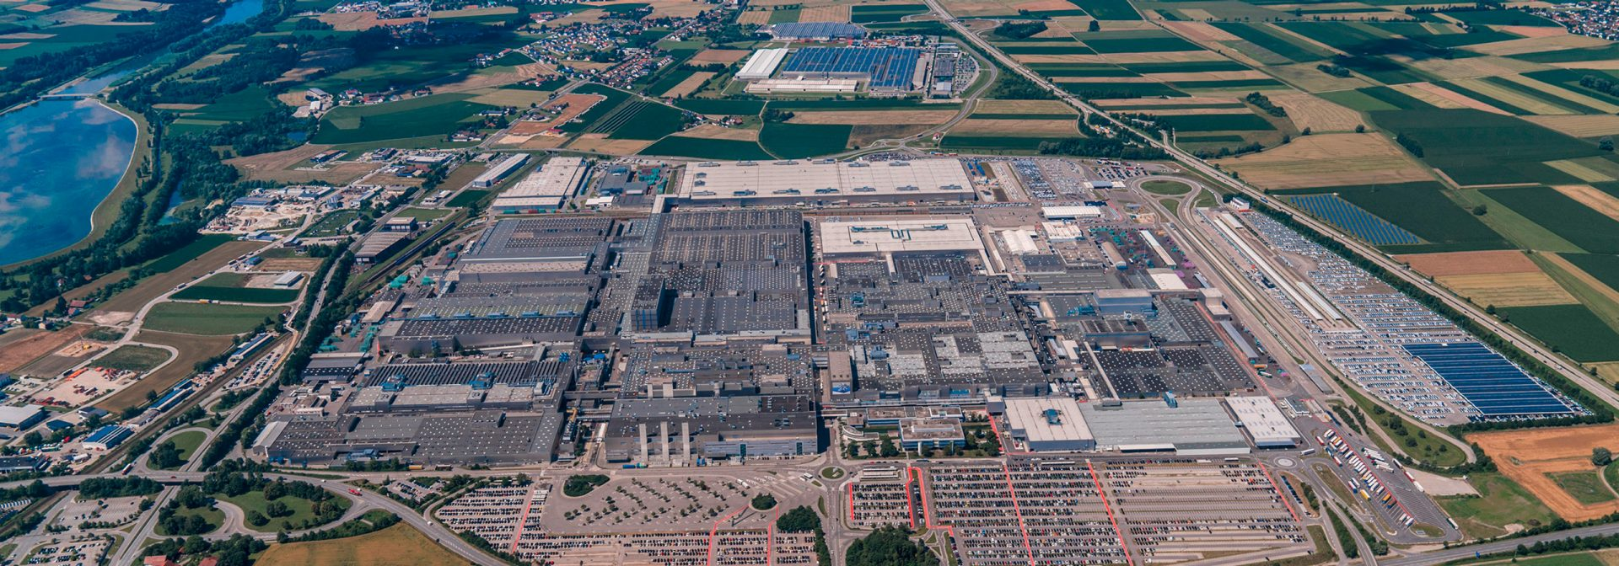
Figure 2: Dingolfing plant
(Source: BMW Group, 2025)
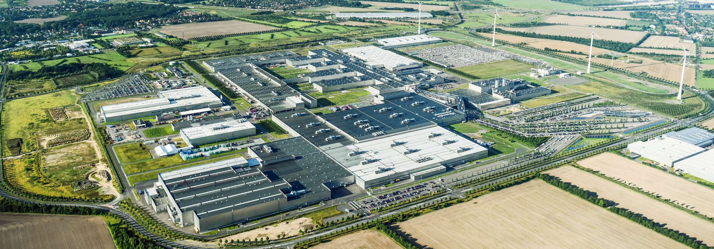
Figure 3: Leipzig plant
(Source: BMW Group, 2025)
The industrial foundation and trained workforce of Germany are also a good facilitator of the innovation of BMW. According to Boeriu (2025), in 2025, BMW overtook Mercedes-Benz to become the leading premium brand in Germany, but this move came because of diversity of products and the efficiency of production. Moreover, the German business units of BMW maintain a close relationship with local suppliers and research units, which, in turn, makes its sphere of innovation-driven business operations more than useful in enhancing its competitive edge (Newaz et al., 2025).
As a result, the German operations do not just outline the technological and design excellence of the company but reflect its corporate history and sustainability-based focusing manufacturing.

1.3 Country B – BMW Operations in USA
BMW's US operations are run by BMW of North America, which is headquartered out of Woodcliff Lake, New Jersey and oversees manufacturing, marketing and customer service across the region. The blending of advanced manufacturing technologies, automation and sustainability initiatives has allowed BMW USA to maintain high levels of productivity (Quinn, 2025). Additionally, the company has been known for eight years in a row as the largest automotive exporter by value in the United States, making this plant a crucial part of the global network for BMW (BMW Group PressClub USA, 2022).
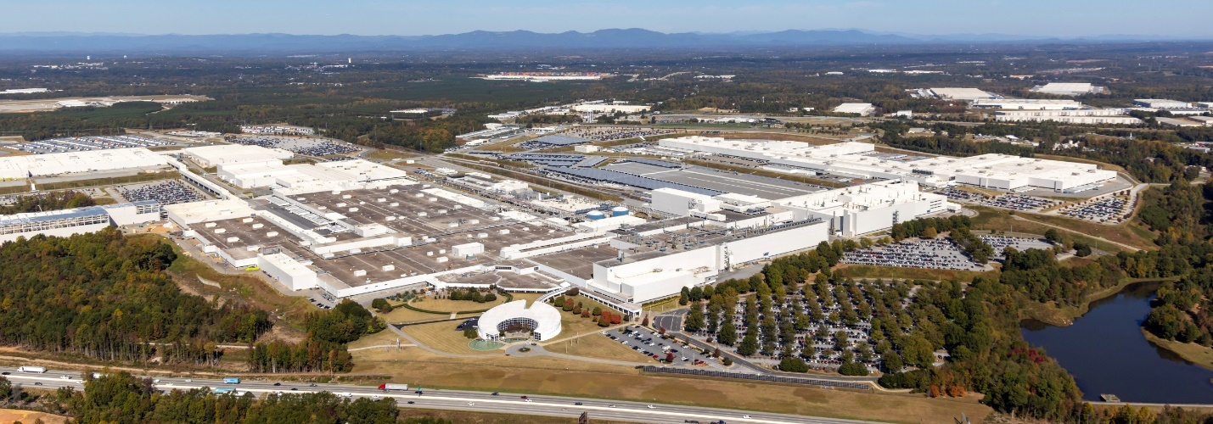
Figure 4: Spartanburg plant
(Source: BMW Group, 2025)
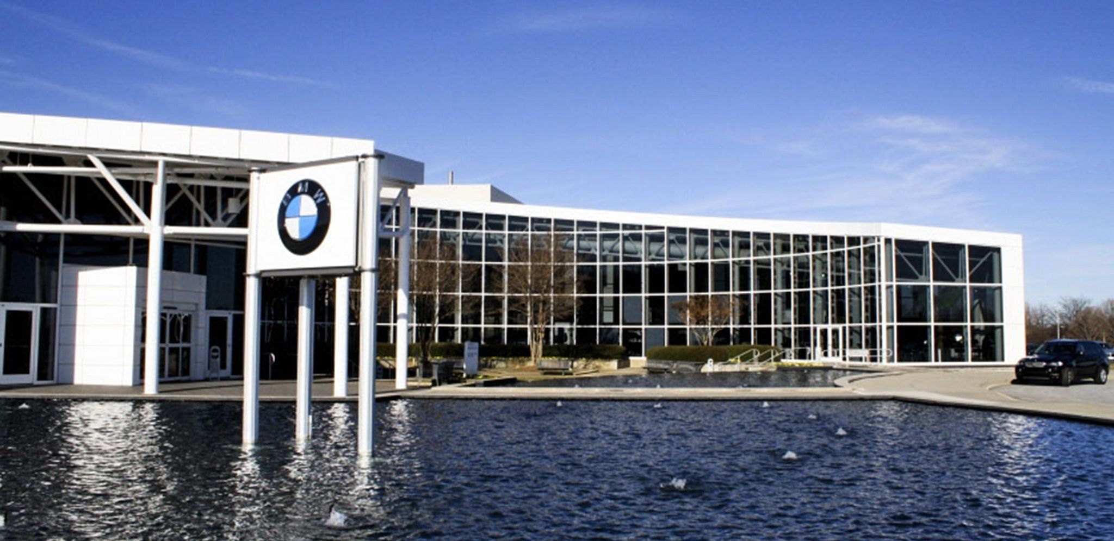
Figure 5: BMW of North America headquarter
(Source: Ventana, 2025)

2. The Macroenvironment (PESTLE) Analysis of BMW
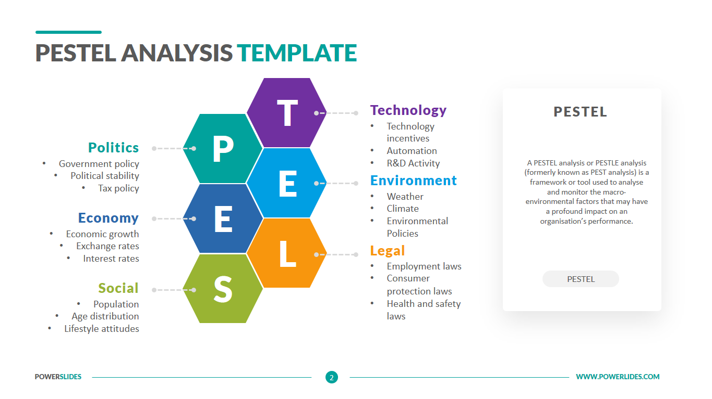
Figure 6: PESTLE Analysis
(Created by learner)
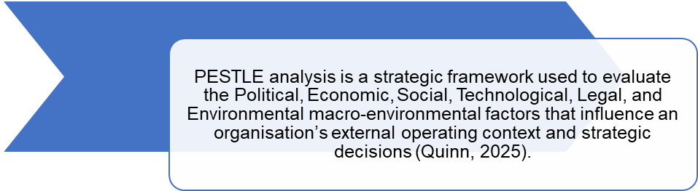
Figure 7: PESTLE Definition
(Created by learner)

PESTLE Factor | Germany – Favourable | Germany – Unfavourable | United States – Favourable | United States – Unfavourable
Political | Strong government support for EV transition, sustainability funding, and industrial stability support BMW’s long-term strategy (BMW Group, 2025). | Strict EU emissions targets and trade policies raise compliance and operational costs (Quinn, 2025). | State-level incentives and political support for manufacturing, especially in South Carolina, strengthen BMW’s production base (BMW Group PressClub USA, 2022). | Periodic US–EU trade tensions and tariff uncertainty disrupt global supply chains (Newaz, Hossain and Uddin, 2025).
Economic (Both favourable) | Strong industrial base, skilled workforce, and integrated Eurozone supply chains support premium production and exports (BMW Group, 2025). | - | Large consumer market, lower production costs, and strong USD enhance sales and export profitability (BMW of North America, 2025). | -
Social | Strong brand heritage, sustainability orientation, and acceptance of premium domestic brands favour BMW’s positioning (Pereira, 2024). | Rising expectations for digital integration and price sensitivity among younger consumers challenge traditional luxury models (Sushmith, 2024). | Status-driven consumers, SUV preference, and digital engagement strengthen BMW’s premium appeal (Pereira, 2024). | Diverse regional attitudes to EV adoption require highly segmented communication strategies (Quinn, 2025).
Technological | Advanced manufacturing, AI-driven production, and leadership in electrification enhance competitiveness (BMW Group, 2025). | High R&D intensity increases cost pressure and innovation risk (Hong, 2024). | Highly automated Spartanburg plant and strong digital capabilities support productivity (Quinn, 2025). | Intense competition from EV pioneers such as Tesla and BYD accelerates innovation pressure (Hong, 2024).
Legal (Both unfavourable) | Stringent EU environmental, data protection, and product liability laws increase compliance and administrative costs (BMW Group, 2025). | High regulatory complexity and recall obligations elevate legal risk (Newaz, Hossain and Uddin, 2025). | Fragmented state-level regulations complicate nationwide compliance and operations (Quinn, 2025). | Legal diversity across states raises costs and operational complexity (Quinn, 2025).
Environmental | Strong renewable energy use and circular production systems support long-term sustainability leadership (BMW Group Report, 2024). | Increasing regulatory and societal pressure raises short-term costs (Ozsevim, 2025). | Advanced water recycling and waste management enhance environmental credibility (BMW Group PressClub USA, 2022). | Rising regulatory and consumer expectations increase compliance and investment pressure (BMW Group, 2025).

Figure 8: PESTLE Diagram
(Created by learner)

2.1 Political Factors
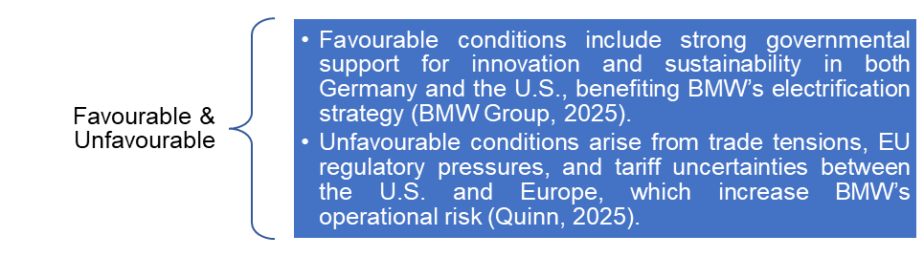
Figure 9: Political Factors
(Created by learner)

2.1.1 Germany
The political stability and government support of the automotive industry of both Germany and the United States have a significant influence on the operations of BMW.
The priorities on sustainable mobility and the available provision of finance to innovation expressed by the German government through such vessels as the “Klimaschutzprogramm 2030” provide BMW with the strong institutionalized support in the transition to the electric vehicles (BMW Group, 2025).
On the other hand, the reinforced emissions rules and trade policies of the EU create complications in the compliance sections and increase operational expenses thereby creating a net effect (Quinn, 2025).
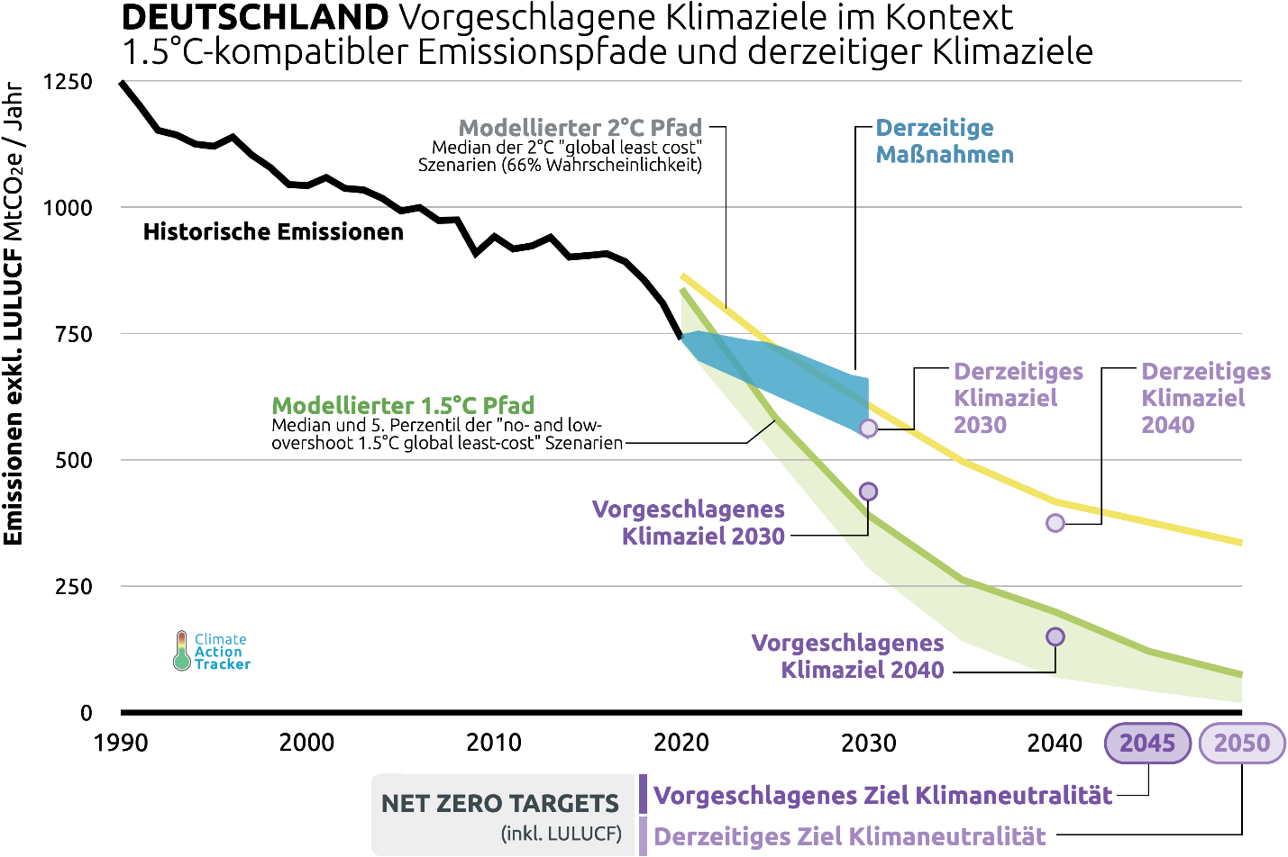
Figure 10: Germany’s Climate Targets and Emissions Pathways
(Source: Climate Action Tracker, 2021)

2.1.2 USA
In the US BMW enjoys state incentives which are meant to support manufacturing and exports, especially in the state of South Carolina, where the company has its Spartanburg plant. The site being labelled the largest automotive exporter in the country speaks volumes of a favourable political climate for industrial expansion (BMW Group PressClub USA, 2022).
Trade tensions and tariff uncertainties between the U.S. and the European Union, however, bring risks from time to time which can interfere with BMW's global supply chains (Newaz, Hossain and Uddin, 2025). Such volatility is a concern of note for logistics of the manufacturer's international activities.

Despite these fluctuations, the political resilience of BMW and its diversified global presence are aimed at stabilising its operations to overcome the negative effects of both domestic and international market perturbations.
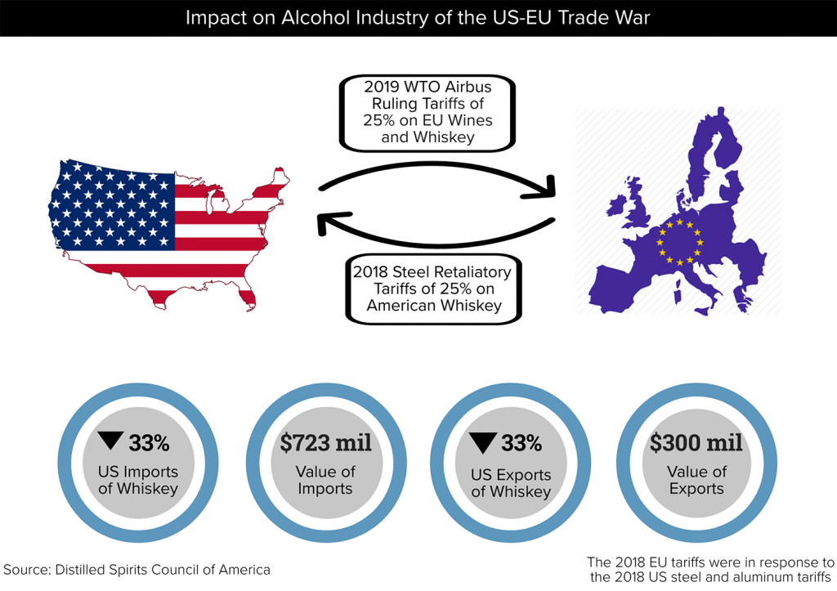
Figure 11: US–EU Trade Tensions
(Source: Moehr, O., 2020)

2.2 Economic Factors
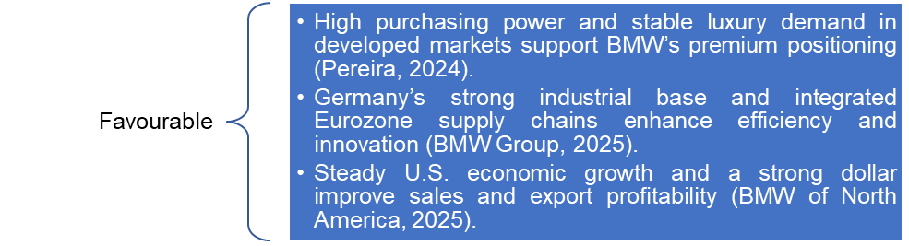
Figure 12: Economic Factors
(Created by learner)

2.2.1 Germany
The business climate, linked to BMW, offers two contradictory opportunities and threats. The strong industrial base of Germany, complemented with a highly skilled workforce and an export-oriented macro-economy may be seen as the foundation of the BMW high-end market).
Moreover, the credibility of the European domestic market as well as the smoothness of the supply-chain network that the Eurozone provides favourable macroeconomic factors that support the production and innovative activities.
On the other hand, an increase in the cost of energy and the overall inflationary trends that pervaded the entire region of Europe could have pressure on production spending, which will effectively translate into direct financial exposures to BMW (Boeriu, 2025).
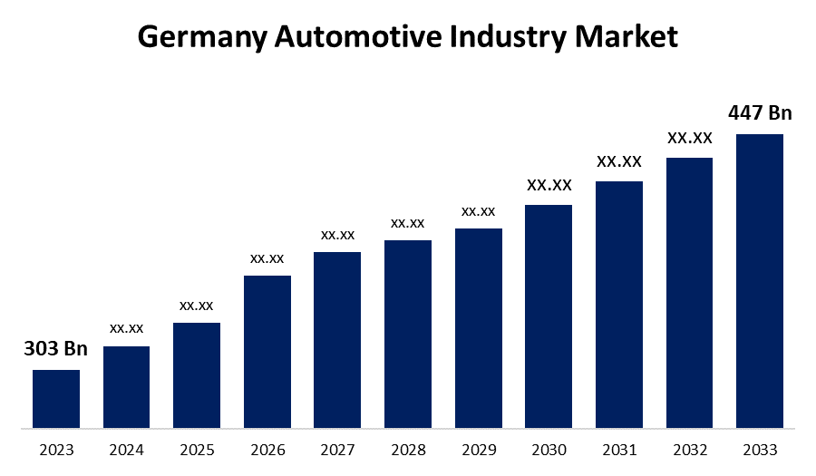
Figure 13: Germany Automotive Market Growth
(Source:

2.2.2 USA
In contrast, BMW's U.S. operations benefit from low production costs, an extensive consumer market and access to trade routes throughout the Americas. Relative strength of the US dollar vis a vis the Euro makes export even more profitable (BMW of North America, 2025). Nevertheless, changes in interest rates and variations in variable consumer demand for luxury vehicles during economic downturns have the potential to decrease the overall sales growth (Hong, 2024). The company's diversified portfolio and solid financial resilience are used to alleviate these risks and thus maintain its globally competitive status.
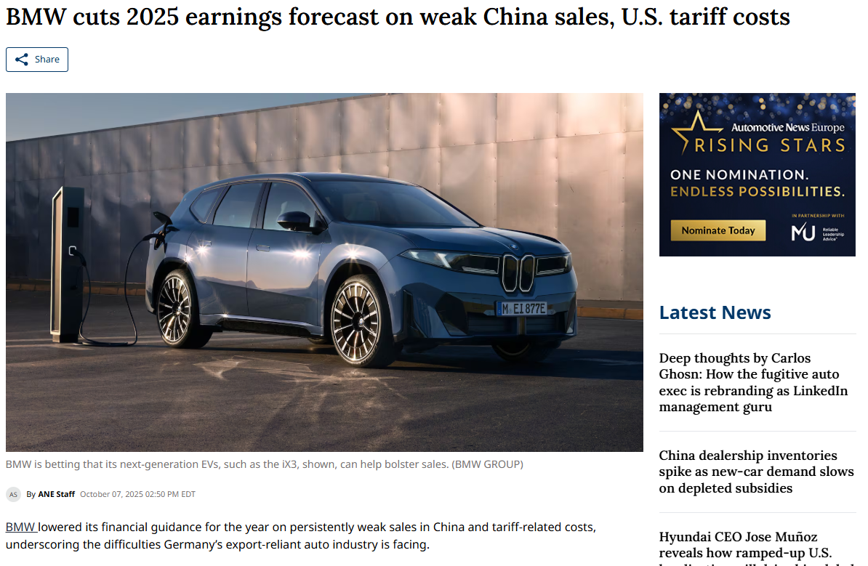
Figure 14: U.S. Tariffs Pressure BMW
(Source: ANE Staff, 2025)

2.2.3 GDP

Figure 15: GDP
(Created by learner)
The Gross Domestic Product of Germany has a struggling contraction, which is due to high energy costs and the decline in industrial production. On the other hand, the GDP of the United States shows continuous growth, because of strong consumer spending and investment inflows. This widening divergence traces a much stronger U.S. economy compared to a relatively weak German market with significant implications for BMW's strategic priorities and market performance in both economies.

2.2.4 Inflation Rate

Figure 16: Inflation Rate
(Created by learner)
Germany was under great inflationary pressure that could be attributed to the energy crises and a disruption in the supply chains, which in turn diluted consumer buying power and increased the production prices. In America, the inflation was the peak, and it reduced gradually as the effect of monetary tightening intervention. As a result, the market in the U.S has taken a more predictable turn and the conditions in Germany has made it such that BMW is required to adopt sound pricing and strict cost-management measures.

2.3 Social Factors
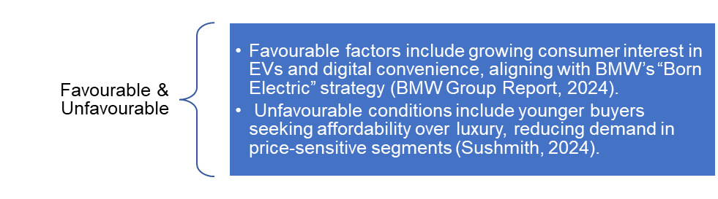
Figure 17: Social Factors
(Created by learner)

2.3.1 Germany
BMW enjoys strong brand value, national imagery on excellence in engineering and high social acceptance of high-end domestic automobile brands in Germany. Consumers are guided by quality, performance, and sustainability, making them close to the strategy of electric mobility and innovation chosen by BMW.
The rising environmental consciousness serves as an additional factor that preconditions the acceptance of the EV pack at BMW and green production (Pereira, 2024; BMW Group, 2025).
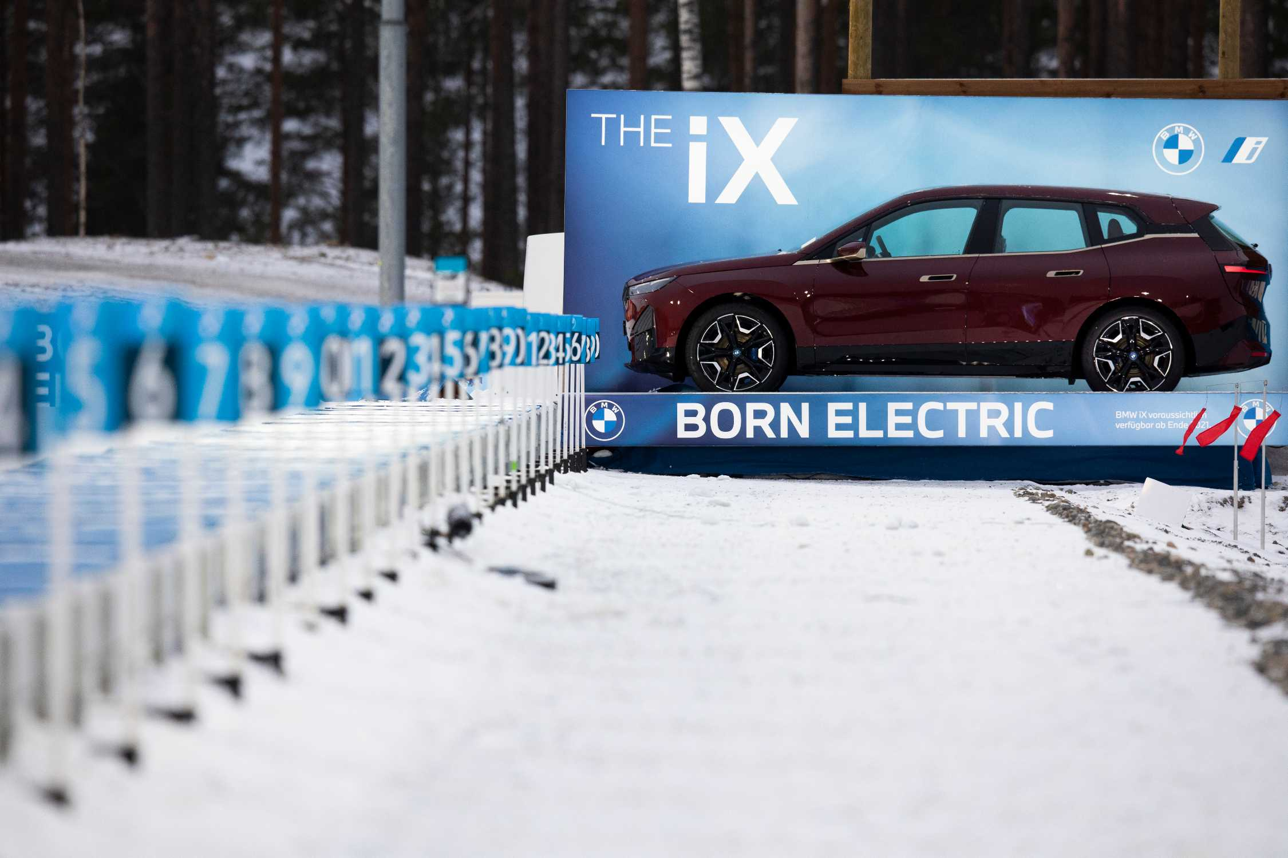
Figure 18: BMW’s Born Electric
(Source: BMW Group, 2020)

2.3.2 USA
In the United States, BMW appeals to status-conscientious, wealthier individuals who attribute the brand operation with the dimension of performance, lifestyle, and technological advancement. The current tendencies in society entail SUV, customization, and digitization, which supports the strong presence of BMW in the fields of premium markets. Greater sustainability awareness within the community also amplifies the desire to purchase electric-powered BMWs at the same time, younger generations expect more and more digital-first experiences and flexible ownership models (Pereira, 2024; Sushmith, 2024; BMW Group, 2025).
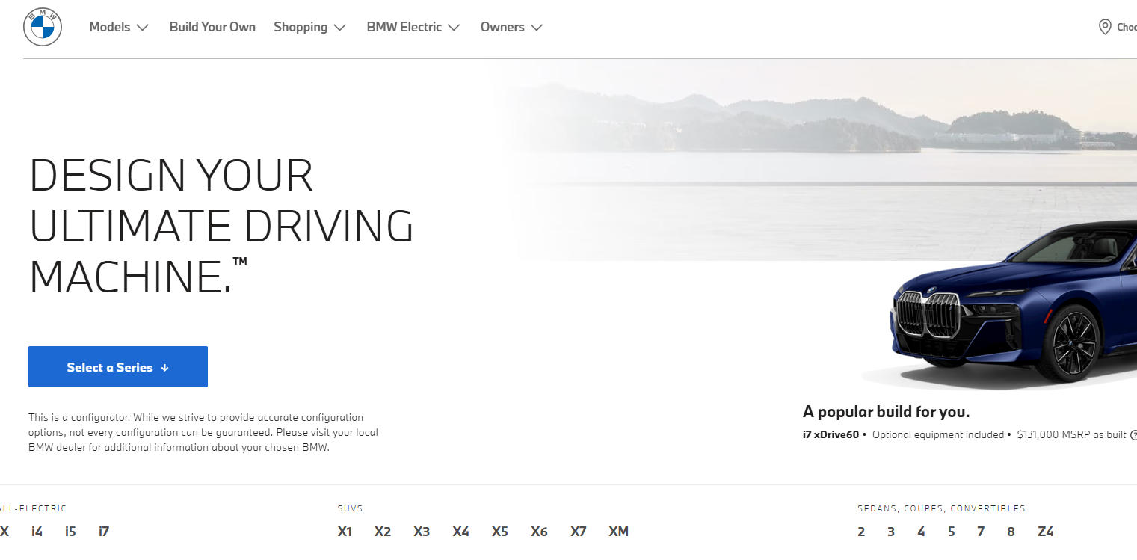
Figure 19: Digital Personalisation Drives BMW USA
(Source: BMW Group, 2025)

2.3.3 Germany: Changing Social Trends

Figure 20: Germany: Changing Social Trends
(Created by learner)
The German consumer base has shown an ever-growing preference for sustainability, safety and quality, which speaks to BMWs eco-luxury positioning and the Neue Klasse electrification strategy very much (BMW Group, 2025; BMW Group Report, 2024).
Urban purchasers expect seamless digital and omnichannel experiences, making this increase in demand for connected services and integration of online retail channels even greater (BMW Group, 2025).
The premium segment favours efficient crossover, low emission fleet vehicles; this means that segmented communications strategies are required to attract both younger as well as mature consumers (Pereira, 2024; Quinn, 2025; Sushmith, 2024).

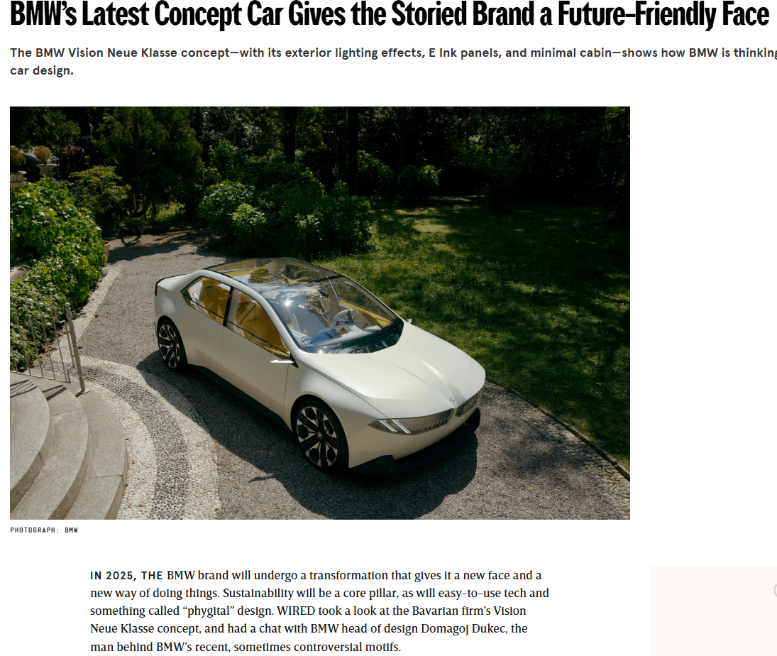
Figure 21: BMW Neue Klasse Concept
(Source: Goy, A., 2023)

2.3.4 USA: Changing Social Trends
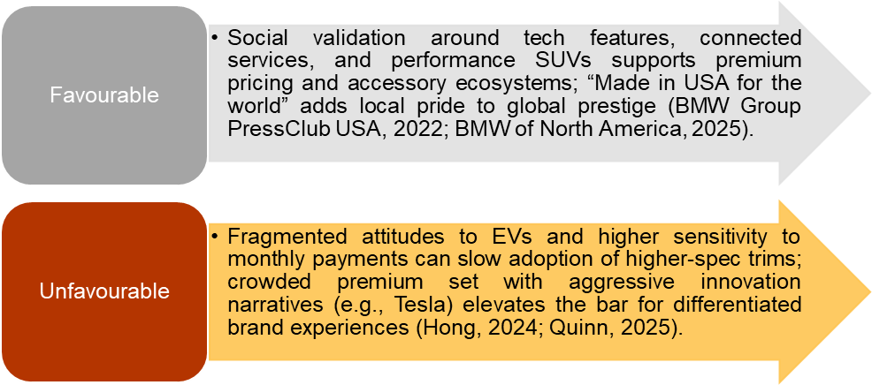
Figure 22: USA: Changing Social Trends
(Created by learner)
U.S. luxury consumers exhibit a high correlation with the driving technologies, digital convenience, and performance-related SUVs as an example of aligned production and experienced positioning of the X-Range by BMW (BMW of North America, 2025; Hong, 2024). Local manufacturing stories coming out of Spartanburg help the brand's relevance and pride (BMW Group Press Club USA, 2022). Influencer-based digital marketing and customized customer relationship management affect customer loyalty and regional differences in EV adoption require tailored communication related to charging convenience and value of ownership (DiIanni, 2023; Quinn, 2025).

2.3.5 Cultural Environment Analysis

2.3.5.1 Hofstede model
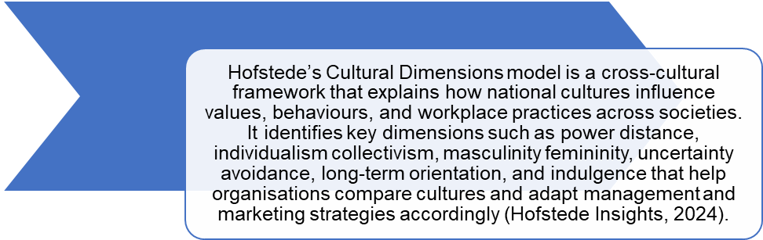
Figure 23: Hofstede model
(Created by learner)
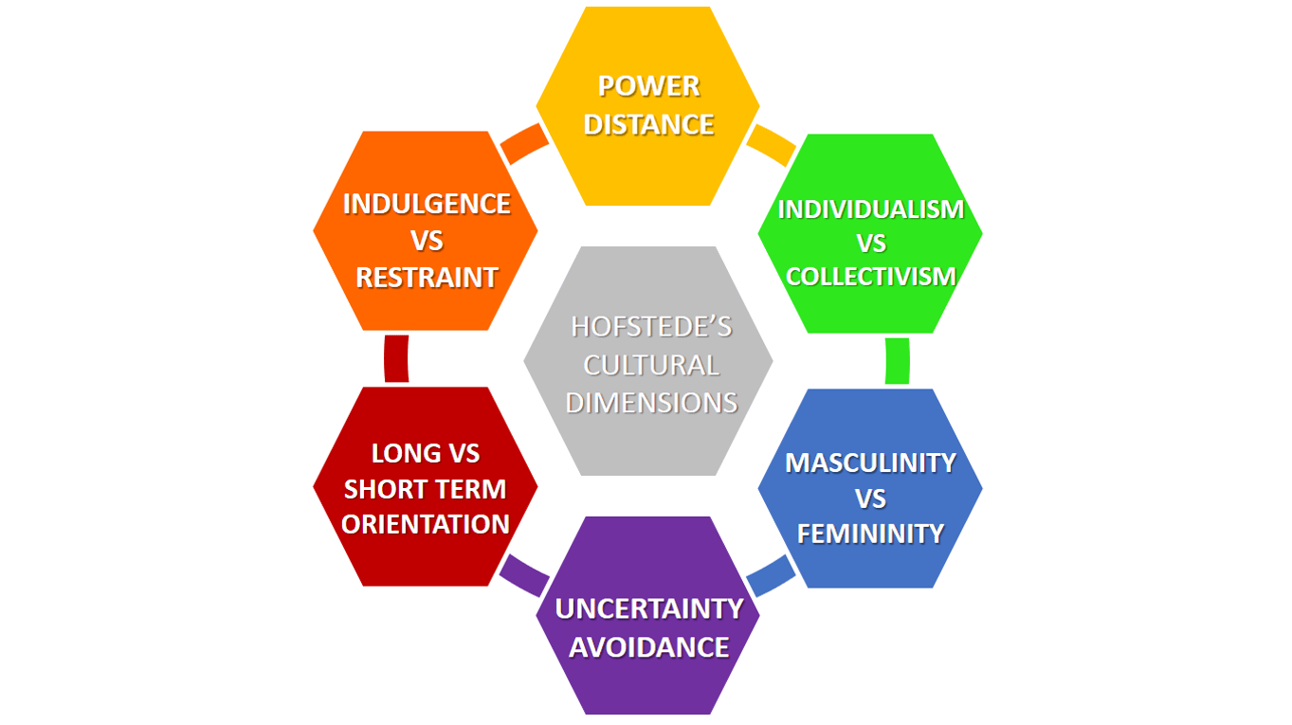
Figure 24: Hofstede Model

2.3.5.2 Advantages and Disadvantages of Hofstede’s Cultural Dimensions model
Advantages of Hofstede’s Cultural Dimensions model
- This framework will provide an organized and transparent method of comparing national cultures, thus supporting the decision-making in the management, leadership, and international marketing settings (Hofstede Insights, 2024).
- It also allows multinational companies to predict cultural differences in communication, motivation and consumer behaviour and, therefore, overcome cross-cultural misconceptions (Hofstede Insights, 2024).
- As it has been substantially validated and its applicability is not complicated, it is a convenient tool in the analysis of the work as well as in business strategy formulation (Quinn, 2025).

Disadvantages of Hofstede’s Cultural Dimensions model
- It uses national averages and thus possibly obscures the fact that cultures may vary across different regions, generations, and individuals within countries (Sushmith, 2024).
- Being originally based on historical data, some of the cultural scores may not properly reflect contemporary socio- cultural transformations and the dynamics of globalization (Hofstede Insights, 2024).
- The idea of cultural stability restricts its ability to capture dynamic and rapidly changing cultural behaviours (Quinn, 2025).

2.3.5.3 Hofstede Cultural Analysis
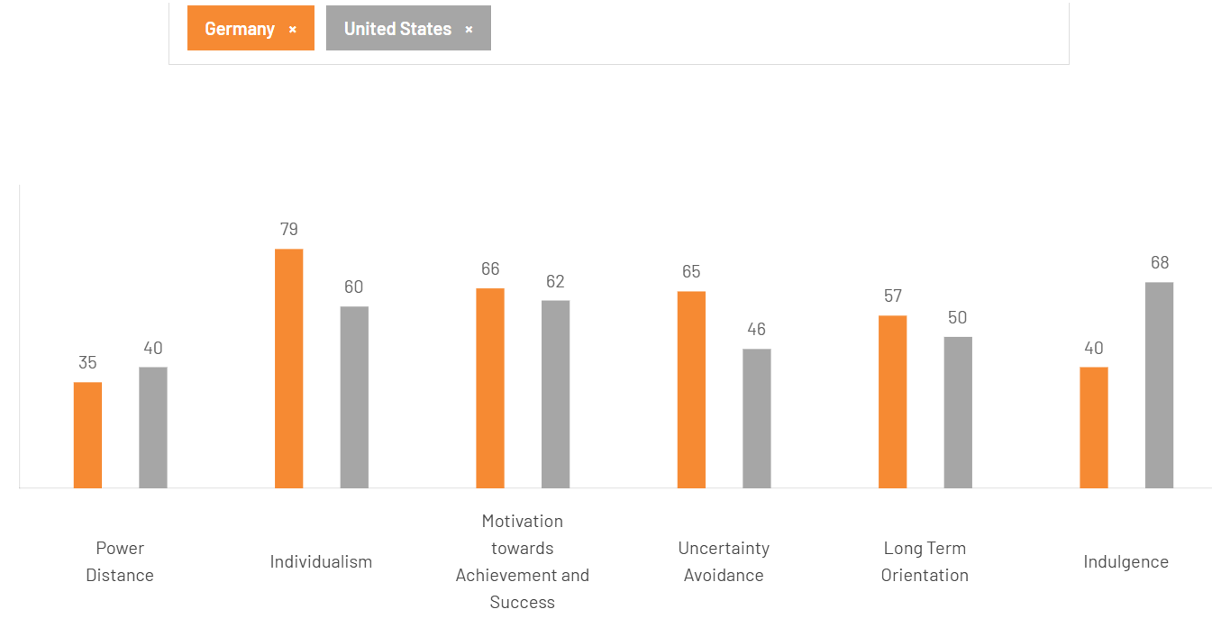
Figure 25: Hofstede Cultural Analysis Germany vs USA
(Created by learner)
As depicted by the Hofstede scores, there exist considerable differences in the cultures of Germany and the United States. In the dimension of Individualism, Germany scores is higher (79) which is a pointer to a high level of individualism emphasized on personal responsibility and independence; the United States is also rated high on the measure but by a slightly lower level (60).
The score of the Uncertainty Avoidance is significantly higher in Germany (65) than in the United States (46), implying that Germans like complex and well-planned settings and risk avoidance, which are the key characteristics of BMW engineering-driven messaging.
The United States has a higher score (68) in Indulgence than Germany (40), which is more pleasure seeking, expressive consumer culture that fits better in marketing approaches that focus on emotions. The scores of both of these countries are moderate in Long-Term Orientation with Germany (57) being a bit higher in planning in the future than the United States (50).

2.3.5.4. Similarities and Differences of cultural factors between Germany and the U.S.
Cultural Similarities
Germany and the United States are among the countries with low power distance, which facilitates the establishment of open communication and participative decision-making process in the organizational structure of BMW. It creates an environment based on the importance of expertise and accountability at both subsidiaries (BMW Group, 2025).
Moreover, the two societies value performance and achievement, which fits well with BMW in its expansion strategies over the globe as a high-performance luxury automobile manufacturer.
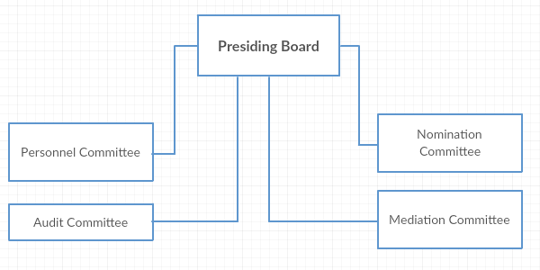
Figure 26: BMW Governance Structure
(Source: Dudovskiy, J., 2016)
Cultural Differences
However, the nation’s exhibit high levels of inequality in uncertainty avoidance and individualism. Germany is characterized by the preference to organized structures, careful planning, and stability, and the United States promotes experimentation and breakthrough (BMW Group Report, 2024). In that regard, the marketing message displayed in Germany by BMW takes a rational/technical approach, and in the United States, it is aspirational/emotional (Pereira, 2024). Additionally, German customers view BMW as an indicator of accuracy and reliability, but American consumers look at the brand as a means of personal expression and improvement of lifestyle (Third Eyeblindproductions, 2023).
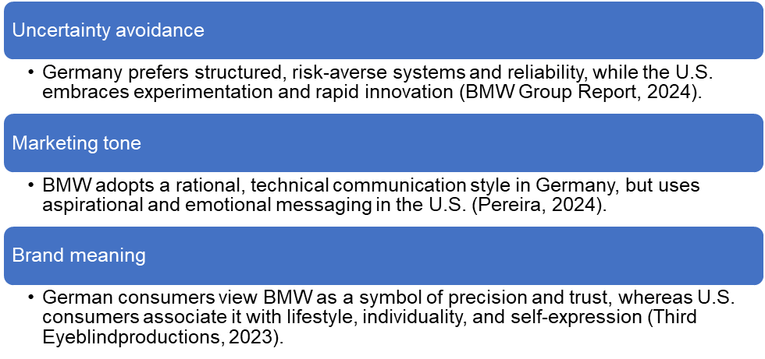
Figure 27: Cultural Differences
(Created by learner)

2.3.5.5. Cultural Factors – Germany
German culture has a high degree of uncertainty avoidance and long-term orientation, which encourages love of being precise, reliable, and organised in the decision-making process. Therefore, BMW has been seen as the symbol of engineering quality and excellence. Marketing approaches of the company present technicality, safety and efficiency, thus, fits the cultural assumptions of rational considerations and sustainability-centred mobility buying options (BMW Group Report, 2024; Pereira, 2024).
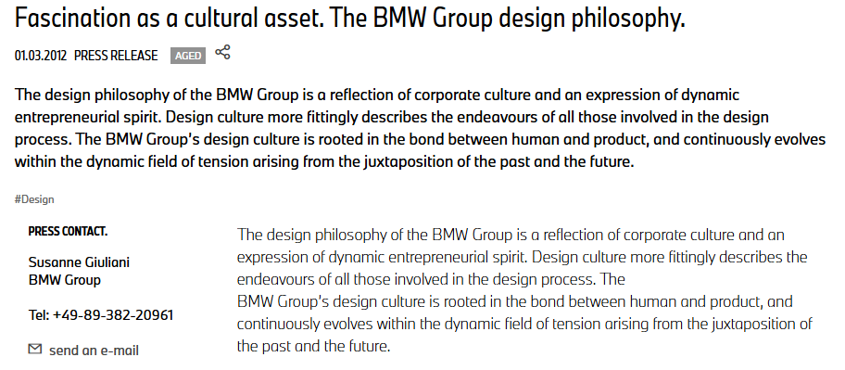
Figure 28: German culture
(Source: BMW Group, 2025)

2.3.5.6. Cultural Factors – United States
The United States cultural framework has been characterised by strong individualism, and limited uncertainty avoidance characteristics, thus favouring innovation, self-expression and affective involvement. Within this context, the BMW brand is perceived as being related to augmenting lifestyle, to superior performance and personal achievement. Contemporary marketing strategies focus on aspirational narrative construction, immersive digital experiences and bespoke customisation, which fortifies affective bonding and brand identity in a culturally heterogeneous and dynamic market place (Pereira, 2024; Third Eye Blindproductions, 2023).
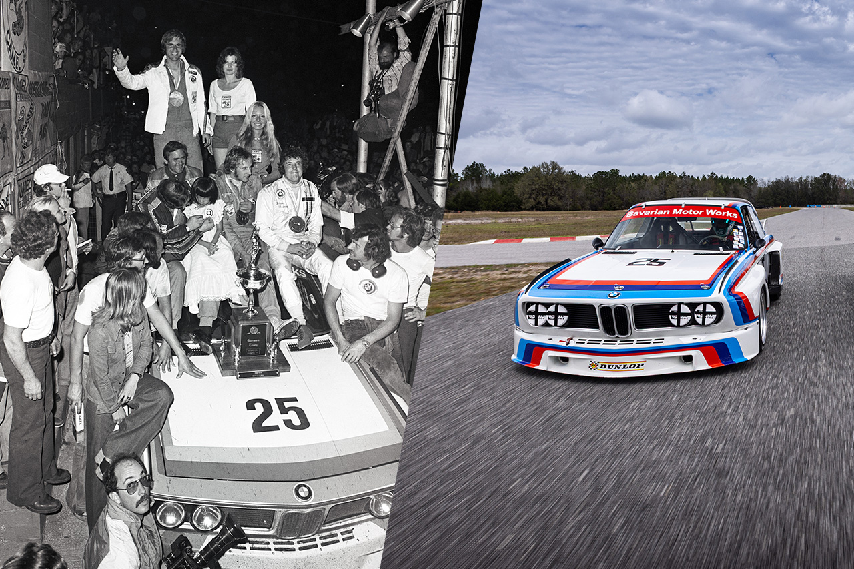
Figure 29: U.S.A culture
(Source: BMW Group, 2025)

2.4 Technological Factors
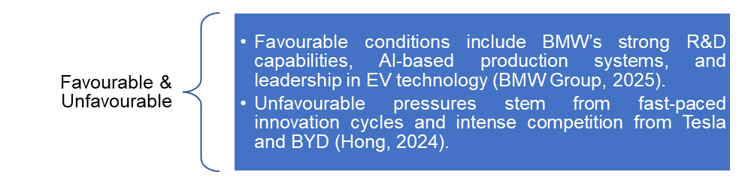
Figure 30: Technological Factors
(Created by learner)

2.4.1 Germany
The deployment of technology represents still one of the key competitive advantages of BMW, and at the same time, as a continuous driver of innovation. The investment BMW made in the electrification and autonomous driving as well as into digital ecosystems through the Neue Klasse platform strengthens its technological leadership in the international automotive market (BMW Group, 2025). Germany has sites of production utilizing AI-based systems and a renewable energy source, such as Dingolfing and Leipzig, thus steering towards the long-term cost-effectiveness and sustainability (BMW Group, 2025).
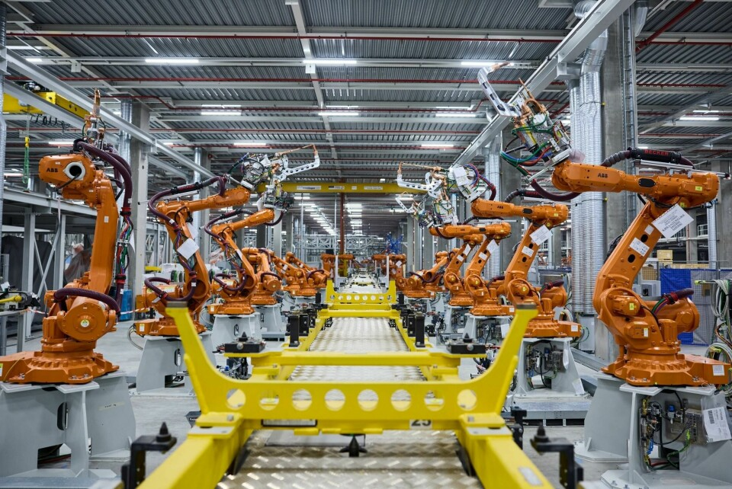
Figure 31: BMW Advanced Robotics Manufacturing
(Source: Ozsevim, I. and Holt, N., 2025)

2.4.2 USA
Robotics, automation and data analytics are being applying in Spartanburg headquarters plant of BMW to maintain high productivity and quality (Quinn, 2025). However, technological interference and threat of newcomers of the electric-vehicle market, like Tesla and BYD are elements that cause high velocities which may force constant innovation (Hong, 2024). BMW has stability due to its research and development knowledge and flexible strategy, which has helped it to stay competitive in the changing trends in technology.
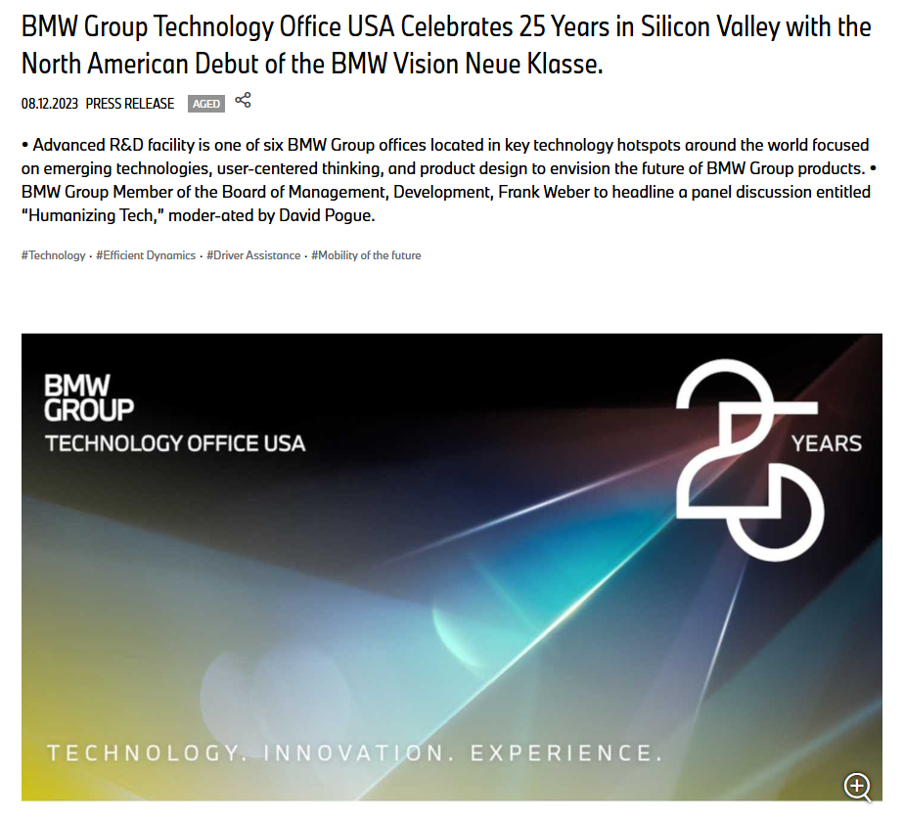
Figure 32: Human-Centred Mobility Innovation
(Source: BMW Group, 2023)

2.5 Legal Factors
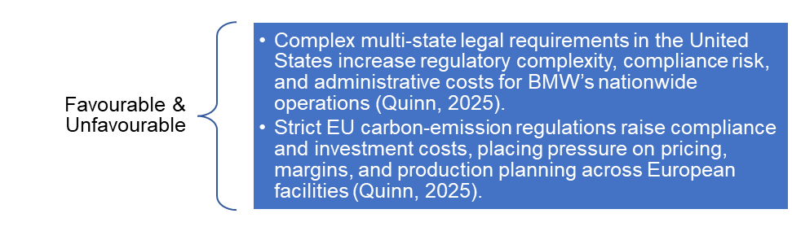
Figure 33: Legal Factors
(Created by learner)

2.5.1 Germany
BMW works in a tightly regulated industry, which is subject to a wide range of legal regimes. In the European Union, the company must adhere to the stringent environmental law and data protection law, especially the EU Green Deal and the General Data Protection Regulation (GDPR) (BMW Group, 2025). These regulations impose ethical and transparent practices and at the same time increase administrative and operation costs.
Moreover, product-liability and recall laws in widely disparate markets require the application of massive quality control schemes (Newaz, Hossain and Uddin, 2025).
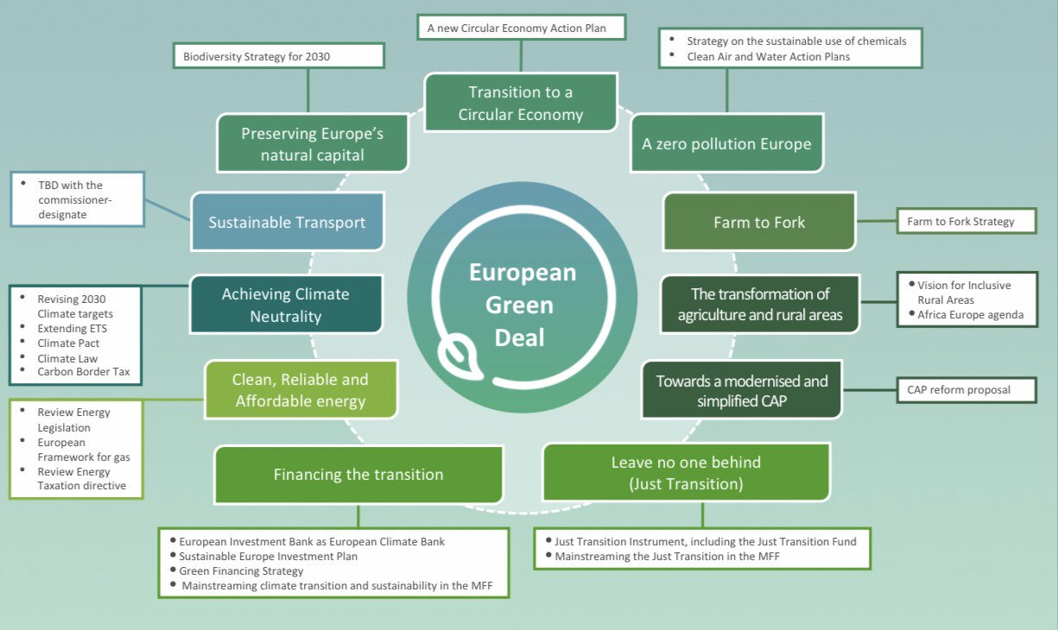
Figure 34: EU Green Deal Compliance
(Source: Compost Network, 2019)

2.5.2 USA
The automotive regulations in the United States pose a layered legal compliance environment and this can be explained by the fact that the automotive standards and emission regulations in the state are heterogeneous. This issue adds to the complexity of operations; however, the active approach of the company and its constant compliance with the relevant legislative principles will strengthen the image of BMW as an efficient producer (Quinn, 2025). Therefore, the wider law has had a two-fold impact, the increase in consumer confidence and at the same time an increase in compliance spending.
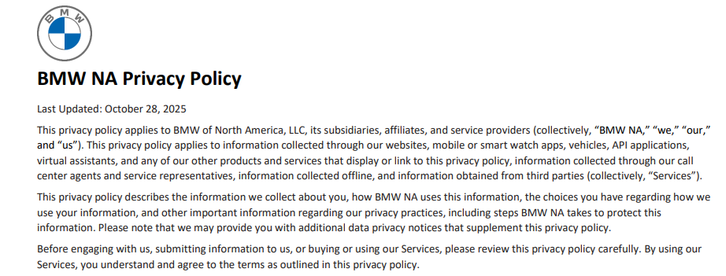
Figure 35: U.S.A legal compliance
(Source, BMW Group, 2025)

2.6 Environmental Factors
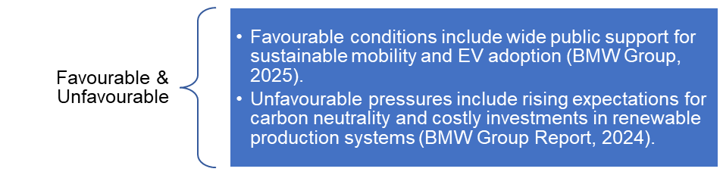
Figure 36: Environmental Factors
(Created by learner)

2.6.1 Germany
BMW has a strategic approach of environmental sustainability, as well as a challenge. The global sustainability vision of the company is based on carbon neutrality by 2050 and the lifecycle emission target of production, logistics, and usage points (BMW Group Report, 2024). In Germany, the efforts of BMW towards renewable energy, and the use of cycles in the manufacturing process like the ones at Leipzig and Regensburg, explains its great concern with the environment (BMW Group, 2025).
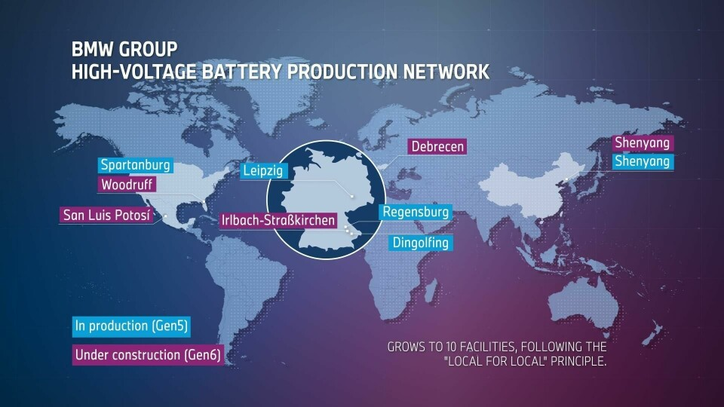
Figure 37: BMW Global Battery Network
(Source: Ozsevim, I., 2025)

2.6.2 USA
In the United States, BMW uses water recycling and waste management methods in its Spartanburg plant, which also helps to reinforce its sustainability credentials (BMW Group Press Club, 2022). Environmental expectations from regulators and consumers, however, are constantly increasing, which therefore creates performance pressure and increases compliance costs. Consequently, while environmental initiatives drive improved long-term competitiveness, environmental initiatives also cause short-term financial and operational challenges.
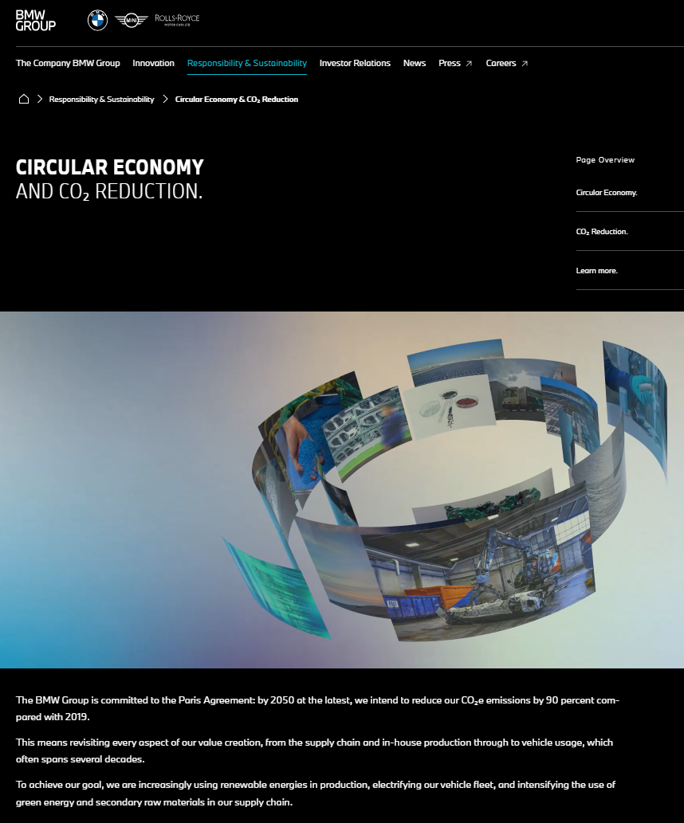
Figure 38: Circular Mobility, Lower Emissions USA
(Source: BMW Group, 2025)

2.7 Similarities and Differences in PESTLE Factors – Germany vs USA
PESTLE Factor | Similarities (Germany & USA) | Differences (Germany vs USA)
Political | Both countries provide strong institutional support for automotive innovation and manufacturing. | Germany emphasises sustainability policies and strict EU emission rules, while the USA offers state-level incentives and faces tariff risks due to US–EU trade tensions.
Economic | Both markets are highly developed and support premium automotive demand. | Germany faces higher energy costs and slower GDP growth; USA shows stronger GDP growth, lower production costs, and currency advantages for BMW exports.
Social | Consumers in both markets value premium quality, performance, and sustainability. | German consumers prefer eco-efficiency and engineering precision; U.S. consumers prefer performance SUVs, lifestyle appeal, and digital convenience.
Technological | Both countries support advanced automotive technologies such as electrification and automation. | Germany focuses on engineering R&D, AI-driven production, and renewable energy; USA emphasises large-scale automation, robotics, and digital manufacturing systems.
Legal | Both markets impose strong regulatory frameworks to ensure safety and quality. | Germany follows strict EU environmental and data protection laws (GDPR); U.S. legal requirements vary by state, increasing compliance complexity.
Environmental | Both markets demand sustainable practices and emission reduction. | Germany focuses on renewable energy and circular production; USA emphasises water recycling and waste management but faces regionally varied environmental expectations.
(Created by learner)
BMW faces similar pressures in the macro environment in both Germany and the United States, such as the need to electrify product lines, growing demands for high technological capabilities, and rising expectations of the premium consumer. But, compared to the relatively flexible and market-driven regulatory environment in the United States, the regulation environment in Germany is characterized by a certain level of rigidity (Quinn, 2025).
From an economic perspective, Germany is experiencing significant inflationary pressure and high energy costs, which is contrasted from the United States, which is marked with good growth of the GDP, as well as a consumeristic perspective which favours the purchase of cars (Boeriu, 2025). Socio-culturally, the German buyers are focused on eco-efficiency while the American buyers are more focused on performance and lifestyle factors (Hong, 2024). These divergent conditions require BMW to customize its marketing mix to fit the national context.

3. Comparison of BMW’s STP Strategies in Country A (Germany) and Country B (USA)
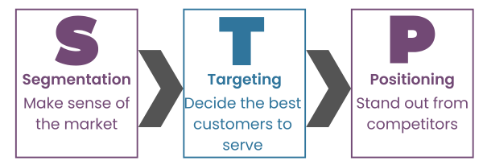
Figure 39: STP Strategies
(Source: EduRev, 2025)

3.1 Segmentation Strategies

3.1.1 VALS-2 Personality Types
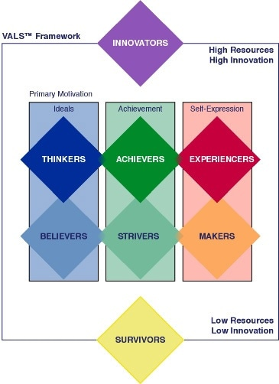
Figure 40: VALS-2 Personality Types
(Source: Töpfer, M. and Bug, P., 2015)
The VALS-2 model offers a more detailed insight into consumer behaviour and should be included in the segmentation models.

In a German market, BMW has a significant pull within the Achiever, Thinker, and Innovator segments, which are categories that are defined by a vision of quality, reliability, and sustainable innovation (Kotler and Keller, 2022). Their preference is towards BMW iX and i4 as these groups believe in the credibility of technology and its environmental sustainability (BMW Group Report, 2024).
In the US, the Experiencer and Striver segments are also very appealing to BMW, as they value excitement, self-expression and lifestyle signalling. These consumers are sensitive to the performance-driven models like the X5, X7, and M Series (Hong, 2024). Inclusion of the VALS-2 segmentation will also boost the ability of BMW to create culturally adaptive communication messages to match certain consumer motivations.

3.1.2 Germany
In Germany, BMW uses demographic, psychographic, and behavioural segmentation techniques to meet the tastes of mature, conscious, and high-income consumers. The German automotive market attaches great importance to engineering excellence, reliability and eco-performance, which leads to an incentive for segmentation strategies based on sustainability awareness and innovation readiness (BMW Group Report, 2024).
BMW's electric and hybrid products, represented by the models with the series i4 and iX, are the target for consumer segments with strong ecological beliefs and specific demands for urban mobility (BMW Group, 2025).
Furthermore, BMW's segmentation framework includes professional classes and corporate fleets that desire luxury while staying low in emissions and getting long term value.
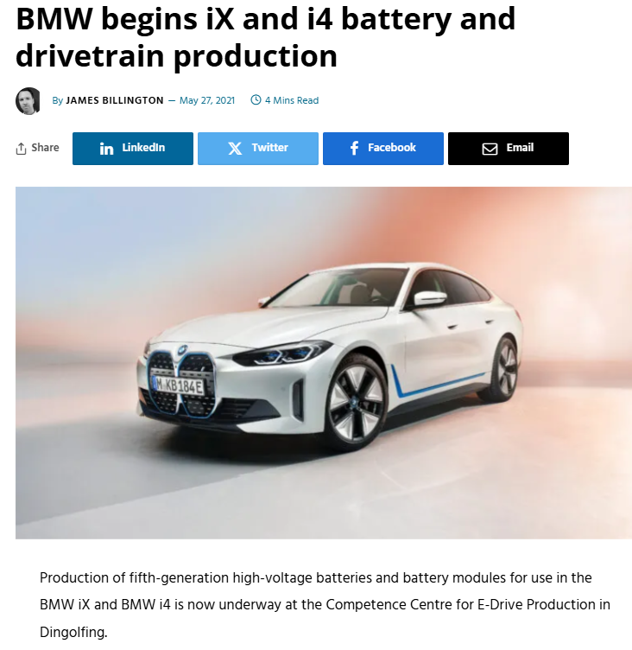
Figure 41: BMW Electric Market Segmentation
(Source: Billington, J., 2021)
This approach is consistent with the premium culture of the automotive and the stringent environmental measures that prevail within the German culture where consumers have high expectations for precision, safety, and environmental responsibility (Quinn, 2025). In turn, the process of segmentation strengthens the sustainable nature of the brand performed by the BMW company while simultaneously strengthening the loyalty of consumers who are high involvement, rational buyers.

3.1.3 USA
The segmentation style mainly used in the U.S is the lifestyle- and experience-based approach, which focuses on individualism, status, as well as performance preferences. BMW segments its American market based on the psychographic indicators, namely adventurousness, performance orientation, and technological curiosity (Hong, 2024). BMW mostly focuses on the sales of its main products here, which include SUVs, sports sedans especially the X 5, X 7 and M series, where its customer target includes families, professionals as well as younger consumers who want excitement and brand identity.
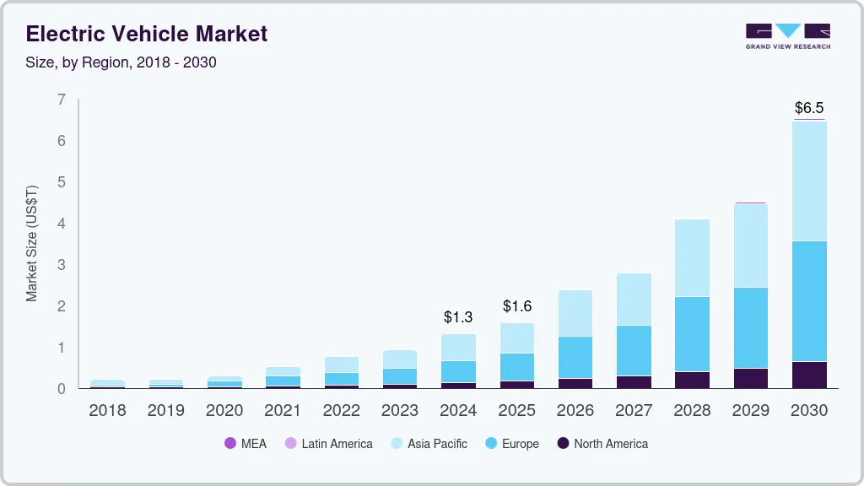
Figure 42: EV Market Growth Trends
(Source: Grand View Research, 2025)
In addition, BMW focuses its segmentation according with geographical trends; more urban areas like California and New York show more interest in electric cars and connectivity opportunities, but Southern and Midwest states prioritise performance and comfort. Such geographically would fit adaptive segmentation allows BMW to remain competitive compared to Tesla and Mercedes-Benz because innovation-focused and high-end consumers can be targeted at the same time (BMW of North America, 2025).

3.1.4 Market Segmentation – Germany vs USA
Segmentation Basis | Germany (Country A) | USA (Country B)
Demographic Segmentation | • Age: 30–60 (professionals, executives)  • Income: High-income earners (€70,000+)  • Gender: Predominantly male but rising female EV interest  • Occupation: Engineers, managers, corporate employees  • Family Status: Small families, dual-income households | • Age: 25–55 (young professionals, families)  • Income: Higher-income groups ($80,000+)  • Gender: Strong appeal across both genders  • Occupation: IT professionals, entrepreneurs, corporate managers  • Family Status: Families preferring SUVs, couples seeking lifestyle vehicles
Geographic Segmentation | • Urban hubs: Munich, Berlin, Hamburg  • High EV adoption zones: Bavaria, Baden-Württemberg  • Regions with sustainability emphasis | • Major metro areas: California, New York, Texas  • Regions preferring large SUVs: Midwest & South  • High EV adoption: California, Washington, Colorado
Psychographic Segmentation | • Eco-conscious and innovation-driven buyers  • Value precision engineering, safety, reliability  • Prefer sustainable mobility and German heritage  • Rational decision-making, long-term planners | • Performance-driven, status-oriented consumers  • Value freedom, self-expression, bold design  • Tech-savvy and lifestyle-focused  • Seek convenience, digital connectivity, excitement
Behavioural Segmentation | • High brand loyalty and repeat purchases  • Early adopters of EVs and hybrid models (i4, iX)  • Usage: Daily commuting, business travel  • Motivated by efficiency, safety, sustainability | • Strong preference for SUVs (X5, X7) and sports models (M Series)  • Usage: Family travel, lifestyle activities, long highway driving  • Motivated by performance, design, prestige  • Frequent users of digital services and OTA features
Benefits Sought | • Engineering quality, safety, eco-performance  • Low emissions, advanced technology  • Long-term value and efficiency | • Driving excitement, luxury experience, status  • High performance, comfort, digital convenience  • Personalisation and bold aesthetics
EV Adoption Segment | • High EV readiness (government incentives, sustainability focus)  • Customers value renewable energy integration | • Growing EV interest but varies by region  • Customers value convenience, range, charging availability
Lifestyle Segment | • Practical, eco-friendly lifestyles  • Strong work–life balance orientation  • Interest in smart mobility services | • Adventure, leisure, road-trip culture  • Strong demand for large vehicles and customisation  • Interest in premium digital features
Table 1: Market Segmentation – Germany vs USA
(Created by learner)

3.1.4.1 Geographic Segmentation
BMW geographic segmentation in Germany focuses on major metropolitan and industrial centres such as Munich, Berlin, and Hamburg with the major focus on the high demand on the most premium manufacturing vehicles and a healthy adoption of electric mobility that is supported by the current regional policy of sustainability (BMW Group, 2025).
The southern states, especially Bavaria and Baden-Wurttemberg are major clusters, which can be explained by the relatively high level of incomes and the oriented cultures of automobile owners.
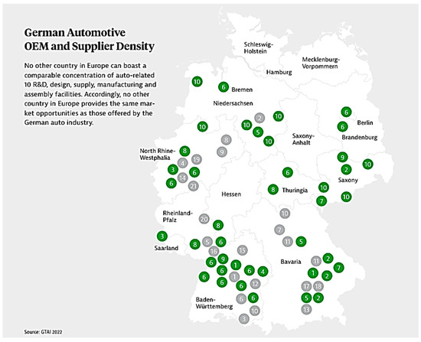
Figure 43: German Automotive Cluster Map
(Source: Koelmel et al., 2024)
In the US, local advertising is concentrated on the largest urban areas, such as California, New York, and Texas, which feature a rather high concentration of luxury automobile owners and the technology adoption level (BMW of North America, 2025). Also, geographical inequalities affect the demand of products, which leads to the prevalence of sport-utility vehicles in the Midwest and South (Hong, 2024).

3.2 Targeting Strategies
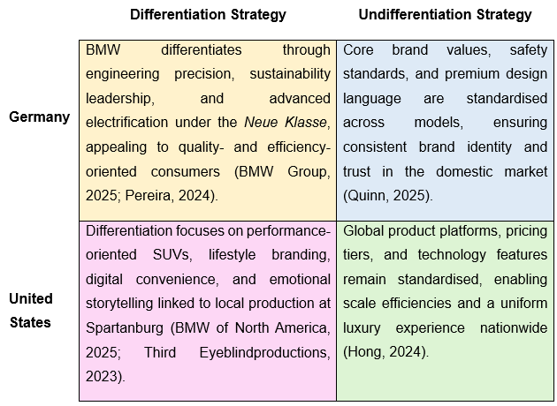
Figure 44: Differentiation and undifferentiation strategies
(Created by learner)

3.2.1 Germany
BMW's approach to targeting within the German market is driven by targeting consumers in the upper middle to high income ranges, corporate fleet operators and technology savvy purchasers. The approach is differentiated targeting, offering a portfolio of models that place emphasis on sustainability, performance and heritage (BMW Group 2025). Marketing efforts are aimed at professionals between 30 and 55 years old, who link high-end automotive offers to high social status and a green perspective (Boeriu, 2025). Corporate clientele constitutes an important segment, supported by BMWs fleet services that promote hybrid and emission reducing vehicles that are in line with national aims towards sustainability. Emotional engagement is developed with the exposure to empirically based storytelling which highlights innovation, craftsmanship and energy efficiency, as opposed to opulent excessiveness (Sushmith, 2024).
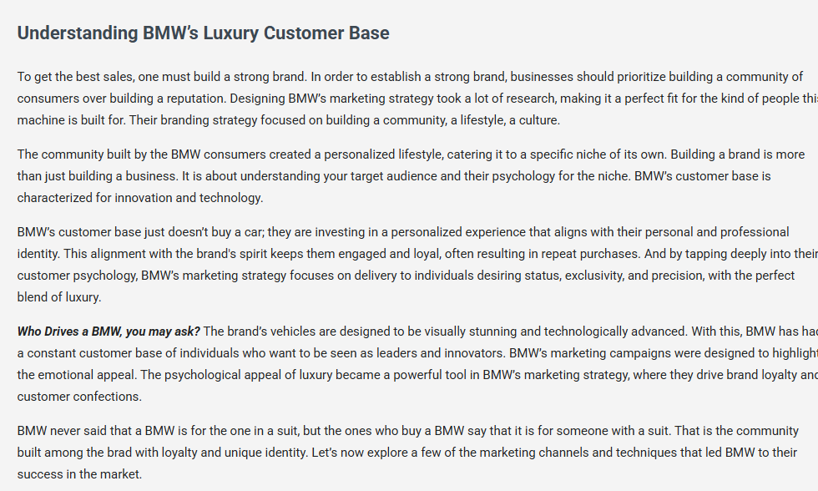
Figure 45: BMW Germany targeting strategy
(Source: Karthikeyan, 2025)

3.2.2 USA
However, the U.S. targeting strategy of BMW is aimed at attracting younger, experience-driven, and brand-conscious customers. Its target market is people between 25 and 50 years who consider their cars not to travel but as a part of their lifestyle (Third Eyeblindproductions, 2023). BMW also takes advantage of the niche market by offering high-performance M series, thus luring lovers of technology and power feeling (DiIanni, 2023). Additionally, digital-sensitive customers are met by data-driven marketing campaigns and customer relationship management. In 2023, BMW collaborated with the Omnicom Group to deepen precision in marketing through AI analytics and storytelling through social media, where communication focused on emotional driving experiences and how to express the Self (DiIanni, 2023).
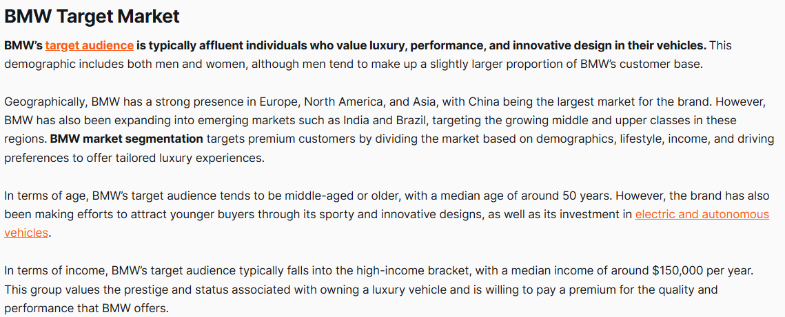
Figure 46: BMW USA targeting strategy
(Source: Karthikeyan, 2025)

3.3 Positioning Strategies

Figure 47: Perceptual map definition
(Created by learner)
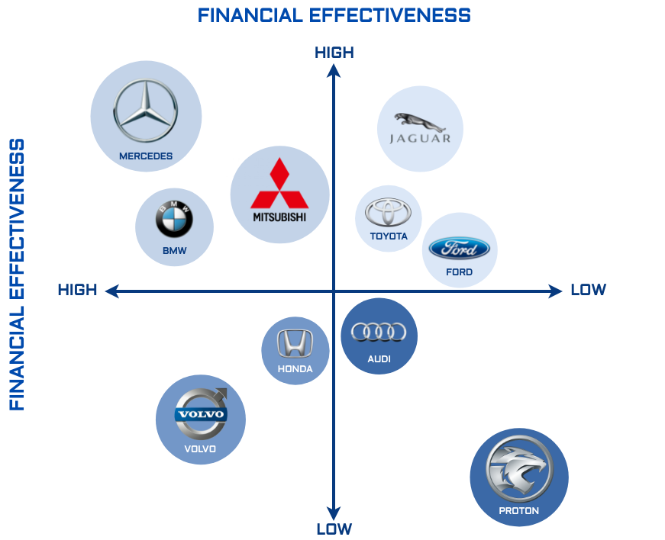
Figure 48: Perceptual map of BMW
(Created by learner)
The figure shows how the automotive brands are competitive in terms of financial efficacy and effectiveness. Mercedes, Volvo, and BMW are ranked high on both metrics, which implies strong performance. In their turn, Jaguar, Toyota, and Ford are very efficient but not very effective. Audi, Honda, and Proton have a lesser overall performance. Mitsubishi, in its turn seems to be in equilibrium, with high results on both scales.

3.3.1 Germany
BMW establishes a product image of a symbol of innovation, craftsmanship, and sustainable luxury in Germany. The positioning statement of the brand, Driven by Innovation and Responsibility indicates a compromise between the accuracy of the traditionalist approach and the sustainability of the modern one (BMW Group, 2025). The BMW economic approach relies on its German engineering, incorporation of the newest technology and production ethics.
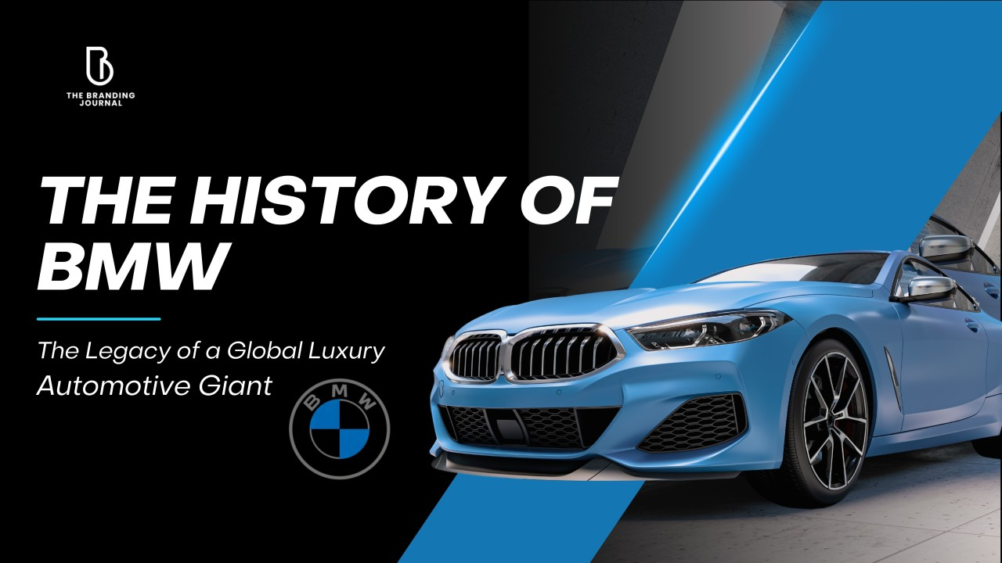
Figure 49: BMW Brand Positioning Germany
(Source: Hasan, M.M., 2025)
BMW positioning in the domestic markets is based on authenticity and environmental transparency, unlike Mercedes-Benz luxury traditionalism and Audi digital minimalism (Boeriu, 2025). As a result, the value proposition of BMW in Germany is based on sustainability and engineering believability, and it helps strengthen the idea of the company itself being a standard of high-quality automobile (BMW Group Report, 2024).

3.3.2 USA
BMW in the United States is a performance and aspiration-based positioning pegged on the notorious condition, The Ultimate Driving Machine. The brand in this case represents freedom, self-actualization, and excitement, which are substantial in American consumer culture (Hong, 2024). BMW focuses on emotional driving, dynamic design, and incorporation of modern technologies, such as, intelligent infotainment and driver-help systems (BMW of North America, 2025).
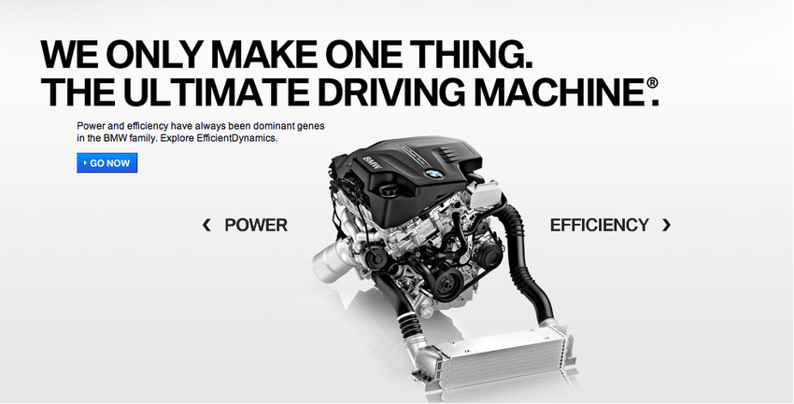
Figure 50: BMW The Ultimate Driving Machine
(Source: Knobel, M., 2013)
The localisation of the positioning goes further by using the Built in America, Driven Worldwide narrative, which plays on the reputation of the Spartanburg plant as the largest vehicle exporter in the USA (BMW Group Press Club USA, 2022). Such hybrid positioning (a blend of German precision and American pride) contributes to greater customer recognition and strengthens the global brand image of BMW as well as intensifying the local appeal.

3.4 STP Comparation Germany vs USA
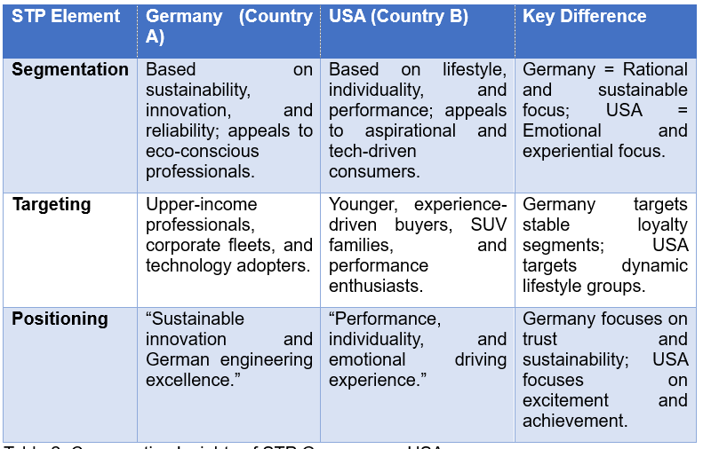
Table 2: Comparative Insights of STP Germany vs. USA
(Created by learner)

4. Comparison of Marketing Mix Strategies in Country A and Country B
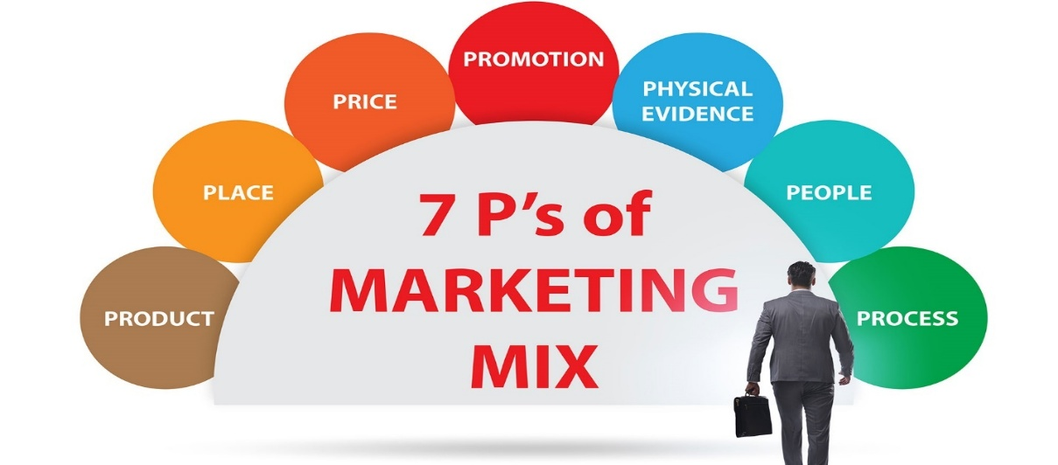
Figure 51: 7P
(Source: Bow-Now, 2021)

4.1 Product Definition

Figure 52: Product Definition
(Created by learner)

4.1.1 Germany
In Germany, BMW's product focus is a legacy of precision engineering, sustainability and high-tech car innovation. German consumers having preference for efficiency, electric drivetrains and technological sophistication motivate BMW to prioritize on electric vehicles like i4, i5 and iX, as well as aerodynamic, performance-efficient sedans (BMW Group Report, 2024). The German market has further requirements for a high manufacturing quality which is met with strong local production in the BMW Group's Munich, Dingolfing and Regensburg plants (BMW Group, 2025).
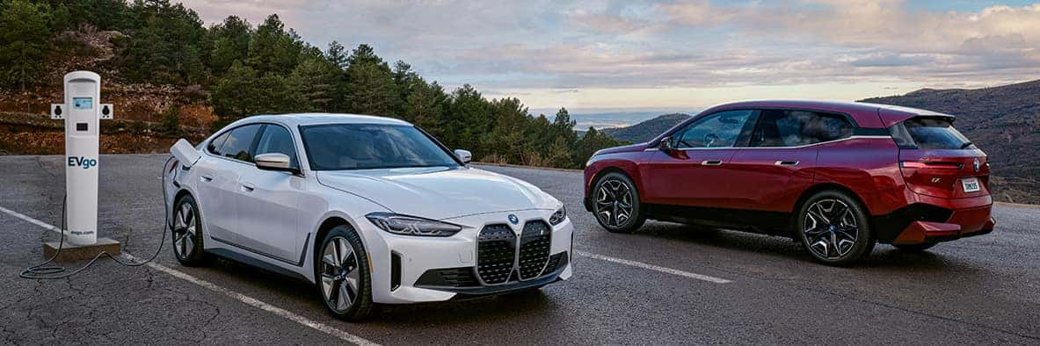
Figure 53: BMW Germany EV Focus
(Source: Princeton BMW, 2025)

4.1.2 USA
The U.S. product profile is quite different, with a focus on large powerful SUVs and performance models with BMW. Models like the X5, X6, X7 and the high-performance M Series are used in a majority due to American preferences that are space, horsepower and lifestyle driven features (Hong, 2024). BMW's Spartanburg plant is the biggest export facility for US-made cars and focuses on X-model production to satisfy the domestic market (BMW PressClub USA, 2022).
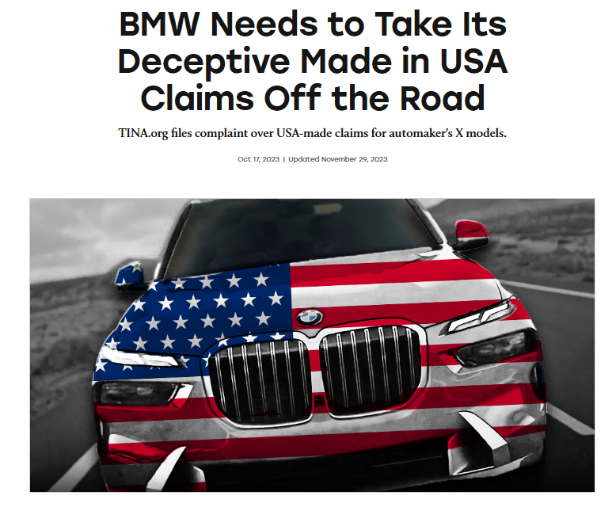
Figure 54: BMW U.S. SUV Focus
(Source: Truth in Advertising, 2023)

4.1.3 Product Variety, Depth & Width

Figure 55: Product Variety, Depth & Width Definition
(Created by learner)

4.1.3.1 Germany
BMW offers a broad and technologically strong product portfolio in Germany, especially when it comes to electric vehicles (EVs) and hybrid drive trains. The German portfolio is rich in electric sedans and small luxury vehicles with solid innovation pipelines in the areas of sustainability and precision engineering (BMW Group, 2025). Product width is further increased with the MINI, Rolls-Royce brands, and hence to serve different segments of the luxury market (BMW Group, 2025).
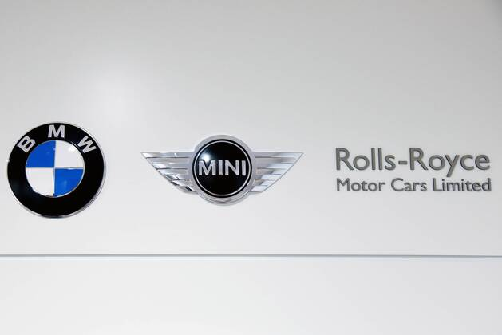
Figure 56: BMW Group Brand Portfolio
(Source: Imago Images, 2017)

4.1.3.2 USA
The US portfolio has a wider and deeper variety of SUV, crossovers, and models that can be customized to high performance. Among them, the X-Series line offers the greatest product mix, including a range of trims, customization packages, and high-power M variants that are targeted to lifestyle-phased customers (BMW of North America, 2025). U.S. market also proves to have a stronger selection towards larger dimensions in vehicles, consequently increasing the differentiation in the SUV segment.
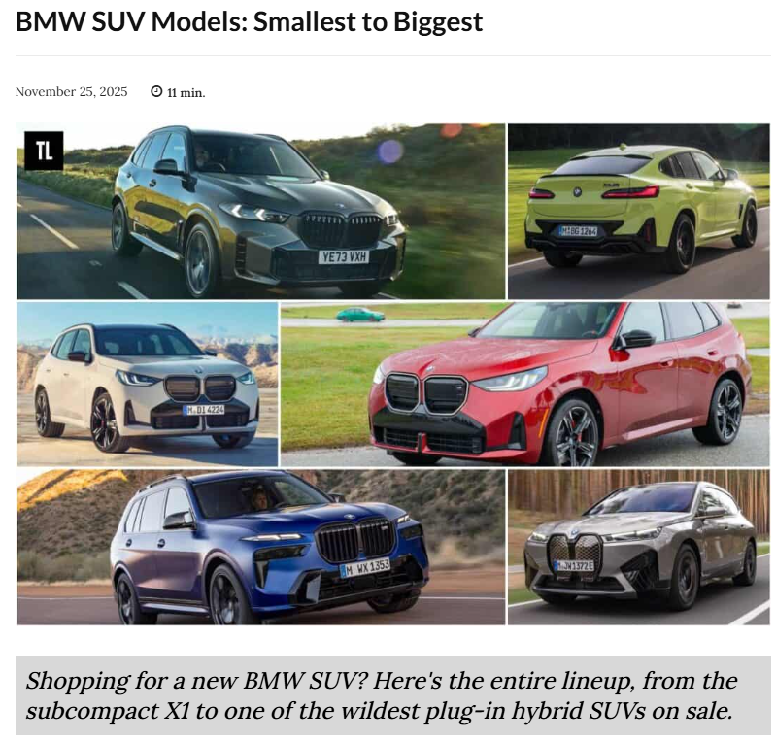
Figure 57: BMW diversity within the SUV category
(Source: TractionLife, 2025)

4.1.3.3 Main Differences Between Germany and the U.S.
Germany has a priority on eco-efficiency, electric mobility, and precision engineering, whereas the United States has its main priorities in size and performance with versatility and has produced a deeper SUV line-up with a broad array of customization options (Hong, 2024; BMW Group Report, 2024).

4.1.4 Product Design

Figure 58: Product Design Definition
(Created by learner)

4.1.4.1 Germany
The philosophy of design that BMW uses in its operation in Germany is focused on aerodynamic efficiency, engineering accuracy, and sustainability. The design features convey a minimalist style, incorporation of technologies, utilization of lightweight materials, hence, the indicative German interests towards effectiveness and practicality (Quinn, 2025). The characteristics of the design of electro vehicles, such as streamlining and low drag rate, help with the regulatory requirements and ecological demands (BMW Group Report, 2024).
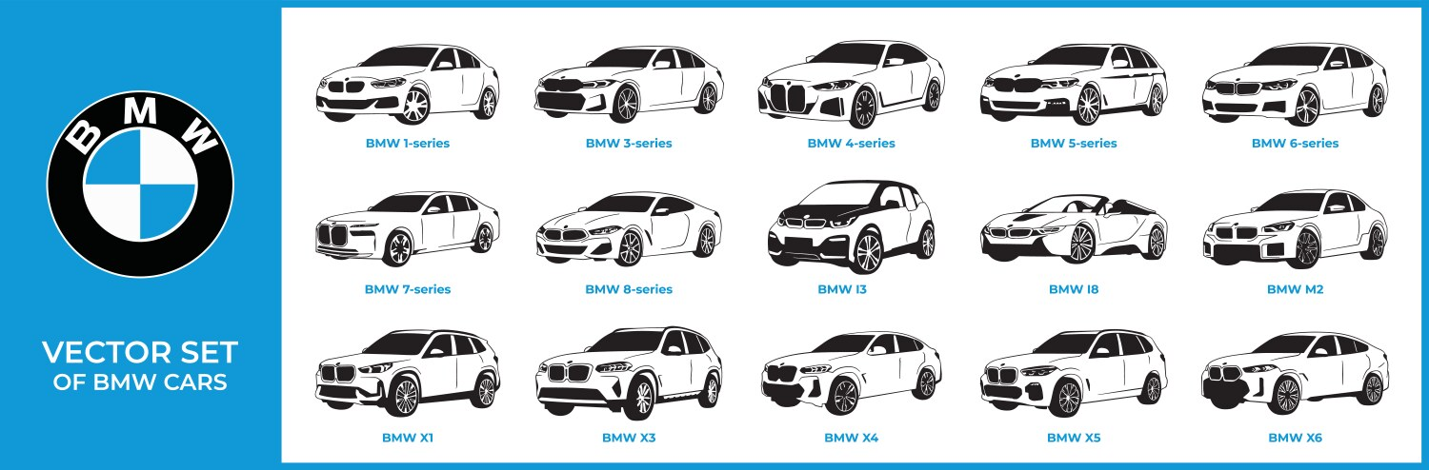
Figure 59: BMW German EV design features
(Source: VectorStock, 2025)

4.1.4.2 USA
In the United States, product design focuses mainly on stunning aesthetics, solid proportions and comfort in the interior. BMW increases cabin dimensions, road presence and entertainment technology to fit American lifestyle choices. SUVs are designed with long wheelbase, aggressive design features and high-performance engine choices to appeal to performance-driven consumers (Pereira, 2024).
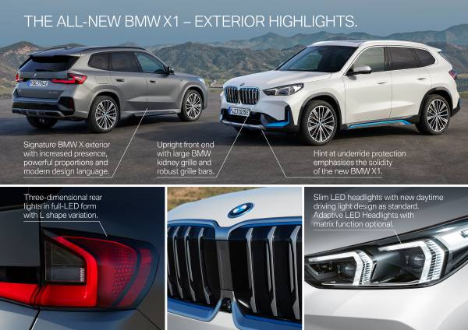
Figure 60: BMW U.S. Design Focus
(Source: BMW Group, 2022)

4.1.5 Branding Strategies

4.1.5.1 Branding Strategies in Germany and the U.S.
BMW is a globally integrated brand that pre-empts innovation, high-end identity, performance, and emotional attachment. However, this strategy is applied differently by each region to fit into the local expectations (BMW Group, 2025).

4.1.5.2 Branding Strategy in Germany
In Germany, BMW is inherently associated with technological innovation, engineering perfection, and sustainability. Campaigns are stressing on the accuracy of production, the carbon-neutral production targets, and the fact that the BMW is the leader in the electric vehicles market, which reflects German values, including relating to the quality of engineering and environmental responsibility (BMW Group Report, 2024). BMW also supports a heritage-based identity with communications that emphasize on craftsmanship and innovation, which are among the values as anchored in German culture (BMW Group, 2025).
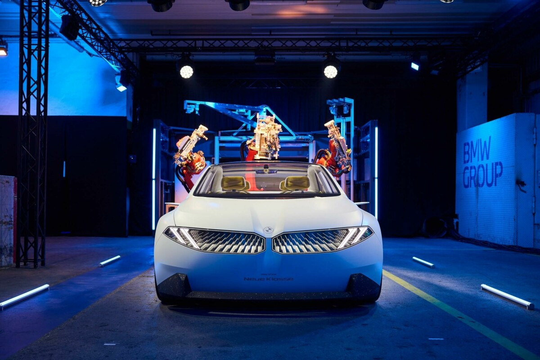
Figure 61: German Branding Innovation
(Source: Ludwig, C., 2024)

4.1.5.3 Branding Strategy in the U.S.
The United States branding strategy focuses on emotional appeal, lifestyle and performance. BMW reinforces the ideas of freedom, the joy of driving, and luxury desires, making the brand a symbol of success and individuality (Sushmith, 2024). Collaborations with marketing agencies in the U.S. and marketing campaigns highlight a sporty style, powerful engines, and the prestige of owning a BMW (DiIanni, 2023). An SUV-focused branding strategy also strengthens BMW's identity as a dynamic brand with a family-oriented but high-performance-oriented identity in the American market.

4.1.5.4 Branding Strategies: Germany vs U.S. (BMW)
Aspect | Germany | United States
Brand Focus | Engineering excellence, technological leadership and sustainability (BMW Group Report, 2024). | Lifestyle, emotional appeal and high-performance identity (Sushmith, 2024).
Core Messaging | Precision manufacturing, innovation heritage and carbon-neutral production goals (BMW Group, 2025). | Driving pleasure, individuality and luxury aspirations (DiIanni, 2023).
Market Positioning | Eco-performance leader with strong EV emphasis (BMW Group Report, 2024). | Dynamic performance brand emphasising SUVs and powerful engines (BMW of North America, 2025).
Communication Style | Rational, engineering-driven and sustainability oriented. | Emotional, bold and lifestyle centric.
Key Brand Assets Used | Heritage, German craftsmanship, advanced technology (BMW Group, 2025). | Sporty design, power, prestige and family-friendly SUVs (Sushmith, 2024).
Table 3: Branding Strategies: Germany vs U.S. (BMW)
(Created by learner)

4.2 Price
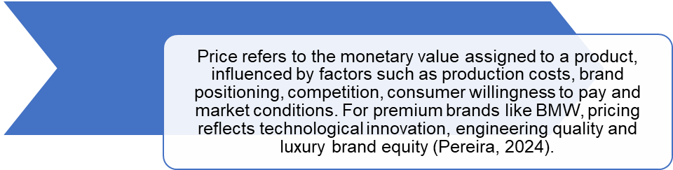
Figure 62: Price Definition
(Created by learner)

4.2.1 Germany
BMW in Germany is experiencing the value-based pricing strategy which is based on the engineering excellence and sustainability performance. The prices are set based on high manufacturing standards and strong brand loyalty within the country. Moreover, the governmental support of the electric vehicles in terms of subsidies on fully electric vehicles encourage the decrease in the overall cost of the ownership and trigger the adoption of the electric (BMW Group Report 2024). After the long-term demand of the high-end market and the alignment of the priorities with the identity of the brand as a high-tech and environmentally friendly manufacturer, German pricing remains relatively stable (BMW Group) 2025).
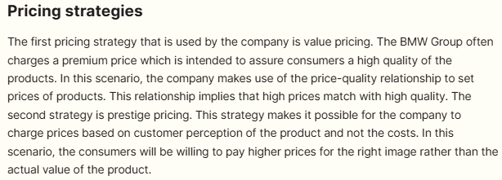
Figure 63: BMW Value & Prestige Pricing
(Source: Ludwig, C., 2024)

4.2.2 USA
BMW has a combination of psycho-economic and competitive pricing and premium pricing in the U.S. market. Packages of lease and financing have been heavily marketed to meet the need of American consumers to have a flexible ownership and to upgrade their vehicle frequently (ThirdEyeblindproductions, 2023).
BMW prices its SUVs and high-performance models at the highest possible prices answering to the strong demand of spacious and powerful vehicles with providing incentives and customization packages to remain competitive in the luxury market (BMW of North America, 2025).
The strategy encourages brand prestige in addition to maximizing sales volumes in an exceptionally dynamic market.
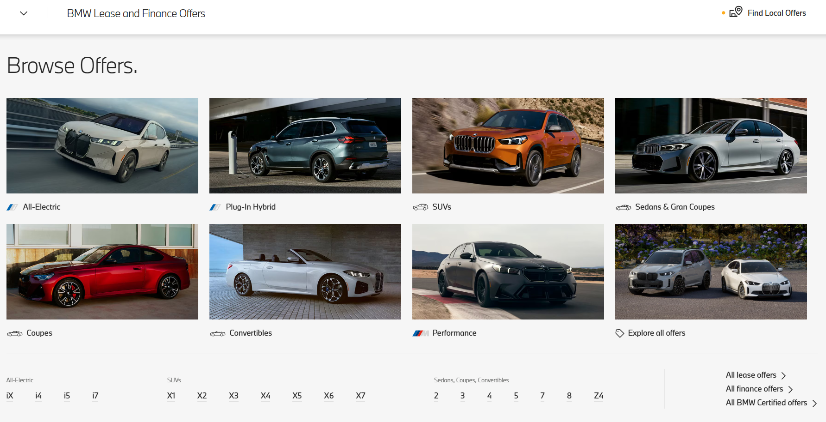
Figure 64: BMW Lease & Finance Offers USA
(Source: BMW Group, 2025)

4.3 Place (Distribution)
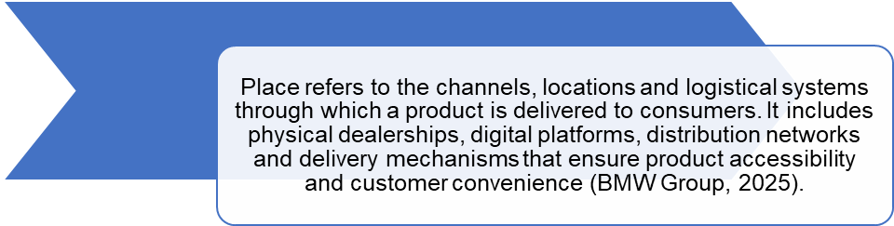
Figure 65: Place (Distribution) Definition
(Created by learner)

4.3.1 Germany
In Germany, the use of highly integrated distribution channel with a stiff dealership network in major cities and close proximity to its domestic plants of production is noted at BMW. The brand will enhance the experience of the customer by providing high-quality delivery experiences, especially with the help of BMW Welt in Munich, where the customers can collect their cars and experience the brand in a new way as part of a factory space (Boeriu, 2025). This strategy builds on the culture of strength found in BMW, engineering identity, and a history of presence in the country, and provides a sense of efficiency in the process of distribution across the country (BMW Group, 2025).
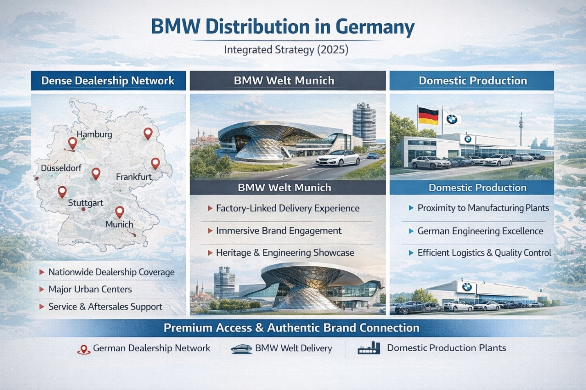
Figure 66: BMW Distribution in Germany
(Created by learner)

4.3.2 USA
In the US, BMW has a hybrid distribution model that combines online sales channels with experience-based "BMW Centres." These centres emphasize individualized service, test drive opportunities, and mode of lifestyle, respecting American consumer expectations of an immersive retail experience (BMW PressClub USA, 2022).
Distribution is further strengthened by the Spartanburg manufacturing plant, the largest BMW facility in the world, it enables efficient distribution of SUVs and short lead times for U.S. customers.
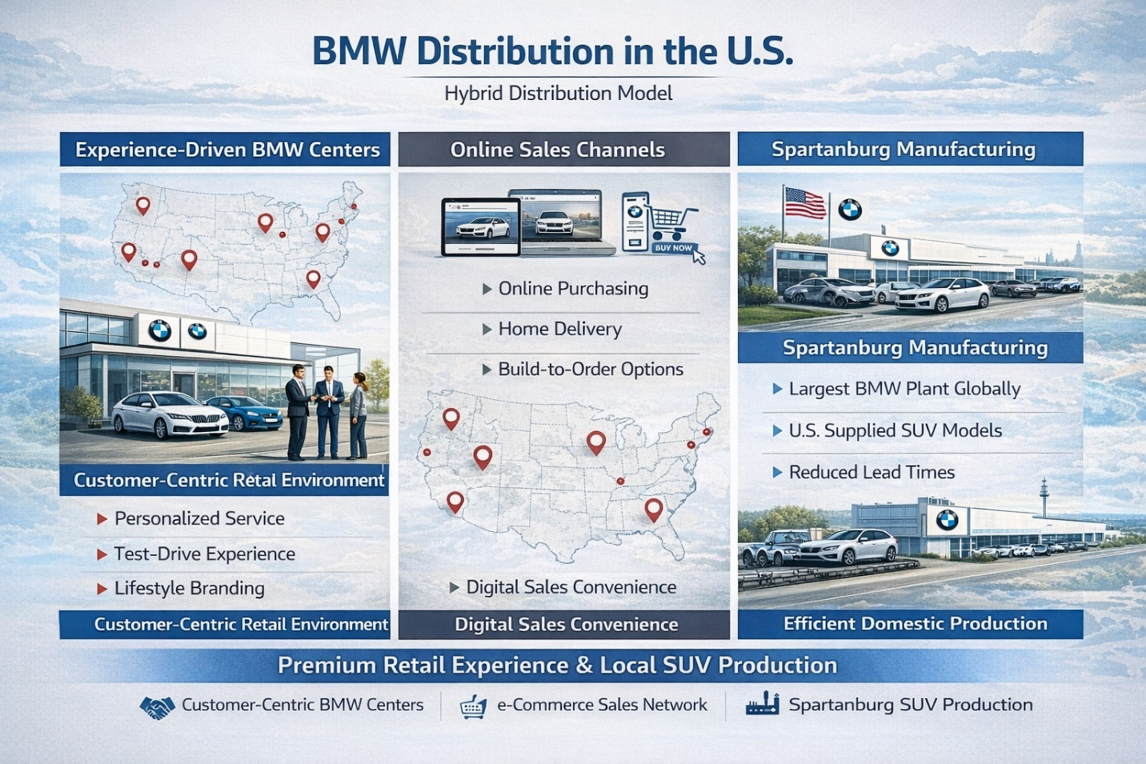
Figure 67: BMW Distribution in USA
(Created by learner)

4.3.3 BMW Distribution Channels: Germany vs U.S.
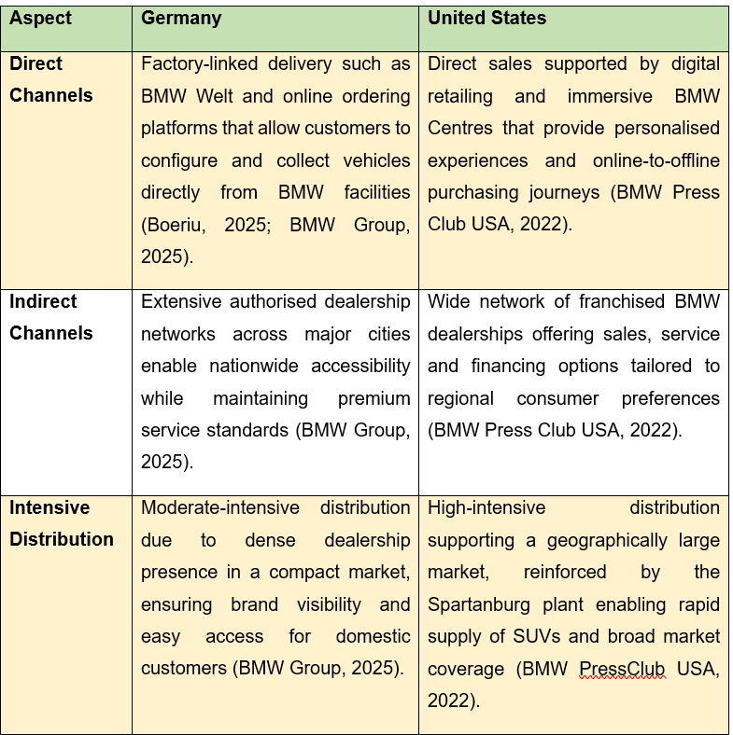
Table 4: BMW Distribution Channels: Germany vs U.S.
(Created by learner)

4.3.4 Market Entry Methods
BMW uses both foreign direct investment (FDI), wholly owned subsidiaries, and strategic partnerships when entering the international market. These strategies allow the business to keep operational control, achieve quality in manufacturing, and a stable globalised brand image (BMW Group Report, 2024). The United States is one of the most important global growth opportunities that BMW achieved under the FDI with the construction of a Spartanburg vehicle plant being the biggest BMW plant in the world and the highest-value car exporter in the United States (BMW PressClub USA, 2022).

4.3.4.1 Market Entry Method Used: Wholly Owned Subsidiary (United States)
The initiative by BMW to enter the United States was mainly achieved by forming BMW of North America and massive investment on entirely owned manufacturing companies. This approach enabled BMW to maintain complete dominance in terms of production and quality levels, and distribution channels, which ensured that there was adherence to the high-premium brand identity (BMW Group, 2025).
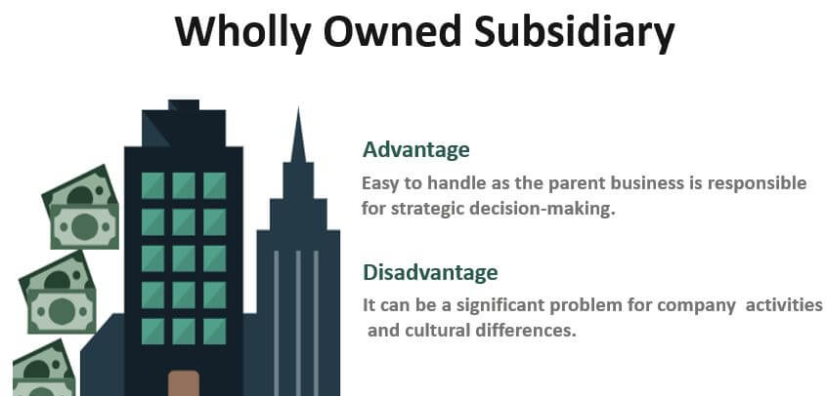
Figure 68: Wholly Owned Subsidiary
(Source: WallStreetMojo Team, 2019)

4.3.4.2 Why BMW Chose This Method
The United States market offers a large market scale, high purchasing power, and strong demand for high-level SUVs, which makes direct investment a good strategy. By creating an entirely owned subsidiary, BMW has been able to localize the production of the X-series vehicles, reducing the tariffs and improving their responsiveness to taste of American consumers (Hong, 2024).

4.3.4.3 Advantages and Disadvantages of BMW’s Wholly Owned Subsidiary Entry Mode (U.S.)
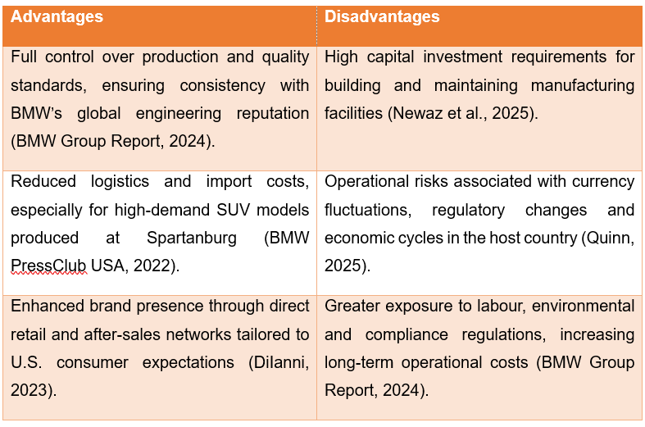
Table 5: Advantages and Disadvantages of BMW’s Wholly Owned Subsidiary Entry Mode (U.S.)
(Created by learner)

4.4 Promotion

Figure 69: Promotion Definition
(Created by learner)

4.4.1 Germany
BMW in Germany has a rational, evidence-based and engineering excellence-oriented and promotional strategy. The communication emphasises efficiency, sustainability, precision technology, and the fact that BMW is the leader in the field of electric mobility, contributes to the segmentation of the German market as it is the analytical and environmentally friendly demands of its consumers (BMW Group Report, 2024). Technical explanations, footage in manufacturing, and environmental pledges are also common in campaigns, which are aimed at reinforcing the BMW high-performance and innovation-driven brand.
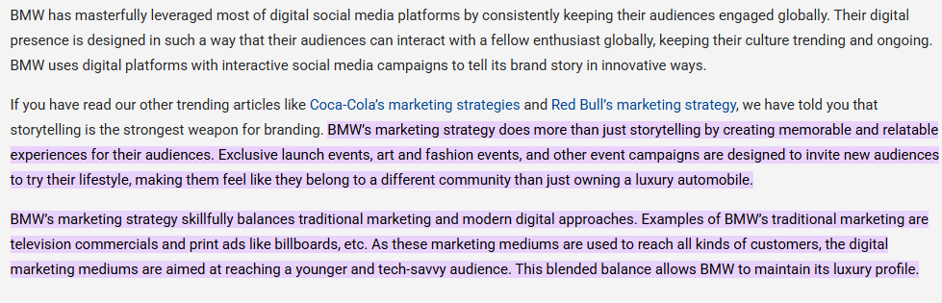
Figure 70: Germany BMW promotional strategy
(Source: Sushmith, 2024)

4.4.2 United States
In the United States, BMW has promotional measures that are strongly biased towards emotional appeals, and based on lifestyle, excitement and driving pleasure. The company's advertising signals notions of freedom, individualism, and superior performance which are supported through partnerships with influencers, high-production cinematic digital content and large-scale experiential events in line with the prevailing cultural expectations in America (DiIanni, 2023). Finally, the presence and appeal of its brand is reaffirmed by the organization through participation in performances, motorsport and SUV-focused campaigns, and helps to enforce its competitive position in a market where distinctions like power, size and prestige have a very significant influence on the final purchase decision on consumer products.

4.4.3 BMW Promotion Strategy Evaluation – Germany vs USA
Promotion Element | Germany | USA
Advertising | Technical, evidence-based, sustainability messaging | Emotional, lifestyle, performance-focused
Digital Marketing | Strong omnichannel integration, configurators | Influencer marketing, online retargeting
Events | Auto shows, engineering exhibitions | Motorsport events, brand experience tours
Sales Promotions | EV rebates, loyalty programs | Leasing deals, financing offers
Table 6: BMW Promotion Strategy Evaluation
(Created by learner)

4.5 People

Figure 71: People Definition
(Created by learner)

4.5.1 Germany
BMW has staff of more than 120,000 members in its headquarters and key manufacturing stations, and thus this forms the heart of worldwide workforce (BMW Group, 2025). This labour force represents the engineering culture of the entire nation, and in Germany, workers are focused on their technical skill, accuracy and professionalism. The training provided to employees is in such a way that it will empower them to deliver products knowledge based on facts and details that are as extensive as possible hence contributing towards customer expectations of quality information, engineering competencies, and openness (Quinn, 2025). This approach will support the domestic brand of BMW as a highly techno-driven and reliability-obsessed brand and make sure that the after-sales service will be at the same level of consistency and efficiency, maintaining high quality and professionalism.
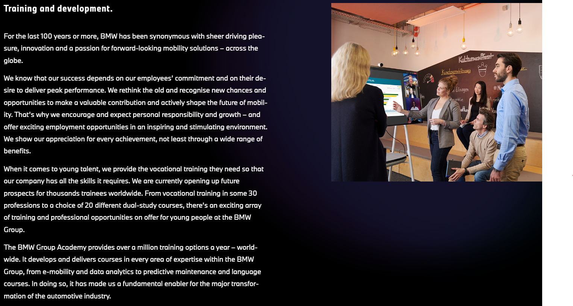
Figure 72: BMW Employee Training Excellence Germany
(Source: BMW Group, 2025)

4.5.2 United States
BMW reported that it has approximately 6,700 people employed in its manufacturing, sales, and regional operations divisions with a primary concentration in the Spartanburg plant (BMW of North America, 2025).
In the United States, the Cultivation of interpersonal relationships and provision of personalized service is given greater resources by the BMW personnel. Customer interactions are marked with increased emotional and experiential traits, with a veil of American retail conventions, which focus on friendliness, engagement and customized assistance throughout the purchasing process (Hong, 2024).
Both the sales and service personnel are trained with the goal of creating an inviting environment, creating customer loyalty, and complementing the all-inclusive brand experience through attentive communication and presentation of products based on lifestyle considerations.
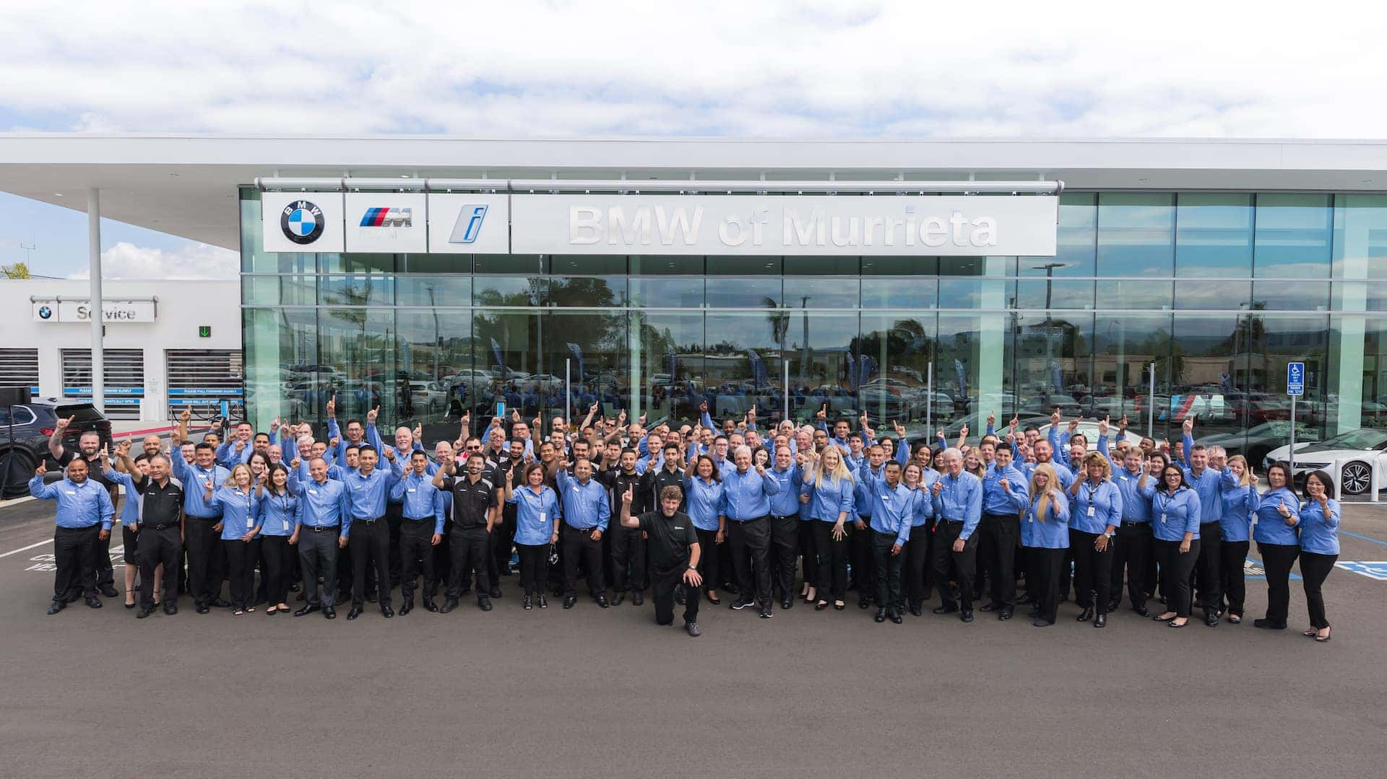
Figure 73: BMW of Murrieta, Southern California Staff
(Source: BMW Group, 2025)

4.6 Process
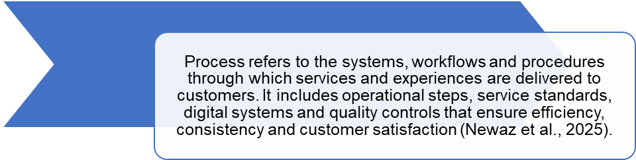
Figure 74: Process Definition
(Created by learner)

4.6.1 Germany
In Germany, processes at BMW are strongly organized and engineering-based, which refer to the focus of the nation on precision, regulatory obedience, and discipline of operations. The business uses sustainability audits, strict quality management procedures and ongoing process optimisation with the help of the well-developed manufacturing technologies (BMW Group Report, 2024). The processes make them reliable, reduce variation, and support the image of BMW as a manufacturer of technical excellence and sustainable production to users of its home market.

4.6.2 Customer Complaint Process Germany
Customer complaint BMW customer complaint procedure in Germany is formal, highly structured, and technologically oriented because of the German cultural emphasis of precision and documents and regulatory compliance. Queries are handled using standard ways of handling issues which start with comprehensive recording of issues that are then assessed by trained service technicians.
Facts are communicated, technical clarifications and written service reports normally passed to the customers thus providing clarity of communication throughout. The German dealerships have a strong focus on root-cause and long-term technical solutions rather than quick solutions which are in line with the demands of the consumers to have reliability, engineering credibility, and stringent quality assurance. The escalations take place through regional service management and BMW headquarters hence ensuring control and consistency within the national network.
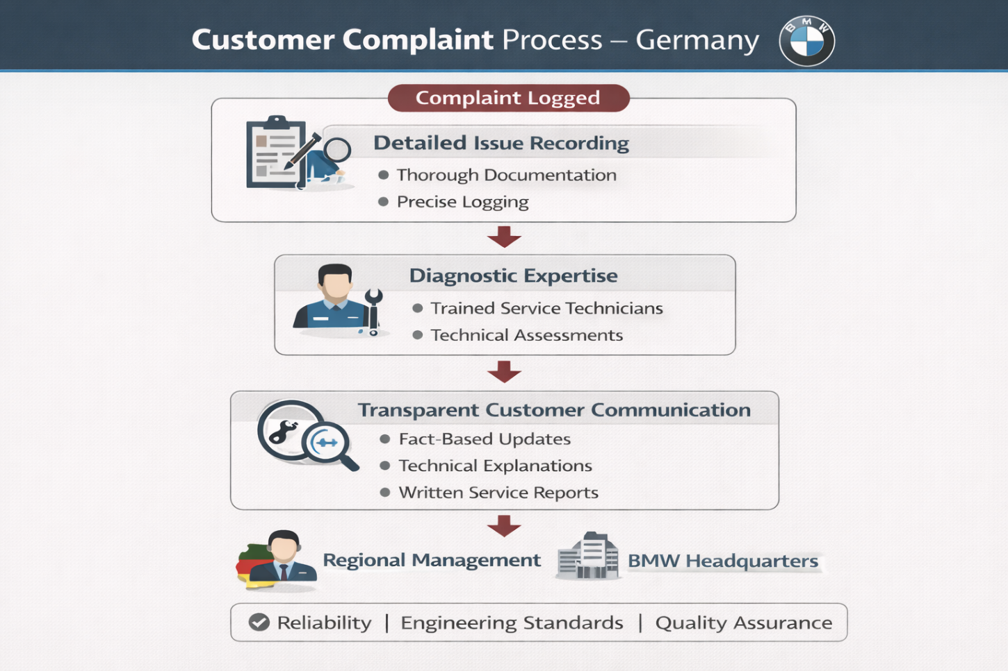
Figure 75: Customer Complaint Process Germany
(Created by learner)

4.6.3 USA
BMW in the United States takes more flexible and customer-driven processes aimed at improving convenience and responsiveness to the service. The CRM analytics, AI-based service systems, and streamlined delivery mechanisms support operations to help get a faster time to appoint, personalised communication, and drop handover of vehicles (BMW of North America, 2025). This strategy is in line with the Australian consumer expectation of speed, flexibility and smooth interactions during service delivery, thus enhancing the competitiveness of the BMW in the American auto luxury market.

4.6.4 Customer Complaint Process United States
The style of customer complaint in the US has been more relationship-oriented and service-oriented, where the customers of the BMW expect attention to their needs, which are empathetic, responsive and personalised. Dealerships focus on the recognition of concerns in an immediate manner, cordial communication, and quick service response to reduce the inconvenience. It involves the use of CRM, digital case tracking and follow-up surveys which ensure that there is constant contact and customer satisfaction. Training of the U.S. staff members is to provide flexible solutions like courtesy vehicles, goodwill adjustments or quick-service repairs to maintain loyalty and to improve the ownership experience. The most frequent type of escalations include the customer relations departments of BMW of North America which focus on conflict management, customer retention, and providing the customer with a favourable service recovery experience.
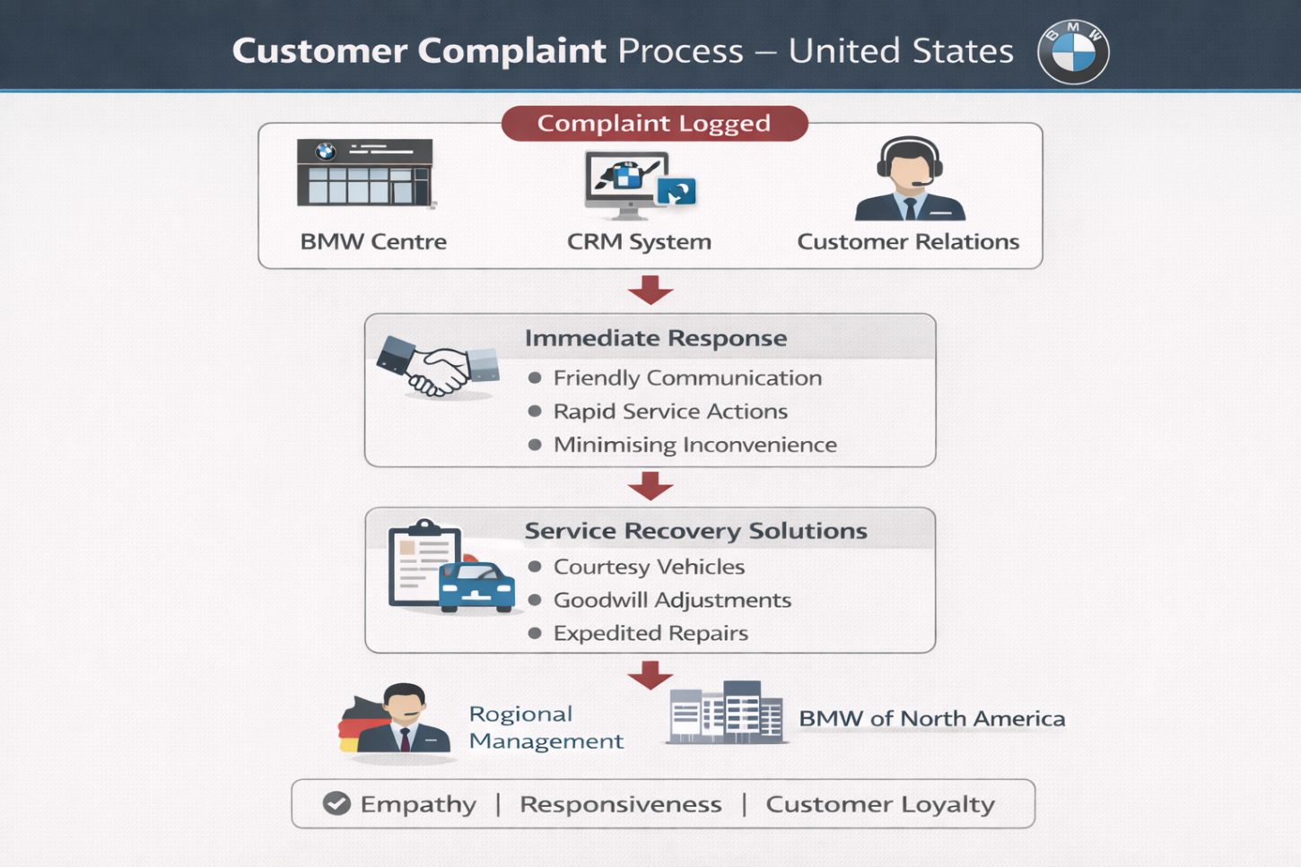
Figure 76: Customer Complaint Process USA
(Created by learner)

4.7. Physical Evidence Definition
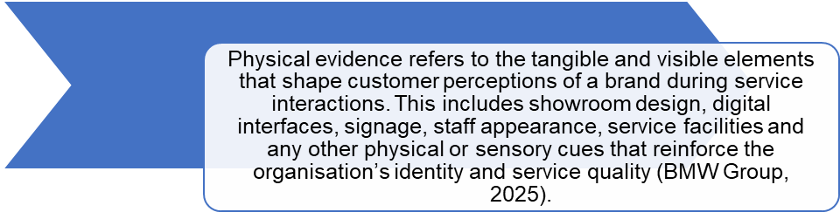
Figure 77: Physical Evidence Definition
(Created by learner)

4.7.1 Germany
In Germany, the physical evidence of BMW has minimalist precision-oriented aesthetics, highlighting engineering excellence and craft. Showrooms are characterised by clean architectural lines, sustainability-focused materials and technologically integrated display spaces that exemplify BMW's focus on operational efficiency and innovation-led values (Boeriu, 2025). The environment is designed to convey reliability, technical mastery and brand's heritage, and thereby create a factual and professional ambience in accordance to the German consumer expectations.
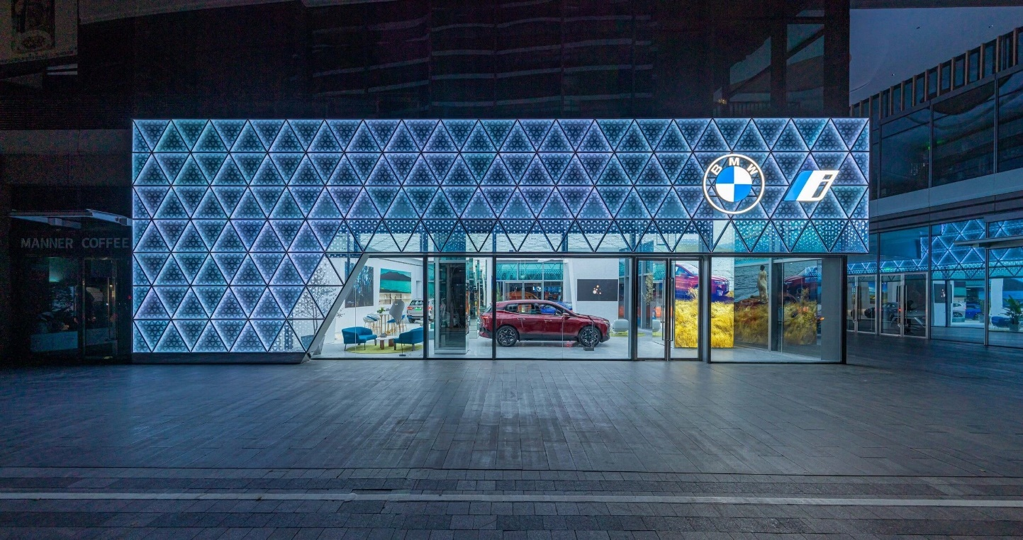
Figure 78: German Showroom Aesthetics
(Source: Archello, 2025)

4.7.2 USA
In the United States, BMW’s physical evidence adopts a more immersive and experience-oriented design approach. Showrooms include dynamic digital displays, performance simulators and lifestyle-focused zones that encourage customer interaction and emotional engagement with the brand (ThirdEyeblindproductions, 2023). This aligns with American preferences for entertainment-driven retail environments and supports BMW’s positioning as a high-performance, aspirational lifestyle brand. The richer sensory experience enhances customer excitement and strengthens the emotional connection to BMW’s products.

4.8 Similarities & Dissimilarities - BMW Germany vs USA (7Ps Comparison)
7Ps Element | Similarities (Both Countries) | Dissimilarities (Germany vs USA)
Product | Premium vehicles with advanced technology, strong EV portfolio, consistent global engineering standards (BMW Group, 2025). | Germany: Focus on eco-efficiency, sedans & EV models such as i4/iX.  USA: Strong demand for SUVs & performance models like X5, X7, M-series (Hong, 2024).
Price | Premium pricing reflecting brand prestige, innovation and performance (Pereira, 2024). | Germany: Value-based pricing supported by EV subsidies & sustainability incentives.  USA: Psychological pricing with leasing/financing options to increase affordability (ThirdEyeblindproductions, 2023).
Place (Distribution) | Omnichannel system with digital platforms + dealership networks (BMW Group, 2025). | Germany: Dense dealership network, BMW Welt factory delivery.  USA: Experience-driven BMW Centers, Spartanburg-based distribution (BMW PressClub USA, 2022).
Promotion | Use of digital marketing, storytelling, experiential events, and brand consistency globally (Sushmith, 2024). | Germany: Technical, sustainability-focused messaging.  USA: Emotional, lifestyle and performance-heavy promotions (DiIanni, 2023).
People | Staff trained to deliver premium service and brand-consistent experiences (BMW Group, 2025). | Germany: Emphasis on technical expertise, precision and factual communication (Quinn, 2025).  USA: Focus on relationship-building, personalised service and friendly communication (Hong, 2024).
Process | High-quality, standardised global procedures to ensure service consistency (Newaz et al., 2025). | Germany: Structured, engineering-oriented, regulated processes.  USA: Flexible, customer-centric, tech-enabled processes (BMW of North America, 2025).
Physical Evidence | Modern, premium showrooms, digital tools and consistent global brand aesthetics (BMW Group, 2025). | Germany: Minimalist, precision-oriented, sustainability-led design (Boeriu, 2025).  USA: Immersive showrooms with simulators, lifestyle zones and entertainment features (ThirdEyeblindproductions, 2023).
Table 7: Similarities & Dissimilarities – BMW Germany vs USA (7Ps Comparison)
(Created by learner)

4.9 Evaluation of Marketing Strategies

4.91 Germany
The German marketing of BMW also focuses on the rational and engineering-oriented communication based on the quality, innovation, and sustainability. Technical excellence, precision, and long-term value are the focus of the campaigns, which match the preferences of German consumers regarding factual and reliable information (BMW Group Report, 2024). It builds trust and authenticity through a powerful domestic brand heritage and experiences e.g. BMW Welten and provides digital services, including configurators, EV -awareness programs and sustainability non-fiction to support the overall narrative (BMW Group, 2025; Boeriu, 2025).
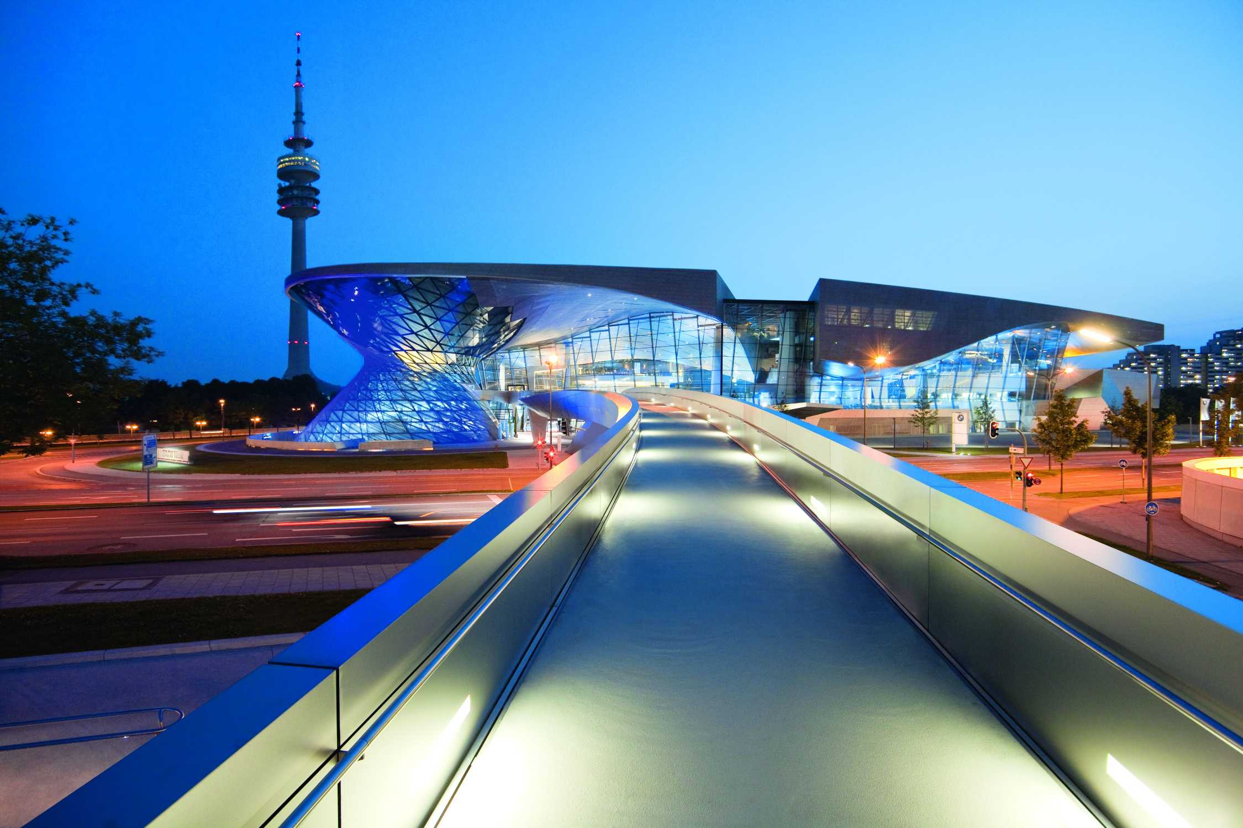
Figure 79: BMW Welt
(Source:

4.9.2 USA
In the United States, BMW's marketing applies an emotional approach with lifestyle orientation, performance, aspiration, and individuality in mind. Campaigns put the "joy of driving" front and centre as a way of thinking, reinforced through influencer marketing, immersive digital media, and experiential activities (DiIanni, 2023; BMW of North America, 2025). The intensive promotion of SUVs helps to highlight features such as power, versatility, and aesthetics which appeals to performance seekers and lifestyle conscious luxury buyers, under a competitive market environment (Hong, 2024).
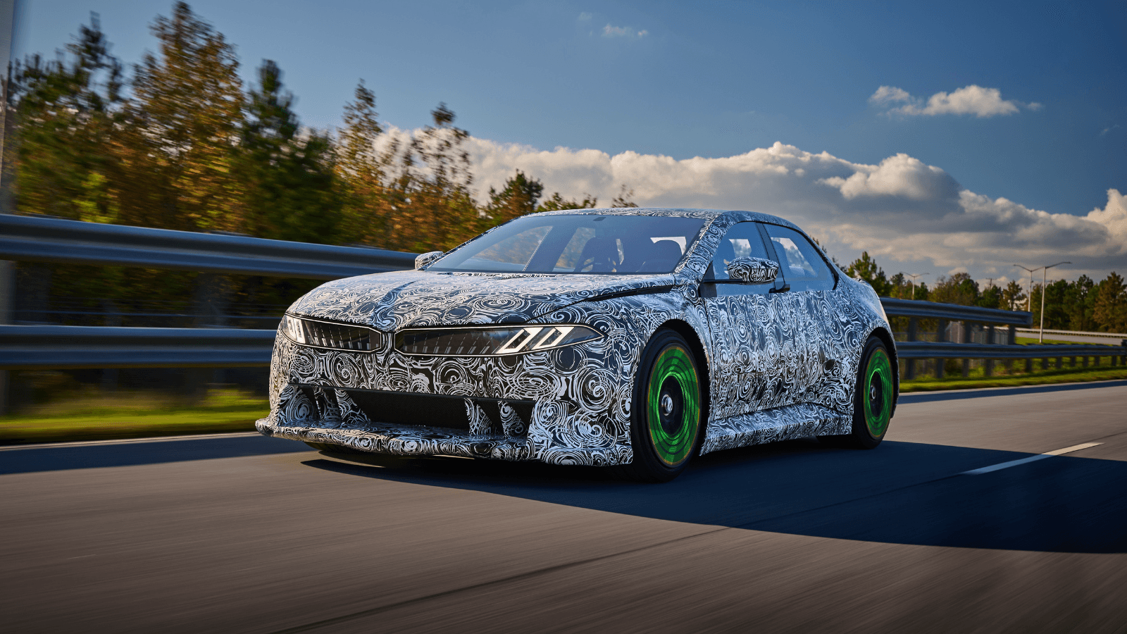
Figure 80: U.S. Performance Marketing
(Source: Phoon, M., 2025)

4.10 Profit and Sales

4.10.1 Germany
Germany is also one of BWMs strongest profit centres, thanks to its large manufacturing base, which has long standing brand heritage and consistent demand for premium sedans and electric vehicles (EV). In 2025, BMW overtook Mercedes as the number 1 premium brand in Germany which was based on a very strong domestic brand loyalty and superior production output (Boeriu, 2025). EV sales have continued to rise in view of sustainability rules and consumer demand for efficient car models such as i4 and iX (BMW Group Report, 2024). Domestic profitability is also reinforced by lower logistics costs and a well-established and efficient supply chain (Newaz et al., 2025).

4.10.2 USA
Within the United States, the largest global market for BMWs in terms of volume is attributed to high sales in SUVs including the X3, X5 and X7. The Spartanburg plant facilitates profitable local production and exports, which make BMW the largest exporter of vehicles by value from the United States (BMW PressClub USA, 2022). Annual sales report shows steady increases, performance is impressive in the premium SUV and M series (BMW of North America, 2025). Moreover, a strong leasing culture fuels recurring streams of revenue and adds to consistent profitability throughout the U.S. market.
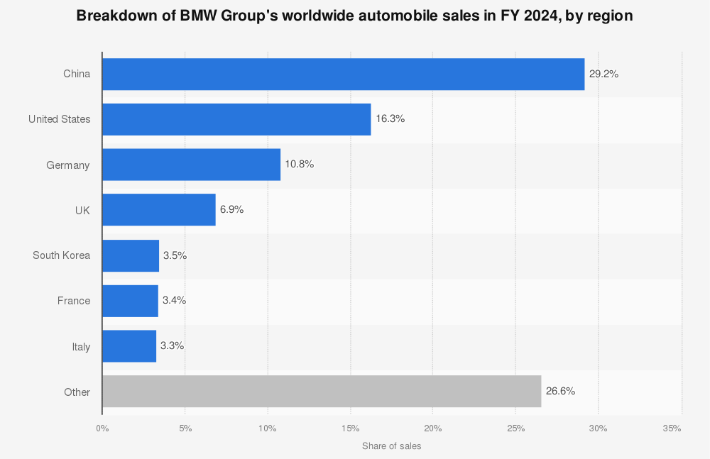
Figure 81: BMW Sales
(Source: Statista, 2025)

4.11 Social Media Engagement

4.11.1 Germany
The social media approach used by BMW in Germany is mainly based on the brand authenticity, distribution of engineering stories, and spreading of sustainable developments. The content on such platforms often contains backstage production footage, innovation of electric cars and achievements in manufacturing plants. This type of content appeals to German customers, who value transparency and technicality (BMW Group, 2025). The user interaction is high among people who seek to identify with technology, design, and environmental conservation.
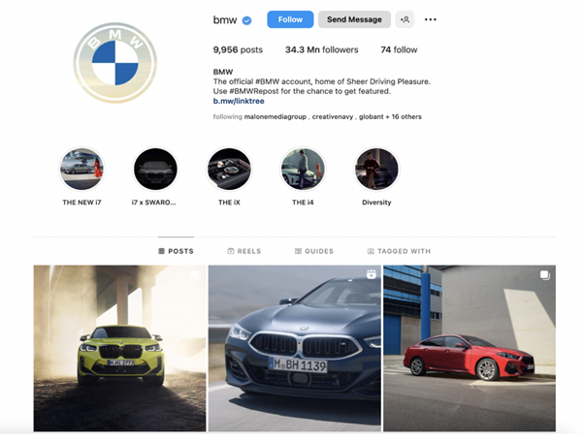
Figure 82: Germany Social Media Engagement
(Source: Instagram)

4.11.2 USA
Back in the United States, the presence of BMW on social media platforms is a future board casted through the digital perspective of the lifestyle with high-performance imagery, influencer partnerships, and emotional emotionality (Sushmith, 2024).
The posts that are published dynamically and feature sport-utility vehicles, motorsport ventures, and film driving vignettes get a lot of interaction.
It is the most interactive as far as the content is inspirational, gives a chance to customize it, and offers the experience that will appeal to the American consumer preferences.
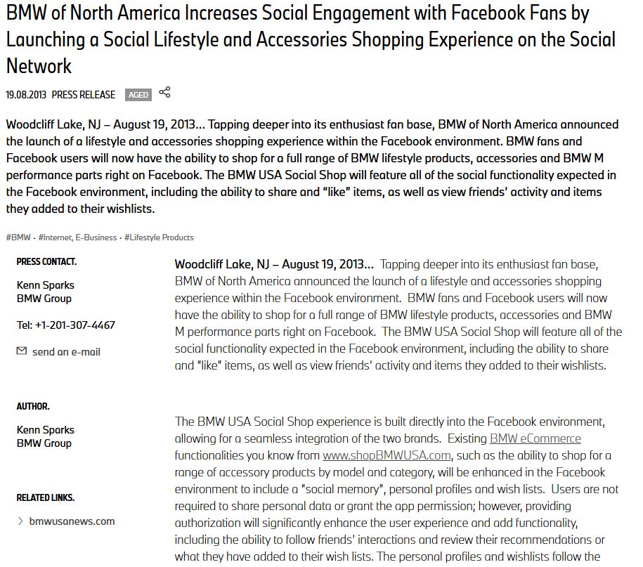
Figure 83: BMW Social Media Strategy USA
(Source: Digital Maven, 2024)

4.12 Customer Reviews

4.12.1 Germany
German customer ratings often focus on the engineering standards of BMW, the quality of their vehicles, and their high level of production as an indicator of the focus that this brand has on good quality (Quinn, 2025). Customers appreciate the technical post lateness of communication in dealership and consider the accuracy-related service procedures in the company especially helpful. Even though criticism somewhat speaks of increased prices of electric vehicles, overall satisfaction levels are high, in part because the brand has local fidelity to the U.S. market, and some of the new technologies are reported to work quite well in recent industry reports (BMW Group Report, 2024).
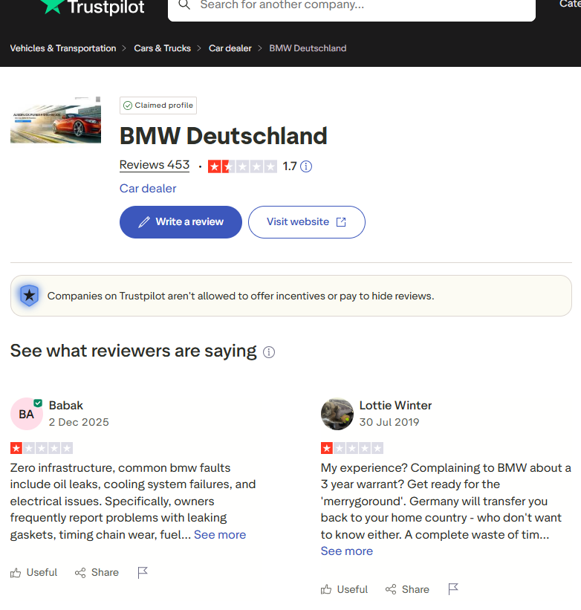
Figure 84: BMW Germany Customer Reviews
(Source: TrustPilot)

4.12.2 USA
U.S. customer reviews often describe the superior driving performance, ride comfort and SUV versatility as the main merits of BMW. Respondents also highlight curated, customer-centred service and flexible leasing arrangements that alleviate barriers of ownership (DiIanni, 2023). Nevertheless, some subset of reviews identifies high maintenance costs and complex technological interfaces as issues. Aggregate satisfaction is still high, due to immersive retail experiences and strong affective brand connections (Hong, 2024).
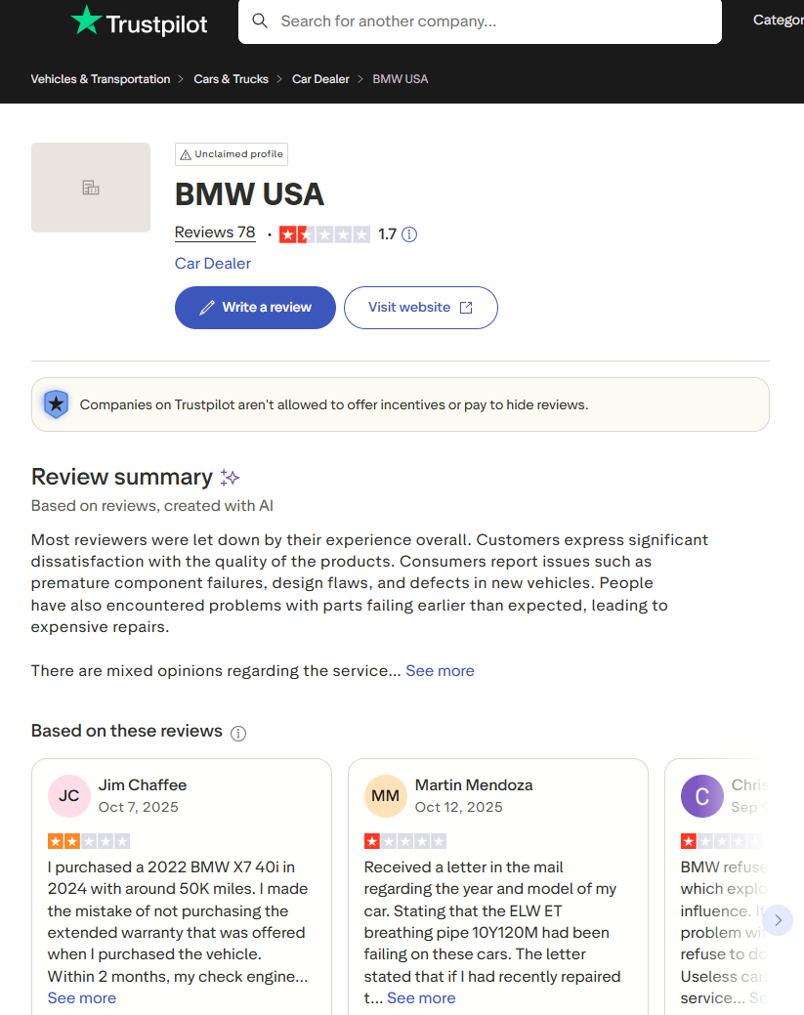
Figure 85: BMW Germany Customer Reviews
(Source: TrustPilot)

4.13 Key similarities and differences between Germany and the USA
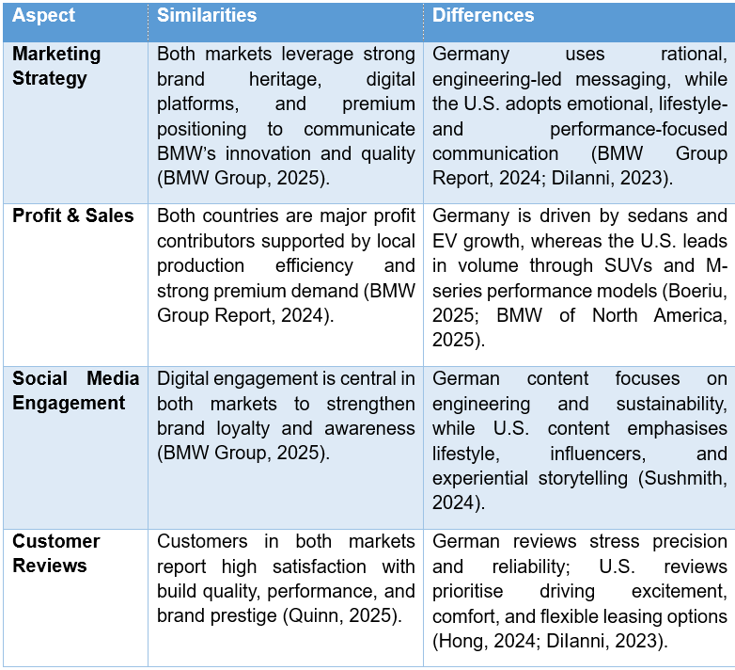
Table 8: Key similarities and differences between Germany and the USA
(Created by learner)

5. Ethics of One Country (Germany)
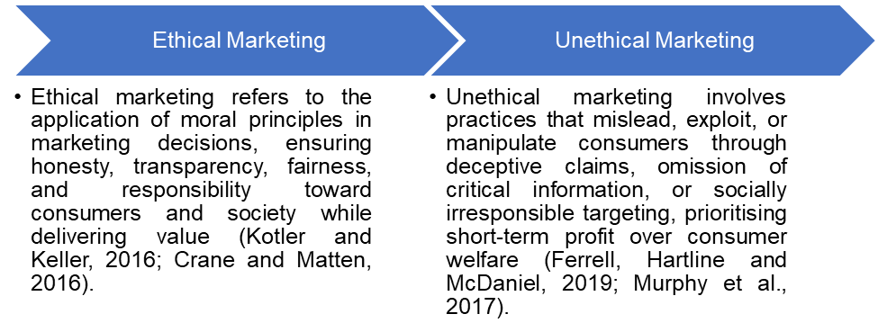
Figure 86: Definitions of Ethics
(Created by learner)
Strictness in regulation and stricter corporate governance coupled with cultural norms of ethics mainly influence ethical practices in Germany which regard integrity, transparency, and environmental accountability. In the case of BMW, working in Germany requires the strict ethical principles built-in to the national laws as well as the social requirements. The Corporate Governance Code of Germany is built on the accountability, responsible leadership, and stakeholders protection frameworks; it is necessary to make sure that the company is characterized by high transparency rates when it comes to reporting, financial behaviour, and sustainability pledges (BMW Group Report, 2024). Ethical behaviour is not merely a set of rules, but a culture: the Germans are anticipating a factual communication, truthful advertising and strict safety of the products, forcing companies like BMW to uphold evidence-founded promotional methods and a high standard of engineering precision (Quinn, 2025).
Another aspect is environmental ethics which is also influential in BMW in Germany. The company must meet manifold emissions requirements, recycling policies as well as green and viable objectives as defined in the national and EU grounds. It has resulted in the greater investment into the circular production systems, carbon-neutral production, and the development of electric vehicles due to the ethical and environmental duty (BMW Group, 2025). Ethics in workplace are also very relevant and the German labour laws favour the payment of good wages, employee development and working in a good environment fuelled by co-determination ideology.
Furthermore, the ethics of BMW's supply chain reflect Germany's general ethical stance towards responsible sourcing practices and respect for human rights. Through thorough audits of suppliers, and through mechanisms of traceability, BMW is obliged to check that especially critical minerals have been obtained with no exploitation or detriment to the environment (Newaz et al., 2025). In general, ethical practices prevalent in Germany requires high levels of transparency, environmental stewardship and responsible corporate citizenship from BMW, in order to create a business environment where ethical conduct is an optional consideration and not merely a basic prerequisite for organisational legitimacy.
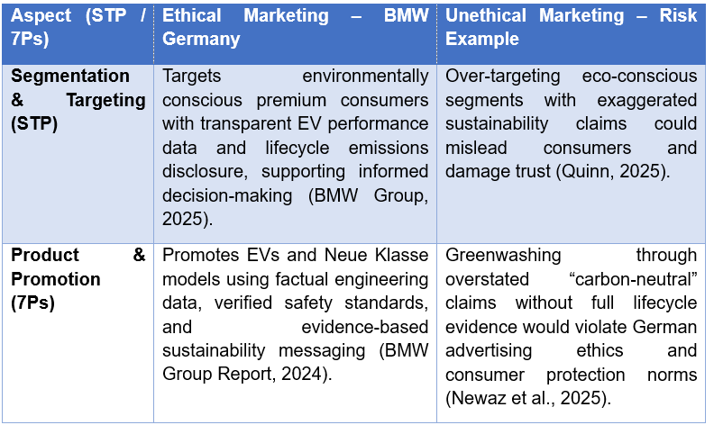
Table 9: Ethical vs Unethical Marketing Practices in Germany (Using STP / 7Ps)
(Created by learner)

6. Recommendations

6.1 Recommendations – Germany
- The commitment to the infrastructure of electric vehicles (EV), carbon-neutral production, and the circular production system should be expanded to strengthen the alignment with the strict sustainability and regulatory requirements of Germany (BMW Group Report, 2024).
- It is important to keep an engineering-oriented, non-psychological communication strategy, which focuses on safety, efficiency, and technical superiority to align with German consumers (Sushmith, 2024).
- The current personalized digital customer relationship management (CRM) and AI-created aftersales services, predictive complaint management, etc., should be improved to fulfil the increasing demands regarding service quality and transparency (BMW Group, 2025).
- Enhancement of ethical disclosure and supply-chain transparency will contribute to staying in line with the German state of governance and consumer trust (Newaz et al., 2025).

6.2 Recommendations – United States
- Localisation and customisation efforts such as performance simulators, virtual configurators, and experience-based retail formats to extend the emotional involvement and devotion (DiIanni, 2023).
- Stick to narrative based, performance-based marketing, with the help of lifestyle branding, motorsport associations, and influencer partnerships to amplify brand aspiration (Sushmith, 2024).
- Further transform the digital CRM and AI-intelligent service systems to enable quick response, personalisation, and flowless omnichannel experiences (BMW Group, 2025).
- Adjust social media and content to focus on lifestyle storytelling and manufacturing pride on the local level to make it more relevant to a variety of U.S. consumer groups (DiIanni, 2023).

7. Conclusion
This report was in the intent of systematically examining the operations of BMW in Germany and the United States through the application of the PESTLE analysis with the help of Hofstede's Cultural Model and the VALS 2 segmentation and carried out a comprehensive comparison of the 7Ps framework. The results suggest that the carmaker BMW strategically adapts its operations to include external environmental considerations, cultural values and consumer motivations to make it strong enough for localization but still maintain a cohesive global brand identity. The German market is characterised by an emphasis on engineering precision, sustainability, structured processes and rational promotion strategies, while the United States market is driven by lifestyle appeal, performance-oriented messaging, flexible service provision and experiential retailing.
Analysis of distribution channels, market entry strategies and ethical considerations further illustrate how BMW balances between operational control and responsiveness to market specific expectations. Comparative insights that relate to product depth and breadth, branding strategies, pricing behaviours, customer processes, physical evidence are found to prove significant variations whilst also showing clear global consistencies. Overall, the ability of BMW to adapt its strategy while upholding its core brand values helps to boost its competitiveness and aid in sustained growth in the various international markets.

References
Archello (2025) BMW i Showroom. Available at: https://archello.com/project/bmw-i-showroom
Billington, J. (2021) BMW begins iX and i4 battery and drivetrain production. Electric & Hybrid Vehicle Technology, 27 May. Available at: https://www.electrichybridvehicletechnology.com/news/manufacturing/bmw-begins-ix-and-i4-battery-and-drivetrain-production.html
BMW Group (2020) ‘Born Electric’: The fully electric BMW iX takes centre stage in the BMW winter sports commitment. Press Release, 2 December. Available at: https://www.press.bmwgroup.com/latin-america-caribbean/article/detail/T0321651EN/born-electric%E2%80%99:-the-fully-electric-bmw-ix-takes-centre-stage-in-the-bmw-winter-sports-commitment?language=en
BMW Group (2022) The all-new 2023 BMW X1. PressClub Canada, 1 June. Available at: https://www.press.bmwgroup.com/canada/article/detail/T0395253EN/the-all-new-2023-bmw-x1?language=en
BMW Group (2023) Everything at one glance: the latest BMW Welt information. PressClub Global, 7 August. Available at: https://www.press.bmwgroup.com/global/article/detail/T0427918EN/everything-at-one-glance:-the-latest-bmw-welt-information?language=en
BMW Group (2025) ‘BMW Group strategy’, BMW Group [online]. Available at: https://www.bmwgroup.com/en/company/strategy.html
BMW Group (2025) ‘Marketing & Communications at the BMW Group. Creativity meets Strategy. For a brand that stays in mind.’ BMW Group Careers [online]. Available at: https://www.bmwgroup.jobs/de/en/job-fields/marketing.html
BMW Group (2025) BMW Group Plant Dingolfing. Available at: https://www.bmwgroup-werke.com/dingolfing/en.html
BMW Group (2025) BMW Group Plant Leipzig. Available at: https://www.bmwgroup-werke.com/leipzig/en.html
BMW Group (2025) BMW Group Plant Spartanburg. Available at: https://www.bmwgroup-werke.com/spartanburg/en.html
BMW Group (2025) BMW Group plants in Germany. Available at: https://www.bmwgroup.jobs/de/en/location/plants-germany.html
BMW Group (2025) BMW Group Report 2024. Available at: https://www.bmwgroup.com/content/dam/grpw/websites/bmwgroup_com/ir/downloads/en/2025/bericht/BMW-Group-Report-2024-en.pdf
BMW Group (2025) History of BMW Group. Available at: https://www.bmwgroup.com/en/company/history.html
BMW Group (2025) Locations & Business Segments in Germany. Available at: https://www.bmwgroup.jobs/de/en/location.html
BMW Group (2025) The Company BMW Group. Available at: https://www.bmwgroup.com/en/company.html
BMW Group PressClub USA (2022) Eight Years in a Row: BMW Manufacturing is Largest Automotive Exporter in the United States. Press release, 15 February, Spartanburg, SC. Available at: https://www.press.bmwgroup.com/usa/article/detail/T0368614EN_US/eight-years-in-a-row:-bmw-manufacturing-is-largest-automotive-exporter-in-the-united-states?language=en_US
BMW of North America (2025) BMW of North America Reports Q3 2025 U.S. Sales Results. Woodcliff Lake, NJ. Available at: https://www.press.bmwgroup.com/usa/article/detail/T0453116EN_US/bmw-of-north-america-reports-q3-2025-u-s-sales-results?language=en_US
BMW of North America (2025) BMW of North America Reports Q3 2025 U.S. Sales Results. Woodcliff Lake, NJ, October 1. Available at: https://www.press.bmwgroup.com/usa/article/detail/T0453116EN_US/bmw-of-north-america-reports-q3-2025-u-s-sales-results?language=en_US
Boeriu, H. (2025) “BMW Overtakes Mercedes as Germany’s Top Premium Car Brand in 2025.” BMWBLOG. Available at: https://www.bmwblog.com/2025/07/09/bmw-overtakes-mercedes-germany-premium-sales-2025/
Boeriu, H. (2025) Germany’s BMW Plants Hit Record Production Despite Sales Dip. Available at: https://www.bmwblog.com/2025/02/27/bmw-2024-german-production-sales-trend/
Bow-Now (2021) What are 7Ps of the marketing mix? 16 June. Available at: https://bow-now.com/media/column/7Ps_of_the_marketing_mix
Climate Action Tracker (2021) Deutschlands vorgeschlagenes Klimaziel für 2030 noch nicht 1,5˚C-kompatibel. Available at: https://climateactiontracker.org/publications/Deutschlands-vorgeschlagenes-klimaziel-fuer-2030-noch-nicht-15c-kompatibel/
Compost Network (2019) EU Green Deal. Published 18 December. Available at: https://www.compostnetwork.info/eu-green-deal/
Digital Maven (2024) Case study 5: Innovative digital marketing strategy of BMW – A journey of excellence. 4 December. Available at: https://digitalmaven.co.in/case-study-5-innovative-digital-marketing-strategy-of-bmw-a-journey-of-excellence/
DiIanni, P. (2023) ‘BMW of North America Consolidates Marketing Activities Under Omnicom Group’, BMW PressClub USA, 21 December. Available at: https://www.press.bmwgroup.com/usa/article/detail/T0438876EN_US/bmw-of-north-america-consolidates-marketing-activities-under-omnicom-group?language=en_US
Dudovskiy, J. (2016) BMW leadership and BMW organizational structure. Available at: https://research-methodology.net/bmw-leadership-and-bmw-organizational-structure/
EduRev (2025) Market segmentation, targeting & positioning: Crash course for UGC NET Commerce. Available at: https://edurev.in/t/371105/Market-Segmentation--Targeting-Positioning
Goy, A. (2023) BMW’s latest concept car gives the storied brand a future-friendly face. WIRED, 2 September. Available at: https://www.wired.com/story/bmw-vision-neue-klasse-concept/
Grand View Research (2025) Electric Vehicle Market (2025–2030): Size, Share & Trends Analysis Report by Vehicle Type, by Propulsion Type, by Drive Type, by Vehicle Speed, by Vehicle Class, by End-use, by Region, and Segment Forecasts. Available at: https://www.grandviewresearch.com/industry-analysis/electric-vehicles-ev-market
Hasan, M.M. (2025) The history of BMW: The legacy of a global luxury automotive giant. LinkedIn, 2 April. Available at: https://www.linkedin.com/pulse/history-bmw-legacy-global-luxury-automotive-giant-md-mehedi-hasan-a6lrc/
Hong, J. (2024) ‘Competitive Strategies and Market Positions of Global Automotive Giants: Toyota, Tesla, and BMW’, Modern Management Science & Engineering, 6(2), p. 53. https://doi.org/10.22158/mmse.v6n2p53
Imago Images (2017) Feature emblem and emblem of the brands BMW, MINI and Rolls-Royce at Germany Frankfurt Event IAA 2017 (13 September 2017). Available at: https://www.imago-images.com/st/0080103890
Knobel, M. (2013) Experience design in the automotive context. 1st edn. Munich: Dr. Hut. ISBN: 978-3843912709.
Koelmel, B., Haug, T., Klein, L., Schwab, L., Bulander, R., Hinderer, H., Weyer, M., Brugger, T., Kuehn, A. and Brysch, T. (2024) ‘Are German automotive suppliers in the commodity trap? Risks and potentials of the Taiwanese platform MIH EV Open’, Commodities, 3(4), pp. 389–420. Available at: https://doi.org/10.3390/commodities3040022
Ludwig, C. (2024) BMW Munich plant to go full electric with Neue Klasse and revamped, digital production system. Automotive Manufacturing Solutions, 12 January. Available at: https://www.automotivemanufacturingsolutions.com/electrification/bmw-munich-plant-to-go-full-electric-with-neue-klasse-and-revamped-digital-production-system/542133
Moehr, O. (2020) De-escalating tariff threats could jumpstart US–EU trade ties and support post-COVID-19 economic recovery. New Atlanticist. Available at: https://www.atlanticcouncil.org/blogs/new-atlanticist/de-escalating-tariff-threats-could-jumpstart-us-eu-trade-ties-and-support-post-covid-19-economic-recovery/
Newaz, A.A.H., Hossain, E. and Uddin, N. (2025) BMW-Supply Chain Management System. University of Bridgeport and Humphreys College. DOI: https://doi.org/10.5281/zenodo.14890184
Ozsevim, I. (2025) BMW Group strengthens circular economy through SK tes battery recycling, advancing sustainability in Europe and beyond. Automotive Manufacturing Solutions, 13 January. Available at: https://www.automotivemanufacturingsolutions.com/sustainability/bmw-group-strengthens-circular-economy-through-sk-tes-battery-recycling-advancing-sustainability-in-europe-and-beyond/539749
Ozsevim, I. and Holt, N. (2025) BMW reinvents its Munich plant with AI, automation and digital logistics to support Neue Klasse production and meet rising demand in a constrained city-centre location. Automotive Manufacturing Solutions, 9 June. Available at: https://www.automotivemanufacturingsolutions.com/digitalisation/bmw-reinvents-its-munich-plant-with-ai-automation-and-digital-logistics-to-support-neue-klasse-production-and-meet-rising-demand-in-a-constrained-city-centre-location/536222
Pereira, D. (2024) ‘Companies Marketing Strategy Examples: BMW Marketing Strategy’, Business Model Analyst Blog, 27 December. Available at: https://businessmodelanalyst.com/bmw-marketing-strategy/?srsltid=AfmBOorOMSJz0Ch0FMzP7F9pHN-kwYpqgPsf2srHfmnDbq8tvaD2-EGP
Phoon, M. (2025) BMW Vision Driving Experience: How the ‘Heart of Joy’ ECU boosts EV range and efficiency. EV.com, 18 February. Available at: https://ev.com/news/bmw-vision-driving-experience-how-the-heart-of-joy-ecu-boosts-ev-range-and-efficiency
Moth, D. (2013) How BMW uses Facebook, Twitter, Pinterest and Google+. Econsultancy, 15 May. Available at: https://econsultancy.com/how-bmw-uses-facebook-twitter-pinterest-and-google/
Princeton BMW (2025) BMW iX and i4: Pre-order information. Available at: https://www.princetonbmw.com/pre-order-bmw-ix-i4/
Quinn, N. (2025) ‘BMW PESTEL/PESTLE Analysis & Recommendations’, Panmore Institute, 10 January. Available at: https://panmore.com/bmw-pestel-pestle-analysis-recommendations-case-study
Quinn, N. (2025) BMW’s Operations Management (10 Critical Decisions) & Productivity. Panmore Institute. Available at: https://panmore.com/bmw-operations-management-10-critical-decisions-productivity-case-study
Sushmith (2024) ‘BMW’s Marketing Strategy: Beyond a Lifestyle Brand’, Sprintzeal Blog, 11 September. Available at: https://www.sprintzeal.com/blog/bmw-marketing-strategy
Third eyeblindproductions (2023) ‘Marketing Strategy of BMW in 2024 – Game Changer’, thrd eyeblindproductions Blog, 9 October. Available at: https://thirdeyeblindproductions.com/marketing-strategy-of-bmw-in-2024-game-changer/
Töpfer, M. and Bug, P. (2015) Classical consumer lifestyle segmentation methods. Reutlingen University. Available at: https://www.researchgate.net/publication/325100495_Classical_consumer_lifestyle_segmentation_methods
TractionLife (2025) BMW SUV models: Smallest to biggest. TractionLife, 25 November. Available at: https://tractionlife.com/bmw-suv-models-up-close-smallest-to-biggest/
Truth in Advertising (2023) BMW needs to take its deceptive “Made in USA” claims off the road. 17 October. Available at: https://truthinadvertising.org/articles/bmw-needs-to-take-its-deceptive-made-in-usa-claims-off-the-road/
VectorStock (2025) Car BMW vector images and illustrations. Available at: https://www.vectorstock.com/royalty-free-vectors/car-bmw-vectors
Ventana (2025) BMW North American Headquarters Project. Available at: https://ventana.vc/project/bmw-north-american-hq
WallStreetMojo Team (2019) Wholly owned subsidiary. 15 August. Available at: https://www.wallstreetmojo.com/wholly-owned-subsidiary/

Appendix

Recommendations – Germany Action Plan
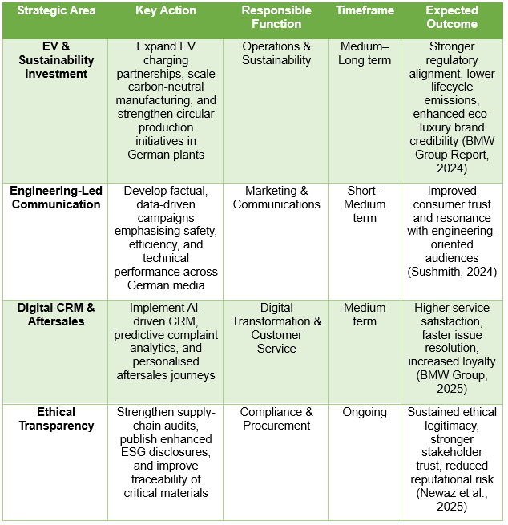

Recommendations – USA Action Plan


