Mohammed Salim, (1807323)
Effective Team Working and Communication, (BMSW4002)
Muhammed Islam
Effective Teamworking for Team Success

Contents page:
Heading: | Page number:
Title Page | 1
Contents page | 2
Introduction | 3
Main body report | 4,5,6,7,8
Discussion | 9
Conclusion | 10
References | 11

Introduction:
This report will be based on the given case study of Next Global. It will consider within the context of this case study the attributes needed to develop an effective team that is cohesive and can motivate itself to complete the appointed task. Tuckman’s model will be used to investigate team development stages and consider the impact effective team working can have on a team and the barriers to this happening. Further, Belbin’s team roles model will be used as a counterpoint to highlight the rationale for choosing Tuckman’s model and later to investigate and examine the detail of team roles and their strengths and weaknesses. The discussion will use personal case study material to understand the dynamics of a real-life situation where team roles are not as transparent as in a research scenario. Finally, it will conclude with its recommendations on the necessity of observing stages and functions being strategic in ensuring a team's success or not and team coaching and mentoring to be part of a group’s fundamental foundation and eventual success.

Definition of a team:
According to Morgon 2017, p204, a team constitutes several individuals who have a shared commitment to working towards a particular goal. In contrast, to juxtapose and clarify this, a group is defined as several people who come together regarding their shared commonalities or characteristics.
There are several attributes that literature has highlighted constituting an effective team; they are commitment to team success and shared goals; interdependence; interdependence; open communication; appropriate team composition; commitment to team processes. To summarise, these such teams are committed to developing an environment which is mutual, inclusive, congruent, trustworthy, accountable, and which is willing to put the group above the individual whilst still offering support on an individual level to bring out the best in all its participants and help all to achieve. Furthermore, there must be a willingness to give and accept criticism freely without partiality, but feedback should be positive and open. Another aspect crucial to a successful team is its composition and the willingness of team members to accept their position and responsibilities fully. Accountability to one's position and role is a natural consequence of such acceptance. Finally, effective leadership will unite the team into a cohesive whole, allowing members to inhabit their roles and engage the team process fully. (Tarricone, P & Luca, J.)
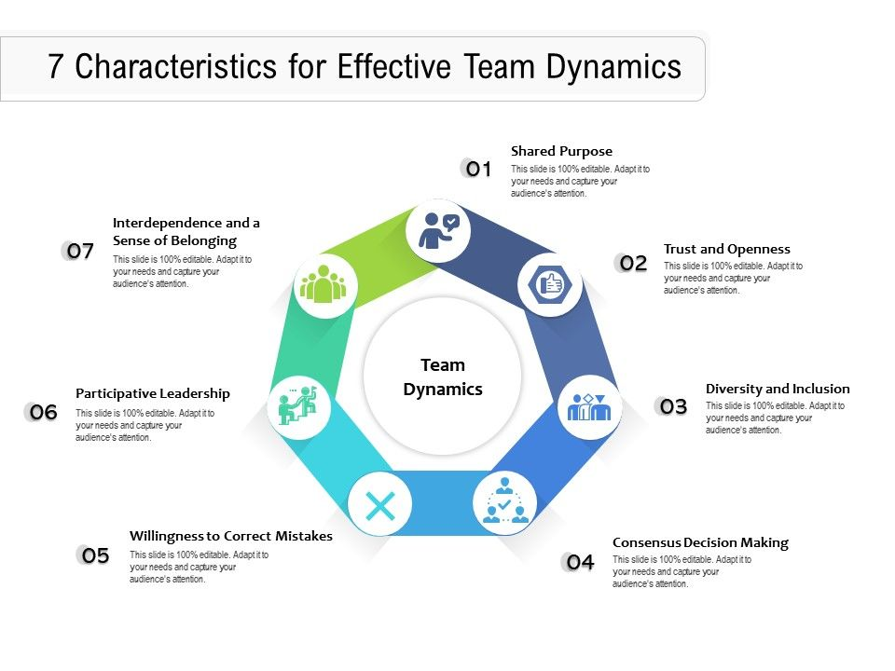
(25 Characteristics of Effective Team in the Workplace. 2022).

Models of Teams Development:
The development model chosen is Tuckman's Model, first formulated in 1965. This model's focus after the team's initial formation is to develop a task from beginning to end using four distinct stages. These stages are Forming, Storming, Norming and Performing, with an additional adjourning and transforming, which Tuckman later added to cover a task's end/completion stages.
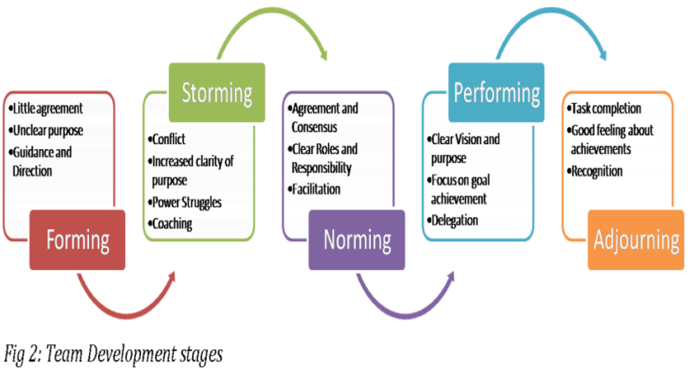

Tuckman and Jensen (1977). Tuckman (forming, norming, storming, performing).

Rationale:
Tuckman’s model would be beneficial given the case scenario because it is first project-focused and sets out the task in stages for a team. Compared to a model such as Belbin’s, which is role-focused, this is preferable as it gives the project a linear progression, fits into time constraints and ensures everyone works simultaneously toward the project’s end goal. For example, Tuckman’s model allows for a stage ‘Forming’ where everyone is unclear and needs direction; it then provides the storming stage for conflict and power struggles as the team develops cohesiveness. Suppose this is not allowed organically, and groups are designated roles before this natural stage occurs. In that case, there is a risk that further conflicts will erupt, and the team will never reach a consensus. With the Next team scenario, there is a breakdown in communication, trust and understanding of shared goals for the project with team members not turning up for group meetings. This could have been handled differently initially by allowing the ‘Forming’ ‘Storming’ stages to take place. Furthermore, as the team comprises global participants with many different cross-cultural ways of working and understanding team roles is vital that these initial stages are not missed to allow people to work out their roles and responsibilities with the project.
https://eactivities.union.ic.ac.uk/training/articles/513
Belbin’s Team roles model is centred upon team members’ roles, and in the Next case scenario; however, it could be beneficial to understand one’s team role and strengths and weaknesses. This model brings nothing to helping a team form and allowing for natural conflict and friction to be settled.

What roles are needed to create a cohesive and effective team?

Belbin’s model defines the roles needed to create a cohesive and effective team. These nine roles are set below with their accompanying strengths and weaknesses. As should be noted, a margin is made for allowable liability before they impinge upon a group’s cohesiveness. Furthermore, it can be seen the team roles have comparative, opposing weaknesses to their strengths. For example, a specialist may give an intense, detailed view of a project element. Yet, their ability to expand and contextualise to a broader macro viewpoint or see other pictures is limited, and they may only contribute in a small way.
Conversely, a Plant role may admirably fulfil their creative, imaginative, free-thinking role but negate the details and not properly invest time in communicating their thoughts and ideas with other team members. In the same manner but for different reasons, the plant and Specialist may not fully share their ideas with the rest of the group. However, as can be seen, one role’s weakness can be made up and augmented by another strength. For example, a Saper could give Resource Investigator the enthusiasm to continue and not lose interest. Consequently, the need for diversity within team roles can be seen as no one member can fulfil all parts, and a diverse team can help to promote a balance that would otherwise not be there.
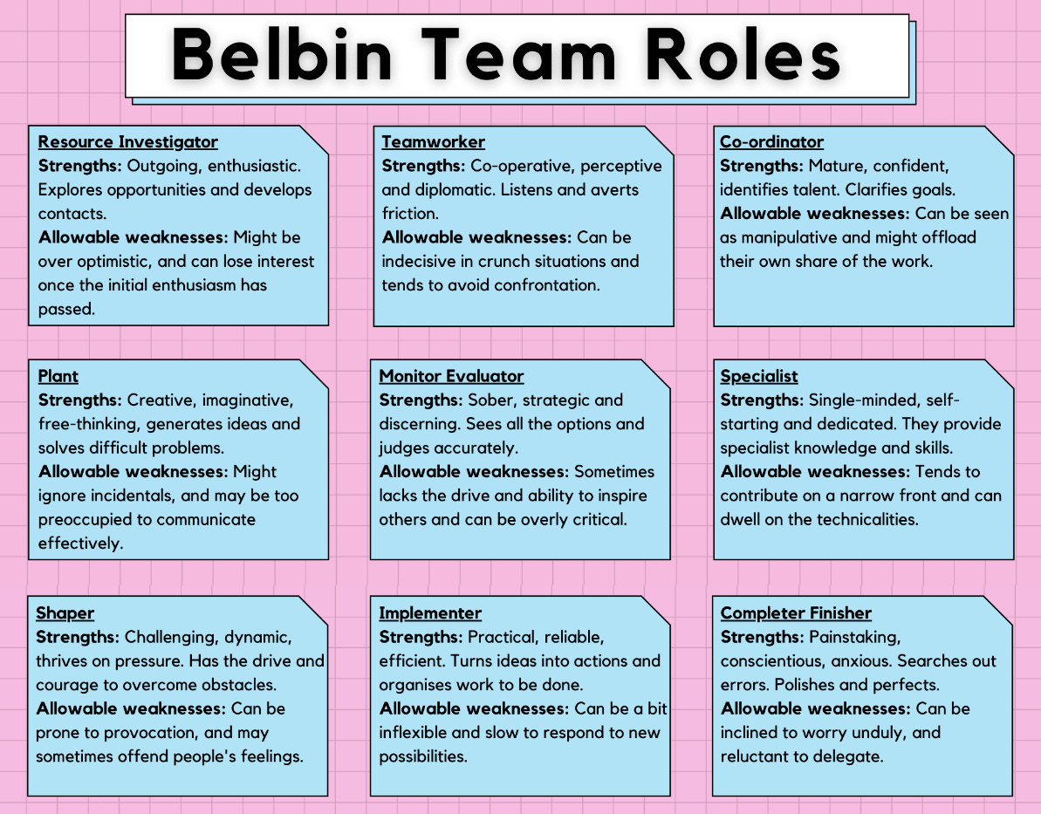

Ayla Erhan, (2018)
Discussion:
Within past working experiences, I have worked in a supervisory bar role. On reflection, my part covered several functions from Belbin’s team role model. For example, I was a co-coordinator and a team member sharing dual duties with other team members when the restaurant became busy. I was also a Completer finisher, as, at the end of the day’s business, I had to ensure that paperwork was completed for that day and any stock order was made. An inventory was made for losses or breakages so that the next day went smoothly.
Further, I was responsible for the maintenance of the building and had to flag any potential infrastructure issues with my management. I feel the role of co-ordinator in Belbin’s model suited my strengths and allowed me to showcase my qualities of being able to work under pressure and complete several tasks concurrently. However, I also know I took on more roles than needed and should have delegated functions to others more frequently.
Macenzie P. (2003) states that an allowable weakness can become a disallowable weakness. In time my position at the restaurant could have been impeded by my unwillingness to allocate work. Nair, D, & Rani M.N. (2020) consider that a coordinator role is the interface of the business with the public and thus enables feedback from the outside to be given to team members. Consequently, in hindsight, I could have been more actively engaged with the other team members and helped motivate them by reflecting on how they were being perceived individually and as a team.
It is essential to consider team roles when selecting team members or recruiting new staff because it is essential to understand the whole group’s way of working and where strengths and weaknesses may be augmented or reduced? Aranzabel. A. et al. (2021) consider that balanced teams boost positive interdependence and individual accountability. However, some of the main problems affecting teams are group composition with ensuing issues such as different motivation and expectations, personality clashes, task and role ambiguity, no norming taking place and conflicts because of perceived unequal contribution, to name but a few. As well as being aware of these difficulties addressing the integration of new team members could be handled through mentorship and coaching session for any new members. Aranzabel.A. et (2021).
Considering the choice of individuals for roles in a team, … states that individuals who possess strengths in one aspect of their role will have relative weaknesses in other parts of their position. Thus, a heterogeneous mix is considered favourable so that there is a balance of team members occupying all roles. (Licorish s. 2009).

Conclusion:
The success of a team or not is, according to research, traditionally based on models of communication and team roles. In this report, both Tuckman's and Belbin’s models have been used to illustrate and investigate how teams can cohere together and be successful. However, there are instances when couples are not formed exclusively for one set task. Still, individuals are part of a larger collective within an organisation and arrive and leave according to the tenure of their position and type of job role. Consequently, Aranzabel’s (2021) call to implement mentorship and coaching within team modelling could enhance other support teams. In the case of Next Global, even though the team were called together on a set task, coaching on their joint mission and responsibilities could help develop more motivation and cohesiveness in regenerating and engaging disinterested members.

Reference List:

- Tarricone P, Luca J. (2002). Successful teamwork: A case study, Australia.

- 25 Characteristics of Effective Team in the Workplace. 2022. 7 Characteristics for effective team Dynamics. Available at: (https://www.careercliff.com/characteristics-of-effective-team) Accessed 19/7/22

Tuckman (forming, norming, storming, performing). Available at: (https://mspguide.org/2022/03/18/tuckman-forming-norming-storming-performing) Accessed 21/07/2022

Ayla Erhan, (2018) Available at:

(https://www.linkedin.com/pulse/belbins-team-roles-ayla-erhan)

Last Accessed: 22/07/2022

- Peter Mackechnie, (2013) Belbin Team Role Theories. Available at: (https://www.businesscoaching.co.uk/files/belbin_team_role_theories.pdf)
Last Accessed: 22/07/2022

D.Nair, (2020) A Review of Prominent Models of Team Roles and Conceptualizing a New Model. Xavier Institute of Management & Entrepreneurship. Available at: (https://papers.ssrn.com/sol3/papers.cfm?abstract_id=3642533),
- Aranzabel.A. et (2021).

