Title Business Report - Comparison of Two Hospitality Organisations
name Andleeb madeha
Student ID number 2239506
Module Title – BMIH5007 Financial Management for the Hotel Industry
lecturer’s name Tristan Hawkins

Table of Contents
Introduction ………………………………………………………………………………………………………………………………03
Total revenues……………………………………………………………………………………………………………………………04
Comparative analysis of total revenue ………………………………………………………………………………………04
Market positioning …………………………………………………………………………………………………………………..05
Comparative analysis of the market positioning……………………………………………………………………….05
Growth potential …………………………………………………………………………………………………………………….06
Comparative analysis of growth potential…………………………………………………………………………………06
Financial commitment to CSR……………………………………………………………………………………………………07
Comparative analysis ……………………………………………………………………………………………………………….08
Recommendation ……………………………………………………………………………………………………………………09
Conclusion ………………………………………………………………………………………………………………………………10
Bibliography …………………………………………………………………………………………………………………………….11
References link…………………………………………………………………………………………………………………………..12

List of tables:
Table 01: Comparative analysis of total revenue……………………………………………………………………………..04
Table 02: Comparative analysis of marketing positioning……………………….……………………………………….05
Table 03: Comparative analysis of growth potential ………………………………………………………………………06
List of figures:
Figure 01: Total revenue of Shangri la hotel ……………………………………………………………………………………04
Figure 02: Market positioning of Shangri la Hotel………………………………………………………………………..…..05
Figure 03: Market positioning of Premier Inn Hotel………………………………………………………………….………05
Figure 04: Growth potential of Premier Inn hotel……………………………………………………………………………06

Business report:
Comparison of Shangri La hotel group and Premier Inn hotel
Introduction
Shangri La Hotel Group belongs to the renowned global hotel chain that is well known for its luxurious accommodations, exceptional services, and the intense bonding it has with its cultural heritage. It was established in 1971. They have a diverse portfolio that operates its properties across Asia, the Middle East, Europe, and North America. They have gained a high position by creating Eastern hospitality and Western luxury that provide a memorable experience for their guests. (Campbell, march 2008)
Premier Inn operates under the parent company Whitbread plc and belongs to the leading budget chain in the United Kingdom. They offer good quality, affordable rates, and comfortable accommodations. Due to these owned qualities, it’s the first choice of travelers who seek the value of money. They have a diverse geographical dispersion across the UK that presents a very convenient and comfortable environment for both leisure and business travelers. Premier Inn has stated itself as a trusted brand in the budget hotel market with the main motive of providing the best stay. (McCaskey, n.d.)
This report objectives to conduct a comparative analysis of Shangri La Hotel Group and Premier Inn hotels that basic financial management strategies and practices further categorizing into revenue, market positing, growth potential, and financial commitment to corporate social responsibility. The assessment will delve into the strengths, weaknesses, and potential areas for improvement in the financial management approaches.

- Total Revenue:
Shangri La hotel group | Premier Inn hotel
Revenues and cost
Shangri La Hotel Group generates solid revenue by renting rooms and providing outclass quality food and beverage services. It also includes ancillary services such as different events and spa treatments. (Alhemeiri, n.d.)  Cost includes property maintenance, operating expenses, and labor costs. | Premier Inn primarily generates its revenue from renting rooms and providing on-site food. A major contribution to their revenue focuses on affordability and consistent quality.  Cost includes labor costs and operating expenses.
Revenue trends
Shangri la has earned a steady revenue over the counter of years by increasing tourism, following strategic partnerships and global availability. During the Covid pandemic, they have experienced a fluctuation in revenue and travel restrictions due to the economic condition. | Premier Inn has experienced a reputation and revenue significantly in the UK market, benefiting UK domestic tourism by attributing its focus on convenience and consistency and investing in new locations. They have shown steady growth in the recent years. (Tranter, 2009)
Revenue driving factors
Factors that contribute to its revenue growth include a strong brand reputation, its global positioning, strategic partnership with airlines, and mainly its focus on providing exceptional customer experiences. | Factors that drive the revenue include competitive pricing strategies and their investment in the technology sector to enhance their customer experience. Their widespread availability also contributes to its revenue.

Total revenue comparative analysis of Shangri La Hotel Group and Premier Inn hotel:
Shangri la Hotel Group and Primer Inn Hotel both basically operate in different sectors but both of them have a strong revenue foundation and growth. Shangri La Hotel Group demonstrates high room rates due to its leading positioning meanwhile Premier Inn focuses on affordability to generate more revenue by attracting a broader range of customers.
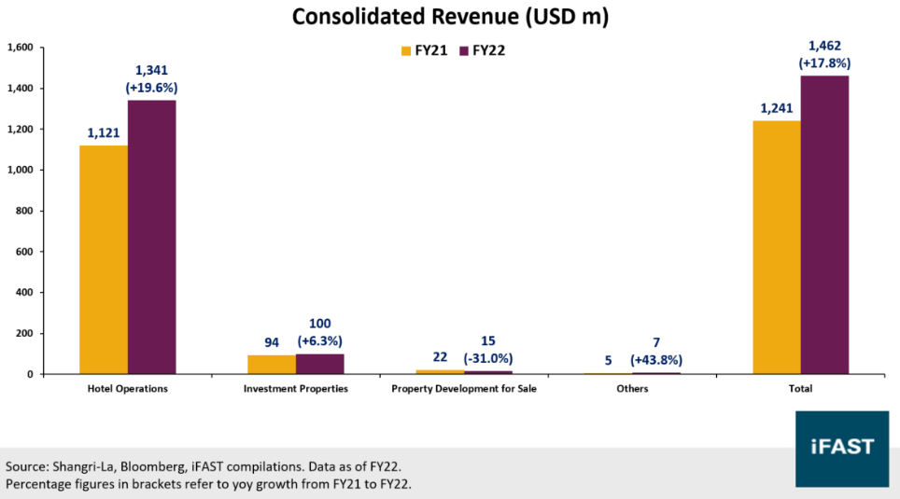
figure 01: Shangri la hotel group

- Market positioning:
Shangri La Hotel Group | Premier Inn hotel
Market share
Being a luxury hotel, Shangri la hotel holds a significant market share in various segment of the world specifically in the Asia. It also holds a wide range of properties in the prime urban areas. | Premier Inn is a dominant hotel chain in Uk. PREMIEER Inn holds a good hand in the market share in the economy segment.
Customer demographics
The target customer demographic includes travelers who seek for comfortable and affordable accommodations. It specifically includes business travelers and event organizers who prefer well experience. (Hilam, 2016) | It primarily targets families who want to have affordable vacations or budget conscious tourists or cost-effective options seek by travelers.
Brand perception
It is specifically classified as a premium brand known fit it exceptional services, culture heritage and luxurious ambiance. | It is widely known for its good value of money. They appeal to a wide range of people for it reliable quality. (Dibb, 1993)

Market positioning comparative analysis of Shangri La hotel group and Premier Inn hotel:
Shangri La hotel group and premier Inn hotel have occupied a good market segment in the economy. Shangri La hotel group is sought by luxury tourists meanwhile premier inn hotel main focus is on the budget conscious travelers. Both have maintained a very strong brand reputations in their respective sectors.

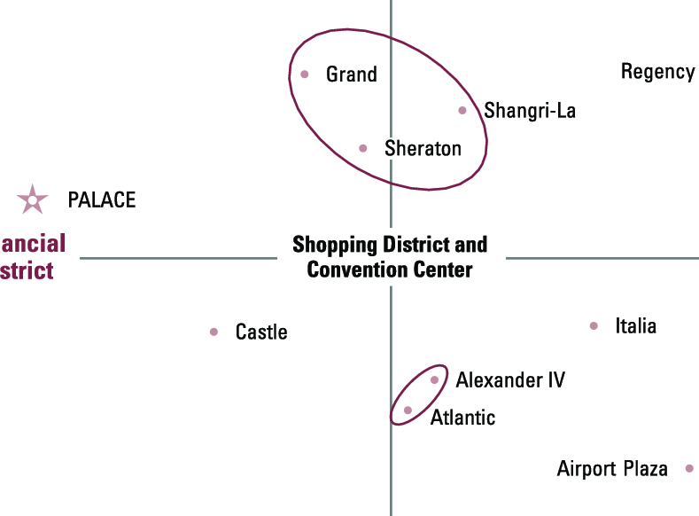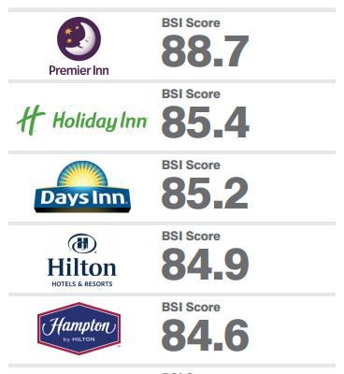
Figure 02: Shangri La hotel group Figure 03: Preimer Inn hotel
Market positioning

- Growth potential:
Shangri la hotel group | Premier inn hotel
Expansion strategies
Shangri la is one of the well-known hotels in its sector focusing on expanding its footprint in market. This emerging market includes Asia Pacific and the middle east. It set its goals high a clear and aims to open new properties to increase their revenue and customers value. They also focus on renovating there existing properties to enhance their customer experience. | Premier Inn is a budget holder in the market that focuses on the value conscious travelers that seek affordable accommodations. Premier Inn aims to expand its across the UK and across the boarders by opening new hotels in planned strategic locations.
Market opportunities
The demand for luxury and most presentable ambiance increases the opportunities for Shangri la hotel group. These opportunities present Shangri la to capitalize on high-net-worth individuals’ preferences (Yang, 2013) | The rapid rise in the domestic tourism increases the level of opportunities for the premier inn hotel. Post pandemic offers particularly growth potential for increase inrevenue and budget accommodations.
Barrier to growth
Beside their good market segment Shangri la hotel group has to face many obstacles including intense competition among all. Barrier also include economic turndown that badly effects the discretionary spending. | Economic fluctuation is a major factor that states to be a potential barrier affecting consumer spending. These barriers initiate increased competition among the market such as Airbnb.

Comparative analysis of Shangri La hotel group and Premier Inn hotel:
Shangri la hotel group and Premier Inn follows a significant expansion model. Shangri La’s mainly targets the emerging markets and its reputation. It also emphasis on its strong positioning for the expansion (Abdullah, 2015) meanwhile Premier Inn’s focuses on providing the affordable accommodations and its efficient operating model enrich it with a competitive advantage in the budget hotel segment.

figure 04: Premier Inn hotel growth potential 2000-2020

- Financial commitment to CSR
Shangri la hotel group (Kumar, 2014)
Shangri la has always contributed in the CSR by taking initiatives that are based on the sustainability of the environment. They actively engage in various activities to safe the community that are serving. Initiative includes reducing carbon footprint by implementing energy saving measures. Efforts include achieving ISO 14001 certification for environmental management system.
- Sustainable investments:
Shangri la hotel group also prefer energy consumption in its properties by using renewable energy sources. They also participate in CSR by following the practices of water saving, waste reduction and, recycling to minimize its environmental impact. Shangri la hotel group has also favors a significant financial commitment to its corporate social responsivity initiatives. they also follow practices which can have long-term financial benefits and use to technologies such as energy efficient infrastructure.
- Specific annual budget:
The company dedicated a specific portion of its annual budget for CSR initiatives involving energy efficiency program and waste reduction initiatives. The financial commitment also involves allocating a considerable amount towards education and training, health and wellness to communities in need and also provide aid to affected communities suffering from natural disasters.
- Partners and donations:
Shangri la hotel partners with different nonprofit organizations to play its role in the CSR. They also donate a specific amount of funds and initiate many projects to support the community in all the favorable condition they can compensate with.
- Employee development and volunteer programs:
Shangri la invests in providing financial incentives or paid time off for employees to participate in such activities and also in employee training and development program to enhance their skills and well-being. They also offer wellness programs and also promote diversity in its workforce to influence a supportive work environment.
- Community engagement projects:
Shangri la hotel commitment to CSR requires substantial financial figures. It also contributes in various projects such as building of schools, hospitals or infrastructure and also collaborates with other local organizations to promote awareness in the community. Shangri la hotel group also take initiatives in the ethical sourcing and presentation cultural heritage. (Cherapanukorn, 2014)

Premier inn’s financial commitment to CSR
Premier Inn has demonstrated commitment to corporate social responsibly. Unlike the large luxury hotel chains, this leading budget hotel chain may not have much resources to have much contribution but still it serves its best with little initiatives. (Universities, 2014)
- Community partnership:
Primer inn hotel has a close relation with local charities and different no profit organizations for the support. These contributions are financial contributions and in-kind donations that make it a participant serving the community.
- Employee volunteering:
Premier inn financial commitment to CSR may not be as extensive but thy encourages employee volunteering and also provides paid off for employees to take part in different community serve activities encounter by the hotel.
- Sustainability initiatives:
Premier inn has taken different measure to reduce its environment impact such as carbon emission and energy efficient lighting. It also takes initiate to have a positive financial impact in the long term by water saving measures, recycling programs and promoting responsible sourcing food products.
Primer inn efforts contribute to CSR to bring in a better community and to reduce its environmental impact. It ensures that its suppliers adhere to fair labor practices and environmental standards contributing its roles in ethical sourcing. There contribution concludes to a better brand image and more socially responisilbe hospitality industry. (Buttle, 2016)
Comparative analysis:
Shangri la and Premier Inn both have a strong demonstrated commitment to CSR. Shangri La significant investments in CSR includes initiatives for reducing carbon emission and responsible sourcing while Premier Inn investments are directed towards community engagement and supporting the environment by improving its efficiency across its property.

Recommendation:
Shangri la hotel group:
- Shangri la hotel group can increase it worthiness by enhancing digital marketing strategies targeting a specific emerging market.
- It can further expand its brand reputation and market position by expanding its offering to include wellness retreats and corporate training facilities.
- It can continue to leverage its luxury positioning by bringing innovation in the technology sector to drive a better experience for guests.
- It can also enhance by exploring opportunities for strategic partnership with different airlines and travel agencies to attract more tourists.

Premier Inn hotel:
- Premier inn should enhance the quality of service keeping the prices at competitive pricing edge, it could improve brand perception.
- It can diversify its revenue by investing in the technological sector to improve the experiences.
- To maintain its competitive edge in the budget hotel segment, premier inn hotel should offer beyond traditional hotel accommodations such as co working space.
- It can also introduce loyalty program that facilitate businesses among customers.

Conclusion:
Shangri la hotel group and premier Inn hotel have demonstrated strong financial performance due to their distinct market positioning and growth strategies. This analysis represents the valuable insights of their financial management and practices. Shangri la hotel group is engaged in luxury and personalized services with strong brand reputation and premium prices.in 2023, it was reported a revenue increase that was driven by a resurgence in travel post pandemic. The average daily rates contribute in the revenue growth despite to the fluctuations and hotel budget. However, potential barriers include geopolitical risk in certain regions. Premier inn hotel mainly focusses on affordability and operational efficiency. It creates the value of money to achieve competitive pricing despite the challenges faced due to lower prices. Premier Inn overshadowed by luxury brands in their CSR activities while in term of social responsibility both have a well financial investments financial on the environmental sustainability.
Overall, both have different approaches to meet its targeted goals and have successfully navigated the competitive hospitality market. Both have contributed in CSR with played a dominant role in outcoming good brand image. For further recommendation both have to adapt their strategies to remain competitive and meet the chafing need of their customers.

References
Abdullah, H., 2015. A Case Study of Shangri-La Hotels (Malaysia) Berhad.. . Strategy Building and Sustaining Competitive Advantage: .
Alhemeiri, N. A. N. A. M. A. Y. A. A. a. N. H., n.d. shangri la hotel group. Financial analysis of Shangri-La Hotel.
Buttle, F. B. D. B. M. a. M. A., 2016. Hospitality Marketing.
Campbell, D., march 2008. Shangri La Hotel. Shangri la hotel, p. 22.
Cherapanukorn, V. a. F. K., 2014. Corporate social responsibility (CSR) and sustainability in Asian luxury hotels: Policies, practices and standards. Asian Social Science, Volume 10(8), pp. 198-209.
Dibb, S. a. S. L., 1993. The strength of branding and positioning in services. International Journal of Service Industry Management,, Volume 4(1), pp. 0-0.
Hilam, H. a. K. N., 2016. A Case Study of Shangri-La Hotels (Malaysia) Berhad. Strategy Building and Sustaining Competitive Advantage.
Kumar, R. a. S., 2014. Corporate social responsibility-A study on hotel industry.. Asian Journal of Multidisciplinary Studies, Volume 2(4), pp. 25-35.
McCaskey, D. a. C. C., n.d. Premier Inn hotel. TRAVEL INN BY WHITBREAD, Volume 23, pp. 2-677.
Tranter, K., 2009. An introduction to revenue management for the hospitality industry.. : Principles and practices for the real world. Pearson Education India.
Universities, E., 2014. CORPORATE SOCIAL RESPONSIBILITY PRACTICES IN INTERNATIONAL HOTEL CHAINS:. A WEB CONTENT ANALYSIS, Issue University of Girona.
Yang, H., 2013. case study 12. Shangri-La hotels expanding to non-Asian markets. In Marketing Cases from Emerging Markets , Issue Berlin, Heidelberg: Springer Berlin Heidelberg, pp. pp. 113-116.

Reference links
https://www.hbs.edu/faculty/Pages/item.aspx?num=35731
https://en.wikipedia.org/wiki/Shangri-La_Hotels_and_Resorts
https://www.researchgate.net/profile/Haitham-Nobanee/publication/355169936_Financial_analysis_of_Shangri-La_Hotel/links/6163aeafae47db4e57c08a1d/Financial-analysis-of-Shangri-La-Hotel.pdf
https://repo.uum.edu.my/id/eprint/23462/2/NCSC%202015%201%2022.pdf
https://core.ac.uk/download/pdf/229670697.pdf
https://core.ac.uk/download/pdf/229670697.pdf
http://www.cek.ef.uni-lj.si/magister/Cernec1527-B.pdf
https://www.taylorfrancis.com/books/mono/10.4324/9781315682549/hospitality-marketing-david-bowie-francis-buttle-maureen-brookes-anastasia-mariussen
https://books.google.com/books?hl=en&lr=&id=EbbUgU805nYC&oi=fnd&pg=PR11&dq=Premier+INN+hotel+revenue&ots=BNU1tQAvoD&sig=KGNcWvPRiNke8MzubHTspb5y_xw
https://www.ingentaconnect.com/content/mcb/085/1993/00000004/00000001/art00002
https://www.ceeol.com/search/article-detail?id=578873
https://digitalscholarship.unlv.edu/cgi/viewcontent.cgi?article=1004&context=premier

