Student Name: Lois James

Student Number: 1700345

Course Title: BA(Hons) Graphic Design

Tutor’s Name: Donna Williams

Title:
How Poster Design generates power and influences change.: Major poster campaigns in the political landscape of the UK and USA from 1903 to the present day.

Word Count: 5940/ 6000

“Submitted in partial fulfilment of the requirements for the degree of BA (Hons) University of Wales Trinity Saint David, Swansea, 11th December 2019.”

Contents:

Introduction – Pages 3 – 4 (354 words)

Chapter 1 – Early History – Pages 5 – 12 (1186 words)

- Brief History of Posters

- Suffragettes

- WW2 and Nazi Germany

Chapter 2 – 1970’s – 2010 – Pages 13 – 22 (1756 words)

- Women’s Strike for equality March 1970

- The Aids Crisis

- Obama Election Campaign

Chapter 3 – 2010 – 2019 – Pages 23 - 32 (1789 words)
- Obama’s second term as President
- The presidency of Donald Trump
- Brexit – ‘Brexit Bus ‘and surrounding campaigns

Analysis/Discussion – Pages 33- 35 (633 words)

Conclusion – Pages. (192 words)

List of Illustrations – Pages 36- 38 (378 words)

Bibliography – Pages 39- 41 (485 words)

Introduction

This Independent Enquiry attempts to address the issue of how posters have been used as tools within the political landscape of both the past and present. Twenty nineteen has been a year of political uncertainty on a global scale, with the generation of new policies regarding European Trading and the election of a controversial President of the United States being brought to the forefront. Despite some of these political changes taking place in opposite corners of the globe, one thing is apparent; posters act as a powerful aide in political movements.

This application of such a prominent design tool isn’t new, in fact posters have been used throughout history by numerous individuals in an attempt to achieve their desired political goals. Through examining these examples, we can gain knowledge into what aspects are successful and how the design choices made can influence public thinking.

As a designer, it is crucial for me to understand the power and influence that my designs can have on people, through the use of tools like the poster. In uncertain times, people want to be able to trust the information they are being given on a daily basis, particularly when it comes to socially sensitive topics like politics.

In chapter one I will look at posters of The Suffragette movement and propaganda used by both Britain and Germany during World War 2. Through the analysis of their design and purpose of creation, I will further explore how they assisted in generating power behind some of history’s most influential political movements.

In chapter two, I will focus on key campaigns created from 1970 to 2010. At this time Britain and America took different approaches when generating political designs and this something discussed within this chapter. This chapter will also look into how designs from this era have had an influence on protests and campaigns created today.

In chapter three I will look at the campaigns for the American Presidency for both Barack Obama and Donald Trump. I will also analyse the designs surrounding Britain’s Brexit campaigns and throughout this chapter discuss the idea of using nostalgia as a design tool.

Chapter 1 – Early History

A Brief History of Posters

Posters act as a tool allowing designers and people across the creative industry to communicate easily with a large audience of people. One of the earliest forms of advertising, poster usage grew in the 19th century and helped with the popularisation of typography. Their ability to communicate quickly in a visually appealing way led to the worldwide use of posters, and they became a staple of the Graphic Design community.
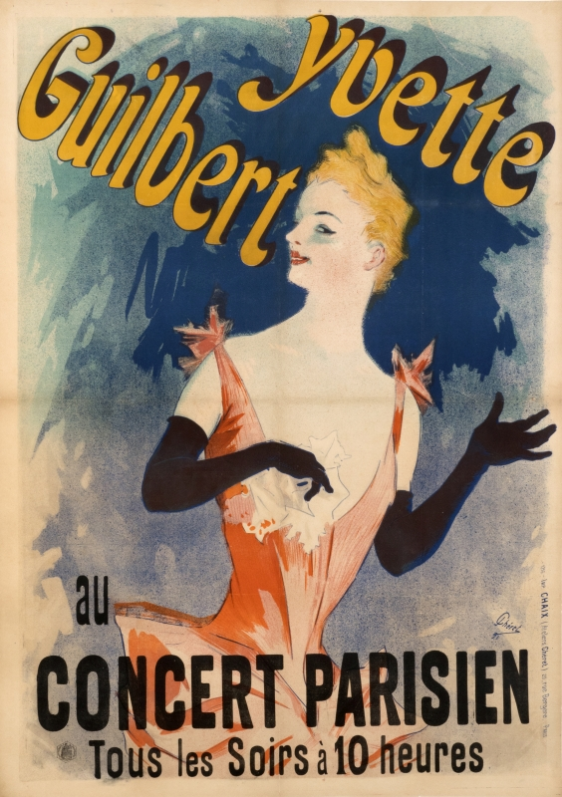

Fig 1. ‘Yvette Guilbert au Concert Parisien’

The first wave of posters mainly used typography and were constructed using the process of letterpress. As technology developed, posters now had the ability to contain large visual elements as well as typography through the use of lithograph. This invention is regarded as a “breakthrough which allowed artists to achieve every color in the rainbow” (International Poster Gallery, 2018). This allowed the poster to become a more mainstream and accessible form of advertising. As time passed, posters were appreciated as an art form and in the begging of the 19th century, the Art Deco movement brought an emphasis of minimalism, shape and colour to transform them from pieces of fine art to something more abstract. This change reflected visual communication at the time and designers started to think more about the imagery and typography they were using.
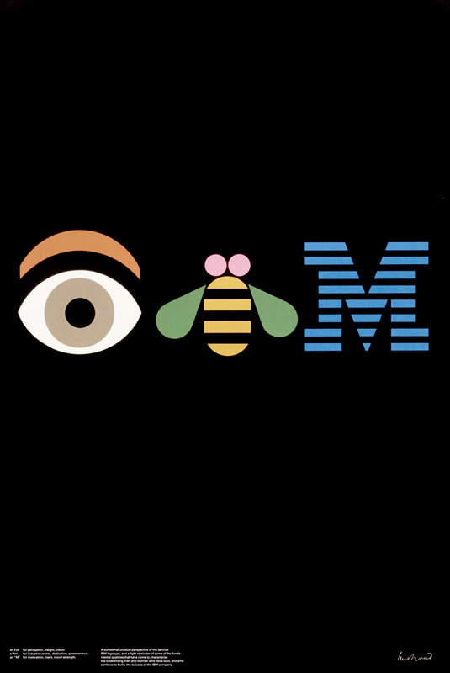
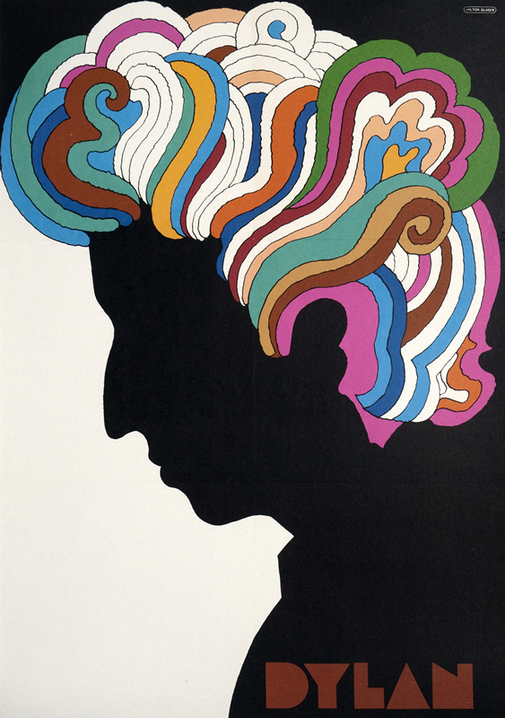

Fig 2. ‘Dylan’ Fig 3. ‘I.B.M’

As time went on, posters embodied the roles of propaganda, rebellion (Fig 2) and post- modern expression (Fig 3) and have continued to change and adapt alongside society. They evolve to fit our needs and despite the introduction of technology such as the internet, posters have continued to be a vital part of a designer’s toolkit.

The Suffragettes

In 1903, members of the Pankhurst family founded the Women’s Social and Political Union and began to campaign for women’s rights to vote. The campaigning consisted of public speeches, marches and even transcended into fashion. The colours purple, green and white were used across all elements of their campaigning and are now something that is commonly associated with suffragette movement. At this time, trying to generate such change led to a large number of arrests and protests but with the input of design, their cause reached a larger audience and affected people of all ages and genders.
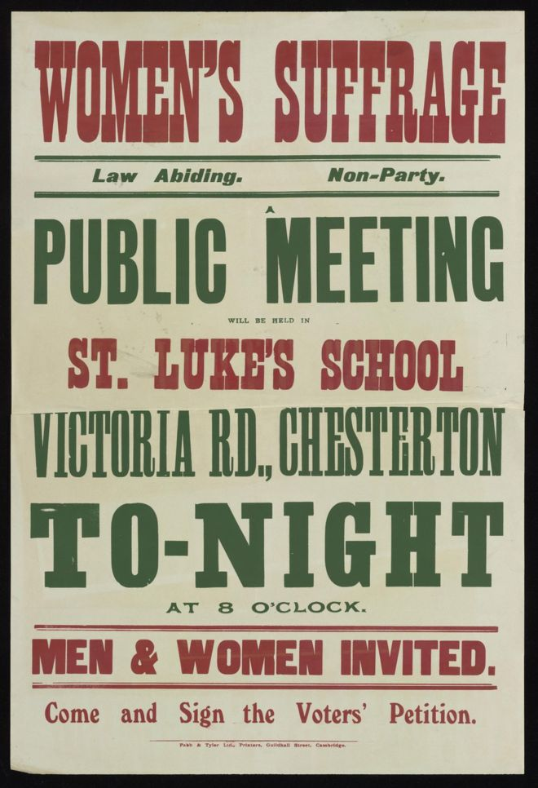
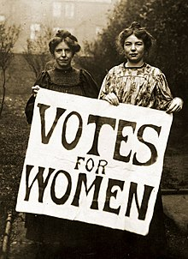

Fig 4. ‘Votes for Women’ Poster (1908). Fig 5. ‘Suffragette Meeting’ Poster (1908)

The first posters used by the Suffragettes were simple and minimal. Containing only large-scale typography, they displayed messages like ‘Votes for Women’ and their slogan ‘Deeds not Words’. They were used to re-inforce why they were gathered and exactly what they were fighting for to politicians and non-supporters. Posters were also used to spread information regarding meetings that would be ‘law-abiding’ however “To be a female suffrage activist of any kind was a militant act” (BBC News, 2018). Colours were used to visually break up text and make key parts of information stand out against other materials at the time and later helped establish a brand for the suffrage movement.

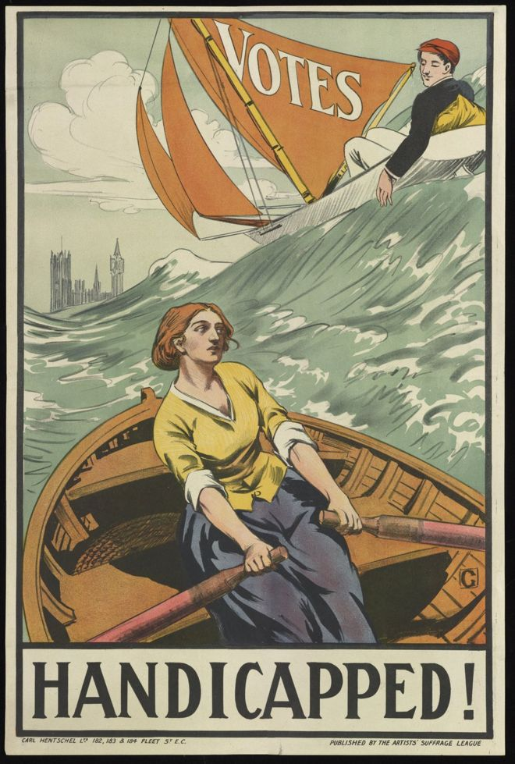
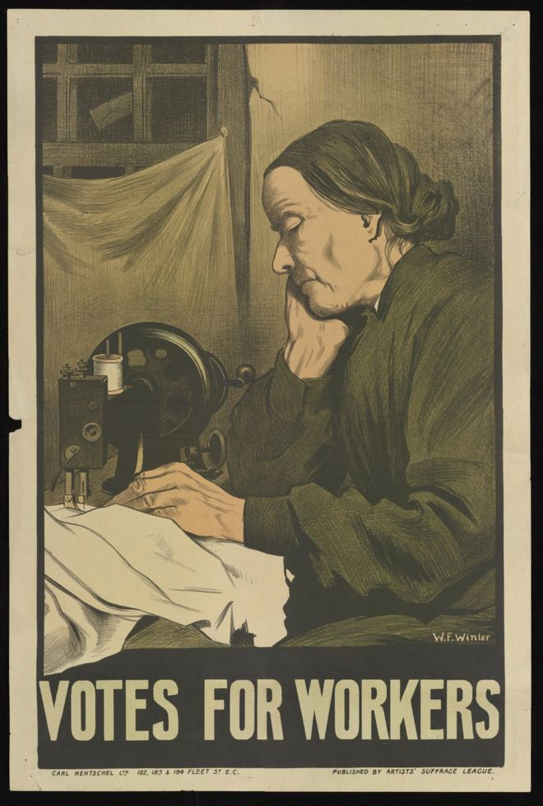

Fig 6. ‘Votes for Workers’ Fig 7. ‘Handicapped’

As the movement grew, so did the need for new campaign material and numerous posters with multiple messages were produced. One of the most notable from the time was produced by artist Duncan Grant. It features a young man in a boat easily navigating the choppy waves with ease with the backing of ‘Votes’ embroidered on his sail whilst a working- class woman is depicted alongside him struggling. The imagery is emotive and tries to connect to how people felt about being discriminated against because of their gender and class. This is reinforced with the use of the word ‘Handicapped’ at the bottom of the poster in capital letters. The fact that it is one of only two pieces of typography used also highlights its importance.

Print production was a central feature to the suffragette’s campaign through the use of large-scale posters and leaflets that were handed out on a daily basis to spread their message of desired change. This format of combining type and imagery was crucial to a victory for women rights and is something that has since been adapted and continues to influence the protests and campaigns of women of today.

World War 2 and Nazi Germany

In 1939 Britain became a part of what is considered one of the biggest global conflicts to date, the second World War. It included one of the most notorious attacks on a religious group when Adolf Hitler and his German soldiers declared hate and death upon Jewish residents in the Holocaust. One of the main ways in which both British and German governments persuaded and manipulated people into participating in the Holocaust was with the use of posters and propaganda. Everett Dean Martin stated that “Propaganda is making puppets of us. We are moved by hidden strings which the propagandist manipulates” (Dean, 1929, pp. 140-150) it suggests that they used this tool of design to mould people’s minds into believing and thinking what they wanted them to regarding topics such as race, gender, religion and ethnicity.
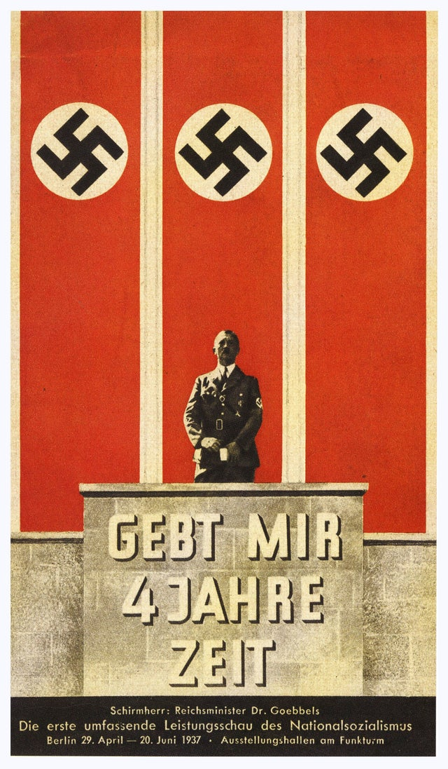

Fig 8. ‘Give me 4 years of Time’

German propaganda is easily recognisable due to its bold and striking use of colour. Mostly consisting of a red and black colour palette combined with stylised imagery, these posters spread messages of anti-Semitism to people of all ages across the country. The typography included amongst the visual elements contain messages relating to Adolf Hitler’s position of power and how he as a figurehead can ensure Germany’s future is successful. The success of the Nazi Germany poster campaigns is evident is the number of casualties that occurred during this time and in a book written regarding the Nazi’s choice to use posters as their main campaign elements Anthony Rhodes states the they were selected due to “The visual effect, being striking, would reach the viewer easily” and “Posters unlike other forms of propaganda, were difficult to avoid”. (Rhodes, 1976, p. 22)

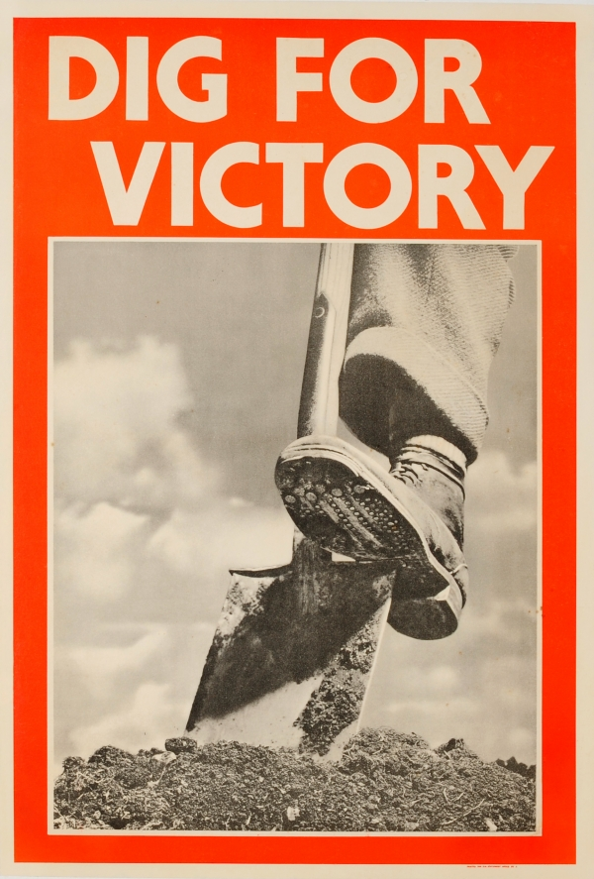
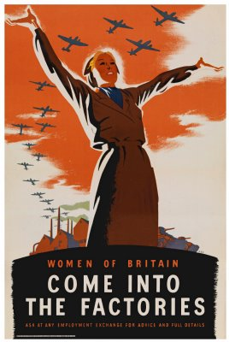

Fig 9. ‘Come into the factories’ Fig 10. ‘Dig for Victory’

Meanwhile, British propaganda was not focused solely on a leader or specific individual, instead they focused on persuading those who were not fighting to join the war effort in other ways such as working in factories, growing produce and increasing production. Using stylised imagery of women hard at work, looking strong and having the posture associated with leaders was inspiring and led to large numbers of women offering their services. The imagery of a ‘Land Army Girl’ is something that is considered iconic when looking at war time propaganda due to its success. Another one of Britain’s most notable examples is the ‘Dig for Victory’ poster (Fig 10), which was used to encourage home farming. The use of the word ‘Victory’ is an element that made this poster successful as it draws upon the public fear of losing the war and implying that growing produce was the way to ensure that Britain emerged as winners. It also reassured people that the effort they were going through in their daily lives was worth it and that they weren’t wasting their time doing pointless tasks.

People across both countries were influenced by the messages the governments delivered in the form of numerous posters and a great deal of power was generated. People were empowered and united in fighting for a cause on a national scale and this demonstrates that before technology, posters still possessed the ability to reach a large audience and manipulate the way that people think.

Chapter 2 – 1970’s – 2010

Women’s Strike for Equality March

On August 26th 1970, following the work and influence of the Suffragettes, feminists took to the streets of New York City to demand equality for women across all aspects of life, and to demonstrate the power that the new feminist movement possessed. One of the main reasons this strike took place was Betty Friedan, a second-wave feminist who noticed that feminism of the past had “destroyed the old image of woman, but they could not erase the hostility, the prejudice, the discrimination that still remained” (Friedan, 1963).
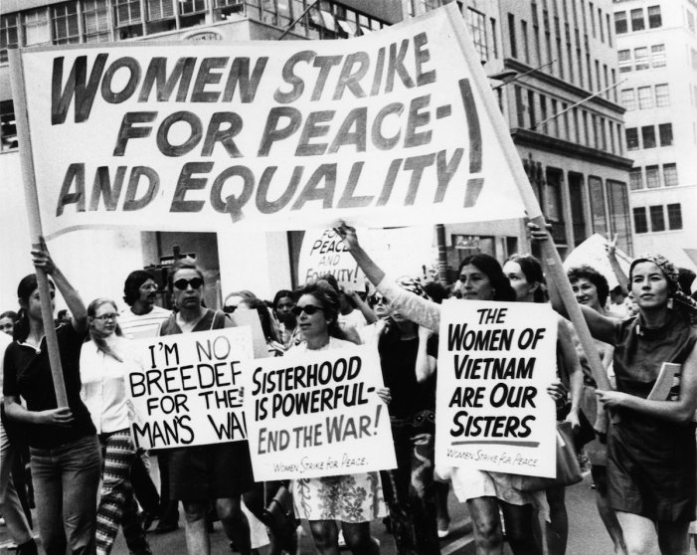

Fig 11. Protesters at Women’s Strike in New York

The women used posters to display messages of distain, such as ‘Don’t iron whilst the strike is hot’ and ‘Sisterhood is powerful- end the war’. Posters of varying sizes were used as a way for the women to display their opinions to anyone that was watching and through the process of putting them on display, the words themselves became more empowering and inspiring. The process of putting words into a written format that everyone can see makes them feel more important and as something that should be taken seriously. This technique was adapted by a large number of women as “The day of activism reached beyond New York City, as thousands of feminists across the country coordinated sister demonstrations” (Cohen, 2015).

The success of this march is clear in terms of achieving better gender equality across areas of higher education and in the workplace, as demonstrated in 1972 the passing of Title IX, which “forbade sex discrimination in any educational program that received federal financial assistance” (Cohen, 2015) and later on in the creation of sexual harassment policies by the Equal Opportunity Commission in 1980. Despite the progress in these sectors, for a number of years law changes for abortions, child-care and the wage gap were still ignored and are a contentious topic that is still discussed today.
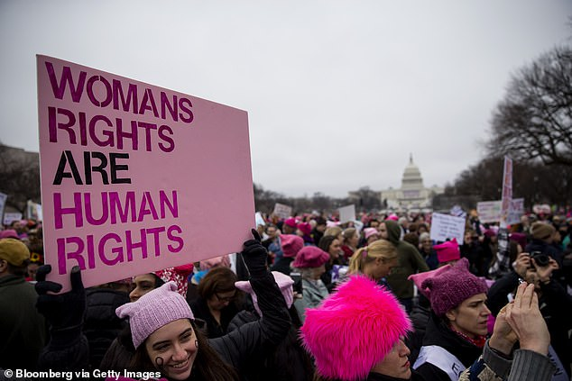

Fig 12. Women’s March in Washington D.C

Although these women didn’t achieve all of their goals, one thing is clear; their ability to highlight the feminist movement and show that it was something that not only women, but people of all ages and genders could be a part of to generate the change they felt was extremely necessary. Its influence continues to build relationships between multigenerational feminists and other members of today’s society who are continuing this unfinished battle for equality.

The AIDS Crisis

For a multitude of individuals across America, the 1980’s were a time embraced with open arms after the radical movements of both the 1960’s and 1970’s; such as inflation, the American involvement in the Vietnam War and a drastic rise in crime rates across a number of states. New waves of music, film, television and Ronald Raegan’s presidency brought along the rise of the ‘Yuppie’, which is defined as “A baby boomer with a college education, a well-paying job and expensive taste’. (History.com Editiors, 2018)

When the AIDS related death of well-known actor Rock Hudson was brought to the attention of the American public in 1985, “the AIDS epidemic became palpable and the threat loomed everywhere” (Shilts, 2011). A widely negative reaction led to a massive increase in homophobia across the country. The Reagan administration didn’t provide any additional funding for research into the disease, meanwhile innocent people were dying, and the disease continued to spread. This ignorance led to the unification of six New York creatives to form the ‘Silence=Death Project’, a project focused on raising awareness and generating power for the people affected by this disease that were being ignored by the government.

They created a poster in 1987, that arguably is now viewed as being one of the most iconic political posters of all time. Eventually reaching a global audience, it united both the gay and lesbian communities at the time whilst also striving towards and succeeding in generating political change. The posters minimalist appearance was intentional, allowing it to be read clearly by people whilst they were in a moving car or on the moving subway trains.
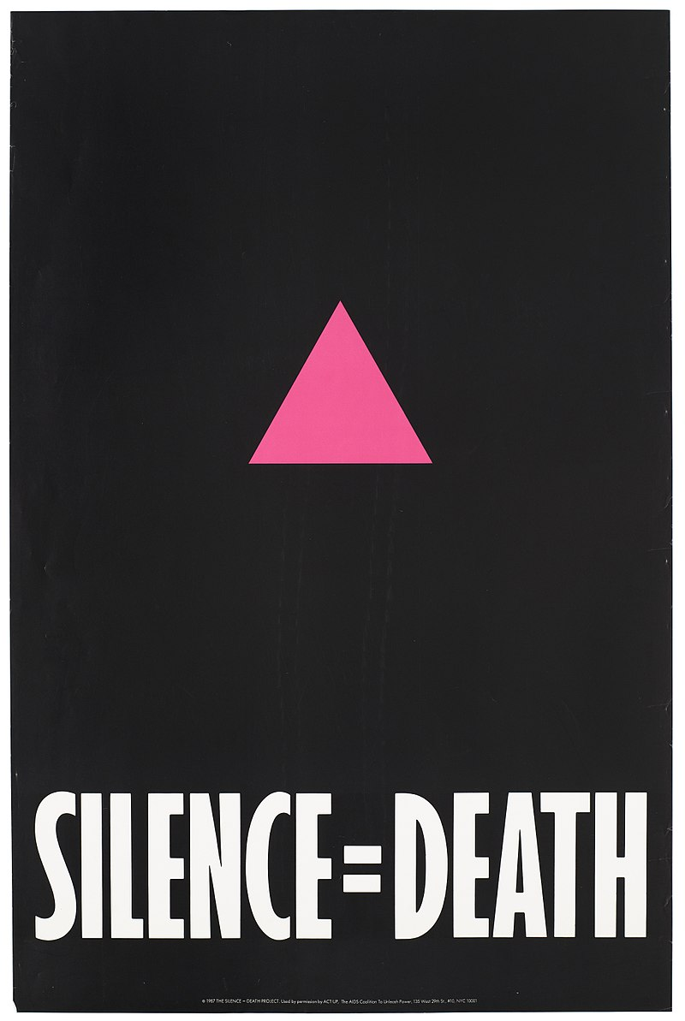

Fig 13. ‘Silence=Death’

The poster simply uses the iconography of the pink triangle combined with the tagline ‘Silence=Death’ to put forward the message that instantly provokes thought and emotion within the poster’s audience. One of the posters designers, Avram Finklestein, stated when coming up with the famous tagline, they wanted to address the silence surrounding the AIDS crisis that came from many different perspectives such as “political silencing, silence as complicity, and scenarios where bystanders became participants without intending to be” (Finkelstein, 2017).

Many people from a plethora of backgrounds saw the power in this poster. The AIDS Crisis became something of great importance to the American People, and politicians eventually realised that they also needed to take action.

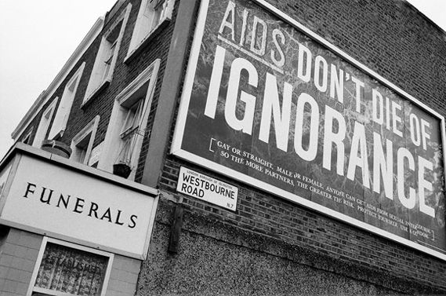

Fig 14. ‘Don’t die of ignorance’

At this time in the United Kingdom, Health Secretary Norman Fowler decided that AIDS wasn’t just an international issue, it was affecting the people of Britain in the same devastating manner and he decided that despite “people in government who felt uneasy about homosexuality. I thought – this is unjust.” (Jonze, 2017). This attitude and way of thinking led to the launch of one of Britain’s biggest ever public health campaigns, which initially involved the generation of large-scale posters but was followed up with a TV advert and leaflets being sent to every home across the United Kingdom.

The posters themselves have a strong use of modern typography to highlight the fact that this disease was new and something that the public needed to be aware of. It contradicted any other medical leaflets that were being generated at the time, which again only reiterated this campaigns importance. The use of underlining is also a key feature to these posters as it changed the disease’s name into more of a logo and helped establish a brand for this hard - hitting campaign. The slogan ‘Don’t die of ignorance’ became something that induced fear amongst the public in an attempt to get people talking and paying attention. Designer Malcolm Gaskin, one of the people directly involved with the campaign stated that including “the death part was important – and knowledge was really the only thing we had at the time to defend ourselves against it.” (Jonze, 2017)

Whilst the posters started to stir up anxiety surrounding AIDS in the United Kingdom, it wasn’t until they were adapted into a television advert featuring a tombstone, and flyers that were posted to every household that the pandemic and need for change gripped the nation. Despite most people remembering the television advert from this campaign, without the initial creation of the poster, the brand and message the government was trying to convey would have been a lot weaker. They helped to establish a creative direction for the rest of the campaign to follow and were a good way to test the effectiveness of the slogan before spending more money. The activism surrounding this topic is something that can still be seen today across all areas of the world and have introduced us to numerous artworks in a range of mediums.

Obama Presidential Campaign

In November 2008, it may be viewed in history as one of the greatest campaigns and a shock vote that Barack Obama, an African American Democrat, defied all the odds against him to become President of the United States. His victory in the presidential elections broke barriers not only concerning racism but “after eight years of conservative control of the White House, it also heralded transformational changes in the nation’s political landscape” (O'Rouke, 2016).
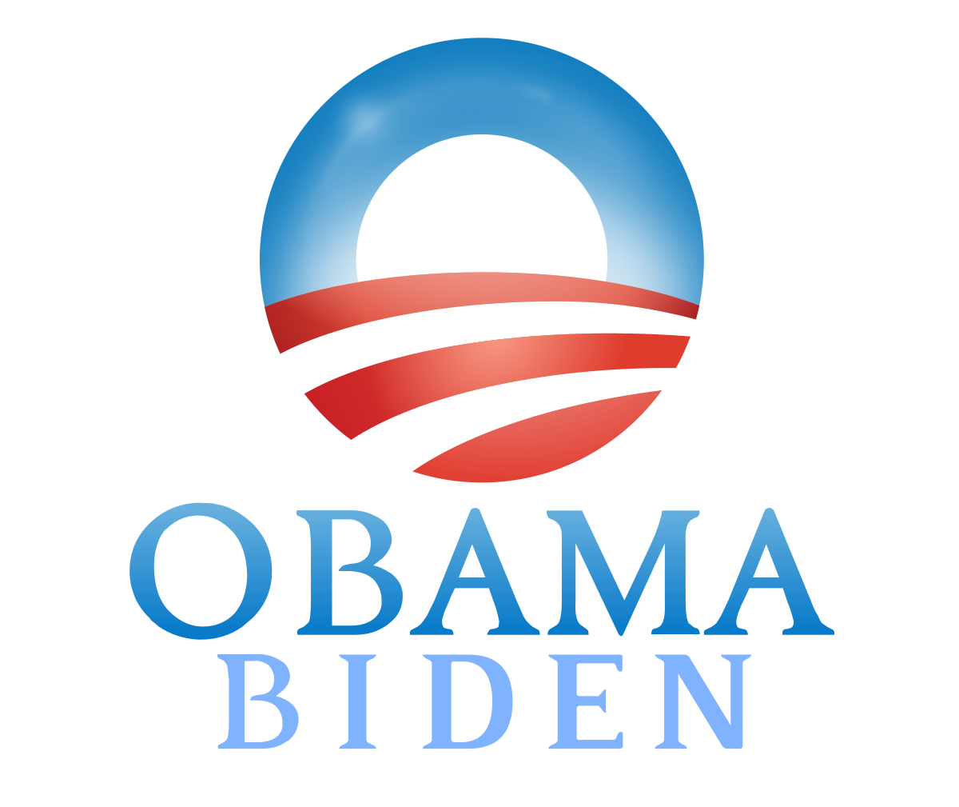

Fig 15. Obama Campaign Logo

It was announced on August 27th 2008 that Barack Obama and Joe Biden would be representing the Democratic Party in the race for President and designs were quickly formulated and distributed across the country to kickstart the campaign. The logo was used extensively across the promotional materials including flyers, signage and posters. The idea was to have “The sun rising over the horizon evoked a new sense of hope” (Glenn, 2007) and used the colour palette of red, white and blue.
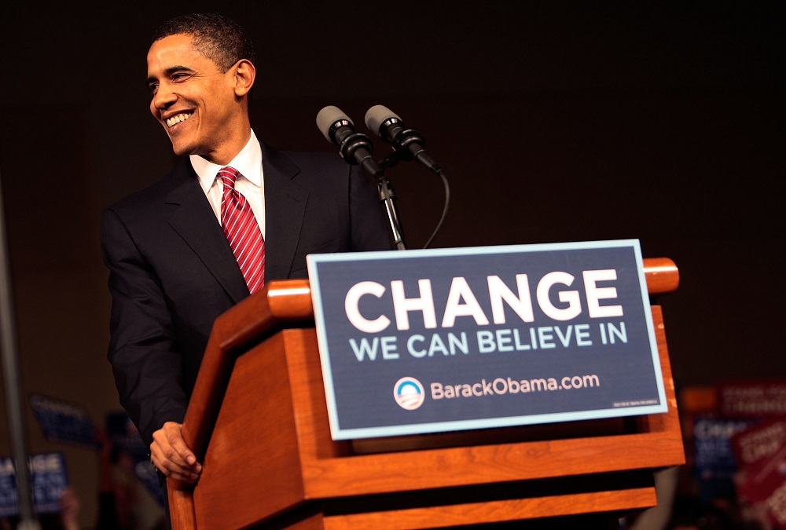

Fig 16. Obama Campaign Poster

The campaign also featured the slogan ‘Change we can believe in’ which was prominent in the design of posters used at rally’s and public speeches. The fact that the word ‘Change’ is the largest piece of text within the layout assists in persuading the viewers that he is the change they are looking for and need. The overall appearance of the posters is minimal and professional which also enables the words themselves to be more powerful.
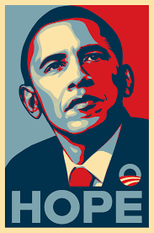

Fig 17. ‘Hope’

An iconic poster relating to the Obama presidential campaign is Shepard Fariey’s creation entitled ‘Hope’. The stylised imagery combined with the bold usage of colour and typography resulted in social media users spreading the image across multiple platforms, increasing its audience and making it a crucial part of generating votes from the younger target audience.

The motivation for this poster came when campaigning for the Democrat leadership. of Obama’s opponent Hilary Clinton had started to gain in the polls and Fairey was called in to generate imagery that “Obama supporters were hungry for” (Scott, 2017). Re-creating a pose previously associated with JFK, the portrait helped establish him as an important political figure whilst still having a modern and fresh appearance. The poster captures Obama’s idealism and was very successful in appealing to the progressive audience who would vote and support him. This poster campaign was clever because through the use of the word ‘Hope’, power was generated on an individual basis through stories and associations people have with that specific word. Even though these images and ideas may not match with that of Obama’s policies, they get caught up in the overall fantasy a word this powerful generates and forget to stop and question exactly who and what it is they are voting for.

The scale of the poster’s success was nationwide and “the demand for the portrait was so large that over the course of Obama’s campaign a total of 350,000 posters were produced” (Scott, 2017). It also circulated online and could be viewed across a number of platforms including official websites, Twitter and Facebook. It has also inspired posters belonging to a series entitled ‘We the People’ (Fig 23) by the same artist relating to the 2018 presidential election.

From this example, it is clear that posters can assist in the generation of power behind specific individuals and are an important element to generating trust in a political campaign. They are crucial to ensuring that the messages politicians want to spread are done so efficiently and effectively and can be appreciated and understood by anyone who views them. Another factor that this poster highlights is the developing use of technology as a tool that designers can harness to greater their artworks influence and power.

Chapter 3 – 2010 – 2019

Barack Obama’s Second Term

After a successful first year as President of the United States, Barack Obama’s influence on the American people had already begun to alter the public perception and opinion regarding healthcare, climate change and the American dream. With the implementation of new laws to boost the American economy, it came as no surprise when he announced his decision to run for re-election in 2011. At the time of the announcement, journalist Michael D Shear states that this new campaign “Would ask Americans to endorse the status quo over the increasingly vocal calls from Republicans” (Shear, 2011) and this was taken into great consideration when designing the new campaign’s identity.
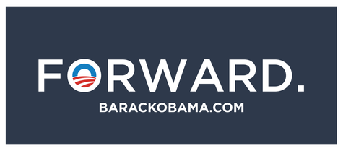

Fig 18. ‘Forward’

It is clear, when comparing this campaign with the previously mentioned work of Shepard Fairey in 2008, that the need to generate and cultivate power with the design is no longer the main goal. Instead, there is a more prominent use of language as a tool of persuasion. Typography plays a dominant role across this campaign as its ability to efficiently highlight and communicate key political ideas and goals without distracting viewers met the designer’s intention; “The pure focus was to reflect president” (Banks, 2012). Overall, the clean and minimalist aesthetic conveys an aura professionalism and reflects the change in the design style of 2012.

Alongside this, the interactive poster collaboration between graphic designers and artists across the United States entitled ’30 Reasons’ began (October 2012). This project consisted of a series of 30 posters, designed by 30 artists, over the course of the 30 days leading up to the 2012 election. Each poster illustrates a different reason why people should vote for Obama and they were shared with the public via e-mail. This use of technology allowed these digital posters to circulate the country much faster and reach a much larger audience. Some of the posters have strong visual links to Obama’s first presidential campaign i.e. they focus more on the use of graphic imagery as opposed to typography, and this highlights just how influential the initial designs were as a form of propaganda and identity development in this presidential campaign.
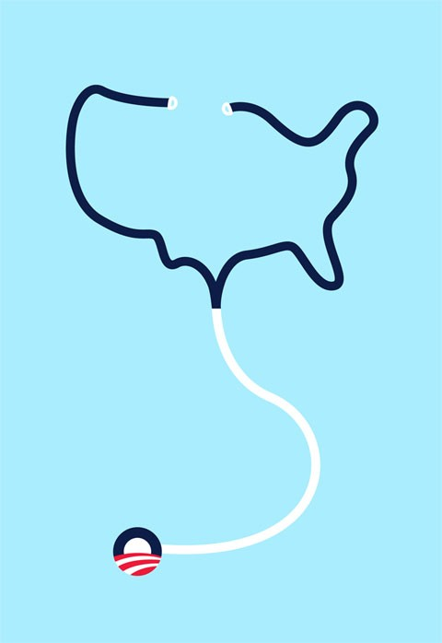
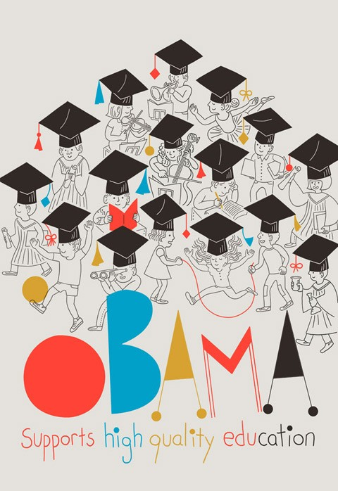

Fig 19. ‘Oct 9th’ Fig 20. ‘Oct 19th’

Obama and vice president Joe Biden were extremely vocal about their support of the changes made to the Federal Marriage Amendment, which was written in 2004. This restricted the rights of LGBTQ+ community. “It would represent the first time a restriction of the rights of a group of people was written into our constitution since it was ratified in Philadelphia in 1789" (Cahill, 2004), and greatly affected the lives of homosexual couples across the country.

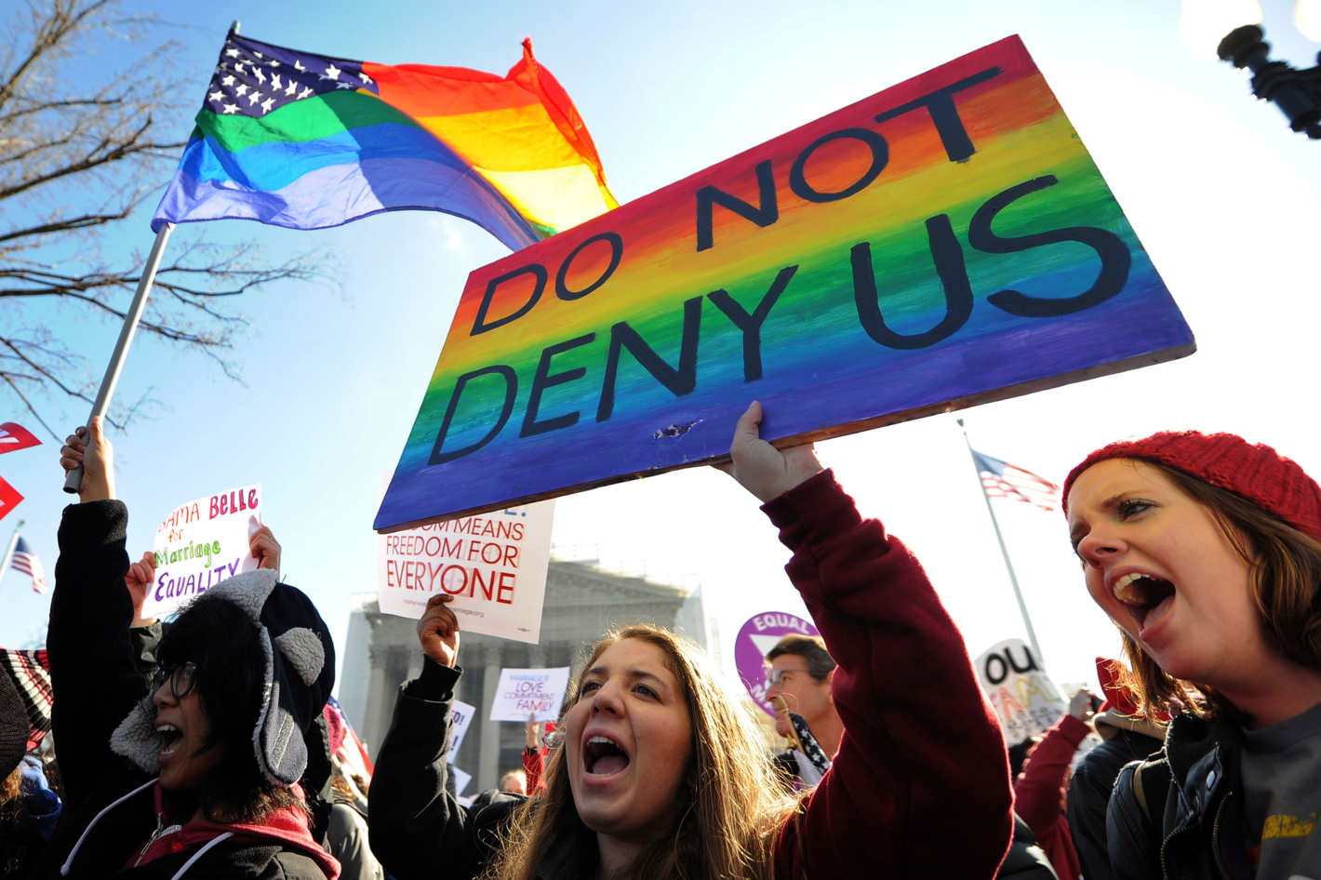

Fig 21. Image of protestors at Equal Marriage March

The fight for marriage equality had become more prominent across the political landscape of 2013 and the masses decided to harness the power of posters themselves in the hopes of speeding up the process. Strikes and marches were held in multiple towns and cities across America and this generation of power proved successful as “22 senators publicly announced changes in their support for same-sex marriage, pushing support to its highest level” (Theriault & Herschel, 2014).

The next two years saw amendments to legislation being implemented state by state, until June 26th, 2015 when the Supreme Court ruled that all fifty states must recognise and allow the marriages of same-sex couples. This was a momentous step in a positive direction for the rights of the LGBTQ+ community and demonstrated the social change that can be inspired by socially conscious design.

The election of President Donald Trump
As Obama’s final term began, his presidency was coming to a close and America was now looking for a new commander-in-chief. Thus, started the political campaigning for the current President of the United States, Donald Trump. One of the key elements and driving forces behind the success of this campaign is the use of the slogan “Make America Great Again”. With a heavy reliance on the nostalgia of a past riddled with racism and inequality, Trump implies that the changes that were previously implemented by the Obama Administration have taken America in the wrong direction, and that it is his leadership, and his leadership alone, that will restore the country’s greatness.



Fig 22. Poster from Donald Trump’s Presidential Campaign

These four words themselves carry elements of nostalgia, back to Ronald Reagan’s reign as President in the 1980’s (akchuck, 2016). The use of the colours red, white and blue are appropriate with the connotations of the American flag, patriotism, freedom and independence, all of which are things that Trump wants to draw upon to gain power. The ideology of recreating a political landscape of the past whilst simultaneously trying to paint a picture for the future is a large part of the controversy surrounding Trump’s election. It has also been a key influence in the creation of posters from artists and activists alike.
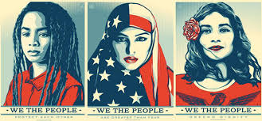

Fig 23. “We the People”

At the news of Trump’s inauguration, artist Shepard Fairey, once again decided to express his opinion in the form of a series of posters entitled ‘We the People’. They were created with the intention to raise awareness of the vulnerable people who would be “feeling that their needs would be neglected in a Trump administration” (Amah-Rose Abrams, 2017)

This poster series takes the patriotic colour palette and uses it to demonstrate that all of the people pictured are American, no matter their race, gender or religion, and to express that the themes of community, inclusion and equality are what should be focused upon by the government administration in order to develop as a nation and build a better future for the American People. Trump’s campaign has a main focus on “Making America Great Again”, which implies a universal promise to every single American for a better and brighter future. However, these illustrations are “Concentrating instead on the ethnic groups that campaigners fear face being excluded from this new president’s America” (Buwert, 2017) due to the deep-rooted racism and prejudice that Trump’s campaign attempts to reignite across the nation. Previous administration had incited positive change towards social inclusion, and these illustrations try to display the urgency behind continuing this change, as opposed to supporting Trump’s ideology and considerably bigoted views. They bring together the worlds of politics and design in order to instil reactions in like-minded people who agree with the message they portray and are willing to be a part in the fight for change.

The overall design of these posters has led to a generation of power in both the political and everyday environment, by empowering individuals and allowing them to realise that they possess the ability to be a key influence in directing the country’s future if they can find “their common humanity, and look beyond maybe one narrow definition of what it means to be American” (Amah-Rose Abrams, 2017). This response to the president’s initial campaign caused a major uprising amongst the public and protests are now a common occurrence across America. This highlights how powerful the combination of type and imagery can be and just how large of an influence one piece of work can make, not only in its country of origin, but across the globe.

Brexit
Currently, the United Kingdom is dealing with a national divide resulting from the controversial policy of Brexit, that will allow Britain to leave the European Union. Much like Donald Trump trying to revisit and emulate America’s past, British politicians are trying to persuade both the older generations and millennials that in order for Britain to have a successful future, we need to look to and draw inspiration from the past. They want us to look to a Britain that was “A simpler time, a time when you had your cup of tea and digestive biscuit and there weren’t any foreigners around” (Barber, 2018). The idea of nostalgia is clearly widespread amongst politicians from across the world and it is resulting in the proposals of major law changes. These themes have been a strong part of the driving force behind the design decisions made during this campaign.

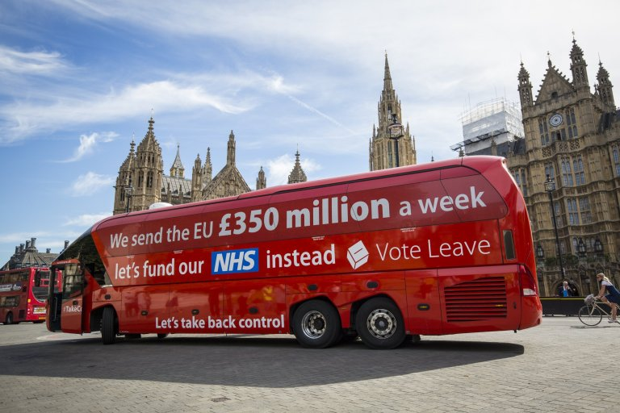
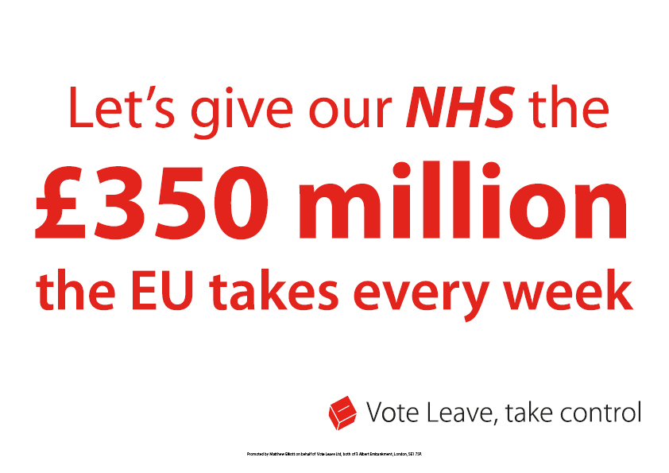

Fig 24. ‘Vote Leave’ Campaign Poster Fig 25. ‘Brexit Bus’

One of the most notable examples is that of the ‘Vote Leave’ campaigns poster depicting ‘facts’ about how much money we give, as a country, to the European Union which was later adapted to fit onto a bus, more commonly known as the ‘Brexit Bus’.

A limited colour palette of red and white in the original poster lends the viewers focus to the typography used and gives the words themselves a much stronger impact. The use of the campaign tagline, ‘Vote Leave, take control’ attempts to convince audiences that, as citizens of the EU, they lack any power to influence politics or insight social change, and is used as a form of persuasion to provoke an emotional reaction and subsequently, vote in favour of the campaign in order to gain this ‘control’. By adapting the poster into a bus wrap, the design and its take-home message reached a larger audience, and this was key in in the making the ‘Vote Leave’ campaign more successful than its opponents. According to marketing experts, “The Britain Stronger in Europe brand was stillborn. On the basis of preparation, presentation and messaging, it deserved the kicking it got”. (Hind, 2016)

Due to the poor public response to the remain campaigns, German artist Wolfgang Tillsmans decided to channel his artistic abilities into creating a series of posters expressing the freedom of movement that the European Union offers us in the United Kingdom.
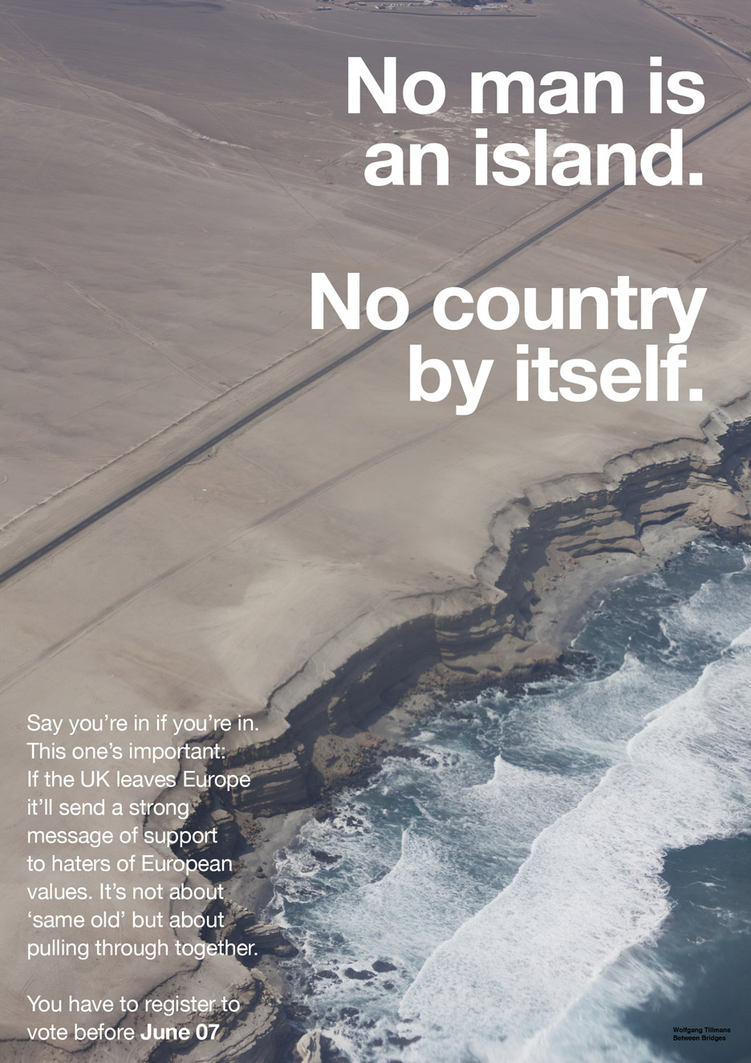
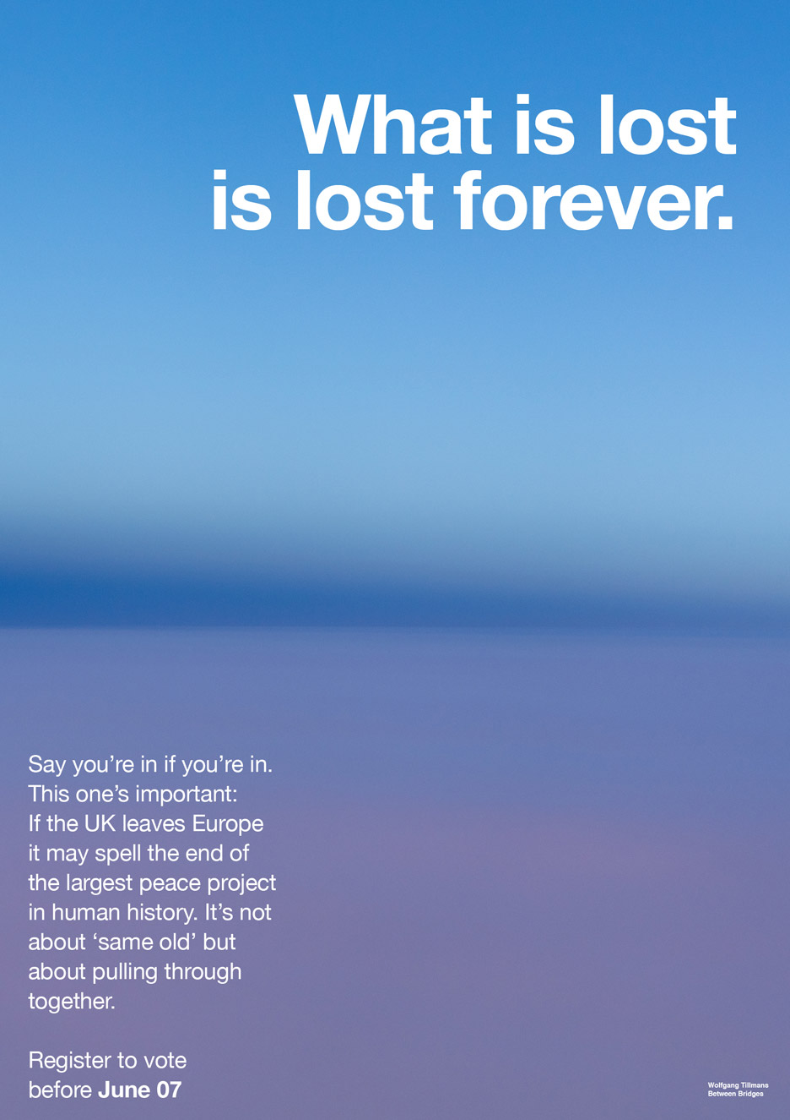

Fig 26. ‘What is lost is lost forever’ Fig 27. ‘No man is an island’

Aimed at students, young voters and like-minded individuals, these posters combine strong imagery with clean, minimal typography. The use of emotive language as a tool for expression and persuasion is apparent across the differing versions and the use of sans-serif text links with the simplicity of the message being portrayed. His posters were also available online, alongside a downloadable information pack encouraging people to vote and share this message with a wider audience through the use of social media. This addition to the physical posters made it more appealing to a modern audience and ‘they reveal a keen understanding of branding and visual communication in the digital age” (Elephant Magazine, 2019). Perhaps, by targeting these posters exclusively to a younger audience, Tillsman’s campaign didn’t reach as large of an audience as it had the potential to, and his references were not understood as well as the would have been by the nations older demographic.

It can be seen from these examples that the design of posters and campaign materials has a huge impact on the audience that views them. They can influence a wide range of public opinions and impact how a party or politician is perceived, and can also act as a main source of information for people to base their votes on. As the Brexit policy continues to be a talking point of British politics, the creation of campaign posters and possibly even posters for protest is something that will continue until a decision is made.

Analysis/Discussion
Since the invention of the poster, it’s purpose and appearance has been manipulated by designers across the globe to deliver their desired messages. For a while they were considered to just be a form of art, however society quickly learned that in fact, posters play an integral role in our everyday lives and have the power to influence our decisions regarding a wide range of topics, but most notably throughout history, a political landscape.

From examining prominent poster campaigns across the political landscape of past and present, design choices regarding imagery, typography, colour and size all effect how much power and influence a poster can have. All of these elements will change the psychology of a design and can generate a different outcome than originally intended, for example: Tillsman’s Brexit campaign posters. (Fig 26 & 27) Political posters have been able to in-still a range of emotions upon people from fear with the AIDS crisis and Nazi propaganda to the ideals of ‘Hope’ and ‘Change’ with the Obama presidency campaign, and all of this is done through the thoughtful usage of design elements.

Whilst many people disliked Donald Trump and thought it impossible for him to become President, a bold, gripping and professional campaign may have been a key factor in his victory. Connecting to the target demographic through clean typefaces and a patriotic use of colour, everything was easy for them to understand. It allowed for no mixed messages and interpretation from voters, they knew exactly what he stood for and trusted in a design. When comparing this to the original Obama campaign that had a strategy of allowing for the broadest interpretations, it shows that as long as design is tailored to the people it represents and a specific target audience. A multitude of combinations can be successful in the generation of power, behind either an individual or campaign.

Both the campaigns for the American Presidency and Britain’s Brexit are a testament to how much people will trust and believe in the words and typography used on posters. The backlash that came from the Brexit Bus after voters realised the facts displayed was incorrect, led to a huge distrust in politicians associated with the leave campaign and people were hurt or duped that they had based their important political decisions on a lie. The use of powerful words that stand alone and slogans such as ‘Make America Great Again’ are used to connect to people on an individual and national scale. It draws upon their ideals and visions for the future which influences images that are linked with the politician.

Despite some of these campaigns being generated numerous years apart and on multiple continents, it is clear that posters using powerful imagery and typography from past and present, have influenced campaign designs. Designers can reflect and learn from important political movements and the posters they created questions accountability. Nostalgia is quite important within the world of design as it allows people to make personal and emotional connections to what we create. Enriching designs with sentimentality and meaning increases the likelihood of remembrance for crucial political campaigns and the overall influence they have on society.

Currently, the Labour Party are running a campaign that involves sourcing Graphic Designers online and using their work as tools for visual persuasion. The passion felt by these designers is channelled into the artwork they create and is subsequently felt by the campaigns audience. Using technology to their advantage, campaigns like this connect to a much larger number of people whilst also creating new relationships between designers across the country who decide to get involved. Perhaps, this way of combining passion and art is the way forward in creating visual exciting campaigns that possess the ability to connect with a national audience on a more emotional level.

Conclusion
In our society, the daily decision-making, based on the information presented to us influences outcomes. The Visual Communication holds an ethical responsibility. The generation of power behind political movements must be treated with importance and caution when designers are tasked with creating visually exciting campaigns, and posters are a highly effective format to use when campaigning for political change.

Abiding to our moral codes as designers can be difficult due to restrictions within a workplace environment. It is important for designers to take on commissions and employment that allow them to challenge both personal and societal perceptions. This makes for more powerful, thoughtful and influential design. Lucienne Roberts states that “Designers tend to be idealists – they are interested in utopian and radical ideas, in changing things and are motivated to make a difference” (Dawood, 2018). If all designers started to carefully consider the impact they have on people, design can be transformed into something viewed as more than just shapes and colours. It can be appreciated by the masses as a generator of power and influence, opening people’s eyes to the level of change we can create in today’s uncertain political climate.
List of Illustrations

Fig 1.Cheret, J. (1891) ‘Yvette Guilbert au Concert Parisien’ [Lithograpah]. Available at: https://collections.lacma.org/node/170563 (Accessed : 24 July 2019)
Fig 2.Glaser,M. (1966) ‘Dylan’ Available at: https://www.moma.org/collection/works/8108 (Accessed: 25 July 2019)

Fig 3.Rand,P.(1981) ‘I.B.M’ Available at: https://collection.cooperhewitt.org/objects/18695343/ (Accessed: 28 July 2019)

Fig 4. (1908) ‘Votes for Women’ Poster

Fig 5. ‘Suffragette Meeting’ Poster (1908)

Fig 6. Mentschel,C.(1908) ‘Votes for Workers’ Poster Available at : https://www.bbc.co.uk/news/in-pictures-42875095 (Accessed: 18 September 2019)

Fig 7. Grant, D. (1909) ‘Handicapped’ Available at : https://www.bbc.co.uk/news/in-pictures-42875095 (Accessed 18 September 2019)

Fig 8.Geobbles, J. (1937) ‘Give me 4 years of Time’ Available at: https://www.nytimes.com/2008/08/03/books/review/Benfey-t.html (Accessed: 17 August 2019)

Fig 9. Zec,P. (1941) ‘Come into the factories’ [Poster] Available at: http://www.iwm.org.uk/collections/item/object/38928 (Accessed: 15 September 2019)

Fig 10. (1938) ‘Dig for Victory’ [Poster] Available at: https://www.alamy.com/stock-photo/dig-for-victory-poster.html (Accessed: 26 August 2019)

Fig 11. (1970) Protesters at Women’s Strike in New York [Photograph] Available at : https://time.com/4687509/day-without-a-woman-history-womens-strikes/ (Accessed: 22 September 2019)

Fig 12. (2018) Women’s March in Washington D.C Available at : https://www.gettyimages.co.uk/collections/bloomberg# (Accessed: 28 August 2019)

Fig 13. ACT-UP (1987) ‘Silence=Death’ Available at : https://nomoi.hypotheses.org/198 (Accessed: 17 September 2019)

Fig 14. O’Connor-Thompson, D. (1987) ‘Don’t die of ignorance’ Available at : https://www.theguardian.com/culture/2017/sep/04/how-we-made-dont-die-of-ignorance-aids-campaign (Accessed: 29 September 2019)

Fig 15. (2008) Obama Campaign Logo Available at: https://www.wired.com/2015/09/maybe-trump-just-borrow-obamas-campaign-logo/ (Accessed: 8 July 2019)

Fig 16. (2008) Obama Campaign Poster Available at: https://www.politifact.com/truth-o-meter/article/2017/jan/05/tracking-obamas-top-25-campaign-promises/ (Accessed: 10 July 2019)
Fig 17. Fairey, S (2008) ‘Hope’ Available at: https://www.esquire.com/news-politics/interviews/a35288/shepard-fairey-street-art-obama-hope-poster/ (Accessed: 13 July 2019)
Fig 18. Higgins, J (2012) ‘Forward’ Available at: https://www.designweek.co.uk/issues/may-2012/designing-the-obama-campaign/ (Accessed:16 September 2019)
Fig 19.Um,T (2012) ‘Oct 9th’ Available at: https://ifitshipitshere.blogspot.com/2008/12/30-graphic-designers-gave-us-30-reasons.html (Accessed: 23 July 2019)
Fig 20. Brand, C (2012) ‘Oct 19th’ Available at: https://ifitshipitshere.blogspot.com/2008/12/30-graphic-designers-gave-us-30-reasons.html (Accessed: 23 July 2019)
Fig 21. Samad, J (2014) ‘Equal Marriage March’ [Photograph] Available at: https://www.gettyimages.co.uk/photos/jewel-samad?family=editorial&sort=best&phrase=jewel%20samad (Accessed: 14 August 2019)
Fig 22.(2016) Poster from Donald Trump’s Presidential Campaign Available at: https://www.donaldjtrump.com/assets/images/site/icons/logo_color.png (Accessed: 16 July 2019)
Fig 23.Fairey,S (2017) “We the People” Available at: http://theconversation.com/shepard-faireys-inauguration-posters-may-define-political-art-in-trump-era-71583 (Accessed: 27 July 2019)
Fig 24. (2015) ‘Vote Leave’ Campaign Poster Available at: http://www.voteleavetakecontrol.org/campaign_resources.html (Accessed: 30 August 2019)
Fig 25. Cummings,D (2016) ‘Brexit Bus’ Available at: https://www.independent.co.uk/news/uk/politics/brexit-latest-news-vote-leave-director-dominic-cummings-leave-eu-error-nhs-350-million-lie-bus-a7822386.html (Accessed: 13 July 2019)
Fig 26.Tillsmans,W (2016) ‘What is lost is lost forever’ Available at: https://elephant.art/wolfgang-tillmans-anti-brexit-posters-make-personal-political/ (Accessed : 28 October 2019)
Fig 27. Tillsmans,W (2016) ‘No man is an island’ Available at: https://elephant.art/wolfgang-tillmans-anti-brexit-posters-make-personal-political/
(Accessed : 28 October 2019)

Bibliography
Akchuck, 2016. Reagan: "Make America Great Again". [Online]
Available at: https://www.youtube.com/watch?v=MGrr3ULSXM
[Accessed 17 August 2019].

Amah-Rose Abrams, 2017. Shepard Fairey Releases ‘We the People’ Series to Protest Trump. [Online]
Available at: https://news.artnet.com/art-world/shepard-fairey-releases-we-the-people-series-824468
[Accessed 21 October 2019].

Banks, T., 2012. Designing the Obama Campaign. [Online]
Available at: https://www.designweek.co.uk/issues/may-2012/designing-the-obama-campaign/
[Accessed 23 June 2019].

Barber, T., 2018. Nostalgia and the promise of Brexit. [Online]
Available at: https://www.ft.com/content/bf70b80e-8b39-11e8-bf9e-8771d5404543
[Accessed 17 May 2019].

BBC News, 2018. The 100-year-old protest posters that show women's outrage. [Online]
Available at: https://www.bbc.co.uk/news/in-pictures-42875095
[Accessed 18 September 2019].

Buwert, P., 2017. Shepard Fairey's inaguration posters may define political art in Trump era. [Online]
Available at: http://theconversation.com/shepard-faireys-inauguration-posters-may-define-political-art-in-trump-era-71583
[Accessed 26 August 2019].

Cahill, S., 2004. Same-sexMarriage in the United States:Focus on the Facts. s.l.:Lexington Books.

Cohen, S., 2015. The Day Women Went on Strike. [Online]
Available at: https://time.com/4008060/women-strike-equality-1970/
[Accessed 28 September 2019].

Dean, M. E., 1929. Are we motivated by Propaganda? : A Debate. [Online]
Available at: https://postflaviana.org/wp-content/uploads/2015/07/martin-bernays-debate.pdf
[Accessed 24 April 2019].

Elephant Magazine, 2019. Wolfgang Tillmans’s Anti-Brexit Posters Make the Personal Into the Political. [Online]
Available at: https://elephant.art/wolfgang-tillmans-anti-brexit-posters-make-personal-political/
[Accessed 28 October 2019].

Finkelstein, A., 2017. After Silence: A History of AIDS through Its Images. 1st Edition ed. s.l.:Univeristy of California Press.

Friedan, B., 1963. The Feminine Mystique. 1st ed. New York: W.W.Norton & Company, Inc..
Glenn, L. Y. a. B., 2007. Chicago designers create Obama's logo. [Online]
Available at: https://web.archive.org/web/20081211033443/http://www.chicagobusiness.com/cgi-bin/news.pl?id=23974&seenIt=1
[Accessed 15 September 2019].

Hind, M., 2016. #epicfail How Britain Stronger In Europe blew it on the basics of PR & marketing communications. [Online]
Available at: https://www.linkedin.com/pulse/epicfail-how-britain-stronger-europe-blew-basics-pr-marketing-hind
[Accessed 26 October 2019].

History.com Editiors, 2018. The 1980s. [Online]
Available at: https://www.history.com/topics/1980s/1980s
[Accessed 24 October 2019].

History.com Editors, 2019. The 1980s. [Online]
Available at: https://www.history.com/topics/1980s/1980s
[Accessed 24 Oct 2019].

International Poster Gallery, 2018. A Brief History of The Poster. [Online]
Available at: https://www.internationalposter.com/a-brief-history-of-the-poster/
[Accessed 11 august 2019].

Jonze, T., 2017. 'It was a life-and-death situation. Wards were full of young men dying': How we made the Don't Die of Ignorance Aids campaign. [Online]
Available at: https://www.theguardian.com/culture/2017/sep/04/how-we-made-dont-die-of-ignorance-aids-campaign
[Accessed 17 October 2019].

Martin, E. D., 1929. Our Debt to Propaganda. In: Are we motivated by propaganda? : A Debate.. s.l.:s.n.

O'Rouke, T., 2016. Chronicle Covers: Barack Obama’s historic victory. [Online]
Available at: https://www.sfchronicle.com/chronicle_vault/article/Chronicle-Covers-Obama-s-historic-victory-8-10372412.php
[Accessed 14 September 2019].

Rhodes, A., 1976. Propaganda: The art of persuasion: World War II. 1st ed. New York: Chelsea Publishing House.

Scott, M., 2017. Obama Hope Poster — Shepard Fairey. [Online]
Available at: https://medium.com/fgd1-the-archive/obama-hope-poster-by-shepard-fairey-1307a8b6c7be
[Accessed 11 June 2019].

Shear, M. D., 2011. "Obama Re-election Facing New Political Challenges". [Online]
Available at: https://thecaucus.blogs.nytimes.com/2011/04/04/obama-launches-re-election-facing-new-political-challenges/
[Accessed 26 June 2019].

Shilts, R., 2011. And the Band Played On: Politics, People, and the AIDS Epidemic. 1st Edition ed. s.l.:Souvenir Press.

Shilts, R., 2011. And The Band Played On: Politics,People, and the AIDS Epidemic. 1st Edition ed. s.l.:Souvenir Press.

Theriault, S. M. & Herschel, T. I. F., 2014. PS: Political Science and Politics. The Diffusion of Support for Same-Sex Marriage, 47(4), pp. 824-828.

