Title of Report: Problem Solving and Decision Making
Evaluation of Possible Solutions in NHS

Number and name of author: 1706193 Gabriela Cocos
Name of Host Organisation: University of Wales Trinity Saint David
Date of Report Publication: 20th of July 2018

Executive Summary

The purpose of this report is to define a complex problem in the workplace including its scope and impact which is the waiting line in the NHS. This problem is solved by various methods learned at the course Problem Solving and Decision Making such as: Fishbone Analysis, Stakeholder Theory, Swot Analysis and PESTLE.
This report highlights an evaluation of possible solutions for the waiting time in the NHS.
The report found that the subject of waiting time in the NHS is not a new one and that in the past were tried various solutions for diminishing the waiting time, only that this problem is still highlight by the patients, the problem for which solutions are found resolution in this report in the form of specific analyses.

Table of content

- Introduction

The NHS represents the National Health service of which all people living on UK territory can benefit without having to pay for the services offered. With the NHS you can benefit from the urgent help from a professional person in the field of medicine or in the ambulance service where a patient's life is endangered and with the help of which (ambulance) you can be transported to a hospital.
The National Health Service (NHS) was set up by the Minister of Health at that time (Aneurin B.) on July 5, 1948. This date was marked in law as the day from which all residents of the UK have the right to medical assistance offered by the Government without having to pay.
Before the NHS, there were more health systems in Britain. People who could not afford to pay their medical treatments, often called on loans to cover expenses, but after the emergence of the NHS all persons who share the territory of the UK have the benefit of the free services offered by Doctors when they were sick or injured.
Many consider the NHS to be one of the most precious resources of society, but historically, the NHS has been subjected to pressure, and this pressure is increasing for some reason. Some reasons are the economic, social and political reason.
“Everyone - rich or poor, man, woman or child - can use it or any part of it. There are no charges, except for a few items. There are no insurance qualifications. But it is not a “charity”. You are all paying for it, mainly as taxpayers, and it will relieve your money worries in time of illness’” (Webster, 1998)
Ever since the NHS was set up, medicine has revolutionized and transformed lives. The NHS principle is to carefully treat all patients without asking for money for this. If the NHS is talking, it's a direct one. It does a great job for individual patients, offering high quality care services. The NHS reduces insecurity for families, especially in economic times and dislocations. And as one of the most cost-effective health systems in the world, it contributes directly to the success of the British economy.
- The quality of NHS services is improving radically.
The care services and conditions that have been offered before, are definitely much better than three or five years ago. Annual cancer survival rates are up and heart attack have tumbled. Greater transparency and growth of expectations means greater awareness of which gaps and variation.
“Although they are substantially lower than they were a decade ago, waiting times have been edging up.” (Anon., 2017)
- Staff numbers are up, but staff are under greater pressure.
In recent years, starting in November 2014, there has been an increase of almost 8000 or more of doctors and nurses working for the NHS, but there are still gaps in certain professions and specializations. The staff in the beginning line of the NHS say their experience at work continues to improve, from year to year. But only about 50% of staff is satisfied with the opportunities and flexibility it offers the job, and about 15% experienced Physical violence on the part of patients, relatives of patients or members of the public.
- The public are highly satisfied with the NHS, but concerned for its future
Perhaps surprisingly, the satisfaction of patients with the NHS is higher than in the last 30 years. This shows public satisfaction that the hospital is much more endowed than it was before.
“In 2016 the NHS remained popular with the public, far more so than it was 10 or 20 years ago” (Fund, 2016)
- The Stakeholders for NHS
A person, a group or an organization who has interest or concern in an organization. stakeholders may affect or be affected by the actions of organisations, or policies. Some examples of key stakeholders have employees, creditors, directors, government, owners, unions, suppliers, and the community from which the business draws its resources.
“Not all stakeholders have equal. The company's customers have entitled to fair trading practices but they are not entitled to the same consideration as the company's employees.” (Anon., 2018)
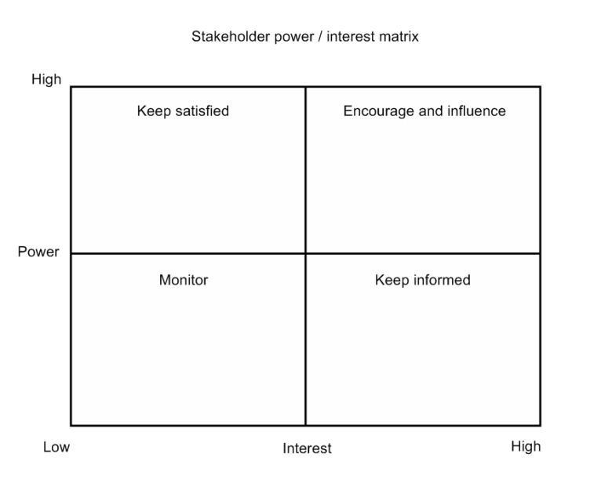
- Customer Service centre
- Strategic Leadership Team

- Adult social care staff
- Director of Public Health
- Head of Health Intelligence and Information

- County Councils Members
- Providers

- Voluntary Voice
- Public Health
- People with existing care needs and carers

- Main Findings
The NHS represents the most effective solution for a UK resident who wishes to benefit from the medical service. The NHS doctors are totally committed to their job, and no one can make them change their principles. The primary risk of the NHS in the Lisp of funds or donations is the high calling time for each patient from registration to the time of treatment, exception making the emergency cases or people suffering from cancer.
The NHS has some of the most competitive standards in the world. These standards cover health care and the time of liability of the ambulance. New measures and ideas come every year to shorten patient waiting time. This waiting time can vary from one patient to another.
“The NHS should be proactively using substantial resources across government to intervene and try to deliver positive improvements in people's standards of living.” (Lansley, 2012)
2.1 The main problem in the NHS
The waiting time starts from the point the hospital or service receives the referral letter, or when first appointment is booked through the NHS e-Referral Service. This is a new system adopted by the NHS to ease patients visit.
During this time, the patient may:
- undergo tests, scans or other procedures to help ensure that your treatment is tailored appropriately to the condition;
- have medication or therapy to manage the symptoms until the patient receive the treatment;
- be referred to another consultant or department;

The waiting time ends if a clinician decides no treatment is necessary, the patient decide to refuse to be treated, or when the treatment begins.
This could include:
- being admitted to hospital for an operation or treatment;
- starting treatment that doesn't require to stay in hospital, such as taking medication;
- beginning fitting for a medical device, such as leg braces;
- agreeing to the condition being monitored for a time to see whether need further treatment;
- receiving advice from hospital staff to manage the condition;

“I'm not going to go mystery shopping in the NHS because we have a million people every day using it and rating its facilities.” (Lansley, 2014)
The seed of the time of waiting in the NHS is not necessarily the procedure or bureaucracy behind this time of waiting, but the waiting time itself. During this time of waiting, patients can weirder their health or give the impression that this is happening, pressure and impatience are also increased by this long waiting time, and physicians are over demanded by the large number of patients who They wait to be treated every day. Another stalemate is that more and more young doctors refuse to work overtime due to much too low wages, and experienced physicians do not have the time to do so.
“If your brain's not right they have good people at the NHS to help you fix it and talk to and counselling to calm you down and to focus you.” (Bruno, 2014)
Through this system in the UK, everyone has the right to free medical assistance, doctors and system clinics (NHS) being fully funded by the state.
Due to gratuity, no matter the social status or money available to a patient, so that all are treated equally by the state-funded health system (NHS).
There are, of course, private clinics and independent practitioners, to which citizens call for various reasons. The main reason is the waiting time, which in the case of the NHS is 2-6 weeks for a consultation with the GP, and in the case of a private clinic it may not even need an appointment.
A&E (Accident and Emergency) – Section/hospital emergency medical system in the UK is different from most systems of the same kind in the world. It is often taken as a model, its effectiveness being increased, both in terms of costs, and from the point of view of patient treatment.
The major differences consist of:
– Gratuity for all patients, without being conditioned to pay an insurance
– The structure of the system, which is based on family medicine.

There are, of course, private clinics and independent practitioners, to which citizens call for various reasons. The main reason is the waiting time, which in the case of the NHS is 2-6 weeks for a consultation with the GP, and in the case of a private clinic it may not even need an appointment.
Only through the family doctor (GP) where a patient is registered, it may be possible to access the British medical system when a patient wants to solicit it. Specialist doctors cannot be contacted directly by the patient but in order to obtain an appointment, a letter of reference from the family doctor from where the patient belongs is required. The UK National Health Service (NHS) is free of charge for all citizens living on the territory of Great Britain. The NHS services include primary medical care with a patient's home visit in case of emergencies, visits to the family doctor, family planning, hospitalization, specialist care and dentistry.
What are the main challenges the NHS must face?
Currently, the following are:
- A growing population,
- An ageing population,
- An increase in reliance,
- Evolving healthcare needs,
- Medical advancements which costs considerably
Some research showed that last year, £ 140bn were spent on health in the UK, which means 10 times more than 60 years ago.
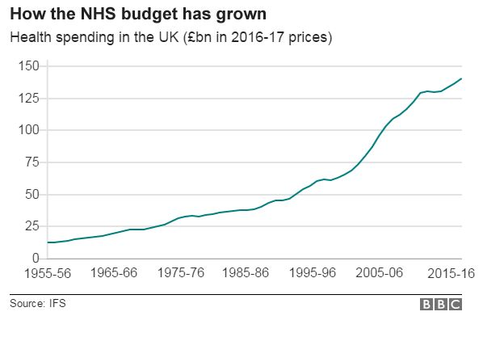 (Triggle, 2017)

More and more people spend more on health
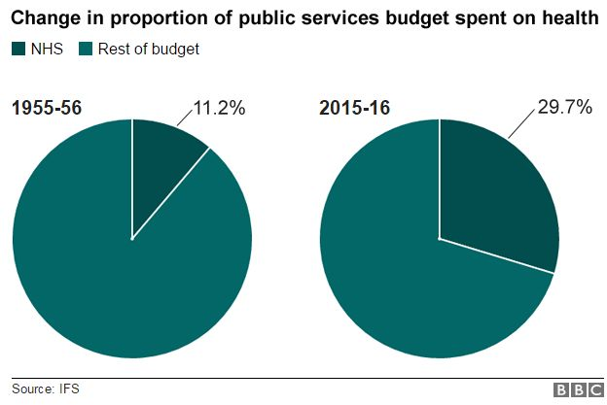 (Triggle, 2017)

The number and proportion of patients in the NHS hospital in UK waiting more than 18 weeks for starting treatment increased to their highest level in just seven years. In February, almost 40,000 admitted patients did not start the treatment in the 18 weeks of calling, and more than 13,000 waited more than 26 weeks. The target the NHS proposed is that 90% of patients receive treatment in less than 18 weeks, but only 87% received.
The most worse performance, for both percentages and the absolute number. The NHS is supposed to ensure that 95% of patients starting treatment in less than 18 weeks, but in February it was 94.7% lowest in June 2008. Almost 45,000 still waited after the 18 weeks, a smaller number than in October and November last year.
Waiting time is the time it takes for a patient to receive treatment after being scheduled at the hospital.
The NHS uses the waiting time to help:

- Diminishing patient anxiety
- Improving the quality of patient life
- Improvement of clinical results
- Improving treatment time

Emergency treatment
The waiting time does not apply to patients who need emergency treatment. If patients are evaluated as needed emergency treatment, patients will be seen within 4 hours, 95% of people should be discharged or transferred within 4 hours.

Waiting time
The waiting time that a patient will have to wait depends on the nature and complexity of the patient's condition and how easy it is to diagnose.

Working time waiting
A waiting time means a series of standards that determine the amount of time a patient will have to wait at each stage of the treatment.

The target for the waiting time for a treatment was not always so simple. Before the target was 90% for patients requiring admission at the hospital, and 95% target for the unadmitted.

The total waiting list has been growing since the year 2012, and there is currently a waiting list that exceeds 4 million. In the period 2007 August 2009 This waiting list has been reduced considerably from 4.2 million to 2.3 million. Unfortunately, these improvements have now been reversed, and now the NHS is almost back to where it started. While remembering that these figures refer to the number of referrals and no patients is clear that the NHS resources are failing to keep up with the growing demand for services.

According to data provided by the Organization for Economic Cooperation and Development (OECD), the United Kingdom allocated 7.7% of GDP to public health expenditure in 2015, compared to 8.6% in France and 9.4% in Germany.

Recognizing that a “huge pressure presses the NHS", Theresa May gave assurances that "never" government did not invest so much in the system, injecting 10 billion extra pounds for six years, until the year 2020.
"false ", said NHS director England, Simon Stevens, who says "the NHS financing in real terms (without regard to inflation) will drop in 2018/19 ".

"The Prime minister is in denial," the leader of the Labour opposition, Jeremy Corbyn, concluded. During a stormy meeting face to face in parliament on Wednesday, he asked Theresa May if she thought it was acceptable what happened to Jack, the child forced to sleep in an emergency chair.

“I worked in the NHS as a hospital orderly during my national service, and people thought it was a noble service. But over the years it's lost its humanity.” (Hockney, 1998)

The Chief of government evoked an "isolated incident". "Joking? I saw a large number of isolated incidents in one day in a single hospital. He has to wake up, "Rose, the mother of the child, was furious in statements for the Daily Mirror.

“The present system of protecting NHS patients was a bit of a shambles.” (Dobson, 2013)

The waiting time of 18 weeks is not only expected to be met over the hospital's trusts and the NHS as a whole, but in all services and specialties. However, Figure from down shows that the average person waiting for a neurosurgery procedure can wait to wait almost three weeks longer than a patient waiting for geriatric care; There are differences during the wait between specialties. In particular, plastic surgery, neurosurgery, cardio-thoracic surgery and trauma and orthopaedic specialties are further to meet the goal of 18 weeks. 92% for plastic surgery reached almost 26 ½ weeks in March 2018, and this may include patients who are awaiting changing life operations, would be reconstruction after mastectomy for breast cancer. The waiting times for trauma and orthopaedic patients are particularly significant because they represent 12% of the total referral pathways.

“I congratulate GPs. The high scores show the new contract is proving successful in giving practices a real incentive to improve the quality of care for NHS patients and to provide a wide range of services locally.” (Warner, 2013)
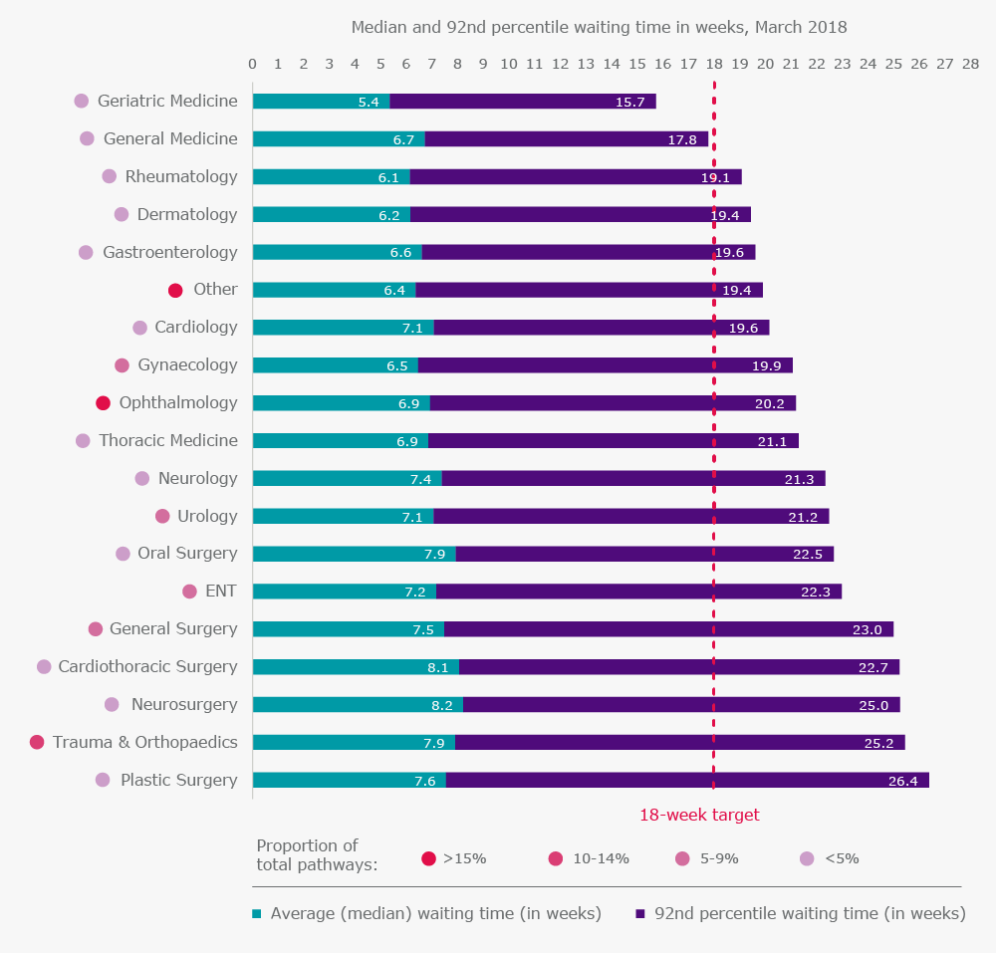 (Moris, 2018)

When it comes to resource-constrained NHS, comes the question of whether it may still happen? Firstly, wait time will increase while doctors will first deal with patients who are urgent, and managers' current demands at that time will mean that other goals, such as the four-hour A & E goal, will be a priority. Second, by postponing the objectives and eliminating financial penalties, hospitals will be able to move away from managing the goal of improving patient scheduling on a need-to-know basis. Finally, the long-term effect will be that the waiting list will increase and increase (including the number of people waiting over one year) to an extent that eventually may require a more radical intervention to tackle unresolved.
“The NHS will last as long as there is folk left with faith to fight for it” (Bevan, 2000)
  - Pestle Analysis

A PESTLE analysis, sometimes referred to as a PEST Analysis, is a useful tool for understanding the industry situation as a whole and is often used in conjunction with a SWOT analysis to assess the situation of an individual business.
A PESTLE Analysis is one of the most important frameworks of macro-environmental analysis, a framework which is a key part of advanced strategic management.
Throughout the past few years, the acronym PESTLE has suffered a number of changes, but PESTLE seems to be the most commonly used and almost unanimously accepted name now. (Staff, 2018)
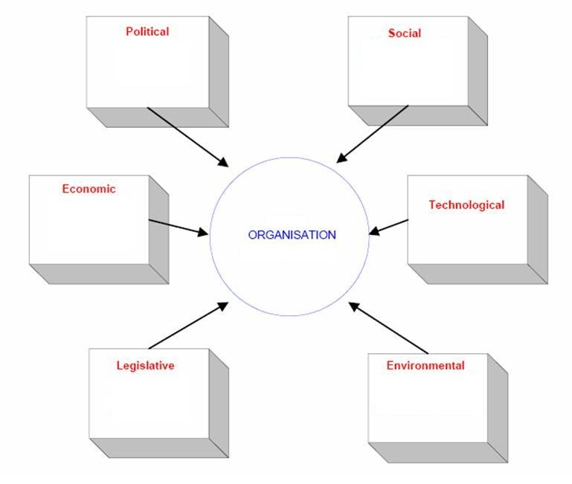
Political - These factors represent the way and extent to which a government influences the economy and a certain type of business. The policy factors are represented by specific areas, for example, tax policy, tariffs or law.
Economical - These factors refer to areas unique to the economy and are directly influenced by economic, for example, inflation rate, economic growth or exchange rates.
Social - These factors generally refer to demographic factors, for example, cultural aspects, or distribution or growth rate.
Technological - Technological factors refer to automation, incentives, the rate of technological change and R&D activity.
Legislative - It refers to all laws directly connected to a business or company and its point of activity.
Environmental - This refers to all the factors directly related, influenced or determined by the surrounding environment. This includes, but is not limited to, weather, climate, geographical position, climate change and even insurance.

- Political
- White Paper – a new direction for commissioning, changed the role of our regulator, Monitor and dissolution of SHAs and PCTs
- The expectation that outcomes improve and become amongst the best in Europe
- Home market lobbying/pressure groups
- Wars and conflict
- Funding, grants and initiatives

- Economical

- Home economy trends
- General taxation issues
- Restricted access to capital and borrowing
- NHS Tariff uncertainty and historical volatility

- Social

- Consumer attitudes and opinions
- Media views
- Law changes affecting social factors
- Ageing population and consequent
- demands upon healthcare providers

- Tehnnological

- Competing technology development
- Replacement technology/solutions
- Advancements in technology leading to a new practice and improved life
- Expectancy

- Legistlation

- Introduction of constitution and impact on NHS service, e.g. legal right to be treated in 18 weeks
- Current legislation home market
- European/international legislation
- Regulatory bodies and processes

- Environmental

- Environmental regulations
- Customer values
- Market values
- Stakeholder/ investor values
In marketing, before any other strategy or plan is implemented, it is crucial to have a situational analysis. Pest analysis is best suited for such situations, and it is recommended to repeat it once every six months to identify changes in macro environment. Organizations that can successfully identify these changes are able to differentiate the competition and create an advantage.

Desiring to be a complete and correct analysis in all respects, below can find SWOT analysis:

  - SWOT Analysis

SWOT Analysis – Strengths Weaknesses Opportunities threats = strength points weaknesses Opportunities threats – is the scientific formulation of the analysis process used to take a decision. Each of us has made at least once in a lifetime a SWOT analysis when it took an important decision.
SWOT analysis is a technique that can be used to evaluate some products, services or organizations so that it is possible to make a correct decision on what better development strategy.
The SWOT analysis is a great way of evaluating the general state of an organisation so that a development plan can be developed in which to take into account its strengths, eliminate weaknesses, effectively exploit Opportunities to counteract any threats.

- Strenghts

- A&E performance against national targets
- Current financial position including historical.
- Identified patient pathways for all three service lines
- Large volunteer workforce
- Management support of the stakeholders

- Weaknesses

- Limited key quality indicators or benchmarking for PTS performance
- Fleet replacement requirement for all three service lines
- delivery Inflexibility and varied utilisation of workforce
- Workforce planning and training
- Time limitation
- Lack of authority

- Opportunities
- Technological advancements
- Identified groups that could benefit from alternative patient pathways
- Foundation Trust freedoms and flexibilities
- Changing patient pathways
- Only strategic health authority area with more than one ambulance service
- Trust objectives for Improving patients’ satisfaction and the quality of care

- Threats

- Geographical and funding variances across the four counties
- Reliance on Cost Improvement Strategy as a source of funding in future years
- National and local tariff
- Poor perception of, competition for any potential loss of UCS and PTS contracts
- Future political ambitions
- Resistance
- Different assessment of the situation

  - Fishbone analysis

The fish Bone Diagram is an analysis tool that characterizes a particular process. It is also called the "Ishikawa diagram", as it was developed by Kaoru Ishikawa or, "Bone fish Diagram", because it resembles the skeleton of a fish. This diagram illustrates the main and secondary causes of a particular effect (symptom).
It is done in the group, through the brainstorming process and is used to identify the basic causes of some problems. This function explains why the present tool is also known as the cause-effect diagram.
In a typical diagram of this kind, the problem to be solved is noted in the "Head of the fish", then the causes, along, bones are strung and divided by categories. Additional causes can be added to new ramifications.

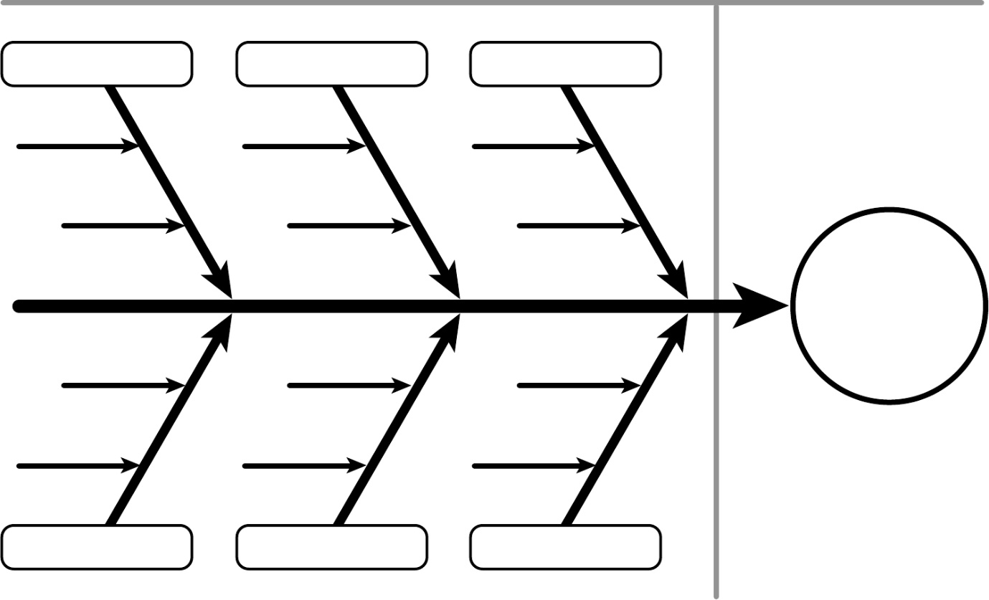
People
Equipment
Environment
Method
Waiting time

Environment
- Small waiting room
- Too few clinic rooms
- Inefficient flows through department
- Process takes too long
- Long clinic lists

Method
- Transport arrives early
- Poor scheduling
- Patient files missing: files disorganised, notes tracking

Equipment
- Poor maintenance
- Wheelchairs difficult to find on arrival
- Patients jump queue
- Limited staff-sickness recruitment

People
- Patient don’t keep appointment time
- Ad-hoc and scheduled patients in one clinic
- Patients defer at last minute

- Recommendations

When it comes to the NHS and the waiting time, absolutely all aspects, legal, human rights, the environment, the rights of people with disabilities, must be taken into account, so as not to offend or disturb anyone the severity of decisions which the NHS took.
That is why those who are determined to make the decisions in the NHS must be very careful.
Following the analysis from above about the time of waiting in the NHS, I have come to the conclusion that some of the resolve of this great problem these days are:
The waiting time may decrease considerably if an idea of more efficient management of patients is applied.
Because in the NHS it takes a strong organization and better management of patients, a software system can be created that allows it to have a repair of patients and their interjection, so as to respect the needs of access control and Order, but also those related to medical needs. It can be a bidirectional program that allows communication between the cabinet, so that if an error occurs and, for example, a patient is inscribed in a different cabinet than needed, very easily doctors can help to correct this error. This solution of a small problem can occur without the patient losing order from the moment of arrival.
This system can be implemented with the help of state funding and implemented in all the NHS computers for better and easy functioning and diminishing time of waiting.
Another way to diminish the waiting time is through the help of patients. They can follow the entire system with which they have to be set up and fill out the GP form before presenting themselves at the hospital.

4.Conclusion
In this report are playable actions and events in the field of health, more specifically related to the NHS and their time of waiting. Not much as many people in the UK are forced to face this waiting time that the NHS suggests, that would not be a problem, the main problem is that calling time is supposed to be a minimum, grows from year to year, as can be seen in the above graphs of the Findings category. These graphs show that the situation of the waiting time is worsening from year to year and that regardless of the measures that the NHS take in order to diminish the waiting time, they do not work. In this report are identified positive features of the NHS over time, as well as negative features. They could be identified using very helpful analyses, which can be used in any type of business. In analysing pest analysis, factors influencing the Increase or decrease the situations of the waiting time and not only. With the help of this analysis, the political, economic, social, technological and environmental factors were identified. The Analysis pest can be completed twice a year for better knowledge of the traineeship in which an organization is located. In this report the pest analysis was useful because it helps to better deal with the NHS point in present. Another analysis that has a high impact in this report, is the SWOT analysis, with which the strengths, weaknesses, opportunities and NHS threats are identified, to demonstrate that any organization has both advantages and disadvantages.
At the end of the report, in the category Recommendation, one of the possible troubleshooting fixes for the NHS can be identified. This refers to the implementation of a software system in every computer that is part of the NHS for better organization of patients. Surely, in order for things to sit down and to decrease the percentage of patients who do not get treated, patients must follow the steps they have to follow to prepare an appointment.
“Government has got to invest more money in our NHS. The people who work in it are heroic. They do an amazing job.” (Gove, 2001)

- Refference List
(Bevan, 2000)
(Bruno, 2014)
(Dobson, 2013)
(Fund, 2016)
(Lansley, 2014)
(Lansley, 2012)
(Moris, 2018)
(Staff, 2018)
(Triggle, 2017)
(Warner, 2013)
(Webster, 1998)
(Anon., 2018)
(Anon., 2017)
(Gove, 2001)
(Hockney, 1998)

