1.1
Evidence Based Practice is the concept that companies can make informed decisions, using the best available information and using critical thinking to influence organisation’s outcomes better.
“Evidence-based practice is about making decisions through the conscientious, explicit and judicious use of the best available evidence from multiple sources… to increase the likelihood of a favourable outcome.” (CIPD, 2025a)
The strengths of using this practice are that it credibly supports the reasons as to why decisions are made, as they are based on evidence and fact rather than personal feeling and bias. However, there are some limitations to using this practice, such as the amount of time it could take to gather the data and evidence, which can then slow down the decision making. “Time constraints are regularly cited in every profession as being a key barrier to the application of EBP.” (The Oxford Review Briefings, 2023). It also requires the skills to analyse and interpret the data so that decisions can have a strong conclusion, which can take time and money.
An example of where Technivara could use this concept could be to improve employee retention. Instead of coming to their own conclusions as to the reason why staff leave, they could gather information from current employees as to how they feel about work (maybe in the form of a questionnaire). They could also compile data from an exit interview questionnaire and see if it correlates with the staff morale. Using this data, Technivara could then incorporate different working methods for ‘trial and error’ testing and gather feedback to then make informed decisions to accomplish staff retention, “Identifying links between employee characteristics, employee behaviour and individual, team and ultimately organisational performance allows the HR function to focus its activity in ways that improve performance.” (Briner, 2023)
Another example the company could incorporate this concept would be if they were wanting to expand their services. Before investing in growing, the company could compile market research (trends and patterns), customer questionnaires and look at competitors. Once all the information is gathered, Technivara can then decide what approach to take to reduce risk, based on evidence and facts.
In conclusion, evidence based practice will enable Technivara to make sound decisions using data and research and being able to test outcomes rather than using assumption, therefore, reducing risks and achieving more reliable results.

1.2
Analysis tools and methods are vital for organisations to recognise problems, challenges and also identify opportunities. The structure to these tools and methods can help interpret the information gathered and provide supportive evidence for decision making.
These tools can improve knowledge and reduce risk going forward, however, they can sometimes be limiting, such as the length of time it may take to gather the information before any issues or opportunities can be bought forward.
Once tool that Technivara could utilise could be PESTLE analysis. This “is a broad fact-finding activity around the external factors that could affect an organisation’s decisions, helping it to maximise opportunities and minimise threats.”(CIPD, 2025)
PESTLE stands for Political, Economic, Social, Technology, Legal and Environmental. For a company to identify issues or opportunities, it is important to look at external factors and the potential impact it could have.
Advantages for Technivara using this tool would be that it does identify opportunities, such as how technology is advancing so that they may continue with their growth, and what regulations (political and environmental) are in place for when they are wanting to expand or bring in something new. By reviewing the information gathered, it can highlight further research needed or potential additional costs.
However, the limitations it could have for Technivara could be that, although it identifies issues or opportunities, it does not suggest actions that they could take. Using PESTLE can also take some time to gather the information, and by the time that information is gathered, could not be as up to date as what the company wants or needs.
With PESTLE gathering external information for the company, an analysis method that Technivara could use to gather internal information could be interviewing staff.
Interviewing internal staff involves collecting information from their employees so that they can understand any operations, issues, the work culture and performance (the positive and the negative).
Taylor and Woodhams (2016) notes that by answering questions, HR professionals will have a clearer understanding of the specific issues facing their organisation and will therefore be better able to target the evidence that will inform them.
The advantages for Technivara doing this would be that it offers an insight into how staff feel, giving an opportunity to voice feelings, ideas and problems. It can also identify what their strengths are, but also what their weaknesses are, in this case, potentially that they are mainly paper based rather that utilising potential technology to increase productivity.
However, interviewing the staff could have its downsides, such as introducing bias opinions or lack of confidentiality between staff. It could also be quite time consuming to conduct the interviews and analyse the findings, especially to a number of people, as interviewing too little may not represent the whole workforce.
In conclusion, tools such as PESTLE and methods like interviews offer different ways to diagnose opportunities and issues, both internal and external, so that informed decisions can be made going forward.

1.3
According to Howlett and Coburn (2019), critical thinking is the ability to think well and to critically reflect on the ideas, opinions and arguments of others.
As people, we can sometimes have personal bias, emotions and agendas, which can then lead to lack of objective thinking, rational arguments and self-criticism. Using critical thinking is a process of evaluating information that is provided, reviewing this rationally and to then reach a debated conclusion that is well reasoned without bias.
Technivara could debate their ideas as this will mean that they are being discussed between people with different strengths and views. Clarity in these discussions ensures that the ideas being put forward are easily understood and that everyone has the facts, not ‘fake news’. By presenting the information, critical thinking ensures that they are not taking the information at ‘face value’, but actually questioning it. Using a triangulation of multiple sources, methods and perspectives can mean that the company can have confidence in coming to their decisions. This ensures that the discussions are relevant to the ideas, logical and fact based.
For example, discussing the opinion of changing some of the people practices that Sue’s predecessor implemented may work for some of the workforce, but not all. “Corporate organisations, by definition, are collaborative. We get things done by working together.” (Howlett and Coburn( 2019 ) Collaborating with other members of the workforce means that ideas can be bounced around, demonstrating multiple perspectives and logic before a decision is made.
In conclusion, it is essential for an organisation to use critical thinking to make effective and informed decisions, based on evidence, multiple perspectives that are non biased.

1.4
To ensure effective outcomes are achieved, good decision making is essential to addressing issues, challenges, and also, potential opportunities, so that they align with an organisation’s goal. To provide clarity, structured processes can be discussed to help achieve these aims or address these issues. Whilst one decision-making approach can solve a problem, a different method may be required for another issue.
“The terms ‘decision making’ and ‘problem solving’ are often used interchangeably but are not identical.” (CMI, 2020)
With this in mind, one process that Technivara could use would be De Bono’s Six Thinking Hats.
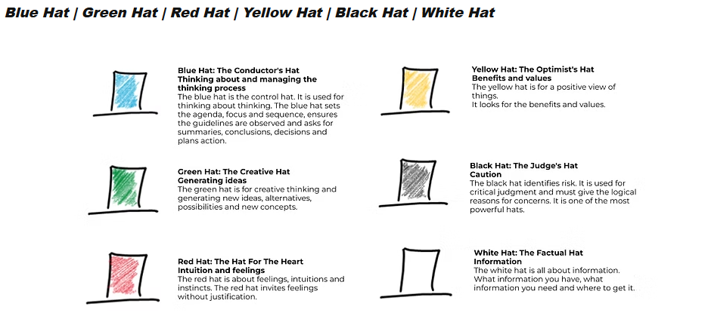
(De Bono Thinking, 2016)
With this, Edward De Bono’s approach is to encourage a group discussion, combining each of their personal thoughts, providing a combined parallel process. People ‘wearing a different hat’ results in people looking at problems differently and then coming up with different solutions. The opinion of Mulder (2016) brainstorming is one of the most effective and widly used methods to kick-start innovation.
The six different frames of mind are-
Information (White) – looking at available data and information to out forward an idea.
Caution (Black) – looking at errors, barriers and risk.
Feelings (Red) – looking at intuition and instinct without justification
Benefits (Yellow) – looking to identify advantages and positive aspects to the discussion
Creativity (Green) – looking at alternative ideas and new possibilities
Thinking (Blue) – sets the agenda, asks for summaries, plans and conclusions
The advantages of this method is that it is a practical way to structure discussions to get everyone involved in making decisions. It also inspires creative thinking, could provide a variety of possible solutions or ideas and it involves the team. However, it also has its disadvantages, including the possibility of people disagreeing strongly and could cause conflict over differences in opinions.
Another approach that Technivara could use is the Problem Frame process. This process is an effective decision-making method that helps a team to identify, understand and then work to resolve the issues.
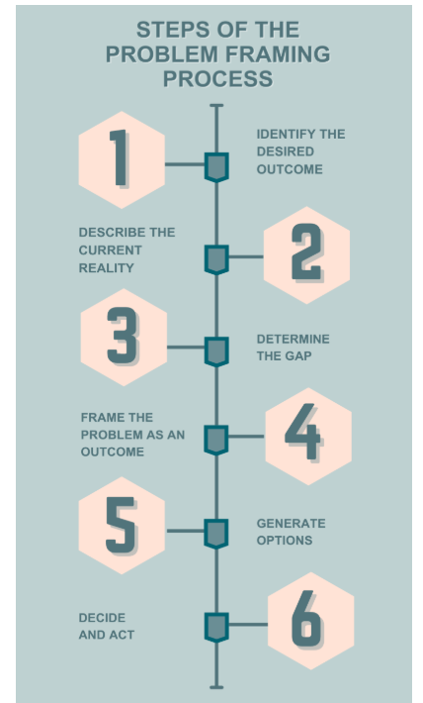
The benefits of using this model, Technivara can begin what they are wanting to achieve, either as an organisational goal, or, even smaller, as a team. Moving to what the current situation is. At this point, they can gather information and facts to generate an accurate picture. After this has been done, then to look at the gap between the two and what the issue or problem is that could stop them from achieving their desired outcome. Then look at the options and start to brainstorm the solutions to these problems. Finally, once the best solution has been agreed, make the decisions to put the plans in place. However, using this model can be based on the bias opinion of the decision-maker on what the problem actually is. It can also potentially limit alternative viewpoints, in turn, limiting creative ideas.
In conclusion, effective decision-making processes can assist the company to achieve their goals, ensuring that the decisions have been evidence based and evaluated. By utilising information and considering multiple view-points, the company can reduce the risk of making haste decisions that could negatively impact them.

1.5
Ethical perspectives and frameworks are a structured way of thinking about what is right and what is wrong about a decision and why. It is vial that an organisation has ethical values as it raises questions such as “Are staff treated with dignity and respect? Are our customers treated fairly? Does our organisation acknowledge its responsibilities internally as well as in society?”
CIPD (2024) defines the practice as the application of ethical values to organisational behaviour. It’s about the discretionary decisions that organisations and the people who work for them make, and transparency with all stakeholders about those decisions.
There are ethical frameworks that can help an organisation decide on what is right or wrong. There perspectives are vital as they can effect not only employees, but the organisation.
One perspective is Utilitarianism. This theory is based on the principal of the greatest good for the greatest number. This theory can be used to influence effective decision making by creating a positive outcome for the majority, and for the organisation as a whole. An example of this would be a company having to make redundancies during an economic downturn. Although this negatively impacts those people, it ensure the longevity of the majority of staff and of the organisation.
There are disadvantages to this theory, such as the reaction of the decision leaving management not always being able to predict the outcome. Also, this theory does focus on what the consequences are, even if the decision was made with the best intention for the majority. This theory also can overlook individuality if they are in the majority who is worse effected by the decision.
Another theory is Deontology. This is based on the principle that “emphasises behaviour rather than consequences – ends do not justify means.” (Taylor and Woodham 2016)
This looks at actions that are judged following moral duties, rather than the outcome. Was the action right or wrong, regardless of the outcome? This principal emphasises that individuals should be treated fairly and with respect. For example – a member of staff being dismissed, even if the outcome was right, but their actions were not moral or ethical.
There are strengths and weaknesses to this theory. It encourages fairness and consistency, and builds trust within an organisation, however, although good for an employee, the outcome for the business may not be as profitable. This principal can also be quite rigid in more complex situations when having to follow the rules.
Technivara could use these ethical perspectives to create fairness and consistency within their company. One is outcome focused, therefore making it useful when making decisions based on large groups, however, it can overlook individual situations. The other prioritises fairness and people’s rights, but it can lack flex when it comes to a more complex situation or solution. Both can help reduce decisions based on bias, and will guide management to promote moral behaviour, and ultimately gain trust of its stakeholders and have positive outcomes.

1.6
Performances within an organisation can be measured both financially and non-financially. Both are essential in making critical decisions and track the overall performance of an organisation. One looking at profitability and monetary outcome, such as gross and net profit, working capital, current ratio, leverage and debt-to-equity ratio, whilst the other looks at employees and other stakeholder satisfaction, such as staff performance and wellbeing, retention of staff, operational efficiency and customer satisfaction.
As an example of financial performance, Technivara could look at their net profit. This figure shows how much the company will retain after all expenses have been deducted and what their profitability is. It shows efficiency, comparing performance over time. With Technivara having consecutive years of success, this indicator can also be useful in relation to possible expansion as it outlines the financial health of the business. They can assess the areas which make the most profit and areas which have the most cost, therefore using “this knowledge to adjust the goals of your department or team and contribute to critical strategic objectives.” (Stobierski, 2020).
As an example of non-financial performance, Technivara could look at staff exit interview data. The purpose of an exit interview is to gather information to understand the experiences and reasons for leaving. According to Rich Newsom (2024), they can identify areas where improvements can be made helping to enhance employee satisfaction and retention. In turn, this can contribute to a more efficient and productive workplace. Once this data has been reviewed, Technivara can see whether there is a common factor for losing its staff, therefore being able to make decisions and plans for staff retention, for example, better pay, if company finances allow. Or putting in place potential learning and development opportunities for staff progression. However, one disadvantage to exit interviews could be that the employee leaving is disengaged from the company or had an unpleasant experience there, therefore could lead to untruthful information.
In conclusion, whilst non-financial performance measures gather information that is operational, ethical and human, combined with an overlook of financial performance, which shows profitability, Technivara can then make long-term informed decisions that are sustainable for them to grow the business.

1.7
People practices are a framework that is applied to an employee. These include recruitment, learning and development, performance management, employee engagement and talent management. By making these practices effective, this will increase employee satisfaction and work culture, therefore productivity of the business.
One example that Technivara could look at could be workforce planning. This is looking at recruitment and selection, as well as looking at training and development for existing staff. “It’s about getting the right number of people with the right skills employed in the right place at the right time, at the right cost and on the right contract to deliver an organisation’s short and long-term objectives.”(CIPD,2023)
Looking at recruitment, it is vital that Technivara recruit suitable candidates. But this process has to be fair and does take time. To recruit, the company will need to look where the gap is within their workforce. The role will then need to be defined and advertised, ensuring it appeals to the right candidates. The application and selection process is then reviewed fairly. The candidates are then invited to interview and are seen by a panel, ideally with an independent panel member also to ensure non-bias outcomes. Once a candidate has been chosen, they are then offered the role, subject to successfully completing all pre-employment checks. These can be ID and qualification checks, references, vetting and medical. Only then, on successfully completing these checks, can they be offered an unconditional offer of employment.
This process can add value to Technivara as it is thorough and can offer the best chance of putting the right candidate in the role, therefore being right for the organisation.
Following this practice would be learning and development. This is crucial as it is ensuring that the staff are trained correctly and efficiently for their role, therefore increasing staff retention and productivity and improved performance. “It’s knowing the current and future capability needs of the organisation, as well as how to create a learning culture that drives engagement in ongoing professional development.”(CIPD, 2025)
Employee questionnaires are another tool that Technivara could use as this can measure how the workforce are feeling and how connected they are to the business. These questionnaires provide a non-financial view of the company and can highlight any improvements to consider within people practices. It can also highlight feedback if a new policy or additional training has been implemented, therefore identifying if it was a good decision or any hidden issues that management are not aware of.
In conclusion, people practices can add value. Workforce planning and employee engagement questionnaires can help measure both financial and non-financial impacts ensuring that these and the companies goals align.

Task 2
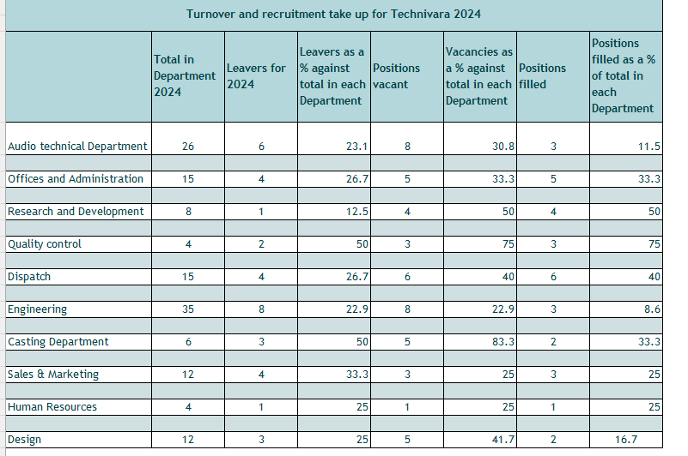

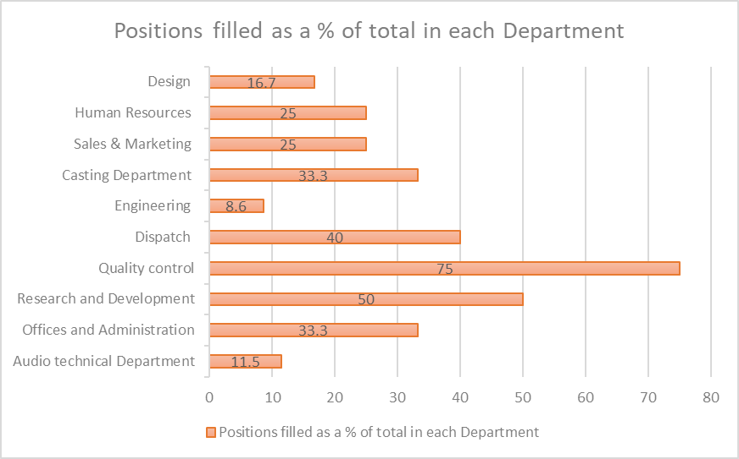

2.3
Analysing quantitative data allows information to be reviewed to see if there are any themes, patterns that can assist in moving forward with an idea.
Looking at the feedback from the evaluation of the 42 employees that participated in the Learning and Development programme, the following the patterns were recognised –

Low Performance Outcome
Engagement and meaningful questioning – 32 negative responses (27 disagree, 5 strongly disagree)
Outcomes being achieved – 33 negative responses (18 disagree, 15 strongly disagree)
Learning linked to performance target – 12 negative responses (11 disagree, 1 strongly disagree, with 24 not sure)
This indicates that the content chosen for the exercise was not relevant to the employees’ job roles, meaning that there was lack of engagement. “Information must be pitched at a level that is appropriate to the audience, and when facilitating a learning event, it is important to ensure that tasks are as workplace relevant as possible.” (Taylor and Woodham 2016)
My recommendations would be to –
- Recruit an in-house trainer to deliver inductions for new starters, any training needs, whether in person or virtually. This person can either be an internal move for someone who knows the company well. Or, potentially, advertise to recruit externally, to attract a facilitator with experience of delivering training.
- Redesign the sessions to increase interaction. The facilitator could include activities, such as group discussions, role play and Q&A’s. “Gathering teams together at the end of projects to review how they’ve worked and to record ‘lessons learned’ can be very effective.” (CIPD, 2024)
- Review training needs for each department, looking at the definitions of training (is instructor-led), learning (self directed and work-based) and development (implying long term process). By reviewing each department, this can then create a more personalised model to deliver what is needed
- Involve management – According to CIPD (2024) the shift from course-led learning experiences to bringing learning directly into everyday work brings a greater role for managers in the learning process. Management can then be more involved to tailor any learning and development to benefit staff as well as the organisation.

Potential Costs
Recruitment of a Trainer/ Assessor – up to £35,000 per annum (FTE) (Indeed, 2026)
It may be worth considering if this person is required full time. With the above being for a 37 hour week, it may be worth considering 22.2 hours per week (3 days) with would be £21,000 per annum.
Alternatively, to promote an internal member of staff for this role, the costing would be the difference in their wages. For example, if the current member of staff was on a salary of £27,000 per year for full time, this would be an increase of £8000 to move them to the Trainer role full time. Potentially, you may want to enrol the person on a course so that they can facilitate training sessions. “The average cost can range from £300 - £1500. For example, the CIPD offers a 3-day online L&D course for £1380.” (Ketkin, 2021).

Venue – Internal or External.
If training was held in a room within one of your own buildings, this would keep costs down. However, for larger groups, a venue would need to be booked. One place to consider that could potentially keep costs down would be a village hall. To hire a local hall, this may cost anywhere from £10 - £30 per hour during the week (this may be higher in cities).

The benefits of implementing these recommendations would be that interactive learning encourages involvement. According to GoFIGR (2024), studies have shown 80% of workers say the chance to learn new skills would increase their engagement levels. (Baravik, 2023)
Another benefit to implementing learning is that employees feel that they are being invested in with the possibility of progression, therefore leading to retention of staff. “The development of L&D programmes isn’t just the only way for companies to build a more competitive and skills-driven workforce – it’s also how they can keep that workforce intact.” (Tambay, 2024)

The evaluation shows that the Learning and Development sessions that were delivered to Technivara’s staff were well delivered, with a high number of staff agreeing that the objectives were clearly set and that the facilitator had sound knowledge of the topic they were teaching. Unfortunately, it lacked relevance and was not engaging. Implementing a People Trainer to redesign sessions to make them more relevant to the staff and the organisation, and to be more interactive, will enhance employee engagement and support the company to move into a more modern way of thinking, grow and expand their goals.

References
1.1
CIPD (2025). CIPD | Evidence-based Practice for Effective decision-making | Factsheets. [online] CIPD. Available at: https://www.cipd.org/uk/knowledge/factsheets/evidence-based-practice-factsheet/.
Briner, R. (2023). Evidence-based HR and people analytics are the same, right? Afraid not. [online] www.peoplemanagement.co.uk. Available at: https://www.peoplemanagement.co.uk/article/1851101/evidence-based-hr-people-analytics-same-right-afraid-not.
The Oxford Review Briefings (2023). The Essential Guide to Evidence-Based Practice. [online] The Oxford Review. Available at: https://oxford-review.com/evidence-based-practice-essential-guide/.

1.2
CIPD (2025). PESTLE Analysis. [online] CIPD. Available at: https://www.cipd.org/uk/knowledge/factsheets/pestle-analysis-factsheet/.
Taylor, S. and Woodhams, C. (2016). Studying human resource management. London: Chartered Institute Of Personnel And Development.

1.3
Howlett, W. and Coburn, T. (2019) Critical thinking | Podcast. [online] CIPD. Available at: https://www.cipd.co.uk/podcasts/critical-thinking#gref [Accessed 10 Jan. 2026].

1.4
CMI (2020). Decision Making. [online] CMI. Available at: https://www.managers.org.uk/knowledge-and-insights/resource/decision-making/.
De Bono Thinking . (2016). Six Thinking Hats | De Bono Thinking. [online] Available at: https://www.debonothinking.com/sixthinkinghats.
Mulder, P. (2019) Six Thinking Hats by Edward De Bono, a decision making tool | ToolsHero. [online] ToolsHero. Available at: https://www.toolshero.com/decision-making/six-thinking-hats-de-bono/

1.5
CIPD (2024). Ethical Practice and the role of people professionals. [online] CIPD. Available at: https://www.cipd.org/uk/knowledge/factsheets/ethics-role-hr-factsheet/#what-is-ethical-practice-in-organisations.
Taylor, S. and Woodhams, C. (2016). Studying human resource management. London: Chartered Institute Of Personnel And Development.
1.6
Stobierski, T. (2020). 13 Financial Performance Measures Managers Should Monitor. [online] Harvard Business School Online. Available at: https://online.hbs.edu/blog/post/financial-performance-measures.
Newsome, R. (2024). Exit interviews: Their purpose & best practices | People HR. [online] www.peoplehr.com. Available at: https://www.peoplehr.com/en-gb/resources/blog/exit-interviews/.

1.7
CIPD (2023). CIPD | Workforce Planning | Factsheets. [online] CIPD. Available at: https://www.cipd.org/en/knowledge/factsheets/workforce-planning-factsheet/#what-is-workforce-planning.
CIPD (2025). Learning and Development. [online] CIPD. Available at: https://www.cipd.org/uk/the-people-profession/the-profession-map/explore-the-profession-map/specialist-knowledge/learning-development/.

2.3
Taylor, S. and Woodhams, C. (2016). Studying human resource management. London: Chartered Institute Of Personnel And Development.
CIPD (2024). Methods of delivering learning interventions. [online] CIPD. Available at: https://www.cipd.org/uk/knowledge/factsheets/learning-methods-factsheet/.
GoFIGR (2024). Employee engagement has become a critical metric for measuring organizational health and performance. Recent surveys have indicated concerningly low engagement scores amongst our workforce. [online] Linkedin.com. Available at: https://www.linkedin.com/pulse/why-lack-skills-development-crippling-employee-engagement-what-ucyce.
Baravik, M. (2023). 27 Employee Development Statistics You Haven’t Heard Of | ClearCompany. [online] blog.clearcompany.com. Available at: https://blog.clearcompany.com/27-surprising-employee-development-statistics-you-dont-know.
Tambay, G. (2024). Why L&D is critical to driving employee retention in 2024. [online] People Management. Available at: https://www.peoplemanagement.co.uk/article/1856529/why-l-d-critical-driving-employee-retention-2024.
https://uk.indeed.com/jobs?q=trainer&l=&from=searchOnHP&vjk=d56093c5b2325817&advn=9017752936955625
Ketkin, I. (2021). What’s the Average Cost of a Learning and Development Course? — The L&D Academy. [online] www.thelndacademy.com. Available at: https://www.thelndacademy.com/post/whats-the-average-cost-of-a-learning-and-development-course.

