Student Name: Emeline Tatiana Loemba Yagazou
Student ID:2416832
Module Title: LCHS4008
Module Code:

TYPE-2 DIABETES

Table of Content
1. Introduction 3
2. Main Body 4
2.1 Implications of Type-2 Diabetes for Communities 4
2.2 Factors Influencing the Health and Wellbeing of People with Type-2 Diabetes and Those Around Them 5
2.3 How Healthcare and Social Care Professionals Can Collaborate More Effectively 6
3.Conclusion 9
Reference 10

1. Introduction
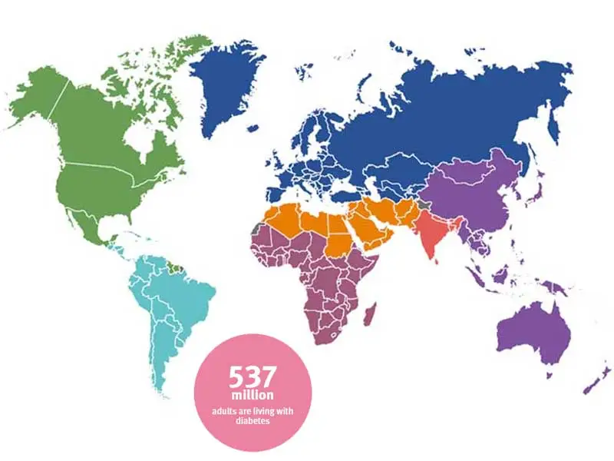
Figure: Type-2 Diabetes (T2D) (Piemonte, 2021).
Type-2 Diabetes (T2D) is a chronic metabolic condition where your body doesn’t produce enough insulin resistance and inability to manage glucose. Or this condition causes high blood sugar level that can lead to very serious health problems. Well, It impacts 537 million adults in the world which is expected to increase to 783 million in the year 2045. In the UK, 4.3 million individuals are diagnosed and 850,000 undiagnosed and more prevalent in deprived and diverse communities. T2D-related care costs the NHS almost £10 billion every year (Diabetes atlas, 2025). Increasing incidence is not just a lifestyle issue but also a structural problem in terms of poverty, obesogenic environments, access to healthy food, and systemic inequalities (Marmot, 2020).

2. Main Body

2.1 Implications of Type-2 Diabetes for Communities
The implications of Type-2 Diabetes (T2D) are far reaching, producing clinical, social and economic burdens that are way beyond the health care of individuals. T2D is a significant risk factor of coronary heart disease, stroke and renal failure, which leads to long-term disability and early death (Harding et al., 2019). Such results are unevenly distributed among the ethnic majority and socioeconomically disadvantaged populations, which demonstrates that vulnerability is determined by structural inequalities and not specific lifestyle choices (England, 2020). Therefore, T2D is a biomedical and social disease that lies within broader determinants of disadvantage.
Social and economic effects are high. T2D is more widespread in poor neighborhoods where the residents have poor access to affordable healthy foods, lack of green spaces, endure chronic stress and insecure jobs (Marmot, 2020). Such structural barriers produce so-called diabetogenic environments which limit healthy behaviors. Communities are brought into lower productivity, sickness absenteeism and welfare dependency economically. The NHS incurs a heavy financial strain, and the estimated yearly costs on diabetes complications related to the condition equate to 10 billion pounds, and most of these complications are preventable (Hex et al., 2012).
The healthcare systems are under pressure due to the increasing prevalence of T2D, which has put pressure on primary care, foot care, kidney, eye care and mental health services. Despite the emphasis the NHS Long Term Plan has put on prevention and early detection, services continue to be reactive in nature because of the lack of resources, which leads to delayed diagnoses and disjointed care (NHS, 2025).
Most importantly, there are still ethnic and social inequalities. South Asian, Black African and Caribbean communities are earlier affected, with poorer outcomes, due to structural racism, language barriers, distrust and lack of culturally-oriented healthcare (Chatterjee, 2017). The solution to T2D thus needs to be a systemic and equity-based response, as opposed to entirely behavioural one.

2.2 Factors Influencing the Health and Wellbeing of People with Type-2 Diabetes and Those Around Them
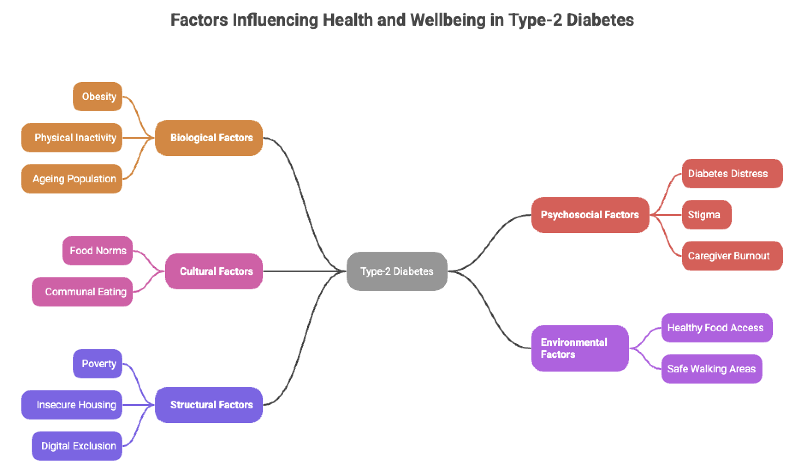
Figure: Factors Influencing Health and Wellbeing in Type-2 Diabetes
The biological, psychosocial, cultural, environmental and structural determinants are interconnected to influence health and wellbeing of individuals with Type-2 Diabetes (T2D). Obesity, aging and physical inactivity are all biological risk factors although these factors are highly mediated by external conditions (Sinclair, 2019). Neighbourhood safety, socioeconomic factors and absence of green space often restrict physical activity, and this proves that lifestyle choices depend on the context (Colberg et al., 2016).
Management is also strongly influenced by psychosocial factors. Diabetes distress, stigma, anxiety, and depression can be experienced by many, weakening the motivation, self-care, and glycaemic control (Fisher et al., 2015). Family caregivers are affected by the emotional burden, which can lead to role strain, fatigue and financial pressures because of the demanding roles, including the meal planning, monitoring and attending appointments (Lee, 2017).
Experiences are also influenced by cultural and environmental situations. Routine diet, communal eating habits and behaviours in South Asian and African-Caribbean families may make it difficult to manage the diet (Chatterjee, 2017). Poor access to affordable healthy food items, poor walking paths and lack of adequate transportations hamper access to healthy lifestyles (Panagioti et al., 2018).
Poverty, poor housing, unstable employment and welfare, structural determinants, are major obstacles impeding management of diabetes through their effect on the capacity to afford healthy diets, keep routines or attend appointments. Digital exclusion also limits access to telehealth, remote care and digital diabetes applications that are increasingly becoming beneficial in care (Marmot, 2020).
On the whole, T2D involves emotional, financial and social burdens on people and families, which explains the necessity of interventions that are likely to affect contextual determinants of the condition instead of focusing on an individual's behaviour.

2.3 How Healthcare and Social Care Professionals Can Collaborate More Effectively
The improvement of the wellbeing of individuals with Type-2 Diabetes (T2D) involves interdisciplinary and system-level cooperation. When communication is both structured and proactive, a properly functioning Multidisciplinary Team (MDT) comprising of GPs, diabetes specialist nurses, dietitians, podiatrists, ophthalmologists, mental health practitioners and social workers will enhance glycaemic outcomes and decrease the number of complications (Davies et al., 2018). The MDTs combine all these areas of expertise (clinical, behavioural and social) making it possible to plan care more holistically, covering diet, activity, emotional wellbeing, and protection issues. Nevertheless, in MDTs, sufficient staffing and shared responsibility are required and are not uniform in the NHS environment.
Table 1. Key MDT Roles in Type-2 Diabetes Care
Professional Role | Key Contribution to T2D Management
GP | Diagnosis, medication management, referrals
Diabetes Nurse | Self-management support, monitoring
Dietitian | Personalised nutrition planning
Podiatrist | Foot care, early detection of ulcers
Ophthalmologist | Screening and treatment of retinopathy
Social Worker | Addressing social determinants, benefits advice
Mental Health Practitioner | Managing diabetes distress, depression
NHS Integrated Care Systems (ICS) through the Integrated Care Pathways are designed to align primary care and acute services, the local authorities and the public health to eliminate fragmented diabetes care. Even though this model advocates intervention at an early stage, it is still in uneven implementation because of the lack of workforce, poor data interoperability, and disparities between regional funding (Charles, 2021). Access equity, however, cannot be achieved solely through policy, but requires structural investment.
Social prescribing provides a community-based intervention; it provides link workers with opportunities to refer people to exercise sessions, culturally relevant cooking lessons, weight-loss programmes and weight-loss support groups- interventions that have been shown to reduce isolation and enable long-term behaviour change (Drinkwater et al., 2019). Nonetheless, its efficacy relies on the accessibility of community services that are well-resourced, which is frequently limited in poorly populated places.
Digital solutions, including remote glucose monitoring, shared electronic health records and AI-based risk prediction, can reinforce continuity of care, but threaten to increase inequalities in the absence of digital literacy, affordability and access consideration (Renmans, 2022). The issues of data autonomy and bias of the algorithm also suggest the necessity of professional control.
It is also important to be culturally competent. Interventions specific to the minority ethnic groups enhance communication among the groups based on their language, dietary culture and religious beliefs (Chin, 2014). Finally, to decrease T2D, it is essential to partner with another non-medical sector, as well as local communities and authorities to modify food landscapes, green areas, pedestrian access, and poverty.

3.Conclusion
Type 2 Diabetes (T2D) has become an escalating worldwide and UK health problem which is responsible for a significant increase in morbidity, early mortality, and an ongoing economic stress on the NHS and the rest of society. This study has proven the consequences of T2D are far more than physical dysfunction and reflect deeply rooted ecological, socioeconomic and social disparities in risks as well as access to healthcare as well as the outcome of diseases. The solution to these problems is more than just a matter of medical management. It requires an integrated, collaborative and culturally responsive system of care that is supported through multidisciplinary teams. Social prescribing the inclusion of digital technology and meaningful community involvement. In order to reduce the burden for communities of T2D will also require addressing factors that affect the upstream, like the effects of poverty, housing insecurity as well as obesogenic and unhealthy environments, not to mention inadequate green spaces. Moving forward, health policies must focus on prevention, equity and continuous monitoring to ensure that interventions are built on structural knowledge rather than focusing on behavior. Through such a systematic approach, which is contextually sensitive, will the increasing rate of T2D reverse effectively.

Reference
- Chin, M.H., Goddu, A.P., Ferguson, M.J. and Peek, M.E., 2014. Expanding and sustaining integrated health care–community efforts to reduce diabetes disparities. Health promotion practice, 15(2_suppl), pp.29S-39S.
- Charles, A., Naylor, C. and Murray, R., 2021. Integrated care systems in London.
- Colberg, S.R., Sigal, R.J., Yardley, J.E., Riddell, M.C., Dunstan, D.W., Dempsey, P.C., Horton, E.S., Castorino, K. and Tate, D.F., 2016. Physical activity/exercise and diabetes: a position statement of the American Diabetes Association. Diabetes care, 39(11), p.2065.
- Chatterjee, S., Khunti, K. and Davies, M.J., 2017. Type 2 diabetes. The lancet, 389(10085), pp.2239-2251.
- Drinkwater, C., Wildman, J. and Moffatt, S., 2019. Social prescribing. Bmj, 364.
- Davies, M.J., D’Alessio, D.A., Fradkin, J., Kernan, W.N., Mathieu, C., Mingrone, G., Rossing, P., Tsapas, A., Wexler, D.J. and Buse, J.B., 2018. Management of hyperglycemia in type 2 diabetes, 2018. A consensus report by the American Diabetes Association (ADA) and the European Association for the Study of Diabetes (EASD). Diabetes care, 41(12), p.2669.
- Diabetesatlas (2025) Diabetesatlas. Available at: https://diabetesatlas.org/media/uploads/sites/3/2025/02/IDF_Atlas_10th_Edition_2021.pdf (Accessed: 22 November 2025).
- England, P.H. (2020) Covid-19: Review of disparities in risks and outcomes, GOV.UK. Available at: https://www.gov.uk/government/publications/covid-19-review-of-disparities-in-risks-and-outcomes (Accessed: 22 November 2025).
- Fisher, L., Polonsky, W.H., Hessler, D.M., Masharani, U., Blumer, I., Peters, A.L., Strycker, L.A. and Bowyer, V., 2015. Understanding the sources of diabetes distress in adults with type 1 diabetes. Journal of Diabetes and its Complications, 29(4), pp.572-577.
- Hex, N., Bartlett, C., Wright, D., Taylor, M. and Varley, D.J.D.M., 2012. Estimating the current and future costs of Type 1 and Type 2 diabetes in the UK, including direct health costs and indirect societal and productivity costs. Diabetic medicine, 29(7), pp.855-862.
- Harding, J.L., Pavkov, M.E., Magliano, D.J., Shaw, J.E. and Gregg, E.W., 2019. Global trends in diabetes complications: a review of current evidence. Diabetologia, 62(1), pp.3-16.
- Lee, A.A., Piette, J.D., Heisler, M., Janevic, M.R., Langa, K.M. and Rosland, A.M., 2017. Family members’ experiences supporting adults with chronic illness: A national survey. Families, Systems, & Health, 35(4), p.463.
- Marmot, M., 2020. Health equity in England: the Marmot review 10 years on. Bmj, 368.
- NHS (2025) NHS Long Term Plan, Wikipedia. Available at: https://en.wikipedia.org/wiki/NHS_Long_Term_Plan (Accessed: 22 November 2025).
- Panagioti, M., Skevington, S.M., Hann, M., Howells, K., Blakemore, A., Reeves, D. and Bower, P., 2018. Effect of health literacy on the quality of life of older patients with long-term conditions: a large cohort study in UK general practice. Quality of Life Research, 27(5), pp.1257-1268.
- Piemonte, L. (2021) Diabetes now affects one in 10 adults worldwide, Diabetes Voice. Available at: https://diabetesvoice.org/en/news/diabetes-now-affects-one-in-10-adults-worldwide/ (Accessed: 22 November 2025).
- Renmans, D., Sarkar, N., Van Belle, S., Affun‐Adegbulu, C., Marchal, B. and Mukumbang, F.C., 2022. Realist evaluation in times of decolonising global health. The International journal of health planning and management, 37, pp.37-44.
- Sinclair, A.J., Abdelhafiz, A.H., Forbes, A. and Munshi, M., 2019. Evidence‐based diabetes care for older people with type 2 diabetes: a critical review. Diabetic Medicine, 36(4), pp.399-413.

