Contemporary Themes in the Hotel and Hospitality Sector

Sustainability and Net-Zero in the Hotel Industry

Student name:Valentina Stoian
Student Id:2209627
Lecturer:Antoinette Milne
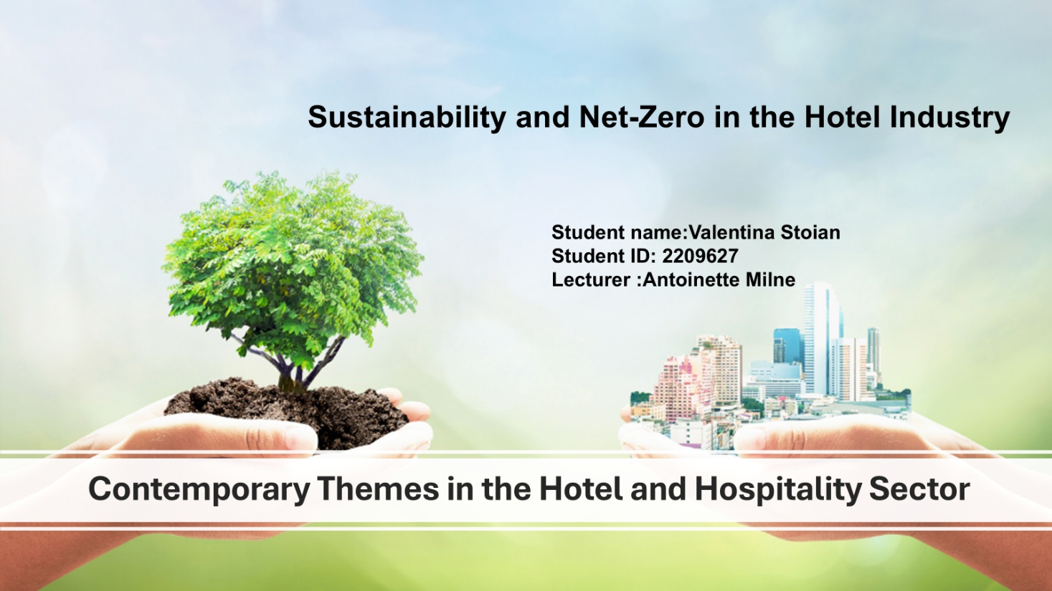

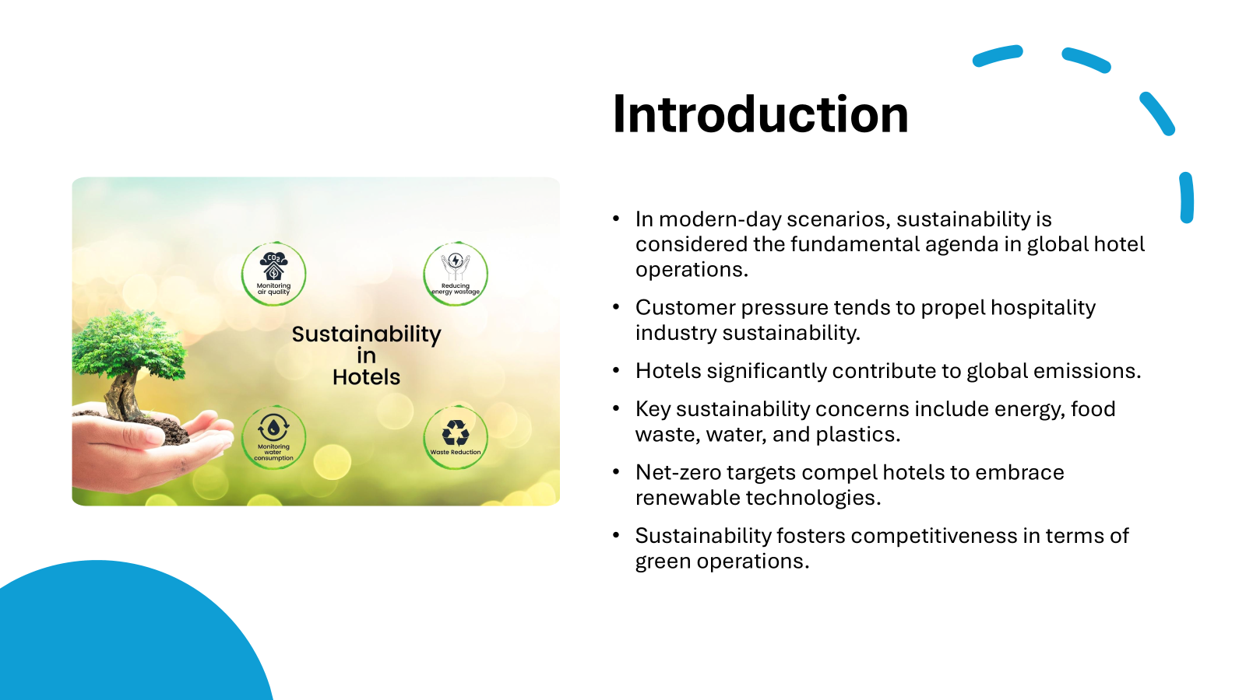



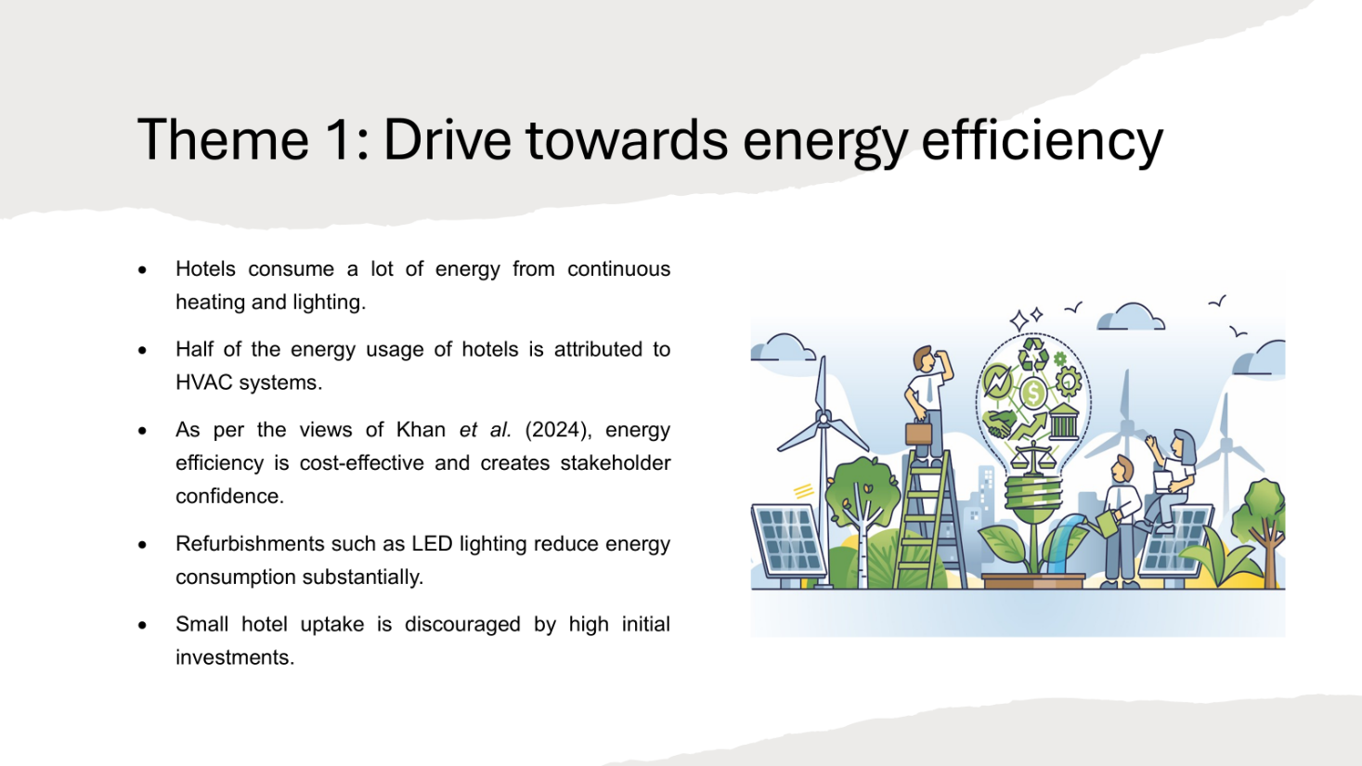

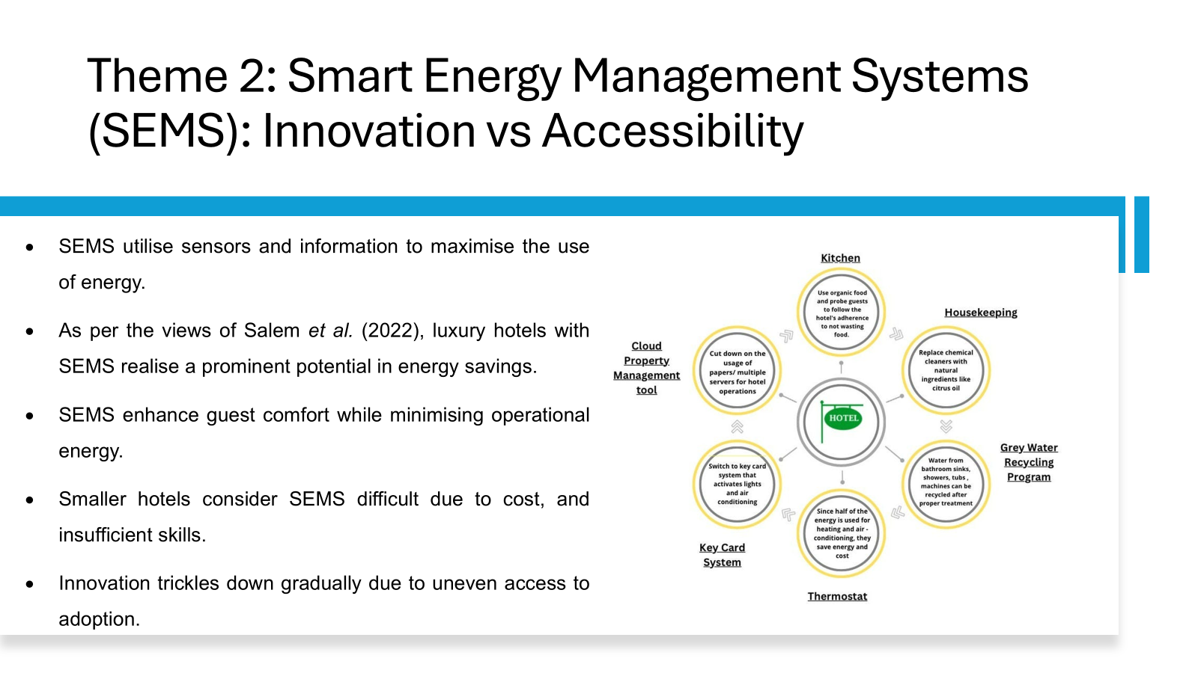

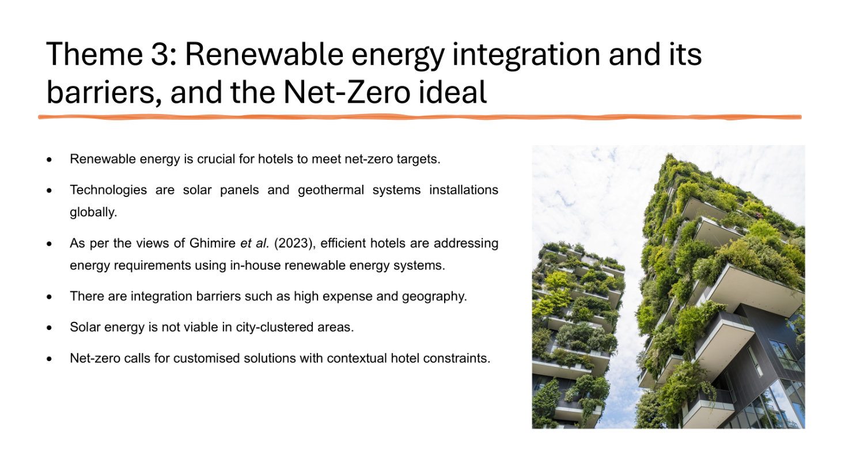

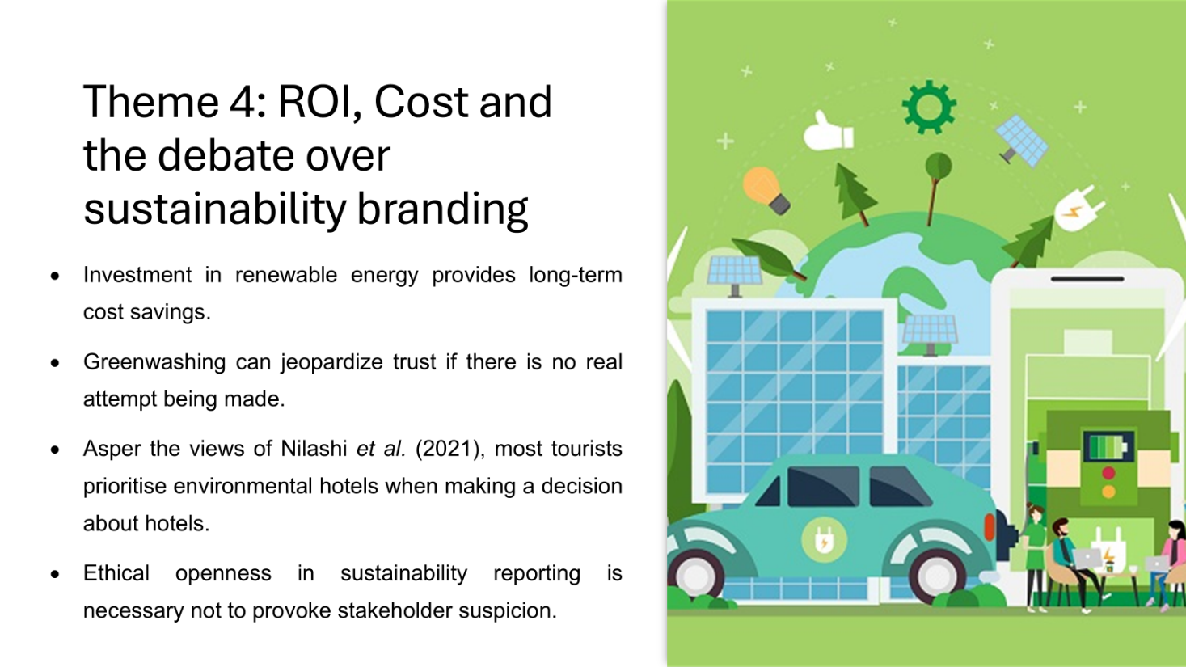

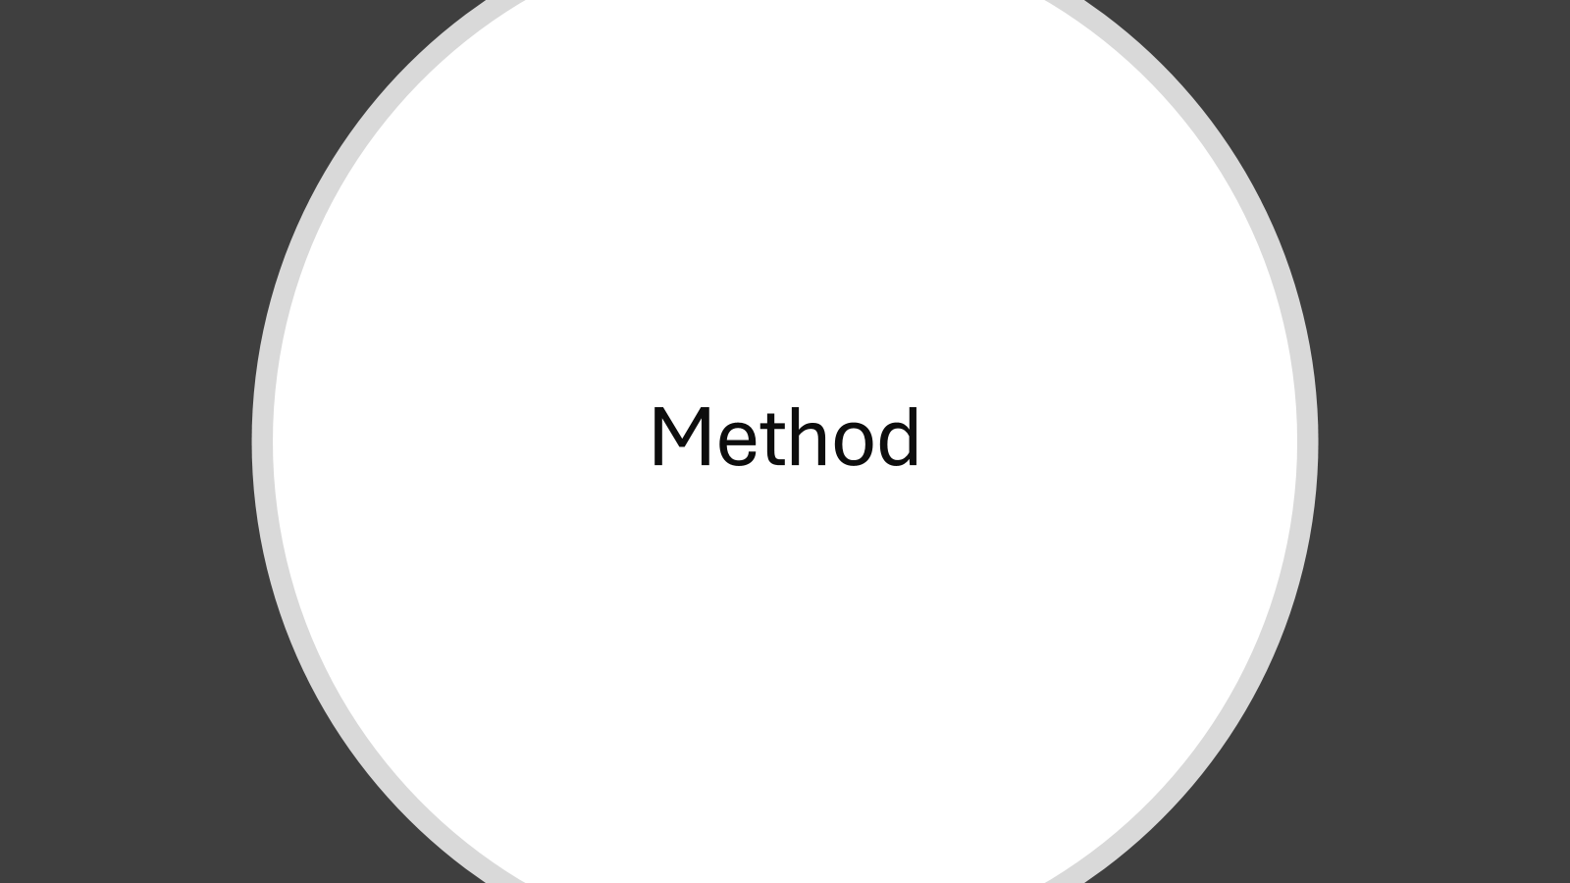

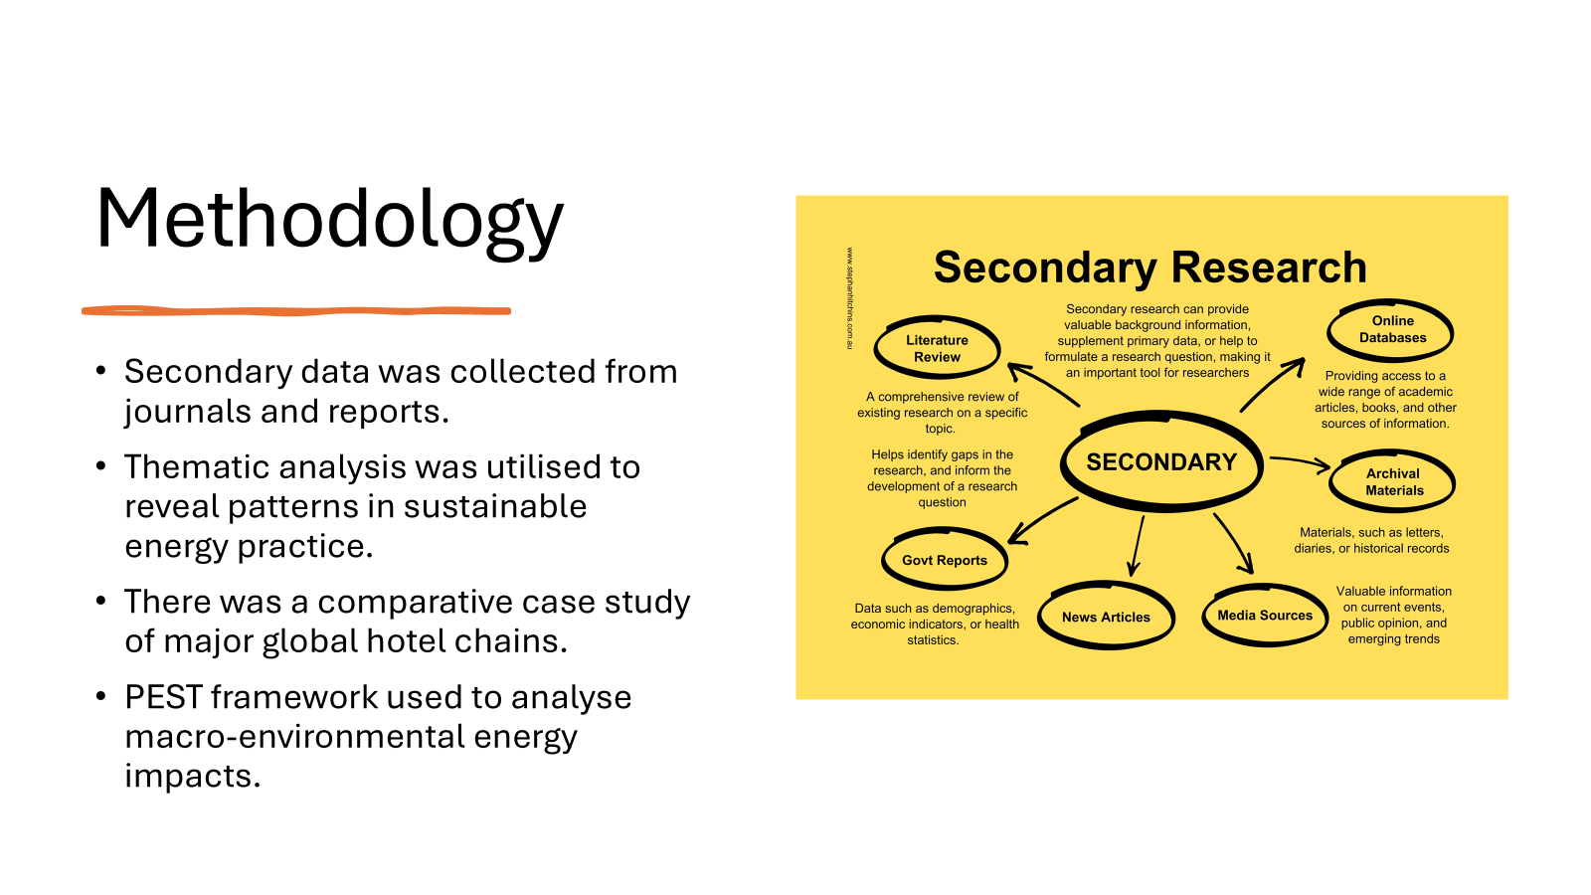

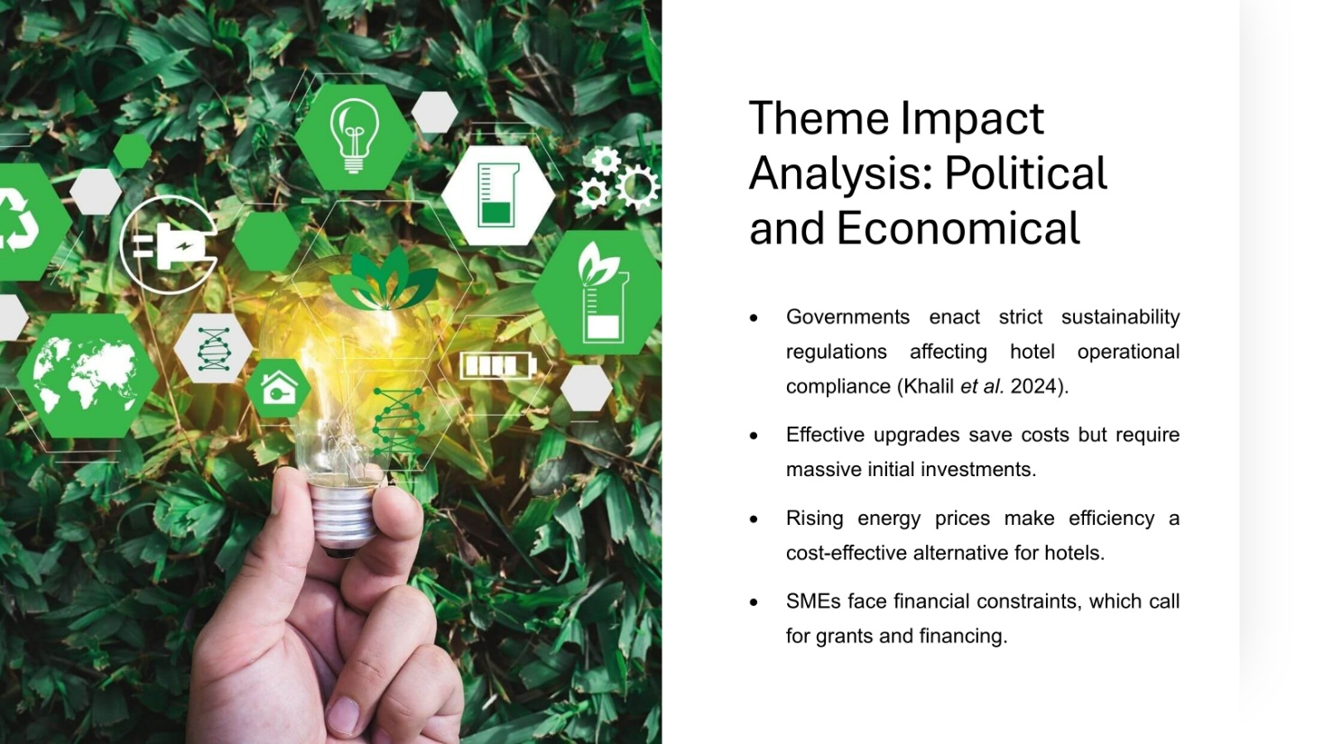

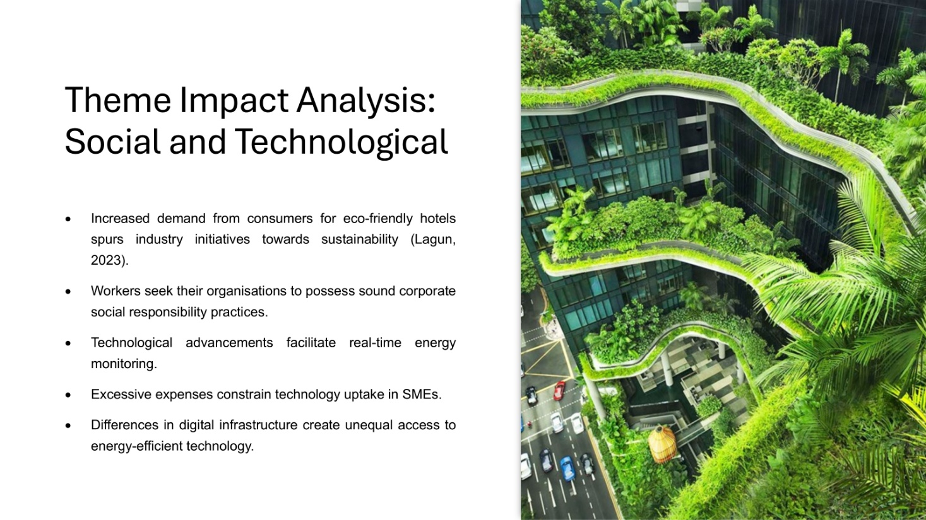

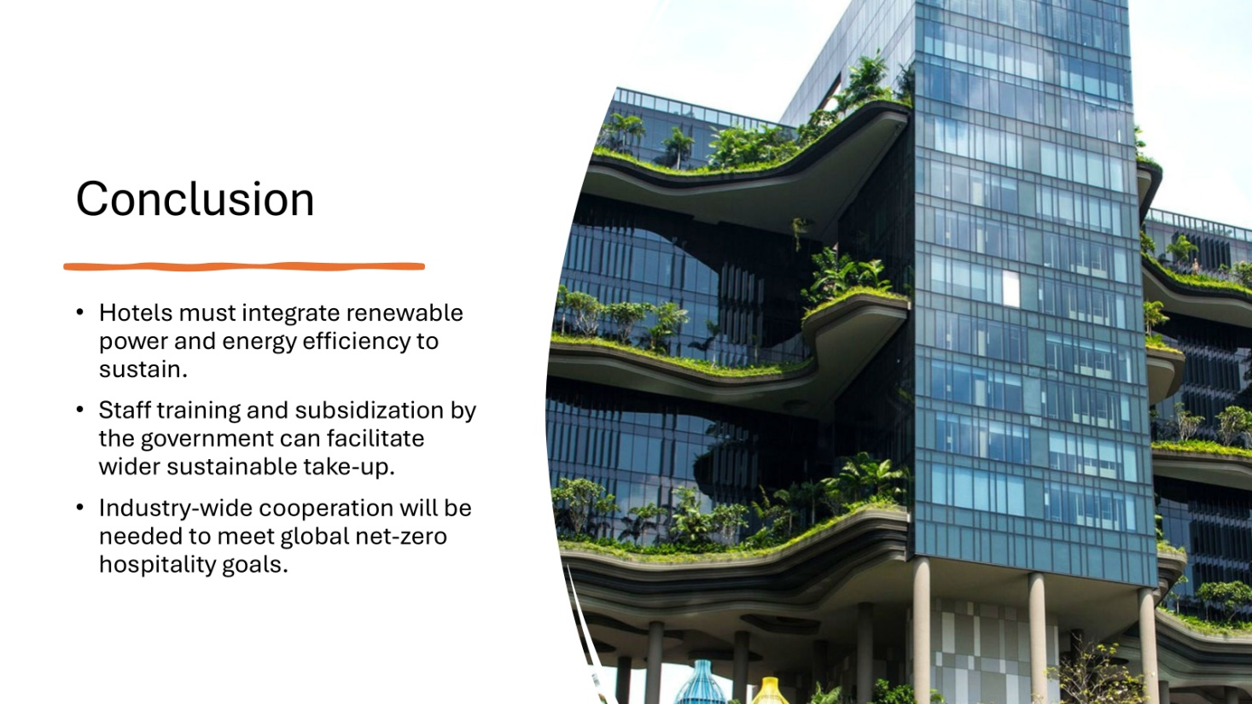

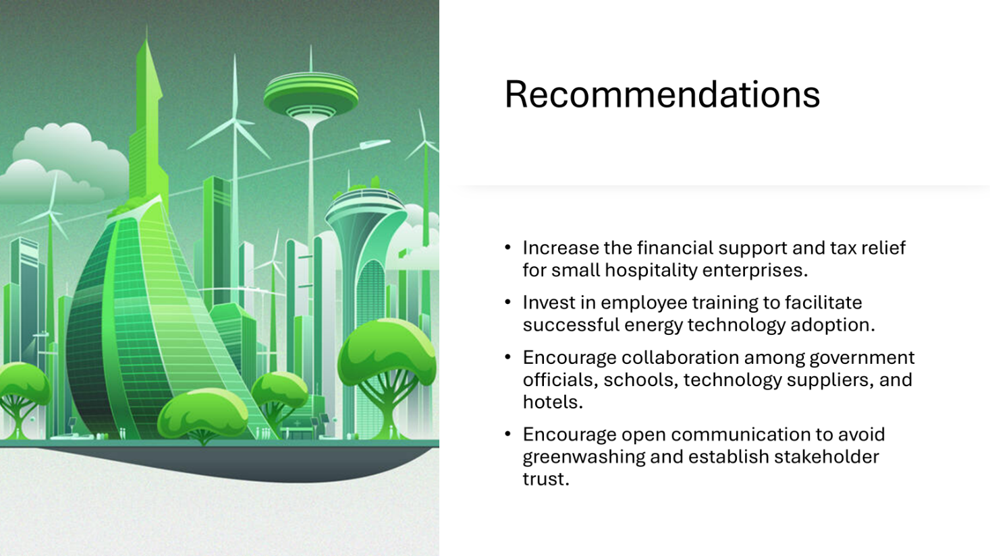

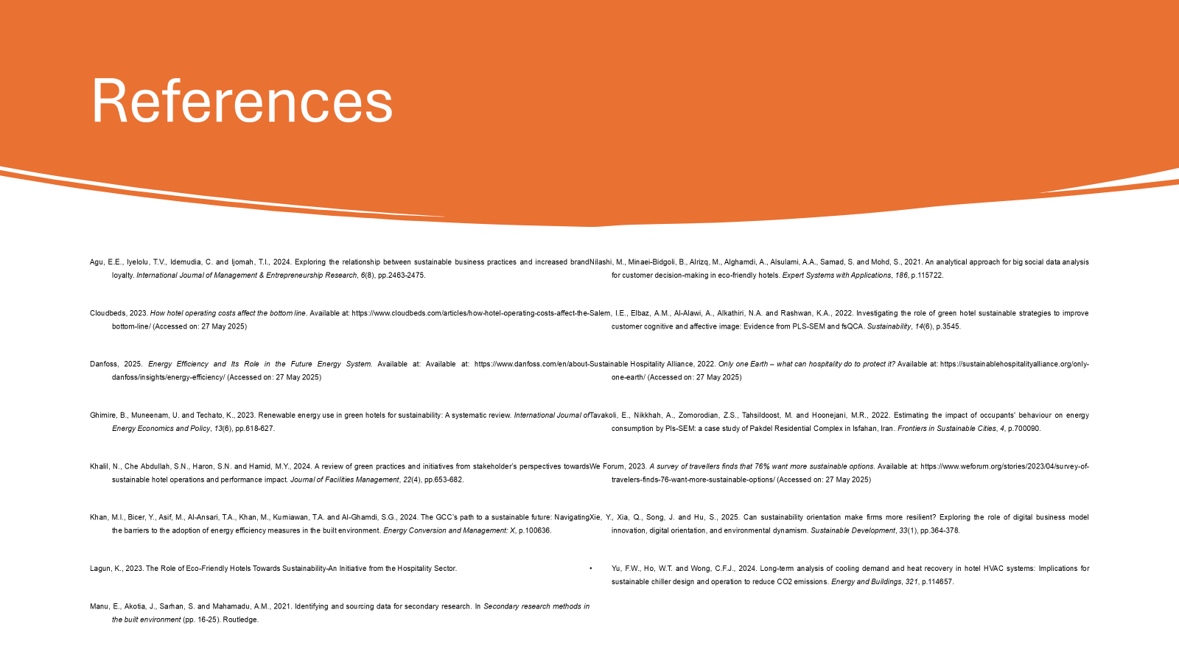

References

Agu, E.E., Iyelolu, T.V., Idemudia, C., and Ijomah, T.I. (2024). Exploring the relationship between sustainable business practices and increased brand loyalty. *International Journal of Management & Entrepreneurship Research*, 6(8), pp. 2463-2475.

Cloudbeds (2023). How hotel operating costs affect the bottom line. Available at: https://www.cloudbeds.com/articles/how-hotel-operating-costs-affect-the-bottom-line/ (Accessed: 27 May 2025).

Danfoss (2025). Energy Efficiency and Its Role in the Future Energy System. Available at: https://www.danfoss.com/en/about-danfoss/insights/energy-efficiency/ (Accessed: 27 May 2025).

Ghimire, B., Muneenam, U., and Techato, K. (2023). Renewable energy use in green hotels for sustainability: A systematic review. *International Journal of Energy Economics and Policy*, 13(6), pp. 618-627.

Khalil, N., Che Abdullah, S.N., Haron, S.N., and Hamid, M.Y. (2024). A review of green practices and initiatives from stakeholders’ perspectives towards sustainable hotel operations and performance impact. *Journal of Facilities Management*, 22(4), pp. 653-682.

Khan, M.I., Bicer, Y., Asif, M., Al-Ansari, T.A., Khan, M., Kurniawan, T.A., and Al-Ghamdi, S.G. (2024). The GCC's path to a sustainable future: Navigating the barriers to the adoption of energy efficiency measures in the built environment. *Energy Conversion and Management: X*, p. 100636.

Lagun, K. (2023). The Role of Eco-Friendly Hotels Towards Sustainability: An Initiative from the Hospitality Sector.

Manu, E., Akotia, J., Sarhan, S., and Mahamadu, A.M. (2021). Identifying and sourcing data for secondary research. In *Secondary Research Methods in the Built Environment* (pp. 16-25). Routledge.

Nilashi, M., Minaei-Bidgoli, B., Alrizq, M., Alghamdi, A., Alsulami, A.A., Samad, S., and Mohd, S. (2021). An analytical approach for big social data analysis for customer decision-making in eco-friendly hotels. *Expert Systems with Applications*, 186, p. 115722.

Salem, I.E., Elbaz, A.M., Al-Alawi, A., Alkathiri, N.A., and Rashwan, K.A. (2022). Investigating the role of green hotel sustainable strategies to improve customer cognitive and affective images: Evidence from PLS-SEM and fsQCA. *Sustainability*, 14(6), p. 3545.

Sustainable Hospitality Alliance (2022). Only one Earth – What can hospitality do to protect it? Available at: https://sustainablehospitalityalliance.org/only-one-earth/ (Accessed: 27 May 2025).

Tavakoli, E., Nikkhah, A., Zomorodian, Z.S., Tahsildoost, M., and Hoonejani, M.R. (2022). Estimating the impact of occupants' behavior on energy consumption using PLS-SEM: A case study of the Pakdel Residential Complex in Isfahan, Iran. *Frontiers in Sustainable Cities*, 4, p. 700090.

We Forum (2023). A survey of travelers finds that 76% want more sustainable options. Available at: https://www.weforum.org/stories/2023/04/survey-of-travelers-finds-76-want-more-sustainable-options/ (Accessed: 27 May 2025).

Xie, Y., Xia, Q., Song, J., and Hu, S. (2025). Can sustainability orientation make firms more resilient? Exploring the role of digital business model innovation, digital orientation, and environmental dynamism. *Sustainable Development*, 33(1), pp. 364-378.

Yu, F.W., Ho, W.T., and Wong, C.F.J. (2024). Long-term analysis of cooling demand and heat recovery in hotel HVAC systems: Implications for sustainable chiller design and operation to reduce CO2 emissions. *Energy and Buildings*, 321, p. 114657.

