Program: BEng (Hons) Mechanical and Manufacturing Engineering.

Student: Adam Hill.

Student Number: 1904039

Date : 10 October 2021.

Module : Stress Analysis and Dynamics (ACMA5010)

Assignment Title : Analysis and Simulation of a Centrifugal Clutch

Assignment No : 1

Lecturer : Rob Goodson



Contents page:

Introduction ~ Page 3.

Part A ~ Page 4 – 8.

Part B ~ Page 9-13.

References ~ Page 14-15.

Introduction.

Part A of this document will be looking into centrifugal and electromagnetic clutches. Distinguishing the difference between both clutches. Researching the pro’s and con’s which both types of the clutches have to offer. Also, looking at different applications which these clutches would be used for and what applications they are suited to best based on their characteristics. Breaking both clutches down into smaller components using diagrams to give a clear and in-depth understanding of how they work, are assembled and function. Part B is based on a scenario involving a centrifugal clutch. Breaking it down into 8 questions highlighting the different types of forces acting on the clutch and its components, using the information provided. With a graph which was produced using formulas, to compare Torque against RPM or angular velocity. Showing how different coefficients of friction change the behavior and capability of the clutch.

Part A.

The centrifugal clutch is a mechanism which transfers power from a driving shaft to an intended load. The energy can be transferred from a motor, Turbine or engine through and axel to drive a separate load. The clutch is made up of several key components to allow it to function.

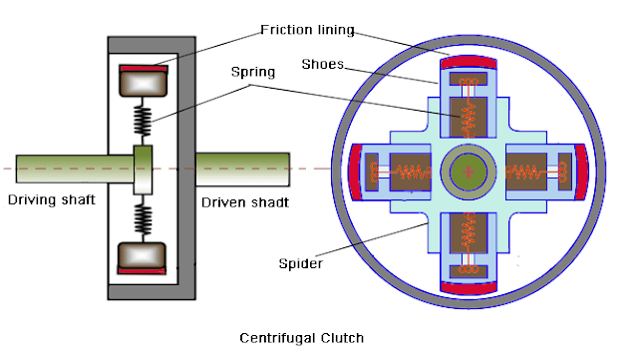

Figure 1. Diagram of Centrifugal clutch and its componentry (Sepac, ELECTROMAGNETIC TOOTH CLUTCHES, 2021)

Driving Shaft – The Driving shaft is driven by engine, turbine or motor.

Spider – The Spider is fixed to the driving shaft and also houses the spring and shoes

Springs – The springs are secured directly to shoes and spider

Shoes – The Shoes are secured to the spring, which pull the shoes inward during low RPM.

High Friction Lining – In this instance the high friction lining is made by Ferrodo. The high friction materials like steel, ceramics and compounds are bonded to the shoes to improve engagement.

Cylinder/Cover plate/Hub – The cylinder is the component which transfers the energy from the driving shaft into the driven component.

Driven Shaft – The driven shaft is secured to the cylinder.
How the centrifugal clutch functions

As the driving shaft spins it generates forces such as centrifugal and centripetal. Centripetal force act inwards, towards the center of the shaft. “Using Newton’s second law of motion, if an object is travelling in a circular path, it is found that the centripetal force of an object moving in a circular path always acts towards the center of the circle.”(BYJU'S, 2021) .Centrifugal force acts outwards, away from the center of the shaft.” centrifugal force, a fictitious force, peculiar to a particle moving on a circular path, that has the same magnitude and dimensions as the force that keeps the particle on its circular path (the centripetal force) but points in the opposite direction.” (Augustyn, 2020) It is the centrifugal force which draws the shoes outwards, once the force become greater than the strength of the springs. “When centrifugal force comes into play, pressing the clutch shoes against the inside wall of the clutch housing, the roughness of the linings provides a good grip, preventing slippage between the shoes and the housing.” (Philip J. O'Keefe, 2012) At This point friction comes into play and the energy is transferred into the driven shaft. “Brake linings are typically made of a rough, high friction materials, such as ceramic compounds. These materials are bonded to the brake shoes, or in the case of clutches, to the clutch shoes. “ (Philip J. O'Keefe, 2012) Due to the nature in which the clutch engages this allows for a smooth and gradual transfer of force. The gradual engagement has many benefits making centrifugal clutches the best choice for certain applications.

Advantages of centrifugal Clutch

“1) It is easier for the driver since the operation becomes simpler.
2) It is low in price.
3) It requires very little maintenance.
4) The engaging speed can be preciously controlled by selecting springs.
5) If optimized in conjunction with a particular engine, the overall operation can become extremely efficient and effective.”
(Walkings, 2020)

Other advantages are Automatic engagement. There are no additional components are required to engage the clutch. Therefore, less components to break or maintain. Also, due to the gradual engagements there is no shock loading to the components which you wish to transfer the energy. If the load applied to the clutch ever surpasses the intended load the clutch will start to slip as the friction will not be great enough to continue driving the load. This is an excellent fail safe to prevent overloading to the driving mechanism. Resulting in less damage if overloading was ever to occur. As the clutch can only engage at a certain RMP or centrifugal force. The driving mechanism can be started with minimum load on its components. Causing less stress to the driving mechanism and component whilst improving longevity.

Disadvantages of centrifugal Clutch

“1) Power transmission is limited due to slippage.
2) Overheating problem due to friction between the drum and shoes. If taken too far due to bad driving/usage habits, permanent damage may completely destroy the clutch.
3) There is a need for frequent oiling of centrifugal clutch arrangement so as to keep the temperature at a safe level.
4) It cannot be used to transmit a high amount of torque.
5) The power transmission is totally dependent on controlling speed.
6) There will be always a power loss due to friction and slipping.”
(Walkings, 2020)

As the centrifugal clutch is totally depend on the friction between the shoes and cylinder/drum, the materials chosen are critical for performance and efficiency. “Since heat energy is a byproduct of the process of creating friction, manufacturers typically use materials that are resistant to heat to make friction materials. The most popular choice for friction materials used to be fibers made from asbestos. However, due to the increase of health concerns associated with exposure to asbestos, ceramic has become a popular material to use as an alternative. Ceramic is highly durable and resistant to heat and is thus used in high friction environments. Friction materials need to be capable of enduring high amounts of physical stress, since the wearing down of material unavoidably produces friction. In addition, manufacturers made products such as semi-metallic brake materials using brass, copper, and steel wool bonded by resin. These elements are like ceramic in terms of durability. ” (Friction Materials , 2020)Due to the nature of a centrifugal clutch it lends itself to certain applications, such as when the driving engine starts with a high inertia. Therefore, the engine can be switched one while the clutch is disengaged due to the low starting RPM without adding any additional stress. This will extend the life of the driving mechanism and its components. Below is a list of applications where centrifugal clutches are commonly used.
- “Vibratory plate compactors and rollers
- Compressor/vacuum/fan drives
- Trowel and concrete finishers
- Compact road/street cleaners
- Transport refrigeration units
- Mobile water pumps
- Ground care equipment – rotary and flail mowers, turf cutters and scarifies
- Go-karts
- Woodchippers/stump grinders/milling cutters”
(Limited, 2020)
Centrifugal clutches are still commonly used in manufacturing and automation. However, in more recent times technology has improved and the electromagnetic clutch has superseded them. Where the centrifugal clutch engages using centrifugal force generated by the driving shaft. An Electromagnetic clutch uses electromagnets to engage and disengage the clutch. One of the main factors why these clutches are chosen over the centrifugal clutch is the ability to instantly control engagement and disengagements. Rather than waiting for the correct RPM to engage or disengage simply switching the magnets on and off will engage and disengage the clutch. “Here’s how the clutch works. When a DC voltage is applied to the electromagnet coil a magnetic field is created. The magnetic circuit passes through the clutch rotor and armature. The force is large enough to deflect the flat spring and the armature is pulled across a small air gap into the rotor face. The friction between the rotor and armature allow the driving shaft and armature to rotate at the same speed. When electrical power is removed from the coil the flat spring returns and pulls back the armature. Without a friction connection the two shafts rotate independently” (Automation, 2021)
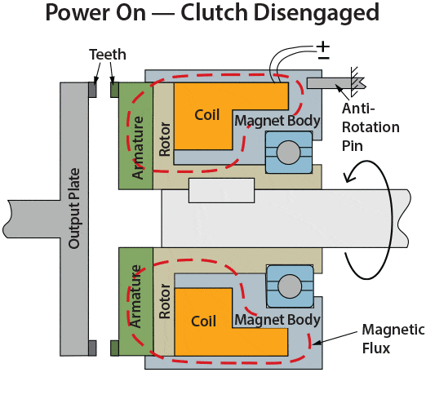 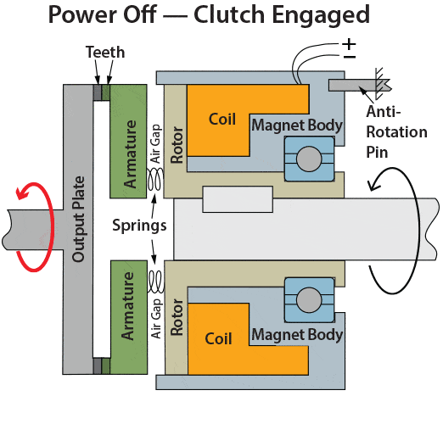Fig.2, Schematic of a cross section of a simple electromagnetic clutch (Sepac, 2021)
The image above shows an electromagnetic clutch when engaged and disengaged. When the coil is magnetized the armature is drawn toward the Rotor/driving shaft and away from the output plate as the electromagnet overcomes the strength of the spring. Allowing the hub to spin freely without transferring energy to the output plate. When the magnet is switched off, the strength of the spring pushes the armature toward the output plate. At this point the teeth on the armature and the teeth on the output plate engage. Instantly transferring energy from the driving shaft to the driven shaft. The delivery of energy would be considered more efficient than a centrifugal clutch as it doesn’t allow slippage. This would be due to the fact the clutch is not relying on the friction of two flat surfaced to engage.

“Advantages of electromagnetic clutch :
- Easy to control.
- Rapid response time.
- Start and stop are smooth.
- Less wear and tear at the contact point.
- Mostly used to achieve automatic transmission.
- No linkage is required to operate the clutch.

Disadvantages of electromagnetic clutch :
- High initial cost.
- Not suitable for high temperature.
- During engagement risk of overheating.
- A periodic check should be done for coil brushes.”
(Funda, 2021)

Due to the rapid response time in which the clutch can be engaged and disengaged as well as the fact that there are no linkages or requirement for manual operation. The electromagnetic clutch lends itself to high speed automation. Below is a list of different types of applications which electromagnetic clutches are used for.
- “Electromagnetic clutches are used in conveyor drives, Copy machines, and lawnmowers.
- And also used in packaging machinery, food processing machinery, printing machinery, and factory automation.
- They may be used for faraway utility due to the fact they do now no longer require linkage to actuate the clutch.
- Electromagnetic clutch utilized in printing machinery, conveyor drives, copier machines and manufacturing facility automation.
- In an automobile, it replaces clutch pedal via way of means of a easy transfer button.
- A smaller EM clutch is used to pressure the compressor of air conditioning system.”
(Kalyani, 2021)

Part B
Consider the centrifugal clutch above that comprises of four ‘shoes’ symmetrically attached to the ‘spider’. Each shoe with its friction lining has a mass of 275 grams and is attached by means of a linear mechanical spring with a stiffness value of 7.5 kN/m. The coefficient of friction of the material attached to the shoes is 0.35. The centre of mass of each of the shoes is at a radius of 95 mm from the shaft centres in the rest position shown above and has a clearance distance of 9 mm to the outer drum. The outer drum has a wall thickness of 4 mm.

- What is the diameter of the outer drum?

Shoes Centre of gravity from shaft centres = 95mm
Shoes centre of gravity from outer drum = 9mm
Thickness of drum wall = 4mm

(95 x 2) + (9 x 2) +(4 x 2) = 216mm

Overall Drum Diameter = 216mm

- Determine the engagement speed of the centrifugal clutch. You should provide your answer in RPM (revolutions per minute) and rounded to the nearest whole value of RPM.

Stiffness of spring = K = 7.5 x10^3 N
Displacement = X = 0.009 M

Force = Stiffness x Displacement F= K x X

F = 7.5x10^3 x 0.009
Force = F = 67.5N

Mass = m = 0.275Kg
Radius = r = 0.104M

Centripetal force formula

F = m ω ² r
m.r m.r

ω ² = Fmm
m.r

ω ² = 67.5
0.275 x 0.104

ω ² = 2360.139

ω=48.581 radians per second 464 RPM
- Calculate the radial force acting on the clutch face when the driving shaft is rotating at a speed of 550 RPM.

Angular Velocity = ω = 57.595 Rad/s
Mass = m = 0.275Kg
Radius = r = 0.104
Stiffness = k = 7.5 x10^3 N
Displacement = X = 0.009 M

F = m ω ² r
m.r m.r

F = m. ω ².r – K.x

F = 0.275 x 3.317x10^3 x 0.104 – 67.5

F = 27.3662N

F.4 = total radial force acting on clutch face

F.4 = 109.464N

- At the driving shaft speed of 550 RPM, what will be the value of torque transmitted to the driven shaft?

T = μ x Fc x r

Centrifugal Force = Fc = 109.464N
Radius = r = 0.104m

T = 0.35 x 109.464 x 0.104
T = 3.98Nm

- Using either MatLab or MS Excel, calculate and plot on a suitable graph the transmitted torque at the driven shaft against driving shaft speed, from 450 RPM to 700 RPM in increments of 25 RPM.

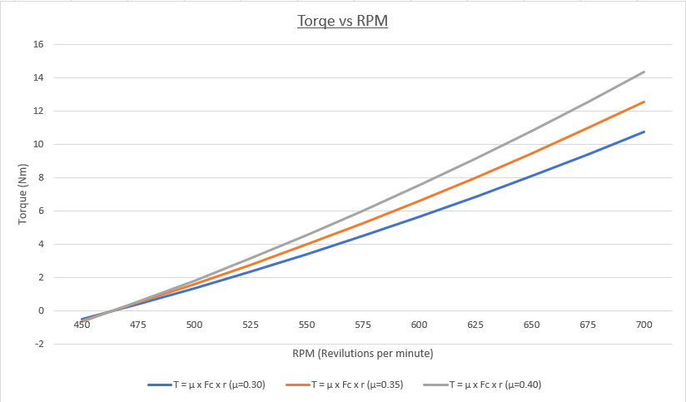

- Undertake the same analysis as in point 5 above but adopt a coefficient of friction of 0.3 and 0.4. Discuss the effect of changing the coefficient of friction of the shoe material on the torque transmitted when comparing the three values of coefficient of friction.

When analysing the graph, above. There is a pattern and clear difference between the three scenarios. When the coefficient of friction is increased on the shoes. The centrifugal clutch is able to delivery more torque at the same RPM as a shoe with a lower coefficient of friction. Therefore, a material which has a higher coefficient of friction will transfer the energy from the driving shaft to the driven shaft more efficiently and with less slippage. However, if a material is selected which has a very high coefficient of friction there is a potential for overloading to whatever mechanism is driving the drive shaft. Also, if a material is selected with too low a coefficient of friction there is the potential for not enough power to be delivered to the driven wheel and induce excessive slippage.

- For the maximum possible transmitted torque determined from either point 5 or 6 above, and given that the mass of the drum is 750 grams and can be considered as a solid disc, what is the angular acceleration of the drum to achieve the maximum possible torque?

Maximum Torque = T = 14.3421Nm
Mass = m = 0.75Kg
Diameter = d = 0.108m

To calculate Inertia radius of gyration must first be found.

k ²=d²/8

k²=0.108²/8

k ²=1.458x10^-3

k=0.038m

Inertia is equal to Mass multiplied by Mass x Radius of Gyration squared

I=mk ²

I=0.75 x 0.038²

I=0.00108Kgm²

Angular acceleration is equal to Toque divided by inertia.

T= I.α

α =T/I

α=14.3421/0.00108

α=13279.72rad/s²

- At the maximum rotational speed of 700 RPM, for a single clutch shoe of effective dimensions 50 mm by 20 mm, what will be the direct stress experienced by the drum? Why at this speed would the stress situation not be considered as a complex stress model?

Revolutions per minute = ω = 700 RPM x 9.549 73.31 rads/s
Area of Shoe = A = 0.1m ³
Mass = m = 0.275kg
Radius = r = 0.104m

Force is required to calculate stress

F = m. ω ².r

F = 0.275 x 73.31² x 0.104
F=153.66N

Stress is equal to force divided by area

σ = F/A

σ = 153.66/0.1

σ = 1536.6 Nm²

References
Augustyn, A. (2020). Centriofugal Force, Physics . Retrieved from Britannica: https://www.britannica.com/science/centrifugal-force
Automation, K. (2021). Electromagnetic Clutch – How It Works. Retrieved from KEB America : https://www.kebamerica.com/blog/how-it-works-electromagnetic-clutch/
BYJU'S. (2021). Centripetal And Centrifugal Force. Retrieved from byju: https://byjus.com/physics/centripetal-and-centrifugal-force/
Cambridge, 2.-2. U. (2004-2020). S Shaped Curves . Retrieved from do it poms: https://www.doitpoms.ac.uk/tlplib/bioelasticity/s-shaped-curves.php
common-properties-of-rubber-elastomers. (2011-2020). Common Properties of Rubber Elastomers. Retrieved from Custom Advanced : https://www.customadvanced.com/common-properties-of-rubber-elastomers.html
Davis, M. (n.d.). What is Potential energy? Retrieved from https://www.livescience.com/65548-potential-energy.html
Dennis R Jones, M. J. (2004). Retrieved from https://journals.sagepub.com/doi/abs/10.1177/154193120404801409
Engineering Toolbox. (2008). Poissons Ratio. Retrieved from Engineering Tool Box: https://www.engineeringtoolbox.com/poissons-ratio-d_1224.html
Engineering ToolBox, (. (2003). Young's Modulus - Tensile and Yield Strength for common Materials. Retrieved from Engineering Tool Box: https://www.engineeringtoolbox.com/young-modulus-d_417.html
Executive, H. a. (2021). Health and Safety in Engineering Workshop. In Health and Safety in Engineering Workshop (p. 45).
Friction Materials . (2020). Retrieved from Friction Materials: https://www.frictionmaterials.com/tag/centrifugal-clutch/
Funda, M. (2021). Advantages and disadvantages of electromagnetic clutch. Retrieved from Mechanical Funda: https://www.mechanicalfunda.com/2019/08/advantage-disadvantage-electromagnetic-clutch.html
Gibbs, K. (2013). Measurment of the moment of inertia of a flywheel . Retrieved from School Physics: http://www.schoolphysics.co.uk/age16-19/Mechanics/Rotation%20of%20rigid%20bodies/text/Moment_of_inertia_measurement/index.html
Gurumurthy, S. (2013, July 1). Apportioning and mitigation of losses in a Flywheel Energy Storage system. Retrieved from Apportioning and mitigation of losses in a Flywheel Energy Storage system: https://www.researchgate.net/publication/271464793_Apportioning_and_mitigation_of_losses_in_a_Flywheel_Energy_Storage_system
JBHFLAM. (2014, November 11). How does weight affect air resistance? Retrieved from How does weight affect air resistance?: https://www.physicsforums.com/threads/how-does-weight-affect-air-resistance.781315/
Kalyani, U. (2021, May 11). Electromagnetic Clutch Applications. Retrieved from Auto Pro Tips: https://www.autoprotips.com/electromagnetic-clutch-applications/
Limited, L. (2020). Centrifugal Clutch Explained – An Engineer’s Guide to a Centrifugal Clutch. Retrieved from Lancereal : https://www.lancereal.com/centrifugal-clutch-explained/
Philip J. O'Keefe, P. M. (2012, June 3). Mechanical Power Transmission – Centrifugal Clutch Shoe Wear. Retrieved from Engineering Experts: http://www.engineeringexpert.net/Engineering-Expert-Witness-Blog/tag/centrifugal-clutch
Revision World. (2007-2020). Rubber. Retrieved from Revision World: https://revisionworld.com/a2-level-level-revision/physics/force-motion/solid-materials/rubber
Roger Lewis, R. T. (2000). Business for Vocational A Level and AVCE. In R. T. Roger Lewis.
Sepac. (2021). Electro Magnetic Tooth Clutch. Retrieved from SEPAC: https://sepac.com/electromagnetic-clutches/spring-engaged-clutches/tooth-clutches/
Simon Robinson, R. D. (2007). Engineering, Business and Professional Ethics. In Engineering, Business and Professional Ethics (p. 75).
Siteware. (n.d.).
Siteware. (2020). Siteware . Retrieved from https://www.siteware.co/en/performance-management/best-business-management-techniques/
The Columbia Electronic Encyclopedia 6th ed. (2012). Rubber: History . Retrieved from Info Please : https://www.infoplease.com/encyclopedia/science/chemistry/organic/rubber/history
The Columbia Electronic Encyclopedia 6th ed. (2012). Rubber:Synthetic Rubber. Retrieved from Info Please: https://www.infoplease.com/encyclopedia/science/chemistry/organic/rubber/synthetic-rubber
The Columbia Electronic Encyclopedia, 6. e. (2012). Rubber: Chemistry and Properties . Retrieved from Info Please: https://www.infoplease.com/encyclopedia/science/chemistry/organic/rubber/chemistry-and-properties)
Walkings, M. (2020). Centrifugal Clutch – Working , Advantages, Disadvantages and Applications. Retrieved from Mechanical Walkins: http://www.mechanicalwalkins.com/centrifugal-clutch-working-advantages-disadvantages-and-applications/
Works, E. (2021). Retrieved from Mind Tools .
World Revision. (2007-2020). Rubber. Retrieved from Revision World: https://revisionworld.com/a2-level-level-revision/physics/force-motion/solid-materials/rubber)

