

Assessment 1: Report
Designing a Human Capital Architecture for Strategic Renewal: Strategic Socialisation, Innovative Job Design and AI-Enabled Capability Development at Helios Urban Mobility

Module Name: Human Capital Management

Module Code: LCMB7023

Lecturer: Alireza Nazarian

Student Name: Harsh Dipak Kundaliya
Student ID: 2535226

Words Count : 2633

Table of Contents
1. Introduction 3
2. Task A: Socialisation, Identity & Business Activism 3
2.1 Strategic Context and Human Capital Challenges 3
2.2 Traditional Onboarding vs Strategic Organisational Socialisation 4
2.3 Theoretical Foundations 5
2.4 HUM CONNECT Socialisation Framework 6
2.5 Organisational Identification & Ethical Professionalism 7
2.6 Business Activist Mindset 7
2.7 Success Measures 8
3. Task B: Strategic and Innovative Job Design 8
3.1 Job Design Challenges 8
3.2 Job Characteristics Model 8
3.3 Job Crafting 9
3.4 Skills-Based Architecture 10
3.5 Internal Talent Marketplace 11
3.6 Intrinsic Motivation and Innovation 11
4. Task C: Reflective Report 12
4.1 AI as Decision-Support 12
4.2 Preserving Human Judgement 12
4.3 Personal Capability Development Plan 12
4.4 Reflective Conclusion 13
References 14
Appendixes 18

1. Introduction
Helios Urban Mobility is an AI-powered clean mobility and smart infrastructure analytics start-up based in Europe, with 450 employees in London, Berlin and Singapore, working for city governments. The organisation has made imposing progress in its international expansion but there is also a more significant issue with its human capital architecture, as it takes 8 months for employees to ramp up to the job and engagement is down at 54% and high levels of employees leaving the organisation, particularly high-potential graduates (Helios-h2020project.eu, 2026). These are inter-related since poor socialisation slows down the process of integration of the employee, low level of organisational identification decreases commitment and poorly designed work restricts career development and innovation (Abate et al., 2025). The report therefore outlines an combined human capital architecture that involves strategic organisational socialisation, organisational identification, ethical professionalism, business activism, job redesign involving innovation and capability growth with the help of artificial intelligence to reinforce employee engagement, speed up productivity gains, enhance retention and facilitate the long-term strategic renewal and sustainable growth of the organisation.

2. Task A: Socialisation, Identity & Business Activism

2.1 Strategic Context and Human Capital Challenges
Helios Urban Mobility The eight-month ramp-up time for employees contributes to a loss in productivity, as people need to be oversaw for a longer period before they can fully participate in AI-powered mobility projects (Halid et al., 2024). Slow integration also slows innovation; employees don't have the flexibility to use their technical skills on the cross-functional problem solving. According to Polymeni et al., (2024) found that the organisational socialisation is weak resulting in lack of clarity of understanding around organisational values, ethical standards and strategic priorities in terms of London, Berlin and Singapore. Figure 1 shows that global employee experience management market size was valued at USD 6.4 billion in 2023 and is expected to grow to reach USD 7.6 billion in 2026, and USD 11.7 billion by 2030 (Grandviewresearch.com, 2026). Coordinating within the global economy adds more challenges because of its rapid growth, and the need to account for cultural differences, communication barriers, and lack of knowledge sharing capacity (Situm et al., 2024). The Human Capital Management and Strategic HRM problem is not about the lack of talent in the organization but around Helios's inability to realize its employees' knowledge, skills and potential into long-term value creation in the organization (Bashynska et al., 2023).
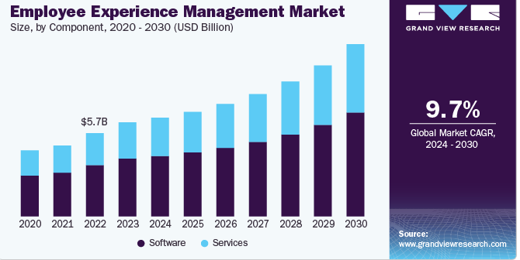
Figure 1: Employee Experience Management Market
(Source: Grandviewresearch.com, 2026)

2.2 Traditional Onboarding vs Strategic Organisational Socialisation
Traditional onboarding at Helios Urban Mobility primarily deals with administrative adjustments (employment documentation, IT access, compliance training, organisation policies and basic role information). With such onboarding, employees can be up and running and legal and procedural risks are minimized. But this is often brief and superficial and can leave space for staff to lack an sympathetic of organisational culture, have limited opportunities to develop professional relationships, or lack a sense of ownership (Borysiak et al., 2025). As a result, staff can be given information efficiently, but not hooked into the wider organization’s strategic direction and innovation plans.

2.3 Theoretical Foundations
The human capital is crucial at Helios Urban Mobility as this strategically valuable human capital is what enable the highly specialized knowledge workers to create AI-enabled electric mobility system and smart infrastructure analytics refer in figure 2. Helios Urban Mobility faces a significant risk of poor return of human capital since the company's ramp-up time of 8 months, engagement score of 54%, graduate attrition of 22 % demonstrate that their invested resources in acquiring this human capital are not effectively being transformed into organisational consequences (Eze, 2025). Good human capital management strategy, beyond just recruitment, has to also include socialisation, capability building, ethical professionalism and effective job design that inspires the desire to produce outcomes, fosters organisation-based identification, stimulates innovation, and cultivates lifelong skill acquisition (Szpilko et al., 2023). This strategy will have an impact on productivity, speed of information spill-over across their London, Berlin and Singapore entities, retention rates and sustainable competitive advantage.
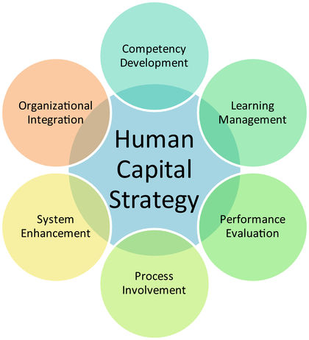
Figure 2: Human Capital
(Source: Referenceforbusiness.com, 2024)

2.4 HUM CONNECT Socialisation Framework
HUM Connect Socialisation Framework, showing a staged process that Helios Urban Mobility takes for socializing new employees from the moment they arrive to the moment they are fully capable, and able to contribute strategically to the organisation in the longer-term.
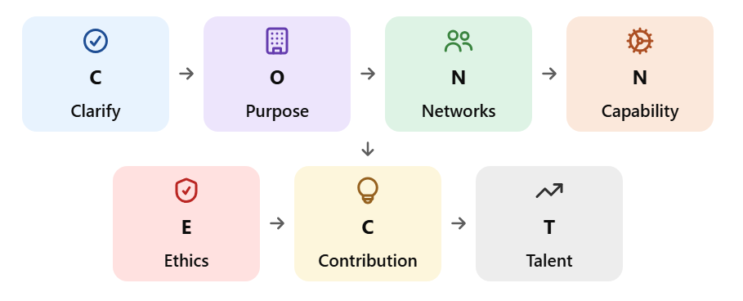
Figure 3: HUM CONNECT Strategic Socialisation Framework
(Source: Self-Craeted)
Stage 1: Pre-boarding: During pre-boarding, Helios Urban Mobility should offer a welcoming digital landing page, realistic role preview, buddy system and clear ethical guidelines (Rouky et al., 2025). These activities lower uncertainty prior to employment, and set down the crushed rules for the psychological contract.
Stage 2: First 30 days: Employees need to be engaged in a global orientation programme, an ethical AI workshop, a cross-location learning cohort and weekly meeting with the manager during the first month. The activities foster cultural consciousness, role clarity and psychological safety.
Stage 3: Days 31–90: Days 31-90 are for employees to complete their technical development, engage in a cross-functional project, receive mentoring support and whole an innovation challenge (Mariprasath et al., 2026). The stage helps to speed up capability development and to promote inter-departmental collaboration.
Stage 4: Months 4–6: Managers have opportunities for job crafting meetings, career development meetings, innovation sprints, and skills profile updating in the first 6 months. These activities improve employees' independence and match their skills with organisation's needs.
Stage 5: Months 7–12: At the end of the first year, employees are expected to take the lead of a strategic project, and to be recognized as organisational citizens, mentor to a new employee and make a learning plan for the second year (D’Ulizia et al., 2026).

2.5 Organisational Identification & Ethical Professionalism
Helios Urban Mobility should boost organizational identity by storytelling for purpose, involving senior leaders, fostering collaboration crossway’s location and connection to organizational values through recognition. Staff who are aware of the impact of their role in a sustainable urban mobility system are additional likely to have better commitment and engagement (Dorostkar et al., 2026). Team-building projects from London, Berlin and Singapore can help to strengthen a common organisational goal through sustainability. Ethical professionalism should be encouraged via ethical AI workshops, formal codes of conduct, confidential speak-up systems and responsible data-use guidance, in view of the fact that Helios develops AI systems, which may have an influence on public transport and data use by citizens (Gheorghe and Soica, 2025).

2.6 Business Activist Mindset
A business activist is a commercially savvy employee who is ethically responsible, deliberately influential and knows their organisation and how they will affect stakeholders. Helios's HR function must be more than just about administration: in line with Ulrich, it should be a strategic partner, an employee advocate, a change organizer and a credible activist (Almulhim, 2025). The employees need to be able to consider the decision from the point of view of the city governments, the transport users, the local community, the environment and investors (Gong et al., 2025). For Helios, this is especially pertinent since the use of AI-powered mobility systems impacts public substructure and the environment.

2.7 Success Measures
The Assessment of the effectiveness of the socialisation system in the HUM Connections should be carried out together qualitatively and quantitatively. Helios will strive to shorten the average ramp-up time to about 4-5 months, up employee engagement from 54% to above 70%, and to have a huge impact on high-potential graduate attrition (Stecuła et al., 2023). Higher retention rates of first year employees should also increase as they are better combined into the organisation's culture and career progression.

3. Task B: Strategic and Innovative Job Design

3.1 Job Design Challenges
Helios Urban Mobility This means there is job design issues that may be influencing the 54% engagement score and 56% high grad attrition. According to Usman (2025) found that job descriptions may hinder creativity and innovation and poor employee autonomy is exposed to have lower acceptance and investment in AI mobility projects. The issue of skills underutilisation may be crucial in the technology environment where employees may have a range of different skill sets not necessarily related to the exact role they were employed for. Poor job visibility can cause graduates to seek alternative roles and changes in AI skill requirements can make existing positions quickly obsolete (Spanos et al., 2025). Helios problem might be additional deeply entrenched, in the nature of work itself, not just remuneration or attraction issues but in something that suggests less challenge, less development, less contribution.

3.2 Job Characteristics Model
Helios needs to reengineer jobs on the basis of five key factors. According to Cirianni et al., (2023) found that multidisciplinary projects that involve the growth of AI solutions and the analysis of sustainability and stakeholder needs can help enhance skill variety. Task identity should allow the employees to be part of the end-to-end mobility projects instead of just doing some technical tasks. The meaningfulness of tasks can be enhanced by connection to sustainable city outcomes and lower urban emissions. Autonomy should mean that employees have options in their projects and their learning and feedback should comprise their manager's, peers' and government-client's point of view (Cordoș et al., 2024). Too much skill variety can lead to excess and too much autonomy can lead to less consistency, however. Helios should embrace bounded autonomy in the context of clearly stated goals, values, and responsibility structures, as the model is pre-digital, not current by digital collaboration.
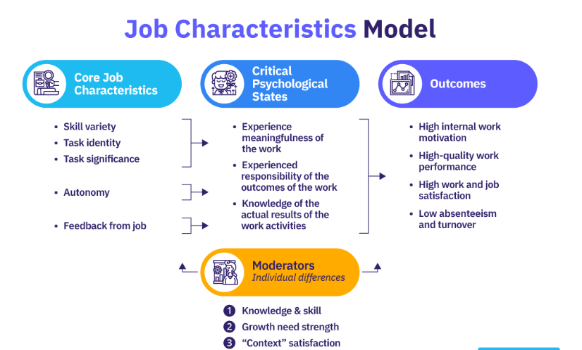
Figure 4: Job Characteristics Model
(Source: Lucas, 2021)

3.3 Job Crafting
Employees' agency and innovation should be enhanced through guided job crafting by Helios. Task crafting would enable an AI engineer to participate in an accessibility project in a mobility context, and interpersonal crafting would encourage AI engineers to collaborate with city planners, sustainability experts and other international experts (Alahi et al., 2023). The use of cognitive crafting would support a data analyst to think about what they are doing as a contribution to urban presence and not just processing data. Regular (quarterly) Job-Crafting Conversation between employees and managers should include opportunities for role adaptation (Chowdhury et al., 2023). This includes benefits such as better person-job fit, increased engagement and increased innovation. However, unmanaged job crafting can lead to job confusion and unsatisfactory managerial support and neglect of roles. Thus, there is a need for flexibility that is within the boundaries of the organizations and ethics.

3.4 Skills-Based Architecture
Helios should move away from a job-based structure of the career journeys and towards a skills-focused approach by a Helios Skills Passport as the heart of the career journey. It will keep profiles of individuals that are not just job-specific but also include data literacy, AI capability, sustainability knowledge, leadership potential and cross-cultural competence (Nawaz et al., 2024). Employees were talented to become more knowledgeable by going to training or participating in projects, as well as getting expert. This would help to accelerate the redeployment of talent with the evolving AI technologies. However, the information on skills can become outdated and approximately workers can feel that they are being "watched too much (Vrontis et al., 2023). To remedy these concerns, it is significant that employees are able to see their profile and managers validate skills evidence transparently. A skills-based system would improve internal mobility and enable lifelong reskilling.
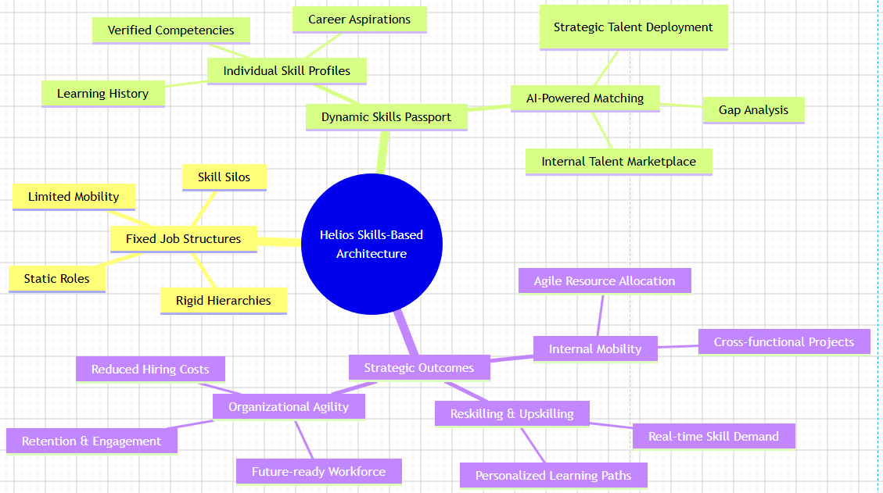
Figure 5: Skills-Based Architecture
(Source: Self-Created, App.diagrams.net, 2026)

3.5 Internal Talent Marketplace
Helios Mobility Exchange will bring Skills Passports together with AI-based opportunity matching, manager conversations, project involvement, skill profile feedback and skill profile updates. According to Stone et al., (2024) found that staff would be able to work on mini-projects, innovation challenges, overseas projects and mentoring. The platform would enhance the mobility of people within London, help to increase the retention of graduates and foster the sharing of knowledge crossways London, Berlin and Singapore. It may also lessen the need for external hires and can be achieved by reallocating existing staff. Some of the risks are algorithmic bias, the talent hoarding by managers and privacy issues. Helios should, therefore, adopt explainable matching criteria, provide regular bias audits, and require human intervention for recommendations (Aydın et al., 2025). These controls would ease a fair and increase the agility of the organisation and visibility of their career.

3.6 Intrinsic Motivation and Innovation
Challenge, ownership and growth opportunities can be combined through the integrated job design architecture, which can enhance intrinsic motivation. Skill variety offers learning and stimulation; task individuality results in ownership of outcomes and task significance means reinforcement of meaningful contribution toward sustainable urban mobility. Autonomy fosters responsibility, guided job crafting raises employee agency and it opens up development opportunities finished an internal talent marketplace (Ghedabna et al., 2024). All these features act as an enabler for experimentation, cross-functional collaboration and innovation. But if you put autonomy into practice, it will not have an innovative performance (Gong et al., 2025). Workers need to feel safe to share ideas, receive the capitals needed to try them, and have a leader who is helpful and will give them time to experiment.

4. Task C: Reflective Report

4.1 AI as Decision-Support
Overall, this module has given me a better understanding of how AI can support human capital decisions whilst keeping the human decision in control. I would use the AI tools to support workforce analytics, skill gap analysis, engagement trend analysis and workforce scenario planning, which would in turn make better quality and quicker HR decisions. I do understand the potential risks that come since the use of algorithms, for example the algorithms could containbias, be imprecise, lack organisation-specific knowledge, cause privacy issues, or even induce automation bias (Bashynska et al., 2023). So, I am a big supporter of the idea that AI is a tool to allow expert decision-making, not to replace it, and in specific when the decision that impacts someone’s career, their work and wellbeing, their faith in the organisation.

4.2 Preserving Human Judgement
I would use a clear process of Question-Verify-Contextualise-Consult-Decide-Review in order to maintain my critical thinking skills. The first thing I would want to ask is what is the source of the info, the next question would be what is the evidence behind it and what is the data that they are presenting from the organizations (Halid et al., 2024). Cultural, ethical and business context would be taken into thought, prior to consulting relevant stakeholders. AI can suggest things, but people are responsible for making choices in hiring, monitoring performance, promoting employees, and ensuring their well-being. The review of outcomes would help to delineate the unintended consequences and improve the quality of future decision making.

4.3 Personal Capability Development Plan
Data literacy and AI ethics in HR are my next growth priorities in the next 6 months, strategic influencing in the next 9 months, and global mobility awareness in the next 12 months. Increasing my data literacy will reinforce my ability to analyze workforce data and make evidence-based choices about HR (Nawaz et al., 2024). This course in AI ethics will enable me to assess the ethical implications of using AI in human resource management. Being better able to develop strategic influencing skills will make my presentation of recommendations to senior leaders easier. This will equip me by the awareness of global mobility so that I can meet the challenges in Strategic HR, People Analytics and International HRM in multinational companies.

4.4 Reflective Conclusion
To conclude, I have discovered that there is a delicate balance between technology, evidence, ethics and critical human judgement that necessity be considered in effective human capital management. I know that in situations where employee decisions impact their career, their wellbeing and organisational trust, humanity necessity still have a seat at the table with AI to support the workforce analytics and identify engagement trends in order to help inform strategic decisions. Overall, this reflection has reinforced my dedication to fostering Data Literacy, Ethical awareness, and Strategic swaying skills to ensure that I apply AI tools in a responsible and ethical manner, while also upholding empathy, fairness, and professional ruling in my future human capital management endeavors.

References
Abate, A.G., Zhang, X., Liu, X. and Keles, D., (2025). Cost-benefit analysis of an AI-driven operational digital platform for integrated electric mobility, renewable energy, and grid management. arXiv preprint arXiv:2506.20631.
Alahi, M.E.E., Sukkuea, A., Tina, F.W., Nag, A., Kurdthongmee, W., Suwannarat, K. and Mukhopadhyay, S.C., (2023). Integration of IoT-enabled technologies and artificial intelligence (AI) for smart city scenario: recent advancements and future trends. Sensors, 23(11), p.5206.
Almulhim, A.I., (2025). Integrating artificial intelligence into smart infrastructure management for sustainable urban planning. Technologies, 13(11), p.481.
App.diagrams.net (2026). Flowchart Maker & Online Diagram Software. [online] App.diagrams.net. Available at: https://app.diagrams.net/# [Accessed 15 July 2026].
Aydın, Ö., Karaarslan, E. and Narin, N.G., (2025). Artificial intelligence, vr, ar and metaverse technologies for human resources management. International Journal of Management Information Systems and Computer Science, 9(2), pp.77-94.
Bashynska, I., Prokopenko, O. and Sala, D., (2023). Managing human capital with AI: Synergy of talent and technology. Scientific Journal of Bielsko-Biala School of Finance and Law, 27(3), pp.39-45.
Borysiak, O., Brych, V., Manzhula, V., Lechowicz, T., Dluhopolska, T. and Putsenteilo, P., (2025). Synergy of Energy-Efficient and Low-Carbon Management of the Logistics Chains Within Developing Distributed Generation of Electric Power: The EU Evidence for Ukraine. Energies, 18(20), p.5512.
Chowdhury, S., Dey, P., Joel-Edgar, S., Bhattacharya, S., Rodriguez-Espindola, O., Abadie, A. and Truong, L., (2023). Unlocking the value of artificial intelligence in human resource management through AI capability framework. Human resource management review, 33(1), p.100899.
Cirianni, F.M.M., Comi, A. and Quattrone, A., (2023). Mobility control centre and artificial intelligence for sustainable urban districts. Information, 14(10), p.581.
Cordoș, N., Duma, I., Moldovanu, D., Todoruț, A. and Barabás, I., (2025). An Overview of Intelligent Transportation Systems in Europe. World Electric Vehicle Journal, 16(7), p.387.
D’Ulizia, A., D’Andrea, A., Pirrone, M. and Su, D., (2026). An AI-powered integrated management model for a sustainable electric vehicle charging infrastructure. Sustainability, 18(7), p.3257.
Dorostkar, E., Ziari, K. and Najarsadeghi, M., (2026). Harnessing AI-driven behavioral analytics for sustainable urban mobility: an interdisciplinary approach to policy, planning, and user adaptation. Transportation Research Interdisciplinary Perspectives, 36, p.101892.
Eze, C.C., (2025). Integration of AI-Driven Multimodal Transport Systems for Optimizing Real-Time Urban and Intercity Mobility Solutions. Int. J. of Research Pub. and Reviews.
Ghedabna, L., Ghedabna, R., Imtiaz, Q., Faheem, M.A., Alkhayyat, A. and Hosen, M.S., (2024). Artificial intelligence in human resource management: Revolutionizing recruitment, performance, and employee development. Nanotechnology Perceptions, 20(S10), pp.52-68.
Gheorghe, C. and Soica, A., (2025). Revolutionizing urban mobility: A systematic review of AI, IoT, and predictive analytics in adaptive traffic control systems for road networks. Electronics, 14(4), p.719.
Gong, Q., Fan, D. and Bartram, T., (2025). Integrating artificial intelligence and human resource management: a review and future research agenda. The International Journal of Human Resource Management, 36(1), pp.103-141.
Grandviewresearch.com (2026). Employee Experience Management Market Size Report 2030. [online] Grandviewresearch.com. Available at: https://www.grandviewresearch.com/industry-analysis/employee-experience-management-market-report [Accessed 15 July 2026].
Halid, H., Ravesangar, K., Mahadzir, S.L. and Halim, S.N.A., (2024). Artificial intelligence (AI) in human resource management (HRM). In Building the future with human resource management (pp. 37-70). Cham: Springer International Publishing.
Helios-h2020project.eu (2026). This is HELIOS - Plug into the pathway to sustainable urban mobility! [online] Helios-h2020project.eu. Available at: https://www.helios-h2020project.eu/project [Accessed 15 July 2026].
Lucas, S. (2021). A Practical Guide to the Job Characteristics Model. [online] AIHR. Available at: https://www.aihr.com/blog/job-characteristics-model/ [Accessed 15 July 2026].
Mariprasath, T., Esakkiappan, K., Ali, S.M., Natarajan, M., Zneid, B.A. and Rubanenko, O., (2026). A system-level critical assessment of electric mobility integrating electric vehicle powertrains, advanced battery technologies, grid impacts, artificial intelligence, and sustainability. Energy Exploration & Exploitation, p.01445987261420536.
Nawaz, N., Arunachalam, H., Pathi, B.K. and Gajenderan, V., (2024). The adoption of artificial intelligence in human resources management practices. International journal of information management data insights, 4(1), p.100208.
Polymeni, S., Pitsiavas, V., Spanos, G., Matthewson, Q., Lalas, A., Votis, K. and Tzovaras, D., (2024). Toward sustainable mobility: AI-enabled automated refueling for Fuel Cell Electric Vehicles. Energies, 17(17), p.4324.
Referenceforbusiness.com (2024). Human Capital - benefits. [online] Www.referenceforbusiness.com. Available at: https://www.referenceforbusiness.com/encyclopedia/Gov-Inc/Human-Capital.html [Accessed 15 July 2026].
Rouky, N., Benmoussa, O., Fri, M., Abourraja, M.N. and Ben-Bouazza, F.E., (2025). Artificial Intelligence Applications for Smart and Sustainable Mobility as a Service Concept: A Systematic Literature Review. Future Transportation, 5(3), p.122.
Situm, M., Sorrentino, G., Mangafić, J. and Lazović-Pita, L., (2024). Smart mobility in German-speaking cities and Sarajevo: Differences, challenges, opportunities, and lessons for implementation success. Sustainability, 16(16), p.7108.
Spanos, G., Siomos, A., Schmidt, C., Tygesen, M., Salanova, J.M., Rodrigues, F., Papadopoulos, A., Antypas, E., Sersemis, A., Gkemou, M. and Lalas, A., (2025). Services for Connected, Cooperated, and Automated Mobility based on Big Data and Artificial Intelligence: The SHOW project paradigm. Open Research Europe, 5, p.24.
Stecuła, K., Wolniak, R. and Grebski, W.W., (2023). AI-Driven urban energy solutions—from individuals to society: a review. Energies, 16(24), p.7988.
Stone, D.L., Lukaszewski, K.M. and Johnson, R.D., (2024). Will artificial intelligence radically change human resource management processes?. Organizational Dynamics, 53(1), p.101034.
Szpilko, D., Naharro, F.J., Lăzăroiu, G., Nica, E. and de la Torre Gallegos, A., (2023). Artificial intelligence in the smart city—a literature review. Engineering Management in Production and Services, 15(4), pp.53-75.
Usman, M., (2025). Smart Infrastructure Engineering: Integrating IoT, AI, and Predictive Analytics for Modern Urban Development. Turing Ledger Journal of Engineering & Technology, 1(2), pp.45-57.
Vrontis, D., Christofi, M., Pereira, V., Tarba, S., Makrides, A. and Trichina, E., (2023). Artificial intelligence, robotics, advanced technologies and human resource management: a systematic review. Artificial intelligence and international HRM, pp.172-201.

Appendixes
Appendix A. HUM CONNECT Socialisation Timeline
Stage | Key Activities | Expected Outcome
Pre-boarding | Digital portal, buddy assignment | Reduced uncertainty
First 30 Days | Global orientation, ethics workshop | Role clarity and cultural understanding
Days 31–90 | Technical training, mentoring | Increased competence
Months 4–6 | Job crafting, career discussion | Higher engagement
Months 7–12 | Strategic project, mentoring others | Organisational commitment

Appendix B. Job Characteristics Model Application
JCM Dimension | Helios Application | Expected Benefit
Skill Variety | Multidisciplinary projects | Learning and challenge
Task Identity | End-to-end mobility projects | Ownership of outcomes
Task Significance | Sustainable city initiatives | Meaningful work
Autonomy | Project and learning choices | Responsibility
Feedback | Manager, peer and client input | Performance improvement

Appendix C. Helios Skills Passport Framework
Capability Area | Evidence Source | Validation Method
AI Capability | Project participation | Manager review
Data Literacy | Training completion | Assessment results
Sustainability Knowledge | Innovation projects | Project evaluation
Leadership | Team coordination | 360° feedback
Cross-cultural Competence | International collaboration | Peer feedback

Appendix D. Performance and Evaluation Metrics
Metric | Current Position | Target
Ramp-up Time | 8 months | 4–5 months
Employee Engagement | 54% | 70%+
Graduate Attrition | High | Significant reduction
First-Year Retention | Baseline required | Increase
Internal Mobility Rate | Baseline required | Increase
Innovation Participation | Baseline required | Increase

