
Name: Sahel Githroo
Student Number: 1605524
Module Title: EMPL4011 (smart technology in the work place)
Assignment Title: Smart Technology In The Work Place
Lecturer’s Name: Renuga Jayakumar

DATE:
Contents
Introduction: 2
Evaluating appropriate uses of technology: 3
1. Tablets and Smartphones: 3
Benefits and workplace efficiency by using tablets and smart phones: 4
Ensuring staff employability: 5
Practical examples of using Tablets and Smartphones in workplace: 5
2. Cloud file storage: 6
Benefits and workplace efficiency with staff employability by using cloud file storage: 7
Practical examples of using cloud file storage in workplace: 8
Social platforms in the workplace: 8
Helpful sites for searching jobs: 9
Advantages and disadvantages of social platforms: 10
Conclusion: 11
References: 11
Appendices: 12
Evidences of my social media: 12

Introduction:
Digitalization and technological enhancement has spread all over the world. Organizations like small and big firms and companies have already implemented some strategic and modernized technology to accumulate new challenges and problems in the workplace. The aim of this report is analyzing digital skills and smart technologies in the workplace, benefits and utilization of those skills for employees and how efficiency and effectiveness will be achieved. As globalization is spreading rapidly across the globe, so organizations are strategically smart enough to appoint skilled personnel and employees to sustain and gain the competitive advantage. As a result, digitalization and digital skills are very much needed and helpful for employees in recent days.

Evaluating appropriate uses of technology:
According to Fisher, he stated that technology has influenced organizations in a way that helps business environment and productivity for a company both internally and externally (Fisher, 2014). So, digital skills has already become popular in the workplace. Candidates and management of companies now a days rapidly using various technological devices like smart phones, PC, laptops, Wi-Fi etc. with various web based email, cloud storage system, cloud file system, web conferencing for business meetings etc. According to Mitchel, he stated that modern workplace is set by digitalization for sustaining in the competition in terms of branding and organizational performance (Mitchel, 2012). So, the usefulness of these digital technology are many in the workplace. Employees can easily accumulate with the work flow effectively and efficiently by using those digitalization with digital skills. Among various technological advancement in the workplace, tablets and smartphones and cloud file storage plays a greater role. Now the effectiveness and efficiency by using those options and how employability increase will be discussed below-

Tablets and Smartphones:
In the organizational perspective, tablets and smartphones actually a very important option to communicate, maintaining tasks etc. At first, it was used for personal use but now it is not only using for personal using but also for efficient go-to options for business in various companies (McWeeney, 2017). So, in companies, employees are increasing the use of tablets and smartphones with internet connection for maintaining internal and external communication. With the latest technological advancement and globalization, companies are now trying to minimizing costs and thus workplace efficiency can be determined by the digitalization among the employees. Smart phones and tablets give the accessing power of opening various files and managing work related tasks and problems in a friendly way. According to Bender, he stated that smart devices like smart phones and tablets will help employees to work efficiently and effectively for achieving their goals and objectives (Bender, 2011).

Figure: Tablets and Smartphones in Workplace
Source: https://4.bp.blogspot.com/-3ublU_4ZRHs/VImbKQTERzI/AAAAAAAARZA/Deko2wCj7kA/s1600/Tablet_in_Office.jpg

Benefits and workplace efficiency by using tablets and smart phones:
- Cost savings:
Various companies like PayPal, EBay are offering different e-payment options for their business and those transactions can easily transact by using tablets or smart devices in the workplace which actually minimizes the cost for company and maximizing the efficiency and effectiveness among employees. Mobile payment system is hassle free and thus it will create a better opportunity for employees as well for management to achieve organizational goals.
- Ensuring more productivity among employees:
Tablets and smart phones will help employees to work flexibly in the workplace when they are out of their desk. According to Richard, he stated that productivity and maximized output will be the key to success for a company and smart devices like PC, laptops, mobile (Smartphones) etc. are evaluating the performance of employees in a very effective way (Richard, 2011). Reliability and responsiveness will be achieved by using those devices and a better communication during meeting and travelling will also be possible for employees and organizations which create more outcome for achieving goals and objectives.
- Tracking inventory:
Various companies are now a days implementing ERP software which are readily available in smart phones and tablets to operate and function. So, keep tracking on inventory for a firm/organization will be customized and efficiently managed which actually increase the workplace efficiency and employee effectiveness. Several methods and technology have invented like bar code scanner, auto completion etc. to make the workplace environment easier for employees.
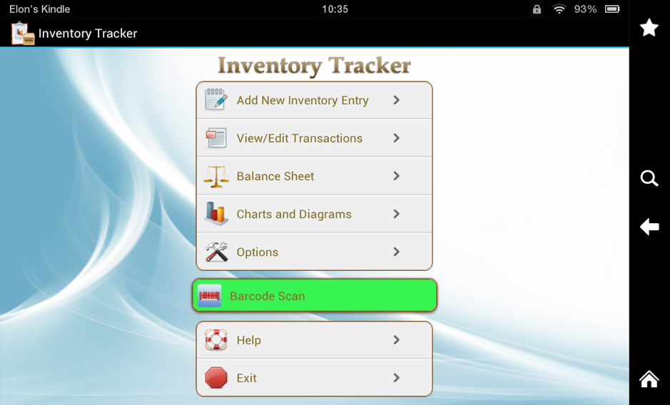
Figure: Inventory Tracker (Platform: Android Smartphone)
Source: https://2.bp.blogspot.com/-Kqk0WOsC-qI/VImclRcdGbI/AAAAAAAARZM/dZyyJDhcjak/s1600/Inventory.png

Ensuring staff employability:
In this age of globalization and digitalization, candidates, staffs and employees are well learned to operate various smart devices. Operating smart devices in workplace will create better opportunity for their given tasks and works which will increase the maximum productivity in a very shortest possible time. Employees will learn different issues and always be updated with latest technology.

Practical examples of using Tablets and Smartphones in workplace:
There are many organizations now a days implementing different strategies for making the working environment more comfortable for employees by using technology like smartphones and tablets. Reputed companies like Google, Microsoft, Apple and Samsung all have their employee’s ID, mobile number and various social identity which are the means of internal communication. Mobile and tablets will help employees and management to be updated with the day to day activities of their work and make it more efficient. Employees can easily communicate, making payments during travel and easily surf internet via mobile and smart devices to solve problems.

Cloud file storage:
Cloud storage is the greatest invention of digitalization and modern technology. This system is actually uses for both personal and commercial purpose. Cloud storage is a system where data and information is stored in a digital cloud or hard drive. Organizations now a days using this cloud storage facilities for communication, data security and efficiency of work. Employees can easily access any data in a shortest possible time in anywhere with cloud storage system. According to John, they stated that information leakage is the biggest threat for organizations and so, cloud storage will prevent and make a secure source of information for companies (John, 2015). Cloud can easily send and receive various files like image, documents, audio, videos etc.
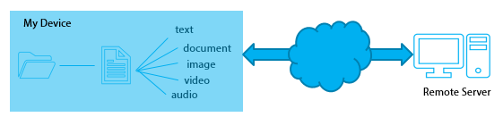
Figure: Cloud Storage
Source: https://cloudstorageadvice.com/what-is-cloud-storage/
There are various cloud service providers are found for both personal and non-personal/business use. The most popular cloud storage service provider name are-
- Dropbox
- Google Drive
- OneDrive
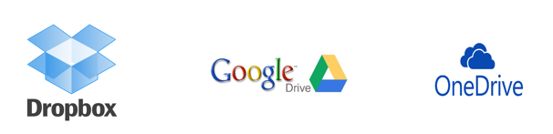
Figure: Cloud Storage Service Provider
Dropbox:
Dropbox is actually the property of Yahoo. This cloud service storage service includes many uses like transferring files from anywhere, sending and storing videos and audios, quick upload and download facility, quick access on files and a maximum 5 GB (Gigabyte) file storage opportunity. For business and companies, they can upgrade the storage capacity and facilities with their own way.
Google Drive:
Google Drive is the cloud storage service provider by Google. It also has the same facilities and services like Yahoo. But Google has offered customers to use 15 GB data capacity for personal use and for business use, clients can upgrade at least 1 TB storage capacity.
OneDrive:
OneDrive is a concern of Microsoft and already offered cloud service facility to its clients. In OneDrive also offered cloud storage capacity of 5 GB to non-business users and users can upgrade storage capacity with their need.

Benefits and workplace efficiency with staff employability by using cloud file storage:
- Increasing employee usability:
With the help of cloud storage, employees can easily find information and accumulates with the flow of managerial work and performance. Many companies like Google, Facebook has their own database and cloud file storage facility for their employees. These clod file storage service actually improve the productivity of employee performance with a shortest period of time. Individuals and teams will be helped by using the WPS Office with drag and drop facility for a file which increases employee performance (Benefits of Using Built-in Cloud Storage, n.d.). Staffs and employees will make a flexible working environment which can create a positive outcome for their employability with the help of cloud file storage in the workplace and in organizations.
- Authorized accessibility:
The most important and essential thing of cloud file storage is its security. Security of information’s is needed for organizations. Employees can easily have their own clod file storage ID, can store files and make a secure folder on it. Organizations like Amazon, Alibaba etc. have their own database and cloud file storage for their internal employees to maintain a secure platform of communication.

Practical examples of using cloud file storage in workplace:
Bigger companies like Netflix, Microsoft and many other tech giants have their own cloud file storage server and database. Due to the huge on-demand streaming service of Netflix, the company has implemented a big cloud database server (Cloud Computing Examples, 2017). Another tech giant Google has already developed a voice assistant on android smart phones with the help of natural cloud based language intelligent auto bots. Apple, iPhone has also the same vice assistant named Siri and it operates through the cloud base AI server.

Social platforms in the workplace:
Every organizations and management have their own social platforms for communication now a days. Because of the digitalization and modernized telephone sector with smart devices and technology, companies are now focusing on the informal communication with their customers. According to Zeithaml, he stated on his book Marketing Management, customer satisfaction is needed for business and social media will help companies to target, help and focus on their needs, wants and demands (Zeithaml, 2010). So, companies are trying to get their customers in social platforms because of the extreme engagement of social media, internet and smart devices. For an employee of any company, he/she needs to have some social platforms to get in touch for his/her professional career. Facebook, Twitter, YouTube, LinkedIn etc. web sites are very popular sites for regarding as professional means of employability.

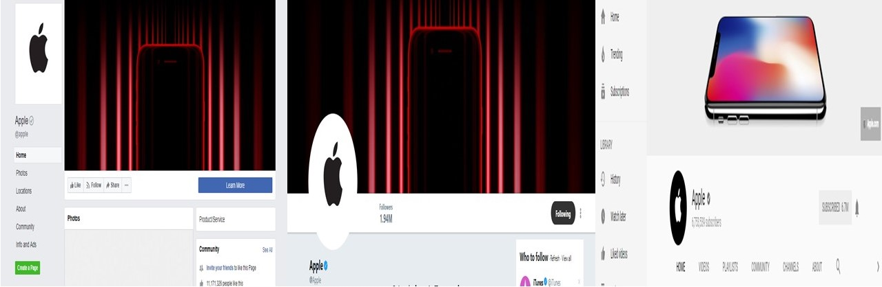
Figure: Social Pages of Apple (Facebook, Twitter, YouTube)
Source: https://www.facebook.com/apple/ https://twitter.com/apple?lang=en https://www.youtube.com/user/Apple
As an employee and digital skilled personnel, for employability purpose I need to accounts to accumulate with the technology and digitalization. Among them LinkedIn and Facebook accounts will help to search job posting, job description, job circular and company information which are readily available and free.

Helpful sites for searching jobs:
There are a lot social sites are rapidly changing their interface with various updates and among them job searching is the main opportunity for professionals. Among all the social sites, LinkedIn is the most popular site for searching jobs and job circular.
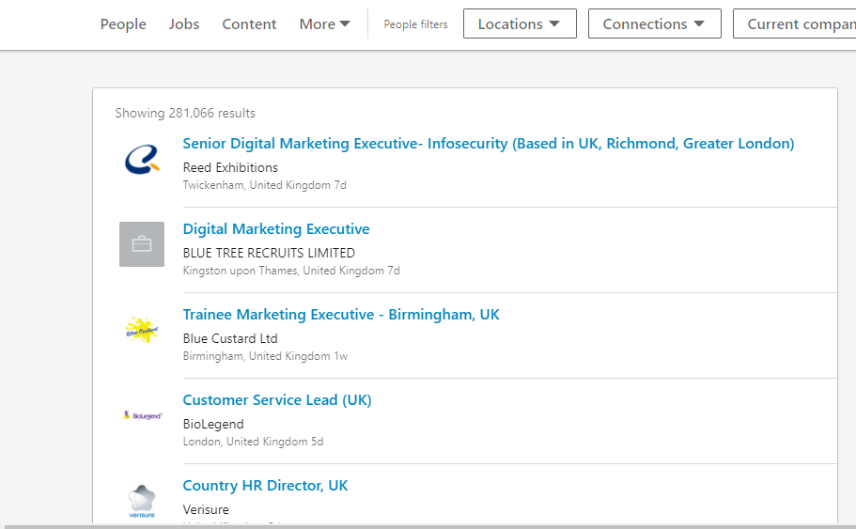
Figure: LinkedIn Job Circular
Source: www.linkedin.com
Here, the picture actually consists of different job circular in UK. Users can easily surf the internet and website with their account and filter which area they want to search or see. LinkedIn is not only using for professionals but also has a nice interface to chat, give messages to employees. So, in my opinion, Facebook, Twitter, YouTube all are essential and skills are required for business and professional purpose but LinkedIn is the best social platform for employability.

Advantages and disadvantages of social platforms:
Though these social sites have influenced employees in various ways but it also have some advantages and disadvantages.
In social sites, everything is informal and candidates or employees can easily see and be updated with job information. So, a candidates doesn’t need any formal authentication or authorization for information or he/she/ doesn’t need to make any monetary transaction. Employability using these sites is more flexible. Candidates can easily browse with internet and can search for their desired content in those social sites. Mobile, tablets, internet, web conferencing, cloud file storage etc. has a great influence now a days and most of the people are now have a minimum literacy about digital skills. So, these are some optimum advantages for candidates.
On the other hand, information leakage, threat of personal information etc. are the main demerits and cons for using these networks. In an informal way in social networks, if a candidate involved in fraudulent activity, he/she doesn’t have any legal help due to the documented evidence. Sometimes many organizations have posted fake and void job circular for employees and as a result, they are being harassed.

Conclusion:
In fine, it is to be noted that employability differs from organizations to organizations. But with the current flow of digitalization and technological advancement, candidates should have some digital skills and social media influence for their professional career. Using web based mail, using cloud file storage and multitasking will be effective and efficient enough for employees for achieving organizational goals and business objectives for companies.

References:
Bender. (2011). Digitalization and Digital Skills for Employees. (Rehnon, Ed.) An Analysis of Wrokplace Effeciency for Organizations, 1(2), 45-65.
Benefits of Using Built-in Cloud Storage. (n.d.). Retrieved from WPS Office Suit: http://blog.wps.com/the-productivity-benefits-of-using-built-in-cloud-storage/
Cloud Computing Examples. (2017, November 15). Retrieved from Newgen Apps: https://www.newgenapps.com/blog/top-10-cloud-computing-examples-and-uses
Fisher. (2014). Technology in Workplace. An Analysis of UK Organizations, 12(5), 56.
John. (2015). E-Commerce and Security. An Analysis of Data Security through Cloud Storage System in UK Organizations, 2(1), 67-69.
McWeeney, J. (2017, June 2). How Mobile Technology Boosts Workplace Productivity. Retrieved from Device Magic: https://blog.devicemagic.com/how-mobile-technology-boosts-productivity-in-the-workplace
Mitchel. (2012). Organizational Performance and Digitalization (4 ed., Vol. 2). Chicago: Pearson.
Richard. (2011). Digital Skills and Research Methods (6 ed., Vol. 3). NY: Pearson.
Zeithaml. (2010). Marketing Management (4 ed., Vol. 3). NY: Pearson.

Appendices:

Evidences of my social media:
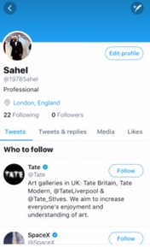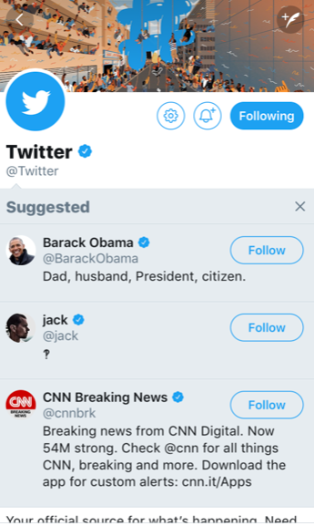
Figure: My Twitter

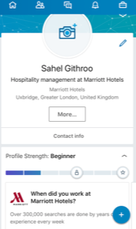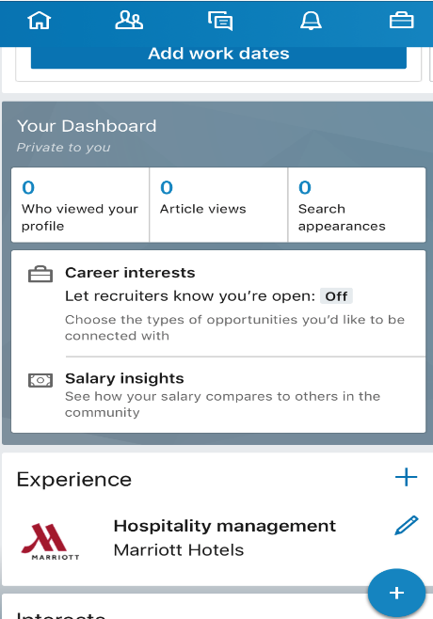
Figure: My LinkedIn
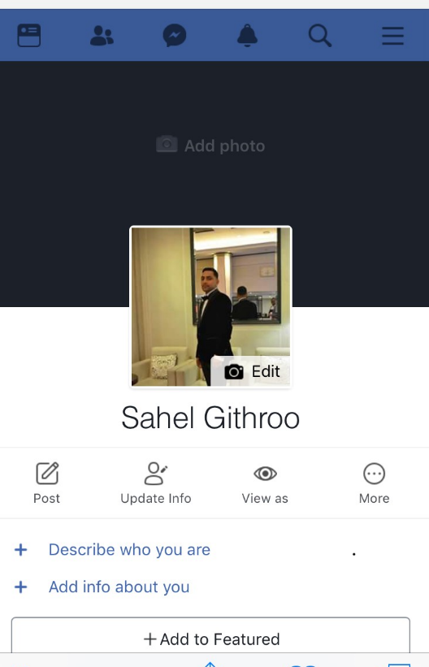
Figure: My Facebook

