Utilising the EntreComp Framework, critically evaluate your own creativity
and enterprise and consider how you might be able to develop the creative and enterprising skills of primary learners through your own pedagogy.

Employers are emphasising the “vital importance of promoting creativity and innovation” (Robinson, 2017, p. 2) and it is important that the curriculum reflects the needs of employers for young people to “move smoothly and successfully into employment” (Donaldson, 2015, p. 7). With a demand for individuals to possess ‘soft skills’ including creativity, there has been an international shift towards a “more skills-based curricula” focusing on essential competences (Welsh Government, 2013, p. 14). Furthermore, the Welsh school system recognises the importance of creativity and enterprise for young people, with Donaldson (2015, p.l 28) stating they are “central features of modern life that should be developed and extended throughout a school career” (Donaldson, 2015, p. 28). One of the four purposes of the developing curriculum is to enable children to become ‘enterprising, creative contributors’. The curriculum will also emphasise lifelong learning which NACCCE (1999) and Kinsella and Fautley (2017) believe has strong links to creativity. The Entrepreneurship Competence Framework (Bacigalupo et al., 2016, p. 5) has been developed with the aim of establishing “a bridge between the worlds of education and work”. The framework breaks down ‘entrepreneurship’ into various competences, providing a progression model which will be used in this essay to evaluate and set targets for personal creativity and enterprise skills whilst also considering how to move learners forward.
In terms of education distinctions are made between ‘enterprise’ and ‘entrepreneurship’. Enterprise focuses on equipping learners with the ability to generate ideas and the skills to make them happen whereas entrepreneurship “takes the next leap” by building on these skills and applying them to business ventures (QAA, 2018, p. 3). Horne (2000, p. 1) argues the “traditional definition of entrepreneurship is out of date” and we should instead, adopt an ‘enterprise culture’ within schools.

It appears to be a well-established view that we live in a time of unprecedented change (Horne, 2000; Cremin and Barnes, 2010; Barnes, 2015; World Economic Forum, 2016a; Robinson, 2017). Thus, we need to think in terms of education for the unknown (Perkins, 2012). However, according to Perkins (2012) 90% of what we teach is insignificant knowledge that children will not encounter again. The World Economic Forum (2016a) estimate that 65% of children today will find themselves in jobs that do not currently exist. “The ability to live with uncertainty and deal with complexity is essential” and creativity helps develop the skills needed for “a rapidly changing world” (Cremin and Barnes, 2010). This ‘rapid change’ will require individuals to be “flexible” with “a new set of skills and attitudes” (Horne, 2000). Through ‘entrepreneurship’ schools may be able to equip children with the skills and attitudes needed for the future, as Bacigalupo et al. (2016) list creativity and coping with uncertainty as key aspects of entrepreneurship. The European Commission (2006, p. 13) identifies “a sense of initiative and entrepreneurship” as a key competence needed for a knowledge-based society whilst the World Economic Forum (2016b) believes that ‘creativity’ is one of the key competencies required for success in the 21st Century with ‘innovation’ and ‘curiosity’ being qualities young people will need to possess.

Creativity is a “broad” and “abstract” concept that is open to interpretation (Beetlestone, 1998, p. 1) which has led to varying definitions. The Oxford English Dictionary simply states that creativity is “to create – to bring in to existence” however, this definition may not do justice to the ‘process’ that is creativity (Duffy, 1998; Kinsella and Fautley, 2017). Duffy (1998, p. 16) suggests that definitions themselves may “limit creativity” and restrict it to the arts, causing creativity to become “misunderstood” (Kinsella and Fautley, 2017) as creativity is fundamental “in all areas of everyday life” (NACCCE, 1999). Definitions may also be ‘elitist’ (Duffy, 1998; NACCCE, 1999) and should instead recognise that everyone can be creative, and this can be harnessed in schools across all subjects (Duffy, 1998; Kinsella and Fautley, 2017; Robinson, 2017). NACCCE (1999) aimed to create a ‘democratic’ definition built on the four purposes of creativity: imagination, purpose, originality and value. Creativity in their view is “imaginative activity fashioned so as to produce outcomes that are both original and of value” (NACCCE, 1999, p. 29). Duffy (1998, p. 18) describes creativity as a more personal process that involves “connecting the previously unconnected in ways that are new and meaningful to the individual concerned”.

There is some discussion around whether creativity is learned or innate. Whilst Land and Jarman (1993) and Robinson (2007) believe that we are naturally creative and this creativity declines with age, De Bono (1992, p. 17) argues “creativity is not natural to the brain” and instead needs to be taught through techniques. Research seems to suggest that although creativity could be a cognitive process, some people are more predisposed to creative traits (Roberts, 1997; Piaget cited in Duffy, 1998; Dacey and Lennon, 1998). Cremin and Barnes (2010, p. 359) state the importance of distinguishing between ‘Big C creativity’ (Gardner 1993a and b) with “studies of highly creative individuals” and ‘little c creativity’ (Craft 2000, 2001) which looks at the ability “ordinary people” have to “innovate and take action” (Cremin and Barnes, 2010, p. 359). Based upon this, Grigg (2010, p. 103) suggests creativity can be seen as a “continuum”.

Being creative is said to be “essential for survival” however, it is being “neglected” in schools (Fryer, 1996, p. 1). This may be due to pressures that teachers face such as meeting targets (Woods, 1995, Cremin and Barnes, 2010; Donaldson, 2015; Robinson, 2017; Kinsella and Fautley, 2017). Other reasons for a lack of creativity in schools could be:
- Limited time (Kinsella and Fautley, 2017)
- 3Rs – “Creative tasks are often perceived to be of lesser importance than reading, writing and number work” (Beetlestone, 1998, p. 24)
- Teachers may feel they are “not skilled enough” (Duffy, 1998, p. 102)
- Educational conformity (Sommer and Sommer, 2014)
- Creative children seen as ‘troublesome’ (Duffy, 1998, p. 77)
- Challenges of assessment (Lucas, Claxton and Spencer, 2013)
Despite the challenges, Beetlestone (1998, p. 26) states that “creativity continues to flourish, because teachers are aware of the way in which it enriches children’s lives”. Furthermore, Ofsted (2003, p. 11) argue that developing creativity in learners is an “essential part” of every educator's job.
NACCCE (1999, p. 104) highlight the difference between teaching creatively and “teaching for creativity”. Teaching creatively refers to imaginative pedagogy to deliver content in a unique way that will motivate and interest pupils; whereas teaching for creativity aims to develop learners’ creative skills and allow opportunities to use them. However, both forms of teaching require teacher creativity; learners’ creativity can be truly enhanced when teachers’ creativity is engaged (NACCCE, 1999; Kinsella and Fautley, 2017). NACCCE (1999, p. 15) states that “greater freedom for teachers in the classroom will help to promote creative teaching and this is essential to promote creative learning.”
Woods (1990) found there were conflicting views regarding teacher creativity, some see teachers as naturally creative whilst others believe they are uncreative. However, Woods believes the profession itself hinders teachers’ creativity stating that they are “mere technicians in the service of the ideas of others” (p. 29). This could refer to restrictions on teachers due to the curriculum and the lack of time to generate creative resources (NACCCE, 1999; Kinsella and Fautley, 2017). During PTE, the reliance on second hand resources was an issue within the Key Stage 2 classroom and thus became a personal target to generate more original, imaginative resources (appendix 1). Using the EntreComp progression framework to move forward it appears that creative resources would come under the ‘curious and open’ thread. The EntreComp proved difficult to navigate in this instance as despite the ‘resources’ area, creativity also discusses resources which seemed to be more relevant to teaching.
In response to the comments made by the mentor during PTE regarding the effective use of resources, it is assumed that the current personal level is low. However, during PTE the comments were addressed through better time management and an increase in creative confidence. Considering this, the author believes to be at an overall level 4, capable of “searching for solutions” that meet the needs of the pupils and the practitioner (Bacigalupo et al., 2016, p. 24). Nevertheless, this will need to be sustained throughout future practice and in order to improve it is crucial to “actively search” for new strategies which links in to the next thread on the EntreComp, ‘develop ideas’. Claxton (1984, p. 228) states that creativity means daring “to be different” and this will be considered when lesson planning and creating resources. By developing creative ideas and resources the aim will be to progress professionally whilst fostering children’s creativity. Less reliance on pre-made resources and worksheets should allow children to “approach a blank page” with confidence (appendix 1).
Despite pressures felt by teachers, ‘reflective’ practitioners are “continuously adapting” by exploring problems and experimenting with innovation and creativity (p. 30). Kinsella and Fautley (2017) argue that teacher reflection is the key to a creative class; this could be viewed as a personal strength. It has been noted on more than one occasion that during Professional Teaching Practice (PTE) assistive reflective conclusions (ARCs) have been completed to a high quality. Formative and summative reports from PTE (appendix 2) have identified “very good engagement with personal reflection” through “honest” ARCs that identify areas of improvement. This is believed to show “development in becoming a reflective practitioner who is focused on constant development of pedagogy.” (Appendix 2). Personal reflection through ARCs could be an exemplification of ‘learning through experience’ (Bacigalupo et al., 2016).
The Entrepreneurship Competence Framework (EntreComp) categorises the competence ‘learning through experience’ into three strands: reflect, learn to learn and learn from experience. Considering evidence from PTE, it appears the personal level of proficiency for ‘reflect’ currently stands at a level 5 as “temporary failures” are viewed as things to develop and improve (Bacigalupo et al., 2016, p. 34). Moving forward the aim will be to address recommendations made by tutors and mentors; consider ‘critical incidents’ that may arise and conduct research for areas identified within action plans.
Another area for development identified from placement is “help others develop their strengths and reduce or compensate for their weaknesses” (ibid). Meeting this recommendation should see improvements in ‘pupil progress’ (appendix 3). Some progress has already been made within this area (appendix 1); RAG rating was used to inform future planning. However, there are still improvements to be made.
There is a need for ‘high expectations’ of learners (appendix 3; Estyn, 2004; Donaldson, 2015; Welsh Government, 2017a). Despite being aware of some of the documented benefits of high expectations on learners, such as increased self-esteem and enabling children to reach their full potential (Symonds, 2015; Welsh Government, 2017b), this was clearly a struggle in practice, particularly when entering a new class due to limited knowledge of each child’s capabilities. There seemed to be a fine line between high expectations and unrealistic ones whilst trying to differentiate work to an appropriate level. If tasks are too easy, there is no sense of achievement whereas extremely difficult tasks can destroy children’s confidence (De Bono, 1992). Holt (1984) argues that this can create a fear of failure, resulting in children withdrawing or becoming disruptive. Behaviourists also stress the importance of achievable tasks believing that if a child is not successful, they give up. For Seelig (2012) though, ‘failures’ do not hold negative connotations, instead they are data to learn from and this is key to creativity and innovation. This view is supported by Bacigalupo et al. (2016) who see motivation and perseverance as key competencies to develop. Hattie’s research (2009) found that the top factor influencing student achievement is their expectations for themselves with teachers’ expectations also being a crucial factor. The practitioner will therefore need to build up intrinsic motivation to succeed within learners for them to overcome challenging tasks, taking into account the ‘expectancy value theory’. If children are interested and engaged, they are likely to persevere with the task (Edwards and Knight, 1994; Beetlestone, 1998). Fryer (1996, p. 31) suggests “accounts of highly creative people refer to their high level of motivation”.
For future practice, it will be ensured that data is requested and collected prior to teaching in order to assess the child’s current level and help them progress. It is hoped that by making children aware of the high expectations set for them, it will allow them to become ambitious and set high expectations for themselves and help engage their “curiosity and enthusiasm” (Donaldson, 2015, p. 110) that will enhance learning and creativity (NACCCE, 1999).
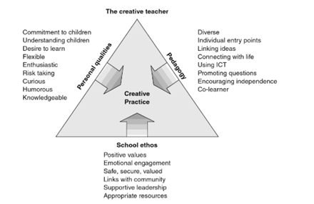
Assessing personal creativity felt daunting, perhaps falling into the category of many who feel they are not skilled enough or naturally creative (Fryer, 1996; Duffy, 1998; NACCCE, 1999; Barnes, 2015). However, upon review of the EntreComp and various literature detailing the characteristics of creative teachers, this view changed somewhat. Barnes (2015, p. 271) outlines what creative practice looks like and none of these aspects felt unobtainable (figure 1.1). Barnes (2015, p. 270) also states that “every teacher needs to understand that they are a creative being” (Barnes, 2015, p. 270).

Figure 1.1 The three dimensions of creative teaching, based on literature review
(source: Cremin et al., 2009; copyright Cremin, Barnes and Scoffham, 2009 cited in Barnes, 2015)
Duffy (1998) suggests that, to enhance creativity in children, the teachers’ role is to develop it through interactions and “create inspiring conditions”. To foster children’s creativity, the practitioner must consider the environment in which they learn. “Teachers need to engage, inspire and enthuse students by creating conditions in which those students want to learn” (Robinson, 2015, p. 104). Many people discuss the importance of physical and the social and emotional environment (Craft, 2000; Cremin and Barnes, 2010; Barnes, 2015) with Beetlestone (1998, p. 124) highlighting the importance of the outdoor environment as it provides a different “emotional climate”. Use of the outdoors is a personal target for future practice as it was challenging to create meaningful outdoor learning for key stage 2 pupils. By using the outdoors as a creative resource, creative thought should flourish (Adams, 1990; Beetlestone, 1998). Beetlestone (1999, p. 108) also discusses the “intellectual environment” and the importance of challenge for creative learning.

Fryer (1996, p. 32) however, suggests that children’s environments may have “no bearing on creative outcomes” as “highly creative people have emerged” from both “highly favourable and highly unfavourable environments”. Although, it is argued that this paradox could be due to the environments having ‘solitude’ in common (Storr, 1988; Fryer, 1996). MacKinnon (1962) supports this view, claiming that highly creative individuals show a preference for solitude. Fryer (1996, p. 32) suggests children are not given the time or space for solitude, believing that group activities are not “conducive to creative work”. Despite the documented need for personal space to think (Osborn, 1993; Fryer, 1996), NACCCE (1999, p. 43) argue that although “some individuals do work alone…creative achievement always draws from the ideas and achievements of other people.” This mirrors Vygotsky’s view (1978) that we have a natural desire to communicate and we need interaction to progress. Duffy (1998) suggests that teachers should ensure time is allocated for independent work as well as work with adults and peers.

The debate around solitude and interaction raises questions about teacher involvement when fostering children’s creativity. Robinson (2007) argues that too much input from teachers is killing children’s creativity, believing it is “virtually impossible” to sustain interest through direct teaching (Robinson, 2015, p. 107) suggesting a move away from traditional pedagogy. Blashcke (2012) claims that neither pedagogical nor andragogical approaches will prepare children for the workplace, instead a more self-directed approach needs to be adopted in schools. Through ‘heutagogy’ educators enable children with the skills to teach themselves and learners can reflect on their progress (Peters, 2004; Kamenetz, 2010; Blashcke, 2012).

The argument for a more self-directed approach to learning seemingly suggests that teachers should adopt a “non-interventionist” role whereby they are not directly involved in children’s creative work (Duffy, 1998, p. 90). This unstructured or ‘laissez-faire’ approach to teaching for creativity is established on the view that intervening may harm creativity and children should not be made to meet adult expectations (Duffy, 1998). Piaget’s view that creativity relies on children’s intellectual level has “sometimes led to the view that the adult’s role is supervisory rather than interactive” (Duffy, 1998, p. 91-2). The opposing view is that children will learn and grow through an ‘interventionist’ role (Bruner, 1975; Vygotsky, 1978; Beetlestone, 1998). Cox (1992) argues that without input children will be left without the skills and knowledge to progress, leading to frustration. Kindler (1995, p. 95) agrees with this, stating that “availability of materials is not enough, adult input is essential”. Thus, Duffy (1998, p. 95) suggests teachers “need to intervene with sensitivity” which should extend learning but not undervalue children’s creative expertise.

NACCCE (1999, p. 30) state that creative processes “always involve thinking” with De Bono (1992, p. 2-5) arguing that thinking is “essential to survival” and “for creativity, design, enterprise and doing anything new, we need thinking”. Thus, developing children’s thinking skills is key to fostering creativity. Fryer (1996, p. 39) states that the term ‘creative thinking’ is often used to discuss both creative thinking and “what is frequently called divergent thinking”. This term arises from the work of Guilford (1950, 1977); the four key elements are: fluency, flexibility, elaboration and originality. Fryer (1996, p. 40) argues creative thinking requires both divergent and convergent thinking, generating lots of ideas and “critically” narrowing them to one idea or solution. However, it is suggested that an ‘incubation’ (Torrance, 1979, Torrance & Safter, 1990) period is necessary to provide children with “ownership of learning” and to pave “the way for moments of creative inspiration to occur” (Hines, Catalana and Anderson, 2019, p. 36). Allowing incubation time helps ideas to “sink in” (ibid) and helps children be flexible with their ideas (John, Naumann, & Soto, 2008).

Sommer and Sommer (2014) believe we can boost creativity in classrooms by allowing time for divergent thinking. However, De Bono (1992, p. 4) argues that spending “time thinking” does not “improve our thinking skills” thus, teacher input is essential to teach children the necessary skills. According to De Bono (1992, p. 145) there are many different types of thinking, each with its own merits and limitations. He suggests the use of ‘six thinking hats’, with each hat representing a different “mode of thinking” for example, the white hat is simply facts and data whereas the green hat is the “generative hat”, producing creative ideas (ibid). The hats can be used individually or in sequence to promote ‘parallel thinking’; a co-operative way of exploring an issue as opposed to a debate, that allows children to think from more than one perspective.

The EntreComp was a valuable resource to begin evaluating personal creativity however, it has not yet been tested in real settings. Despite the framework being “adaptable” (McCallum et al., 2018, p. 11) it was found to be very business orientated in areas and difficult to relate to education, whilst the progression steps lacked continuity. Areas identified for personal development are: creative resources, consider ‘critical incidents’ in ARCs and conduct research from action plans, high expectations of learners and the use of outdoors. These recommendations aim to not only help personal development and creativity but also the learners’ creativity. Teachers should consider the physical and conceptual learning environment when supporting and developing creative learning. Teachers should also consider their role and “intervene with sensitivity” (Duffy, 1998, p. 95), allowing time for independent thinking as well as collaborative work. Thinking is a key aspect of creativity thus, teachers should consider how to develop skills effectively.

Appendix
1.
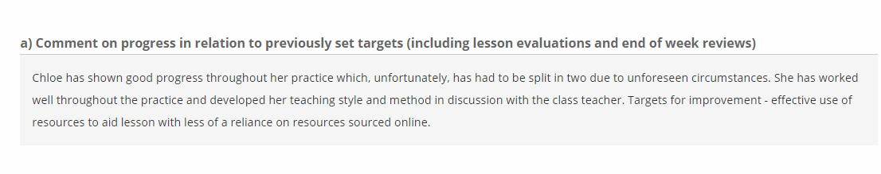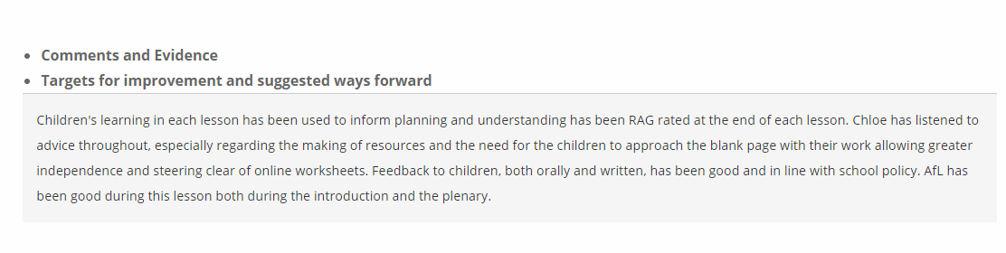
2.
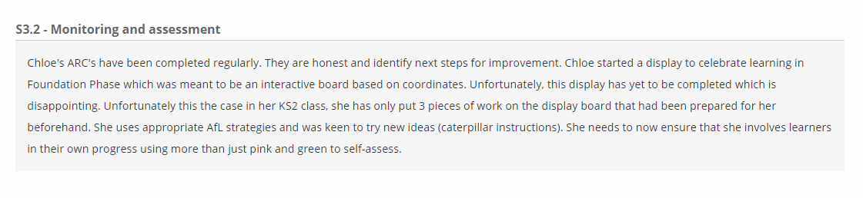
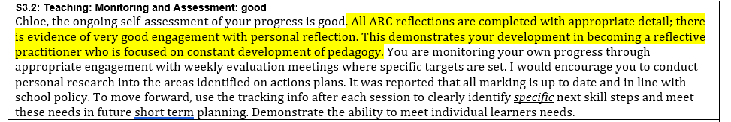

3.
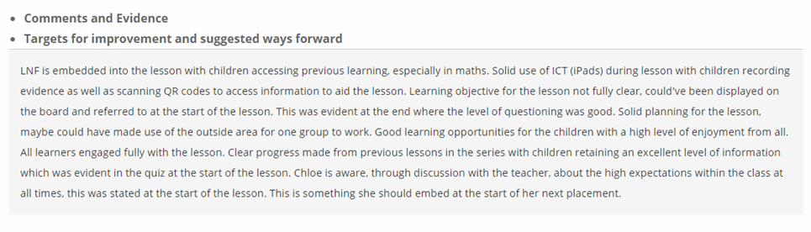
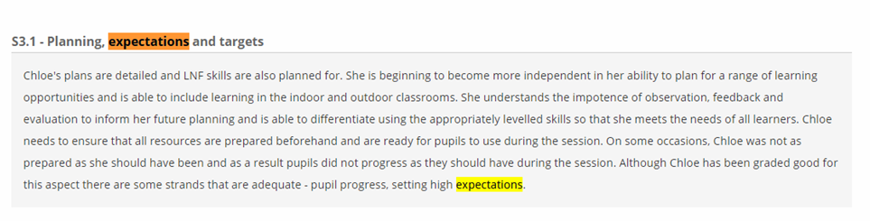
Reference List

Adams, E. (1990) Learning Through Landscapes: A Report on the Use, Design, Management and Development of School Grounds. Winchester: Learning Through Landscapes Trust.
Bacigalupo, M. et al. (2016) EntreComp: The Entrepreneur-ship Competence Framework. Luxembourg: Publication Office of the European Union.
Barnes, J. (2015) Cross-curricular learning 3-14. 3rd ed., Los Angeles: Sage Publications.
Beetlestone, F. (1998) Creative Children, Imaginative Teaching. Buckingham: Open University Press.
Blashcke, L. M. (2012) Heutagogy and Lifelong Learning: A Review of Heutagogical Practice and Self-Determined Learning. Available at: http://www.irrodl.org/index.php/irrodl/article/view/1076/2087 [Accessed: 31st January 2019]
Bruner, J. (1975) ‘The ontogenesis of speech acts’, Journal of Child Language, 2, 1-9.
Claxton, G. (1984) Live and Learn. London: Harper and Row.
Cox, M. (1992) Children’s drawings. London: Penguin.
Craft, A. (2000) Creativity Across the Primary Curriculum: Framing and Developing Practice. London: RoutledgeFarmer.
Craft, A. (2001) ‘Little c: creativity in craft’, in A. Craft, B. Jeffrey and M. Liebling (eds) Creativity in Education. London: Continuum.
Cremin, T., Barnes, J. (2010) ‘Creativity in the Curriculum’, in Arthur, J., Cremin, T. (ed.) Learning to Teach in the Primary School. 2nd end. Oxon: Routledge.
Dacey, J. S., & Lennon, K. H. (1998) Understanding creativity: The interplay of biological, social and psychological factors. San Francisco, CA: Jossey-Bass.
De Bono, E., (1992) Teach your child how to think. Harmondsworth: Penguin.
Donaldson, G. (2015) Successful Futures: Independent Review of Curriculum and Assessment Arrangements in Wales. Cardiff: Crown.
Duffy, B. (1998) Supporting Creativity and Imagination in the Early Years. Buckingham: Open University Press.
Edwards, A. and Knight, P. (1994) Effective Early Years Education. Buckingham: Open University Press.
Estyn (2004) Aiming for Excellence in Key Stage 3: Moving On…Effective Transition from Key Stage 2 to Key Stage 3. Cardiff: Crown.
European Parliament and the Council (2006) ‘Recommendation of the European Parliament and of the Council of 18 December 2006 on key competences for lifelong learning.’ Official Journal of the European Union, L394/310-18.
Fryer, M. (1996) Creative Teaching and Learning. Birmingham: Imaginative Minds.
Gardner, H. (1993a) Frames of Mind: The Theory of Multiple Intelligences. London: Fontana Press.
Gardner, H. (1993b) The Creating Mind. New York: Basic Books.
Grigg, R. (2010) Becoming an Outstanding Primary School Teacher. London: Routledge.
Guilford, J. P. (1950) ‘Creativity’, American Psychologist, 5, pp. 444-54.
Guilford, J. P. (1977) Way Beyond the IQ, The Creative Education Foundation Inc., in association with Bearly, Buffalo: NY.
Hattie, J. (2009) Visible learning: a synthesis of over 800 meta-analyses relating to achievement, London: Routledge.
Hines, M. E., Catalana, S. M., Anderson, B. M. (2018) When Learning Sinks In: Using the Incubation Model of Teaching to Guide Students Through the Creative Thinking Process. Available at: https://journals.sagepub.com/doi/10.1177/1076217518804858 [Accessed: 3rd February 2019]
Holt, J. (1984) How children fail. Rev., Harmondsworth: Penguin.
Horne, M. (2000) Enterprise Learning. Available at: http://www.readyunlimited.com/wp-content/uploads/2015/09/Enterprise-learning-horne.pdf [Accessed: 14th January 2019]
John, O. P., Naumann, L. P., & Soto, C. J. (2008) ‘Paradigm shift to the integrative Big Five trait taxonomy’. In A. P. John, R. W. Robins & L. A. Pervin (eds), Personality handbook: Theory and research (pp. 114-158). New York, NY: Guilford Press.
Kamenetz, A. (2010) Edupunks, edupreneurs, and the coming transformation of higher education. Canada: Chelsea Green Publishing Company.
Kindler, A. (1995) ‘Significance of adult input in early childhood artistic development’, in Thompson, C. M. (ed.) The Visual Arts and Early Childhood. Washington: National Association for the Education of Children.
Kinsella, V., Fautley, M. (2017) Creativity – Getting it right in a week. St Albans: Critical Publishing.
Land, G., Jarman, B. (1993) Breakpoint and Beyond: Mastering the future – today. New York: HarperBusiness.
Lucas, B., Claxton, G. and Spencer, E. (2013) ‘Progression in Student Creativity in School: First Steps Towards New Forms of Formative Assessments’ OECD Education Working Papers, No. 86, OECD Publishing. Available at: http://www.oecd.org/education/ceri/5k4dp59msdwk.pdf [Accessed: 23rd January 2019]
MacKinnon, D. W. (1962) ‘The personality correlates of creativity: a study of American architects’, in G. S. Nielson (ed.) Proceedings of the Fourteenth Congress on Applied Psychology, 2, Munksgaard, pp. 11-39.
McCallum, E. et al. (2018) EntreComp into Action: get inspired, make it happen (M. Bacigalupo & W. O’Keeffe Eds.) [Online]
National Advisory Committee on Creative and Cultural Education (1999) All Our Futures: Creativity, Culture and Education. Available at: http://sirkenrobinson.com/pdf/allourfutures.pdf [Accessed: 26th January 2019]
Office for Standards in Education (Ofsted) (2003) Expecting the unexpected: Developing creativity in primary and secondary schools. Available at: https://dera.ioe.ac.uk/4766/1/Expecting_the_unexpected_(PDF_format).pdf [Accessed: 25th January 2019]
Osborn, A. F. (1999) Applied imagination: Principles and Procedures of Creative Problem-solving. NY: Creative Education Foundation Press.
Perkins, D. (2012) What’s Worth Learning? [video]. Available at: https://www.youtube.com/watch?v=_CAdXXekKKM [Accessed: 25th January 2019]
Peters, O. (2001) Learning and teaching in distance education: Analyses and interpretations from an international perspective. 3rd edn. London: Kogan Page.
QAA (2016) Enterprise and Entrepreneurship Education: Guidance for UK Higher Education Providers. Available at: https://www.qaa.ac.uk/docs/qaa/about-us/enterprise-and-entrpreneurship-education-2018.pdf?sfvrsn=20e2f581_10 [Accessed: 26th January 2019]
Roberts, E. (1997) ‘Managing invention and innovation: What we’ve learned’, in R. Katz (ed.) The human side of managing technological innovation: A collection of readings. New York: Oxford University Press.
Robinson, K. (2017) Out of Our Minds: The Power of Being Creative. 3rd edn. West Sussex: John Wiley & Sons.
Robinson, K. (2007) Do Schools Kill Creativity? [video] Available at: https://www.youtube.com/watch?v=iG9CE55wbtY [Accessed: 16th January 2019]
Seelig, T. (2012) InGenius, a crash course on creativity. New York: Harper Collins
Sommer, G., Sommer, L. (2014) Classroom think talk. Available at: https://www.slideshare.net/leonardsommer3/classroomthinktankcanneslions2014 [Accessed: 25th January 2019]
Storr, A. (1988) The School of Genius. London: Deutsch.
Symonds, J. (2015) Understanding School Transition: What happens to children and how to help them. London: Routledge.
Torrance, E. P. (1979) ‘An instructional model for enhancing incubation.’ The Gifted Child Quarterly, 23, 23-35.
Torrance, E. P., & Safter, T. H. (1990) The Incubation model of teaching: Getting beyond the aha! Buffalo, NY: Bearly.
Vygotsky, L. (1978) Mind in Society. Cambridge, Mass.: Harvard University Press.
Welsh Government (2013) A Rapid Evidence Assessment on the Impact of Curriculum and Assessment Arrangements within High Performing Countries. Cardiff: Welsh Government.
Welsh Government (2017b) Our National Mission. Available at: https://beta.gov.wales/sites/default/files/publications/2018-03/education-in-wales-our-national-mission.pdf [Accessed: 30th January 2019]
Welsh Government (2017a) Professional standards for teaching and leadership. Available at: http://learning.gov.wales/docs/learningwales/publications/170901-professional-standards-for-teaching-and-leadership-en.pdf [Accessed: 30th January 2019]
Woods, P. (1995) Creative Teachers in Primary Schools. Buckingham: Open University Press.
Woods, P. (1990) Teacher Skills and Strategies. London: The Falmer Press.
World Economic Forum (2016a) The Future of Jobs: Employment, Skills and Workforce Strategy for the Fourth Industrial Revolution. Available at: http://www3.weforum.org/docs/WEF_FOJ_Executive_Summary_Jobs.pdf[Accessed: 4th December 2018]
World Economic Forum (2016b) What are the 21st-century skills every student needs? Available at: https://www.weforum.org/agenda/2016/03/21st-century-skills-future-jobs-students [Accessed: 6th December 2018]

