Data Handling and Business Intelligence
LCBB5000 - Assignment 2
student ID: 2011288
sTUDENT NAME: nIKOLAY pETKOV

Contents
Introduction 2
Analysis and Discussion 2
Assessment Component: 1 2
Current trends in data warehousing, business intelligence, and data mining 2
Assessment Component: 2_Part:1 3
Crime rate and number of offences evaluation 3
Assessment Component 2: Part-2 5
Data Analysis with SPSS 5
Requirement:1 6
Requirement: 2 7
Requirement: 3 7
Part: a 8
Part: b 10
Part: c 10
Conclusion 11
References 12

Introduction
Data analysis has become an important component in today's corporate environment. Data analytics may be described as the science of analysing raw data in order to make a conclusion. Data analysis is mostly used to process and analyse raw data in order to make a choice or decide anything. Its role is critical since it allows firms to improve their performance. Data-driven business models can help save expenses by discovering more efficient methods of doing business. The company may also use data analytics to enhance business choices and analyse customer trends and pleasure, that may also lead to the creation of upgraded goods and services. This assessment deals with different data analysis and different data analytic tools to find the solution of several inquiries.

Analysis and Discussion

Assessment Component: 1

Current trends in data warehousing, business intelligence, and data mining

 | Trends
Data Warehousing (It is a location where data from many data sources is saved in order to be utilized for historical and trend analysis reporting) | Service Modernization: Infrastructure is being upgraded by government and non-governmental organizations in order to enable and provide more digital services in a more rapid way. A high-performance storage facility enables efficient work as well as low-risk, ongoing cloud migration.  Simplifying Analysis: A data warehouse provides a variety of ready-to-use tools to help jumpstart and simplify data processing. These in-database analytics capabilities reduce the need to transport data from one system to another for analysis, resulting in more streamlined and efficient data discovery.  Single Data Warehouse: Making all data available in one service, rather than many data warehouses on separate architectures, is becoming a trend that also greatly decreases cost. This may be accomplished by the consolidation of all data into a single store, as well as the usage of a large-scale serverless data warehouse (Subrahmanyam and Doja, 2013).
Business Intelligence (Business intelligence refers to the tactics and technology used by businesses to analyse data and monitor business information) | Artificial Intelligence: Artificial intelligence (AI) has taken over every element of business, including business intelligence. The technology's enormous potential promises to boost human intellect by transforming how users engage with corporate data and analytics.  Mobile Business Intelligence: The workforce is more mobile than ever before, and mobile data analytics solutions are evolving. These developments indicate that business intelligence is evolving to make new sources of information accessible, digestible, and valuable to enterprises of all sizes, even those lacking strong analytics capabilities or in-house resources.  Real time Analysis: Interactive presentations are taking the place of static reports. Interactivity allows business users to explore and answer questions using real-time data. By monitoring the most recent data allows decision makers to respond with more precision and speed (Mirchandani and Gaur, 2019).
Data Mining (It is the practice of collecting enormous amounts of data in order to identify patterns and connections that will aid businesses in solving problems through data analysis) | Mobile Data Mining: The evolution of information technology has resulted in a huge increase in social networks. Visual data is becoming increasingly difficult to comprehend. As a result, data mining emerges as an appropriate approach for delving into this material. It is quite useful to analyse client habits and plan the next marketing step to appeal to the greatest number of users.  Location based Data Mining: A large amount of data is kept in several locations, making it difficult to solve. Companies may opt to keep information in many places for security reasons. Analysts, on the other hand, can follow data in the proper place and use appropriate methodologies to mine information with the aid of location-based data mining.

Assessment Component: 2_Part:1

Crime rate and number of offences evaluation
The crime rate data and number of offences (in million) will be evaluated from the provided data where crime rates of 47 samples are presented and the evaluation will be divided into two segments as the instruction provided. Both of the parts are discussed below with the proper procedure of calculation.
Data pre-processing
Data pre-processing involves the sorting data according to the convenience, data cleaning of the irrelevant data. As the provided data is not based on time series or any other relevant series, there won’t be any data sorting part. Besides the numeric data there are also Boolean data which is normally denoted with 0 and 1. As there is no descriptive of these Boolean data, these data are cleansed and then the data processing part take place.
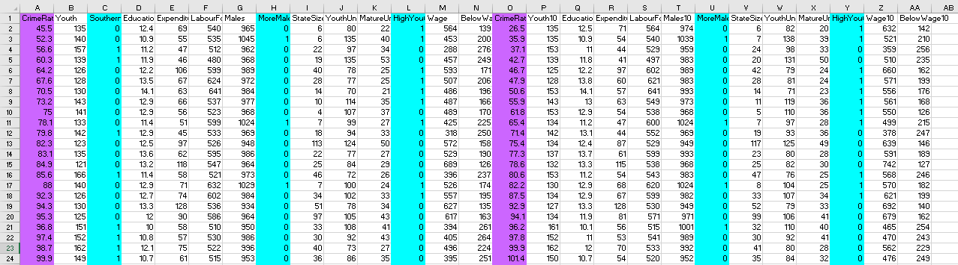
The cyan coloured data are the Boolean type data and these are irrelevant so they are cleaned and the violet coloured data is the relevant data which will later be processed.
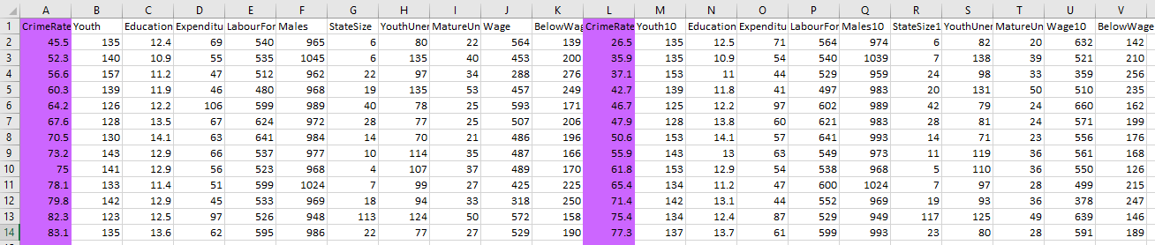
Data Analysis and Visualization
After the data is processed, then data analysis is started and it can be done in various way. In this assignment, the data analysis is done with using excel function to find the crime rate and also the number of offences per million. It is done with calculation of summing the 47-sample data and then averaging it to find the actual crime rate. For finding the number of offences, the crime rate is converted into millions and then evaluating it to million. Along the data analysis, data visualization is done with the excel help to demonstrate the result graphically.
The crime rate (in 100,000) is 102.439 and the number of offences (in million/1000,000) is 1024.39

For demonstration of the answer with another excel function, the pivot table has been selected and presented every step of calculation as below:

Assessment Component 2: Part-2

Data Analysis with SPSS

Requirement:1
According to requirement 1, the number of students who like vanilla flavour are 95. The calculation is done with the frequency analysis of SPSS software.

ice_cream
 |  | Frequency | Percent | Valid Percent | Cumulative Percent
Valid | Vanilla | 95 | 47.5 | 47.5 | 47.5
Valid | Chocolate | 47 | 23.5 | 23.5 | 71.0
Valid | Strawberry | 58 | 29.0 | 29.0 | 100.0
Valid | Total | 200 | 100.0 | 100.0

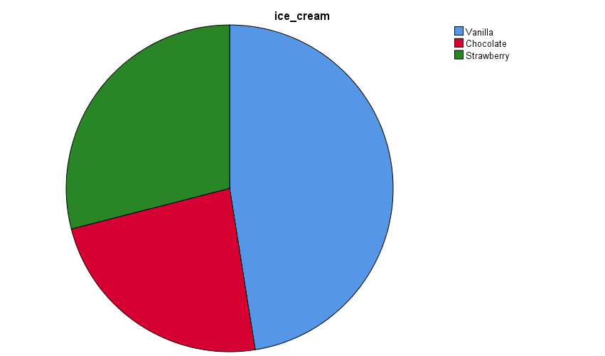

Requirement: 2
For finding the number of students who are male and female, again the Frequency analysis from analysis option in the SPSS application is done. During the process, the chart has been selected as pie chart and as a result the result is visualized with pie chart.
gender
 |  | Frequency | Percent | Valid Percent | Cumulative Percent
Valid | Male | 91 | 45.5 | 45.5 | 45.5
Valid | Female | 109 | 54.5 | 54.5 | 100.0
Valid | Total | 200 | 100.0 | 100.0

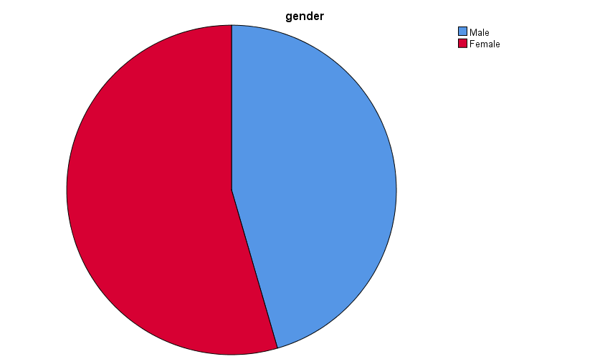

Requirement: 3
For the third requirement, the data is firstly split and then the analysis process is proceeded. In the split section the ice-cream section is selected as the Chocolate and the Strawberry flavour’s mean and median is to be evaluated. The from the analysis option, the mean and median is selected from statistics sub section. The result is as below:
Statistics
ice_cream
N | Valid | 47
N | Missing | 0
Mean |  | 2.00
Median |  | 2.00
ice_cream = Chocolate

Statistics
ice_cream
N | Valid | 58
N | Missing | 0
Mean |  | 3.00
Median |  | 3.00
ice_cream = Strawberry

Part: a
Cluster Analysis
The cluster analysis is done in two steps. In the first step, the descriptive option is selected from the descriptive analysis option under Analysis section. As for the variables, Ice-cream, video and puzzle is selected. In the delivered section these are shown in Z starting section name format. Then the K cluster analysis is performed. And the result is found as below:

Initial Cluster Centers
 | Cluster
 | 1 | 2
Zscore(ice_cream) | 1.38273 | .21587
Zscore(video) | 1.73217 | -2.30787
Zscore(puzzle) | 1.73206 | -2.45953

Iteration Historyª
Iteration | Change in Cluster Centers
Iteration | 1 | 2
1 | 2.011 | 2.261
2 | .072 | .081
3 | .061 | .065
4 | .034 | .035
5 | .024 | .026
6 | .000 | .000
a. Convergence achieved due to no or small change in cluster centers. The maximum absolute coordinate change for any center is .000. The current iteration is 6. The minimum distance between initial centers is 5.937.

Final Cluster Centers
 | Cluster
 | 1 | 2
Zscore(ice_cream) | .30563 | -.33110
Zscore(video) | .59979 | -.64977
Zscore(puzzle) | .71282 | -.77222

Number of Cases in each Cluster
Cluster | 1 | 104.000
Cluster | 2 | 96.000
Valid |  | 200.000
Missing |  | .000

Part: b
Some common data mining and text mining methods
 | Method
Data mining: It’s the process of examining vast databases of information in order to produce new information. | Pattern Recognition: It is a fundamental method in data mining that is used to find patterns in data sets.  Clustering: It’s similar to classification in that data is categorized based on similarities.  Prediction: It is used to forecast what kinds of data will be seen in the future. Recognizing and comprehending historical tendencies might sometimes enough to make an accurate prediction of what will occur in the future (McDaniel, 2019).
Text Mining: Exploring into unstructured data in order to uncover significant patterns and insights for examining textual data sources. | Extraction of Data: It is the technique of extracting useful information from large amounts of textual data. The text mining approach focuses on extracting entities, properties, and connections from semi-structured or unstructured texts.  Summarization: It is the process of automatically creating a compressed version of a given text that contains useful information for the end user.  Text Visualization: It's a method that converts enormous amounts of written information into a visual map layout, allowing for increased browsing as well as easier searching (Editorial, n.d.).

Part: c
Advantages and disadvantages of using SPSS and Excel
 | Advantages | Disadvantages
SPSS | - It's relatively simple to use.  - Each measurement is represented by a single row of data.  - When data is arranged in a database, such as Excel, students can import data from various sources.  - For visual learner, it is extremely user friendly. | - It's very pricey and requires a license.  - It is not recommended for multi-level analysis.  - It cannot be used to examine massive amounts of data.  - Functionality is limited (Opie, 2019).
EXCEL | - Large volumes of data are powerfully analysed.  - Tables have around 50 pre-set table Styles.  - Using Excel's built-in User form, you may recover lost data.  - There is a good graphic presentation available.  - Spreadsheets may be worked on concurrently with other users (DiMaria and Ostrow, 2009). | - Inadequate control and security.  - Excel is prone to human mistake and might be difficult to consolidate.  - Excel is not intended to be used in a collaborative environment.  - Advanced pricing rules are difficult to administer and are unsuitable for dynamic company processes.

Conclusion
The assessment is mainly focused on different analysis part of a data through different analytic tools use. Basically, the assessment solution of the first part is done with the excel application and the final part is done with the IBM SPSS application. All the requirement is tried to fulfil properly according to the instruction. Though it is tried to respond all the question with utmost sincerity, there is still room for improvement specially in the data analysis part of the first section.

References
DiMaria-Ghalili, R.A. and Ostrow, C.L., 2009. Using Microsoft Excel® to teach statistics in a graduate advanced practice nursing program. Journal of Nursing Education, 48(2), pp.106-110.
Editorial (n.d.). Text mining methods and techniques: The beginner’s guide. [online] roboticsbiz.com. Available at: https://roboticsbiz.com/text-mining-methods-and-techniques-the-beginners-guide/.
McDaniel, S. 2019. 16 Data Mining Techniques: The Complete List - Talend. [online] Talend Real-Time Open Source Data Integration Software. Available at: https://www.talend.com/resources/data-mining-techniques/.
Mirchandani, A. and Gaur, B., 2019. Current trends & future prospects of social media analytics in business intelligence practices. Journal of Content, Community and Communication, 5(9), pp.123-130.
Opie, C., 2019. Using excel/spss in your research. Getting Started in Your Educational Research: Design, Data Production and Analysis, 309.
Subrahmanyam, V.V. and Doja, 2013. M.N., Recent Trends in Data Warehousing.

