University of Wales Trinity Saint David

Institute of Science and Art
Engineering Materials
Materials and Manufacturing (ACHA4025)

Will McPherson
2501006
27th April 2026
Contents
1 Introduction 2

Introduction
This report is an investigation of an aluminium alloy that was used to manufacture the driveshaft for a Dakar rally car. The aluminium alloy driveshaft was used in two cars and failed with a complete fracture in both instances. To begin with, this report will research and surmise the material properties and test methods that should be considered for the application. A test sample of the material has been provided for this investigation and will be tested for yield strength, ultimate tensile strength and Young’s modulus. This data can then be compared and analysed given the design problem that the Dakar rally cars pose. Potential causes for the failure can then be concluded, and mitigations can be proposed to prevent similar failures in the future.

Literature Review
The Dakar rally is one of the most unique engineering challenges in the world. The cars are required to navigate 8000km of desert over 15 days through temperatures reaching 40°C in the day and getting down to -5°C at night. This context makes material selection enormously complex. The materials must be very tough being able to withstand repeated impacts from the terrain without damaging the function or the safety of the car. They also must be able to maintain their properties in hot and cold conditions. The Loprais team puts it like this: A Dakar-style race car must be built with materials that can withstand rough terrains, extreme temperatures, and high-speed impacts. (Loprais Team, 2025). They then go onto explain why an aluminium alloy might be an ideal choice for a Dakar rally car. Aluminium alloys are favoured in Dakar-style race cars for several reasons:
- Lightweight: Reduces overall vehicle weight, enhancing speed and fuel efficiency.
- Corrosion Resistance: Essential for withstanding harsh environmental conditions.
- Strength: Provides the necessary support for the vehicle’s structure without adding excessive weight.
(Loprais Team, 2025)
When applying this to the design of a driveshaft, a range of other material properties need to be considered. Most importantly, a high tensile/shear strength since the driveshaft will have significant torsional load applied through it. Corrosion resistance is also an important property for this application since the materials will be exposed to water and sand along with humid conditions which will promote corrosion. Fatigue resistance should be considered since the car must withstand long stages with repeated load applied. A material with a low density will be ideal since a lighter driveshaft will decrease the weight of the car and therefore increase the performance. Finally, toughness will be vital for the design since there is a high likelihood of impacts to the driveshaft.
The Izod test is a useful method for testing the toughness of a material. A test sample with a small notch is hit with a hammer. The hammer is swung with a known velocity at impact calculated from its gravitational potential energy. The height that the hammer reaches after breaking the specimen is used to calculate how much energy the material absorbed during the impact. (Dunn, n.d.).

Tensile strength can be tested using a tensile test such as the ES6 test kit, paired with a test sample of the material. The tensile test is a destructive test that adds an increasing axial (tensile) load or force to a material specimen, while measuring its elongation. The tests help you to find the yield strength, tensile strength and elongation (an indication of ductility). (TecQuipment, 2012). This is the method that will be followed in this investigation.

Methodology
To test the mechanical properties of the aluminium alloy, the ES5 test kit was used and its guidance followed. Below shows an image of the equipment required to carry out the test.
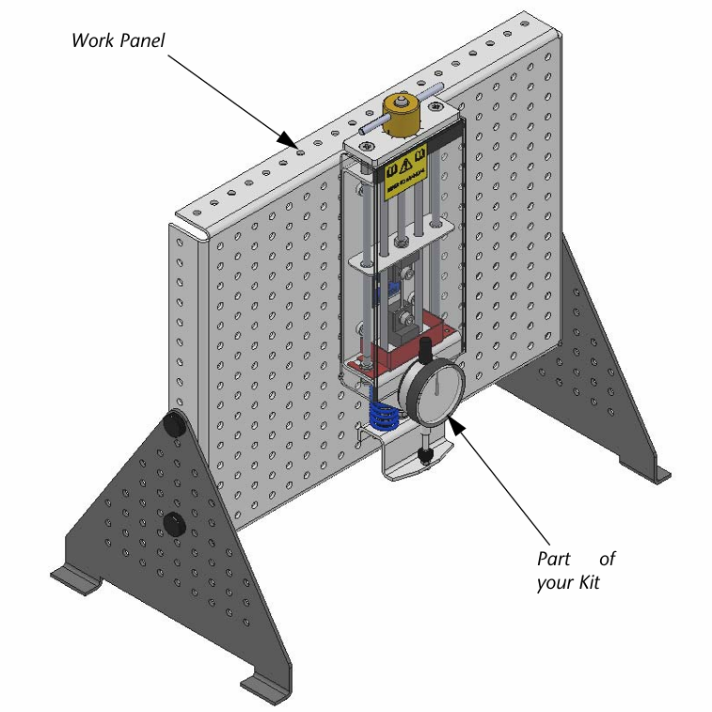
Figure 1 (ES6 Tensile Tester equipment) (TecQuipment, 2012)
The aluminium alloy specimen is secured into the test kit by a top chuck and bottom chuck. As the load nut is turned, it pulls the top chuck upwards hence putting a tensile force through the specimen. The load nut has incremental notches on its circumference each corresponding to an extension of 0.1mm. The bottom chuck connects to the two large springs. A Dial Indicator measures the deflection of the springs as you apply force. The springs obey Hooke’s Law, so the measurement from the Dial Indicator helps to show force. (TecQuipment, 2012). An important step in the process is to turn the load nut until the dial indicator begins to move, at which point the dial indicator should be set to 0. This is to take up any slack in the chucks/nuts. For the test carried out for this report, the load nut was turned by 2 notches, corresponding to 2mm of load nut movement, and a measurement from the dial indicator was taken. This process was repeated until the specimen broke. This data was plotted into a table of load nut movement with dial indicator measurement.

Test Results
The table below shows the raw data collected from the test (two left columns) and parameters calculated from the raw data that could then be plotted into the graph of stress against strain.
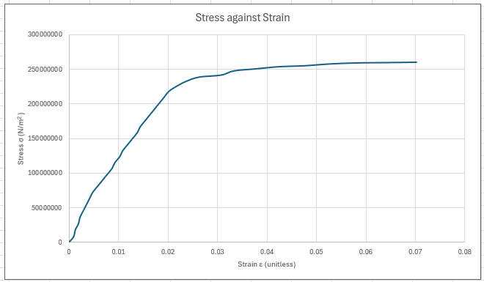
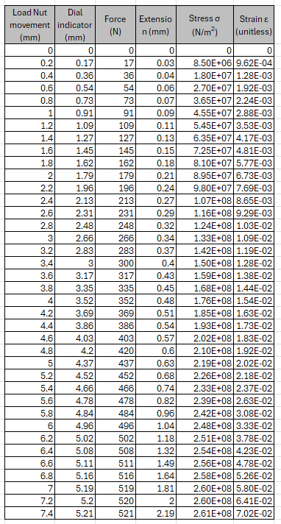
Figure 2 (Graph showing stress against strain)
Table 1 (Table showing test results)
The table shows the load nut measurements go up from 0mm to 7.4mm, after which it broke through the centre of the specimen. The failure is shown in figure 3 below.

Figure 3 (Aluminium alloy test specimen failure)

Analysis
The graph below shows the analysis of the graph in figure 2. The elastic and plastic regions have been identified along with Young’s modulus, elastic limit, yield point and ultimate tensile strength identified.
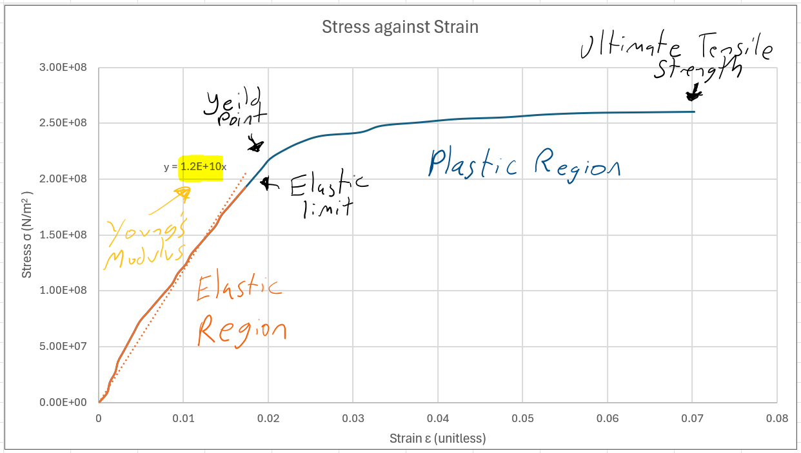
Figure 4 (Labelled graph of Stress against Strain)
This figure shows the elastic region to be within the strain values 0 to approximately 0.017. The strain continues to increase into the plastic region until the strain reaches 0.07 which corresponds to the ultimate tensile strength and the fracture point. This yield point corresponds to a yield strength of 220MPa given a 0.2% offset from the elastic limit which is at 193MPa. The ultimate tensile strength is the highest point on the graph or the highest value for stress in the table which in this test was 260MPa. Finally, the Young’s modulus is the gradient of the elastic region which follows Hooke’s law. This was calculated at 12GPa.
This value of Young’s modulus differs significantly from expected values for aluminium alloys. The Young's Modulus of aluminium alloys ranges between 69,000 and 77,000 MPa (SkyCiv Engineering, 2023). The value calculated from the test was 12GPa or 12,000MPa which is only 15% of the expected values. This inaccuracy can be explained by the compliance in the test rig. The specimen is secured to the rig by a bolt into the chuck. This system has a significant amount of compliance before the rest of the test equipment is considered. The specimen will move relative to the bolt and to the chuck which will make the strain values inaccurate. Since the specimen is only 31mm long, these slight movements in the equipment make a more significant impact on the strain values as strain is extension over original length. This increase in the values for strain results in a decrease in the value of the Youngs modulus since the equation for Youngs modulus is stress divided by strain.
This increase in strain also affects the yield point. An expected strain value for yield point is around 0.002 whereas it is closer to 0.02 on the graph in figure 4. This is a significant inaccuracy in strain values which affects the gradient, and points taken along the x-axis such as the yield point. However, the parameters such as the yield strength and the ultimate tensile strength are taken from the y-axis (stress) which is independent of the x-axis.

Conclusion
The test, though inaccurate for some parameters, was very inciteful for diagnosing the failure seen in the driveshaft of the rally raid cars. The yield stress was 220MPa and the driveshafts experienced a maximum stress of 90MPa. At face value, this means that the driveshaft should not have failed since 90MPa < 220MPa, however this 90MPa maximum is during monotonic loading and in single load events. This is very unrealistic for a rally raid car during the Dakar rally. The driveshaft is under continuously high loads for long stages day after day through a range of harsh conditions. Therefore, the failure is explicable by fatigue, stress concentration and dynamic loading.
Fatigue is a very important factor when considering the cause of the failure. The driveshaft experiences huge changes in torque very quickly as the car brakes or accelerates suddenly or, most significantly, goes over a jump. This continued loading and unloading, with each load event reaching high loads (up to 90MPa), will result in wear in the driveshaft. Cesar Azevedo puts it well in his book ‘Engineering Failure Analysis’. Fatigue failure is defined as a delayed fracture under cyclic loading. It is a cumulative damage rather than a once-load damage. Fatigue is the most common failure mode of shafts owing to the effect of cyclic loads acting on these under normal working conditions. Fatigue failure occurs at stress levels below the yield or ultimate strength of the material. It begins with cracks in critical areas that are subjected to stress concentrations. (Azevedo et al., 2026). This is directly related to the context here. The driveshaft experiences cyclic loads below the yield stress but through repetition, weaknesses formed which create stress concentrations and caused the driveshaft to fail. These small weaknesses present as notches or cracks which decreases the yield stress in a localised section of the driveshaft. These localised areas of weakness are often the areas experiencing the highest stress, since the weaknesses were formed there in the first place. Further cyclic loading on these localised weaknesses will ultimately cause the part to fail. This process can be seen retrospectively in the image of the failure shown in figure 5 below.
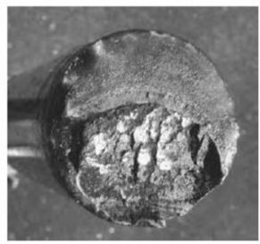
Figure 5 (Driveshaft Fracture)
The image shows cracking and gradual failure starting from the bottom of the image. This would have happened due to fatigue and stress concentration. The top half of the shaft is a much smoother fracture. This is because the localised yield point was reduced by the fatigue to below 90MPa at which point the shaft entirely fractured, leaving a clean split.
Dynamic loading is another consideration when diagnosing the failure. Dakar is extremely harsh meaning the materials experience forces and impacts from all directions due to rough terrain and often harsh turns, acceleration, braking and jumps. This means that, though the torsional stress may not exceed 90MPa through a single load event, the net load on the driveshaft may be much higher due to tensile, shear or compressive forces acting on the shaft caused by sudden forces on the car.
Impacts to the shaft from rocks or other components on the car may also be detrimental to the strength of the shaft. Small surface deformations may cause localised weaknesses and therefore stress concentrations that will lead to a failure. These impacts can be exaggerated by thermal expansion. The temperature can change by over 40°C during the Dakar. A surface deformation like a chip or a scratch is more likely to happen when the shaft is hot since metals lose hardness with heat. When the shaft cools down it becomes more brittle meaning the cracks are more likely to propagate and spread making the shaft weaker.
Therefore, this specific aluminium alloy can be deemed as an inappropriate material for the application. To find a more appropriate material, a materials selection chart can be used as seen below.
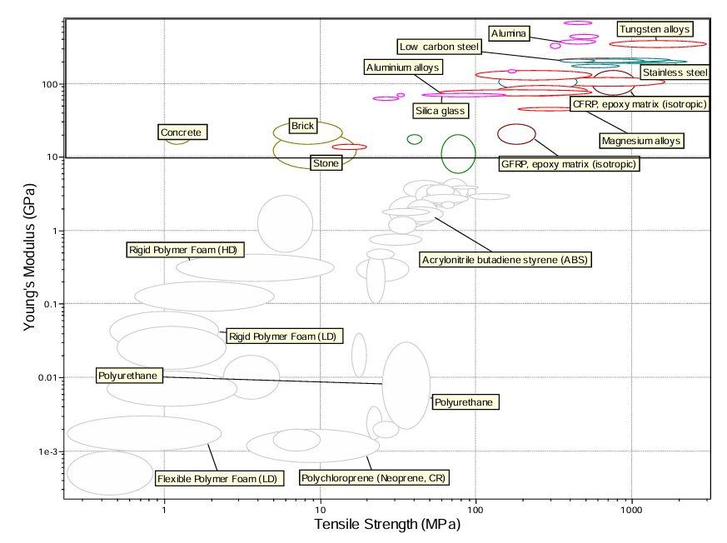
Figure 6 (Materials selection chart) (Itugha et al., n.d.)
The chart shows aluminium alloys with reasonably high and comparable Youngs modulus to other material options but lower than its competitors on tensile strength. A more appropriate material would be a steel such as carbon steel or alloy steel. These materials maintain the ease of manufacture of aluminium whilst significantly increasing the strength. Some other options may include a tungsten alloy, a composite such as carbon fibre or titanium. Tungsten alloys are very dense which will increase the weight of the car and therefore decrease the performance capabilities. Carbon fibre is a much more promising driveshaft since it is light, stiff and easily accessible in a race team. However, it is brittle and is more susceptible to dramatic failure. Titanium is light and very strong; however, it is also very expensive and difficult to manufacture due to its hardness.
Therefore, to prevent future failures such as the one in this investigation, the designers should consider using a steel such as carbon steel or alloy steel.

References
Dunn, D. (n.d.). Material Properties and Testing Class Notes.
TecQuipment LTD. (2012). ES6 Guidance_1012.
Itugha, O. D., Jumbo, E. E., & Obaseki, E. (n.d.). Investigation Of Key Materials Selection Parameters For Drive Shafts Manufacture, Cost And Energy Economics. Retrieved www.jmess.org
Palaci, M., Gonca, G., & Palaci, Y. (2026). Failure analysis of the bolted connection in a shipboard crane tower: A case study of catastrophic bolt fracture. Engineering Failure Analysis, 193. https://doi.org/10.1016/j.engfailanal.2026.110862
SkyCiv Engineering. (2023). Aluminum Alloys Material Properties | Material Specifications. https://www.beamdimensions.com/materials/Other/Non-Ferrous_Metals/Aluminum_Alloys/
What are the best materials for building a Dakar-style race car? (2025, November). https://instaforex-loprais.com/what-are-the-best-materials-for-building-a-dakar-style-race-car/

