University of Wales Trinity Saint David

Wales Institute of Science & Art


Engineering Problem
(ACHA4001)

Cara Williams
2401134
8th March 2025
Wordsntents
Table of Contents
Table of Tables 1
Table of Figures 1
1. Introduction 3
2. Interpretation of Client Brief and Specification 4
3. Related Safety Legislation Considerations 5
4. Gantt Chart for Producing the product. 6
5. Research 7
5.1 Bi-Folding Door Mechanism 7
5.2 Sliding Mechanism 9
5.3 Hinge Mechanism 9
5.4 Divider Solution 9
6 Final Design 10
6.1 Material Choice 10
7 Technical Drawings of Final Design 11
8 Manufacturing Process 12
Conclusion 13
References 14

Table of Tables
Table 1- Issues and constraints 4
Table 2- SWOT analysis of the current design 7
Table 3- SWOT analysis of Bi-Folding Mechanism 8
Table 4 - SWOT Analysis of Hinge Mechanism 11
Table 5 - SWOT Analysis of Divider Solution 12

Table of Figures
Figure 1- Gantt chart for Producing the Product 6
Figure 2 - Current Design of Cover 8
Figure 3 - Students Design for Bi-Folding solution. 9
Figure 4 - Bi-Folding Mechanism 9
Figure 5- Sliding Concept 2 10
Figure 6 - Sliding Concept 1 10
Figure 7 - Sliding Concept Website (Unfinished wood sliding lid box: 25X17X10CM: Keepsake memory trinket case holder 2025) 11
Figure 8 - Sliding Concept 3 11
Figure 9 - Hinge Concept 1 12
Figure 10 - Hinge Concept 2 12
Figure 11 - Divider Concept 2 13
Figure 12- Divider Concept 1 13
Figure 13 - Divider Concept 1 Developed 14
Figure 14 - Divider Concept 2 Developed 14
Figure 15 - Weight calculation for PP 15
Figure 16 - Cost of PETE per cover (Clear PETE acrylic sheet: Cut to size: 3MM: CPS 2023) 15
Figure 17 - Cost of PP per cover (CUT plastic sheeting,2024) 15
Figure 18 - Final material selection excluding fail materials. 16
Figure 19 - Final material selection including fail materials. 16
Figure 20- Table of pass/fail materials against limits. 17
Figure 21 - Final CAD Design 2 19
Figure 23 - Final CAD Designs 1 19
Figure 22 - Technical drawing of student’s final design 19

Abbreviation Table
Abbreviation | Meaning
- Kilos / Kgs  - CAD  - Inspo  - Pers  - SWOT  - W/ | - Kilograms  - Computer Aided Design  - Inspiration  - Person  - Strengths, Weaknesses, Opportunities, Threats  - With

Introduction
This report presents the design process and proposed solution for improving the removable cover of a tank used in the anodisation process. The current anodising tank cover, made of 5 mm-thick stainless steel, poses both safety and operational challenges, as it requires two operators to lift and position it correctly. This has been identified as a significant risk to staff, particularly in facilities managing multiple tanks. The objective of this project is to develop a safer and more efficient cover while ensuring compatibility with existing processes. The report details key stages of the product design cycle, including the interpretation of the client brief, legislative considerations, Gantt charts, relevant research, design concept sketches, CAD models of the final design, manufacturing processes, justification for design choices, and a conclusion summarising the main findings of this professional-standard design report.

Interpretation of Client Brief and Specification
The client highlighted several challenges in the brief, primarily that the cover requires two people to lift and is difficult to position correctly. In response, this project aims to develop a solution that enables single-person operation while ensuring the cover is safe to install and remove. However, the design must adhere to specific constraints, including maintaining the tank’s dimensions and ensuring sufficient clearance above the tank to accommodate the lowering of aluminium parts. The solution must be practical and user-friendly, enhancing the cover’s functionality while maintaining safety and operational efficiency. Below is a table summarising the requirements.
Table 1- Issues and constraints
Issues | Constraints
- Requires Two people to place and remove.  - Difficult to place correctly.  - Cover is too heavy a significant safety issue.  - Takes a long time to mount and remove | - No modifications can be made to the tank.  - Space above the tank for run time usage.  - Must be efficient, practical solution due to installation needed on hundreds of tanks at facility.

Related Safety Legislation Considerations
When designing a solution for the anodising tank, the student must ensure that they are compliant with UK laws surrounding these facilities. The Health and Safety at Work Act 1974 (HSE, 1980) is one piece of legislation that mandates that employers ensure a safe working environment, which applies to handling hazardous substances like sulphuric acid. Furthermore, The Control of Substances Hazardous to Health (COSHH) Regulations 2002 (HSE, 2002) require risk assessments and protective measures to minimise chemical exposure, ensuring worker safety. Additionally, the Manual Handling Operations Regulations 1992 (HSE, 1992) highlight the need to reduce strain from lifting the current heavy tank cover, requiring a design that allows for easier, safer operation. Adhering to these regulations will ensure a compliant and practical solution for the anodising process.

Gantt Chart for Producing the product.
Figure 1- Gantt chart for Producing the Product
The Gantt chart above outlines the key milestones of the project from the student’s perspective, providing a clear overview of tasks and their respective deadlines. Many tasks overlap due to dependencies; for example, the interpretation of the client brief and the definition of requirements are intricately linked, as the requirements are derived from the client’s brief. Additionally, certain tasks, such as the communication of results, have extended deadlines to account for uncertainties in the time required to draft the design report. A buffer has been included to accommodate potential unforeseen issues during the project.

Research
Before the student could embark on the concept design journey, they did thorough research into the current design, as well as an investigation into what alternative designs are already being used in similar environments. They firstly began conducting a SWOT analysis on the current cover and have displayed the results in a table below.
Table 2- SWOT analysis of the current design
STRENGTHS | WEAKNESSES
- Simple Concept.  - Effective in its role. | - Safety hazard for workers due to its 71.58kg weight.  - Requires two people to remove and place.  - The cover is hard to align and fit on correctly.  - When removed takes up a lot of unnecessary space.
OPPORTUNITIES | THREATS
- The current cover can be reused and repurposed due to the simple design of the cover.  - There is a clean slate for the designer to create a new cover because of the simplicity of it. | - The current material poses an issue because of the weight of it, so to repurpose the cover a lot of work must go into lightening the load on the workers.

The student created concept designs for each solution, including a drawing of the current design seen in figure 2.
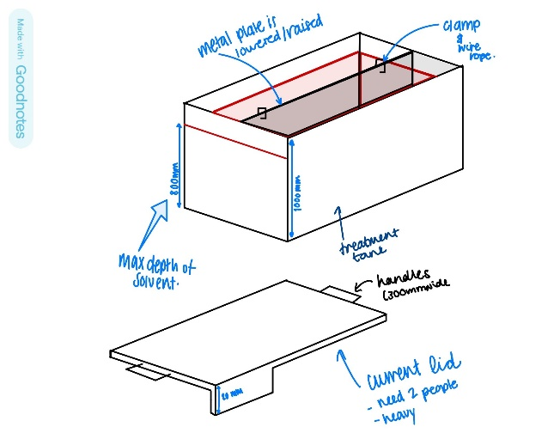
Figure 2 - Current Design of Cover

They collated their research into four potential solutions; A Bi–Folding mechanism, a sliding on and off mechanism, a hinge like solution for the cover and a solution that requires cutting the cover into sections for a staggered placement and removal.

Bi-Folding Door Mechanism
Initially, when the student began investigating alternative covers, Bi–Folding Door Mechanisms seemed most relevant for the design requirements. Below is a SWOT analysis depicting the feasibility of the concept.

Table 3- SWOT analysis of Bi-Folding Mechanism
Strengths | Weaknesses
- One person placement and removal  - Safer method for the workers to cover the tanks.  - Quicker method of placement and removal | - The method is a more complex mechanism to alternative concepts which will pose complications when executed on hundreds of tanks.
Opportunities | Threats
- With quicker placement and removal, the company can reduce the workforce. Workers can be relocated or made redundant saving the company money. | - Complex method of installation meaning an installation of rails or runners for the cover to side on. Meaning more frequent inspections of the tanks and potentially specialist workers to conduct these checks because of the complexity of the system.

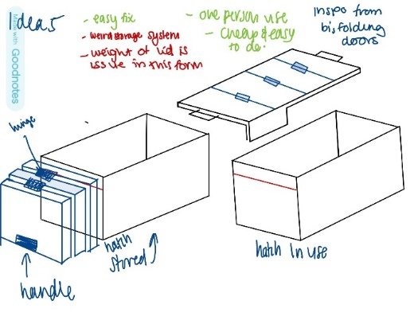
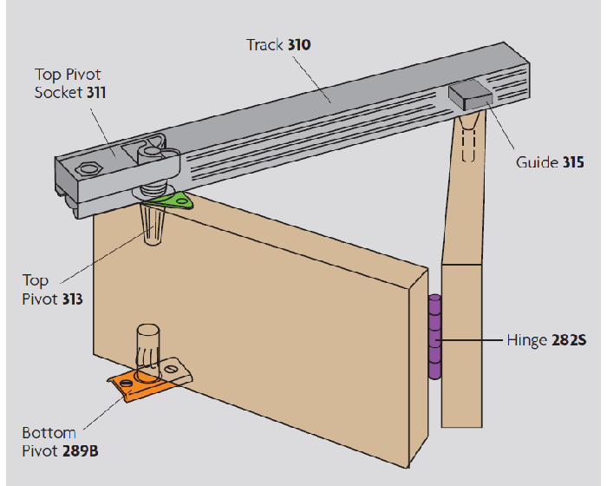
This image illustrates what the concept mechanism would look like (Johns, 2020).
Bi-Folding Mechanism

Figure 4 - Bi-Folding Mechanism
Figure 3 - Students Design for Bi-Folding solution.
To adapt this design for the intended application, the runners are positioned along the sides of the tank, ensuring full access for the aluminium sheets to be lowered into the tank during operation, as illustrated in Figure 4. This design facilitates easier manual handling, as the reduced weight per section improves manoeuvrability. Additionally, the cover can be manufactured using durable materials that would otherwise be too heavy, such as coated aluminium, stainless steel, or polypropylene. This cover without a change of material would cause several issues as the weight and design would cause more issues than it would solve therefore the student discarded this idea.

Sliding Mechanism
The sliding mechanism is another credible design solution that would be effective in this application. A SWOT Analysis for this concept along with the student’s concept drawings can be seen below.
Strengths | Weaknesses
- One person placement and removal  - Safer method for the workers to cover the tanks.  - Quicker method of placement and removal | - The method is a more complex mechanism to alternative concepts which will pose complications when executed on hundreds of tanks.  - Need at least 1.46 M clearance for on one side of the tank as it sits slanted off the box.
Opportunities | Threats
- With quicker placement and removal, the company can reduce the workforce. Workers can be relocated or made redundant saving the company money. | - Complex method of installation meaning an installation of rails or runners for the cover to side on. Meaning more frequent inspections of the tanks and potentially specialist workers to conduct these checks because of the complexity of the system.  - Could get in the way of pipes and key features.

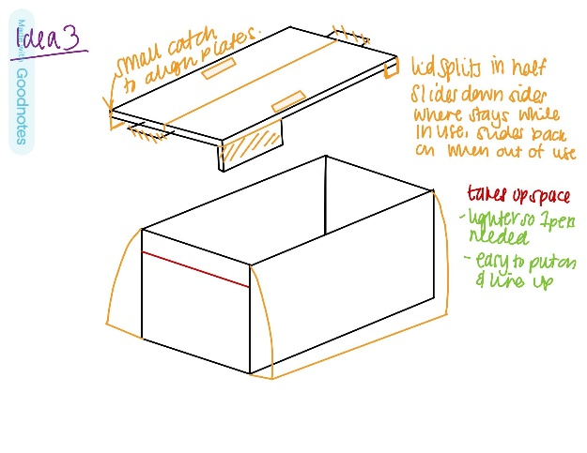
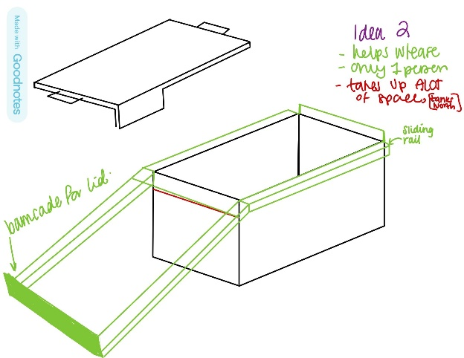
Figure 5- Sliding Concept 2
Figure 6 - Sliding Concept 1

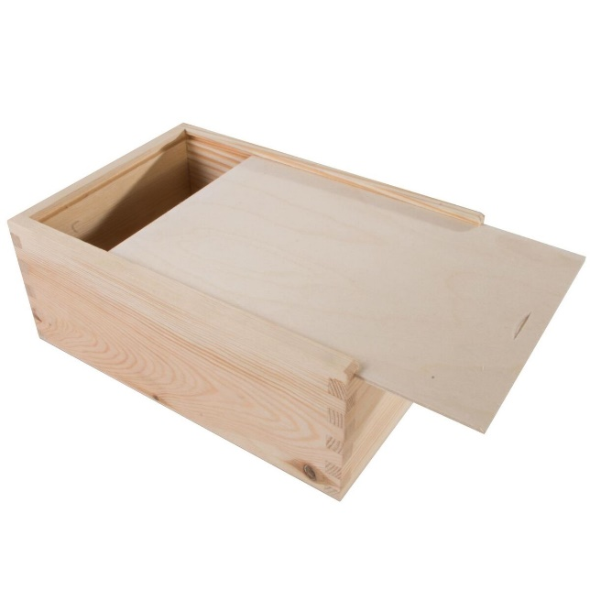
Figure 7 - Sliding Concept Website (Unfinished wood sliding lid box: 25X17X10CM: Keepsake memory trinket case holder 2025)
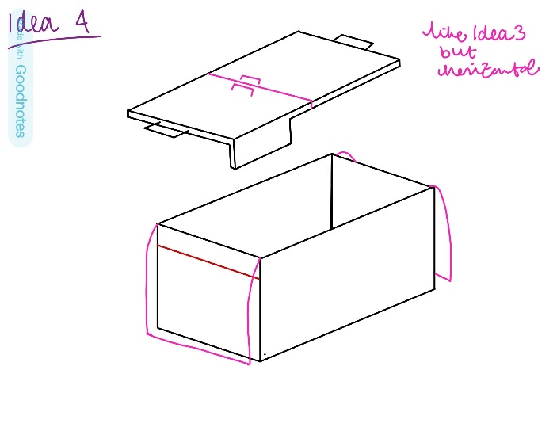
Figure 8 - Sliding Concept 3

Hinge Mechanism
The hinge mechanism offers a functional solution to the current issues, meeting the design requirements while also being aesthetically pleasing. However, without reducing the weight of the cover, the most effective approach would be to install gas struts to assist in holding the cover open during usage. The main concerns with this solution are that hinges typically require regular maintenance, and gas struts can be costly to replace if they fail. With two struts required per tank and a total of 200 units to be installed, the potential replacement cost could be significant. The average gas strut for this application costs £60 overall installation would cost £12,000 not including labour costs. However, a full SWOT analysis can be seen below highlighting further constraints and concerns as well as concept designs to communicate what the student believes the hinge mechanism would look like in this application.

Table 4 - SWOT Analysis of Hinge Mechanism
Strengths | Weaknesses
- One person placement and removal  - Safer method for the workers to cover the tanks.  - Quicker method of placement and removal | - The method has a tedious installation process compared to alternative concepts which could pose problems when executed on hundreds of tanks.  - Need at least 0.55 M clearance for on one side of the tank as it sits slanted off the box.  - Could be awkward angle to place and remove for the employee due to the angle off the tank
Opportunities | Threats
- With quicker placement and removal, the company can reduce the workforce. Workers can be relocated or made redundant saving the company money. | - More frequent inspections of the tanks to ensure hinges are functioning properly.  - Could get in the way of pipes and key features when opened.  - Could still be hard to lift on and off if material stays the same

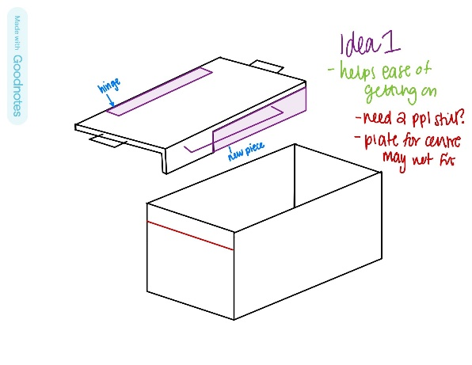
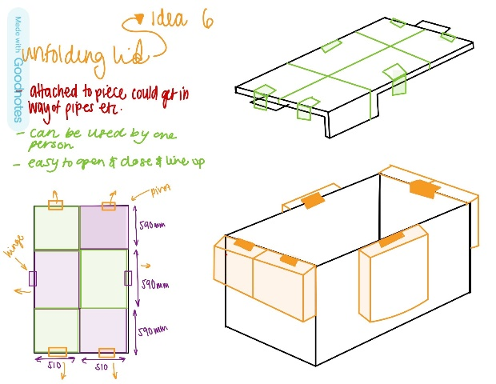
Figure 9 - Hinge Concept 1
Figure 10 - Hinge Concept 2

Divider Solution
The Divider solution is the most ideal choice for the designer because of the simplicity of the change. The solution involves dividing the cover into 3 to make it easier for the worker to lift the cover off. Along with cutting the cover into sections the student suggests a materials change. Even with the cover divided into 3 the heaviest part (mid-section) would weigh 35.79 Kgs. Below is a SWOT Analysis based on the suggestion of a lighter material.

Table 5 - SWOT Analysis of Divider Solution
Strengths | Weaknesses
- One person placement and removal  - Safer method for the workers to cover the tanks.  - Quicker method of placement and removal  - Space saving  - Cheapest solution | - Process may take time to implement once order has been placed due to magnitude of the change.
Opportunities | Threats
- With quicker placement and removal, the company can reduce the workforce. Workers can be relocated or made redundant saving the company money.  - Old lids can be sold for a profit (£10,313). | - Segments could get lost or damaged if not cared for.

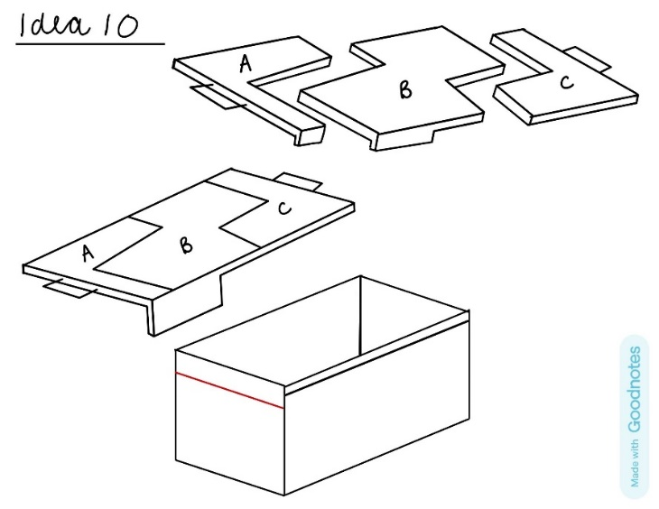
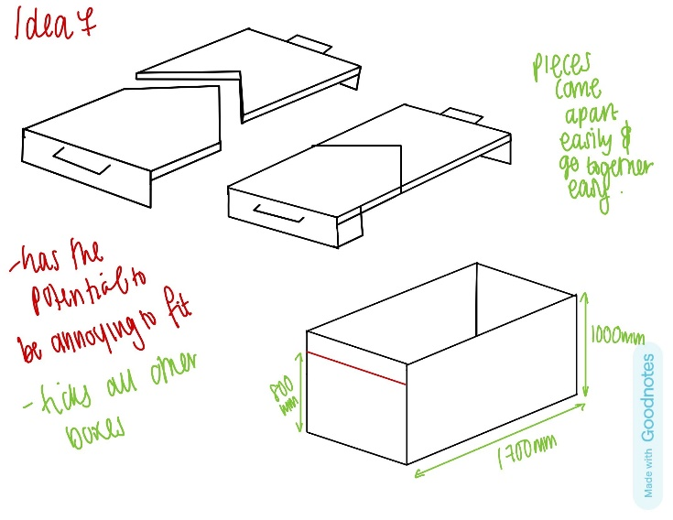
Figure 11 - Divider Concept 2
Figure 12- Divider Concept 1
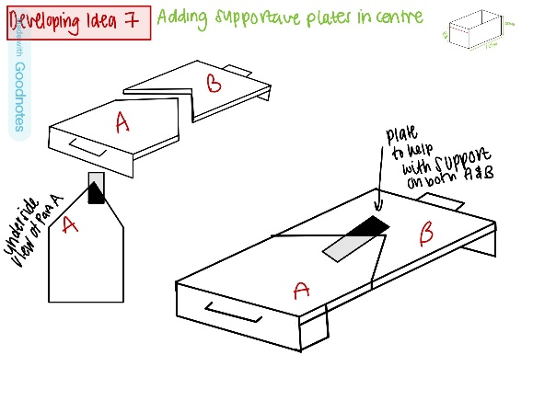
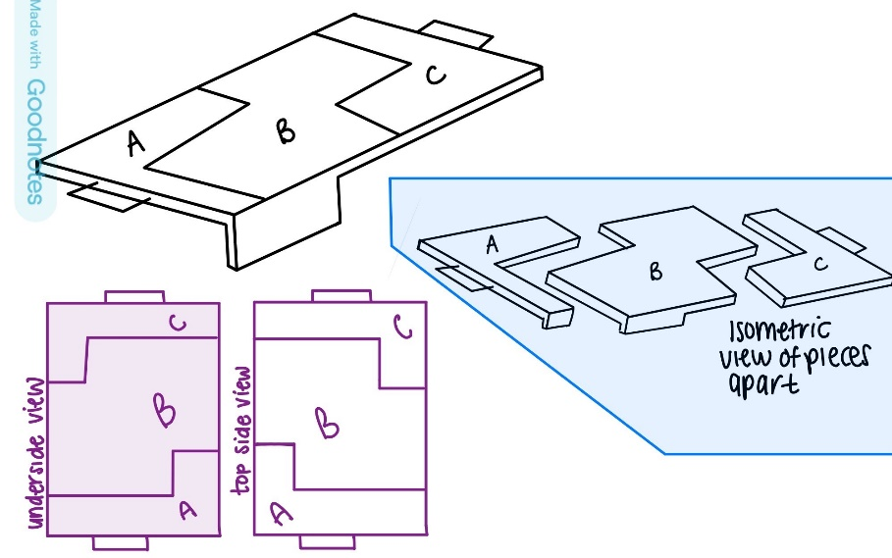
Figure 13 - Divider Concept 1 Developed
Figure 14 - Divider Concept 2 Developed

Final Design

6.1 Material Choice
For this investigation, the student used a software called Granta to investigate potential materials for the new cover. The original cover weighed 71.58 Kilograms, which for the average individual is 16 kilos for women and 25 kilos for men. The students updated solution must have the overall weight of the cover below 10 kgs to meet their brief of one person placement and removal. Below is a chart depicting the feasible materials based on the following criteria: Cost, Machinability, Resilience against 30% sulfuric acid concentration, Density and Sustainability.
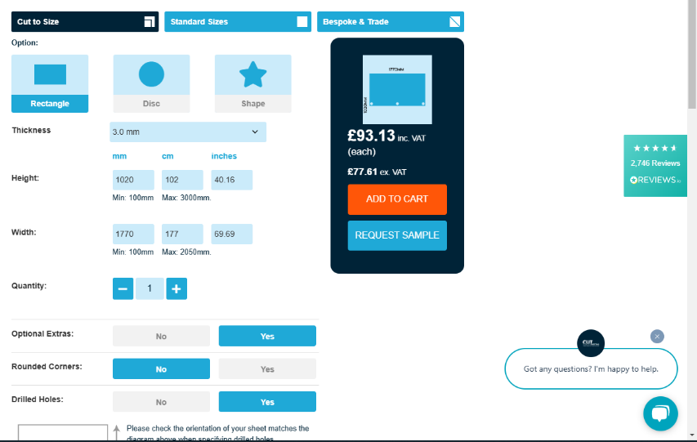
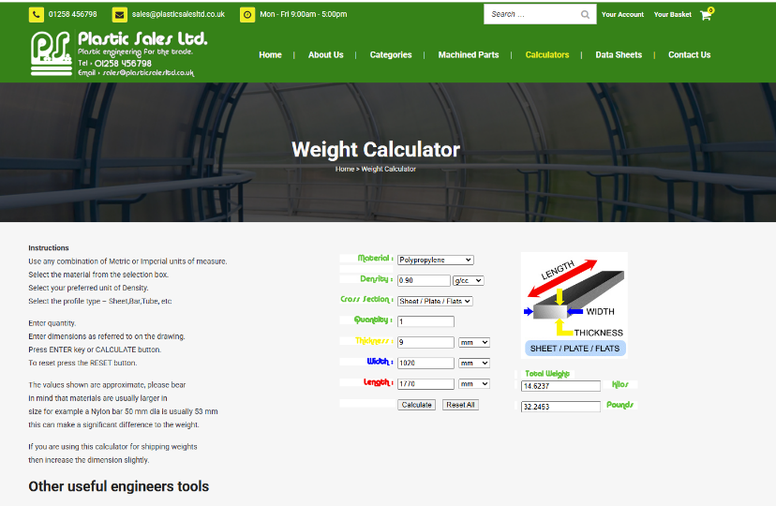
By looking at the Granta data we can see two realistic materials, Polyethylene terephthalate (PETE) or Polypropylene (PP). Both materials have similar properties the only major factor differentiating them is cost and weight. This can be seen below in figures 15, 16 and 17.
Figure 15 - Weight calculation for PP
Figure 16 - Cost of PETE per cover (Clear PETE acrylic sheet: Cut to size: 3MM: CPS 2023)
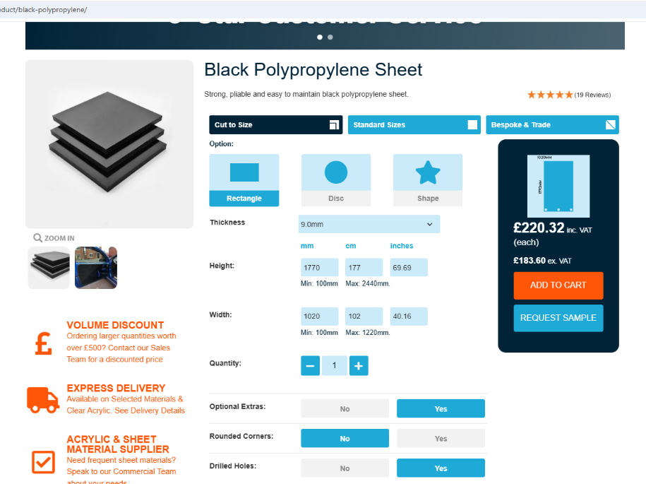

Figure 17 - Cost of PP per cover (CUT plastic sheeting,2024)

The PETE costs £93.13 and weighs 12 kilos including the assistive pieces and the PP costs £220.32 and weighs 14.6 kilos. In the student’s perspective the PETE is the optimal choice because for the same structural integrity the PETE is 6mm thinner, £127.19 cheaper per cover and 2.6 Kilos lighter.

As stated above the most suitable material would be using Polyethylene terephthalate referred to as PET (PETE) the material used to carry out the calculations in the introduction to this chapter.
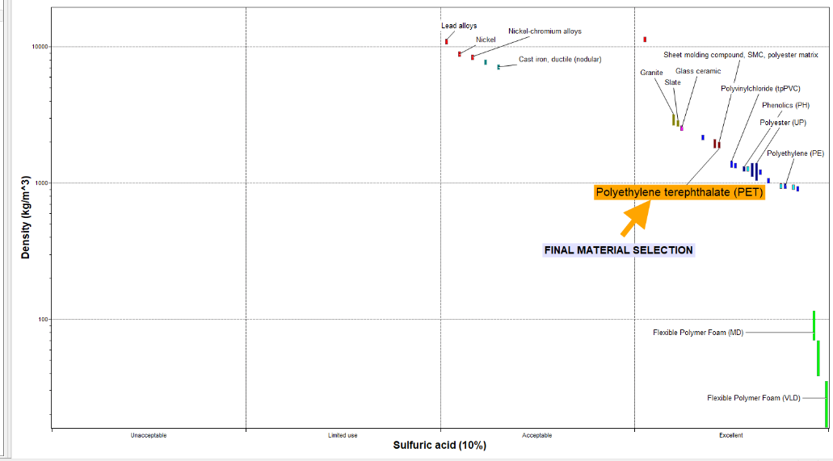

Figure 18 - Final material selection excluding fail materials.
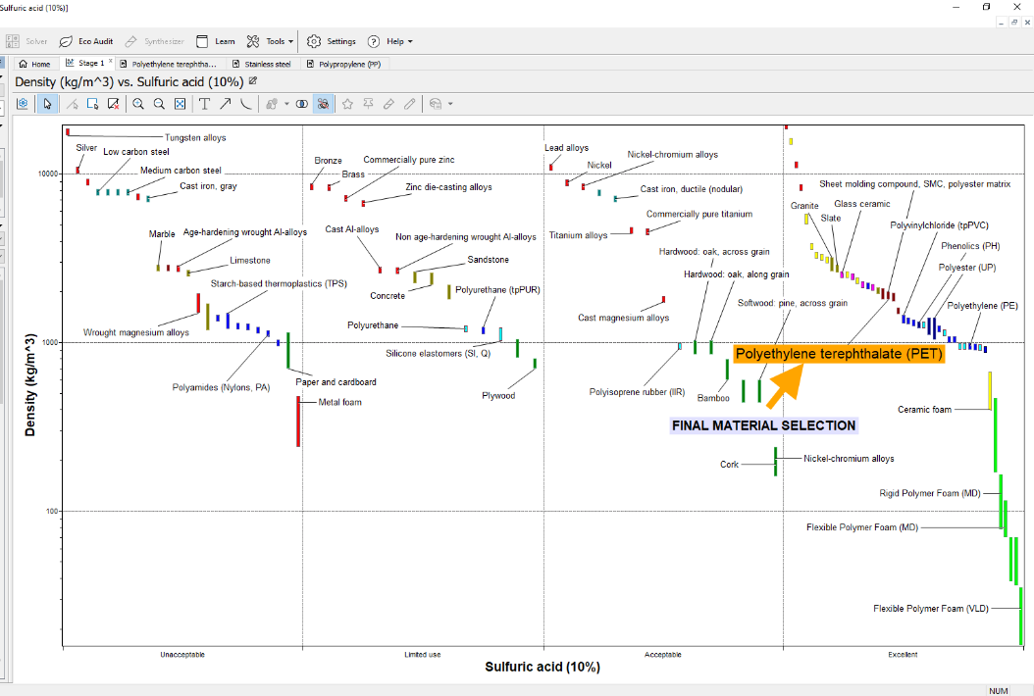
Figure 19 - Final material selection including fail materials.

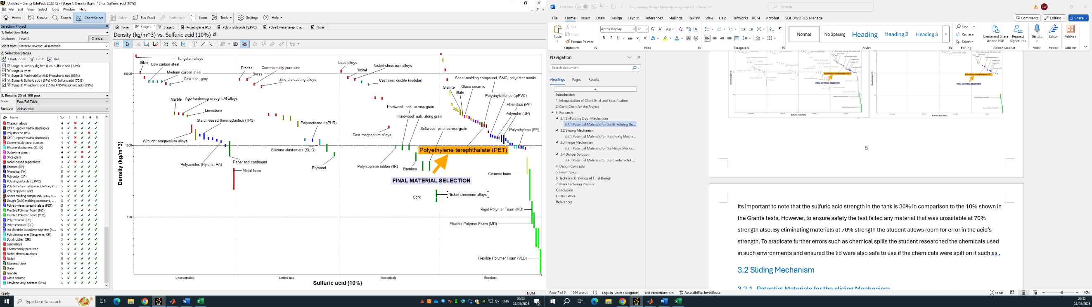

Figure 20- Table of pass/fail materials against limits.
The student used ‘limits’ to whittle down the potential materials as seen in the figures above. It is important to note that the sulphuric acid concentration in the tank is 30%, compared to the 10% used in the Granta tests this is because the software only supports fixed concentration options of 10% and 70%, and does not accommodate variable concentration acidic solutions. However, to ensure safety, the test limits were set to exclude any material that was unsuitable even at a 70% acid strength. By eliminating materials based on their performance at 70% strength, the student accounted for potential variations in the acid’s concentration. To further minimise risks, such as chemical spills, the student researched the chemicals commonly used in such environments and ensured that the cover was safe for use, even if chemicals like phosphoric acid were spilled on it.

6.2 Final Design Conclusion
To summarise, the student’s suggestion to the client would be to select the divider solution and take the existing stainless-steel covers and sell them for a profit, offsetting the cost of material and manufacturing changes. Grade 316 stainless steel sells for £1.40 per kilogram, and each cover weighs 71.58 kg. Assuming the lower bound value of ‘in the low hundreds’ is 100 tanks, the total revenue from selling the old covers would amount to £10,021.20. To replace the lids, a collaboration has been established with CUT Plastic Sheeting, which will supply the Clear PETE plastic sheets, cut them into sections A, B, and C, and attach the supportive overhang pieces at a cost of £10,313. The total cost of supplying the new lids is £10,687, with an additional £1,374 charged for cutting and assembly using M4 bolts. A bulk discount has been secured due to the high volume of units required. As a result, the client will only be responsible for labour costs associated with removing the old lids and an additional £374, which exceeds the revenue generated from selling the old covers. The total cost is £12, 061 but the net cost for the client is £1,748 (316 stainless steel scrap metal Manchester: 2025).

Technical Drawings of Final Design and CAD Model.
The student has shown snippets of their cad model to show a further view of their solution, below it can be seen that there is an isometric view of the design as well as a zoomed in version of part B’s screw positions as an example for piece A and C also. The Technical drawing for manufacturing can be used to create the cover and highlights the dimensions for size clarity in this report.
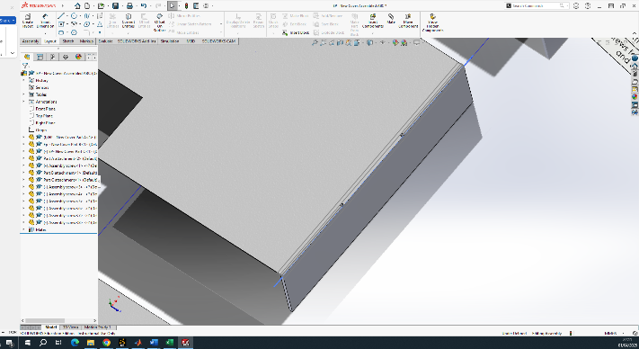
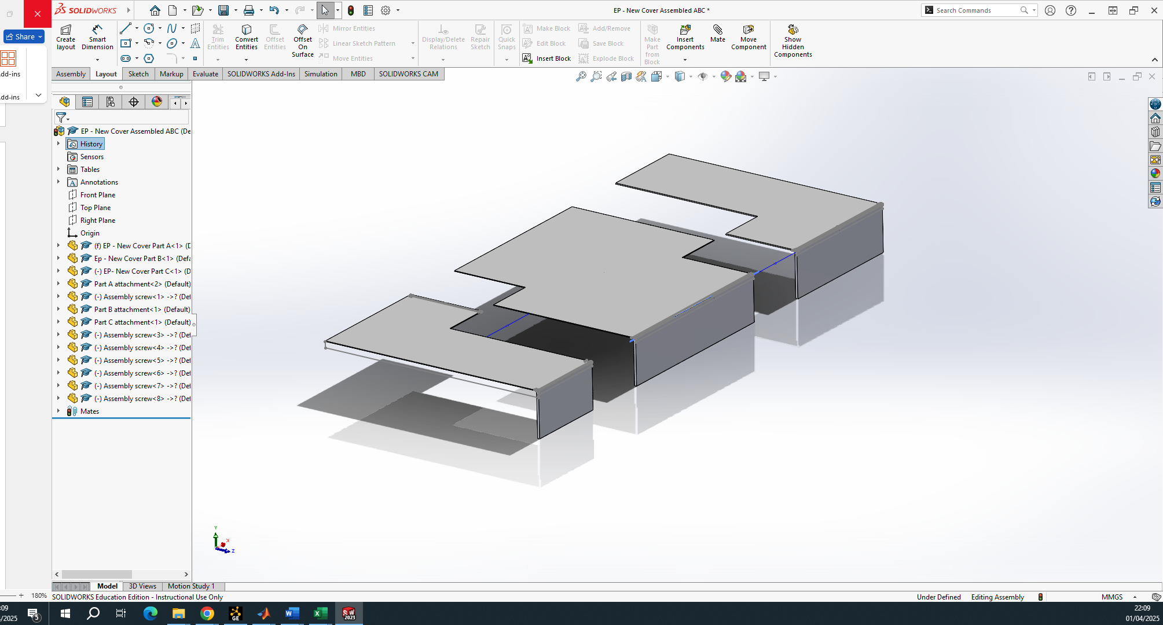
Figure 21 - Final CAD Design 2
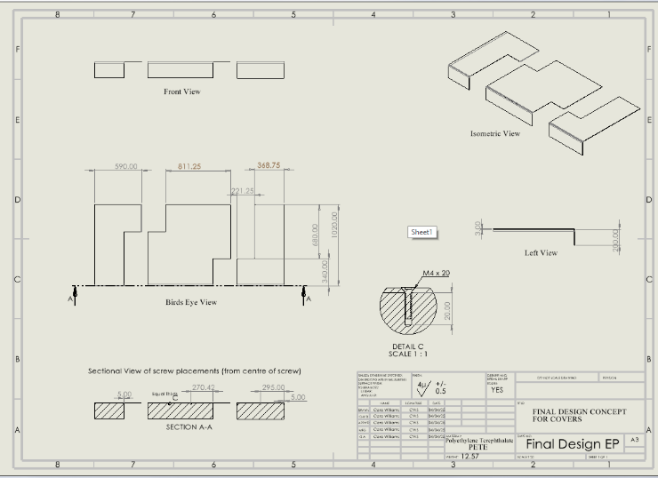
Figure 23 - Final CAD Designs 1
Figure 22 - Technical drawing of student’s final design

Manufacturing Process
Due to the connection with CUT Plastics, there will be no manufacturing required on the client’s behalf. It is likely that the company utilises CNC machining or laser cutting, depending on the level of precision required. The installation of the lids will be smooth and straightforward and can be installed in a normal working day. I.e. the old covers can be removed during aluminium anodisation, with the new ones fitted at the end of the working day when the covers would be typically put back on.

Conclusion
In conclusion, the new design addresses the main concerns and offers an environmentally friendly solution, which is done economically by increasing the funding for the project by repurposing the old lids and investing in new, long lasting and HSE compliant covers for as little as £400. The proposed lid can be mass produced and assembled at CUT plastic sheeting for a cost-effective price of £1,748. The lead time for receiving the covers could be up to a month, however, during the students correspondence between the manufacturers and them they have said it could be fast tracked due to them being quieter this time of year.
Ultimately, the client could select any of the solutions proposed in this report and achieve a more practical outcome than they had previously. However, the student recommends choosing the final design due to the reasons outlined above.

References
Internal bi-fold door kits (no date) G Johns & Sons Ltd. Available at: https://www.gjohns.co.uk/sliding-door-gear/folding-door-gear-for-internal-timber-doors.html (Accessed: 24 March 2025).
Unfinished wood sliding lid box: 25X17X10CM: Keepsake memory trinket case holder (2025) eBay. Available at: https://www.ebay.co.uk/itm/134641825919 (Accessed: 04 April 2025).
Participation, E. (1980) Health and safety at work etc. act 1974, Legislation.gov.uk. Available at: https://www.legislation.gov.uk/ukpga/1974/37/contents (Accessed: 31 March 2025).
Control of Substances Hazardous to Health (COSHH) (2002) HSE. Available at: https://www.hse.gov.uk/cleaning/topics/coshh.htm (Accessed: 31 March 2025).
Manual Handling Operations Regulations 1992 (as amended) (MHOR) (1992) Backpain - Advice for employers - Manual handling regulations. Available at: https://www.hse.gov.uk/msd/backpain/employers/mhor.htm?utm_source=chatgpt.com (Accessed: 31 March 2025).
316 stainless steel scrap metal Manchester: (no date) Greengate Metals - Your gateway to being green. Available at: https://www.greengatemetals.co.uk/scrapmetal/316+Stainless+Steel.html (Accessed: 04 April 2025).
Clear PETE acrylic sheet: Cut to size: 2MM – 15MM: CPS (2023) Cut Plastic Sheeting. Available at: https://www.cutplasticsheeting.co.uk/product/clear-pete-plastic-sheet/ (Accessed: 04 April 2025).
Cut Plastic Sheeting. (2024). Black Polypropylene Sheet | Correx Fluted | 4MM | CPS. [online] Available at: https://www.cutplasticsheeting.co.uk/product/black-polypropylene/.(Accessed: 04 April 2025)
‌

