Northern Lights Pvt.
Initial findings
From the case study, the different DBMS users in Northern Lights Pvt. Are:
- Branch managers
- Department Heads
- Event patrons
- Suppliers
- Accountants
- Management Customers
To enable these users to carry out their duties successfully and efficiently, the DBMS should grant them varying levels of access based on their roles and responsibilities. The database's data should be protected from unauthorized access and misuse by the system.
Different departments types every branch of the company might need :
- Sales and Marketing Department
- Event Planning Department
- Audio and Visual Department
- Operations and Logistics Department
- Accounting and Finance Department
- Customer Service Department
The specific departments required at each branch may vary depending on the size and complexity of the events being organized and the resources and staff available. The DBMS should provide a platform for effective communication and collaboration between these departments, enabling them to work together seamlessly to ensure the success of the events.
Entity relationship diagram
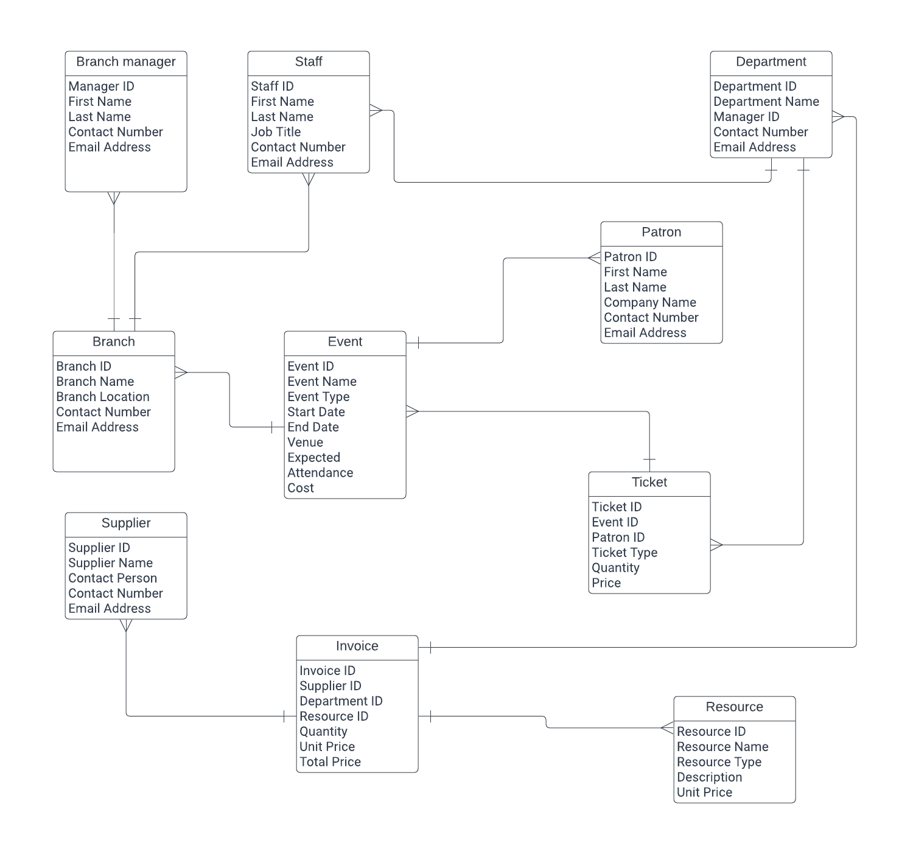
- Events have one or more providers: An event may have several providers who provide the necessary resources, such as catering, audio and video equipment, and other services.
- Customers reserve events based on their preferences, including the event's kind, location, day, and time.
- Branches plan one or more events: Each branch of the business is in charge of planning events in their region and overseeing related responsibilities, including putting up supplies, selling tickets, and keeping the location clean.
- Products supplied by Suppliers and utilized in Events: Suppliers offer goods needed for the events, such as decorations, food, and equipment.
- The accounting and finance department creates and sends bills to clients for events. Invoices are made and sent to clients for Events: The Accounting and Finance Department generates and sends invoices for clients for payment based on the event's particulars.
Tables:
- Event
- Customer
- Ticket
- Department
- Supplier
- Purchase

Fields Created
- Event
Event_ID (Primary Key)
Event_Name
Event_Date
Event_Type
Event_Location
Event_Description
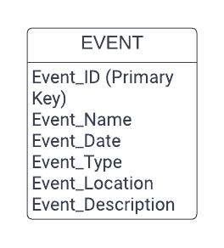
- Customer
Customer_ID (Primary Key)
First_Name
Last_Name
Email_Address
Phone_Number
Company_Name
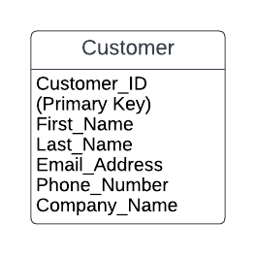
- Ticket
Ticket_ID (Primary Key)
Event_ID (Foreign Key)
Customer_ID (Foreign Key)
Department_ID (Foreign Key)
Ticket_Price
Ticket_Status
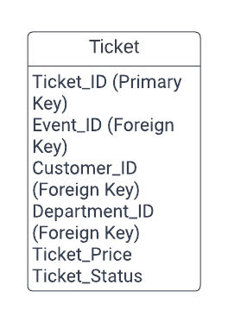
- Department
Department_ID (Primary Key)
Department_Name
Branch_Location
Branch_Manager
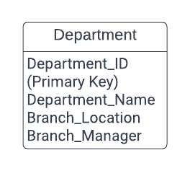
- Supplier
Supplier_ID (Primary Key)
Supplier_Name
Supplier_Contact_Number
Supplier_Email
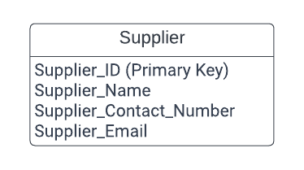
- Purchase
Purchase_ID (Primary Key)
Supplier_ID (Foreign Key)
Purchase_Date
Purchase_Amount
Department_ID (Foreign Key)
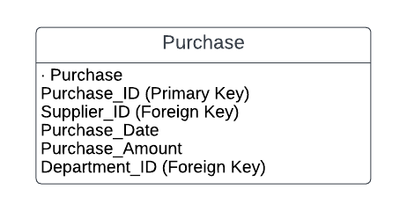
- Foreign keys created:
Event_ID (in Ticket table)
Customer_ID (in Ticket table)
Department_ID (in Ticket table)
Supplier_ID (in Purchase table)
Department_ID (in Purchase table)
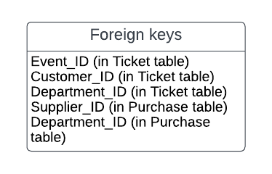
- Relationships created:
Event to Ticket: One-to-Many (1:N)
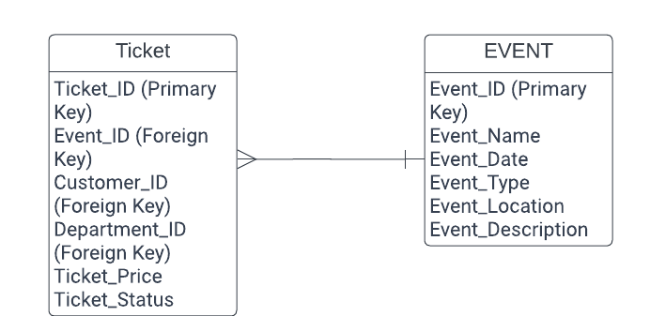
Customer to Ticket: One-to-Many (1:N)
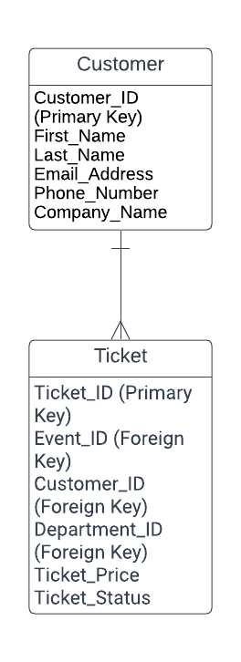
Department to Ticket: One-to-Many (1:N)
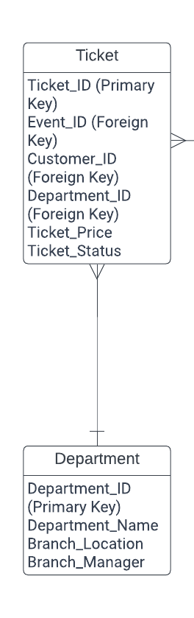
Supplier to Purchase: One-to-Many (1:N)
Department to Purchase: One-to-Many (1:N)


