Student: Elitsa Ivanova
Student ID number: 2123375
Module: Project Management
Module code: LCBB5005
Assignment 1
Lecturer: Md Sadeque Imam Shaikh

Table of Contents
Introduction 3
Body 3
Time 3
Cost 4
Stakeholder management 6
Risk management 8
Quality 10
Conclusion 11
References 13

Introduction
This report explores the specific case of a large construction project with the nickname of “Landscraper” (Construction UK, 2022). More specifically, this construction project refers to the development of the new headquarters of Google in the UK and the first Google-designed building outside of the US (Construction UK, 2022). The project is interesting due to its characteristics. It is planned to be 330 meters long and with 11 storeys; thereby, having the shape of a landscaper. The total area is expected to be 92,000 square metres by hosting more than 4,500 employees of Google (Construction UK, 2022). The new building also appreciates the concept of 'multi-use' by incorporating various amenities, such as cafes, indoor recreational spaces encompassing a basketball court, a 25-meter swimming pool, and a fitness facility (Construction UK, 2022). Additionally, the establishment features a meticulously designed rooftop garden that has been carefully manicured, incorporating a functional running track (Wilde, 2023).
The above-mentioned characteristics of the construction project indicate its scale and complexity. Thus, the completion of the construction project can be quite challenging given the scale, numerous design specifics and innovative features. The report in interested in exploring the project implementation process in more depth by focusing on several key project related aspects, such as time, cost, stakeholder and risk management, as well as quality. Some key external developments and the evidence from the project are critically discussed to assess performance and identify relevant ideas for improvement.

Body

Time
Time is a key element in project management (Pinto, 2016). Respectively, the analysis of the construction project’s schedule is an important element in evaluating Google’s performance in the field of project management.
It is important to mention that there is no detailed information regarding the schedule of the construction project. As a private project, Google is not required to deliver detailed scheduling plans to the public. Based on the available information, it can be suggested that Google is behind schedule due to several factors.
First, the actual project was initiated quite late. According to Shead (2023), the project was announced a decade ago in the year 2013. According to the initial plans, the new headquarters had to be completed by 2016 (Shead, 2023). The actual start of the construction process began in 2018 after several changes in the design of the building and other key elements of the project (Wilde, 2022). The second major issue refers to the pandemic and its impact in delaying the construction works. More specifically, the imposed lockdowns and other pandemic-related disruptions slowed down the project implementation, most notably in the year 2020 (Office Reality, 2022). Third, there is not an official ending date. As suggested by Wilde (2022), the scarce information, which is available to the public, indicates a completion date somewhere in the year 2024.
Considering the information, the time management of the project is far from being efficient. The starting date of the construction process was postponed, and the unforeseen effects of the pandemic additionally contributed to the observed delays. If the project is ended in 2024, as suggested by the most recent expectations, there will be a period of 11 years between the initial project plan and its completion. This is evidence of a lack of efficiency in time management.

Cost
The initial budget cost of the construction project is exactly £1 billion (Office Reality, 2022). The cost assessment was made prior to the start of the project in 2018 (Office Reality, 2022). There is no detailed information showing the cost breakdown by activities or any other criteria. Thus, the report can only discuss the total cost of £1 billion, as announced at the start of the project.
The sum is considerable and shows the large size and complexity of the project. Considering the risk of cost overruns, which commonly takes place in large-scale projects, the critical analysis must estimate the actual ability of Google to meet the stated budget constraints. The main area of concern is related to the high inflation in the UK during the post-pandemic period by reaching a peak in October 2022 at a level of 11% per annum and causing a major cost-of-living crisis (Francis-Devine et al., 2023). Price increases have also affected the construction costs (Cost Modelling, 2023). The following chart shows the long-term changes in the tender and construction cost indices in the UK (Cost Modelling, 2023). Since the announcement of the £1 billion total cost of Google’s construction project in 2018, the construction cost index has increased from 175 to 230, or a net increase of more than 31% (Cost Modelling, 2023). It is important to note that such a pace of increase is much higher than the average construction cost inflation in the UK during the last two decades.
Figure 1 – Changes in tender and construction cost indices (2000 – 2023)
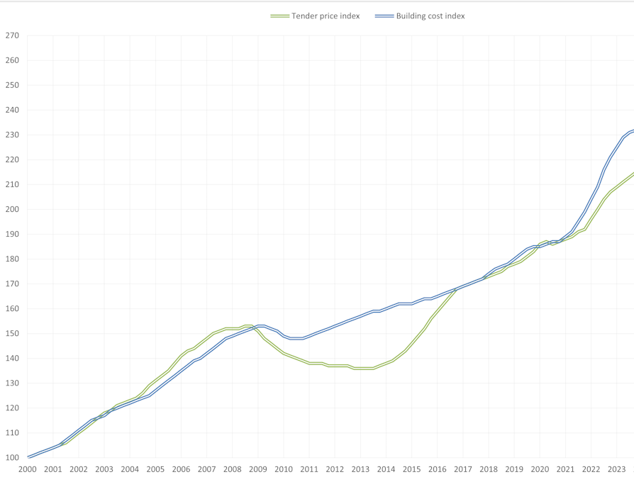
Source: Cost Modelling (2023)
Therefore, it is difficult for Google to accurately project the actual costs of the long-term construction project. Even if the company accounts for some increases in construction prices in alignment with the long-term trends, the recent construction costs escalation has been quite significant and without precedent in modern history, as shown by figure 1.
Given these key considerations, the currently discussed construction project is likely to experience a major cost overrun. Exact numbers are not available, since this is a private project and Google is not required to provide such information to the public. The large resources of Google can be used to meet the funding needs of the construction project; hence, the cost overrun does not jeopardise the actual execution of the construction project. Nevertheless, the example with Google and its management of a large-scale project in an environment of high inflation is quite indicative for the risks associated with cost management in construction projects.

Stakeholder management
Effective stakeholder management is important in guaranteeing the success of projects, particularly in the context of large-scale construction projects, as is the case with Google. Therefore, analysing the stakeholder management process is quite relevant. According to Karlsen (2002), stakeholder groups contain all parties that have the potential to exert influence on or be impacted by the project. In the broader context, stakeholders can be categorised as either internal, meaning those who are directly involved in the project, or external, referring to individuals or groups who are not directly responsible for the project's execution but still possess an interest in and/or are impacted by it (Karlsen, 2002).
When examining the specific context of Google, internal stakeholders include a range of individuals and entities that play a direct role in the project's execution and ultimate realisation. These stakeholders include civil engineers, architects, construction site workers, project managers, funding institutions, suppliers of construction materials and others affecting the project implementation. External stakeholders comprise a diverse range of entities, such as regulators, future users of the building, community members, non-government organisations (NGOs) and the media.
Given the existence of many and diverse stakeholders, their effective involvement and governance is vital. The process commences with accurately identifying and evaluating each stakeholder group. The power-interest grid model is frequently employed for this objective. The approach involves the assessment of different stakeholders, considering their level of influence and interest in the project. Subsequently, these stakeholders are categorised into four distinct clusters, which determine how their needs and expectations are addressed (Moreno-Marimbaldo and Manso-Callejo, 2020). The model framework is depicted in the following diagram.

Figure 2 – Stakeholder mapping for the current project
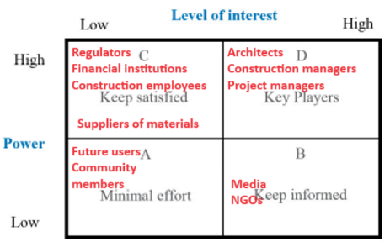
Source: Moreno-Marimbaldo and Manso-Callejo (2020)
The analysis of Google’s stakeholders related to the construction project is important. Findings identify different stakeholders with diverse interests and levels of power. The company must apply relevant communication and stakeholder engagement strategies to gain the support of stakeholders and optimise the use of the available resources (Karlsen, 2002; Moreno-Marimbaldo and Manso-Callejo, 2020). As suggested by the positioning of stakeholders on the stakeholder map, minimum efforts must be directed to future users and community members, as both stakeholder groups have limited interest and power to affect the construction project. In relation to the media and NGOs, Google must disseminate information to meet the high interest of these stakeholders in the construction project.
Most stakeholders have a high level of power, and the company must put more effort into meeting their needs. For instance, regulators, financial institutions, suppliers of materials and construction employees are not so much interested in the project; however, their actions may influence the project implementation. Therefore, Google must keep them satisfied by fulfilling the respective financial obligations, such as paying salaries and debts), as well as meeting the regulatory requirements.
Respectively, maximum efforts must be made to meet the needs of architects, project managers and construction managers – stakeholders with high power and interest in the project. Given the position of these key stakeholder groups, Google must satisfy their needs and engage them in the decision-making process regarding the project’s implementation.

Risk management
The process of recognising, planning, and mitigating various risks that can impact the successful completion of a project and result in variations from the original plan and schedules. The application of the risk matrix concept is typically employed for this purpose. According to Guo (2015), the use of a risk matrix enables project managers to categorise different risks and subsequently formulate plans and initiatives to effectively manage and reduce their impact. Risks are classified by two main criteria - likelihood and impact (Guo, 2015). These criteria are also used when analysing the relevant risks in the case of the current construction project.
Figure 3 – Risk assessment matrix in the case of Google’s project
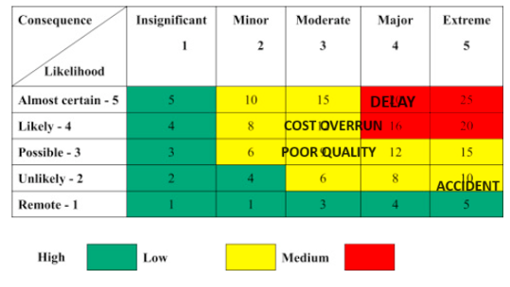
Source: Guo (2015)
The most significant risk originates from delays. Large construction projects are susceptible to delays, as suggested by Omoregie and Radford (2006). Delays often reach a considerable period, as suggested by the analysis of previous large-scale construction projects (Omoregie and Radford, 2006). In addition to being frequent, delays have a negative impact on completing a construction project on time and may cause extra costs (Omoregie and Radford, 2006; Olawale and Sun, 2015). Considering the real risk of delays, several strategies must be employed to better manage the risk. It is important to formulate a precise plan and adapt it accordingly to accommodate unforeseen changes, while simultaneously engaging in attentive oversight of diverse tasks. Moreover, the proposed project schedule should implement a conservative approach, which entails incorporating larger intervals between individual activities.
Another common risk in construction project management stems from cost overruns. As discussed earlier in the report, the escalating costs of construction pose a major challenge for accurately budgeting long-term construction projects (Cost Modelling, 2023). Thus, cost overruns are common and have a moderate negative impact on construction management. To mitigate the negative impact of the risk, Google must employ strict monitoring and controlling mechanisms in cost management. The project may also be re-structured to optimise costs if possible.
Accidents in construction are rare, but their negative impact can be quite considerable. Accidents cause harm to humans and negatively impact organisational reputation. Therefore, the risk of accidents, although having a moderate profile according to the risk matrix, must be carefully managed. Google must ensure the application of the best health and safety standards of work on the construction site. Training and pre-cautionary measures must also be applied to all construction workers. The use of the most advanced materials, processes and safety procedures is also necessary to boost the level of health and safety.
The last major risk refers to poor quality. The risk, as shown on the risk matrix, has a moderate profile in terms of likelihood and impact. A range of activities must be considered to ensure the high quality of the construction process. In this relation, it is advisable to exercise caution when choosing materials, subcontractors, and labour, ensuring that the selection is based on the optimal balance between price and quality. In addition, it is important for Google to consistently monitor and exercise control over performance. The company must also conduct a comparative analysis of the actual quality at each stage in relation to the planned and anticipated quality.

Quality
The construction project is designed in alignment with the architectural style followed by Google in the US. This style applies an extensive range of creative work settings, since over 50% of designated spaces have been dedicated to foster communication landscapes (E-architecture, 2023). This allocation provides employees with several possibilities to engage in flexible collaboration and communication with their fellow colleagues at Google, within a diverse and stimulating setting (E-architecture, 2023). In addition to the innovative design, the high-quality of materials must be recognised. Specifically in the case of the new headquarters, the choice of materials is steel, glass and timber (PG, 2023). The building is also unique due to its façade. The state-of-the-art façade is expected to cover more than 23,000 square meters once completed – a construction development without precedent in the UK (PG, 2023).
The project's high quality is further demonstrated by the extensive range of amenities available to the users. The premises comprise a variety of amenities that are specifically designed to accommodate athletic activities, including but not limited to football fields, a swimming pool, conference facilities, dining establishments, a retail complex, an extensive garden on the roof, a special meeting room with a seating capacity of 210 and many others (PG, 2023).
The quality of the project is well-addressed in its design specifics. Despite its significant size, the new building is developed with the idea of offering enough open spaces, functional areas, as well as a good connection between stores (PG, 2023). These ideas are not random; instead, they are intended to apply the most innovative solutions in developing an inclusive working environment with the best possible quality of the interior environment. Another key factor, which shows the quality and innovativeness of the project, refers to the large garden located on the roof (Gillespies, 2023). The open garden, which can reach a total area of one million square feet, differentiates the building and contributes to its uniqueness. In addition to boosting the quality of the project, the garden also demonstrates the best practices of mixing urban and environmental design features (Gillespies, 2023).

Figure 4 – An overview of the intended rooftop garden at Google’s headquarters

Source: Gillespies (2023)
The discussion clearly shows the ability of the project to deliver the best design features and high-quality architectural solutions.

Conclusion
To conclude with, the report explored the challenges faced by the construction project. Despite the lack of official information about some of the project’s performance aspects, the analysis indicated an elevated risk of cost overruns together with major delays in the actual implementation stage. Moreover, the large scale of the project poses challenges in terms of stakeholder and risk management. Quality is the best performing areas which is expected to differentiate the completed building. Given the challenges of the project, Google may consider some ideas for performance improvement, as discussed below.
The project is almost completed. This means that any changes now can have a little contribution to its overall implementation. Google is advised to better understand the needs of its stakeholders. Regular meetings, involvement in the decision-making process and following the communication strategy recommendations, which are derived from the stakeholder mapping process, are suggested. Another idea for improvement stems from the need to minimise costs. Google should eliminate some non-essential elements of the project to cut some costs. Using its power as a large buyer may also be of help in negotiating better construction material prices. In addition, health and safety should not be neglected in the last year of the project. Thus, Google must ensure the execution of the best standards in health and safety, so that major accidents at the construction site are fully avoided.

References
Construction UK (2022) Google HQ: Bearing the weight of a grand vision, [online] Available: https://constructionmaguk.co.uk/google-hq-bearing-the-weight-of-a-grand-vision/ [Accessed: 18 November 2023]
Cost Modelling (2023) UK tender price and building cost indices, [online] Available: https://costmodelling.com/construction-indices [Accessed: 21 November 2023]
E-architecture (2023) Google Buildings: New Office Architecture, [online] Available: https://www.e-architect.com/articles/google-buildings [Accessed: 23 November 2023]
Francis-Devine, B., Harari, D., Keep, M., Bolton, P., Barton, C. and Carthew, H. (2023) Rising cost of living in the UK, [online] Available: https://commonslibrary.parliament.uk/research-briefings/cbp-9428/ [Accessed: 21 November 2023]
Gillespies (2023) Goggle headquarters, [online] Available: https://www.gillespies.co.uk/projects/google-headquarters [Accessed: 23 November 2023]
Guo, L., (2015) Implementation of a Risk Management Plan, International Journal of Nursing Sciences, Vol. 2(4), pp. 348-354.
Karlsen, J. (2002) Project Stakeholder Management, Engineering Management Journal, Vol. 14(4), pp. 19-24.
Moreno-Marimbaldo, F. and Manso-Callejo, M. (2020) Methodological Approach to Incorporate the Involve of Stakeholders in the Geodesign Workflow of Transmission Line Projects, International Journal of Geo-Information, Vol. 9(1), pp. 178-204.
Office Reality (2022) Googles new HQ costs 1 billion pounds but is it enough to tempt people back in to the office? [online] Available: https://www.officereality.co.uk/blog/googles-new-landscaper-hq-at-kings-cross-london-costs-1-billion-pounds-but-is-it-enough-to-tempt-people-back-in-to-the-office#:~:text=%C2%AB%20Design-,Googles%20new%20HQ%20costs%201%20billion%20pounds%20but%20is%20it,back%20in%20to%20the%20office%3F&text=If%20you%20have%20been%20anywhere,gauntlet%20alongside%20the%20railway%20lines [Accessed: 21 November 2023]
Olawale, Y. and Sun, M. (2015) Construction project control in the UK: current practice, existing problems and recommendations for future improvement, International journal of project management, Vol. 33(3), pp. 623-637.
Omoregie, D. and Radford, D. (2006) Infrastructure delays and cost escalation: Causes and effects in Nigeria, [online] Available: https://core.ac.uk/download/pdf/78911604.pdf [Accessed: 23 November 2023]
Permasteelisa Group (PG) (2023) Google KGX1, [online] Available: https://www.permasteelisagroup.com/project-detail?project=1797 [Accessed: 23 November 2023]
Pinto, J. (2016) Project Management, 4th edition, Boston: Pearson Education Limited
Shead, S. (2023) An Inside Look at the Plans for Google's Massive New London Headquarters, [online] Available: https://www.inc.com/business-insider/google-headquarters-uk-offices-london-landscraper-pool-basketball-court.html [Accessed: 21 November 2023]
Wilde, D. (2022) Google wants to turn its King Cross HQ into a destination for tourists, community projects, and more, [online] Available: https://9to5google.com/2022/04/14/google-wants-to-turn-its-king-cross-hq-into-a-destination-for-tourists-community-projects-and-more/ [Accessed: 21 November 2023]

