PCC Gym Web Development
Table of Contents
PCC Gym Web Development 1
Introduction 3
Storyboard 4
Page Title: Login – Login/register page 4
Page Title: Index – Home page 4
Page Title: Insert BMI– Insert Data page 5
Page Title: Profile/BMI/Stats– Display Data page 5
Page Title: admin panel– View User page (only access by high level accounts) 6
Page Title: Admin panel– Edit/Add user page 6
Story Board Notes 7
Flow Diagram 8
Pseudo Code 9
ERD 12
Data Dictionary 13
Maintenance Documentation 14
Annotated Procedure/Subroutine/ Variables 14
Testing 29
User Guide 31
How to get access to it 31
Login 32
Register 32
My Profile 33
My BMI 34
My statistics 34
Equipment/weights 35
Admin panel 35
Evaluation 37
Bibliography 38
Appendix A 39
Code dump 39
Login 39
Register 40
Dashboard 41
Myprofile 42
Weight 48
Adminpanel 50

Introduction
After Discussing with the community centre, I have been tasked in developing a system to monitor and analyse data from their gym equipment via a web based application. This will be developed in stages, meaning not to be the full iteration in the first stage, for example automatically gathering the data from the machines themselves. Future developments will be taken into consideration when developing this web application

Storyboard

Page Title: Login – Login/register page

Page Content

Background: Dead by daylight BG image (JPEG or PNG) + Black image to hold text and images

CSS File: Style.css
Title Font - Size:30 Style: Arial
Colour: White
Nav, Information & Copyright Font– Size:30 Style: Arial Colour: white

Images: 2 images
2 Maps (in game map) images

Sound: (from video if sound is enabled)

Videos: Trailer video

Interaction: Links change colour when hovered and clicked on

Navigation: Home (map), Killer, Survivor & contact page

Meta-Tagging:
Dead by daylight (additionally), Maps, Map

Password:
Username:

Feature to request a new account

Page Title: Index – Home page

Title

Nav
Page Content

Background: Dead by daylight BG image (JPEG or PNG) + Black image to hold text and images

CSS File: Style.css
Title Font - Size:30 Style: Arial
Colour: White
Nav, Information & Copyright Font– Size:30 Style: Arial Colour: white

Images: 2 images
2 Maps (in game map) images

Sound: (from video if sound is enabled)

Videos: Trailer video

Interaction: Links change colour when hovered and clicked on

Navigation: Home (map), Killer, Survivor & contact page

Meta-Tagging:
Dead by daylight (additionally), Maps, Map
Gym Equipment

Information

Gym Equipment

Information

Gym Equipment

Information

Gym Equipment

Information

Footer

Page Title: Insert BMI– Insert Data page

Title

Submit

Nav
Weight:
Height:

Background: Dead by daylight BG image (JPEG or PNG) + Black image to hold text and images

CSS File: Style.css
Title Font - Size:30 Style: Arial
Colour: White
Nav, Information & Copyright Font– Size:30 Style: Arial Colour: white

Images: 2 images
2 Maps (in game map) images

Sound: (from video if sound is enabled)

Videos: Trailer video

Interaction: Links change colour when hovered and clicked on

Navigation: Home (map), Killer, Survivor & contact page

Meta-Tagging:
Dead by daylight (additionally), Maps, Map

Result

Footer

Page Title: Profile/BMI/Stats– Display Data page
Background: Dead by daylight BG image (JPEG or PNG) + Black image to hold text and images

CSS File: Style.css
Title Font - Size:30 Style: Arial
Colour: White
Nav, Information & Copyright Font– Size:30 Style: Arial Colour: white

Images: 2 images
2 Maps (in game map) images

Sound: (from video if sound is enabled)

Videos: Trailer video

Interaction: Links change colour when hovered and clicked on

Navigation: Home (map), Killer, Survivor & contact page

Meta-Tagging:
Dead by daylight (additionally), Maps, Map

Title

Footer

Nav
Profile BMI Stats

INFO BELOW
Background: Dead by daylight BG image (JPEG or PNG) + Black image to hold text and images

CSS File: Style.css
Title Font - Size:30 Style: Arial
Colour: White
Nav, Information & Copyright Font– Size:30 Style: Arial Colour: white

Images: 2 images
2 Maps (in game map) images

Sound: (from video if sound is enabled)

Videos: Trailer video

Interaction: Links change colour when hovered and clicked on

Navigation: Home (map), Killer, Survivor & contact page

Meta-Tagging:
Dead by daylight (additionally), Maps, Map

Page Title: admin panel– View User page (only access by high level accounts)

Title

Nav
Background: Dead by daylight BG image (JPEG or PNG) + Black image to hold text and images

CSS File: Style.css
Title Font - Size:30 Style: Arial
Colour: White
Nav, Information & Copyright Font– Size:30 Style: Arial Colour: white

Images: 2 images
2 Maps (in game map) images

Sound: (from video if sound is enabled)

Videos: Trailer video

Interaction: Links change colour when hovered and clicked on

Navigation: Home (map), Killer, Survivor & contact page

Meta-Tagging:
Dead by daylight (additionally), Maps, Map
Table of all users, able to add new or edit/delete selected

Footer

Page Title: Admin panel– Edit/Add user page

Title

Nav
Background: Dead by daylight BG image (JPEG or PNG) + Black image to hold text and images

CSS File: Style.css
Title Font - Size:30 Style: Arial
Colour: White
Nav, Information & Copyright Font– Size:30 Style: Arial Colour: white

Images: 2 images
2 Maps (in game map) images

Sound: (from video if sound is enabled)

Videos: Trailer video

Interaction: Links change colour when hovered and clicked on

Navigation: Home (map), Killer, Survivor & contact page

Meta-Tagging:
Dead by daylight (additionally), Maps, Map
Last Logged in
(Automatic)
(Can’t change your own or someone else’s higher than current level

Access level
Password:
Delete
Submit

Username:
Name:

Footer
Background: Dead by daylight BG image (JPEG or PNG) + Black image to hold text and images

CSS File: Style.css
Title Font - Size:30 Style: Arial
Colour: White
Nav, Information & Copyright Font– Size:30 Style: Arial Colour: white

Images: 2 images
2 killer (character) images

Sound: (from video if sound is enabled)

Videos: Killer video

Interaction: Links change colour when hovered and clicked on

Navigation: Home (Map), Survivor & contact page

Meta-Tagging:
Dead by daylight (additionally), killer, Nurse, Mike, Mikael Myers, Trapper
And so on (all killers names)

Story Board Notes
Colour/Font/Stylel are all gonna be layed out from a template of my choosing, one suited to look like a gym website. Additional backround features will be needed such as Session (log out timer), SQL database to hold all the information gathered to displayed, and JS plugins to allow graphics to be displayed on page, also another Plugin to ensure validation.

Flow Diagram

Correct login

Incorrect login

Login

Logout / Session
Add Edit Delete User
Settings, (only High level access)
View Users

Create account

My Stats

My BMI
Home page
Dashboard

My Profile

Pseudo Code
Logon;
If first time launch, logout, timeout
Open page

If Username & Password is inserted
Check Database for matching results
If correct
Proceed to homepage
Else
Stay on page, present error

Home Page;
Begin Login Session timer for every page
If user is inactive for set time then
Send to login page

BMI – calculator;
If “All” input fields are added and suit validation
Add data to database and be sent to View page
Else
Display validation errors on screen “Try again error…”

My Profile – View/Amend/
Pull information based on the current user
Display it
If update is selected then
Display and allow changes
Any changes save else go back

My Statistics
Gather all records, shared and users
Display Shared records in a graph
Display Users records in a graph

Settings – View/Add/Edit/Delete user;
Access to this page is only for higher access level users
Gather all users
Display this in a table

If add record is selected then
Send to add page

If “All” input fields are added and suit validation
Add data to database and be sent to View page
Else
Display validation errors on screen “Try again error…”

If record is selected then
Access view/amend/delete page for that record

If record is amended and validation check
Then edit data in database
Else
Display validation errors on screen “Try again error…”

If record is deleted then
Remove from database

ERD
Here I will illustrate the relationships in the database:
Equipment (x?)
Equipment ID
Speed/weight
Reps/time
User ID
Users
ID
Username
Password
Accesslevel
LastUpdated
Loginname
jobrole
lastlogedin

Data Dictionary
Field No | Name | Length | Type | Key
users
1 | ID | 11 | int | Primary
2 | Username | 150 | varbinary
3 | Password | 150 | varbinary
4 | Accesslevel | 11 | int
5 | LastUpdated | N/A | timestamp
6 | Loginname | 50 | varchar
 | jobrole | 100 | varchar
7 | lastloggedin | N/A | timestamp
weight
1 | WeightID | 11 | int | Primary
2 | weightkg | 11 | int
3 | Reps | 11 | int
4 | ID | 11 | int | Foreign
I have chosen to use MySQL as my database over my web application. It’s an effective database program, for what is required in the creation of my website. It’s simple to called using SQL scripts, layered with PHP to manipulate the data as needed for example an Add/Edit/Delete function.

Maintenance Documentation

Annotated Procedure/Subroutine/ Variables
Method | Code | Notes
Includes | <!-- Javascript files-->  <script src="../assets/vendor/jQuery/jquery-3.2.1.js"></script>  <script src="../assets/vendor/popper.js/umd/popper.min.js"> </script>  <script src="../assets/vendor/bootstrap/js/bootstrap.min.js"></script>  <script src="../assets/vendor/jquery-validation/jquery.validate.min.js"></script>  <script src="https://cdnjs.cloudflare.com/ajax/libs/Chart.js/2.5.0/Chart.min.js"></script>[1]  <script src="../assets/js/charts-home.js"></script>  <script src="../assets/js/charts-custom.js"></script>  <script src="../assets/js/front.js"></script>  <script src="../assets/vendor/Validation/dist/jquery.validate.js"></script>  <script src="../assets/vendor/Parsley/dist/parsley.js"></script>  <script src="../assets/vendor/Chartjs/src/charts/Chart.Line.js"></script>  <script src="https://cdnjs.com/libraries/Chart.js"></script>  <script src="https://cdnjs.cloudflare.com/ajax/libs/Chart.js/2.4.0/Chart.min.js"></script>  /*Required on mostly every page*/  include "../assets/scripts/includes/sessionstart.php";  include "../assets/scripts/includes/config.php";  include "../assets/scripts/includes/dbconn.php";  include "../assets/scripts/includes/sessionhandling.php";  include "../assets/scripts/includes/checklogin.php";[2] | The JavaScript includes allows for functions of my website to work, for example [1] is needed to allow my charts to function (Java script plugin)  Also the includes below are require mostly on each page as there function is needed, for example [2] makes sure the be checking login status, if user isn’t logged in and access a page outside of login, it will redirect them (this is require on all pages expect login)
Session handling (AFK) | <?php  if (isset($_SESSION['LAST_ACTIVITY']) && (time() - $_SESSION['LAST_ACTIVITY'] > $sessionexpiry)) {  // last request was more than 30 minutes ago  session_unset(); // unset $_SESSION variable for the run-time  session_destroy(); // destroy session data in storage  session_start();  /* redirect to the login */  echo "died";  die();  header("location: ../login");  exit();  }  $_SESSION['LAST_ACTIVITY'] = time(); // update last activity time stamp  ?> | This deals with the users activity, if the user is not active on the website in a set given time, the website will log you out and redirect you to login page (security measure)
Login | /* get username/password from form */  $username = $_POST['username'];[1]  $password = $_POST['password'];  /* now generate the query */  $sql = $dbconn->prepare("select id, loginname, AES_DECRYPT(username,'$key') as username, [2] accesslevel, jobrole, lastloggedin from users where AES_DECRYPT(username,'$key') = ? and AES_DECRYPT(password,'$key') = ?"); [5]  $sql->bind_param('ss', $username, $password);  /* execute the query */  $sql->execute();  $sql->bind_result($id, $loginname, $username, $accesslevel, $jobrole, $lastloggedin);  $sql->store_result();  $sql->fetch();  if (!empty($sql->error))  {  echo "Error: " . $sql->error;  echo "Error No: " . $sql->errno;  die();  header("location: ../login");  exit();[2]  }  // reset session variables  unset($_SESSION['errormessage']); [3]  unset($_SESSION['login']);  unset($_SESSION['id']);  unset($_SESSION['loginname'] );  unset($_SESSION['uname']);  unset($_SESSION['accesslevel']);  unset($_SESSION['jobrole']);  unset($_SESSION['lastloggedin']);  unset($_SESSION['LAST_ACTIVITY']);  $_SESSION['errormessage'] = '';  $_SESSION['login'] = true;  $_SESSION['id'] = 0;  $_SESSION['loginname'] = '';  $_SESSION['uname'] = '';  $_SESSION['accesslevel'] = 0;  $_SESSION['jobrole'] = ''; [3]  /*sort out the date time format */  [4] $_SESSION['lastloggedin'] = '';  $_SESSION['LAST_ACTIVITY'] = time();  /* launch dashboard if only 1 record */  if ($sql->num_rows == 1)  {  /* clear error and get user details data */  $_SESSION['errormessage'] = 'No Error';  $_SESSION['login'] = true;  $_SESSION['id'] = $id;  $_SESSION['loginname'] = $loginname;  $_SESSION['uname'] = $username;  $_SESSION['accesslevel'] = $accesslevel;  $_SESSION['jobrole'] = $jobrole;  /*sort out the date time format */  $date = strtotime($lastloggedin);  $_SESSION['lastloggedin'] = date("d-m-Y h:i a");  $_SESSION['LAST_ACTIVITY'] = time();  $_SESSION['errormessage'] = '';  /* update users account with new login time */  $sql = $dbconn->prepare("update users set lastloggedin = now() where id = ?");  $sql->bind_param('i', $id);  $sql->execute();  /* redirect to the dasboard */  $sql->close();  $dbconn->close();  header("location: ../dashboard");  exit();  }  else  {  $_SESSION['errormessage'] = 'Error 1: Invalid Login/Password Entered. Try Again';  $sql->close();  $dbconn->close();  echo "No Rows".$sql->num_rows;  header("location: ../login"); [4]  } | $username & $password are retrieving the inserted data of username and password[1]  Next the Query is gathering all the current user logins and passwords so it can check if they existed and are correct, if wrong, stop if correct process to website by…[2]  Also the query sets variables to then later use $id, $loginname, $username, $accesslevel, $jobrole, $lastloggedin  For example when loading dashboard the user name will be displayed based on the user logged in  Resetting and setting new sessions encase of some else previously logged in[3]  Lastly updating the database of users login data with correct formatting d/m/y[4]  SQL scripts tide with PHP [5]
My profile  This includes my stats and my BMI | $userid = $_SESSION['id'];[1]  /*$sql = $dbconn->prepare("SELECT reps from weights where id=? ORDER BY weightid DESC Limit 4");  //execute the query  $sql->execute();  $sql->bind_result($outcome);  $sql->store_result();  $sql->fetch();  $cresult2017 = $sql->num_rows();  $sql->close();*/  /* now generate the query */  $sql = $dbconn->prepare("select AES_DECRYPT(username,'$key') as username, AES_DECRYPT(password,'$key') as password, firstname, lastname, lastloggedin from users where id=?");  $sql->bind_param('i', $userid);  /* execute the query */  $sql->execute();  $sql->bind_result($username, $password, $firstname, $lastname, $lastloggedin);  $sql->fetch();  $sql->close();  if (isset($_POST['UpdateUser']))[1]  {  $newusername = $_POST['username'];[2]  $newfirstname = $_POST['firstname'];  $newlastname = $_POST['lastname'];  /* checks are ok. Post the data - be careful of the prepare and brackets ??? */  $sql = $dbconn->prepare("UPDATE users SET username = AES_ENCRYPT(?,'$key'), firstname= ?, lastname = ? Where id = ?");  $sql->bind_param("sssi", $newusername, $newfirstname, $newlastname, $userid);  /* execute the query */  $sql->execute();  /*close the date(format)atabase */  $sql->close();  $dbconn->close();  /* redirect to userdetails */  header("location: ../myprofile");  }  if (!isset($_POST['MyBMI']))  {  $bmi = "";  }  if (isset($_POST['MyBMI']))  {  $cmhight = $_POST['cm'];  $kg = $_POST['kg'];  $allhight = $cmhight / 100;  $mmhight = $allhight;  $bmi = $kg / ($mmhight * $mmhight);[2]  }  //Gathers the data and pasted left to right from the latests 4 records  [3]$sql = $dbconn->prepare("SELECT reps from weights where id=? ORDER BY weightid DESC limit 4");  $sql->bind_param('i', $userid);  //execute the query  $sql->execute();  $sql->bind_result($result);  $sql->store_result();  ?> | On this page all My profile, stats and bmi are located on one page in a “card” which then call to all these functions  First off function grabs the current users login using sql scripts with php input[1]  Next is the BMI calculator the total up the inputted data[2]  Lastly the last function is sorting out the displayed graph data based on current user logged in[3]
Equipment  Weight | /*set and clear variables before use*/  if(!isset($_POST['weightresult']))  {  $weight = "";[1]  $reps = "";  $userid = "";  }  if(isset($_POST['weightresult']))  {  $weight = $_POST['weight'];[1]  $reps = $_POST['reps'];  $userid = $_SESSION['id'];  /* checks are ok. Post the data - be careful of the prepare and brackets ???, Function to add time sheet */  $sql = $dbconn->prepare("INSERT INTO weights (weightkg, reps, id ) values (?,?,?)");[2]  $sql->bind_param("iii", $weight, $reps, $userid);  /* execute the query */  $sql->execute();  /*close the date(format)atabase */  $sql->close();  $dbconn->close();  } | First off setting the variable names to use of gathering the users input [1]  Then sql to insert it into the database to then be later grabbed i.e my statistics[2]
Admin panel gathering all Users | /* now generate the query */  $sql = $dbconn->prepare("select id, loginname, AES_DECRYPT(username,'$key'), accesslevel, jobrole, lastloggedin from users");[2]  /* execute the query */  $sql->execute();  $sql->bind_result($id, $loginname, $firstname, $lastname, $accesslevel, $jobrole, $lastloggedin);[1]  $sql->store_result(); | This retrieves all the users from the database to then be displayed in a table using the variables provided[1]  Also SQL injection to retrieve the data[2]
Add New User | /* variables for keeping hold of data */  if (!isset($_POST['newuser']))  {  $username = "";[1]  $password = "";  $accesslevel = "";  $loginname = "";  $jobrole = "";  }  /* get username/password from form */  if (isset($_POST['username']))  {  $username = $_POST['username'];  /* now generate the query */  $sql = $dbconn->prepare("select AES_DECRYPT(username, '$key') from users where AES_DECRYPT(username,'$key') = ?");[2]  $sql->bind_param('s', $username);  /* execute the query */  $sql->execute();  $sql->bind_result($username);  $sql->store_result();  $sql->fetch();  /* process query and inform user of duplicate username */  if ($sql->num_rows > 0)[5]  {  echo $userresult = "Username already in use";  }  else  {  if (isset($_POST['newuser']))  {  $username = $_POST['username'];  $password = $_POST['password'];  $accesslevel = $_POST['accesslevel'];  $loginname = $_POST['loginname'];  if($accesslevel == 0)[3]  {  $jobrole = "disabled";  }  elseif($accesslevel == 1)  {  $jobrole = "Read Only";  }  elseif($accesslevel == 2)  {  $jobrole = "Standard User";  }  elseif($accesslevel == 3)  {  $jobrole = "Full Control";  }else{header("location: ../settings/addusers.php");}[5]  /* checks are ok. Post the data - be careful of the prepare and brackets ??? */  $sql = $dbconn->prepare("insert into users(username, password, loginname, accesslevel, jobrole) values (AES_ENCRYPT(?,'$key'), AES_ENCRYPT(?,'$key'), ?, ?, ?)");  /* Past inserted data*/  $sql->bind_param('sssis', $username, $password, $loginname, $accesslevel, $jobrole);  /* execute the query */  $sql->execute();  /*close the database */  $sql->close();  $dbconn->close();  /* redirect to userdetails */  header("location: ../settings/settings.php");  }  }  $sql->close();[4]  $dbconn->close();  } | Here is the function to add a user to the MySQL database  First things first is to set the variables, and clear them before the user inserts any data (remove previous input)[1]  Next method is to POST it by gathering the data inserted and using SQL alongside some PHP, to insert into the MySQL database[2]  Also using a drop box method to limit the users options of access level shown here [3]  Lastly making sure to close the database after use and direct to view user to see it inputted[4]  Also I have it check for a duplicate username being create to stop users creating multiple users[5]
Amend User | $thisid = $_GET['id'];[1]  /* now generate the query */  $sql = $dbconn->prepare("select AES_DECRYPT(username,'$key') as username, AES_DECRYPT(password,'$key') as password, accesslevel, LastUpdated, Loginname, jobrole, lastloggedin from users where id=?");[2]  $sql->bind_param('i', $thisid);  /* execute the query */  $sql->execute();  $sql->bind_result($username, $password, $accesslevel, $lastUpdated, $loginname, $jobrole, $lastloggedin);[1]  $sql->fetch();  $sql->close();  if(!isset($_POST['UpdateUser']))[1]  {  $newusername = "";  }  if(isset($_POST['UpdateUser']))  {  $newusername = $_POST['username'];  $newaccesslevel = $_POST['accesslevel'];  $newpassword = $_POST['password'];  /* checks are ok. Post the data - be careful of the prepare and brackets ??? */  $sql = $dbconn->prepare("UPDATE users SET username = AES_ENCRYPT(?,'$key'), password = AES_ENCRYPT(?,'$key'), accesslevel = ? Where id = ?");  $sql->bind_param("ssii", $newusername, $newpassword, $newaccesslevel, $thisid);  /* execute the query */  $sql->execute();  /*close the date(format)atabase */  $sql->close();  $dbconn->close();  /* redirect to the next signup page. */  header("location: settings.php");  }  $dbconn->close(); | Clicking view on a user from the table will then get the id [1] from the chosen record and retrieve all the data from it to then be display using variables to like with text box fields.  SQL is used to get access to the data[2]  Now using the POST method function “updateuser” it inserts the new variables and posts back onto the same record id, making any changes using SQL injection [3]
Delete User | if(isset($_POST['DeleteUser']))[1]  {  /* checks are ok. Post the data - be careful of the prepare and brackets ??? */  $sql = $dbconn->prepare("delete from users where id=?");[1]  $sql->bind_param("i", $thisid);  /* execute the query */  $sql->execute();  /*close the date(format)atabase */  $sql->close();  $dbconn->close();  /* redirect to the next signup page. */  header("location: settings.php");  } | Simple command that deletes the user based on the current record selected (stored data) using simple SQL injection [1]
Graph Display | <script>[1]  new Chart(document.getElementById("line-chart"), {  type: 'line',  data: {  labels: ["Latest session", "last session", "Session before", "Session before (before)"],  datasets: [  <?php  echo "{  data: [";  while ($sql->fetch())[2]  {  echo "$result". ",";  }  echo "],  label: 'My Rep results',  borderColor: '#3e95cd',  fill: false  },";  $sql->close();  $dbconn->close();  ?>  ]  },  options: {  scales: {  yAxes: [{  ticks: {  beginAtZero: true  }  }]  }  }  });  </script>[1] | JS scripts[1] are required and are referenced (includes) to below  Using the variables above, its able to retrieve the data and create a graph based on the information gathered[2]

Testing
No. | Test | Expected result | Actual result | Notes
Login
1 | Create user | Successfully make a new user with standard control | Successfully make a new user with standard control
2 | Create user | With the same user prevents creation | With the same user prevents creation
3 | Login | Wrong input | Wrong input
4 | login | Correct input | Correct input
Dashboard
5 | Dashboard | Displays all css/html correctly with working navigation for all pages | Displays all css/html correctly with working navigation for all pages
7 | Log out and session end | If session ends or logout button is press, proceed to login page | If session ends or logout button is press, proceed to login page
My profile
8 | My BMI | Insert height and weight will provide you with result based on weight | Insert height and weight will provide you with result based on weight
9 | My profile | Allows you to view current user details and update | Allows you to view current user details and update
10 | My statistics | Shows a graph based on the user logged in of the last 4 entries of weight training | Shows a graph based on the user logged in of the last 4 entries of weight training
Equipment list
11 | Weight | Inserting weight and number will be stored based on the current user logged in and will affect the users graph | Inserting weight and number will be stored based on the current user logged in and will affect the users graph | Currently only weight in the gym is 10KG
Admin panel
12 | First lunch | Grabs all current users on the database | Grabs all current users on the database | Also this only displays for high access level such as admin/god
13 | Add user | Allows you to add user + validation and not allow to add the same username twice | Allows you to add user + validation and not allow to add the same username twice
14 | View user | Displays selected users login details | Displays selected users login details
15 | Update user | Will update all the changes | Will update all the changes | Not allow to add the same username
16 | Delete user | Delete will remove them entirely for the database | Delete will remove them entirely for the database

User Guide

How to get access to it
Only required installation is XAMPP allowing to act as a virtual server (If no server is current). I will be providing my version of XAMPP to be used for XAMPP.
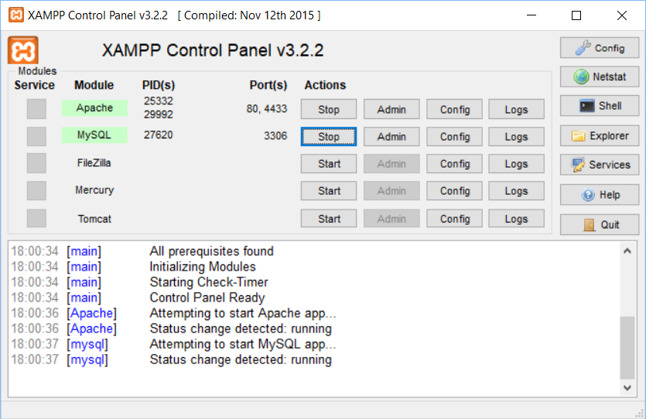
If your current server provides services like apache and MySQL and doesn’t seem to be functioning correctly, I will provide this XAMPP encase, as your current version may not reflect the ones I was currently using.
I strongly recommend that the installation files and database are backed up to a remote location on a daily basis.

How to deploy the files;
Ensuring your using XAMPP make sure apache and MySQL are running to allow all functions of the website to work correctly, once done simply type "localhost/gymapp " and you be presented with the login screen. Also once in basic admin control will be username “admin” password “password” these can be change
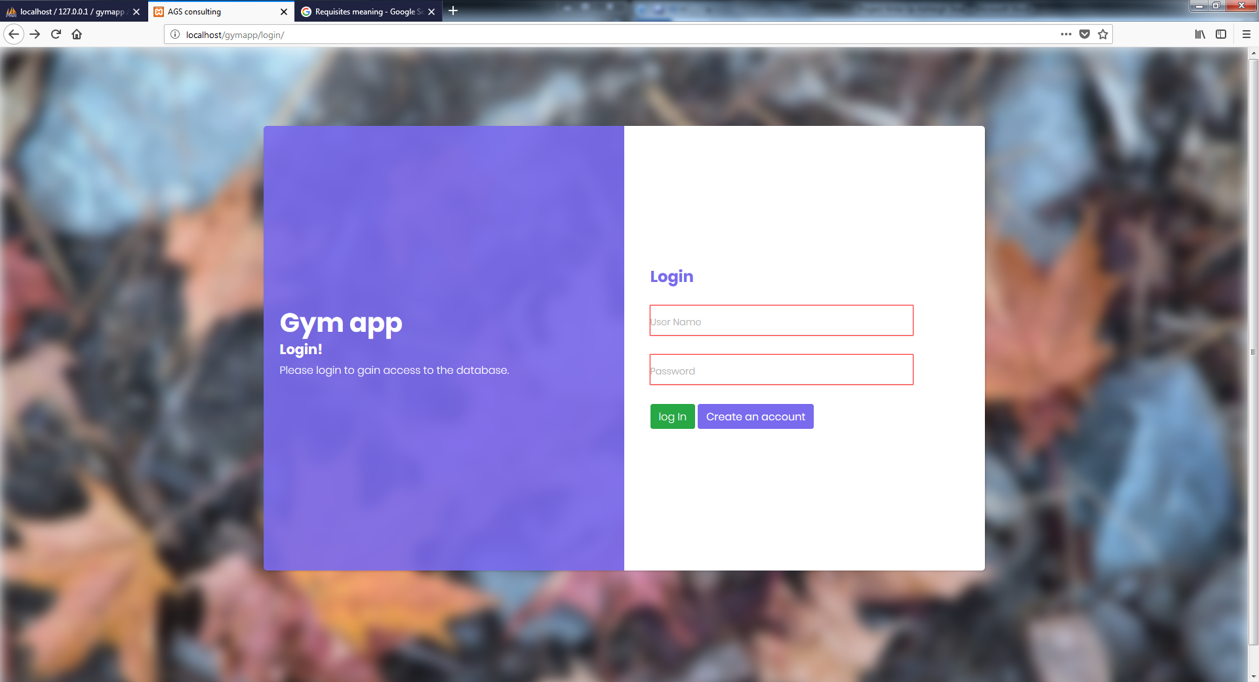

Login
Once open, logged off, or session ended (AFK) you will have to insert your username and password shown above

Register
If you’re a new user you can insert your new account detail and then be redirected back to login page where you can insert your new username and password
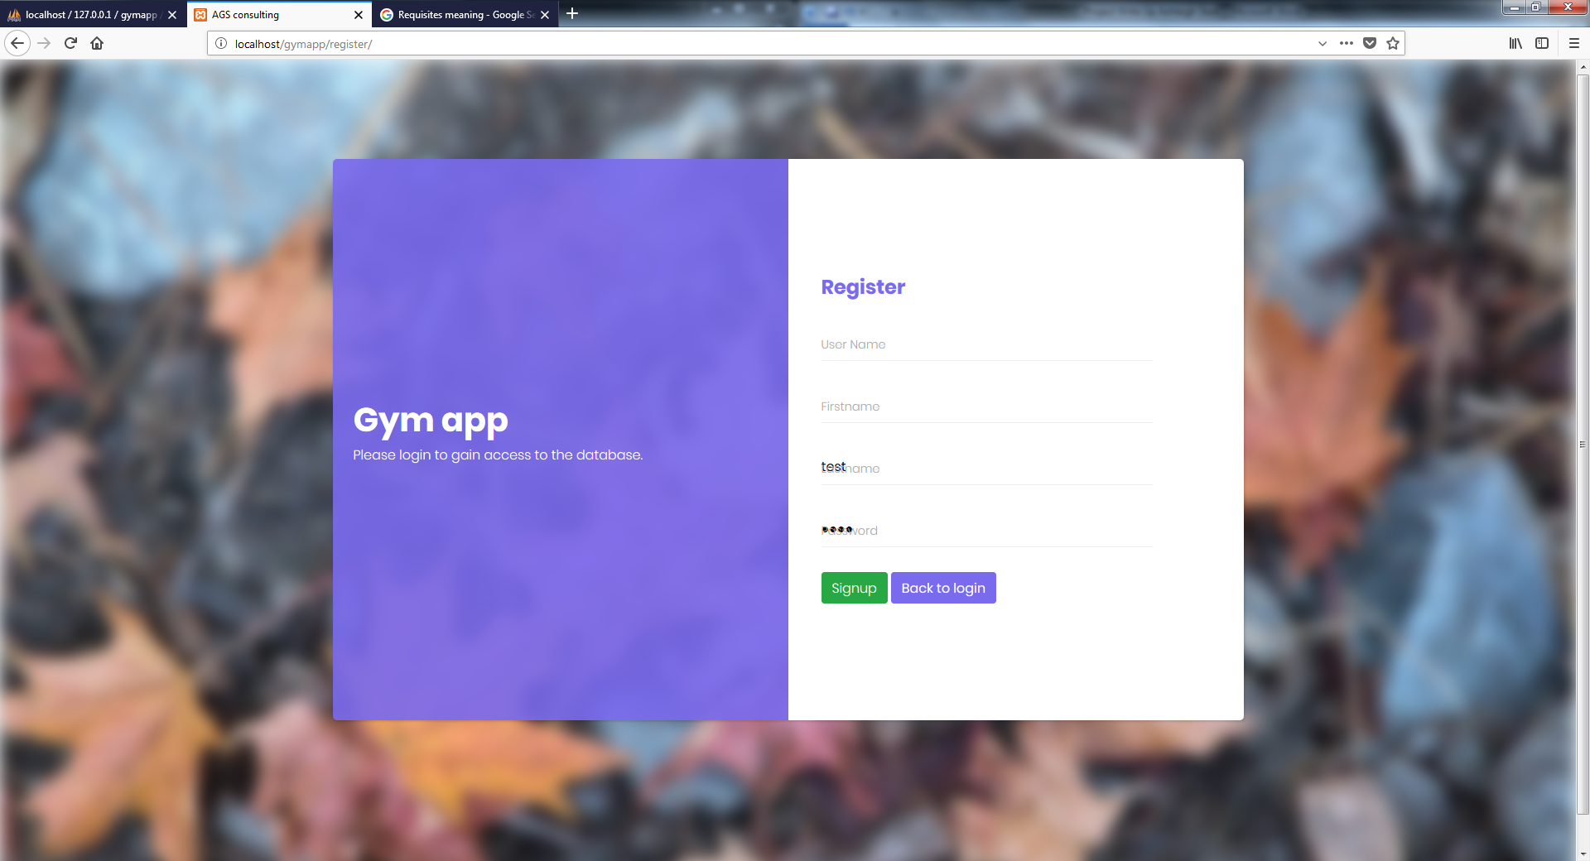

My Profile
Based on your current logged in user it will display your details on my profile where you will be able to edit it and save shown below
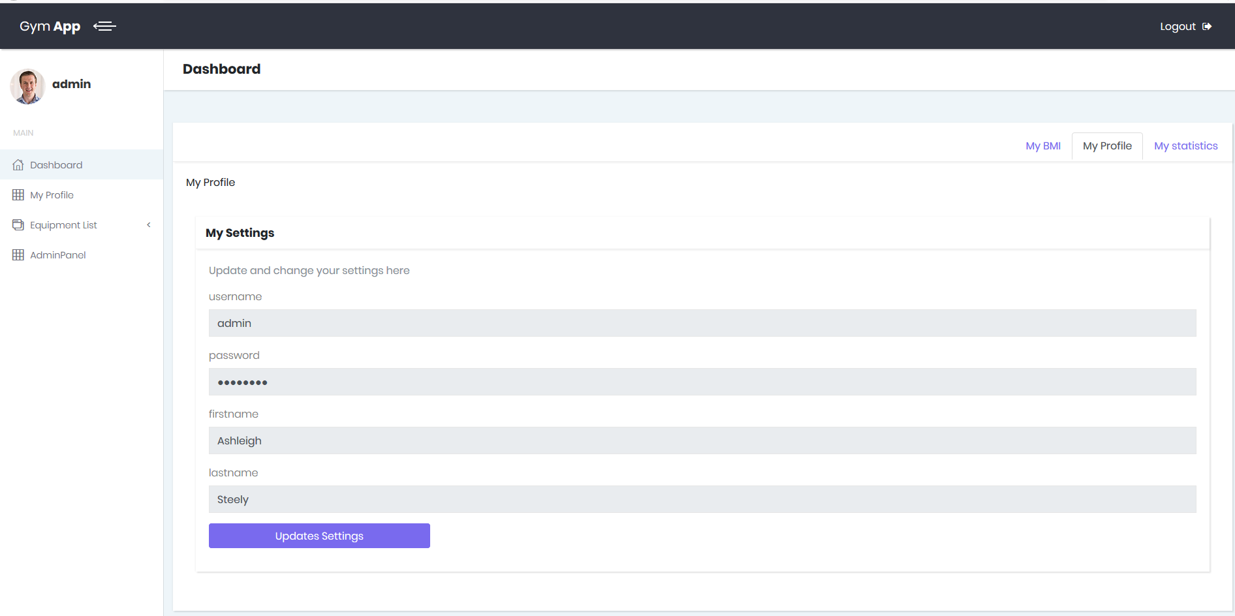
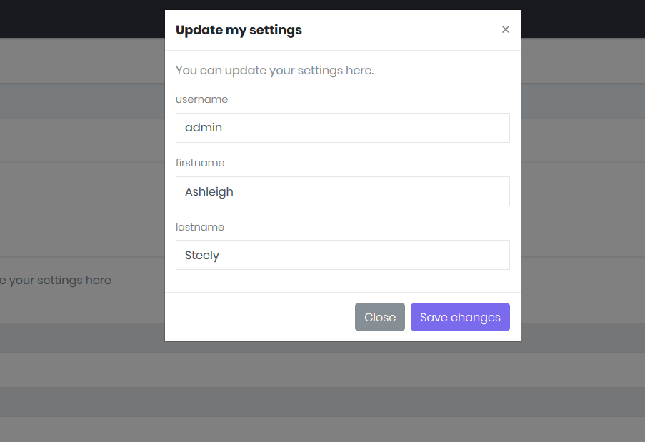

My BMI
Here you are able to insert your height and weight to see what your BMI result is shown below
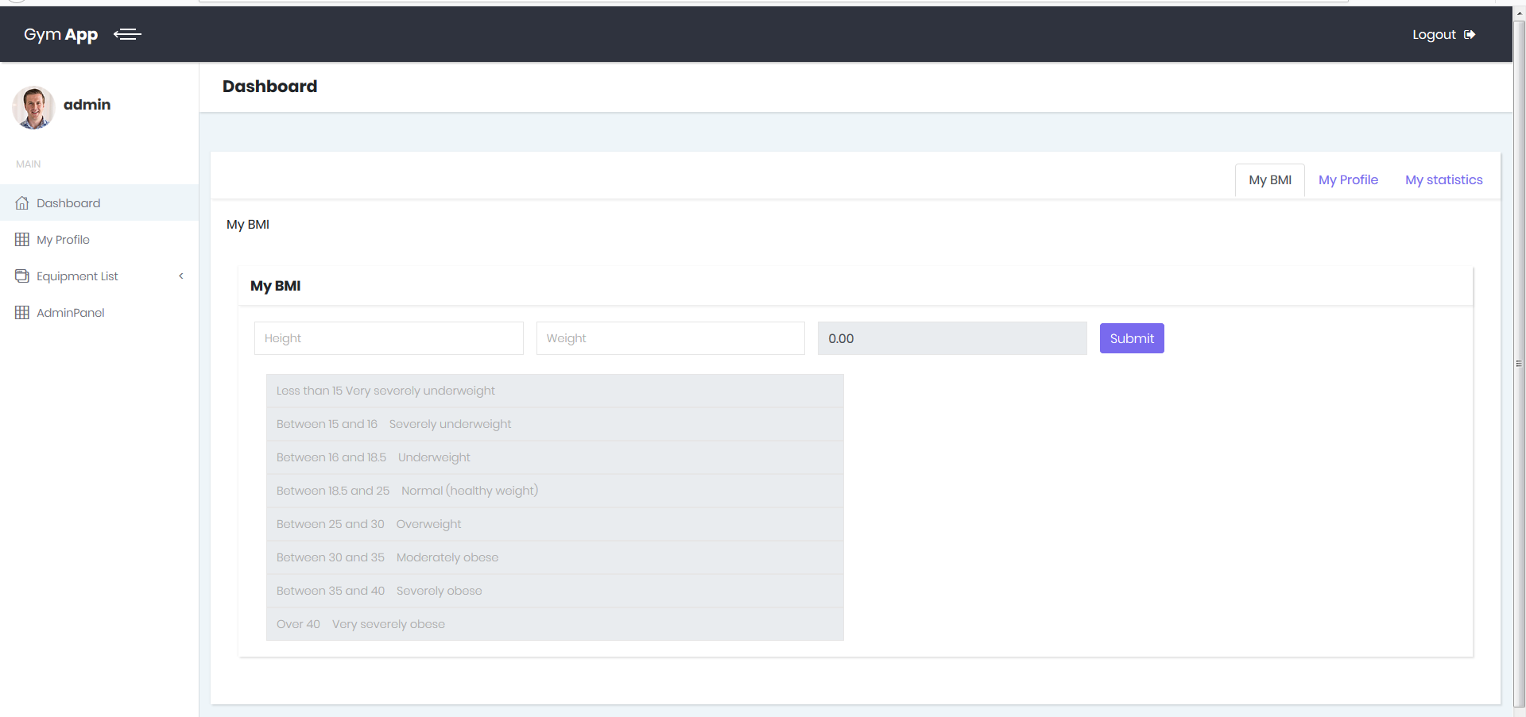

My statistics
Here it will keep track of your current progress (weights) based on what the current user inserted
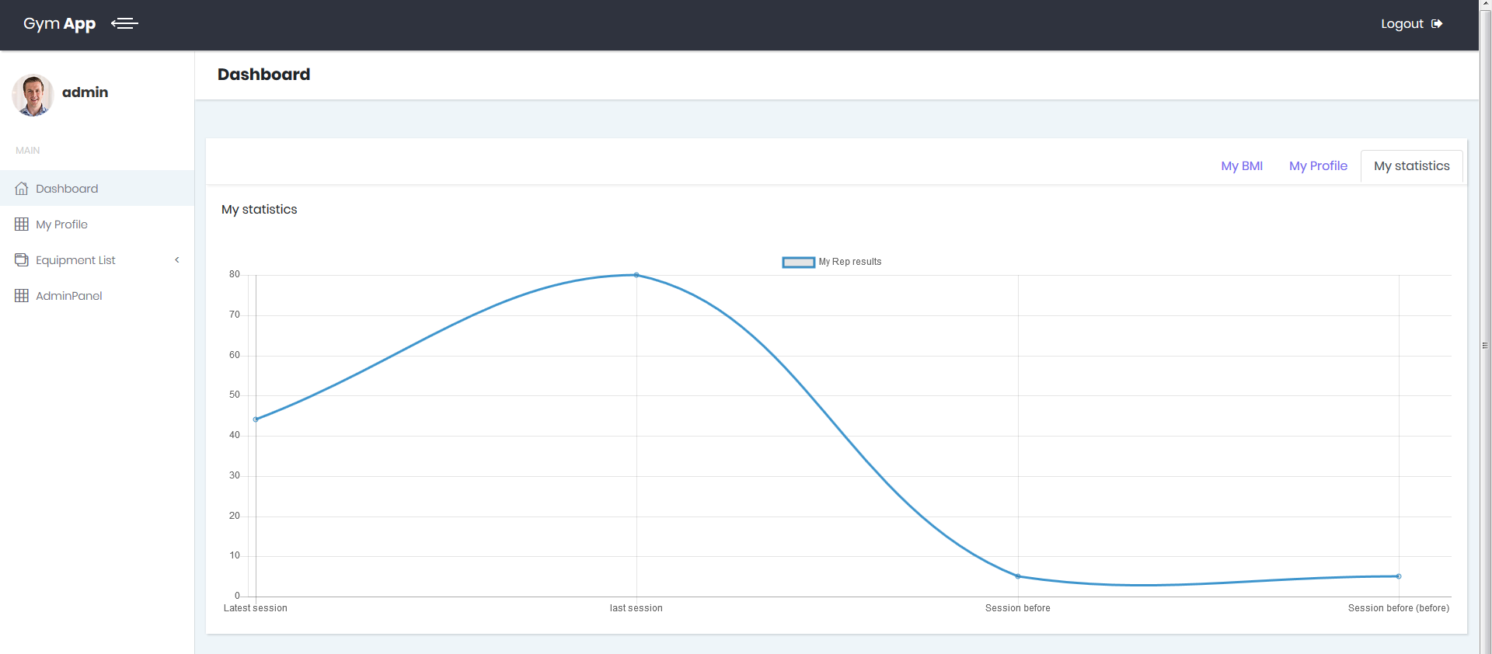

Equipment/weights
Here you can insert your progress based on your results on the weights
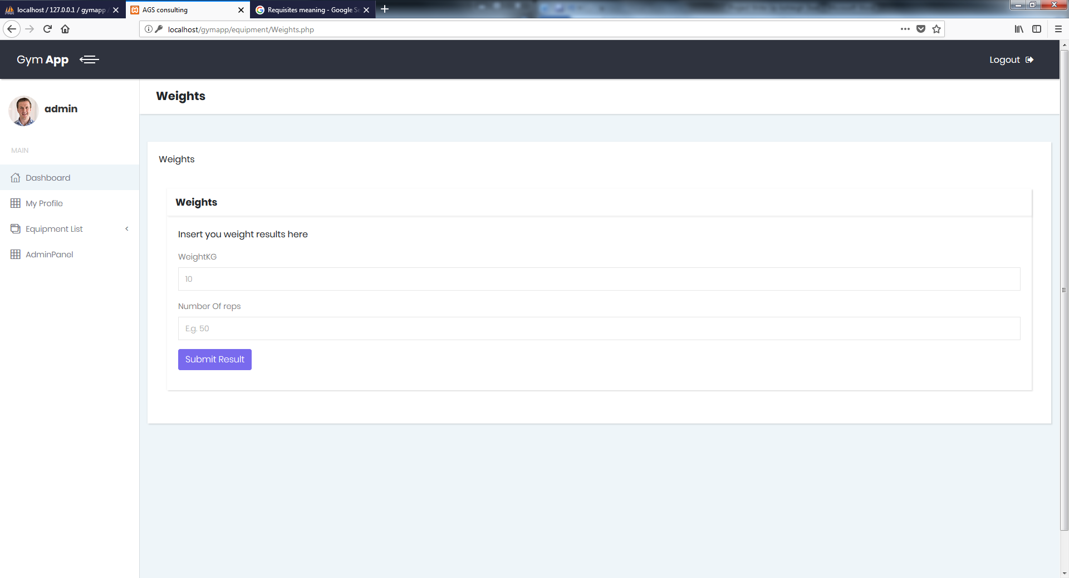

Admin panel
Admin and creator will be allowed access to "admin panel" which will allow them to view all users
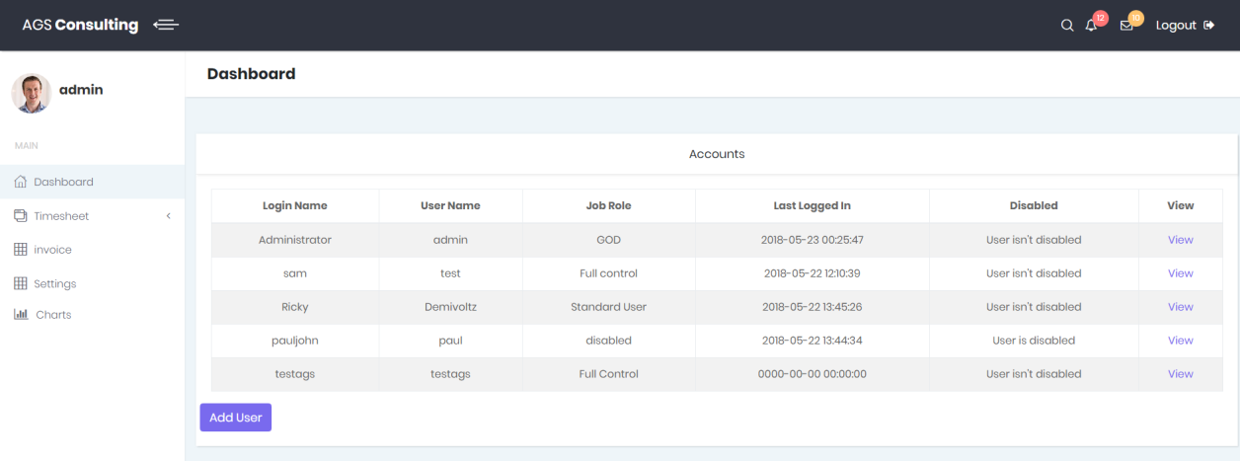

Manage People - Basic User Creation
Here you will be able to create users with set access levels
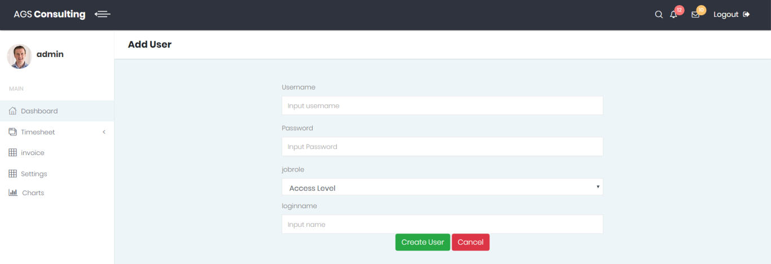

Manage People - Basic User Viewing
Also you will be able to view, amend and delete users based on your access level (can’t encase access level higher than your own)
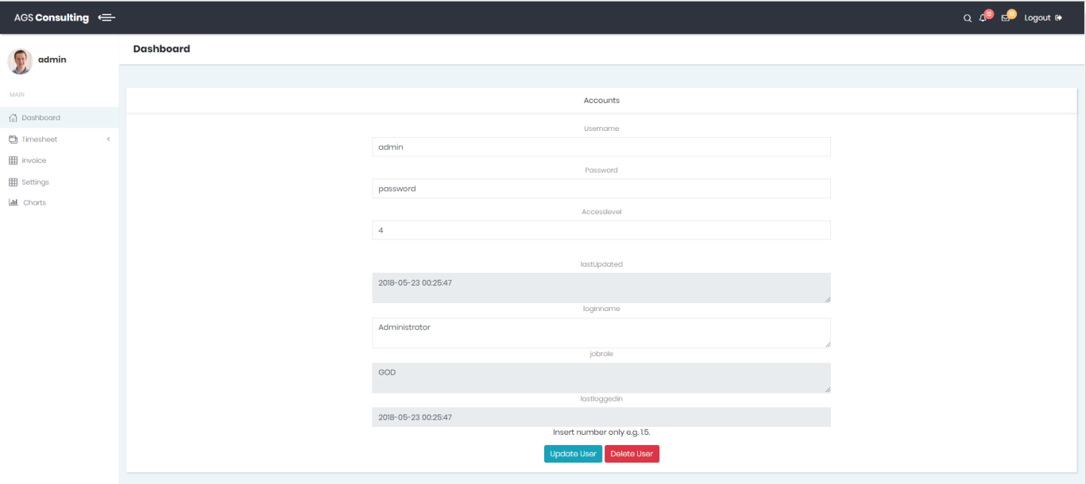
Lastly
Validation has been made to ensure minimal errors to accrue, any problems, bugs, or quires make sure to get hold of your high employees or me on ashleighjsteel@hotmail.com,

Evaluation
I do feel with the creation of my website, I have illustrated that with more development this could become a functional gym app, but currently I do feel that I lack the current knowledge of what equipment is there and what data they want to store.
I feel that I have still achieved and with some more time and improvements once speaking with the gym, I will be able to analyse and easily build from here into a full functioning gym website that can be access not just by staff but users via the web provided by them
Otherwise I feel this will become a great tool to allow users to monitor their progress, perhaps future improvements would be to store BMI results so they can also track their weight loss

Bibliography
[1]Template, admin templates; N/A; https://bootstrapious.com/admin-templates; 01/11/2017
[2] How to make a user friendly site, sageworld; 2013; http://www.sageworld.com/blog/index.php/2015/07/02/9-ways-to-instantly-make-your-website-more-user-friendly/; 10/12/2017
[3]Chats in web app, Chart js; N/A; https://www.chartjs.org/; 16/01/2018
[4]Test strategies, Guru99, N/A; https://www.guru99.com/test-plan-v-s-test-strategy.html; 20/02/2018
[5]Examples, w3schools, N/A; https://www.w3schools.com/; used all Year
[6]Php, php, N/A; http://www.php.net/; All Year
[7]MySQL, MySQL, N/A; https://www.mysql.com/; All Year
[8]Bootstrap 4, Bootstrap; 18/01/2018; http://blog.getbootstrap.com/2018/01/18/bootstrap-4/; all year
[9]Bootstrap 3, Bootstrap; N/A; http://getbootstrap.com/docs/3.3/; Chose to use Bootstrap 4

Appendix A

Code dump

Login
!DOCTYPE html>
<html>
<?php include '../assets/scripts/includes/includeHeader.php'; ?>
<body>
<div class="page login-page">
<div class="container d-flex align-items-center">
<div class="form-holder has-shadow">
<div class="row">
<!-- Logo & Information Panel-->
<div class="col-lg-6">
<div class="info d-flex align-items-center">
<div class="content">
<div class="logo">
<h1>Gym app</h1>
<h2>Login!</h2>
</div>
<p>Please login to gain access to the database.</p>
</div>
</div>
</div>
<!-- Form Panel -->
<div class="col-lg-6 bg-white">
<div class="form d-flex align-items-center">
<div class="content"><div class="logo text-primary"><h1>Login</h1></div><br>
<form action="login.php" method="post">
<div class="form-group">
<input id="login-username" name="username" type="text" name="loginUsername" required="" class="input-material">
<label for="login-username" class="label-material">User Name</label>
</div>
<div class="form-group">
<input id="login-password" name="password" type="password" name="loginPassword" required="" class="input-material">
<label for="login-password" class="label-material">Password</label>
</div><button type="submit" class="btn btn-success">log In</button>
<a href="../register"><div class="btn btn-primary">Create an account</div></a>
</div>
</div>
</div>
</div>
</div>
</div>
<?php include '../assets/scripts/includes/includeFooter.php';?>
</div>
<?php include '../assets/scripts/includes/includeFooterScripts.php';?>
</body>
</html>

Register
?>
<!DOCTYPE html>
<html>
<?php include '../assets/scripts/includes/includeHeader.php'; ?>
<body>
<div class="page login-page">
<div class="container d-flex align-items-center">
<div class="form-holder has-shadow">
<div class="row">
<!-- Logo & Information Panel-->
<div class="col-lg-6">
<div class="info d-flex align-items-center">
<div class="content">
<div class="logo">
<h1>Gym app</h1>
</div>
<p>Please login to gain access to the database.</p>
</div>
</div>
</div>
<!-- Form Panel -->
<div class="col-lg-6 bg-white">
<div class="form d-flex align-items-center">
<div class="content"><div class="logo text-primary"><h1>Register</h1></div><br>
<form method="post">
<div class="form-group">
<input id="register-username" name="username" type="text" required="" class="input-material">
<label for="register-username" class="label-material">User Name</label>
</div>
<div class="form-group">
<input id="register-username" name="firstname" type="text" required="" class="input-material">
<label for="register-username" class="label-material">Firstname</label>
</div>
<div class="form-group">
<input id="register-username" name="lastname" type="text" required="" class="input-material">
<label for="register-username" class="label-material">Lastname</label>
</div>
<div class="form-group">
<input id="register-password" name="password" type="password" required="" class="input-material">
<label for="register-password" class="label-material">Password</label>
</div><button type="submit" name="signup" class="btn btn-success">Signup</button>
<a href="../login"><div class="btn btn-primary">Back to login</div></a>
</div>
</div>
</div>
</div>
</div>
</div>
<?php include '../assets/scripts/includes/includeFooter.php';?>
</div>
<?php include '../assets/scripts/includes/includeFooterScripts.php';?>
</body>
</html>

Dashboard
?>
<!DOCTYPE html>
<html>
<?php include '../assets/scripts/includes/includeHeader.php'; ?>
<body>
<div class="page home-page">
<?php include '../assets/scripts/includes/headtab.php';?>

<div class="page-content d-flex align-items-stretch">
<?php include '../assets/scripts/includes/includeSideMenu.php';?>

<div class="content-inner">
<!-- Page Header-->
<header class="page-header">
<div class="container-fluid">
<h2 class="no-margin-bottom">Dashboard</h2>
</div>
</header>
<!-- Page Content-->
<section>
<p>Here infomation about AGS-Consulting will be shown, updateded and interactable i.e. video</p>
</section>
</div>
</div>
</div>
</div>
</div>
</div>
</section>

<?php include '../assets/scripts/includes/includeFooter.php';?>
</div>
</div>
</div>
<?php include '../assets/scripts/includes/includeFooterScripts.php';?>
</body>
</html>

Myprofile
?>
<!DOCTYPE html>
<html>
<?php include '../assets/scripts/includes/includeHeader.php'; ?>
<body>
<div class="page home-page">
<?php include '../assets/scripts/includes/headtab.php';?>

<div class="page-content d-flex align-items-stretch">
<?php include '../assets/scripts/includes/includeSideMenu.php';?>

<div class="content-inner">
<!-- Page Header-->
<header class="page-header">
<div class="container-fluid">
<h2 class="no-margin-bottom">Dashboard</h2>
</div>
</header>
<!-- Page Content-->
<section>
<div class="col-lg-12">
<div class="card ">
<div class="card-header">
<ul class="nav nav-tabs card-header-tabs pull-right" id="myTab" role="tablist">
<li class="nav-item">
<a class="nav-link active" id="My-BMI" data-toggle="tab" href="#BMI" role="tab" aria-controls="BMI" aria-selected="false">My BMI</a>
</li>
<li class="nav-item">
<a class="nav-link" id="My-Profile" data-toggle="tab" href="#home" role="tab" aria-controls="home" aria-selected="true">My Profile</a>
</li>
<li class="nav-item">
<a class="nav-link" id="My-Statistics" data-toggle="tab" href="#contact" role="tab" aria-controls="contact" aria-selected="false">My statistics</a>
</li>
</ul>
</div>
<div class="card-body">
<div class="tab-content" id="myTabContent">
<!--My profile-->
<div class="tab-pane fade" id="home" role="tabpanel" aria-labelledby="My-Profile"><p>My Profile</p><br>
<div class="col-lg-12">
<div class="card">
<div class="card-header d-flex align-items-center">
<h3 class="h4">My Settings</h3>
</div>
<div class="card-body">
<p class="text-muted">Update and change your settings here</p>
<div class="form-group">
<label class="form-control-label">username</label>
<input placeholder="Username" class="form-control" type="text" name="username-" disabled value="<?php echo $username;?>">
</div>
<div class="form-group">
<label class="form-control-label">password</label>
<input placeholder="password" class="form-control" type="password" name="password-" disabled value="********">
</div>
<div class="form-group">
<label class="form-control-label">firstname</label>
<input placeholder="Firstname" class="form-control" type="text" name="firstname-" disabled value="<?php echo $firstname;?>">
</div>
<div class="form-group">
<label class="form-control-label">lastname</label>
<input placeholder="Lastname" class="form-control" type="text" name="lastname-" disabled value="<?php echo $lastname;?>">
</div>
<div class="form-group">
<input value="Updates Settings" data-toggle="modal" data-target="#myModal" class="btn btn-primary">
</div>
</div>
</div>
</div>
</div>
<!--My profile update-->
<div id="myModal" tabindex="-1" role="dialog" aria-labelledby="exampleModalLabel" aria-hidden="true" class="modal fade text-left">
<div role="document" class="modal-dialog">
<form method="post">
<div class="modal-content">
<div class="modal-header">
<h4 id="exampleModalLabel" class="modal-title">Update my settings</h4>
<button type="button" data-dismiss="modal" aria-label="Close" class="close"><span aria-hidden="true">×</span></button>
</div>
<div class="modal-body">
<p class="text-muted">You can update your settings here.</p>
<div class="form-group">
<label class="form-control-label">username</label>
<input placeholder="Username" class="form-control" type="text" name="username" value="<?php echo $username;?>">
</div>
<div class="form-group">
<label class="form-control-label">firstname</label>
<input placeholder="Firstname" class="form-control" type="text" name="firstname" value="<?php echo $firstname;?>">
</div>
<div class="form-group">
<label class="form-control-label">lastname</label>
<input placeholder="Lastname" class="form-control" type="text" name="lastname" value="<?php echo $lastname;?>">
</div>
</div>
<div class="modal-footer">
<button type="button" data-dismiss="modal" class="btn btn-secondary">Close</button>
<button type="submit" name="UpdateUser" class="btn btn-primary">Save changes</button>
</div>
</div>
</form>
</div>
</div>

<div class="tab-pane fade show active" id="BMI" role="tabpanel" aria-labelledby="My-BMI"><p>My BMI</p><br>
<div class="col-lg-12">
<div class="card">
<div class="card-close">
</div>
<div class="card-header d-flex align-items-center">
<h3 class="h4">My BMI</h3>
</div>
<div class="card-body">
<form class="form-inline" method="post">
<div class="form-group">
<label for="inlineFormInputGroup" class="sr-only">Height: CM</label>
<input id="inlineFormInputGroup" name=cm placeholder="Height" class="mr-3 form-control" type="text"></input>
</div>
<div class="form-group">
<label for="inlineFormInput" class="sr-only">Weight: KG</label>
<input id="inlineFormInput" name=kg placeholder="Weight" class="mr-3 form-control" type="text"></input>
<label for="inlineFormInput" class="sr-only"></label>
<input id="inlineFormInput" name=bmi placeholder="BMI Result" value="<?php echo number_format((float)$bmi, 2, '.', '');; ?>" class="mr-3 form-control" type="text" disabled></input>
</div>
<div class="form-group">
<button type="submit" name=MyBMI class="btn btn-primary">Submit</button>
<label for="inlineFormInput" class="sr-only"></label>
</div>
</form><br>
<div class="col-lg-6">
<input id="inlineFormInput" name=resultchart placeholder="Less than 15 Very severely underweight" class="text-danger mr-3 form-control" type="text" disabled></input>
<input id="inlineFormInput" name=resultchart placeholder="Between 15 and 16 Severely underweight" class="mr-3 form-control" type="text" disabled></input>
<input id="inlineFormInput" name=resultchart placeholder="Between 16 and 18.5 Underweight " class="mr-3 form-control" type="text" disabled></input>
<input id="inlineFormInput" name=resultchart placeholder="Between 18.5 and 25 Normal (healthy weight)" class="mr-3 form-control" type="text" disabled></input>
<input id="inlineFormInput" name=resultchart placeholder="Between 25 and 30 Overweight" class="mr-3 form-control" type="text" disabled></input>
<input id="inlineFormInput" name=resultchart placeholder="Between 30 and 35 Moderately obese" class="mr-3 form-control" type="text" disabled></input>
<input id="inlineFormInput" name=resultchart placeholder="Between 35 and 40 Severely obese" class="mr-3 form-control" type="text" disabled></input>
<input id="inlineFormInput" name=resultchart placeholder="Over 40 Very severely obese" class="mr-3 form-control" type="text" disabled></input>
</div>
</div>
</div></div>

</div>

<div class="tab-pane fade" id="contact" role="tabpanel" aria-labelledby="My-Statistics"><p>My statistics</p><br>

<canvas id="line-chart" width="200" height="60"></canvas>

</div>
</div>
</div>
</div>
</div>

</section>
</div>
</div>
</div>
</div>
</div>
</div>
</section>

<?php include '../assets/scripts/includes/includeFooter.php';?>
</div>
</div>
</div>
<?php include '../assets/scripts/includes/includeFooterScripts.php';?>
<!--Chart here-->
<script>
new Chart(document.getElementById("line-chart"), {
type: 'line',
data: {
labels: ["Latest session", "last session", "Session before", "Session before (before)"],
datasets: [
<?php
echo "{
data: [";
while ($sql->fetch())
{
echo "$result". ",";
}
echo "],
label: 'My Rep results',
borderColor: '#3e95cd',
fill: false
},";

$sql->close();
$dbconn->close();
?>
]
},
options: {
scales: {
yAxes: [{
ticks: {
beginAtZero: true
}
}]
}
}
});

</script>
</body>
</html>

Weight
?>
<!DOCTYPE html>
<html>
<?php include '../assets/scripts/includes/includeHeader.php'; ?>
<body>
<div class="page home-page">
<?php include '../assets/scripts/includes/headtab.php';?>

<div class="page-content d-flex align-items-stretch">
<?php include '../assets/scripts/includes/includeSideMenu.php';?>

<div class="content-inner">
<!-- Page Header-->
<header class="page-header">
<div class="container-fluid">
<h2 class="no-margin-bottom">Weights</h2>
</div>
</header>
<!-- Page Content-->
<section>
<div class="col-lg-12">
<div class="card ">
<!--<div class="card-header">
<ul class="nav nav-tabs card-header-tabs pull-right" id="myTab" role="tablist">
<li class="nav-item">
<a class="nav-link active" id="My-Profile" data-toggle="tab" href="#home" role="tab" aria-controls="home" aria-selected="true">Weights</a>
</li>
</ul>
</div>-->
<div class="card-body">
<div class="tab-content" id="myTabContent">

<div class="tab-pane fade show active" id="home" role="tabpanel" aria-labelledby="My-Profile"><p>Weights</p><br>
<div class="col-lg-12">
<div class="card">
<div class="card-header d-flex align-items-center">
<h3 class="h4">Weights</h3>
</div>
<div class="card-body">
<p>Insert you weight results here</p>
<form method = "post">
<div class="form-group">
<label class="form-control-label">WeightKG</label>
<input placeholder="10" class="form-control" name="weight" type="reps">
</div>
<div class="form-group">
<label class="form-control-label">Number Of reps</label>
<input placeholder="E.g. 50" class="form-control" name="reps" type="reps">
</div>
<div class="form-group">
<input value="Submit Result" name="weightresult" class="btn btn-primary" type="submit">
</div>
</form>
</div>
</div>
</div>
</div>
</div>
</div>
</div>

</section>
</div>
</div>
</div>
</div>
</div>
</div>
</section>

<?php include '../assets/scripts/includes/includeFooter.php';?>
</div>
</div>
</div>
<?php include '../assets/scripts/includes/includeFooterScripts.php';?>
</body>
</html>

Adminpanel

Settings/userdisplay
?>
<!DOCTYPE html>
<html>
<?php include '../assets/scripts/includes/includeHeader.php'; ?>
<body>
<div class="page home-page">
<?php include '../assets/scripts/includes/headtab.php';?>

<div class="page-content d-flex align-items-stretch">
<?php include '../assets/scripts/includes/includeSideMenu.php';?>

<div class="content-inner">
<!-- Page Header-->
<header class="page-header">
<div class="container-fluid">
<h2 class="no-margin-bottom">Dashboard</h2>
</div>
</header>
<!-- Page Content-->
<section>
<div class="col-md-12">
<div class="card text-center">
<div class="card-header">
Accounts
</div>
<div class="card-body">
<div class = "row">
<div class="col-md-12 col-sm-12 col-xs-12">
<div class = "x_panel">
<div class="box-body table-responsive">
<table id="users" class="table table-bordered table-striped">
<thead>
<tr>
<!-- change these for the titles such as "client number"," description" etc.-->
<th>User name</th>
<th>Last name</th>
<th>Job Role</th>
<th>Last Logged In</th>
<th>Disabled</th>
<th>View</th>
</tr>
</thead>
<tbody>
<!-- display users here -->
<?php
while ($sql->fetch())
{
echo "<tr>";
/* stop the admin account being selected */
/*if ($username == "admin" or $username == $_SESSION['uname'])*/
echo "<td>".$lastname."</td>";
/*else
echo "<td><a href=edituser.php?id=".$id.">".$loginname."</a></td>";*/

echo "<td>".$username."</td>";
echo "<td>".$jobrole."</td>";
echo "<td>".$lastloggedin."</td>";
if ($accesslevel == 0) {echo "<td>User is disabled</td>";} else {echo "<td>User isn't disabled</td>";}
echo "<td><a href=viewuser.php?id=".$id.">View</td>";
/* stop the admin account being deleted */
/*-------
if ($username == "admin" or $username == $_SESSION['uname'])
echo "<td></td>";
else
echo "<td><a href=deleteuser.php?id=".$clientnumber.">Delete</a></td>";
echo "</tr>";-----*/
}
?>
</tbody>
</table>
</div>
</div>
</div>
<a href="../adminpanel/adduser.php" class="btn btn-primary">Add User</a>
</div>
</section>
</div>
</div>
</div>
</div>
</div>
</div>
</div>
</div>
</div>
</section>

<?php include '../assets/scripts/includes/includeFooter.php';?>
</div>
</div>
</div>
<?php include '../assets/scripts/includes/includeFooterScripts.php';?>
</body>
</html>

Adduser
?>
<!DOCTYPE html>
<html>
<?php include '../assets/scripts/includes/includeHeader.php'; ?>
<body>
<div class="page home-page">
<?php include '../assets/scripts/includes/headtab.php';?>

<div class="page-content d-flex align-items-stretch">
<?php include '../assets/scripts/includes/includeSideMenu.php';?>

<div class="content-inner">
<!-- Page Header-->
<header class="page-header">
<div class="container-fluid">
<h2 class="no-margin-bottom">Add User</h2>
</div>
</header>
<!-- Page Content-->
<section>
<form method="post">
<div class="row">
<div class="col-md-3"></div>
<div class="col-md-6">
<div class="form-group">
<label for="field-2" class="control-label">Username</label>
<input type="text" name="username" placeholder = "Input username" class="form-control" required>
<?php if(empty($userresult)){}else{echo "<span class='text-danger'>" . $userresult . "</span>";} ?>
</div>
</div>
<div class="col-md-3"></div>
</div>
<div class="row">
<div class="col-md-3"></div>
<div class="col-md-6">
<div class="form-group">
<label for="field-2" class="control-label">Password</label>
<input type="text" name="password" placeholder = "Input Password" class="form-control" required>
</div>
</div>
<div class="col-md-3"></div>
</div>
<div class="row">
<div class="col-md-3"></div>
<div class="col-md-6">
<div class="form-group no-margin">
<label for="field-7" class="control-label">Job role</label>
<select name="accesslevel" id="accesslevel" class="form-control input-sm" title="Access Level" required>
<option value="" disabled selected>Access Level</option>
<option value=0>Disabled</option>
<option value=1>Read Only</option>
<option value=2>Standard User</option>
<option value=3>Full Control</option> </select>
</div>
</div>
</div>

<div class="row">
<div class="col-md-3"></div>
<div class="col-md-6">
<div class="form-group no-margin">
<label for="field-7" class="control-label">First name</label required>
<input type="text" name="firstname" placeholder = "Input name" class="form-control">
</div>
<div class="form-group no-margin">
<label for="field-7" class="control-label">Last name</label required>
<input type="text" name="lastname" placeholder = "Input name" class="form-control">
</div>
</div>
<div class="col-md-3"></div>
<div class="col-md-12 text-center">
<button type="submit" name="newuser" class="btn btn-success text-center">Create User</button>
<a href = "../settings/settings.php"><button type="button" name="Cancel" class="btn btn-danger">Cancel</button></a>
</div>
</div>
</form>
</section>
</div>
</div>

<?php include '../assets/scripts/includes/includeFooter.php';?>
</div>
</div>
</div>
<?php include '../assets/scripts/includes/includeFooterScripts.php';?>
</body>
</html>

Viewuser
?>
<!DOCTYPE html>
<html>
<?php include '../assets/scripts/includes/includeHeader.php'; ?>
<body>
<div class="page home-page">
<?php include '../assets/scripts/includes/headtab.php';?>

<div class="page-content d-flex align-items-stretch">
<?php include '../assets/scripts/includes/includeSideMenu.php';?>

<div class="content-inner">
<!-- Page Header-->
<header class="page-header">
<div class="container-fluid">
<h2 class="no-margin-bottom">Dashboard</h2>
</div>
</header>
<!-- Page Content-->
<section>
<div class="col-md-12">
<div class="card text-center">
<div class="card-header">
Accounts
</div>
<div class="card-body">
<form method="post">
<div class="row text-center">
<div class="col-md-3"></div>
<div class="col-md-6">
<div class="form-group">
<label for="field-2" class="control-label">Username</label>
<input type="text" name="username" value="<?php echo $username;?>" class="form-control">
<?php if(empty($userresult)){}else{echo "<span class='text-danger'>" . $userresult . "</span>";} ?>
</div>
</div>
<div class="col-md-3"></div>
</div>
<div class="row">
<div class="col-md-3"></div>
<div class="col-md-6">
<div class="form-group">
<label for="field-2" class="control-label">Password</label>
<input type="text" name="password" value="<?php echo $password;?>" class="form-control">
</div>
</div>
<div class="col-md-3"></div>
</div>

<div class="row">
<div class="col-md-3"></div>
<div class="col-md-6">
<div class="form-group">
<label for="field-2" class="control-label">Accesslevel</label>
<input type="text" <?php if ($_SESSION['accesslevel'] >= 4){} else {echo "disabled";} ?> name="accesslevel" value="<?php echo $accesslevel;?>" class="form-control"><span class="help-block-none"><?php if ($_SESSION['accesslevel'] >= 4){} else {echo "<span class='text-danger'>You cannot change a user that is equal or greater than your access level</span>";} ?></span>
</div>
</div>
<div class="col-md-3"></div>
</div>

<div class="row">
<div class="col-md-3"></div>
<div class="col-md-6">
<div class="form-group no-margin">
<label for="field-7" class="control-label">lastUpdated</label>
<textarea class="form-control" name="lastupdated" id="Descrisption" placeholder="" disabled><?php echo $lastUpdated;?></textarea>
</div>
</div>
<div class="col-md-3"></div>
</div>

<div class="row">
<div class="col-md-3"></div>
<div class="col-md-6">
<div class="form-group no-margin">
<label for="field-7" class="control-label">First Name</label>
<textarea class="form-control" name="firstname" id="Descrisption" placeholder=""><?php echo $firstname;?></textarea>
</div>
</div>
<div class="col-md-3"></div>
</div>

<div class="row">
<div class="col-md-3"></div>
<div class="col-md-6">
<div class="form-group no-margin">
<label for="field-7" class="control-label">Last Name</label>
<textarea class="form-control" name="lastname" id="Descrisption" placeholder=""><?php echo $lastname;?></textarea>
</div>
</div>
<div class="col-md-3"></div>
</div>

<div class="row">
<div class="col-md-3"></div>
<div class="col-md-6">
<div class="form-group no-margin">
<label for="field-7" class="control-label">jobrole</label>
<textarea class="form-control" name="jobrole" id="Descrisption" placeholder=""disabled><?php echo $jobrole;?></textarea>
</div>
</div>
<div class="col-md-3"></div>
</div>

<div class="row">
<div class="col-md-3"></div>
<div class="col-md-6">
<div class="form-group">
<label for="field-2" class="control-label">lastloggedin</label>
<input type="text" disabled name="lastloggedin" value="<?php echo $lastloggedin;?>" class="form-control"><span class="help-block-none"disabled>Insert number only e.g. 1.5.</span>
</div>
</div>
<div class="col-md-3"></div>
<div class="col-md-3"></div>
<div class="col-md-6">
<button type="submit" name="UpdateUser" class="btn btn-info">Update User</button>
<button type="submit" name="DeleteUser" <?php if ($_SESSION['accesslevel'] <4){echo "disabled";}else{};?> class="btn btn-danger">Delete User</button>
</div>
</div>
</form>

</div>
</section>
</div>
</div>
</div>
</div>
</div>
</div>
</div>
</div>
</div>
</section>

<?php include '../assets/scripts/includes/includeFooter.php';?>
</div>
</div>
</div>
<?php include '../assets/scripts/includes/includeFooterScripts.php';?>
</body>
</html>

