Name: Steffan John Benson
P Number: P151818
Module Title: Agent AI
Module Code: M5X01022
Module Lecturer: Gordon Dickers
Assignment Title: Pathfinding AI

Contents
Search Algorithm and Implementation 3
User Guide 3
Testing 4
Screenshots 5
References 8

Figure 1 - Maze once target node has been reached. 5
Figure 2 - Portion of whereCanIGo() method. ………………………………………………………………………………….. 5
Figure 3 - Checks for target node and dead ends. ……………………………………………………………………………. 6
Figure 4 - File reader and start/target node print outs. ……………………………………………………………………. 6
Figure 5 - maze print out. ………………………………………………………………………………………………………………… 7

Search Algorithm and Implementation

The search algorithm utilised to search the maze pertains to the Depth First Search (DFS) method. DFS methods will continue down a specified branch until it reaches the end of the branch, before returning to a node where an unexplored branch begins[1][2].
Implementing this into the solution is done by searching in each direction, which are in order of up, down, left and right, and checking to see if there is a wall (#) or an empty space ( ) in each direction. If a check returns a wall, the following code is ignored. If the search finds an empty space, the position is modified to reflect the movement of the AI. If multiple empty spaces have been found, the AI will move in the direction it finds first, as per the order mentioned above. Once the AI reaches a ‘dead end’, it will return to the last node on the stack where an empty space was recorded and not explored. The return to this node is done by popping all previous nodes off of the stack, until an unexplored node is at the top of the stack. This process is repeated as many times as necessary until it reaches the target node, signified by the letter Y. The AI will check to see if it has detected the target node, and if the check returns positive, the search will terminate and the position of the target node is printed below the final maze view.
In order to prevent the AI from returning to the start location, a check is performed to see if the AI has moved. If the AI has moved, the startSpace variable is changed from true to false, which will prevent the current location of the AI from being reset to the start location.

User Guide

In order to run the program, open Microsoft Visual Studio 2015. Open the MazeSearch.sln file, clean and build the solution before running. Run without debugging, using the CTRL+F5 shortcut, and the pre-programmed maze will open. Should you wish to test with a different sized maze, the height and width values at the top of the programme should be modified to the height and width of the maze plus 1 for both values. The name of the .txt to be read should also be changed before testing with a different maze. Once the programme begins, the search begins automatically and will run until the target node has been located. The maze may flicker slightly as the search is performed, this is unavoidable as the maze is cleared and reprinted for every movement of the AI.
Multiple mazes have been provided for further testing, however the use of an online maze generator can be used to make more[3].

Testing
Test No. | Test Description | Expected Result | Actual Result | Pass/Fail
1 | Test to ensure file reader works. | Maze File is read in successfully. | Maze File is read in successfully. | Pass
2 | Search for start location. | Start location located and printed at end of search. | Start location located and printed at end of search. | Pass
3 | AI movement in 4 different directions. | AI can move in all 4 specified directions. | AI can move in all 4 specified directions. | Pass
4 | AI wall recognition. | AI recognizes walls and will not travel through them. | AI recognizes walls and will not travel through them. | Pass
5 | AI backtracking if it reaches a dead end. | AI can return to previous nodes. | AI can return to previous nodes. | Pass
6 | AI target node detection. | AI can detect the target node. | AI can detect the target node. | Pass
7 | Search termination once target node has been reached. | The search stops once the AI detects the target node. | The search stops once the AI detects the target node. | Pass

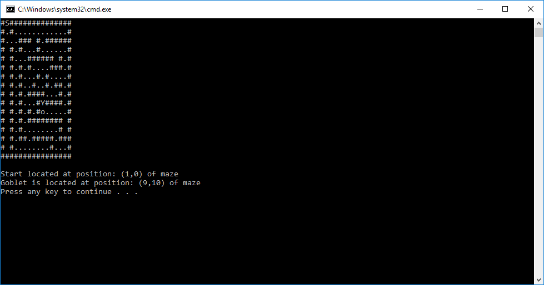
Screenshots

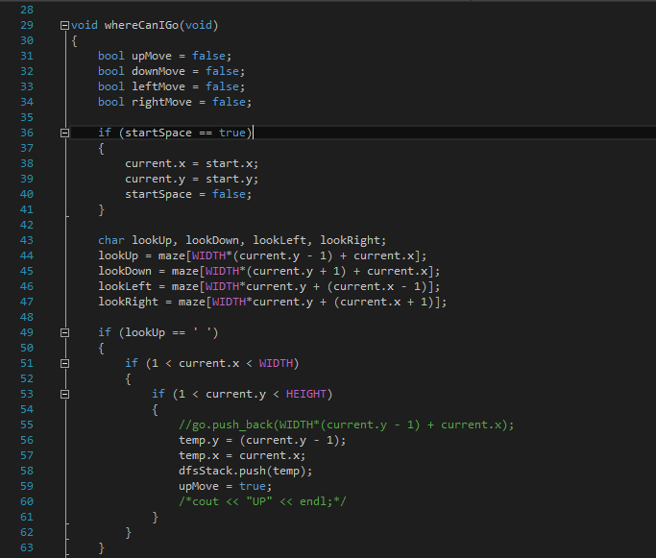
Figure 1 - Maze once target node has been reached.
Figure 2 - Portion of whereCanIGo() method.
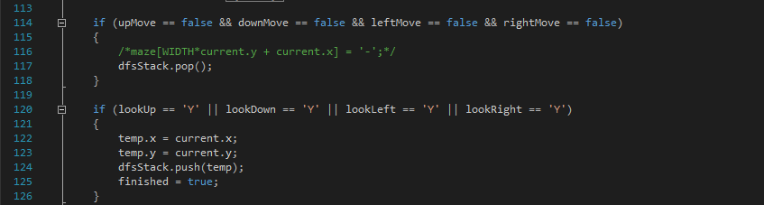
Figure 3 - Checks for target node and dead ends.
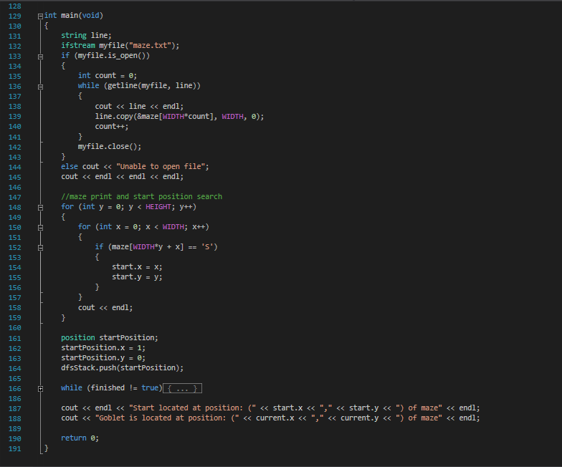Figure 4 - File reader and start/target node print outs.
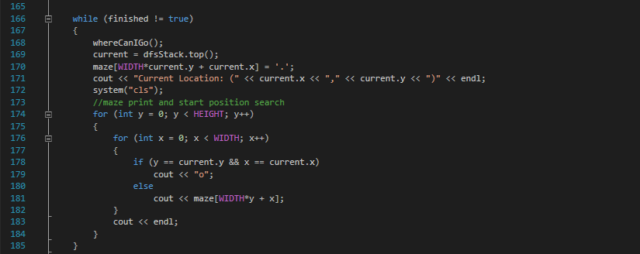
Figure 5 - maze print out.

References

[1] K. Moore and K. Jenkinson, “Depth-First Search (DFS) | Brilliant Math &amp; Science Wiki.” [Online]. Available: https://brilliant.org/wiki/depth-first-search-dfs/. [Accessed: 16-Mar-2018].
[2] “BFS vs DFS for Binary Tree - GeeksforGeeks.” [Online]. Available: https://www.geeksforgeeks.org/bfs-vs-dfs-binary-tree/. [Accessed: 16-Mar-2018].
[3] Unknown, “Maze Generator.” [Online]. Available: http://www.delorie.com/game-room/mazes/genmaze.cgi. [Accessed: 19-Mar-2018].

