
MODULE NAME: MARKETING MANAGEMENT
MODULE CODE: LCMB7024
MARKETING ENVIRONMENT ANALYSIS AND STRATEGIC GROWTH FOR TATA STEEL'S TRANSITION TO A LOWER-CARBON BUSINESS MODEL
STUDENT NAME: ANKIT GOPALBHAI RABARI
STUDENT ID:2535776

Table of Contents
1. Task 1: Marketing Environment Analysis 3
1.1 Company Selection and Context 3
1.2 External Marketing Environment Actor 1: Natural Environment 3
1.3 External Marketing Environment Actor 2: Technological Environment 5
2. Task 2: Strategic Growth and Competitive Positioning 6
2.1 Strategic Growth Recommendation Using the Ansoff Matrix 6
2.2 Competitive Advantage Through a Lower-Carbon Business Model 9
3. Task 3: Critical Reflection on AI Usage 11
3.1 Tool Disclosure 11
3.2 Critical Evaluation of AI Output 11
3.3 Contribution Analysis 11
3.4 Ethical and Professional Reflection 12
References 13

1. Task 1: Marketing Environment Analysis

1.1 Company Selection and Context
Tata Steel is one of India’s largest steel manufacturers that has maintained a prominent position with a diversified product portfolio, consistent quality and an extensive network. Tata steel in 1907 emerges as the first integrated private steel enterprise in Asia. In Asia, Europe and other international markets, there have been delivery of Tata Steel’s products in engineering, packaging, automotive and construction at the current time (Tatasteel, 2026). In a competitive and transformation-driven market, Tata Steel has maintained its resilient position, gaining support from its continuous focus on innovation and sustainability priorities. IEA report presents that, on an annual basis, there is the emission of 2.6 gigatonnes of carbon dioxide.
This amount is 7% of worldwide energy-related CO₂ emissions (IEA, 2026). In response to the climate change challenge, Tata Steel has set an ambition that by the year 2045 it will achieve Net Zero carbon emissions (Tatasteel, 2026). Considering this aspect, it prioritises significant investment in resource-efficient production, green hydrogen technology, scrap-based steelmaking and renewable energy use. Transition towards low-carbon steel production is supported with these initiatives, which is strategic for achieving long-term growth and success in business. However, adaptation in operational processes must be done based on the external market environment, fulfilling stakeholders and regulatory requirements.

1.2 External Marketing Environment Actor 1: Natural Environment
Climate change, biodiversity loss concerns, environmental policies, and resource scarcity such kinds of issues poses notable impact while there is a transition towards lower-carbon steel production at Tata Steel’s operations.
Climate Change and Carbon Emissions:
Higher amounts of carbon emissions from the steel sector raise the concern for environmental degradation which highlights the requirement of transitioning towards cleaner production methods. 7% of global greenhouse gas (GHG) is emitted from the steel sector, where green steel manufacturing is crucial in lowering emissions (Mckinsey, 2024). In today’s time, there is a requirement for steel manufacturers to adopt this method as there is a growing expectation for lower-carbon products from consumers, local communities, investors and government. Both opportunities and challenges are presented at Tata Steel’s operation.
Green steel market expansion presents opportunities for firms in differentiating their products and strengthening corporate reputation, keeping sustainability at central at operation (Tolettini and Di Maria, 2023). However, Tata Steel’s transition towards a low-carbon steel business adds higher capital expenditure in the areas of clean energy sources and resource-efficient technologies. Despite short-term cost increases, the associated benefits are a lower negative impact on the environment and maintaining competitiveness.
Carbon Regulations and Environmental Policies:
Transition to a lower-carbon business model has also become strategic at Tata Steel’s operations as there is the presence of stringent policies that need to be strictly followed by firms for dealing with environmental degradation concerns. For instance, the Carbon Border Adjustment Mechanism (CBAM) has been introduced by the EU, where steel manufacturers are encouraged to transition towards cleaner methods and technologies. Under this rule, there is a requirement to pay a carbon charge on the emissions of imported products (OECD, 2025). While financial incentives like subsidies, tax benefits and green financing are provided to firms which are engaged in decarbonising projects (EY, 2026). Tata Steel must strictly comply with essential rules and regulations for mainating competitiveness in international markets. Modernisation of production facilities and greater investment in low-carbon technologies are well-aligned with the net-zero carbon emissions target of 2045 at Tata Steel. However, it increases operational and capital expenditure. Overall, ESG performance is effective for enhancing stakeholders’ trust and engagement.
Resource Scarcity and Circular Economy:
Natural resources like iron, coal, ore and other minerals are required for the operations at Tata Steel (Tatasteel, 2026). Disruption in operations may happen at any time when there is scarcity in resources, as there is higher dependence on virgin materials. Circular economy practices thus emerge as a key strategic approach for sustainable steel production (Berlin et al., 2022). These approaches include resource-efficient production and scrap steel recycling. With these approaches, Tata Steel can maintain a strong corporate reputation; however, there is a requirement for higher capital on low-carbon technologies, infrastructure and training programs for employees.
Opportunities, Threats and Critical Evaluation:
Sustainable steel’s growing demand and stronger ESG expectations have become strategic opportunities for Tata Steel in strengthening positive brand image and competitiveness. In biodiversity conservation, reduction of natural resources depletion, and compliance cost removal can be done by firms with the inclusion of circular economy practices in operations (Roberts et al., 2023). However, these transitions add further operational complexity and cost requirements which must be effectively balanced by firms. Therefore, a balanced sustainable strategy supports lower-carbon steel production and market competitiveness.

1.3 External Marketing Environment Actor 2: Technological Environment
Justification for Selecting the Technological Environment:
Tata Steel’s transition towards a lower-carbon business model has a significant influence on the technological environment. The use of advanced technologies like Carbon Capture, Electric Arc Furnaces (EAFs), and Artificial Intelligence (AI) helps in optimising production procedures along with energy efficiency (Zhang et al., 2025). Associated benefits are optimum operational and environmental performance. Therefore, market competitiveness and resilient position depend on the technological environment in Tata Steel’s operation.
Influence on Tata Steel's Lower-Carbon Transition:
Tata Steel is expanding its investment in pilot projects for Carbon Capture, Utilisation and Storage (CCUS) that support the reduction of greenhouse gas emissions (Tatasteel, 2025). There is also inclusion of artificial intelligence and other advanced technologies for enhancing operational efficiency and moving towards a lower-carbon operational model. On a short-term there is a higher level of operational cost of using advanced technologies in sustainable steel manufacturing. However, in the long run, it helps in achieving operational growth and strengthening competitiveness.
Opportunities, Threats and Competitive Implications:
In greener production at Tata Steel, there is a notable influence of technological innovation. Unique differentiation in products and optimisation in operational efficiency are fundamental in strengthening competitiveness in a highly dynamic steel sector. However, major challenges that have to be faced by the firm include high capital investment requirements in technologies and infrastructure (Teixeira, 2025). Ongoing investment in employee training is equally important for strengthening their competence to easily adapt to the changes. Despite initial financial, operational and implementation risk, it supports protecting the environment from degradation and increasing market share.

2. Task 2: Strategic Growth and Competitive Positioning

2.1 Strategic Growth Recommendation Using the Ansoff Matrix
Application of the Ansoff Matrix:
Growth strategies, including inherent risk for firms, can be found by focusing on our key dimensions, like market penetration, market development, product development, and diversification, applying the strategic planning framework of the Ansoff Matrix (Ferreira and de Sá, 2024). The best strategic option for Tata Steel’s operation while transitioning towards a lower-carbon business model can be identified with the strategic implementation of the Ansoff Matrix.
Evaluation of Strategic Growth Options:
Market Penetration: In the market penetration approach, brands in the existing marketplace prioritise the expansion of the currently available product or service market share. A sustainability-focused marketing approach and a priority given to strengthening positive relationships with consumers enable Tata Steel in increasing its sales at current marketplace (Tripathi and Karumathil, 2024). Optimisation of operational efficiency is effective for achieving higher growth. However, a key limitation associated with the approach is that it is not prioritising product innovation, which decreases the firm’s ability in lowering carbon emissions. Negative impacts associated with it include decreased stakeholders’ trust and poor corporate image, where sustainability is a key priority with the growing concern for environmental degradation.
Market Development: This growth approach recommends brands find the most suitable new industrial markets or geographical locations for their existing product sales. The steel production operation of Tata Steel can be expanded in Australia, Latin America and other strategies. However, for achieving strategic growth by implementing this approach there is a requirement of strict compliance with essential environmental standards like CBAM (Islam, 2025). However, environmental pressure cannot be addressed alone with this approach, as existing sales increase is a key priority rather than decreasing production-related carbon emissions.
Product Development: In the existing market, under this approach, priority is given to the development of new or improved products. Renewable energy, EAF technology, Carbon Capture, Utilisation and Storage (CCUS), and green hydrogen support the development of lower-carbon products at Tata Steel (Miani, 2025). A successful transition towards a lower-carbon business model is effective for meeting the current consumers’ demand for sustainable products. Decreased greenhouse gas emissions and strict compliance with essential regulations are effective for sustaining long-term business growth, strengthening positive corporate reputation and increasing consumers’ trust.
Diversification: Innovative products targeting new consumer segments are developed under this growth approach. Entire new products and unfamiliarity with the regions present a higher level of risk in operations (solange Nouteya-Jackson, 2022). However, its strategic implementation and success support firms in receiving additional revenue opportunities. Tata Steel, if adopt this approach, may diverge from its central objective of decarbonisation in its steel production.

Figure 1: Ansoff Matrix
(Source: Self-developed)
Recommended Strategy: Product Development
Lower-carbon steel production has become central for Tata Steel’s operation with the growing concern for environmental degradation, where product development is the most viable expansion strategy. With this approach, the firm can produce products with a low carbon level using cleaner technologies and approaches (Mallett and Pal, 2022). Other key benefits are that it prevents the strategic risk of expanding business in unfamiliar industries and markets. Sustainable manufacturing and the use of advanced technologies support the production of green steel. Increasing biodiversity loss, climate change, and resource depletion concerns are addressed through this process and help in achieving resilience and competitiveness in the market. Furthermore, environmentally responsible steel products help in maintaining differentiation in the market and sustaining long-term business growth and strategic position (Tolettini and Di Maria, 2023). However, higher upfront cost, technological capabilities and a competent workforce pose operational challenges. Effective navigation of such challenges and compliance with regulations support in building a lower-carbon business model at Tata Steel’s operations.

2.2 Competitive Advantage Through a Lower-Carbon Business Model
Porter’s Generic Strategies: This is a strategic management framework that states how cost leadership, differentiation or focus supports brands in competing and achieving higher-level success in a dynamic and competitive business marketplace. Differentiation and cost leadership are most suitable approaches at Tata Steel for strengthening its competitive position while transitioning towards a lower-carbon business model. Modern consumers are increasingly demanding sustainable supply chain solutions, where Tata Steel’s offering of green steel products enables it in mainating a unique position (Gróbarczyk, 2025). Automotive, construction, and infrastructure become highly active in adapting their operational approaches for the reduction of their carbon footprint, complying with essential regulations, where green product offering acts as a valuable market differentiator. In addition, cost leadership is supported at Tata Steel using clean technologies and an energy-efficient production system, as it helps in minimising energy consumption, compliance costs, and strengthening operational efficiency.
Achieving Competitive Advantage: Green product differentiation at Tata Steel enables it successful meeting growing expectations of consumers for sustainable products. In addition, this firm can build strong and positive relationships with eco-conscious consumers that enable it in strengthening competitive position. Corporate value of brands can be optimised when there is strong sustainable branding and ESG performance of brands (Otaru and Begum, 2025). With it, Tata Steel can attract a wide range of potential consumers and investors into its business that support its strategic growth in its operations. Furthermore, higher capital investment in advanced technologies and infrastructure is effective for strengthening its operational efficiency. Use of advanced technologies like Electric Arc Furnaces (EAFs) and Carbon Capture supports it in progressing towards lower-carbon steel production. Consumers of Tata Steel can fulfil their own sustainability objectives by receiving green steel. Tata Steel must require adoption of competitive pricing and ongoing innovation priority for mainating strategic position in the long-run.
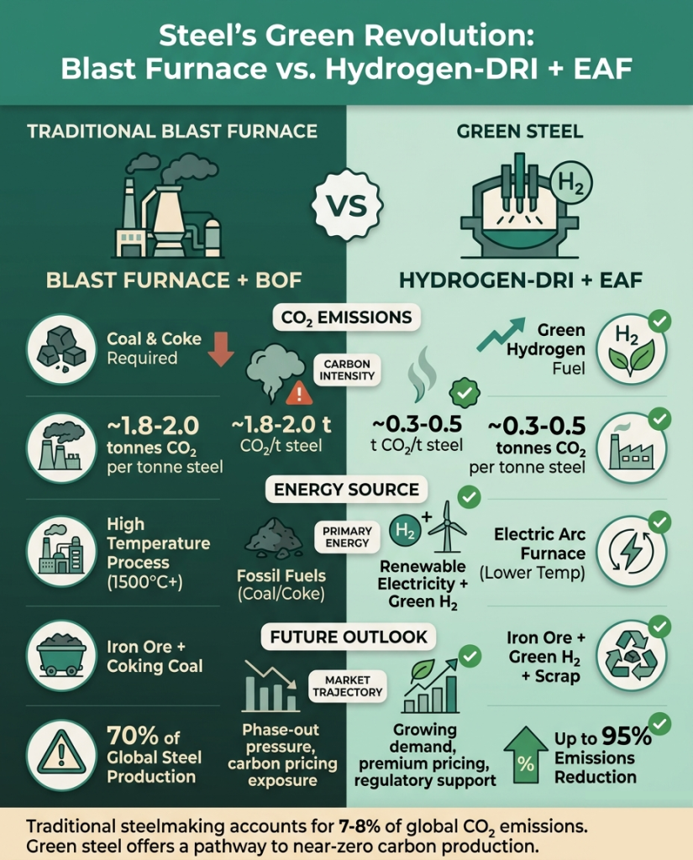
Figure 2: Steel’s green revolution
(Source: Climatesort, 2026)
Sustaining Competitive Position: The evolving nature and intense competition from the steel industry generate the requirement of continuous investment in R&D, advancing technologies and production capabilities for consistent product quality and lower emissions that help in maintaining responsiveness to market changes. Increasing pressure is created at Tata Steel’s operation as its competitors like ArcelorMittal and SSAB have given strategic importance to low-carbon steel production (Knuutinen, 2024). However, Tata Steel puts sustainability as central to its operation, that help it in strengthening market reputation and growth.

3. Task 3: Critical Reflection on AI Usage

3.1 Tool Disclosure
Tata Steel's Transition to a Lower-Carbon Business Model report developed is supported using AI tool, particularly ChatGPT. In the initial idea generation, logical flow maintenance and proper academic language use, there is specific use of AI. This tool provided assistance in gaining insights into the importance of low-carbon steel production at the current time. Moreover, concepts such as the Ansoff Matrix and Porter’s Generic Strategies have been gained for their proper use in this report. However, AI is used only as a supporting tool while the complete research is done by myself for maintaining academic integrity and rigour in research.

3.2 Critical Evaluation of AI Output
AI-generated content has been verified carefully, making comparisons with real-world data and information from peer-reviewed articles, journals, and industry reports Tata Steel Annual Report, OECD, IEA. Critical evaluation of AI-generated information is required as it can give biased results and outdated information that can lead to poor findings and decrease overall research reliability. Adopting a holistic evaluation approach adoption by me helps in finding that some AI-generated responses are false, and there are a few statements without proper evidence. By removing inconsistent results, accurate information has been used by me in my writing, which strengthens the credibility and reliability of my overall research.

3.3 Contribution Analysis
Brainstorming and idea generation using AI enabled me to make an appropriate structure for my study and progress in a logical way that fulfils all the assessment criteria. Complex sustainability concepts became very simple for me using AI. As a result, it has helped me making my writing better (Henriksen, et al., 2024). Tata Steel's marketing environment and strategic growth options while transitioning towards a low-carbon business model have been analysed critically and comprehensively by me with the use of theoretical frameworks, the Ansoff Matrix and Porter’s Generic Strategies. Based on my assessment, I have suggested key strategic approach for Tata Steel which it can apply for achieving optimum growth in business and maintain a competitive position within this dynamic steel industry.

3.4 Ethical and Professional Reflection
In academic work, there is a requirement of strict adherence to ethical and professional responsibilities. Using AI in work highlights the higher importance of following strategic guidelines on it and proper disclosure to the University. In writing, when there is excessive dependence on AI, critical interpretation, independent thinking and originality level are minimised (Octaberlina et al., 2024). There is also the possibility of using biased information or a higher risk of plagiarism. Keeping those in mind, I have maintained the transparency of AI usage in my writing. Critical assessment of multiple resources and my own judgement have helped me in highlighting the benefits and challenges for Tata Steel while transitioning towards low-carbon steel production in its business model. Thus, this tool is only used for guidance rather than completely using it in my writing. Efficiency and outcomes in research can be optimised when priority is given to using AI responsibly. However, AI cannot fully replace human expertise. The rationale behind it is that critical judgement in writing strengthens overall reliability and credibility.

References
Berlin, D., Feldmann, A. and Nuur, C., (2022). ‘Supply network collaborations in a circular economy: A case study of Swedish steel recycling’. Resources, conservation and recycling, 179, p.106112. Available at: https://www.sciencedirect.com/science/article/pii/S0921344921007205 (Accessed: 23 July 2026)
Climatesort, (2026) Top Green Steel Companies Leading Sustainable Production Available at: https://climatesort.com/green-steel-companies/ (Accessed: 23 July 2026)
EY, (2026) Decarbonizing India’s steel industry: A strategic roadmap Available at: https://www.ey.com/en_in/insights/mining-metals/decarbonizing-india-s-steel-industry-a-strategic-roadmap (Accessed: 23 July 2026)
Ferreira, A.P.P.F.S. and de Sá, M.M.B.P., (2024). ‘The importance of the Ansoff matrix for the study of the information services market’. The Canadian Journal of Information and Library Science, 47(2), pp.78-84. Available at: https://ojs.lib.uwo.ca/index.php/cjils/article/download/17432/15874 (Accessed: 23 July 2026)
Gróbarczyk, E.M., (2025). ‘Sustainable supply chain management in the European union steel industry’. Available at: https://repositorio.ucp.pt/bitstreams/8fa08d56-bb7a-48d4-9fbb-4b7dd64c4730/download (Accessed: 23 July 2026)
Henriksen, D., Mishra, P. and Stern, R., (2024). ‘Creative learning for sustainability in a world of AI: Action, mindset, values’. Sustainability, 16(11), p.4451.Available at: https://www.mdpi.com/2071-1050/16/11/4451 (Accessed: 23 July 2026)
IEA, (2026) Iron and Steel Technology Roadmap Available at: https://www.iea.org/reports/iron-and-steel-technology-roadmap (Accessed: 23 July 2026)
Islam, M.Z., (2025). ‘Europe’s policy transition toward green steel development: Prospective and challenges’. International Journal of Green Energy, 22(2), pp.288-306. Available at: https://www.academia.edu/download/124135019/Europe_s_policy_transition_2024.pdf
Knuutinen, J., (2024). ‘Strategies for decarbonizing steel production’. Available at: https://www.theseus.fi/bitstream/handle/10024/876108/Knuutinen_Jarkko.pdf?sequence=2 (Accessed: 23 July 2026)
Mallett, A. and Pal, P., (2022). ‘Green transformation in the iron and steel industry in India: Rethinking patterns of innovation’. Energy Strategy Reviews, 44, p.100968. Available at: https://www.sciencedirect.com/science/article/pii/S2211467X22001626 (Accessed: 23 July 2026)
Mckinsey, (2024) Green-steel hubs: A pathway to decarbonize the steel industry Available at: https://www.mckinsey.com/industries/metals-and-mining/our-insights/green-steel-hubs-a-pathway-to-decarbonize-the-steel-industry (Accessed: 23 July 2026)
Miani, F., (2025). ‘Steel Decarbonization in India: Balancing Rapid Growth with Climate Ambitions’. Available at: https://www.gotrawama.eu/estep25udine/pdf/D_India.pdf(Accessed: 23 July 2026)
Octaberlina, L.R., Muslimin, A.I., Chamidah, D., Surur, M. and Mustikawan, A.,(2024). ‘Exploring the impact of AI threats on originality and critical thinking in academic writing’. Edelweiss Applied Science and Technology, 8(6), pp.8805-8814.Available at: http://repository.uin-malang.ac.id/23054/2/23054.pdf (Accessed: 23 July 2026)
OECD, (2025) Carbon Border Adjustments: The potential effects of the EU CBAM along the supply Chain Available at: https://www.oecd.org/content/dam/oecd/en/publications/reports/2025/03/what-to-expect-from-the-eu-carbon-border-adjustment-mechanism_a21e9b51/719d2ff9-en.pdf (Accessed: 23 July 2026)
Otaru, V. and Begum, S., (2025). ‘ESG performance and brand image: the case of employee well-being in consumer brands’. Available at: https://www.theseus.fi/bitstream/handle/10024/908924/Otaru_Begum.pdf?sequence=3 (Accessed: 23 July 2026)
Roberts, L., Georgiou, N. and Hassan, A.M., (2023). ‘Investigating biodiversity and circular economy disclosure practices: Insights from global firms’. Corporate Social Responsibility and Environmental Management, 30(3), pp.1053-1069.Available at: https://onlinelibrary.wiley.com/doi/pdfdirect/10.1002/csr.2402 (Accessed: 23 July 2026)
solange Nouteya-Jackson, M., (2022). ‘Small Business Strategies to Implement Product Diversification Effectively’. Available at: https://scholarworks.waldenu.edu/cgi/viewcontent.cgi?article=14924&context=dissertations (Accessed: 23 July 2026)
Tatasteel, (2025) Climate Change Report Available at: https://www.tatasteel.com/investors/integrated-report-2024-25/climate-change-report.html (Accessed: 23 July 2026)
Tatasteel, (2026) BUSINESS RESPONSIBILITY AND SUSTAINABILITY REPORT Available at: https://www.tatasteel.com/media/25901/brsr.pdf (Accessed: 23 July 2026)
Tatasteel, (2026) Company Profile & Details Available at: https://www.tatasteel.com/corporate/our-organisation/company-profile/ (Accessed: 23 July 2026)
Tatasteel, (2026) Inside Tata Steel India Available at: https://www.tatasteel.com/tata-steel-brochure-19-20/inside-tata-steel.html (Accessed: 23 July 2026)
Teixeira, R.L.P., (2025). ‘Assessment of green steel production technologies: Feasibility, scalability, and economic viability’. Revista de Gestão Social e Ambiental, 19(3), pp.1-16. Available at: https://www.researchgate.net/profile/Ricardo-Teixeira-4/publication/389929434_Assessment_of_Green_Steel_Production_Technologies_Feasibility_Scalability_and_Economic_Viability/links/67d9679a35f7044c9232bb93/Assessment-of-Green-Steel-Production-Technologies-Feasibility-Scalability-and-Economic-Viability.pdf (Accessed: 23 July 2026)
Tolettini, L. and Di Maria, E., (2023). ‘Structuring and measuring environmental sustainability in the steel sector’: A single case study. Sustainability, 15(7), p.6272. Available at: https://www.mdpi.com/2071-1050/15/7/6272 (Accessed: 23 July 2026)
Tripathi, R. and Karumathil, A., (2024). ‘Humanistic leadership and the paradoxical pursuit of sustainability and profitability: A Case Study of the Tata Group in India’. In Humanistic leadership practices: Exemplary cases from different cultures (pp. 237-265). Cham: Springer International Publishing. Available at: https://www.researchgate.net/profile/Anjana-Karumathil/publication/378615313_Humanistic_Leadership_and_the_Paradoxical_Pursuit_of_Sustainability_and_Profitability_A_Case_Study_of_the_Tata_Group_in_India/links/67a0607896e7fb48b9afd23f/Humanistic-Leadership-and-the-Paradoxical-Pursuit-of-Sustainability-and-Profitability-A-Case-Study-of-the-Tata-Group-in-India.pdf
Zhang, J., Guo, H., Yang, G., Wang, Y. and Chen, W., (2025). ‘Sustainable transition pathways for steel manufacturing: Low-carbon steelmaking technologies in enterprises’. Sustainability, 17(12), p.5329.Available at: https://www.mdpi.com/2071-1050/17/12/5329 (Accessed: 23 July 2026)

