b. Displaying our JSON-extracted data from previous handout in a table

In the last handout, we displayed our JSON data in a label:

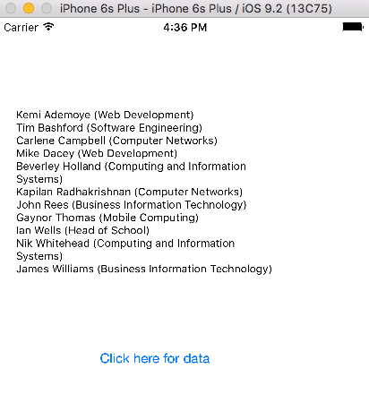

Let us now change this to a nice scrolling table. The data is already in arrays, and we already know how to display things in a table, so it is just a matter of drawing together our previous knowledge

1. Start a new project, delete the ViewController, and add a TableViewController. Make sure “Is Initial View Controller” is checked on the Attributes inspector:

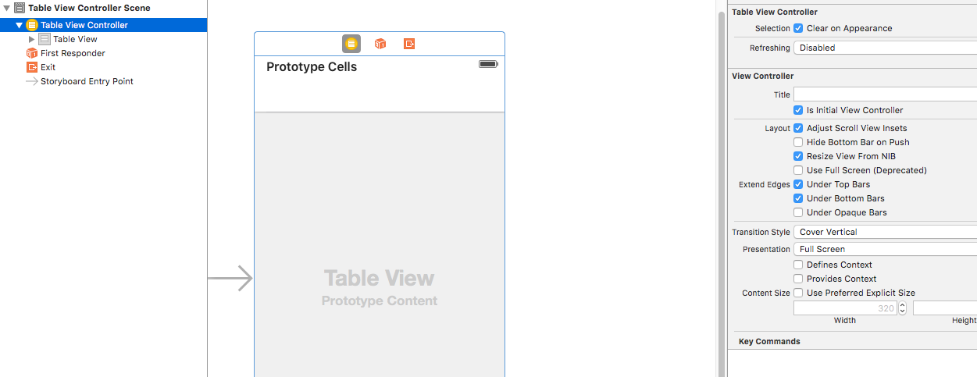

2. Now move your code (arrays, JSON etc) from ViewController.swift in the previous project to StaffTableViewController. Don't forget to add "Add Arbitrary Loads" to the Info.plist
Remove any reference to label display from the code.

3. We want to customise the display of our table view, so create a new Cocoa Touch Class called “StaffTableViewController”. It must be a subclass of UITableViewController.

Tell the Table View Controller on Main.storyboard to use the new class (on the Identity Inspector)

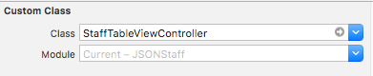

4. On the Table View Controller, set the Prototype Cell to “Cell” on the Attributes Inspector, and make sure it is “Custom”

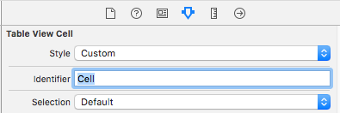

5. Set up the StaffTableViewController to use multiple reusable cells:

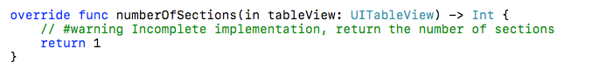

Don’t forget to override the number of sections (0 by default)

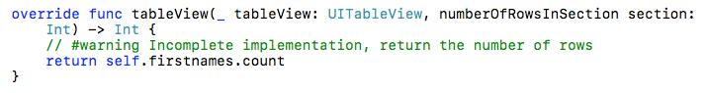

This gives us an app with empty cells:
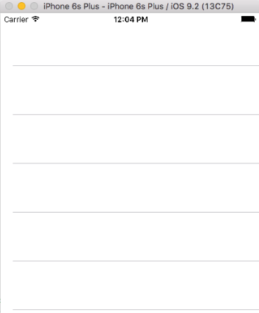

6. Set up table cell

Add the required contents of your cell. We’re going to need an Image View for the photo, and at least 2 labels for the information. Change the sizes of the text as required:

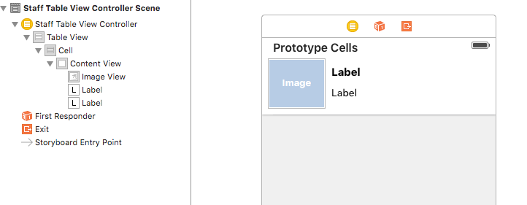

Change the text on the label so it’s easy for us remember what data we intend to put in them:

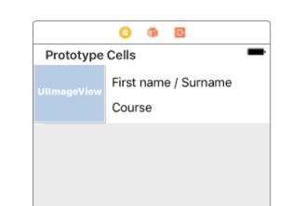

7. We are customising our cell, so create its own Cocoa Touch Class (subclass of UITableViewCell). Call it StaffCustomCell. Make sure you select the Table Cell and set it to use this new Class:

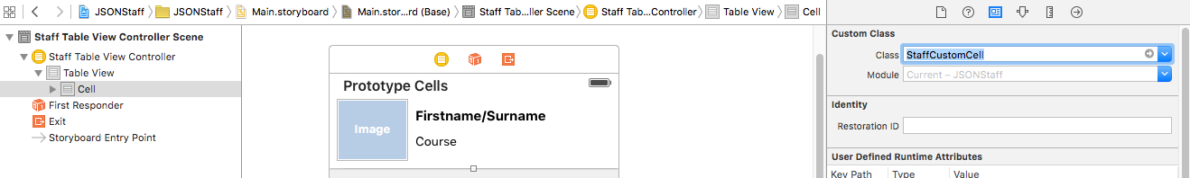

8. In StaffCustomCell.swift, create outlets for the image and label

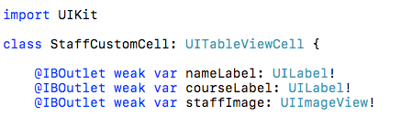

9. Back in StaffTableViewController.swift

- Add as! StaffCustomCell to the cell
- Print the JSON-populated arrays into the cell's labels (we'll come on to the image later):

func tableView now looks like this:

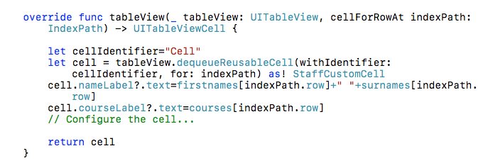

When we run the app however, it still looks blank!

Unfortunately, the table has loaded before the JSON data arrived (because it takes longer to download over the web compared to creating a table locally, plus it is in a different thread)

We need to tell the main thread to reload the table:

Just after the for loop in the JSON routine, add this:

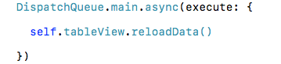

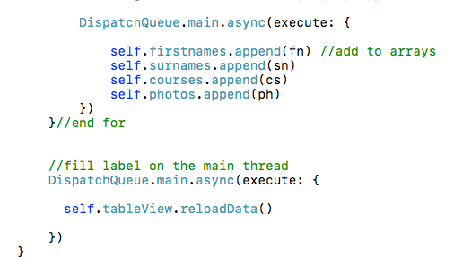

This will re-load the table, and now we can see the JSON-populated data when we run our app:

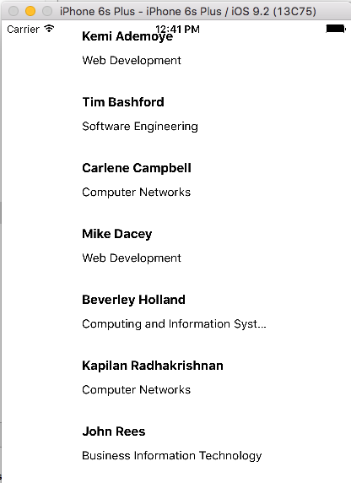

10. All we need now is to add the photos – again, we will draw on previous knowledge about getting photos from URLs (we already have the filename in our JSON-populated array)

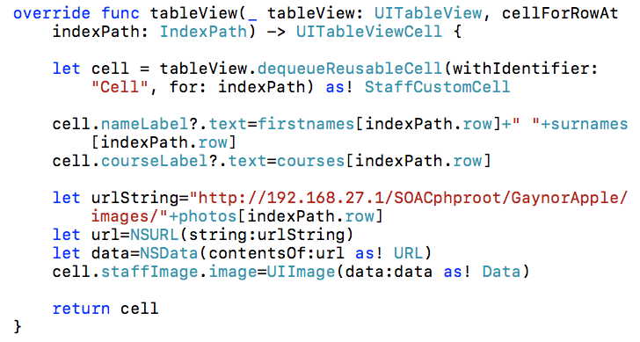

11. Now we have a fully working table-based Staff list in our app, populated via JSON.



If any staff are added or amended at a future time, the JSON will pick up the new information from the database, and it will get pushed through to the app automatically:



