BMSP6006
Strategies for Resilience and Prosperity
Glenn Behenna
Nia Lewis
16th October 2020

Executive Summary –
This report reflects the importance of strategic management within a business and explains how it enables businesses to adapt to any major disaster or circumstance and operate effectively. Building resiliency into a business is also important as it continues the operation of providing a service for customers whilst facing any external threats that may occur. This often allows business to be prosperous and successful within their field in the market. This report outlines multiple strategic management tools including a PESTLE analysis, SWOT analysis, Stakeholder analysis and Bowman’s Strategic Clock. These tools are used to help minimise any internal and external factors that would impact the operation of a business, such as Amazon.

Table of Contents
Executive Summary – 1
1.0 Objectives of the report 3
1.1 Introduction. 4
1.2 Strategic Management. 4
1.3 Mintzberg’s 5Ps of Strategy. 5
1.4 Company background 6
1.5 Amazon Business Strategy 6
2.0 Main Findings. 7
2.1 Strategy analysis of Amazon PESTLE Analysis. 7
2.2 Evaluation of PESTLE Analysis. 8
2.3 Strategy analysis of SWOT Analysis. 9
2.4 Evaluation of SWOT Analysis. 11
2.5 Strategy Analysis of Stakeholder Analysis. 12
2.6 Evaluation of Stakeholder Analysis. 13
2.7 Strategy analysis of Bowman’s Strategic Clock. 13
2.8 Evaluation of Bowman’s Strategic Clock. 14
3.0 Conclusion 15
Bibliography 16

Objectives of the report
- Identify the multiple business strategies of Amazon and have an understanding of their everchanging business environment.

- Assess Amazons business strategy with use of relevant academic sources and strategic management tools.

- Identify the importance of business resilience and prosperity.

1.1 Introduction.
In this report there will be a critical analysis of Amazons strategic management tools. All internal and external factors that affect the environment of the business will be analysed to understand the aspects of sustainability and resilience. Strategy is important within a business and reflects the direction of an organisation over a period of time. This attains an advantage in an everchanging environment through chosen resources with the purpose of fulfilling stakeholder expectations (Scholes, 2008).

1.2 Strategic Management.
Henry Mintzberg states that emergent strategies are more realistic for businesses. This strategy emerges to the changes in the external and competitive environment in the absence of a precise mission and goal which accommodates reality (Mintzberg, The Rise and Fall of Strategic Planning, 2020) . In comparison, Michael Porter suggests that deliberate strategies are most affective and more important during times of change and uncertainty (Porter, 2012).
Porter and Mintzberg have both had an influence on the study of strategy, and both have a different perception on the meaning of strategy. Porters views takes a more deliberate strategy approach which reflects a formal traditional approach that focuses on achieving the intended business aim. Porters perception of deliberate strategy is making necessary trade-offs and choices and understanding that differentiation will evolve (Young, 2007). In comparison to Mintzberg who focuses on emergent strategies and states that strategies evolve rather than result from a formal process.
There are three core areas of strategic management. Strategic analysis, strategy development and strategy implementation. The implementation of strategic analysis gives an understanding of the business’s current strategic position and provides value for the people involved in the organisation, the stakeholders. The development of the strategy enables the business to develop advantages over competitors. The third element is the implementation of the strategy which can be difficult in relation to power relationships, negotiations and motivating staff although this is the final process of translating the strategy into actions (Lynch, 2007).

1.3 Mintzberg’s 5Ps of Strategy.
In 1987 Henry Mintzberg first wrote the 5PS of Strategy which is a strategic model which has five different elements of developing strategy within a business. The 5Ps are Plan, Ploy, Pattern, Position and Perspective. The use of this strategic management tool allows businesses to consider their strength and capabilities (Godfrey, 2016). Mintzberg suggests that planning is an essential element of the strategy formulation process whilst considering multiple options and planning how to deliver them. Strategy as ploy reflects the process of plotting to disrupt and discourage competitors from a specific operation intended to outwit them, an example would be reducing prices of products (Smith, 2002). When considering strategy as a pattern for Mintzberg’s 5Ps it is clear that organisations need to reflect on their previous behaviour patterns that have been successful and decide which patterns should continue. Strategy position gives a business an understanding of where they are in the marketplace in comparison to competitors. The last element of the 5Ps is strategy as perspective which reflects shaping the culture of the business. Similar patterns of thinking will shape all stakeholders which is why management would focus on everyone sharing the same perspective to create a valued culture (MindTools, 2020).

1.4 Company background
Amazon is a concentric diversification business founded in 1995 by Jeff Bezos. Amazon sold only books during the first few years of business however, Bezos had a vision that it would be a one stop online shop one day. The company turned their first profit in 2001, and in 2005 launched Amazon Prime which soon became popular and now has one hundred million global users (Stern, 2019). Amazon is now the world’s leading largest online retailer that sells an endless amount of goods including electronics, groceries, apparel, personal care items, baby products and other everyday goods (Moore, 2019). Amazon also have physical stores based in the USA and plan to open at least 30 UK stores (Barr, 2020). Despite the previous poor press coverage of unethical working environments for employees, Amazon have been recognised as the second world’s best employer of 2020 and the world’s fourth most valuable brand on the Forbes list (Forbes, 2020)

1.5 Amazon Business Strategy
Amazon have a different business strategy which may be why their competitive stance is successful, they are a customer obsession-based business rather than competitor focused (Amazon,2020). Amazon also have Amazons Web Services which has an operational resilience and continuity of service through processes and technology, they are adaptive to continuous change, this gives Amazon the ability to operate in the event of disruptive events. (Amazon, 2019). Amazon have also adapted a sustainability pledge to their strategy and have ambitious commitments towards reaching their goals, this includes a 100% renewable energy for all operations by 2025, investing in 100,000 electric delivery vehicles and also donating 100 million dollars in reforestation projects (AmazonSustainability, 2020). By implementing sustainability to a business, it creates a long-term value approach for customers as they are perceived to have ethical practises and it improves reputation and brand image (Borland, 2018). Mintzberg suggests to operationalize the management of strategy into phases of different stages of formulation and operation, Mintzberg explains that it is essential to identify a internal and external analysis of the business and industry (Mintzberg, 1985).
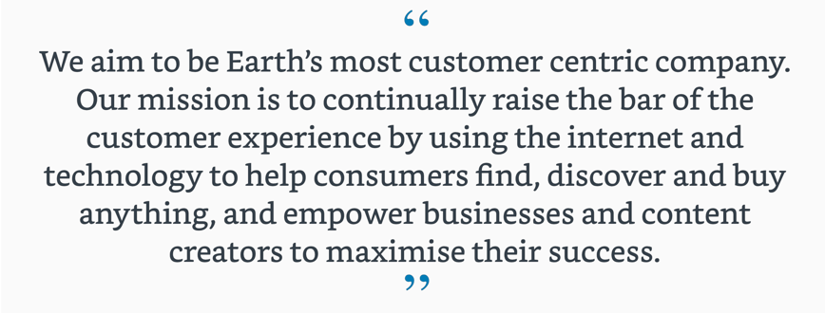
Please refer to Figure 1 for Amazons missions’ statement.

Figure 1 (Amazon, Amazon, n.d).

2.0 Main Findings.

2.1 Strategy analysis of Amazon PESTLE Analysis.
The purpose of a PESTEL Analysis is to limit any external factors that would affect the performance of the business. This model allows the business to monitor the competitive business environment and understand their current market position. The analysis of a PESTLE enables businesses to update their strategies, targets and to implement risk response strategies (Perera, 2017).

 | External factors to consider | Importance to organisation
Political | - The UK made a decision to leave the European Union in 2016 which means that there is a significant uncertainty within the UK economy. This political factor could have an impact on the free flow of goods (Forbes, 2016).  - Taxes and regulations with Amazon selling global results in complying with different countries policies for taxes and regulations (Amazon, 2020) | - Medium  - Medium
Economical | - Due to the Global Pandemic of 2020 the UK is in recession as the economy has reduced by 20.4% record in second quarter (Wearden, 2020). The effect of a recession results in a decrease of consumer disposable income. | - High
Social | - There is an increase in developing countries of consumerism. It is expected by the end of 2020 the middle class in countries such as Brazil, Pakistan and Indonesia will develop to over 100 million people (EuropeanCommision, n.d). | - Medium
Technological | - As technology is advancing for e-retail business, Amazon have adapted a drone delivery service. in 2017 Amazon trailed their delivery drone and expect this project will start within the foreseeable future (Forbes, 2019).  - There has been an increase in cybercrime in recent years, in 2019 82% of all surveyed companies in UK and USA stated they have encountered cybercrime at least once. This is a detrimental factor for Amazon as they heavily rely on their online presence (CyberEdge, 2020). | - Low  - High
Legal | - One legal factor that Amazon would have to comply with is the consumer protection law. The purpose of this law is to protect consumers from unfair trading practises (BBC, 2020). | - High
Environmental  Figure 2. | - Increase in ethically and environmentally conscious consumers and an interest in the ethical practises that businesses such as Amazon implement. (Baker, 2019) Amazon have adapted to this environmental trend as they have implemented a sustainability pledge that includes using electric delivery vehicles for logistics (Amazon, 2020). | - High

2

2.2 Evaluation of PESTLE Analysis.
PESTLE is used as a strategic planning tool to evaluate the effects of external factors that could impact the performance of a company. A PESTLE analysis represents six external factors Political, Economical, Social, Technological, Legal and Environmental. Figure 2 also illustrates the importance of the factors to the organisation categorised from high, medium and low this helps Amazon take into account the most important factors. A positive factor from the PESTLE model is the increase in consumerism in developing countries this could be an opportunity for Amazon to widen their target market. One negative factor is the impact that the global pandemic has had on the economy resulting in the UK going into recession, this would result in a higher percentage of unemployment and lower wages which means consumers will have less disposable income (King, 2020). This diagram makes up the macroenvironmental factors that need to be considered and monitored.

2.3 Strategy analysis of SWOT Analysis.
A SWOT analysis can be recognised as one of the most widely used strategic tools in modern times. The advantages of this strategic model is that it is easy to understand as the diagram is simple, it can also be applied through different levels within an organisation such as individuals, teams and can also be applied at different depths depending on how simple or complex the circumstances are (Sarsby, 2016). This business model was created in 1960 by Albert Humphrey and was developed as part of the Harvard Business Policy which reflects why it is a valued strategic management model for businesses. (Pahl, 2007)
Strengths  - Financial performance has grown, Jeff Bezos’s net worth is expected to reach $1 trillion by 2026 (Huddleston, 2020).  - Amazons identified as a customer centric brand which is the core of their mission and values (Wheeler, 2013).  - Amazon have superior logistic and distribution system which reflects the businesses global capabilities. | Weaknesses  - Poor press coverage of Amazon warehouse workers for poor treatment and poor working conditions (Sainato, 2019).  - Product failures from own products including Fire Phone, Kozmo, Kindle app, Amazon Wallet and Amazon local (Green, 2019).  - Amazon have had a poor track record of their sustainability solutions.
Opportunities  - Amazon have adapted healthcare as part of their future, this is a new market and industry for the global business (Houser, 2018).  - Amazon plans to open at least 30 stores in the UK, physical stores drive brand affinity (The.Independent, 2020).  - There are emerging markets within developing economies such as China, India and Brazil, this could be an opportunity for Amazon to widen their target market (Tanchua, 2019). | Threats  - Amazon has an increased competitive pressure from competitors such as eBay, Alibaba and Microsoft. Please refer to Figure 4 for a full diagram of competitors.  - Amazon has experienced cybercrime on customer data which often results in phishing and fraud (Rubins, 2020).  - The Global Pandemic of 2020 has had an effect on consumer spending resulting in less disposable income for consumers who are unemployed (Jones, 2020).
Figure 3.

Amazons Competitors.
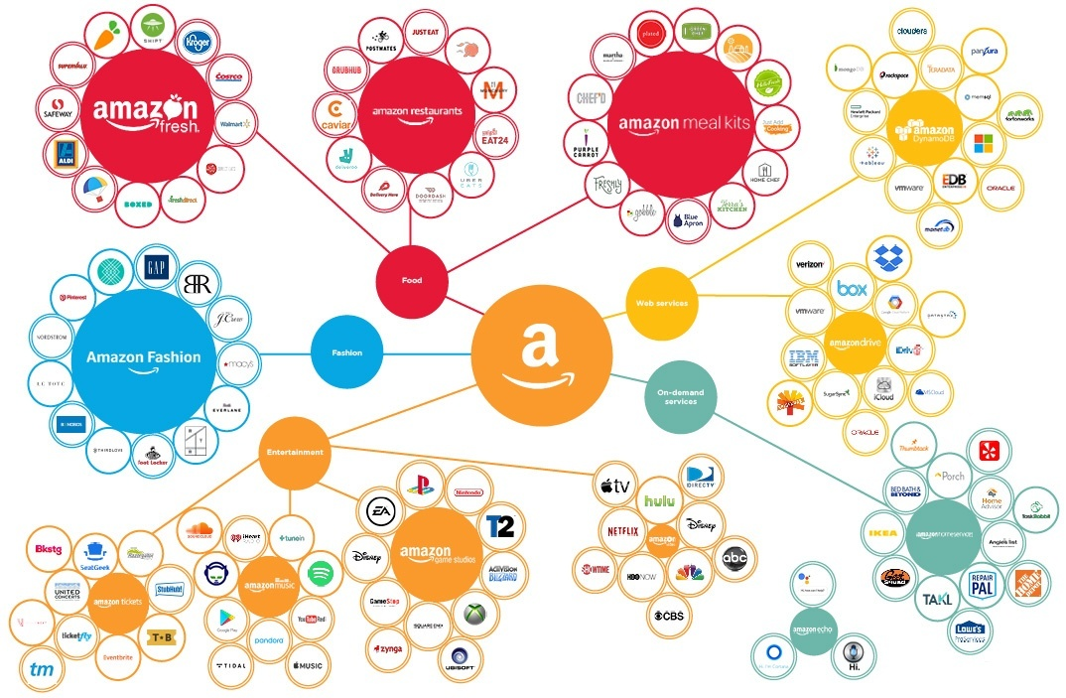
Figure 4 (PitchBook, 2017).

2.4 Evaluation of SWOT Analysis.
A SWOT analysis of Amazon gives a clear source of information about the internal and external factors that could potentially affect them. When looking at the SWOT analysis it is clear to recognise the strengths and weaknesses of the company. It highlights that Jeff Bezos will be the world’s first trillionaire which reflects the success of the company. The SWOT analysis also shows that Amazon have previous poor track record of their sustainability practises in previous years although, they have recently adapted a ‘climate pledge’ to their business strategy (Amazon, 2020). The opportunities within the model outlines the potential expansion of the business and the possibility of entering new markets which would initiate growth within the business. The threat factors of the SWOT analysis can be detrimental to Amazon so these factors would be monitored closely.

2.5 Strategy Analysis of Stakeholder Analysis.
The stakeholder analysis model is used to systemically collect and analyse information to identify each stakeholders interest. This is conducted by determining stakeholder influence in decision making when implementing strategies or policies into the business. The stakeholder management model reflects four different categorise which shows how to manage different stakeholders depending on their power and interest (Weiss, 2009). The purpose of stakeholder mapping is the procedure of understanding a company’s stakeholders. It identifies stakeholder expectations and power which influences the understanding of political priorities (G Johnson & Scholes, 2006).
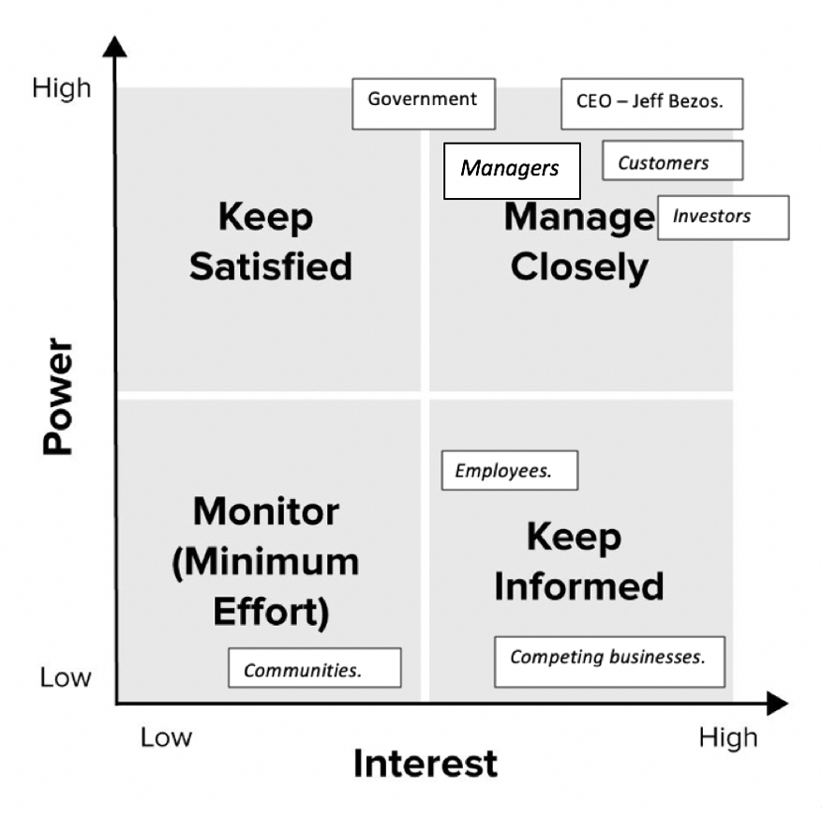
Figure 5.

2.6 Evaluation of Stakeholder Analysis.
This strategy model reflects the different interests and power of Amazons stakeholders, all stakeholders are categorised and identified within the four different sections.
Customers are placed within the manage closely section, this is because Amazon’s mission statement states they aim to be earths most customer centric company so customers have a high power and high interest in Amazons new ideas, policies and performance (Amazon, Amazon Jobs, 2020). The government has been placed on this model between the keep satisfied and manage closely section, this is due to them having an interest within the business as Amazon is one of Americas largest employers which results in an increase in taxation and also keeps the economy going (Rosoff, 2019).
Employees are within the keep informed category, this is because although they have a higher interest within the company, they have a limited power in terms of influence on decision making. In comparison to managers who would have the authority to be involved in decision making.

2.7 Strategy analysis of Bowman’s Strategic Clock.
This strategic management tool was created by Cliff Bowman, the clock as seen in Figure 6 reflects multiple positions in a market where consumers have different expectations in terms of value for money. These different positions reflect a set of generic strategies to ensure that a business can compete against their competitors (Johnson, 2008). This model can help managers recognise the changing environment of their markets and the choice they make in terms of having a competitive advantage, which is why this model is important to businesses.

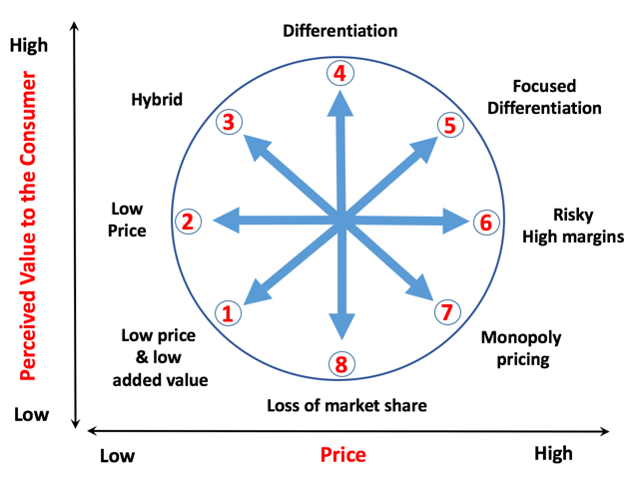

Figure 6 (Tutor2yu, n.d)

2.8 Evaluation of Bowman’s Strategic Clock.
When looking at Bowman’s Strategic clock, it is clear that Amazon is placed between the Low Price and Hybrid categories. Amazon has a low-cost strategy that is shown through their cost savings and deals they offer through their website; they use these promotions to also stay competitive. Although due to the wide product range that Amazon offer to customers with over 12 million different products on their website, some items can be identified within the Hybrid area which offer a middle range price but also offers consumers an element of differentiation and perceive an added value of the product. (Thomson, 2010). Overall Amazon uses cost leadership as their competitive strategy as it offers customers product range, affordable prices and convenience which is placed at the core of Amazons competitive advantage (Dudovskiy, 2020)

3.0 Conclusion
In conclusion, this report has outlined different strategic management tools that Amazon can use to understand their position in the business environment by evaluating the internal and external factors. The PESTLE analysis, SWOT Analysis, Stakeholder analysis and Bowman’s Strategy Clock all provide Amazon with a framework for decision making. The use of strategic management is a procedure that involves leadership and analysis that develops a business to respond to change and competes for funds in a global financial market. Strategic managing represents managing for the present as well as creating change so that the business can remain prosper in an uncertain business world (FitzRoy, 2012). Amazon has a strong business strategy which reflects their mission statement and values of the business.

Bibliography
Amazon. (2019, March). Retrieved from https://d1.awsstatic.com/whitepapers/compliance/AWS_Operational_Resilience.pdf
Amazon. (2020). Retrieved from https://sustainability.aboutamazon.com/?energyType=true&workerCount=true&engagementProgram=true&productCategory=true
Amazon. (2020). Retrieved from https://sustainability.aboutamazon.com/?energyType=true&workerCount=true&engagementProgram=true&productCategory=true
Amazon. (2020). Retrieved from https://sellercentral.amazon.co.uk/gp/help/external/G201468380?language=en_GB
Amazon. (2020). "Who We Are". Retrieved from https://www.aboutamazon.com/.
Amazon. (2020). Amazon Jobs. Retrieved from https://www.amazon.jobs/en/working/working-amazon#:~:text=When%20Amazon.com%20launched%20in,customers%20are%20worldwide%20now%2C%20and
Amazon. (n.d). Retrieved from Amazon: https://www.aboutamazon.co.uk/uk-investment/our-mission
AmazonSustainability. (2020). https://sustainability.aboutamazon.com/?energyType=true&workerCount=true&engagementProgram=true&productCategory=true.
Baker, J. (2019, April 2). The Guardian. Retrieved from The Guardian.
Barr, S. (2020, August 3rd). Independent. Retrieved from https://www.independent.co.uk/life-style/amazon-uk-shops-go-open-launch-jeff-bezos-a9651231.html
BBC. (2020). Retrieved from https://www.bbc.co.uk/bitesize/guides/znvfscw/revision/5
Borland, H. (2018). Business Strategies for Sustainability. Taylor and Francis.
CyberEdge. (2020). Retrieved from https://cyber-edge.com/wp-content/uploads/2020/03/CyberEdge-2020-CDR-Report-v1.0.pdf
Dudovskiy, J. (2020). Amazon Business Strategy: cost leadership & customer centricity.
EuropeanCommision. (n.d). Developments and Forecasts of Growing Consumerism. Retrieved from European Commision: https://ec.europa.eu/knowledge4policy/foresight/topic/growing-consumerism/more-developments-relevant-growing-consumerism_en
FitzRoy, P. (2012). Strategic Management. Routledge.
Forbes. (2016, June 30). Retrieved from https://www.forbes.com/sites/greatspeculations/2016/06/30/how-can-brexit-impact-amazon/#2679d4234c4a
Forbes. (2019, June 5).
Forbes. (2020, May). Retrieved from https://www.forbes.com/companies/amazon/#3f9460676fb8
G Johnson, & Scholes, K. (2006). Exploring Corporate Strategy: Text and Cases,. UK.
Godfrey, R. (2016). Strategic Management: A Critical Introduction. Routledge.
Green, D. (2019, July 5). Retrieved from The Business Insider: https://www.businessinsider.com/amazon-products-services-failed-discontinued-2019-3?r=US&IR=T
Houser, K. (2018, March 16). Retrieved from Futurism: https://futurism.com/neoscope/amazons-healthcare-plans
Huddleston, T. (2020, May 15). Retrieved from CNBC: https://www.cnbc.com/2020/05/15/could-jeff-bezos-really-become-the-worlds-first-trillionaire-by-2026.html#:~:text=Overall%2C%20Bezos'%20net%20worth%20has,point%20he'll%20be%2062.
Johnson, G. (2008). In Exploring Corporate Strategy (pp. 220-224.). UK: Pearson Education.
Jones, K. (2020, May 2). Retrieved from World Economic Forum: https://www.weforum.org/agenda/2020/05/coronavirus-covid19-consumers-shopping-goods-economics-industry
King, B. (2020, September). BBC. Retrieved from https://www.bbc.co.uk/news/business-52986863
Lynch, R. (2007). Strategic Management.
MindTools. (2020). Retrieved from Mintzberg's 5 Ps of Strategy : https://www.mindtools.com/pages/article/mintzberg-5ps.htm
Mintzberg, H. (1985). Of strategies, deliberate and emergent’, Strategic Management Journal,.
Mintzberg, H. (2020). In The Rise and Fall of Strategic Planning (pp. 20-26). GB: Financial Times.
Moore, S. (2019). Amazon. USA: Abdo Publishing.
Pahl, N. (2007). Swot Analysis - Idea, Methodology and a Practical Approach. Auflage.
Perera, R. (2017). The PESTLE Analysis. Nerdynaut.
PitchBook. (2017). Retrieved from https://pitchbook.com/news/articles/bezos-is-coming-mapping-amazons-growing-reach
Porter, M. (2012). In Understanding Michael Porter (p. 182). USA.
Rosoff, M. (2019, December 13). CNBC. Retrieved from https://www.cnbc.com/2019/12/13/amazon-will-be-the-most-important-company-of-the-2020s.html
Rubins, A. (2020, October 9). Retrieved from CyberNews: https://www.cybernewsgroup.co.uk/amazon-prime-day-will-cause-increase-in-phishing-fraud-attacks/
Sainato, M. (2019, Jan 1). Retrieved from The Guardian: https://www.theguardian.com/technology/2019/jan/01/amazon-fulfillment-center-warehouse-employees-union-new-york-minnesota
Sarsby, A. (2016). SWOT Analysis. GB.
Scholes, J. a. (2008). In Exploring coporate strategy (p. 601). England: Pearson.
Smith, P. R. (2002). Strategic Marketing Communications:. UK: Kogan Page.
Stern, N. (2019, July 11). Retrieved from Forbes: https://www.forbes.com/sites/neilstern/2019/07/11/amazon-at-25-a-fascinating-journey-through-retail-history/#4887a7cb3027
Tanchua, J. (2019). Retrieved from https://www.spglobal.com/en/research-insights/articles/-markets-may-offer-the-most-potential-for-the-worlds-largest-consumer-focused-companies
The.Independent. (2020, August 3). Retrieved from https://www.independent.co.uk/life-style/amazon-uk-shops-go-open-launch-jeff-bezos-a9651231.html#r3z-addoor
Thomson, N. (2010). In Basic Strategy in Context. (p. 184). WILEY.
Tutor2yu. (n.d). Retrieved from https://www.tutor2u.net/business/reference/strategic-positioning-bowmans-strategy-clock
Wearden, G. (2020, August 12). The Guardian. Retrieved from The Guardian: https://www.theguardian.com/business/live/2020/aug/12/uk-gdp-slump-recession-covid-19-q2-june-business-live
Weiss, J. (2009). In Business Ethics: A Stakeholder and Issues Management Approach (pp. 30-45). USA: Cencage.
Wheeler, A. (2013). In Designing Brand Identity: (p. 221). USA: John Wiley.
Young, A. (2007). In Profitable Marketing Communications (p. 147). UK: Kogan Page.

