Programme: BA International Hotel Management
Module: Contemporary Themes in the Hotel and Hospitality Sector.
Module code: BMIH6001

Chosen Theme: Option Five: The mounting financial pressures faced by the hospitality industry

Assignment 1: Conference Research Paper
Student name: Ioana Dobre
Student ID number: 2224087

Abstract
Financial pressure is a major contemporary issue found in the hospitality sector, which affects a business's operability, especially within high-cost areas such as inventory management and managing external pressures. Most hospitality organisations often experience uncontrollable management of the costs because enhancing prices for products and services is limited by consumer spending and competitive institutions' pricing strategies. In this context, this contemporary theme puts financial pressure on hospitality firms and creates urgency. During economic uncertainties or financial pressures, hospitality institutions operate based on dynamic changes in the market and predict perceived uncertainties to hold operations and manage the economic environment. However, changing economic trends hinge their strategies. The current investigation has corresponded with the use of a secondary approach in combination with the narrative review method. The findings highlighted the political, economic, social, and legal aspects as major contributors to the development of financial pressure on hospitality firms. This could be manageable through the application of a revenue management and earnings management system in support of technological advancement.
Table of Contents
1. Introduction 4
2.1 Theoretical Underpinnings 4
2.2 The Financial Pressure Context in Hospitality 5
2.3 Revenue Management as a Strategic Response 6
2.4 Earnings Management under Pressure 7
2.5 Literature Gap 8
3. Method 8
4. Theme impact analysis 9
4.1 PESTLE Analysis 9
4.2 Finding and Analysis 11
4.2.1 Financial Pressure Context in Hospitality 11
4.2.2 Revenue and Earning Management as Strategic Responses 11
5. Conclusion 13
6. Recommendations 13
6.1 Implement a dynamic revenue management system with AI integration 13
6.2 Develop Comprehensive customer loyalty programs linked to data analytics 13
6.3 Adopt sustainable operational practices to reduce long-term costs 13
6.4 Diversify Revenue Streams through ancillary services and strategic partnerships 14
7. References 15

1. Introduction
The hospitality sector experienced a slow evolution in the 1920s, which was highly fragmented and dispersed. However, in current segments, economic downturns and the effects of global evolution are affecting the hospitality industry. Globally, hospitality firms are facing intense pressure in the financial domain due to increasing wages, rising costs and tighter credit with less profit margin (Milutinović and Stanišić, 2023). Within a similar situation, fluctuating inflation rates affect consumer spending by reducing their willingness to spend on products and services (Ford and Sturman, 2020; Dawson, J. Lemelin and Stewart, 2012). This situation has resulted in demand for resolving financial pressure issues, especially after the post-pandemic period. Menicucci and Paolucci (2024) and Melián-Alzola, Fernández-Monroy and Hidalgo-Peñate (2020) anticipated that luxurious organisations in the hospitality sector are more resilient towards uncertain economic conditions. This contemporary research paper focuses on investigating the mounting financial pressures experienced by hospitality firms by conducting a review of previously published scholarly articles, and describes the approach used for gathering information. Based on the data, this research paper comprehends previously obtained industrial knowledge along with academic learning and examples of industry responses using an appropriate analysis tool. This data critically reflects how hospitality firms can respond to chosen contemporary issues with their limitations and strengths. Further data corresponds with the potential solutions in managing financial pressure to increase the competitive rivalry of hospitality firms.
2. Literature Review

2.1 Theoretical Underpinnings
Institutional theory and a resource-based view (RBV) theory obtain logical attention in practical applications. Ramon-Jeronimo, Florez-Lopez and Araujo-Pinzon (2019) asserted that our baby theory enables firms to gain stronger benefits, especially in gaining rivalry by using appropriate sources. For each organisation, sources are a must to manage operations and smoothen functions. Another approach, institutional theory specifically reconsiders the different set of institutional values and practices (Struckell et al., 2022; Kelling et al., 2020; Ölmez, Bilgiç and Aydın, 2024). This brings a new area for strengthening the financial capabilities of hospitality organisations. Based on these, the framework suggests a reasonable financial behaviour that institutions need to follow. These frameworks-oriented building capacity of hospitality institutions to manage financial pressure.

2.2 The Financial Pressure Context in Hospitality
Financial markets create issues for hospitality industries and make it more problematic to implement operational measures. Crespi-Cladera, Martín-Oliver and Pascual-Fuster (2021) predicted that around 25% hospitality organisations experience financial distress conditions whenever revenues drop by around 60%. This observation was made based on stress test methodology, which organisations are more likely to experience financial distress in the Spanish hospitality sector during the COVID-19 period. The study has supported that financial uncertainties have especially affected small organisations, and most firms experience solvency issues with total assets being incapable of paying all debts. The strength of the article is its contribution to hospitality literature by offering financial strength variables. However, the study is limited to Spain's geopolitical conditions. In contrast, Tascón, Castro and Valdunciel (2023) analysed operating hospitality firms in Europe from 2016 to 2020 utilising ordinary least squares. The results indicated that pre-pandemic situations are the key drivers of financial health, but were affected during the pandemic.
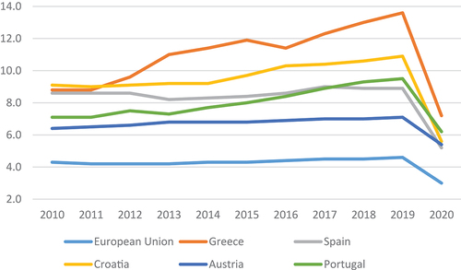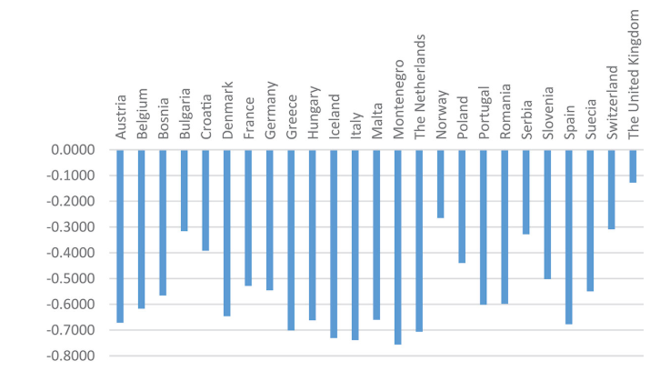
Figure 1: Sales Variations in 2020 compared to 2019
(Source: Tascón, Castro and Valdunciel, 2023)
The author highlighted the decreased sales of the hospitality sector in specific countries in 2020 compared to 2019. This showed that the overall average decline is 58.67% and found the highest drop in many countries (Tascón, Castro and Valdunciel, 2023). However, the study has only considered the larger hospitality organisations in sampling and used the Z-score model, which affects the relationship presentation with respect to the accounting variables.

2.3 Revenue Management as a Strategic Response
Revenue management is a profound solution for managing financial uncertainties. Subying and Yoopetch (2023) asserted that revenue management has become a primary choice in the hospitality industry. Shifting towards revenue management, probably long-term focused, and customer-centric approaches to gain revenue from setting prices. This study has utilised the bibliometric review approach involving 1165 Scopus in-text articles. The research has specifically shifted revenue management towards consumer orientation. However, the study has only offered broader features and comprehension-based perspectives and has not examined the substantive findings, nor has it used a single database. In contrast, Lentz, Berezan and Raab (2021) have uncovered the functioning of revenue management along with the hospitality loyalty programs to manage financial crisis issues. The study has oriented results from focus groups and personal interviews with industry experts. A total of 13 personal interviews were conducted to evaluate the effectiveness of revenue management and loyalty programs. Findings support that in the management of revenue phenomenon organisations can utilise data gathered from loyalty initiatives to effectively design offers and promotions to increase revenue. Through these businesses, they can encourage repeated visits and generate their emotional connections with the audience to reduce the mounting pressure of the financial crisis. However, data collection can raise the potential social desirability bias that could impact the generalisability of findings. Besides, compared to the review approach, this investigation is quite reliable due to the involvement of human phenomena to understand how effective revenue management techniques are.
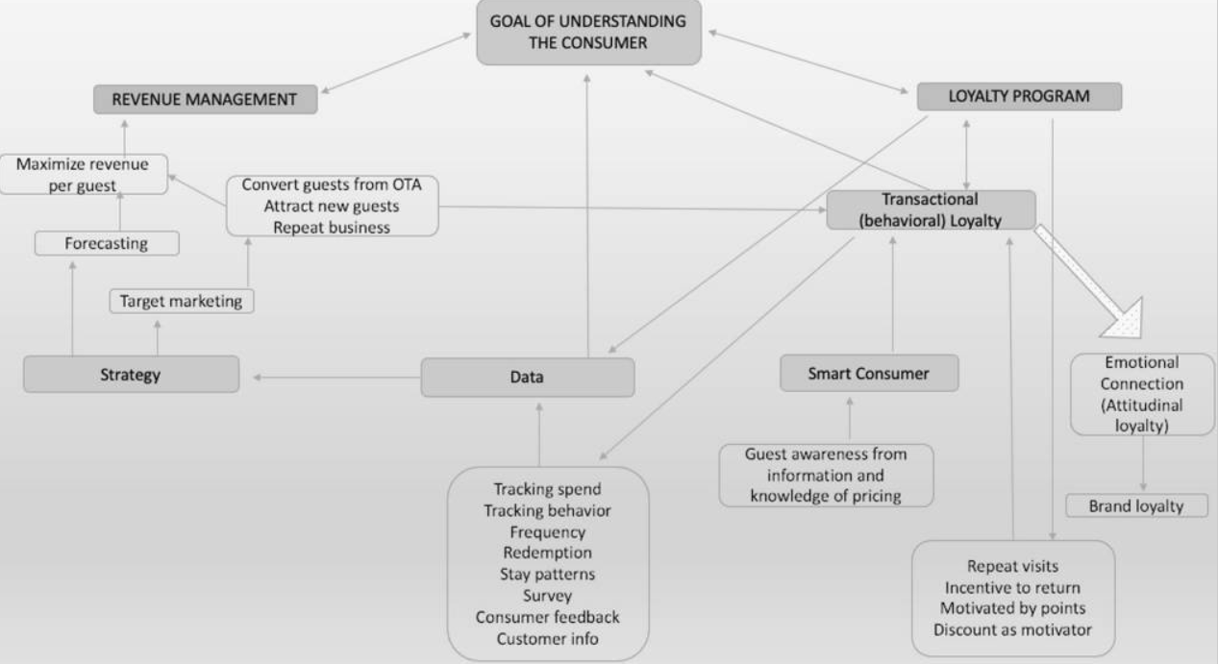
Figure 2: Strategic Revenue Management and Loyalty Programs
(Source: Lentz, Berezan and Raab, 2021)

2.4 Earnings Management under Pressure
Earning management is an equivalent strategy utilised by hospitality managers to impact underlying economic situations. Gonçalves, Coelho and Pinto (2024) suggested that earnings management is a widely used technique by hospitality managers to manage different manipulation techniques to raise the company's revenue. However, the study has reported that earning management often results in reduced quality of financial reporting and creates problems for regulators, investors and auditors. Therefore, the financial accountants who use this method need to comprehend the risk characteristics in terms of current and prospective investments. This study is dependent on subjective perspectives rather than considering the form of retrospective, selective and observational investigation, leading to substantial bias. In contrast, Luu Thu (2023) found that firms involved in earning management and manipulating earnings through real functions can reduce the risk of financial distress. Through these organisations, they see an improvement in their financial performance and gain a competitive advantage in the same industry. These results were obtained by involving data from 601 companies between 2010 and 2021. From the data, the study highlights the high risk of financial pressure on companies and the need for earnings management. Compared to other review method interpretations, the findings of this study are more considerable due to the involvement of industrial data, giving strong empirical support for business strategies.

2.5 Literature Gap
The existing article has efficiently provided insights into the financial pressures in the hospitality industry by highlighting the need for revenue management and earnings management. Studies have a limited focus on this specific reason, such as Martín-Oliver and Pascual-Fuster (2021) and Tascón, Castro and Valdunciel (2023), who focused on Spain and European regions, respectively, and involved mainly larger organisation insights. This impacts the comprehension of smaller institutions. Additionally, studies have not considered industrial insights along with the academic insights by involving Industrial perceptions with scholarly literature. In this context, research plans to manage these gaps by involving secondary and narrative review approaches to synthesise diverse worldwide evidence.

3. Method
This study combines two important methodological approaches involving secondary qualitative and narrative review. Within the first approach of secondary, the study includes Industrial reports, especially work in the hospitality sector, including government publications and credible sources. On the other hand, in the second narrative approach, the study synthesised the existing scholarly articles gathered from reputable databases. For this, the study considers the PESTEL framework to interpret current financial pressures experienced by the hospitality sector from secondary sources. Narrative reviews generally offer a thoughtful, readable and practical synthesis on a research topic and enable researchers to advance new ideas (Sukhera, 2022; Turnbull, Chugh and Luck, 2023). This helped to integrate the qualitative and quantitative findings from different studies to develop new perspectives. Furthermore, in context with the analysis tool, the research involves a thematic method. This comparative synthesis through the secondary and narrative format was oriented towards the idea of filling a research gap and the differences found in existing methodological approaches in scholarly articles.

4. Theme impact analysis

4.1 PESTLE Analysis
Political Factors | - Hospitality firms are highly impacted by the national and local government policies, including taxation, safety standards and labour laws.  - For instance, a Hospitality organisation is struggling with cost pressure due to the increased inflation rate by the government, exemplifying 11.1% in October 2022 (Rice, 2024).
Economic Factors | - Hospitality organisations closely relied on consumer spending and local economic growth, which were affected by the fluctuating exchange, interest and inflation rates.  - For instance, the Monthly trade policy is expected to increase, which has been fueling the financial turbulence (UNCTAD, 2025).  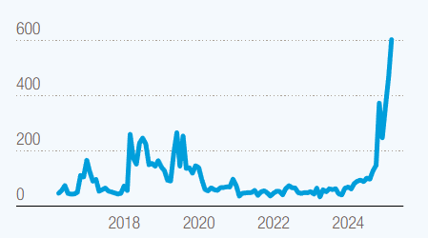  Figure 3: Monthly Trade Index from 2016 to 2025  Source: (UNCTAD, 2025)
Social Factors | - Changing social aspects affect demand towards hospitality products and services, and are affected by changing inflation rates, which directly affect user spending.  - Due to reduced spending, people are more likely to engage with the cheaper brands and even buy less (Wedel, 2025).  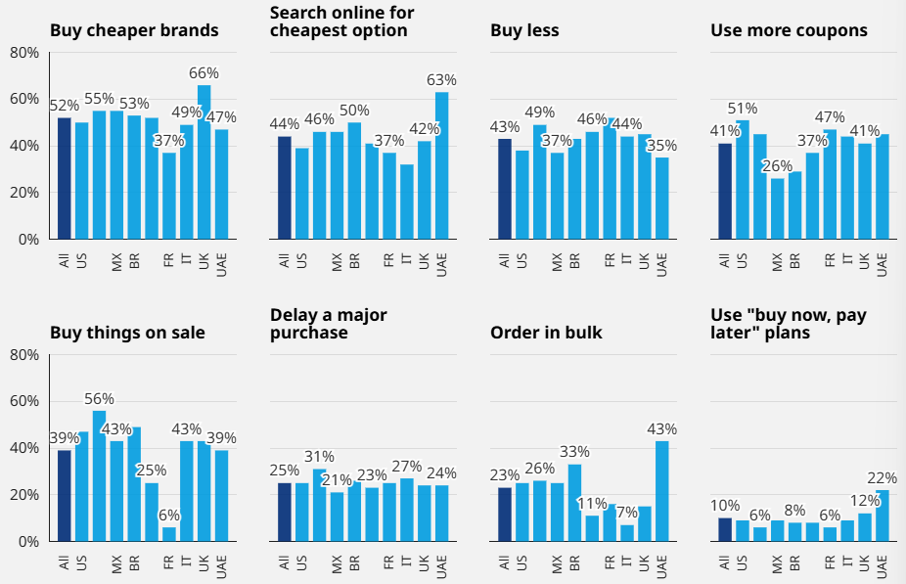  Figure 4: Changing Purchasing Behaviour  (Source: Wedel, 2025)
Technological Factors | - Technological Factors have presented an opportunity to manage financial pressures for utilising the Digital Revenue Management system.  - For instance, Hilton Hotels has an AI-based energy management system to manage its revenue and reduce operational costs (Hilton Travel, n.d.).
Environmental Factors | - The costing and operational functionality often increase due to environmental concerns.  - National and domestic governments mandate the sustainable standards for hospitality institutions to invest in eco-friendly infrastructure (Bien, 2025).
Legal Factors | - Modifications in the travel regulations regarding safety guidelines and visa policies affect the demand for the hospital sector.  - For instance, Brexit has introduced unique visa requirements, causing various travel uncertainties in the UK, creating complexities for hospitality firms (GOV.UK, 2022).
Table 1: PESTLE Analysis
(Source: Self-developed)

4.2 Finding and Analysis

4.2.1 Financial Pressure Context in Hospitality
Political, economic, social, environmental and legal are the corresponding aspects that create the financial pressure on hospitality institutions. Rice (2024) reported struggles of hospitality firms due to increased inflation, with 11.1%. Similarly, Wedel (2025) highlighted that changing inflation rates reduce spending and affect consumer choices for products and services. Further, the contrast insights reported by UNCTAD (2025), that changing trade policies are causing major financial uncertainties. The similar financial uncertainties were highlighted by academic articles. Martín-Oliver and Pascual-Fuster (2021) emphasised that 25% organisations experience financial turbulence, resulting in a 60% drop in their revenue. On the other hand, UNCTAD, Tascón, Castro and Valdunciel (2023) emphasised the pre-pandemic situation as a driver of financial health, which was further affected during the Pandemic, with a 58.67% decline 58.67% drop for hospitality firms. These issues are often related to changing government trends, and economic fluctuation reduces financial pressure.

4.2.2 Revenue and Earning Management as Strategic Responses
Efficient revenue management strategies are equally important for hospital organisations as supply management. The secondary report by Hilton Travel (n.d.) exemplified the opportunity of using technology aspects at hotels. Hilton Hotel has integrated the AI-oriented energy management system to generate a strong revenue by minimising operational costs. This has presented a significant opportunity for businesses to reduce financial pressure on themselves by strengthening their revenue management approaches. Similar observations were found by Subying and Yoopetch (2023) and Lentz, Berezan and Raab (2021), as a revenue management system provides long-term growth based on the customer-centric approaches. This management can also support the loyalty program activities to understand consumer perceptions and reduce mounting economic pressure. In contrast, Gonçalves, Coelho and Pinto (2024) emphasise the idea of earnings management. However, the study indicates it often reduces the quality of financial reporting and develops problematic situations for investors, regulators and auditors. Meanwhile, Luu Thu (2023) found that earnings management is an efficient manipulation strategy to minimise financial distress. Overall, the data showcased that revenue and earnings management are profound for hospitality firms to reduce mounting financial pressure.

5. Conclusion
The increasing financial strains of the hospitality sector can be noted as one of the most acute current issues that require high-level intervention and dynamic management solutions. This study has established that financial distress has been occasioned by both political, economic, social, environmental and legal factors. The inflation rates, the ever-changing consumer expenditure, as well as changes in regulations, have made a major burden in the operations of hospitality companies. The analysis indicates that although revenue management and earnings management can be used as legitimate strategies of logical reaction. The success of their implementation is dependent on the context-appropriate application, technological absorption, and correspondence with the customer-focused principles.

6. Recommendations

6.1 Implement a dynamic revenue management system with AI integration
Hospitality businesses must invest in how artificial intelligence can be used in the context of leveraging the technology in revenue management to adjust all the prices in real-time on the basis of demand forecasts, competitor and market trends. An example of this strategy is the case of Marriott International, which has its own proprietary revenue management system that evaluates more than 200 million pieces of information every day to tune its prices in the global portfolio (Marriott International, 2022). These systems can optimise room rates, food and beverage rates and other charges on ancillary services.

6.2 Develop Comprehensive customer loyalty programs linked to data analytics
Hilton Hotel can also exhibit this strategy with more than 173 million members who generate about 60 per cent of the room nights that the company receives. Through data in a loyalty program, Hilton develops specific promotions that stimulate direct reservations, which helps cut distribution costs and maximise profitability (Hilton, 2025). This produced emotional contacts that shield the business against market segments in the market that may occur during recessions.

6.3 Adopt sustainable operational practices to reduce long-term costs
Hospitality companies need to move to environmentally friendly operations. This strategy is shown by the Planet 21 program by AccorHotels, with the fact that there has been a decrease in energy and water consumption in its premises. It was associated with exportation rates of 13 and 17 per cent over the period of 2011 to 2020, leading to substantial cost savings (Accor, 2022). Hence, enhancing fiscal strength and fulfilling the growing environmental rules and standards of sustainability and expectations of the consumers.

6.4 Diversify Revenue Streams through ancillary services and strategic partnerships
Hospitality organisations ought to grow beyond the conventional accommodation and food service income by innovating complementary sources of revenue based on the existing infrastructure and customer base. This is the type of diversification that CitizenM Hotels pursues by turning lobbies into colourful social networks where people can co-work. The local art owners can display their works, and the community helps in making more money on the brand as well as updating the place (CitizenM Hotels, 2024). The feasibility of diversified revenue models was proven during the pandemic when many hotels used transcendent packages, tele-offices, and staycation experiences.

7. References
Accor (2022) Accor -Climate Change 2022. Available at: https://assets.group.accor.com/yrj0orc8tx24/4rnCWHNwAAUkdOUAQE0lCX/400b01ee89cc5e3a4eb2dacfb301ec49/Accor_CDP_Climate_2022.pdf (Accessed: 6 October 2025).
Bien, A. (2025) GSTC Standards Overview. Available at: https://www.gstc.org/gstc-criteria/ (Accessed: 08 October 2025).
CitizenM Hotels (2024) citizenM Redefines the Hybrid Work Experience with the Launch of Co-Working. Available at: https://www.hospitalitynet.org/news/4122598.html (Accessed: 6 October 2025).
Crespi-Cladera, R., Martín-Oliver, A. and Pascual-Fuster, B. (2021) ‘Financial distress in the hospitality industry during the Covid-19 disaster’, Tourism Management, 85(4), p.104301.
Dawson, J. Lemelin, H. Stewart, E. (2012) Last Chance Tourism: Adapting Tourism Opportunities in a Changing World. Routledge, London
Ford. R.C Sturman, M.C. (2020) Managing Hospitality Organisations. 2nd Edn. Sage, London.
Gonçalves, B., Coelho, L.S. and Pinto, P. (2024) ‘Earnings Management in the hospitality industry: A systematic literature review’, Tourism & management studies, 20(1), pp.65–77.
GOV.UK (2022) Travel or do business in Europe: Brexit guidance. Available at: https://www.gov.uk/government/collections/brexit-guidance (Accessed: 07 October 2025).
Hilton (2025) Outset Collection by Hilton: Launching Hilton’s 25th Brand. Available at: https://stories.hilton.com/releases/launch-of-outset-collection-by-hilton (Accessed: 6 October 2025).
Hilton Travel (n.d.) HILTON ENERGY STEWARDSHIP STATEMENT. Available at: https://cr.hilton.com/wp-content/uploads/2019/05/Hilton-Energy-Stewardship-Statement_April-2019.pdf (Accessed: 08 October 2025).
Kelling, N.K., Sauer, P.C., Gold, S. and Seuring, S. (2020) ‘The Role of Institutional Uncertainty for Social Sustainability of Companies and Supply Chains’, Journal of Business Ethics, 173.
Lentz, M., Berezan, O. and Raab, C. (2021) ‘Uncovering the relationship between revenue management and hotel loyalty programs’, Journal of Revenue and Pricing Management, 21(3).
Luu Thu, Q. (2023) ‘Impact of earning management and business strategy on financial distress risk of Vietnamese companies’, Cogent Economics & Finance, 11(1).
Marriott International (2022) Hotel Platform & Reservation System Available at: https://www.hotel-development.marriott.com/power-of-marriott (Accessed: 6 October 2025).
Melián-Alzola, L., Fernández-Monroy, M. and Hidalgo-Peñate, M. (2020) ‘Hotels in Contexts of uncertainty: Measuring Organisational Resilience’, Tourism Management Perspectives, 36, p.100747.
Menicucci, E. and Paolucci, G. (2024) ‘The effects of economic policy uncertainty on hotel performance: evidence from the Italian hospitality sector’, Journal of Hospitality and Tourism Insights, 8(11), pp.19–38.
Milutinović, S. and Stanišić, T. (2023). The impact of global crises on international tourism in Southern and Mediterranean Europe. Management in hospitality and tourism, 11(2), pp.103–115.
Ölmez, F., Bilgiç, E. and Aydın, E. (2024) ‘Understanding determinants of outward foreign direct investment: the role of economic policy uncertainty, institutional quality, and globalisation’, Journal of Economics, Finance and Administrative Science, 29(58).
Ramon-Jeronimo, J.M., Florez-Lopez, R. and Araujo-Pinzon, P. (2019) ‘Resource-Based View and SMEs Performance Exporting through Foreign Intermediaries: The Mediating Effect of Management Controls. Sustainability, 11(12), p.3241.
Rice, C. (2024) Inflation: Hospitality sector struggling with cost pressures. Available at: https://www.bbc.com/news/articles/cw99e8v0wg1o (Accessed: 06 October 2025).
Struckell, E., Ojha, D., Patel, P.C. and Dhir, A. (2022) ‘Strategic choice in times of stagnant growth and uncertainty: An institutional theory and organisational change perspective’, Technological Forecasting and Social Change, 182(1), p.121839.
Subying, C. and Yoopetch, C. (2023) ‘A Bibliometric Review of Revenue Management in the Tourism and Hospitality Industry, 1989–2021’, Sustainability, 15(20), pp.15089–15089.
Sukhera, J. (2022) ‘Narrative Reviews: Flexible, Rigorous, and Practical’, Journal of Graduate Medical Education, 14(4), pp.414–417.
Tascón, M.T., Castro, P. and Valdunciel, L. (2023) ‘Effects of financial restrictions on firms’ financial resilience against the COVID-19 pandemic: evidence from the European hospitality industry’, Applied economics, pp.8226–8241.
Turnbull, D., Chugh, R. and Luck, J. (2023) ‘Systematic-narrative hybrid literature review: A strategy for integrating a concise methodology into a manuscript’, Social Sciences & Humanities Open, 7(1), p.100381.
UNCTAD (2025) ‘Trade tensions and rising uncertainty drag global economy towards recession. Available at: https://unctad.org/news/trade-tensions-and-rising-uncertainty-drag-global-economy-towards-recession (Accessed: 07 October 2025).
Wedel, J. von (2025) Rising Inflation Triggers Shift In Global Consumer Spending. Available at: https://www.oliverwyman.com/our-expertise/insights/2023/sep/inflation-impact-on-global-consumer-spending.html (Accessed: 08 October 2025).

