PROGRAMME: MSC PUBLIC HEALTH AND SOCIAL CARE IN PRACTICE
MODULE: QUALITY ASSURANCE AND SERVICE IMPROVEMENTS
MODULE CODE: LCHS7006
Student Name :- Meetkumar Sangani
Student Code :- 2435003
COMPONENT 2: SERVICE IMPROVEMENT REPORT

Table of Contents
Introduction 2
Main Body 3
a. Rationale for Using Quality Management Frameworks 3
b. Application of the Donabedian Model 4
c. Fishbone Diagram Analysis of Root Causes 6
d. SWOT Analysis 7
e. Critical Evaluation of the Frameworks 8
f. Implications for Evidence-Based Recommendations 9
Recommendations 9
a. Strengthening Clinical Governance and Rapid Escalation 9
b. Safe Staffing and Competency Assurance 9
c. Creating a Speak-Up and Learning Culture 10
d. Data Surveillance and Process Reliability 10
e. Independent Assurance and Continuous Monitoring 11
Conclusion 11
References 13

Introduction
Evolving healthcare systems are primarily focused on quality management and service improvements as any failure in the system can lead to patient harm, loss of trust which involve regulatory authorities and potentially expensive costs (Reuters, 2025). The case of nurse Lucy Letby at the Countess of Chester Hospital is one of the largest patient safety crises to ever occur in the NHS. Lucy Letby, a neonatal nurse was convicted of murdering seven babies and several consecutive attempts on other patients under her care during her time in the neonatal ward between 2015-2016 (NHS UK, 2023). However, beyond just the crime itself, other organizational challenges arose: failure to properly escalate issues in a timely manner, poor oversight from leaders as well as weak governance structures and communication and stress on staff. So not only is this case a legal problem but it’s also a quality management problem, particularly in the context of public health and social services (Reuters 2025).
This scenario is significant especially due to the dependence of the patient population in question. Neonatal care includes the treatment of premature babies that require prompt clinical decisions, specialized nursing staff as well as close monitoring of their conditions. The number of nurses, nursing skills and compliance with safety measures were recognised to be strong predictors for the quality of neonatal care (Dillner, et al. 2025). Subpar performance in these areas reflects increased risk of mortality, infections and adverse events. This implies the quality failures of neonatal care can lead to instant and irreversible effects (Thirlwall, 2025). In the Countess of Chester case, however, concerns were raised by nurses well before a key action was taken, an indicator of a systemic level of avoidable error as early warnings have been ignored. This does not align with the concept of high reliability organizations because in those, any rare events must be immediately investigated (Kampfner, 2025).
It is also essential to view the problem from the perspective of the entire NHS environment. Staffing shortages persist as a long-term structural challenge in the UK healthcare system. NHS England has consistently highlighted staffing shortages in nursing and specialized positions, amid increasing demand for emergency and complicated care services. Moreover, neonatal units are under strain due to their reliance on skilled professionals and safe nurse-to-infant ratios. The findings from the survey conducted among 120 NHS trusts presented to the Thirlwall Inquiry show inconsistencies in staffing structures, governance practices, and monitoring within maternity and neonatal units. The Countess of Chester Hospital case could therefore be considered a worst-case scenario of problems resulting from staff shortages together with lack of proper governance and ineffective organizational culture (Nuffield Trust, 2024).
Organisational culture also poses an important issue. According to healthcare literature, patient safety is positively associated with psychological safety among workers and enables raising concerns without facing any consequences such as blaming and punishment. On the contrary, a defensive culture based on hierarchy tends to inhibit such concerns from being expressed (RCPCH, 2025). Reports suggest conflict between the executives and healthcare professionals regarding how allegations were treated. If so, it shows how culture may act as a hindrance in ensuring quality assurance. Hence, improving services entails not only policy but also behaviours from leaders that foster transparency, accountability, and learning (Halliday, 2025).
The focus of this report is on analysing the Lucy Letby case through a perspective that looks at it as a problem for service improvement, not just an individual’s misconduct. The report will use critical analysis techniques to examine the reasons behind the failure, utilizing quality models such as the Fishbone Diagram, 5 Whys, Donabedian Model, and SWOT Analysis. These techniques are invaluable since they shift the analysis from blame to systems thinking through an examination of how structure, process as well as outcomes interact. The will also generate evidence-based suggestions through improvement processes like PDSA, PDCA, Lean, and Six Sigma to enhance governance, patient safety along with sustainable quality improvement in health and social care organizations.

Main Body

a. Rationale for Using Quality Management Frameworks
An analysis of the Lucy Letby case should be done based on the principles of improving a system rather than individual wrongdoing. In medicine, catastrophic results tend to occur when several organizational safeguards break down at once. This principle is aligned with Reason’s model of systems thinking, which views accidents as the consequence of latent flaws within the organization’s leadership, workforce, procedures, and organizational culture rather than a single mistake (Leveson, et al. 2020). Thus, the Donabedian Model, Fishbone Diagram, and SWOT Analysis can be considered suitable methods for this purpose because they assess how structural things shape clinical systems, besides patient outcomes. In tandem, these models provide a basis for addressing root causes and developing sustainable improvement approaches. The evidence provided to the Thirlwall Inquiry suggests that the issue transcended one worker and involved elements of governance escalation, staffing, documentation, supervision, and organizational reaction, thus highlighting the value of a systems approach (Nuffield Trust, 2024; Thirlwall, 2025).

b. Application of the Donabedian Model
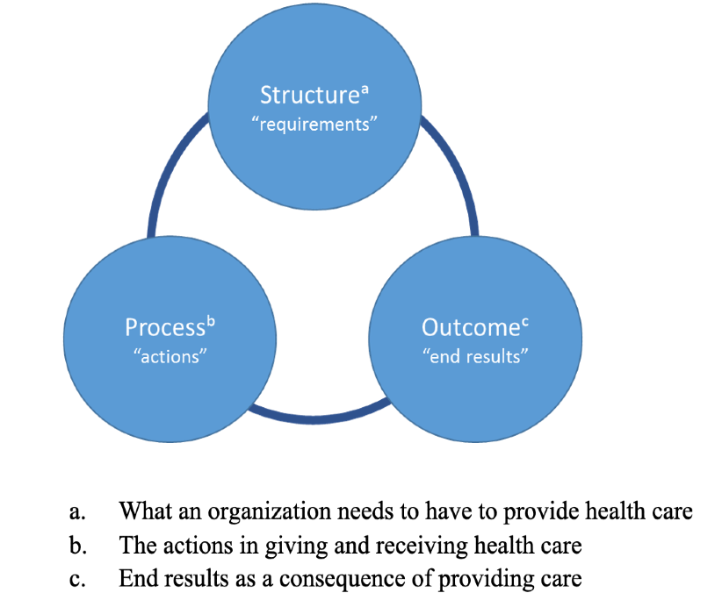

Figure: Donabedian model
(Source: Tossaint-Schoenmakers, et al. 2021)
The Donabedian’s model assesses health care quality by using the three interrelated concepts of structure, process, and outcomes. The advantage of this approach is that it clearly demonstrates that bad results are never incidental but a result of the deficient structure and faulty process of treatment (Shroyer, Carr and Grover, 2019).
Structure: Workforce, Leadership and Resources
Structure mainly represents the environment where the care is provided, taking into account such factors as staffing, infrastructure, equipment, and governance. Several points noted in regard to the structure are relevant for understanding the incident at the Countess of Chester Hospital. They include problems with management responsiveness, escalation mechanisms, as well as staff capability. From the review conducted by the Nuffield Trust on 120 NHS trust organizations, it was noted that there were variations in governance structure, staffing and surveillance methods, suggesting that maturity levels vary from one provider to another. In cases where such structures are underdeveloped, warning signs can be overlooked (Patient Safety Learning, 2025).
Staffing is especially crucial in the care of newborns because they need to be continuously monitored and intervened at an urgent moment. According to studies, under-staffing is linked to high mortality rates, missed and unsafe care. In other words, if there were not enough specialists to work and supervise, then risks could increase regardless of any crimes committed (Nantsupawat, 2022). An alternative opinion is that many NHS organizations work under stress but do not encounter any such event, meaning that staffing cannot alone account for the seriousness of the incident. This argument is true; nonetheless, staffing shortages are not necessarily the only reason to be an important risk factor (Conn, 2025).
Process: Escalation, Communication and Governance
Process involves what is actually done by practitioners and managers, such as the process of reporting incidents, communicating, investigating, monitoring, and decision-making. Here, the major issues include delayed escalation related to consultant warnings and poor organizational response time. According to Reuters (2025), the public inquiry was set up in order to investigate why the action had gone unnoticed and what was done regarding the prior concerns. It shows a failure in recognizing the anomaly and acting quickly on it.
Effective organizations make utilisation of real-time incident monitoring, death reviews, and multidisciplinary challenges to the system. In cases where issues keep cropping up from clinical staff, the organization’s systems should kick into action, conducting reviews, re-deployment, external investigation, and risk assessment.
The possibility that reputational factors could have been considered along with safety considerations implies that there might have been a mismatch in governance considerations. From a critical viewpoint, managers are likely to be presented with incomplete information and liability risks while taking action against employees (Domer, et al., 2021). However, according to patient safety models, precaution is always prioritised when signs of danger point toward patients who are highly susceptible. Consequently, a major quality assurance gap is represented by delayed escalation (Conn, 2025).
Outcome: Harm, Trust and Organisational Damage
The results will be mortality, injury, employee health, legal implications, and public trust. Immediate results were death, collapse, and deep emotional scarring to family members. Long-term results are damage to the reputation of the hospital, eroded trust in the neonatal unit, and government review of the NHS safety processes. These results highlight why quality management encompasses more than just clinical performance, as organizational legitimacy and employee satisfaction are also products of the system’s performance (Thirlwall, 2025). This example highlights the basic tenet of Donabedian: poor structure as well as process can have serious repercussions.

c. Fishbone Diagram Analysis of Root Causes
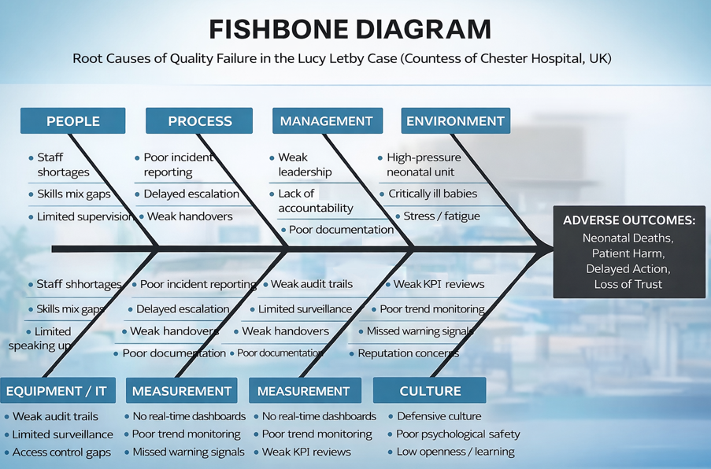
Figure: Fishbone Diagram
(Source: Created by Author)
According to Kumah et al. (2024), the Fishbone which also means Ishikawa Diagram, enables the categorization of root causes into various classes, including people, process, environment, equipment, management, and measurement. The significance of this tool is that it steers conversations away from placing blame to identifying interactional causes.
People
This section contains issues related to staffing, competencies, supervision, and whistleblowing. The inquiry findings have taken into account the whistleblowing system and Freedom to Speak Up initiatives, demonstrating the importance of staff voice. Should clinicians or juniors feel incapable of raising their concerns, the risk level would be higher (Nadaf, et al. 2025).An opposing view would be that there were some concerns raised by the workers. But the raising of concerns alone is inadequate if the system does not translate the concern into action (The Thirlwall Inquiry, 2025).
Process
Process examples are incident review, handover, documentation, and escalation process. Late identification of patterns of collapse suggests a poor monitoring process. Healthcare institutions have increasingly embraced Statistical Process Control along with Mortality Dashboards to spot abnormal variability. Absence of these mechanisms would likely mean that there were missed chances for proactive measures (Nuffield Trust, 2024).
Environment
In neonatology, it is always a risky environment due to the nature of patients and how fast things deteriorate (Sokou, et al. 2025). This means that when under pressure, overload and fatigue might prevent one from noticing problems. The environment hence exacerbates other problems.
Equipment and Technology
Digital records, drug access registers and monitoring systems are key control measures. This is illustrated by the review conducted by the Nuffield Trust on how trusts manage electronic record systems and access to drug stores. Where technology is patchy or poorly monitored, investigations and preventive efforts become difficult (Nuffield Trust, 2024).
Management
Safety culture, board assurance, and leadership accountability constitute the essence of the fishbone analysis. The occurrence of latent risks is elevated if the organization’s leadership emphasizes reputation, employee relations, or risk management rather than safety precautions. Good governance, objective assessment, and decision-making are essential for successful management (Karsono, 2023).
Measurement
The unmeasured tends to be the unmanaged. When companies do not have immediate metrics for unplanned breakdowns, staff shortages, close calls, or speaking up, the risks can never be determined. Thus, contemporary quality management requires visibility and feedback cycles (Lighterness, et al. 2024).

d. SWOT Analysis
Strengths | Weaknesses
These include national standards, CQC regulation, and a legal duty of candour, all of which have been incorporated into the existing NHS framework. Professional internal vigilance is illustrated through the existence of experienced healthcare professionals who expressed their concerns (Kissler et al., 2024). National learning from inquiries can facilitate reform. | Staff stress, inadequate real-time monitoring, inconsistent governance frameworks, delayed warning escalation, possible executive indecision, and lack of communication mainly between executives and physicians.
Opportunities | Threats
The introduction of digital early warning dashboards, enhancing Freedom to Speak Up, extending training for neonatal staff, implementing independent mortality review, using Plan Do Study Act cycles for rapid testing, and sharing lessons learned across all NHS Trusts must be ensured (Alhmoud et al., 2022). | Potential safety issues if the recommendations are not implemented, staff shortages, budget constraints, costs associated with lawsuits, burnout, negative publicity that makes recruiting difficult, and opposition to culture change.
Table: SWOT Analysis
(Source: Created by Author)
SWOT analysis is advantageous since it helps link internal strengths to external threats and opportunities. Nevertheless, it is not ideal when determining causation compared to the Donabedian and Fishbone approaches. The main benefit of SWOT analysis is during strategic planning once the causes have been determined.

e. Critical Evaluation of the Frameworks
Each one of them has its unique advantages. Donabedian has clarity in concepts due to the connections he makes between the structures, process, and results of health care. The Fishbone diagram is useful for multi-disciplinary root cause analysis sessions as it promotes inclusiveness in the process. SWOT is useful in prioritizing actions when faced with external challenges.
However, there are downsides to every model. The limitations of Donabedian include oversimplification of interactions and underestimation of organizational politics/culture (Ness, 2024). The Fishbone diagram may generate a large number of possible causes without prioritizing their importance. SWOT analysis tends to be descriptive rather than analytical.
Hence, one cannot rely on just one model. Together, they work effectively; Donabedian identifies where failures occur, Fishbone determines why failures occur, while SWOT provides direction on which improvements to prioritize.

f. Implications for Evidence-Based Recommendations
From the comprehensive evaluation, the following recommendations are identified: escalation governance, improved staffing practices, enhanced data surveillance, psychological safety when speaking up, and accountability at the board level for neonatal quality. Such recommendations align with the NHS-wide learning experience indicating that improvement efforts must address not only technical control but also cultural change. Hence, the next part will implement the PDSA or PDCA cycles, Lean, and Six Sigma tools in translating the results into specific service improvement initiatives (Patient Safety Learning, 2025).

Recommendations

a. Strengthening Clinical Governance and Rapid Escalation
Firstly, governance frameworks should be re-designed such that any occurrence of negative events should immediately prompt a review process. In the Lucy Letby scenario, there was a lack of timely response and reporting on incidents. Literature on healthcare quality highlights that more effective institutions have strong accountability frameworks, fast-paced learning processes, and review mechanisms for strange patterns of harm. The new policy regarding governance should entail that any occurrence of sudden infant collapse, death, or any other incident must be reported instantly to the medical director, nursing director, and another impartial individual (Hughes, 2008).
The PDSA approach fits here because it allows for piloting before general implementation. In this case, the organization is able to design its own escalation process and pilot it among neonatal services to check if response time improves, and then act on the results received from the pilots. PDSA works well here since it fosters fast adjustments without having to wait for major policy changes (Barr and Brannan, 2024).

b. Safe Staffing and Competency Assurance
Secondly, it entails sufficient staffing, specialist skills, and constant supervision. According to studies, poor patient outcomes, missed care, and increased mortality have been associated with insufficient nursing staffing levels (Ball, et al., 2018). The neonatal department is highly susceptible due to the rapid deterioration of patients and the need for constant supervision. Therefore, there is a need for trusts to adopt evidence-based staffing ratios, an escalation policy when staffing falls below recommended levels, and competency testing for all nurses working in critical care departments (Bonner, et al., 2017).
Newly graduated staff should be provided with systematic mentoring and training for emergencies involving newborns. PDCA methodology may help implement such measures by preparing appropriate standards for staffing, performing the new staffing plan, measuring the number of vacancies and incidents, and acting upon the results. Such a cyclic method is useful since workforce management needs to be flexible to meet changing demand (Patrician, et al. 2024).

c. Creating a Speak-Up and Learning Culture
When employees lack a sense of security, technical systems will break down. According to studies done in relation to patient safety culture, psychological safety contributes to better reporting, team work, and risk identification. It is important that organisations improve their Freedom to Speak Up, confidentiality reporting systems, and walk-around processes for senior management involving direct interaction with frontline employees (Montgomery, et al. 2025). Senior management must address concerns raised and make learning activities public.
Lean management is very pertinent since it stresses respect for humanity, workforce participation, and elimination of any obstacles that would hinder safe working conditions. In contrast to presuming that management knows everything, Lean management involves frontline employees in finding any wastage, delays, and unsafe practices (Barr and Brannan, 2024). Nevertheless, culture change necessitates consistent behavior by the leadership rather than single training workshops. This explains why employee survey metrics, whistle-blower reporting response times, and team climate assessments should be evaluated periodically by the board (Samanta and Gurumurthy, 2023).

d. Data Surveillance and Process Reliability
An additional suggestion is the deployment of enhanced digital monitoring mechanisms for early detection of anomalies. Many problems within health care are still common because organizations gather information but fail to translate it into intelligence. Dashboards must be utilized to track the mortality rate, recurrent collapses, medication errors, shortage of staff, and pending investigations (Adeleke, 2022). Statistical process control techniques will enable one to differentiate between normal variability and abnormal trends.
The approach is highly advantageous since it involves working towards minimizing defects and variations via measurable process reengineering. In most cases, defects can involve the delay in reviewing incidents, incomplete documentation, and failure to escalate issues (McDermott, et al. 2022). Through the DMAIC method (define, measure, analyze, improve, control), the trust can pinpoint the cause of problems, improve processes, and implement controls. Despite its strength, the approach must not replace clinical judgment in most cases, considering that many healthcare decisions require more than data-driven solutions (McDermott, et al. 2022).

e. Independent Assurance and Continuous Monitoring
The final recommendation would be to integrate the principles of transparency with stronger external assurances. In situations where reputational risk is high, internal governance alone can be a safeguard. Independent mortality reviews and regular peer reviews conducted externally by outside clinicians or local networks need to be used in such cases. A scorecard incorporating such aspects as staff compliance, training, response time, patient results, and speaking up by the staff must be followed by the board (Hughes, 2008).
Transparency in the communication of certain measures could play a vital role in regaining confidence as well. In light of the fact that most interventions fall flat once the initial zeal fades away, continuous monitoring becomes essential. Governance structures that ensure constant evaluation, measurement, and improvement in performance over time are fundamental to service improvement. Taking everything into account, incorporating PDSA, PDCA, Lean, and Six Sigma provides a viable framework for moving from crisis management to safety leadership and treatment (Barr and Brannan, 2024).

Conclusion
Analysis of the Lucy Letby case at the Countess of Chester Hospital has been thoroughly undertaken in this study for a number of reasons. The fact that it constituted a major quality assurance failure within health and social care is not in doubt. It must however be mentioned that the broader organizational context also proved to be very important in this case. The report exhibits through the Donabedian Model that structural weaknesses, such as those in staffing, leadership, and governance, led to the occurrence of risky processes, which included delays in escalation, poor communication, and ineffective monitoring. The end result was catastrophic outcomes such as neonatal deaths, emotional stress for the families involved, and loss of trust in healthcare facilities.
As can be seen in the Fishbone diagram, patient injuries rarely occur due to one single cause. Rather, various interrelated factors like staffing problems, poor accountability, inadequate monitoring systems, environmental influences, and a defensive environment allowed for the emergence of risk factors without their early detection and control. This is seen through the SWOT analysis which offered a strategy through the realization that although there were significant weaknesses in the NHS, there were equally significant regulatory frameworks and learning processes at both the organizational and national levels to help achieve the reform process. This illustrates that when learning are converted into empirically supported action, healthcare organisations can bounce back from setbacks.
Thus, the proposals focused on improving digital surveillance, increasing independence in assurance, fostering a speak-up culture, ensuring safe staffing, and improving governance. PDSA, PDCA, Lean, and Six Sigma are some of the quality improvement techniques that have been demonstrated to be effective in implementing and sustaining these improvements. To conclude, the most important lesson learned from this case study is that patient safety cannot be achieved simply through personal competency alone but requires resilient systems, open leadership, and an ongoing process of improvement. Institutions that prioritize these elements will be better equipped to provide safe and effective care in the years to come.

References
Adeleke, O., 2022. Influence of Interoperable Health Information Systems, Real-Time Data Dashboards, and Predictive Intelligence on the Effectiveness of Public Health Early Warning and Surveillance Systems.
Alhmoud, B., Melley, D., Khan, N., Bonicci, T., Patel, R. and Banerjee, A., 2022. Evaluating a novel, integrative dashboard for health professionals’ performance in managing deteriorating patients: a quality improvement project. BMJ open quality, 11(4).
Ball, J.E., Bruyneel, L., Aiken, L.H., Sermeus, W., Sloane, D.M., Rafferty, A.M., Lindqvist, R., Tishelman, C., Griffiths, P. and RN4Cast Consortium, 2018. Post-operative mortality, missed care and nurse staffing in nine countries: A cross-sectional study. International journal of nursing studies, 78, pp.10-15.
Barr, E. and Brannan, G.D., 2024. Quality improvement methods (lean, pdsa, six sigma). In StatPearls [Internet]. StatPearls Publishing.
Bonner, O., Beardsall, K., Crilly, N. and Lasenby, J., 2017. ‘There were more wires than him’: the potential for wireless patient monitoring in neonatal intensive care. BMJ innovations, 3(1).
Conn, D. 2025. The convictions of Lucy Letby: Should they be overturned?, The Guardian. Available at: https://www.theguardian.com/uk-news/2025/may/14/the-convictions-of-lucy-letby-should-they-be-overturned?utm (Accessed: 16 April 2026).
Dillner, P., Göransson, K.E., Norman, M., Unbeck, M. and Förberg, U., 2025. Nurse staffing skill mix and acuity-adjusted provision ratios in Swedish neonatal care: A cohort benchmark study. International Journal of Nursing Studies Advances, p.100471.
Domer, G., Gallagher, T.M., Shahabzada, S., Sotherland, J., Paul, E.N., Kumar, K.N., Wilson, B., Salpekar, S. and Kaur, P., 2021. Patient safety: preventing patient harm and building capacity for patient safety. In Contemporary Topics in Patient Safety-Volume 1. IntechOpen.
Halliday, J. 2025. Hospital ex-bosses accused of ‘opportunistic’ call for halt to Lucy Letby inquiry, The Guardian. Available at: https://www.theguardian.com/uk-news/2025/mar/18/countess-of-chester-hospital-lucy-letby-inquiry?utm (Accessed: 16 April 2026).
Hughes, R., 2008. Patient safety and quality: An evidence-based handbook for nurses.
Kampfner, C. 2025. Lucy letby inquiry: What have we learnt as it comes to an end?, The Times & The Sunday Times. Available at: https://www.thetimes.com/uk/crime/article/lucy-letby-inquiry-what-have-we-learnt-as-it-comes-to-an-end-bmcbpfj28?u (Accessed: 16 April 2026).
Karsono, B., 2023. Good Corporate Governance: Transparency, accountability, responsibility, independency dan fairness (literature review). Dinasti International Journal of Management Science, 4(5), pp.811-821.
Kissler, M.J., Porter, S., Knees, M., Kissler, K., Keniston, A. and Burden, M., 2024. Attention among health care professionals: a scoping review. Annals of internal medicine, 177(7), pp.941-952.
Kumah, A., Nwogu, C.N., Issah, A.R., Obot, E., Kanamitie, D.T., Sifa, J.S. and Aidoo, L.A., 2024. Cause-and-effect (fishbone) diagram: a tool for generating and organizing quality improvement ideas. Global Journal on Quality and Safety in Healthcare, 7(2), pp.85-87.
Leveson, N., Samost, A., Dekker, S., Finkelstein, S. and Raman, J., 2020. A systems approach to analyzing and preventing hospital adverse events. Journal of Patient Safety, 16(2), pp.162-167.
Lighterness, A., Adcock, M., Scanlon, L.A. and Price, G., 2024. Data quality–driven improvement in health care: systematic literature review. Journal of medical Internet research, 26, p.e57615.
McDermott, O., Antony, J., Bhat, S., Jayaraman, R., Rosa, A., Marolla, G. and Parida, R., 2022. Lean six sigma in healthcare: a systematic literature review on challenges, organisational readiness and critical success factors. Processes, 10(10), p.1945.
McDermott, O., Antony, J., Bhat, S., Jayaraman, R., Rosa, A., Marolla, G. and Parida, R., 2022. Lean six sigma in healthcare: a systematic literature review on motivations and benefits. Processes, 10(10), p.1910.
Montgomery, A., Chalili, V., Lainidi, O., Mouratidis, C., Maliousis, I., Paitaridou, K. and Leary, A., 2025. Psychological safety and patient safety: A systematic and narrative review. PLoS One, 20(4), p.e0322215.
Nadaf, C., Bench, S., Halpin, Y. and Terry, L., 2025. Critical points of risk in registered nurses' use of a national early warning score—perceptions and challenges. Journal of Advanced Nursing, 81(8), pp.4871-4882.
Nantsupawat, A., Poghosyan, L., Wichaikhum, O.A., Kunaviktikul, W., Fang, Y., Kueakomoldej, S., Thienthong, H. and Turale, S., 2022. Nurse staffing, missed care, quality of care and adverse events: A cross‐sectional study. Journal of nursing management, 30(2), pp.447-454.
Ness, S., 2024. Integrating Sociopolitical, and Cultural Dimensions into the Donabedian Framework for Comparative Legal and Healthcare Policy Analysis. Issue 2 Int'l JL Mgmt. & Human., 7, p.3271.
NHS UK, 2023. The Thirlwall Inquiry, NHS choices. Available at: https://www.coch.nhs.uk/corporate-information/the-thirlwall-inquiry.aspx?utm (Accessed: 16 April 2026).
Nuffield Trust, 2024. Report for the Thirlwall inquiry analysis of Questionnaires. Available at: https://www.nuffieldtrust.org.uk/sites/default/files/2025-03/Nuffield%20Trust%20report%20for%20the%20Thirlwall%20Inquiry_FINAL%20report_0.pdf (Accessed: 16 April 2026).
Patient Safety Learning, 2025. Report for the thirlwall inquiry: Analysis of Questionnaires from 120 NHS trusts, Nuffield Trust. Available at: https://www.nuffieldtrust.org.uk/research/report-for-the-thirlwall-inquiry-analysis-of-questionnaires-from-120-nhs-trusts (Accessed: 16 April 2026).
Patrician, P.A., Campbell, C.M., Javed, M., Williams, K.M., Foots, L., Hamilton, W.M., House, S. and Swiger, P.A., 2024. Quality and safety in nursing: recommendations from a systematic review. The Journal for Healthcare Quality (JHQ), 46(4), pp.203-219.
RCPCH, 2025. RCPCH statement on Thirlwall Inquiry Closing Statements, RCPCH. Available at: https://www.rcpch.ac.uk/news-events/news/rcpch-statement-thirlwall-inquiry-closing-statements (Accessed: 16 April 2026).
Reuters, 2025. Final report on Lucy Letby Baby Murders due in early 2026, Inquiry says | Reuters. Available at: https://www.reuters.com/world/uk/final-report-lucy-letby-baby-murders-due-early-2026-inquiry-says-2025-05-22/ (Accessed: 16 April 2026).
Reuters, 2025. UK police widen investigation of hospital where killer nurse Lucy Letby worked | Reuters. Available at: https://www.reuters.com/world/uk/uk-police-widen-investigation-hospital-where-killer-nurse-lucy-letby-worked-2025-03-13/ (Accessed: 16 April 2026).
Samanta, A.K., G, V. and Gurumurthy, A., 2023. Implementing lean six sigma in health care: a review of case studies. International Journal of Lean Six Sigma, 14(1), pp.158-189.
Shroyer, A.L., Carr, B.M. and Grover, F.L., 2019. Health services information: application of Donabedian’s framework to improve the quality of clinical care. Health Services Evaluation, pp.109-139.
Sokou, R., Lianou, A., Lampridou, M., Panagiotounakou, P., Kafalidis, G., Paliatsiou, S., Volaki, P., Tsantes, A.G., Boutsikou, T., Iliodromiti, Z. and Iacovidou, N., 2025. Neonates at risk: understanding the impact of high-risk pregnancies on neonatal health. Medicina, 61(6), p.1077.
The Thirlwall Inquiry, 2025. Thirlwall-inquiry-14-January-2025.PDF. Available at: https://thirlwall.public-inquiry.uk/wp-content/uploads/2025/01/Thirlwall-Inquiry-14-January-2025.pdf (Accessed: 16 April 2026).
Thirlwall, 2025. Thirlwall Inquiry. Welcome to the Thirlwall Inquiry website, Thirlwall Inquiry. Available at: https://thirlwall.public-inquiry.uk/?d102_cookies_enabled=all (Accessed: 16 April 2026).
Tossaint-Schoenmakers, R., Versluis, A., Chavannes, N., Talboom-Kamp, E. and Kasteleyn, M., 2021. The challenge of integrating eHealth into health care: systematic literature review of the Donabedian model of structure, process, and outcome. Journal of medical Internet research, 23(5), p.e27180.

