Module: Professional and Career development
Module code: BMSW 4005

Student Name: EDIE JOBE-NJIE
Student ID: 1917941

Table of Contents
Introduction 2
1. Skills and Competencies Audit 3
SWOT Analysis on personal skills and competencies 3
Personal Development Plan (PDP) 4
2. Skills required to be an ‘effective’ Manager in financial sector 5
3. Gibbs' Reflective Cycle: Professional and Career development 7
Conclusion: 11
References: 11

Introduction
Professional and Career development module enabled us to achieve a wide variety of knowledge and skills related to career development .
To conclude this module I have audited my own skills and competencies using the SWOT Analysis and Personal Development Plan (PDP) . After that I have analysed the skills required to be an ‘effective’ Manager in Goldman Sachs & Co which is in the finance industry.
Lastly with the help of Gibbs reflective cycle model I have assessed the concepts we have learned from this module.

Skills and Competencies Audit

SWOT Analysis on personal skills and competencies

STRENGTH | WEAKNESS
- Leadership skill  - Team person  Flexible in nature  Optimistic in hard situation  - Believer in hard & focused work  - Problem solver  - Empathetic and sincere to others | - Lack of communication skills  - Doubt on personal strengths  - Committed to excellence
OPPORTUNITIES | THREAT
- Opportunity to learn new skills and achieve new experiences  - Working on skill development  - Studying to increase knowledge | - Shortage of soft skill  - Lack of knowledge on new and ever changing market  Not goal-oriented

Personal Development Plan (PDP)

Name: personal skills and competencies Date: 10.12.21

Objective | Success criteria | Actions | Implementation
What is my main objective? | What is my measure of success? | What will be the methods to learn my objectives? | How would I practice and apply my learnings?
Increase communication skills as much as possible. | 1.others recognition of my communication skills.  2.using communication skills to improve personal & team productivity. | 1. finding out where I can contribute more.  2. helping co-workers or colleagues in their work with my skill .  3. working with my team to increase our skill and offer necessary help where it is required. | 1. keep in touch with my mentors and coaches to learn new opportunities and how to contribute this with my team.  2. mentor others if they want.
To increase my own confidence | 1.Recognition from others  2. Feeling confident in particular field by myself | 1.Increasing skills in particular field which I think I should focus on  2.Practising more rather than focusing on perfection | 1.Doing practice work regarding that particular field.  2.Helping others to solve their problem on that field

2. Skills required to be an ‘effective’ Manager in financial sector

As there are opportunities worldwide and as a dynamic industry my selected industry is the financial sector as a manager of Goldman Sachs & Co. Which is one of the most stable career choices currently in the world. There are varied career paths and options and always opportunities for growth, it is exciting, challenging & fast-paced. So the following are the skills required to be an effective manager in the financial sector.

1. Personality Qualities
We used to think that managers in financial sectors are people who work from their rooms and interpersonal skills are not that necessary . but what we are seeing is that managers in the finance sector must deal with people on a daily basis . you have to be nice and approachable when you are in the financial sector , it will help you to maintain positive connections with co-workers & customers. Nowadays, if you want to do well in the financial sectors , you have to be friendly & approachable.

- Formal qualifications
Nowadays managers in the finance industry need experience as well as some formal qualifications which will enable them to get an advantage from the rest of the world. Some industries will search for dashing personalities with good experience to go through their managerial work .But in finance career education is important because you have to do many fundamental tasks to go through your work on a daily basis. To understand some accounting standards various certified diplomas and degrees may be required.

3. Problem solving skills
As a finance manager you must know how the process and system works . Also it is important that you have the ability to solve critical problems, when a complicated problem arises.it can be dealing with company finance or a tax problem. A good manager takes necessary steps to solve problems.

4.Analytical skills

Most finance managers think logically ,they analyse scenarios and generate appropriate judgments. Managers embrace and utilise this facet of their employment, demonstrating their ability to think logically and methodically. For any managerial position this is a very crucial skill to have because as a manager your job will be complex , most of the time you have to think rationally and ignore emotion to get satisfactory results.

- Technologically knowledgeable .
Current financial world is very adaptive with technology , this reduced time consumption and increased speed and productivity. As a result, technical skills must be prioritised in financial professional training. To compete in the industry's specialised tools and platforms, they must be up to speed on the latest apps and go above and beyond. You'll fall behind and become a less valuable asset to the banking business if you don't have this information.

- A strong drive to create
Though almost every rule in the finance world is fixed, there is space to innovate . This industry likes productivity and always finding ways to improve by innovating. New ideas may increase productivity which will help your company so new ideas are always welcomed. That’s why a finance manager may always try to push think outside of the box.

- Exceptional management
If you are a beginner in the finance industry or long term veteran , leadership and motivation are two sought after qualities in this sector. Every managers should have these qualities .these qualities will set you apart from competitors .whether you are a project manager or a line manager you should have skills in motivation and leadership

So these are the skills required to be an ‘effective’ Manager in the financial sector, there are many more skills that can be required to ace in the financial sector but the above mentioned are the most important for a manger (Herriot, Pemberton, and Hawtin, 1996)

3. Gibbs' Reflective Cycle: Professional and Career development
Throughout the professional and Career development module ,we have learnt a lot . which will enable us to learn more about Higher Education Skills for the Workplace. So now I would like to use Gibbs' Reflective Cycle model to assess the concepts we have learned from this module.

Gibbs' Reflective Cycle
Gibbs reflective cycle model is very well known, it takes us through six stages ,such as description, after that feelings ,appraisal or evaluation , analysis ,conclusion and action plan.

.

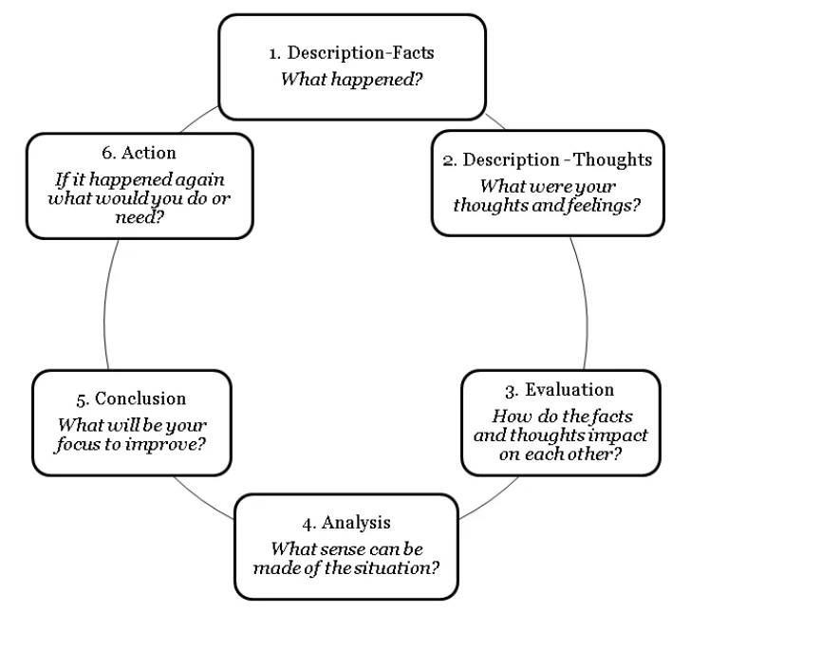
Figure: Gibbs' Reflective Cycle (Adeani, Febriani and Syafryadin, 2020)

1.Description – what happened?
Throughout the professional and Career development module ,we have learned about The many ways to self-measurement and instruction, as well as the concepts of self-conversance ,how Baseline surveys are used to assess self - directed learning choices. Individual abilities, shortcomings, and skills are examined to aid professional growth planning (Cottrell, 2010). Private assurance, learning, and free thinking are some of the concepts discussed. Obtaining, choosing, and compiling news from a variety of resources is a strategy for researching work choices. Methods for expressing findings in a logical, clear, and systematic way. A look at appropriate methods including shift work, workplace safety, and excellent performance policies. Employee recruiting, performance reviews, selection procedure, position description, screening, orientation, teaching, appraisals, and employment concerns are all covered in this orientation to future career tactics. Participants' trust and preparedness for employment are developed through activities also including personal responsibility, social interactions, civil discourse, and trustworthiness. Protocols and legal requirements are referred to as needed. Select relevant professional practise of tolerance, efficient leadership, and productive collaborations. and more. We have learnt the theory as well as the applications

2 .Feelings – what were you thinking and feeling?
This module was a lot of fun for me. The module was well planned for the participant and easy to follow. Homework and tests were not so hard. So it was easy for the participant to do well and complete their task. The tasks were created in a way so that I don’t feel hurried .Generally, I like this program since the lecturers, assignments, and assessments are also all straightforward. Another of the reasons I detest the curriculum is that there should be possibilities for extra credit. The program was exactly what it said it would be: fun but challenging.

3. Evaluation – What are all the positive and negative aspects of the observation? What worked well and what didn't ?
The main advantage of this module is that it provides us with useful advice and direction when it comes to making professional options. We learn about our own aspirations, goals, and wants, as well as how to shape our careers. We may now create more realistic goals and objectives that we can achieve throughout the course of our lives. It also helped us enhance our communication skills. The best thing was that we could receive comments on our work. This encourages us to enhance our working style and to learn new talents. In the end, the process results in work enrichment and increased job satisfaction. The learning process went well, but for me exhaustion and personal fatigue is a big problem. If I could have avoided that while studying and practising then it would have been very helpful for me. I think personal career development and personal satisfaction and relaxation is as much important .

4. Analysis – what sense can you make of the situation?
The main objective of this module was to Appreciate the abilities and information needed for efficient functioning, as well as exhibit preparation for sociability and self - growth by identifying professional strengths and areas for improvement, and finally, set targeted objectives and construct a specific roadmap.
What I can see after finishing the module is that we have achieved that goal. Now we have a clear vision about these things, and we have an action plan as well.

5.Conclusion – what else could you have done?
The module was very well constructed and it was self-explanatory ,there is not enough space to complain about the module . Moreover, the module helped me to learn things I did not know before and enabled me to try new things. So I think following the module was very beneficial and I could have engaged more and applied more of what I have learnt from this module.

6.Action plan – if it arose again, what would you do?
So now as already I have a clear picture about the professional and Career development module, I know a couple of things about professional and career development ,so if I have to take the module again it will be much easier for me, but this time I would like to change a couple of things or two. I would focus more on independent learning rather than scheduled learning. I would like to improve practical application skills . But I would not neglect Cognitive and Intellectual Skills or Knowledge and Understanding Skills. These are very important too, but most importantly my action plan is to apply what I have learned from modules in my real career , so that I can achieve what I desire to become in the long term .

Conclusion:
Professional and Career development modules enabled us to learn some new things which we can use directly in our career . These tasks were the testimony of what we have learnt from this module. By doing SWOT and PDP analysis I have an opportunity to know myself better than ever. The managerial role analysis let me understand what skills I need in my desired career and finally the reflective cycle analysis gave me a clear picture of what we have learnt throughout the module .

References:
Adeani, I.S., Febriani, R.B. and Syafryadin, S., 2020. USING GIBBS’REFLECTIVE CYCLE IN MAKING REFLECTIONS OF LITERARY ANALYSIS. Indonesian EFL Journal, 6(2), pp.139-148.
Cottrell, S. (2010) Skills for Success: The Personal Development Planning Handbook (2nd edition). Hampshire: Palgrave MacMillan.
Herriot, P., Pemberton, C. and Hawtin, E., 1996. The career attitudes and intentions of managers in the finance sector. British Journal of Management, 7(2), pp.181-190.
Maund, A. Schriek, M. and Tinkler, P. (2017). Certificate in Higher Education: Skills for the Workplace Student Yearbook. Sage Publications
Morgan, P. (2016). The Business Student’s Guide to Study and Employability. Sage Publications
Niles, S.G. and Harris-Bowlsbey, J., 2013. Career development interventions in the 21st century (p. 528). Boston, MA: Pearson.
Rowe, D.A. and Test, D.W., 2013. Effects of simulation to teach students with disabilities basic finance skills. Remedial and Special Education, 34(4), pp.237-248.

