Manifesto

- We have a duty to protect and preserve our environment and planet. We must, at all costs strive for a more sustainable way of living.
- We must not condone the irresponsible actions of ‘fast fashion’ but instead should embrace new ways and ideas of how to extend the life cycle of our clothing.
- We must not tolerate or play ignorant to the damage that we cause from the over consumption of purchasing low-cost, poor-quality clothing. We must listen to the facts about what our greed has caused, not only to our natural resources but to the living conditions of other humans.
- We must continue to fight for the protection of animals. To boycott fashion brands that farm and kill animals for their fur. We no longer need, nor can we sustain the demand for fur farms. We must take a moral standing to defend and protect mistreated animals.
- We must not let our own vanity and desire for status and adoration destroy our only home.
- We must hold ourselves accountable for the damage that we have caused and contributed to without considering the future generations and the fate of the planet.
- We must not believe that this will fix itself. We must be part of the change and make conscious choices when purchasing clothes.
- We must understand that some of the smallest changes can have the biggest impact.

Key Statement:
3. We must not tolerate or play ignorant to the damage that we cause from the over consumption of purchasing low-cost, poor-quality clothing. We must listen to the facts about what our greed has caused, not only to our natural resources but to the living conditions of other humans.
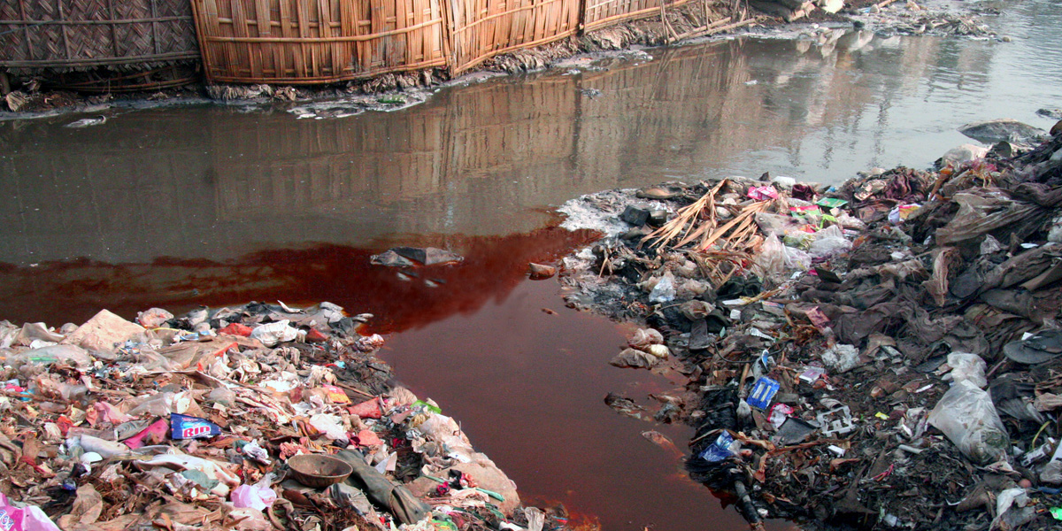
Fig 1. Dye entering a river. Photo: RiverBlue, 2016

The phrase “Ignorance Is Bliss” was coined by the English poet Thomas Gray in 1742. This phrase has become the rule to follow for those who actively choose to deny the insurmountable and unfathomable destruction that has been forcefully implanted into developing nations by the fashion and textile industries. The over-production of “wear it once” items, fuelled by major high street clothing brands in highly developed countries have led to devastating effects on the environment. The natural resources in countries such as China are now facing severe environmental stress. “There is a joke in China that you can tell the ‘it’ color of the season by looking at the color of the rivers” says fashion designer and activist Orsola de Castro (Riverblue, doc, 2016). While acknowledging the spilling of red dye into a river (fig.1) not only seems unnatural but also serves as a reminder that the connotations of the colour red incite thoughts of bloodshed, and at its very core, these industries are killing our planet, one garment at a time.

Key statement:
2. We must not condone the irresponsible actions of ‘fast fashion’ but instead should embrace a more traditional approach of how to extend the life cycle of our clothing.
A survey carried out by British Wool in 2022 stated that the average British person will throw away 6 pieces of clothing a month, totalling 72 pieces a year (fig.2) .
With rapidly changing trends and easily accessible, low-cost clothing there no longer appears to be the need to maintain the longevity of our staple wardrobe items. Shamelessly buying a new dress or shirt every weekend as to not be photographed wearing the same outfit twice. The wardrobe becomes a graveyard for unloved, unwanted, and impulsively bought clothes.
To preserve resources during WWII the British Government introduced the ‘Make-do and Mend’ campaign (fig.3). This was to reduce the consumption of clothing and encouraged people to repair or rework the items that they already owned, bringing new life to old clothes.

Fig 2. British Wool survey poster, 2022
Fig 3. Make-do and mend, WWII propaganda poster, 1942.

Key statement:
8. We must understand that some of the smallest changes can have the biggest impact.

With the current economic uncertainty that a lot of countries are facing, it is easy to understand that people are more concerned about how they will feed their family, rather than ruminating over the life cycle of every item of clothing that they own.
It is wildly ambitious (at the present time) to suggest that individuals should only purchase organic cotton clothing or replace every synthetic material they own with natural fibres. For most, it is financially impossible. However, small steps can be taken in all households to lead a more conscientious way of living and each playing our small part in fixing a bigger problem. Climate activist Livia Firth of Eco-Age started the “30 wears” challenge in 2016. “It all starts with a simple question: will I wear this clothing item at least 30 times before I throw it out?” (Firth, 2016). A simple question to consider before thoughtlessly purchasing something that we may not need.

Reference list:
RiverBlue, (2016). Directed by Roger Williams, David McIlvride. Canada, Paddle Productions.

Firth, L. (2016) Wear me 30 times [Website Wear Me 30 Times]. Available at: https://wearme30times.com (Accessed 31st October 2023)

Gray, T. (1768) Poems. London, J. Dodsley. pp 17-25.

List of Figures
Figure 1:Dye entering a river, RiverBlue documentary, 2017. Accessed: https://www.instagram.com/p/BNsCY2yBa6g/?igshid=MzRlODBiNWFlZA%3D%3D
Figure 2: British wool survey poster, 2022. Accessed: https://shop.britishwool.org.uk/wool-clothing-apparel/
Figure 3: ‘Make-do and Mend’ WWII propaganda poster, 1942. Accessed: https://www.iwm.org.uk/collections/item/object/19999

Word count: 465

