Aimee Thomas
The Irish Question 1886-1998 (from Charles Parnell to the Good Friday Agreement)
(HPHI5020)
University of Wales Trinity Saint David
Dr Lester Mason
18.10.2024
Document Analysis
The two documents chosen are photographs of Countess Constance Markievicz. The first photograph of Countess Markievicz is taken a year before the Easter Rising of 1916. The second document is a magazine publication of Countess Markievicz in 1917, after the Rebellion. Countess Constance Markievicz was born on the 4th of February in 1868, to Anglo-Irish aristocratic parents Sir Henry Gore-Booth and Lady Georgina. Constance Markievicz first got involved with politics when she first joined the National Union of Women Suffrage Societies in 1892. After her marriage to Count Casimir Markievicz, in 1900, she moved to Dublin which saw the beginning of her involvement with the Republican Sinn Fein Party and the Daughter of Ireland, a radical women’s group in 1908. Countess Constance Markievicz was an Irish nationalist, a socialist and a suffragette.

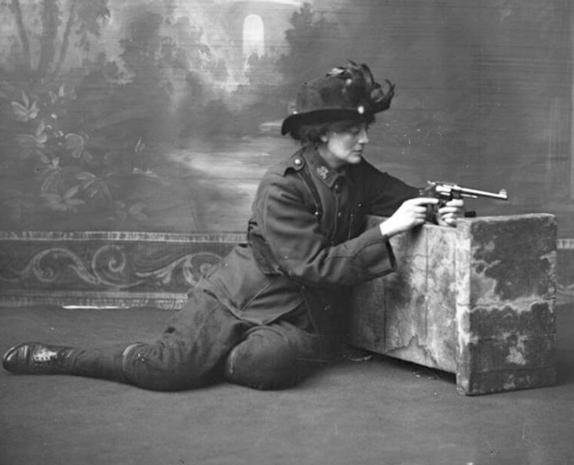
Figure 1 Countess Constance Markievicz in uniform, kneeling against a studio prop holding a gun, Keogh Brothers Ltd (photographers), ‘Keogh photographic collection’, (1915), National Library of Ireland
The first document (figure 1) is a studio photograph taken of Countess Constance Markievicz by the Keogh Brothers of Dublin in 1915. The black and white photograph shows Countess Markievicz in a full Sinn Fein male uniform with a feathered decorated hat and a revolver. She is positioned in a defensive position leaning upon a small section of a wall in front of a painted canvas. The canvas background is painted with a romantic scene of a wooded landscape featuring a river with a stone bridge. She appears to be studying the gun as if ready to point and pull the trigger. This image is part of a set of three photographs that were commissioned by Countess Markievicz.
In the period of 1915, the United Kingdom was currently involved with fighting the Great War as well as seeing a Women’s Right Campaign, the Suffrage Movement. Alongside this, the Sinn Fein party and a few nationalist leader sympathisers were actively planning a full-scale Rebellion against British Rule in Ireland. This photograph was taken by the Keogh Brothers of Dublin in 1915 of Countess Markievicz. The Keogh brothers were established in 1909 in Dublin. The company found itself to be associated with some key figures of the rebellion and produced a collection of photographs of the Easter Rising. One such group included the Irish Republican Brotherhood, which was a secret fraternity dedicated to the cause of Irish independence. They used the Keogh Brothers to photograph their leaders for propaganda use. The Countess Markievicz became acquainted with the Irish Republican Brotherhood, however due to her gender she was not officially a member but worked alongside them. The countess was also involved in many radical nationalist groups during this time, such as James Connolly and training the Irish Citizen Army. At this time Countess Markievicz was involved in early planning of the rebellion. The countess was tasked to prepare and organise volunteers as well as distributing firearms.
The usage of photographs during this time served as a tool for propaganda by the Irish Nationalists. Irish Nationalist used the Keogh Brothers to promote their propaganda by having their pictures taken. Countess Markievicz supported the Irish Nationalist, as such to contribute and support the propaganda she had commissioned this image as well as two others as a set of three to be used. After the event of the Easter Rising, photographs such as this, with the revolutionary leaders, photographic pamphlets were then distributed to the Irish public, the pamphlets were then becoming popular. The photograph foretold the story of her involvement in the violence and the rebellion. The image expresses to the public that Countess Markievicz was viewed as a soldier by the Irish Nationalist and was taken seriously. However, the images do not disregard countess Markievicz femininity, this is shown with her hat. While the image lacks a feminine outlook, she replaces the Irish Citizen Army slough hat for a more feminine and decorative headwear instead. This could be seen as a way to empower women into involving themselves politically, especially during a time of women rights campaign. By using images such as these the Irish nationalist would hope to see an increase of support, especially with the photograph of the countess from women in Ireland.
The photograph was commissioned by the countess herself. This suggests foresight of the rising and the desire for the narrative to include the participation of women in the fight for the freedom of Ireland. Countess Markievicz understood that art, particularly photographs, were a way to tell a story. She made numerous collections of photographs commissioned throughout her life including from theatrical background. The intended message analysed by Baylis appears to suggest that countess Markievicz wanted to be remembered for her participation of the Rising as well as within History itself. The photographs were seen as a documentation of history. By using photographs, it allowed to record and document history in a more profound way. The intention of the image, while to gain nationalist support, would also have been a bold statement. A woman in trousers holding a gun would not have been a common image. As such the photograph would produce attention from the Irish public but also from Great Britain to the nationalist cause. The photograph ensures that Countess Markievicz would be remembered for her support and the foresight of her participation within the Easter Rising.
This document is useful when researching the Irish Nationalist propaganda as well with engaging with some key figures, such as Countess Constance Markievicz, before the Easter Rising. Similarly, the image allows an insight to the political activism of Countess Markievicz and her engagement with supporting the suffrage movement within Ireland.

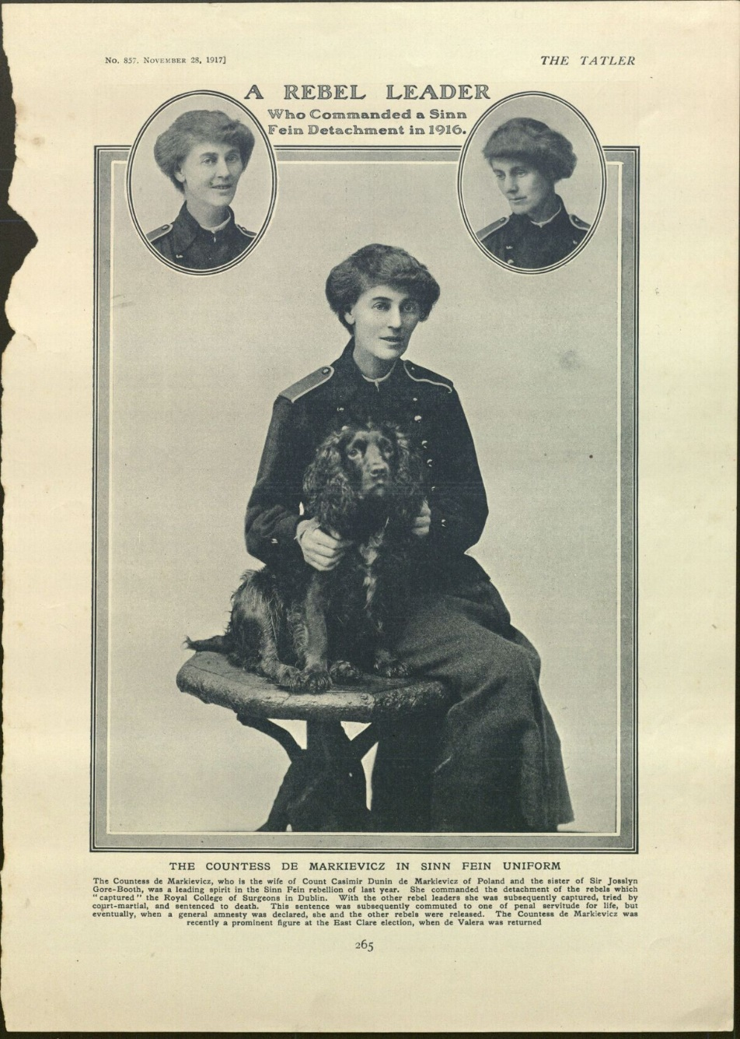
Figure 2 ‘Rebel Leader’, Tatler Magazine (1917) Kenneth Spencer Research Library blog
This document (Figure 2) is part of a magazine issue on Countess Constance Markievicz. The document was published by a gossip columnist, Tatler, on the 28th of November 1917, a year after the Easter Rising in 1916. The print displays three images of Countess Markievicz, two circular head shots with a full body portrait in black and white. She is positioned sitting with a dog on a stool, wearing a more feminine version of a Sinn Fein uniform with a skirt instead of trousers. She is pictured in a lady-like pose. However, this is contrasted by the title, ‘The Rebel Leader’ used in a bold font. In small writing, in between the two circular headshots, it announces her involvement in the Easter Rising Rebellion. Along with the miniature font at the bottom of the page that informs the reader of her participation in the Easter Rising and her sentencing.
Tatler magazine began publishing in 1901 in London, their focus was on society and gossip. Tatler is still currently catered to a society readership. In the early 20th century, Tatler curated to high society and was primarily published on gossip and drama. Countess Markievicz would have most likely engaged with Tatler due to the countess privileged upbringing and marriage title. Tatler magazine typically engages with high society people and events as such the story of the countess would be of interest. It showed an aristocratic woman being involved in politics before women were allowed to vote.
At the time of publication, it was a year later after the failure of the Easter Rising. Countess Markievicz was released from prison as the countess was arrested due to her involvement in the rebellion. The main aim of the Easter Rising was to remove Great British Rule within Ireland. Countess Markievicz was actively involved with the rebellion, which is slightly described by Tatler on the bottom of the page. The countess was given her own section of the city to occupy and defend, the Royal College of Surgeons in Dublin. The countess was tasked to support the para-military youth organisation, Fianna Eireann, during the rebellion. Fianna Eireann was co-founded by Countess Markievicz in 1909 and was part of the violence in the Easter Rising in 1916. Due to her participation in the violence, she was arrested and was sentenced to death along with the leaders of the Easter Rising Rebellion. Fortunately, she was spared due to her gender and was given commute to penal servitude for life until her release in June 1917 by the General Amnesty. When the countess was released from prison, she continued her political activism and supporting the Irish Nationalist, which is demonstrated with the publication by Tatler of Countess Markievicz wearing Sinn Fein uniform. Two months after this publication the Sinn Fein party won seventy three seats in Ireland from the 1918 general election. This saw Countess Markievicz as the first female member of the British parliament. Famously she refused to take her seat. Alongside this, the first victory of the women’s right campaign would see the Representation of the People Act in November 1918 come to pass. This would grant women over the age of 30 to vote.
Tatler readership in the early 20th century was targeted to high and upper middle class. Having to allow to profile the countess, this brings a genuine curiosity to the Irish public on how a woman that was involved in such a violent campaign could look soft and feminine. Her choice to wear the Sinn Fein uniform, all be it with a traditional feminine gown demonstrates her attachment to Ireland rather than to Great Britain. As well as Countess Markievicz cooperation with Tatler allowed the countess to take advantage of Tatler readership. By using the readership and Tatler publicity she could continue to keep her memory alive within History. While also using it as another form of propaganda that the countess could take advantage of to promote the Sinn Fein party, especially with the upcoming general election during this time. The readership would also be confronted with a women involved with politics around a time where talks were on-going between British politicians in between 1916 to 1917, to allow women the vote over the age of 30. By Tatler having to publish the gossip column of the countess, it could demonstrate a support for women enfranchisement during this time. Especially since Countess Markievicz was a well-known political activist in Ireland and Great Britain.
The time of Countess Markievicz imprisonment the perception of females involved of the Easter Rising was changing. The Easter Rising historiography was already re-writing women out of the rebellion. Female participation was being forgotten in the memory of the rising or ignored due to the stereotype of women during this time. There was a real fear by Countess Markievicz of being written out of history, as some nationalists were already doing to over one hundred women who were actively participated during the Rebellion. There was an conscious effort by Countess Markievicz to be remembered in the ongoing struggle of Ireland’s independence at this time. Due to this Countess Markievicz is sometimes viewed as the only female involved with the Easter Rising rebellion. The publication by Tatler could be perceived as an attempt by the countess to revoke her status in society while also continuing to support women enfranchisement. The countess wanted to be remembered for her support and activism in politics while also her participation of fighting for Irish independence.

Comparing both documents the image and the Tatler publication demonstrate a willingness from the countess to not be forgotten in the role she played in Irish Independence and the support of women rights. Both pictures show her attachment and support of Ireland rather than Britain through the uniforms the countess wears. There is a bold statement made by the countess’s commission of the image and Tatler description of the countess. The image stands out due to a women wearing a Sinn Fein male uniform, with the revolver, in a time where it would have been deemed inappropriate. Similarly, Tatler makes the publication bold with its statement of ‘Rebel Leader’ along with Countess Markievicz wearing a more lady-like Sinn Fein Uniform. Both documents support women enfranchisement as it illustrates a support of a women engaging with politics at the time. Figure 1 and figure 2 both support Irish nationalist propaganda as the countess pictured wearing their uniform in both images. However, there is a clear transition between the two. Figure 1 exhibits a bold statement of the countess ready to participate in battle to defend Ireland from British rule, that the countess commissioned herself. Figure 2 displays a more passive attempt to engage the public in politics. Perhaps due to the countess recent releasement from prison, by using Tatler, the countess can re-introduce herself into high society and fix her image after her imprisonment. Both documents inform the political life of the countess and her engagement with the Sinn Fein party, alongside the Irish nationalist propaganda and media representation.
Analysing the two documents both tells a story about women’s involvement in the Easter rising through Countess Markievicz three-piece series and Tatler publication. Alongside, the Irish nationalist usage of propaganda. The image of the countess demonstrates the Irish nationalist attempt of propaganda and their willingness to record the rebellion through documentation of images. Although, both documents demonstrate information of the countess herself, her political activism and her support of the women rights campaign. The documents engage with Countess Markievicz with her involvement in the Easter Rising. As well as her political activism through the suffrage movement and the Sinn Fein Party. Both documents engage with the political activism of Countess Markievicz, the politics of the Sinn Fein party and the Easter Rising Historiography.

Reference List:
Barber, Dr Fionna, ‘Constructing Constance (and Some Other Women)’, in Beyound the Pale: The Art of Revolution (presented at the Highlanes and Drogheda Arts Festival, Highlanes Gallary, 2016), pp. 1–19.
Baylis, Gail, ‘Con Colbert’s Portrait: The Lives of a Photograph’, History of Photography, 41.1 (2017), pp. 44–60, doi:10.1080/03087298.2017.1284365.
———, ‘What to Wear for a Revolution? Countess Constance Markievicz in Military Dress.’, Eire-Ireland, 54.3/4 (2019), pp. 94–122, doi:10.1353/eir.2019.0015.
BBC, ‘War and Conflict, 1916 Easter Rising - Profiles - The Irish Republican Brotherhood’, BBC History, 2024 <https://www.bbc.co.uk/history/british/easterrising/profiles/po17.shtml> [accessed 17 October 2024].
British Newspaper Archive, ‘The Tatler in British Newspaper Archive’, 2024 <https://www.britishnewspaperarchive.co.uk/titles/the-tatler> [accessed 17 October 2024].
Clarke, Mollie, ‘The National Archives - Constance Markievicz: 1916 and Beyond’, The National Archives Blog (The National Archives, 2021) <https://blog.nationalarchives.gov.uk/constance-markievicz-1916-and-beyond/> [accessed 14 October 2024].
———, ‘The National Archives - Constance Markievicz: The Making of a Rebel Countess’, The National Archives Blog (The National Archives, 2021) <https://blog.nationalarchives.gov.uk/constance-markievicz-the-making-of-a-rebel-countess/> [accessed 14 October 2024].
De Bromhead, Alan, Alan Fernihough, and Enda Hargaden, ‘Representation of the People: Franchise Extension and the “Sinn Féin Election” in Ireland, 1918’, The Journal of Economic History, 80.3 (2020), pp. 886–925, doi:10.1017/S0022050720000376.
Edge, Sarah Jane, ‘Photographic History and the Visual Appearance of an Irish Nationalist Discourse 1840–1870’, Victorian Literature and Culture, 32.1 (2004), pp. 17–39, doi:10.1017/S1060150304000348.
Forker, Martin, ‘Revolution: A Photographic History of Revolutionary Ireland, 1913-1923’, Irish Studies Review, 20.2 (2012), pp. 204–7, doi:10.1080/09670882.2012.676297.
Keogh Brothers Ltd (photographers), ‘Keogh photographic collection’, (1915), National Library
of Ireland <Holdings: [Countess Constance Markievicz in uniform, kneeling against a studio prop holding a gun, studio full-length portrait] (nli.ie)> [accessed: 13 October 2024].
National Army Museum, ‘Easter Rising’, National Army Museum, 2024 <https://www.nam.ac.uk/explore/easter-rising> [accessed 13 October 2024].
Tatler, ‘Rebel Leader’, (1918), Kenneth Spencer Research Library blog
< Kenneth Spencer Research Library Blog » Representing the Countess: Constance Markievicz in the Poetry of Eva Gore-Booth & W. B. Yeats (ku.edu)> [accessed: 13 October 2024].
UK Parliament, ‘Women Get the Vote’, Women and the Vote, 2024 <https://www.parliament.uk/about/living-heritage/transformingsociety/electionsvoting/womenvote/overview/thevote/> [accessed 18 October 2024].
Weihman, Lisa, ‘“Doing My Bit for Ireland”: Transgressing Gender in the Easter Rising.’, Eire-Ireland, 39.3/4 (2004), pp. 228–49, doi:10.1353/eir.2004.0025.

Bibliography:
Barber, Dr Fionna, ‘Constructing Constance (and Some Other Women)’, in Beyound the Pale: The Art of Revolution (presented at the Highlanes and Drogheda Arts Festival, Highlanes Gallary, 2016), pp. 1–19
Baylis, Gail, ‘Con Colbert’s Portrait: The Lives of a Photograph’, History of Photography, 41.1 (2017), pp. 44–60, doi:10.1080/03087298.2017.1284365
———, ‘What to Wear for a Revolution? Countess Constance Markievicz in Military Dress.’, Eire-Ireland, 54.3/4 (2019), pp. 94–122, doi:10.1353/eir.2019.0015
BBC, ‘War and Conflict, 1916 Easter Rising - Profiles - The Irish Republican Brotherhood’, BBC History, 2024 <https://www.bbc.co.uk/history/british/easterrising/profiles/po17.shtml> [accessed 17 October 2024]
British Newspaper Archive, ‘The Tatler in British Newspaper Archive’, 2024 <https://www.britishnewspaperarchive.co.uk/titles/the-tatler> [accessed 17 October 2024]
Clarke, Mollie, ‘The National Archives - Constance Markievicz: 1916 and Beyond’, The National Archives Blog (The National Archives, 2021) <https://blog.nationalarchives.gov.uk/constance-markievicz-1916-and-beyond/> [accessed 14 October 2024]
———, ‘The National Archives - Constance Markievicz: The Making of a Rebel Countess’, The National Archives Blog (The National Archives, 2021) <https://blog.nationalarchives.gov.uk/constance-markievicz-the-making-of-a-rebel-countess/> [accessed 14 October 2024]
De Bromhead, Alan, Alan Fernihough, and Enda Hargaden, ‘Representation of the People: Franchise Extension and the “Sinn Féin Election” in Ireland, 1918’, The Journal of Economic History, 80.3 (2020), pp. 886–925, doi:10.1017/S0022050720000376
Edge, Sarah Jane, ‘Photographic History and the Visual Appearance of an Irish Nationalist Discourse 1840–1870’, Victorian Literature and Culture, 32.1 (2004), pp. 17–39, doi:10.1017/S1060150304000348
Forker, Martin, ‘Revolution: A Photographic History of Revolutionary Ireland, 1913-1923’, Irish Studies Review, 20.2 (2012), pp. 204–7, doi:10.1080/09670882.2012.676297
National Army Museum, ‘Easter Rising’, National Army Museum, 2024 <https://www.nam.ac.uk/explore/easter-rising> [accessed 13 October 2024]
UK Parliament, ‘Women Get the Vote’, Women and the Vote, 2024 <https://www.parliament.uk/about/living-heritage/transformingsociety/electionsvoting/womenvote/overview/thevote/> [accessed 18 October 2024]
Weihman, Lisa, ‘“Doing My Bit for Ireland”: Transgressing Gender in the Easter Rising.’, Eire-Ireland, 39.3/4 (2004), pp. 228–49, doi:10.1353/eir.2004.0025

Mollie Clarke, ‘The National Archives - Constance Markievicz: The Making of a Rebel Countess’, The National Archives Blog (The National Archives, 2021) <https://blog.nationalarchives.gov.uk/constance-markievicz-the-making-of-a-rebel-countess/> [accessed 14 October 2024].
Clarke, ‘The National Archives - Constance Markievicz’.
Clarke, ‘The National Archives - Constance Markievicz’.
Gail Baylis, ‘What to Wear for a Revolution? Countess Constance Markievicz in Military Dress.’, Eire-Ireland, 54.3/4 (2019), pp. 94–122, doi:10.1353/eir.2019.0015. Keogh Brothers Ltd (photographers), ‘Keogh photographic collection’, (1915), National Library of Ireland <Holdings: [Countess Constance Markievicz in uniform, kneeling against a studio prop holding a gun, studio full-length portrait] (nli.ie)> [accessed: 13 October 2024].
National Army Museum, ‘Easter Rising’, National Army Museum, 2024 <https://www.nam.ac.uk/explore/easter-rising> [accessed 13 October 2024].
Gail Baylis, ‘Con Colbert’s Portrait: The Lives of a Photograph’, History of Photography, 41.1 (2017), pp. 44–60, doi:10.1080/03087298.2017.1284365. p.46
BBC, ‘War and Conflict, 1916 Easter Rising - Profiles - The Irish Republican Brotherhood’, BBC History, 2024 <https://www.bbc.co.uk/history/british/easterrising/profiles/po17.shtml> [accessed 17 October 2024].
Clarke, ‘The National Archives - Constance Markievicz’. Martin Forker, ‘Revolution: A Photographic History of Revolutionary Ireland, 1913-1923’, Irish Studies Review, 20.2 (2012), pp. 204–7 (p. 205), doi:10.1080/09670882.2012.676297.
Clarke, ‘The National Archives - Constance Markievicz’.
Clarke, ‘The National Archives - Constance Markievicz’.
Forker. p.205
Forker, p. 204.
Dr Fionna Barber, ‘Constructing Constance (and Some Other Women)’, in Beyound the Pale: The Art of Revolution (presented at the Highlanes and Drogheda Arts Festival, Highlanes Gallary, 2016), pp. 1–19 (p. 9).
Barber, pp. 4–5. Baylis, ‘What to Wear for a Revolution?’, p. 105.
Baylis, ‘What to Wear for a Revolution?’p.107
Sarah Jane Edge, ‘Photographic History and the Visual Appearance of an Irish Nationalist Discourse 1840–1870’, Victorian Literature and Culture, 32.1 (2004), pp. 17–39, (p.18) doi:10.1017/S1060150304000348.
Lisa Weihman, ‘“Doing My Bit for Ireland”: Transgressing Gender in the Easter Rising.’, Eire-Ireland, 39.3/4 (2004), pp. 228–49 (p. 229), doi:10.1353/eir.2004.0025.
Baylis, ‘What to Wear for a Revolution?’, p. 108.
Tatler, ‘Rebel Leader’, (1918), Kenneth Spencer Research Library blog < Kenneth Spencer Research Library Blog » Representing the Countess: Constance Markievicz in the Poetry of Eva Gore-Booth & W. B. Yeats (ku.edu)> [accessed: 13 October 2024].
British Newspaper Archive, ‘The Tatler in British Newspaper Archive’, 2024 <https://www.britishnewspaperarchive.co.uk/titles/the-tatler> [accessed 17 October 2024].
National Army Museum.
Clarke, ‘The National Archives - Constance Markievicz’.
Mollie Clarke, ‘The National Archives - Constance Markievicz: 1916 and Beyond’, The National Archives Blog (The National Archives, 2021) <https://blog.nationalarchives.gov.uk/constance-markievicz-1916-and-beyond/> [accessed 14 October 2024].
Clarke, ‘The National Archives - Constance Markievicz’.
Alan De Bromhead, Alan Fernihough, and Enda Hargaden, ‘Representation of the People: Franchise Extension and the “Sinn Féin Election” in Ireland, 1918’, The Journal of Economic History, 80.3 (2020), pp. 886–925 (p. 887), doi:10.1017/S0022050720000376.
Constructing Markievicz p. 4
UK Parliament, ‘Women Get the Vote’, Women and the Vote, 2024 <https://www.parliament.uk/about/living-heritage/transformingsociety/electionsvoting/womenvote/overview/thevote/> [accessed 18 October 2024].
De Bromhead, Fernihough, and Hargaden, p. 887.
UK Parliament, ‘Women Get the Vote’, Women and the Vote, 2024 <https://www.parliament.uk/about/living-heritage/transformingsociety/electionsvoting/womenvote/overview/thevote/> [accessed 18 October 2024].
Baylis, Gail. “What to Wear for a Revolution? Countess Constance Markievicz in Military Dress.” Eire-Ireland 54. 3/4 (2019),94–122 (p.108-109) < https://doi.org/10.1353/eir.2019.0015>.
Weihman, p. 229; Weihman, p. 231.
Constructing Markievicz p. 4
Weihman, p. 231.
Forker, p. 205.

