University of Wales Trinity Saint David
LONDON CAMPUS
Data Security and Compliance
ACCA5034
Module Name: Data Security and Compliance
Module Code: ACCA5034

Student Name: Dumitru Danilov
Student ID: 2430681

Lecturer’s Name: Dr Ayman Al Hajjar

Contents
Task 1. 2
Abstract 2
1. Introduction 2
2. Why AI Governance Is Necessary 2
3. Risks of AI and Machine Learning Systems 3
4. Governance Frameworks for AI 4
5. Security, Privacy and Compliance Controls 5
6. Critical Comparison of Governance Approaches 7
7. Business Continuity and Regulatory Compliance 8
8. Implementation Challenges and Limitations 10
9. Recommended AI Governance Roadmap 10
10. Conclusion 12
References 13
Task 2 14
Abstract 14
1. Introduction 14
2. Strategic Objectives and Cybersecurity Design Principles 15
3. Organisational Structure and Accountability 16
4. Policies and Procedures 17
5. Governance Model Based on NIST Cybersecurity Framework 2.0 18
6. Compliance and Regulatory Alignment 19
7. Risk Management and Assessment 19
8. Incident Response and Disaster Recovery Programme 21
9. Protection Controls and Implementation Roadmap 22
10. Conclusion 23
References 24

Task 1.
Governance of AI and Machine Learning Systems: Managing risk, ethics, and compliance for AI data and models

Abstract
Artificial Intelligence (AI) and Machine Learning (ML) are widely used to automate tasks, detect fraud, improve customer service, and support decision-making. However, they also create security, privacy, ethical, and compliance risks that require effective governance throughout the AI lifecycle.
This research examines how organisations can manage AI-related threats using frameworks such as NIST AI RMF, ISO/IEC 42001, and the EU AI Act. It also considers implementation challenges and proposes a practical roadmap for secure, responsible, and compliant AI governance.
Keywords— Artificial Intelligence, Machine Learning, AI Governance, Data Security, Compliance, Risk Management, ISO/IEC 42001, NIST AI RMF.

Introduction

Artificial Intelligence has changed how organisations process information and make decisions across industries such as healthcare, banking, manufacturing, and cybersecurity [12].
As AI adoption grows, governance frameworks have become increasingly important [1], [2], [5], [13]. The NIST AI RMF uses four functions—Govern, Map, Measure, and Manage—while ISO/IEC 42001 provides an AI management standard and the EU AI Act introduces legal requirements based on risk levels.
This paper examines how AI governance helps organisations anticipate threats, protect data and models, detect abnormal behaviour, respond to incidents, and manage practical implementation challenges [1], [8].

2. Why AI Governance Is Necessary
Artificial intelligence provides significant benefits but also increases organisational risks, especially when governance develops more slowly than AI adoption [1], [7]. Effective AI governance therefore requires continuous risk management, particularly because poor-quality or biased data can produce inaccurate and unfair decisions [4], [11].
Privacy and ethics are also important because AI systems often process personal information and influence decisions in areas such as employment, finance, and healthcare. Organisations must comply with privacy regulations and ensure transparency, accountability, and human oversight [3], [5], [7], [13].
The NIST AI RMF addresses these challenges by promoting continuous governance throughout the AI lifecycle, including clear policies, responsibilities, monitoring, documentation, and regular risk assessment [1].

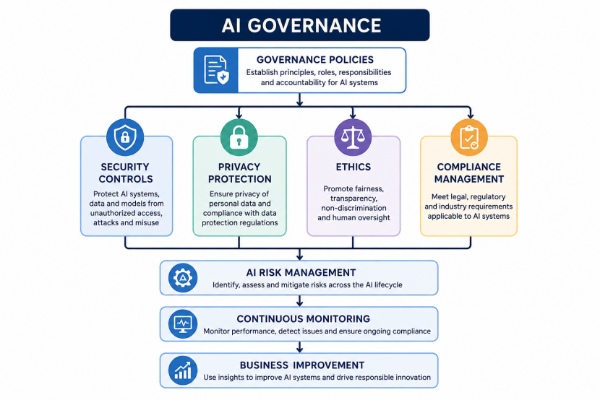
Figure 1. Example of an AI governance framework integrating security, privacy, ethics and regulatory compliance.

3. Risks of AI and Machine Learning Systems
AI systems introduce risks related to data, models, cybersecurity, compliance, and business operations. Organisations must understand these risks before implementing effective governance.
3.1 Data Risks
AI depends heavily on data quality. Incomplete, outdated, incorrect, or biased data can reduce model accuracy and produce unfair decisions [4], [11]. Organisations should therefore establish clear data ownership, quality checks, classification, and secure storage.
3.2 Model Risks
AI models may become less accurate as conditions change, known as model drift, requiring continuous monitoring and retraining [1], [11]. Models may also be stolen or used to extract confidential information, making model protection an important security requirement.
3.3 Security Risks
AI-specific threats include data poisoning, adversarial attacks, model theft, model inversion, and prompt injection. Traditional security controls alone are insufficient, so organisations need AI-specific testing, secure development, and continuous monitoring [6], [10], [11].

3.4 Compliance and Legal Risks
Organisations must comply with growing AI, privacy, and cybersecurity regulations [5]. Failure to demonstrate compliance may result in penalties, investigations, or restrictions. Documentation, audit logs, and regular risk assessments are therefore essential.
3.5 Business Risks
Poor AI governance can cause financial losses, operational disruption, reputational damage, and loss of customer trust. AI governance should therefore support not only compliance but also trustworthy innovation and long-term business resilience [1], [2].

4. Governance Frameworks for AI
AI governance combines policies, standards, processes, and technical controls to reduce security, privacy, ethical, and legal risks while supporting responsible innovation.
The NIST AI Risk Management Framework (AI RMF 1.0) provides voluntary guidance for managing AI risks throughout the lifecycle [1]. It includes four main functions:
- Govern – establish policies and responsibilities.
- Map – identify AI systems and risks.
- Measure – assess performance, fairness, and security.
- Manage – reduce risks and continuously improve governance.
ISO/IEC 42001:2023 provides a structured AI Management System (AIMS), including policies, responsibilities, risk management, audits, and continuous improvement [2]. ISO/IEC 27001 complements it by providing information security controls for data protection, access management, and incident response [3].
The EU AI Act provides a legal, risk-based approach, with stricter requirements for high-risk AI systems, including transparency, human oversight, cybersecurity, and documentation [5].
Although these frameworks have different purposes, they share principles such as accountability, transparency, monitoring, and continuous risk management. Organisations can combine them according to their business and regulatory needs.

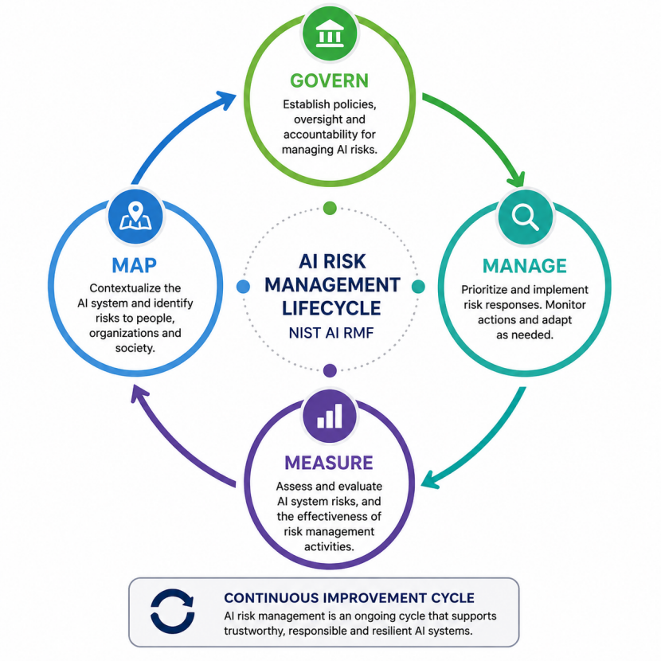
Figure 2. Relationship between ISO/IEC 42001, ISO/IEC 27001, NIST AI RMF, and the EU AI Act [1].

5. Security, Privacy and Compliance Controls
Effective AI governance depends not only on policies but also on practical security controls. Organizations should protect both the data used to train AI models and the models themselves. Security controls should cover the entire AI lifecycle, from data collection to system retirement.
One of the first controls is data governance [4]. Training data should be accurate, complete, and regularly reviewed for quality. Organizations should know where the data comes from, who owns it, and whether it contains personal or confidential information. Poor data quality often results in unreliable AI decisions.
Access control is another important requirement [3]. Only authorized employees should have permission to access training datasets, AI models, and development environments. Multi-factor authentication, role-based access control, and regular permission reviews help reduce the risk of unauthorized access.
Organizations should also encrypt sensitive information both while it is stored and while it is transmitted across networks. Encryption reduces the impact of data breaches and supports compliance with privacy regulations [3], [8].
Continuous monitoring is equally important [8]. AI systems should be monitored for unusual behavior, unexpected outputs, performance degradation, and possible security attacks. Security logs should be collected and reviewed regularly so that incidents can be detected quickly.
Modern organizations are also introducing AI-specific security testing [6], [10]. Traditional penetration testing focuses mainly on networks and applications. AI systems require additional testing against threats such as data poisoning, adversarial attacks, prompt injection, and model extraction. Regular testing helps identify weaknesses before attackers exploit them.
Finally, employees should receive regular AI security awareness training [2], [8]. Human error remains one of the most common causes of security incidents. Staff should understand AI risks, recognize suspicious activities, and follow organizational policies when developing or using AI systems.

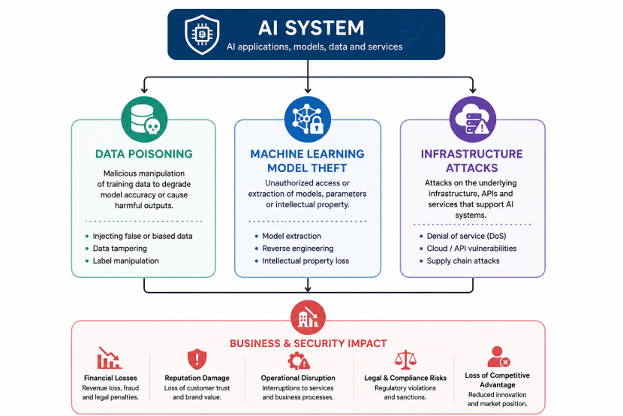

Figure 3. AI System Security Risks

6. Critical Comparison of Governance Approaches
Different AI governance frameworks have different strengths and weaknesses. No single framework can solve every organizational challenge. For this reason, many organizations combine several standards and regulations.
The NIST AI RMF is flexible and practical. It can be applied by organizations of different sizes and industries. Because it is voluntary, organizations have freedom to adapt it to their own business environment. However, this flexibility may also lead to inconsistent implementation because there are no mandatory certification requirements [1].
In contrast, ISO/IEC 42001 provides a structured management system. It clearly defines organizational responsibilities, documentation requirements, internal audits, and continual improvement. Certification may also increase customer confidence. On the other hand, implementation requires additional time, resources, and organizational commitment, which may be difficult for smaller businesses [2].
The EU AI Act differs from both NIST and ISO because it is legislation rather than guidance [5]. Organizations operating within the European Union must comply with its legal requirements. The risk-based approach allows regulators to focus on applications that have the greatest impact on society. However, meeting all compliance requirements may increase costs and slow down AI deployment, especially for organizations that develop high-risk AI systems.
The three approaches also differ in their primary focus. NIST concentrates on practical risk management. ISO/IEC 42001 focuses on organizational governance and management systems. The EU AI Act focuses on legal compliance and protection of fundamental rights. Instead of competing with each other, these approaches complement one another.
For many organizations, the best solution is to combine them. NIST AI RMF can guide day-to-day risk management, ISO/IEC 42001 can establish organizational governance, and the EU AI Act can ensure legal compliance where applicable. Together they create a stronger governance framework than any single approach alone [1], [2], [5].
Table 1 Summarizes the main differences.
Framework | Main Purpose | Strengths | Limitations
NIST AI RMF | AI risk management | Flexible, practical, continuous improvement | Voluntary, no certification
ISO/IEC 42001 | AI management system | Structured governance, internationally recognised | More complex and resource-intensive
EU AI Act | Legal regulation | Clear legal requirements, risk-based approach | Compliance may increase cost and administrative effort
Overall, organizations should not view governance as an obstacle to innovation. Well-designed governance improves trust, strengthens cybersecurity, supports regulatory compliance, and reduces long-term business risk. As AI technologies continue to develop, organizations that establish effective governance today will be better prepared to respond to future technological and regulatory changes [1], [2], [5].

7. Business Continuity and Regulatory Compliance
Artificial Intelligence is becoming an important part of daily business operations. Many organizations use AI to automate customer support, analyze financial transactions, monitor cybersecurity threats, and improve decision-making. Because these systems often support critical business processes, organizations must ensure that AI remains available, reliable, and secure during unexpected events.
One important requirement is the development of Business Continuity Plans (BCPs) and Disaster Recovery Plans (DRPs) that include AI systems. Traditional business continuity plans often focus on servers, databases, and network infrastructure. However, AI introduces additional assets that must also be protected, including training datasets, machine learning models, feature engineering pipelines, and model configuration files [3].
Regular backups are essential for AI environments. Organizations should securely store copies of datasets, trained models, documentation, and configuration settings. Backup procedures should be tested regularly to ensure that AI services can be restored quickly after an incident [8].
Regulatory compliance has become another important aspect of AI governance. Governments around the world are introducing new regulations that require organizations to manage AI responsibly. The European Union AI Act introduces a risk-based approach where high-risk AI systems must satisfy strict requirements related to documentation, transparency, cybersecurity, human oversight, and risk management. Organizations operating within the European market must ensure that their AI systems meet these legal obligations [5].
Privacy regulations also affect AI governance. Personal information used for training or operating AI systems must comply with laws such as the General Data Protection Regulation (GDPR). Organizations should minimize the amount of personal data collected, define clear retention periods, and implement appropriate technical and organizational security measures [3], [5].
Compliance should not be viewed only as a legal obligation. Strong compliance programmers increase customer confidence, improve organizational reputation, and reduce financial and legal risks. AI governance therefore supports both regulatory requirements and long-term business resilience [2], [8].

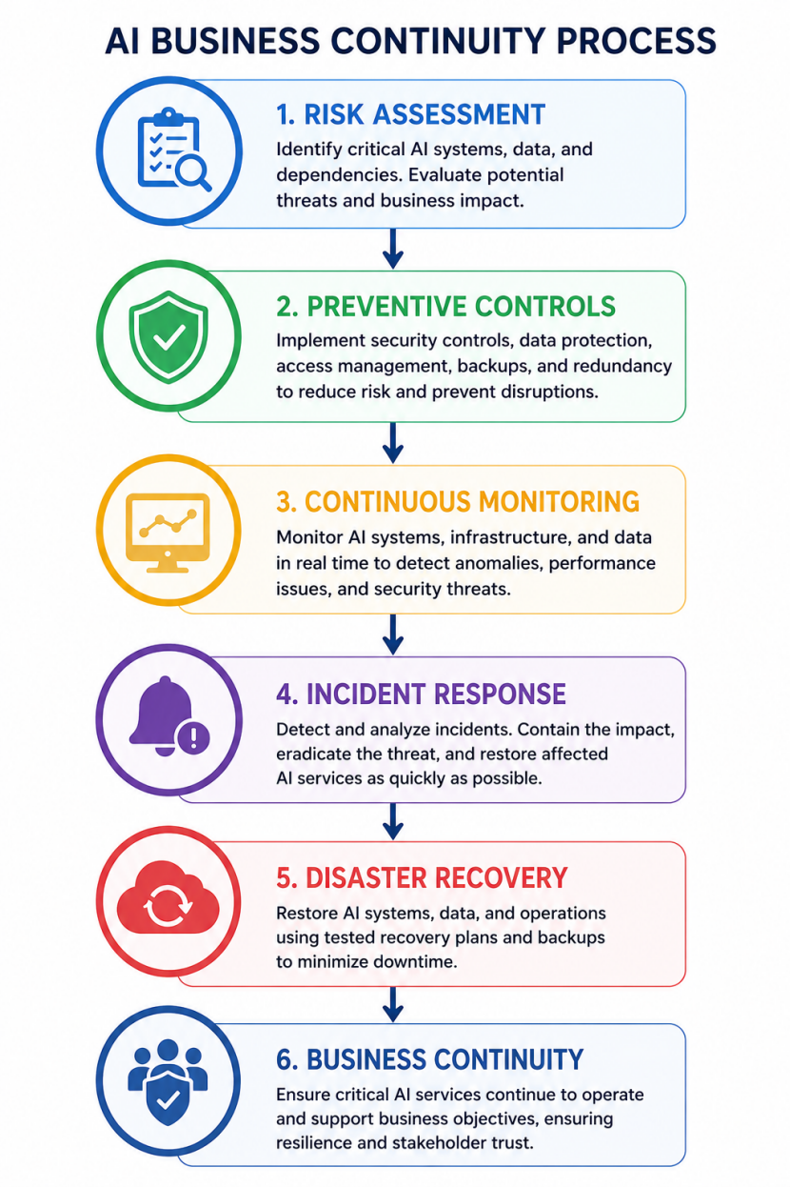
Figure 4. Business Continuity Process for AI Systems. (Figure will be inserted in the final document.) [3], [8].

8. Implementation Challenges and Limitations
Although AI governance provides many benefits, implementation can be difficult because of technical, financial, organisational, and legal challenges. AI technology develops faster than many standards and regulations, making governance of new technologies such as generative AI more complex [1], [5].
Another challenge is the shortage of professionals with combined knowledge of AI, cybersecurity, data protection, ethics, and compliance [2]. Data quality is also important because incomplete, outdated, or biased training data can produce unreliable or unfair AI decisions [4], [11]. In addition, complex AI models can be difficult to explain, reducing transparency and trust [12], [13].
Implementation also requires investment in security tools, training, audits, and documentation. International organisations face additional difficulties because regulations vary between countries. At the same time, excessive governance may slow innovation. Organisations therefore need to balance security, compliance, cost, and business flexibility [5], [7].
Despite these challenges, effective AI governance provides long-term benefits by improving security, compliance, trust, and readiness for future technological and regulatory changes [1], [2].

9. Recommended AI Governance Roadmap
Successful AI governance should be implemented gradually through a structured improvement programme. Based on current international standards and industry best practices, organisations can follow the roadmap below.
Step 1 – Establish Governance Structure
Senior management should define AI governance policies and assign clear responsibilities. A cross-functional governance committee should include representatives from cybersecurity, legal, compliance, data science, IT, and business departments [2].
Step 2 – Identify AI Systems
The organisation should create an inventory of all AI applications currently in use. Each system should be classified according to its business purpose, data sensitivity, and potential level of risk [1].
Step 3 – Perform Risk Assessment
Each AI system should undergo a structured risk assessment. The assessment should consider cybersecurity threats, privacy risks, ethical concerns, operational risks, and regulatory requirements. High-risk systems should receive additional security controls and management oversight [4].
Step 4 – Implement Technical Controls
Security controls should include:
- Multi-factor authentication;
- Role-based access control;
- Encryption;
- Secure software development practices;
- Continuous vulnerability management;
- AI-specific security testing;
- Continuous monitoring and logging.
These controls reduce both cybersecurity and operational risks [3], [8].
Step 5 – Develop Documentation
Organisations should maintain complete documentation covering datasets, model development, testing procedures, security controls, model versions, risk assessments, and management decisions. Good documentation supports audits and demonstrates compliance [2].
Step 6 – Monitor and Improve
AI governance should be reviewed regularly. Internal audits, performance monitoring, security testing, and compliance assessments should identify opportunities for improvement. Lessons learned from incidents should be incorporated into future governance activities [1].
This roadmap follows the principle of continuous improvement found in both the NIST AI Risk Management Framework and ISO/IEC 42001. Rather than treating governance as a one-time project, organisations should integrate it into normal business operations [1], [5].

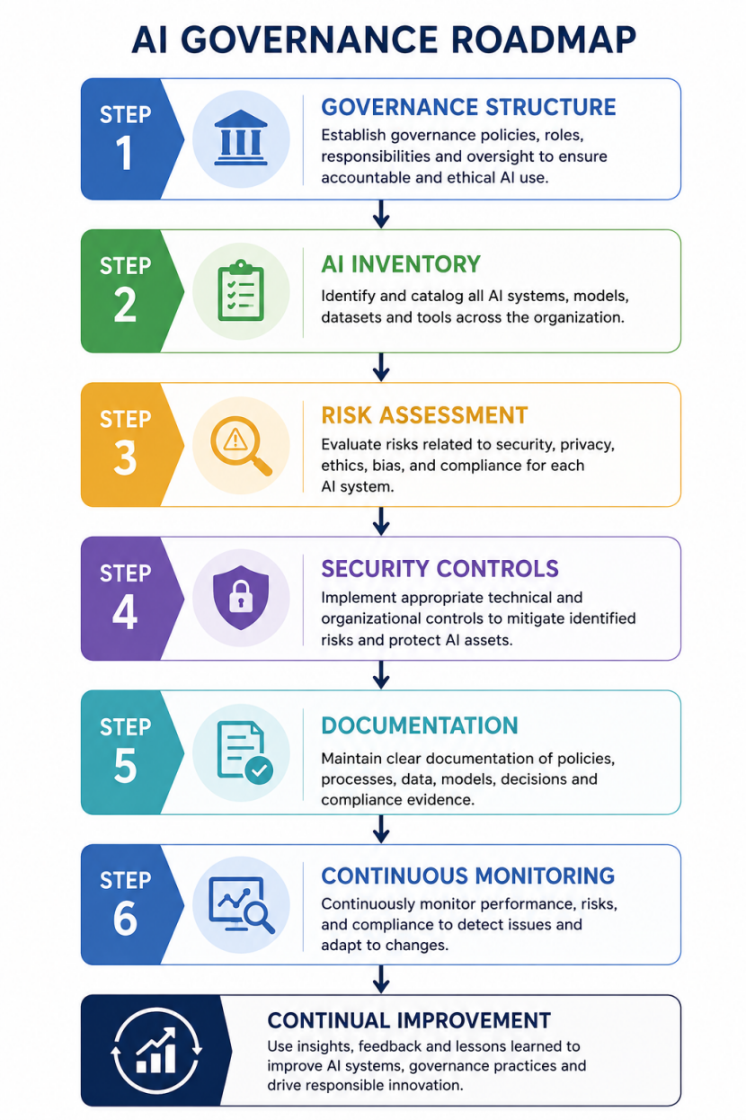
Figure 5. Recommended AI Governance Implementation Roadmap. (Figure will be inserted in the final document.)

10. Conclusion
Artificial Intelligence provides significant benefits in automation, decision-making, and business efficiency, but it also creates new security, privacy, ethical, and regulatory risks. Effective AI governance therefore requires a combination of organisational policies, security controls, legal compliance, and continuous risk management.
Frameworks such as NIST AI RMF, ISO/IEC 42001, ISO/IEC 27001, and the EU AI Act provide organisations with guidance for developing trustworthy AI systems. Although implementation can be challenging due to cost, skills shortages, data quality, and changing regulations, strong governance improves security, compliance, customer trust, and business resilience.
AI governance should be a continuous process. Organisations must regularly review risks, monitor AI systems, and improve controls as technology develops. This will help companies use AI safely, responsibly, and in compliance with future regulations [1], [2], [5].

References
[1] National Institute of Standards and Technology, Artificial Intelligence Risk Management Framework (AI RMF 1.0). Gaithersburg, MD, USA: NIST, Jan. 2023.
[2] International Organization for Standardization and International Electrotechnical Commission, ISO/IEC 42001:2023 Information technology — Artificial intelligence — Management system. Geneva, Switzerland: ISO, 2023.
[3] International Organization for Standardization and International Electrotechnical Commission, ISO/IEC 27001:2022 Information security, cybersecurity and privacy protection — Information security management systems — Requirements. Geneva, Switzerland: ISO, 2022.
[4] International Organization for Standardization and International Electrotechnical Commission, ISO/IEC 23894:2023 Information technology — Artificial intelligence — Guidance on risk management. Geneva, Switzerland: ISO, 2023.
[5] European Parliament and Council of the European Union, Regulation (EU) 2024/1689 Laying Down Harmonised Rules on Artificial Intelligence (Artificial Intelligence Act), Official Journal of the European Union, Jul. 2024.
[6] European Union Agency for Cybersecurity (ENISA), Multilayer Framework for Good Cybersecurity Practices for AI. Heraklion, Greece: ENISA, 2023.
[7] Organisation for Economic Co-operation and Development (OECD), OECD Principles on Artificial Intelligence. Paris, France: OECD Publishing, 2019.
[8] National Institute of Standards and Technology, Cybersecurity Framework (CSF) 2.0. Gaithersburg, MD, USA: NIST, Feb. 2024.
[9] Microsoft, Microsoft Responsible AI Standard, Version 2. Redmond, WA, USA: Microsoft, 2024.
[10] Google, Secure AI Framework (SAIF). Mountain View, CA, USA: Google, 2023.
[11] I. Goodfellow, Y. Bengio, and A. Courville, Deep Learning. Cambridge, MA, USA: MIT Press, 2016.
[12] S. Russell and P. Norvig, Artificial Intelligence: A Modern Approach, 4th ed. Hoboken, NJ, USA: Pearson, 2021.
[13] UNESCO, Recommendation on the Ethics of Artificial Intelligence. Paris, France: UNESCO, 2021.

Task 2
Case Scenario: Data Security and Compliance
Designing a Cybersecurity Governance Programme for Equifax Following the 2017 Data Breach

Abstract
The Equifax data breach of 2017 remains one of the most significant cybersecurity incidents in recent history. Attackers exploited a known vulnerability in the Apache Struts web application framework that had not been patched, allowing unauthorised access to sensitive personal information belonging to approximately 147 million individuals. The incident demonstrated that technical vulnerabilities alone are rarely responsible for major breaches. Weak governance, ineffective patch management, poor visibility of information assets, and limited executive oversight all contributed to the success of the attack.
This report applies cybersecurity governance principles to design an improved security programme for Equifax. The proposed programme focuses on clear organisational accountability, formal security policies, governance based on the NIST Cybersecurity Framework 2.0, structured risk management, and stronger protection controls. The report also demonstrates how business continuity, regulatory compliance, and continuous monitoring work together to reduce organisational risk. The recommendations aim to help organisations anticipate cyber threats, protect critical assets, detect attacks earlier, and respond more effectively to security incidents.

1. Introduction
The 2017 Equifax breach exposed sensitive personal data of approximately 147 million people. Attackers exploited an unpatched Apache Struts vulnerability (CVE-2017-5638) and remained inside the network for more than two months before detection [1].
The incident showed both technical and organisational failures, including poor patch management, incomplete asset visibility, weak monitoring, and insufficient cybersecurity oversight. This demonstrates why organisations need to combine technical protection with governance, risk management, and clear accountability.
This report proposes a structured cybersecurity programme based mainly on the NIST Cybersecurity Framework (CSF) 2.0, supported by vulnerability management, incident response, and business continuity practices.

2. Strategic Objectives and Cybersecurity Design Principles
The main objective of the cybersecurity programme is to reduce cyber risk while supporting business operations, customer trust, and legal compliance. Security resources should be prioritised according to business risk, with sensitive systems receiving stronger protection.
The programme uses defence in depth, combining controls such as firewalls, EDR, network segmentation, vulnerability scanning, encryption, and secure authentication. The least privilege principle should also limit users and third parties to the minimum access required [5].
Continuous monitoring through automated scanning, SIEM, and endpoint detection helps identify threats quickly. Strong governance ensures that cybersecurity risks are regularly reported to senior management and the Board.
Finally, cybersecurity requires continuous improvement through audits, testing, incident reviews, and policy updates. These principles directly address the governance, monitoring, and vulnerability management weaknesses demonstrated by the Equifax breach.
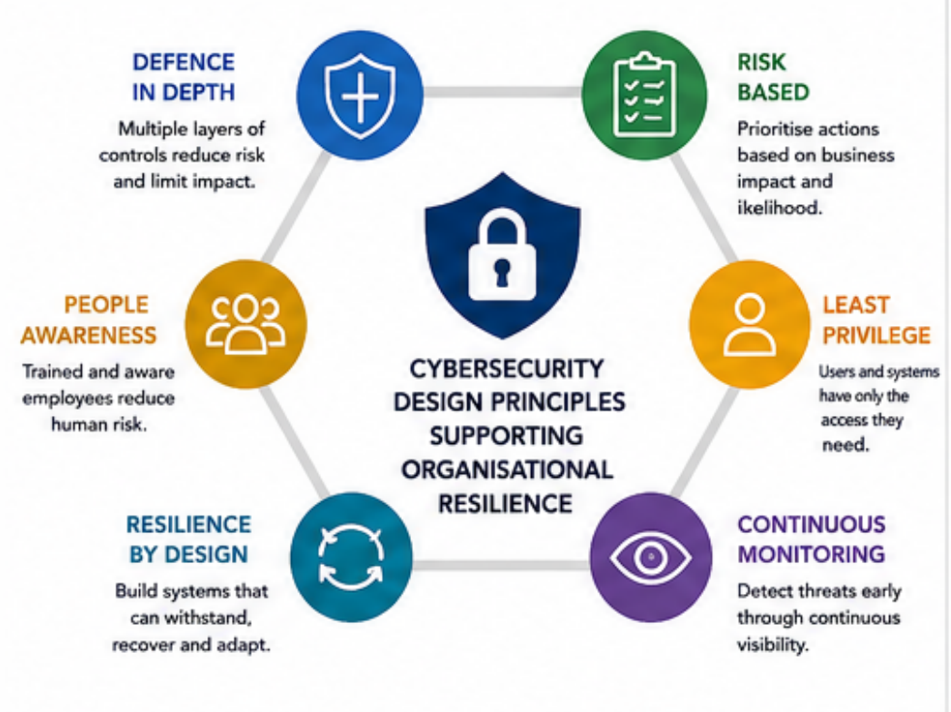
Figure 1. Cybersecurity Design Principles Supporting Organisational Resilience. (Professional diagram will be inserted in the final document.)

3. Organisational Structure and Accountability
The Equifax breach demonstrated weaknesses in organisational accountability and communication. To address this, the proposed structure establishes clear responsibilities and stronger executive oversight [1].
The Board of Directors should oversee cybersecurity risks and strategy, while the CEO ensures sufficient resources and organisational support. The CISO, reporting directly to the CEO and Board, should manage cybersecurity strategy, risk, and security operations [2].
Specialised teams should report to the CISO. The Security Operations Centre (SOC) monitors threats and coordinates incident response, while the Security Architecture Team ensures secure system design. The Vulnerability and Patch Management Team maintains asset visibility and ensures critical patches are applied on time. The Secure Development Team integrates security testing into the software lifecycle, while the GRC Team manages policies, risk assessments, compliance, and audits.
This structure makes cybersecurity a shared organisational responsibility, improves communication, and ensures that important risks receive management attention before they become major incidents.
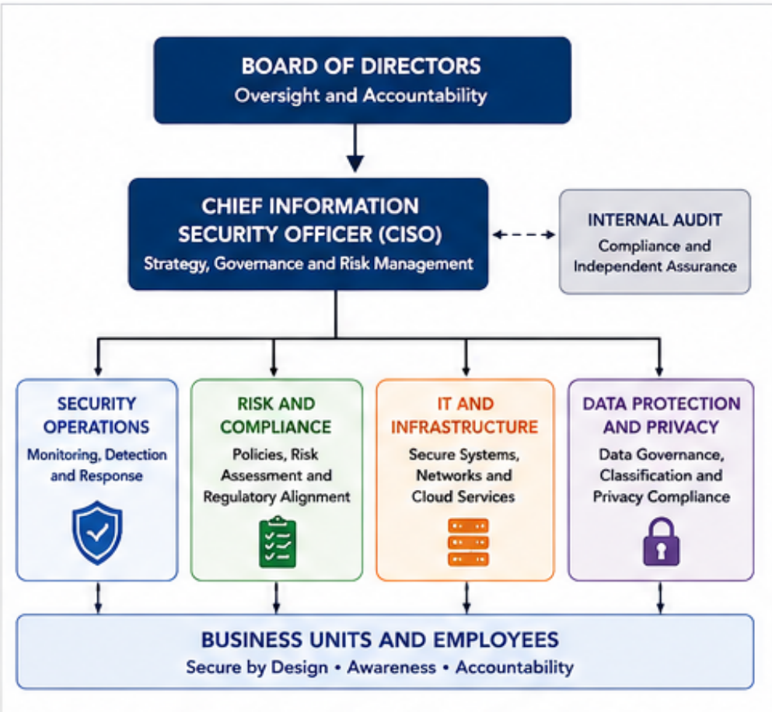
Figure 2. Recommended Cybersecurity Governance Structure for Equifax. (Professional organisational chart will be inserted in the final document.)

4. Policies and Procedures
The Equifax breach showed that security policies must be properly implemented, monitored, and measurable. The unpatched Apache Struts vulnerability demonstrated the need for stronger vulnerability and patch management processes.
A Vulnerability Management Policy should use automated scanning to identify, assess, and prioritise security weaknesses. A related Patch Management Policy should define clear deadlines, such as applying critical patches to internet-facing systems within 48 hours, with regular compliance reporting [3].
An Asset Management Policy should maintain an accurate inventory of systems, applications, and software versions. A Secure SDLC Policy should include secure coding, dependency checks, code reviews, and security testing before release.
A Security Monitoring Policy should collect logs through SIEM and generate automated alerts to reduce attacker dwell time. Finally, a Data Protection Policy should require encryption, access controls, MFA, and secure backups [9].
All policies should define responsibilities, measurable objectives, review periods, and audit requirements to ensure they are consistently followed.

Table 1. Proposed Cybersecurity Policies
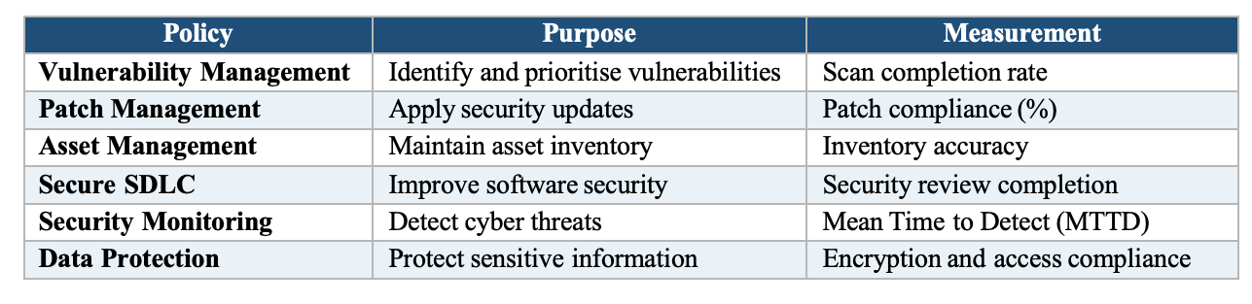

5. Governance Model Based on NIST Cybersecurity Framework 2.0
The proposed programme follows the NIST Cybersecurity Framework (CSF) 2.0, which connects cybersecurity risk management with business objectives through six functions [2].
Govern establishes leadership, policies, and accountability, with the Board providing oversight and the CISO managing cybersecurity strategy. Identify focuses on understanding assets, sensitive data, and risks. Better asset visibility could have helped Equifax identify the vulnerable Apache Struts system earlier.
Protect includes controls such as MFA, encryption, network segmentation, secure development, and patch management. Detect uses continuous monitoring, SIEM, EDR, and automated alerts to identify suspicious activity quickly.
Respond defines procedures for containment, investigation, communication, and regulatory notification. Recover restores business operations through tested backups and disaster recovery plans [2].
Together, these six functions create a continuous cybersecurity process that supports prevention, early detection, effective response, recovery, and long-term organisational resilience.
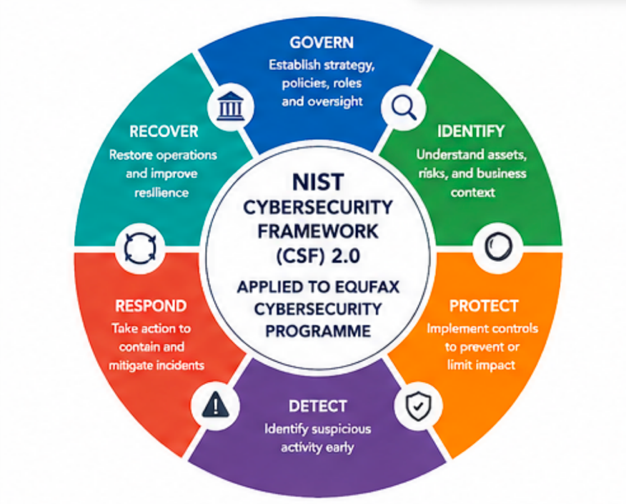
Figure 3. NIST CSF 2.0 Applied to the Equifax Cybersecurity Programme. (Professional diagram will be inserted in the final document.)

6. Compliance and Regulatory Alignment
Regulatory compliance is an important part of cybersecurity governance. Organisations must protect sensitive information and demonstrate that security controls meet legal requirements. Failure to comply can result in financial penalties, legal action, and reputational damage.
For international organisations, the GDPR requires appropriate security measures and notification of certain personal data breaches within 72 hours. ISO/IEC 27001 also supports risk-based security, management responsibility, auditing, and continuous improvement [6], [7].
In the United States, guidance from NIST and CISA supports vulnerability management, incident response, and continuous monitoring. The Equifax breach showed that weak cybersecurity controls can quickly become governance and compliance failures.
Compliance should therefore not be treated as a checklist. It should combine governance, technical controls, audits, staff awareness, and continuous improvement to reduce business risk, protect customer information, and maintain organisational trust.

7. Risk Management and Assessment
Effective cybersecurity requires organisations to identify and prioritise risks before they are exploited. The Equifax breach showed how a single unpatched vulnerability can cause major financial, operational, and reputational damage [1], [3].
Key risks include internet-facing systems, which require regular vulnerability scanning and penetration testing, and patch management failures, which should be controlled through automated updates, clear ownership, and defined SLAs.
Poor asset visibility is another risk because unknown or outdated systems may remain unprotected. Organisations should therefore maintain accurate inventories of hardware, software, and cloud services. Supply chain risks should also be assessed because third-party software and providers can introduce vulnerabilities.
Finally, strong network segmentation can limit attacker movement and reduce the impact of a successful breach. Table 2 summarises these risks and their proposed mitigation measures [1], [8].
Table 2. High-Level Cybersecurity Risk Assessment
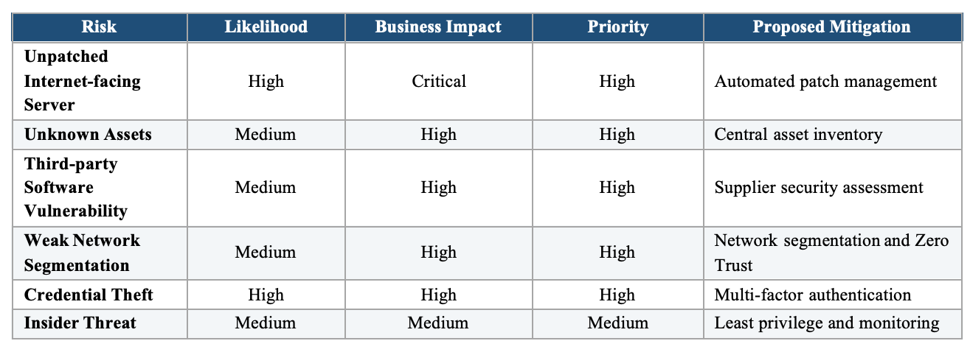
Risk management should not be treated as a one-time activity. New vulnerabilities appear every day, and organisations should regularly review risks, update mitigation plans, and reassess business priorities. Continuous risk assessment supports informed decision-making and improves long-term organisational resilience.
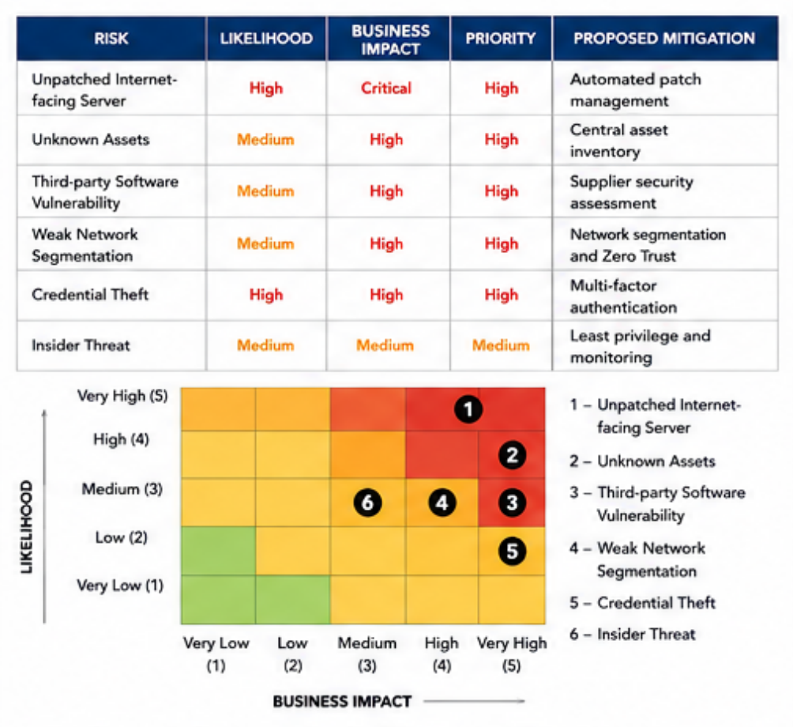
Figure 4. Cybersecurity Risk Assessment Matrix. (Professional diagram will be inserted in the final document.)

8. Incident Response and Disaster Recovery Programme
Even strong cybersecurity controls cannot eliminate all risks, so organisations need a structured incident response and disaster recovery programme to reduce disruption and recovery time [4].
The programme includes six stages. Preparation establishes procedures, responsibilities, communication channels, and staff training. Detection and Analysis uses SIEM, EDR, and automated monitoring to identify suspicious activity. Containment isolates affected systems, disables compromised accounts, and blocks malicious connections.
During Eradication, security teams remove threats, patch vulnerabilities, and identify the root cause. Recovery restores services using verified backups and monitors systems for further attacks. Finally, Lessons Learned reviews the incident and improves policies, controls, and training.
The Equifax breach shows why early detection is critical. Continuous monitoring, automated alerts, and clear response procedures can significantly reduce attacker dwell time and business impact [1].

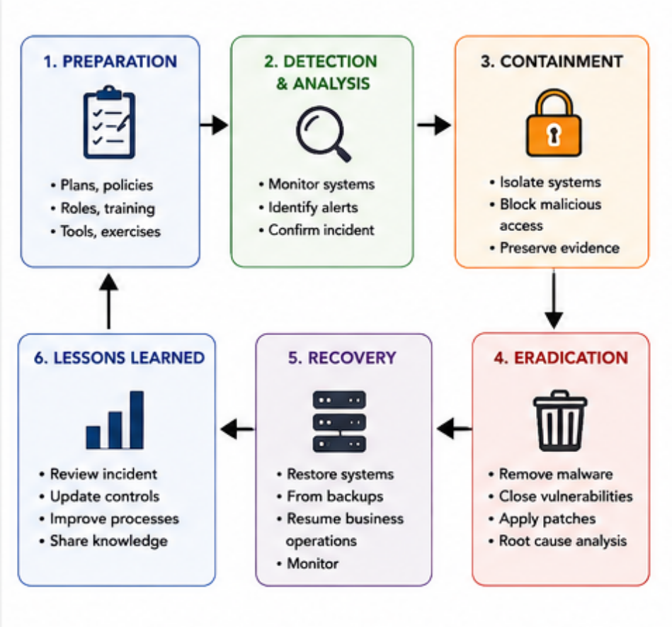
Figure 5. Incident Response Lifecycle. (Professional diagram will be inserted in the final document.)

9. Protection Controls and Implementation Roadmap
The proposed cybersecurity programme uses multiple layers of protection to reduce organisational risk. Continuous vulnerability scanning should identify and prioritise weaknesses based on business impact. MFA and RBAC should protect accounts and limit unnecessary access [5].
EDR should monitor endpoints for malicious behaviour, while SIEM collects and analyses security logs to detect suspicious activity. Sensitive data should be protected through encryption, and network segmentation should separate critical systems from public-facing applications.
Implementation should follow three phases:
- Phase 1 (Months 1–3): establish governance, complete asset inventory, introduce vulnerability scanning, and improve patch management.
- Phase 2 (Months 4–6): deploy SIEM, EDR, MFA, network segmentation, and incident response procedures.
- Phase 3 (Months 7–12): conduct penetration testing, audits, staff training, and governance reviews.
This phased approach improves cybersecurity gradually while controlling costs and maintaining business continuity.

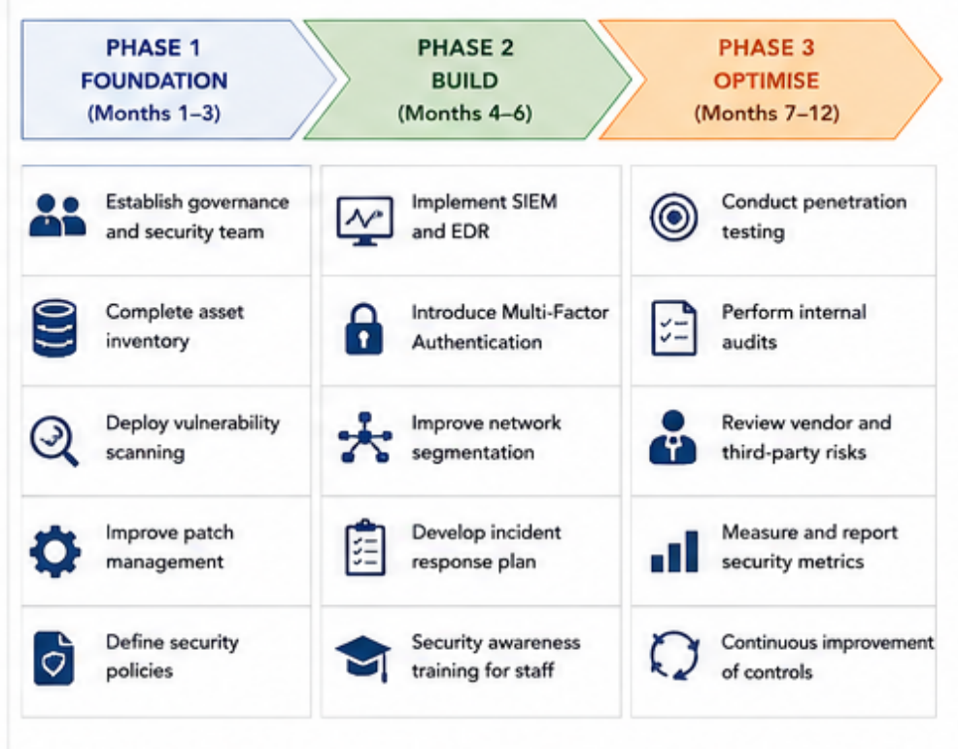
Figure 6. Cybersecurity Implementation Roadmap. (Professional roadmap diagram will be inserted in the final document.)

10. Conclusion
The Equifax data breach demonstrated that cybersecurity failures are often caused by weaknesses in governance rather than by technology alone. Although the Apache Struts vulnerability had already been identified and patched by the software vendor, ineffective governance, poor patch management, limited asset visibility, and insufficient executive oversight allowed attackers to exploit the organisation successfully.
This report proposed a structured cybersecurity governance programme designed to reduce the likelihood and impact of similar incidents. The programme introduced clear organisational accountability, measurable cybersecurity policies, governance based on the NIST Cybersecurity Framework 2.0, structured risk assessment, effective incident response, and layered technical security controls.
The proposed governance model demonstrates that cybersecurity should support business objectives rather than operate as an isolated technical function. Continuous monitoring, automated vulnerability management, strong authentication, secure software development, and business continuity planning work together to improve organisational resilience.
Finally, cybersecurity should be viewed as a continuous improvement process. As new threats and technologies emerge, organisations must regularly review risks, update security controls, strengthen governance, and invest in employee awareness. Organisations that combine strong leadership with effective technical controls will be better prepared to protect sensitive information, maintain customer trust, and respond successfully to future cyber threats [1], [2].

References

[1] U.S. House of Representatives, Committee on Oversight and Government Reform, The Equifax Data Breach, Staff Report, Dec. 2018.
[2] C. Pascoe, S. Quinn, and K. Scarfone, The NIST Cybersecurity Framework (CSF) 2.0, NIST CSWP 29, National Institute of Standards and Technology, Feb. 2024, doi: 10.6028/NIST.CSWP.29.
[3] M. Souppaya and K. Scarfone, Guide to Enterprise Patch Management Planning: Preventive Maintenance for Technology, NIST SP 800-40 Rev. 4, Apr. 2022, doi: 10.6028/NIST.SP.800-40r4.
[4] A. Nelson, S. Rekhi, K. Scarfone, and M. Souppaya, Incident Response Recommendations and Considerations for Cybersecurity Risk Management: A CSF 2.0 Community Profile, NIST SP 800-61 Rev. 3, Apr. 2025, doi: 10.6028/NIST.SP.800-61r3.
[5] Joint Task Force, Security and Privacy Controls for Information Systems and Organizations, NIST SP 800-53 Rev. 5, National Institute of Standards and Technology, Sep. 2020, doi: 10.6028/NIST.SP.800-53r5.
[6] ISO/IEC, ISO/IEC 27001:2022 — Information Security, Cybersecurity and Privacy Protection — Information Security Management Systems — Requirements, International Organization for Standardization, Geneva, Switzerland, 2022.
[7] European Parliament and Council of the European Union, “Regulation (EU) 2016/679 (General Data Protection Regulation),” Official Journal of the European Union, 2016.
[8] Cybersecurity and Infrastructure Security Agency, Zero Trust Maturity Model, Version 2.0, Apr. 2023.
[9] OWASP Foundation, OWASP Software Assurance Maturity Model (SAMM), Version 2.
[10] U.S. Federal Trade Commission, Equifax Data Breach Settlement, Federal Trade Commission, 2019.

