

LOCATION: Swansea | LLEOLIAD: abertawe
LEVEL 4 | LEFEL 4
EXAMINATION PERIOD | CYFNOD ARHOLIADAU
September 2021 | medi 2021

MODULE CODE: ACDB4002 / ACDA4006
Electrical & Electronic Principles

TIME: 2 HOURS
answer all questions

Equipment or materials required – Calculator, Formulae Sheet
Adnoddau neu ddefnyddiau sydd eu hangen – Cyfrifiannell, Taflen Fformiwla

ANSWER ALL QUESTIONS

- For the circuit shown in Fig Q1. Determine the following:
  - Total circuit resistance
[4 Marks]
Redraw Circuit
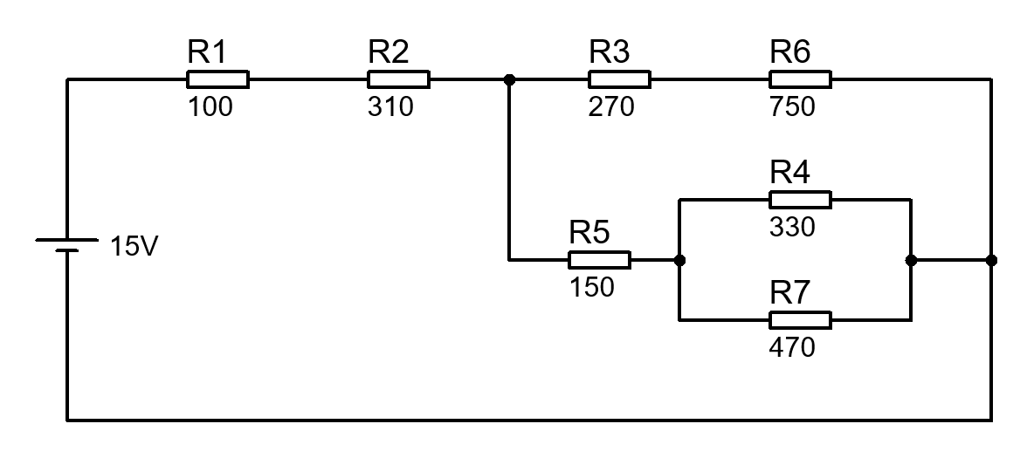
$$R_{1-2}=R1+R2=100+310=410 Ω$$

$$R_{3-6}=R3+R6=270+750=1020 Ω$$

$$R_{4-7}=\frac{R_{4}R_{7}}{R_{4}{+R}_{7}}=\frac{330×470}{330+470}=193.875 Ω$$

$$R_{5-4-7}=R5+R_{4-7}=150+193.875=343.875 Ω$$

$$R_{3-6-5-4-7}=\frac{R_{3-6}R_{5-4-7}}{R_{3-6}+R_{5-4-7}}=\frac{1020×343.875}{1020+343.875}=257.173 Ω$$

$$R_{T}=R_{1-2}+R_{3-6-5-4-7}=410+257.173=667.173 Ω$$

  - Total circuit current
[2 Marks]
$$I=\frac{V}{R}=\frac{15}{667.173}=22.483×{10}^{-3}$$

$$I=22.483 mA$$

  - Current flowing through R3
[2 Marks]
$$I_{R3}=I_{T}\frac{R_{5-4-7}}{R_{3-6}+R_{5-4-7}}$$

$$I_{R3}=22.483×{10}^{-3}×\frac{343.875 }{1020+343.875 }$$

$$I_{R3}=5.669 mA$$

  - Total power delivered by the battery
[2 Marks]
$$P=IV=22.483×{10}^{-3}×15=0.337 W$$

  - Power dissipated by R4
[4 Marks]
$$I_{R5}=I-I_{R6}=22.483×{10}^{-3}-5.669×{10}^{-3}=16.814×{10}^{-3} A$$
$$I_{R4}=I_{R5}\frac{R7}{R7+R4}=16.814×{10}^{-3}×\frac{470}{470+330}=9.878×{10}^{-3} A$$
$$P_{R4}={I_{R4}}^{2}R4={9.878×{10}^{-3}}^{2}×330=32.2 mW$$

  - R7 is replaced by a wire link. What is the new circuit current?
[4 Marks]
$$R_{T}=R1+R2+\left(\frac{R5×\left(R3+R6\right)}{R5+\left(R3+R6\right)}\right)$$

$$R_{T}=100+310+\left(\frac{150×\left(270+750\right)}{150+\left(270+750\right)}\right)=540.769 Ω$$

$$I=\frac{V}{R}=\frac{15}{540.769}=27.738×{10}^{-3} A$$

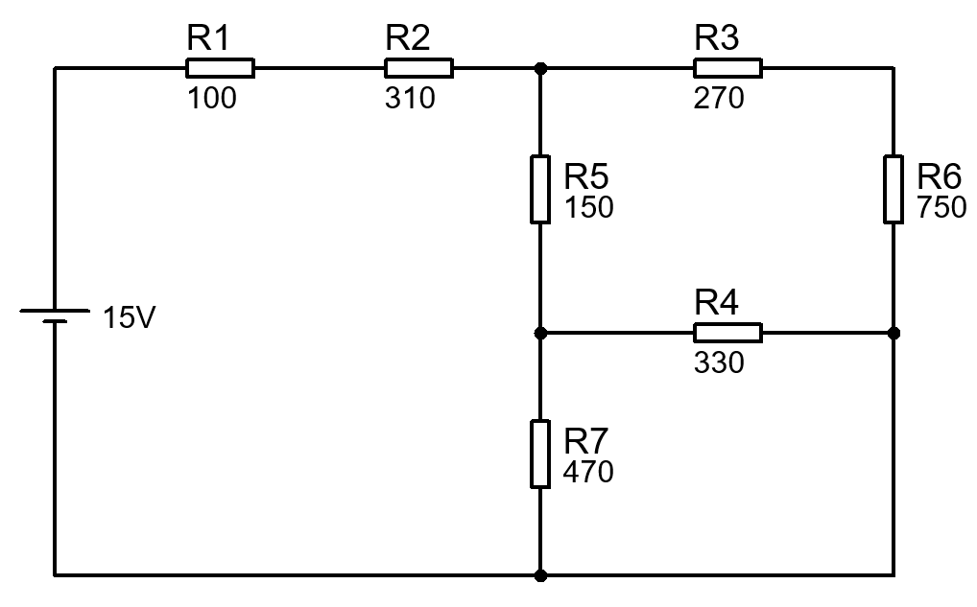
Fig. Q1

- An oscilloscope display shows the above voltage waveform. The oscilloscope settings are shown in the box next to the waveform.

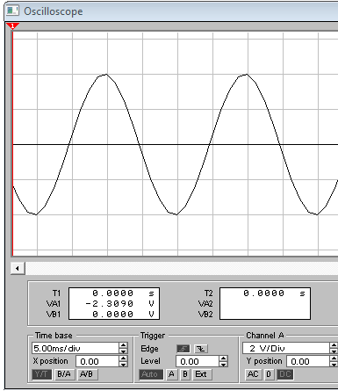
Oscilloscope settings:
500 mV/div
100 ms/div

- Estimate the period of the waveform
[1 Mark]
$$4div×100ms=400ms$$

- From the estimated period, determine its frequency
[1 Mark]
$$f=\frac{1}{T}=\frac{1}{400×{10}^{-3}}=2.5 Hz$$

- Determine its peak to peak amplitude
[1 Mark]
$$4div×500mV=2V$$

- Determine the RMS value of the waveform
[2 Marks]
$$V_{RMS}=V_{Pk}×0.707=\frac{2}{2}×0.707=0.707 V$$

- The discharging equation for a series resistor/capacitor network is given by:
$$V_{C}=V_{0}\left(e^{{-t}/τ}\right)$$
Where $V_{C}$ is the voltage across the capacitor and $V_{0}$ is the initial capacitor voltage.
Assuming the following: R = 40k, C = 10µF and V₀ = 12V:
- Calculate $V_{C}$ at time t = 1.6 seconds.
[3 Marks]
$$τ=RC=40×{10}^{3}×10×{10}^{-6}=0.4 Seconds$$
$$V_{C}=V_{s}\left(e^{{-t}/τ}\right)=12×\left(e^{{-1.6}/{0.4}}\right)=0.2198 V$$

- Sketch a labelled graph that would represent the discharging curve.
[5 Marks]

Marks for trend, labels, units, scales, headings

- What is the stored energy within the capacitor before it is discharged?
[3 Marks]
$$E=\frac{1}{2}CV^{2}=\frac{1}{2}×10×{10}^{-6}×{12}^{2}=0.720 mJ$$

- Calculate the time taken for the stored energy within the capacitor to reach 0.1mJ
[4 Marks]

$$E=\frac{1}{2}CV^{2}$$

$$V=\sqrt{\frac{E}{1/2C}}$$
$$V=\sqrt{\frac{0.1×{10}^{-3}}{1/2×10×{10}^{-6}}}=4.472 V$$

$$V_{C}=V_{s}\left(1-e^{{-t}/τ}\right)$$

$$t=-τ×\ln\left(\frac{V_{C}}{V_{S}}\right)$$

$$t=-0.4×\ln\left(\frac{4.472}{12}\right)=0.3948 Seconds$$

- For the circuit shown in fig Q4, determine the following:
  - Total Impedance
[2 Marks]
$$Z=R+j\left(X_{L}-X_{C}\right)$$
$$X_{L}=2πfL=2×π×100×200×{10}^{-3}=125.664 Ω$$
$$X_{C}=\frac{1}{2πfC}=\frac{1}{2×π×100×5×{10}^{-6}}=318.310 Ω$$
$$Z=200+j\left(125.664-318.310\right)=200+j192.65 Ω$$

$$\left|Z\right|=\sqrt{{200}^{2}+{\left(125.664-318.310\right)}^{2}}=277.694 Ω$$
  - Total current supplied to the circuit
[2 Marks]
$$I=\frac{V}{Z}=\frac{20}{277.694 }=72.022 mA$$

  - Phase difference between the supply voltage and current
[2 Marks]
$$φ=\tan^{-1}{\frac{X_{T}}{R}}$$

$$φ=\tan^{-1}{\frac{-192.65 }{200}=43.928°}$$

  - Voltage across the resistor.
[2 Marks]
$$V=I×R$$
$$V=72.022×{10}^{-3}×200=14.404 V$$

  - Voltage across the capacitor
[2 Marks]
$$V=I×X_{C}$$
$$V=72.022×{10}^{-3}×318.31=22.925 V$$

  - Voltage across the inductor
[2 Marks]
$$V=I×X_{L}$$
$$V=72.022×{10}^{-3}×125.664=9.051 V$$

  - The resonant frequency
[2 Marks]
$$f_{res}=\frac{1}{2π\sqrt{LC}}$$

$$f_{res}=\frac{1}{2π\sqrt{200×{10}^{-3}×5×{10}^{-6}}}=159.155 Hz$$

Fig Q4

- A 230 V step-down mains transformer has a 20W lamp connected to its secondary winding. The turns ratio of the transformer is 1/20.
  - Sketch the circuit
[2 Marks]
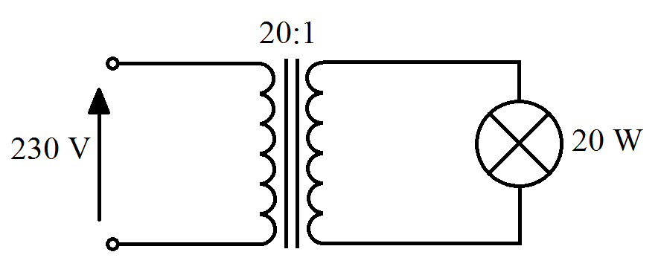

  - Calculate the secondary current supplied to the load
[2 Marks]
First calculate secondary voltage
$$V_{s}=V_{p}×\frac{1}{N}$$

$$V_{s}=230×\frac{1}{20}=11.5 V$$
Next secondary current
$$I=\frac{P}{V}$$

$$I=\frac{20 W}{11.5 V}=1.739 A$$

  - The primary current taken from the supply.
[2 Marks]
Primary Current
$$I_{P}=\frac{P}{V_{P}}$$

$$I_{P}=\frac{20 W}{230 V}=87 mA$$

  - Draw the symbol for a standard rectifier diode and label the anode and cathode
[2 Marks]
Anode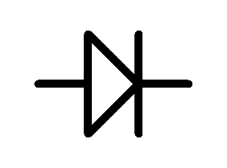Cathode

  - Describe what happens to the distribution of electrons within the diode when it is forward biased and reverse biased. Consider using a diagram to aid your explanations.
[10 Marks]
Description to include: depletion layer, n-type silicon, p-type silicon, free electrons, breakdown voltage

Diwedd/End

Formulae Sheet
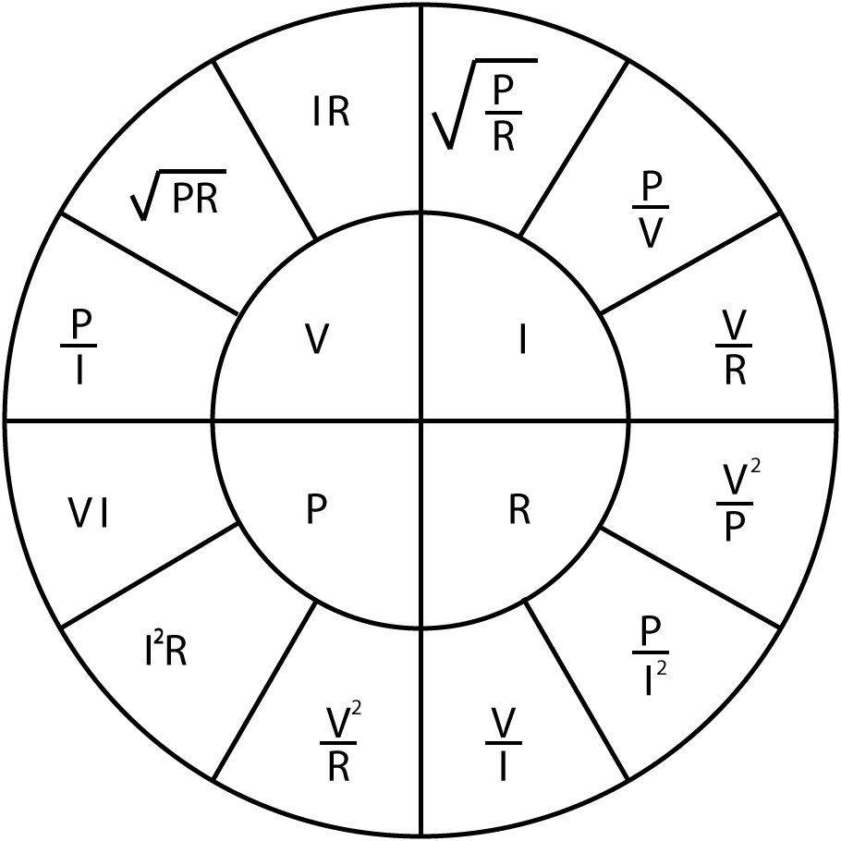 |  | $$R_{T}=R_{1}+R_{2}+…+R_{n}$$  $$\frac{1}{R_{T}}=\frac{1}{R_{1}}+\frac{1}{R_{2}}+…+\frac{1}{R_{n}}$$  $$\frac{1}{C_{T}}=\frac{1}{C_{1}}+\frac{1}{C_{2}}+…+\frac{1}{C_{n}}$$  $$C_{T}=C_{1}+C_{2}+…+C_{n}$$  $$L_{T}=L_{1}+L_{2}+…+L_{n}$$  $$\frac{1}{L_{T}}=\frac{1}{L_{1}}+\frac{1}{L_{2}}+…+\frac{1}{L_{n}}$$ | $$V_{Out}=V_{in}\frac{R_{B}}{R_{A}+R_{B}}$$  $$I=I_{in}\frac{R_{B}}{R_{A}+R_{B}}$$
$$X_{C}=\frac{1}{2πfC}$$
$$X_{C}=-j\frac{1}{ωC}$$

$$X_{L}=2πfL$$
$$X_{L}=jωL$$

$$Z=R+j\left(X_{L}-X_{C}\right)$$  $$\left|Z\right|=\sqrt{R^{2}+{\left(X_{L}-X_{C}\right)}^{2}}$$ | $$ω=2πf$$  $$X_{T}=X_{L}-X_{C}$$ | $$φ=\tan^{-1}{\frac{X_{T}}{R}}$$  $$pf=\cos{φ}$$ | $$f_{res}=\frac{1}{2π\sqrt{LC}}$$
$$V_{C}=V_{s}\left(1-e^{{-t}/τ}\right)$$  $$I_{C}=\frac{V}{R}\left(e^{{-t}/{RC}}\right)$$  $$V_{C}=V_{0}\left(e^{{-t}/τ}\right)$$  $$I_{C}=-\frac{V}{R}\left(e^{{-t}/{RC}}\right)$$  $$τ=RC$$ | $$τ=\frac{L}{R}$$  $$V_{L}=V\left(e^{{-Rt}/L}\right)$$  $$V_{L}=-V\left(e^{{-Rt}/L}\right)$$  $$I_{L}=\frac{V}{R}\left(1-e^{{-Rt}/L}\right)$$  $$I_{L}=\frac{V}{R}\left(e^{{-Rt}/L}\right)$$ | $$f=\frac{1}{2πRC}$$  $$A_{V}=20\log{\frac{V_{out}}{V_{in}}}$$  $$A_{P}=10\log{\frac{P_{out}}{P_{in}}}$$ | $$Q=\frac{X_{L}}{R}$$  $$Q=\frac{X_{C}}{R}$$  $$Q=\frac{f_{R}}{f_{U}-f_{L}}$$  $$Q=\frac{1}{R}\sqrt{\frac{L}{C}}$$
$$E=\frac{1}{2}CV^{2}$$
$$E=\frac{1}{2}LI^{2}$$
$$V_{B} \text{=}\frac{\text{RB2}}{\text{(}\text{RB}\text{1 + }\text{RB}\text{2)}}\text{×} V_{CC}$$  $$V_{E}=V_{B}-0.7$$  $$I_{C}=I_{E}$$  $$V_{C}=V_{CC}-\left(I_{C}×R_{C}\right)$$  $$Av=\frac{v_{c}}{v_{b}}$$  $$V_{E}=10\%V_{CC}$$  $$R_{IN}=\frac{1}{\frac{1}{{RB}_{1}}+\frac{1}{{RB}_{2}}+\frac{1}{\left(h_{FE}×R_{E}\right)}}$$  $$R_{OUT}=R_{C}$$  $$A_{V}≈-\frac{R_{C}}{R_{E}}$$ |  | $$V_{out}=-\frac{R2}{R1}×V_{in}$$  $$V_{out}=\left[1+\frac{R2}{R1}\right]×V_{in}$$  $$V_{out}=\frac{R2}{R1}×\left[V_{2}-V_{1}\right]$$  $$V_{out}=-\frac{R2}{R1}×\left[V_{1}+V_{2}\right]$$  $$V_{out}=-\left[\frac{R}{R1}×V_{1}+\frac{R}{R2}×V_{2}+…+\frac{R}{Rn}×V_{n}\right]$$

Detach this page and place in answer book

Student Number …………………………. Question Number ……………………….



