A Critical Evaluation of Manchester United Hospitality Management
Student Number: P146489
Host Organisation – Manchester United Football Club
Date of Publication 29/03/2018

Executive Summary
In this report the author Shazer Essar has critically evaluated the effectiveness of a range of hospitality services to improve the customer experience within the sport, leisure, entertainment and sports tourism-based industry at Manchester United Football Club. The researcher has thoroughly provided the importance of hospitality management and the strategic decisions involved in maintaining and improving of sports facilities linked to the income generation of the practice. The researcher looked at the history of the club and the reasons why the club is as successful as they are today in football as well as hospitality. Manchester United became the first club to introduce the executive boxes in 1966 to provide fans with the entertainment factor. The author looks at how Manchester United football club use sales strategies, endorsement, merchandise and social media connections to keep in touch with their fans. By analysing the club’s organisation structure from the very end to the very top, looking at roles and responsibilities of waiting on staff, bar staff, kiosk staff and the back of house assistant which all require training to be able to provide VIP treatment on match day. The author also configures how important uniform, hygiene and licensing is to Manchester United. This report also concludes the importance of relationship management and a critical evaluation of customers experience at the hospitality boxes and what impacts was made to make Manchester United football club to offer the very best hospitality services.

Contents Page | Page Number
- Term of Reference | 4
- Procedure | 4
2.1 A Variety of Secondary Materials have been Accessed | 4
- Findings | 5
3.1 Introduction | 5
3.2 Hospitality Management | 6
3.21 Hospitality Management at Manchester United Football Club | 6
3.3 Customer Service | 12
- Conclusion | 13
- Recommendation | 14
- Appendices | 16
- Acknowledgements | 19
- References | 19
- Bibliography | 20

- Terms of Reference
The report was made on request by the CEO of Manchester United football club Ed Woodward. The date required for the report is 16/02/2018. The purpose of the report is to help Manchester United football club to improve customer experience within the sport, leisure, entertainment and sports tourism-based industry. The report will be published on 29/03/2018 and the report was compiled by the club’s hospitality manager, Shazer Essar.

- Procedure
The following procedure has been adopted for the investigation to take place and the report compiled.

2.1 A Variety of Secondary Material have been accessed
The materials included in the report are case studies, textbooks, journals, websites and organisation literature.

- Findings
“A Critical Evaluation of Manchester United Hospitality Management”

3.1 Introduction
The club, Manchester United best interest is to provide excellent customer service so on match days the customers feel that they had a VIP experience, the analysis and evaluation requires discussion of a range of hospitality services which impact upon the customer experience at a sporting organisation. Being a manager at a prestigious club such as Manchester United requires important roles, such as monitoring and evaluating the quality, performance and future development of hospitality services within the organisation. As the hospitality manager, the manager must undertake responsibilities for the future planning of human resources and physical resources, the manager also must be accountable for ensuring a strong financial performance and growth in market share within the sports hospitality sector. Manchester United is a gigantic team in English football and is significantly known worldwide as global ambassadors as well as a fantastic football team.
“Financial performance is a subjective measure of how well a firm can use assets from its primary mode of business and generate revenues. This term is also used as a general measure of a firm's overall financial health over a given period of time, and can be used to compare similar firms across the same industry or to compare industries or sectors in aggregation. “
https://www.investopedia.com/terms/f/financialperformance.asp#ixzz5AsVfRqIo (23/03/2018)
“Physical resources are necessary for all types of business. Product-based businesses use physical resources for providing the goods for sale and for the operation of the business. Service-based businesses use physical resources to facilitate the delivery of the service, such as having a space to work, tools that are needed for the service, and resources used to support the service.” https://study.com/academy/lesson/what-are-physical-resources-in-business.html (23/03/2018)
Human Resources is “The division of a company that is focused on activities relating to employees. These activities normally include recruiting and hiring of new employees, orientation and training of current employees, employee benefits, and retention. Formerly called personnel.” http://www.businessdictionary.com/definition/human-resources.html (23/03/2018)

3.1.1. The Historical Development of the Club
The Club is also known as “The Red Devils”. The team was founded in 1878 Newton Heath, known as L&YR Football Club. Manchester United have operated for over 138 years. The club first entered the English first division, at that time it was the highest league in English football, for the start of the 1892/93 season. The clubs name changed to Manchester United in 1902 and had won first of their 20 English League Titles in 1908. In 1910 Manchester United moved to Old Trafford stadium, which is also known as the “Theatre of Dreams”. Manchester United played their first game at Old Trafford in 19th February 1910, it was a match against Liverpool. At the time the stadiums consisted of one covered seating stand and open terraces on the other three sides. The capacity for the match was slightly over 80,000. Old Trafford currently holds a capacity of 75,643 seats. The highest ever recorded crowd at Old Trafford was in 1939 during a FA Cup semi-final match between Wolves and Grimsby Town, the attendance on the day was 76,962.

3.2 Hospitality Management
Hospitality sector includes hotels, catering, and events management.’ Stated in Mullins (2013). This would include ‘sports’ stadia event management, sports such as Football, Rugby and Cricket. Organisations including Manchester United hospitality management like to place customer first in the sector skills council, for hospitality.
The term Sector Skills in Hospitality management.
‘Transforming skills in the sector particularly in the areas of management and leadership, customer service and craft and technical skills. We are committed to ensuring public funds support the industry to develop only those qualifications and programmes that meet the needs of employers’ Mullins (2013) P2.
3.21 Hospitality Management at Manchester United Football Club
The importance of hospitality management at Manchester United football club is very high. In 1966 Manchester United became the first Club anywhere to introduce executive boxes and since then hospitality standards and experience have grown with their list of honours. Manchester United offer a VIP match day experience at Old Trafford where you can experience top class hospitality. A match day VIP experience includes some of the best seats in the stadium to watch all the action on the pitch. The customers are welcomed with a welcome drink on arrival, fantastic food and drink and Q&A from Manchester United former football players. A VIP match day experience is subjected to everybody whether it is a family day out, impressing business client, or even witnessing one of the greats ground for the time. A match VIP experience ensures an unforgettable day out at the “Theatre of Dreams”.
The club’s hospitality offers two suites, Evolution suite and Champions suite. See (Appendix 1 and 2) for the VIP offering each suite provides. The evolution suite is located in the North East Quadrant at Old Trafford and offers a modern and sophisticated environment to enjoy football. This outstanding offers guests to enjoy in dining from la carte menu before taking their luxury padded seats in the North East Quadrant. The facility Evolution suite has to offer is outstanding as it is the only facility within the ground which is glass fronted and overlooks the pitch, stadiums and Manchester City docks and quays. The Champions suite is made up of two, twenty-two seater suites in the North Stand on level 5, the legends lounge and the Sir Alex suite offering a stylish and relaxed setting for guests. The champions suites are a great setting to enjoy the magic of hospitality at Old Trafford for a minimum of two guests or privately for twenty-two guests. The fully inclusive package including exceptional standard or service, will ensure that you will have a day to remember. After a three- course a la carte dining experience you will find your seats on the half way line near to the front of the first tier, where you can relax and watch Manchester united. See (Appendix 3) for remaining fixtures and price breakdown of Evolution and Champions Suite.
3.2.2. Sales Strategies used by the Club
Manchester United football club use sales strategies to increase revenue and profitability by expanding their high growth businesses that leverage their brand, global community and marketing infrastructure.
There are four key elements of the strategy:
- Clubs Portfolio for Sponsors
- Development of Retail, Merchandising, Apparel and Product Licensing
- Exploit New Media and Content Opportunities
- Enhance the Reach and Distributor of the Clubs Broadcasting rights.
Clubs Portfolio for Sponsors
Manchester United football club announced nine global sponsorship partnerships, During fiscal year 2017. The club is well positioned to continue and to secure sponsorships with leading brands, they have historically implemented a proactive approach to identifying, securing and supporting sponsors. Manchester United have one regional sponsorship partnership and two financial services and MUTV partnership. MUTV is Manchester United very own television channel. MUTV is a great way to see the latest news of the club as well as seeing the classic games from the past. Manchester United experienced a 4.6% compound annual growth rate in their sponsorship revenue from fiscal year 2015 through fiscal year 2017. Additionally, the club is aware that historical growth rates does not necessarily mean they will achieve comparable rates in the future. To develop a global sponsorship portfolio, the club is focused on segmenting new opportunities by product category and territory.
http://www.manutd.com/en/Partners.aspx (03/03/2018) (view website to see the clubs Official Global Partners)
Development of Retail, Merchandising, Apparel and Product Licensing
Manchester United football club currently have a ten-year sponsorship deal with adidas. The deal began on 1st August 2015. The deal with adidas does not conclude the rights with respects to mono-branded licensing rights or right to create and operate Manchester United branded soccer schools, physical retail channels and e-commerce retail channels. These rights were previously held by Nike. The reversion of these rights to the club provides them with increased commercial opportunities and control. One of the strategies the club comprehend by is merchandise. Manchester United have a club shop outlet located within the stadium, they also have a website United Direct ‘The Official Online Mega Store’ where you can get the latest Manchester United merchandise. In the future the clubs plan is to expand portfolio of product licensees to enhance the range of product offerings available to their followers. They may also pursue to segment the different elements of this business and to increase focus on developing these rights more proactively, alone or with other partners.
Exploit New Media and Content Opportunities
Manchester United have one hundred and forty-seven million connections on social media. See (Appendix 4) for all the social media websites Manchester United are on. The rapid growth of media consumption is very beneficial to the club. The use of Internet, Mobiles and Social Media promotes Manchester United with multiple growth opportunities and new revenue streams, the use of social media has become one of the primary methods of engagement with the followers around the world. Manchester united thrives to continue to evolve media team’s capability to address these opportunities. In January 2013, the club acquired the remaining one-third stake in MUTV, these actions help to ensure a greater degree of control over the production, distribution and quality of proprietary content and better insight into how to evolve mobile & content strategy as the club continues to develop and roll out carefully, targeting new products and services. In addition to developing their own digital properties, Manchester United intend to leverage third party media platforms and other social media as a means of further engaging with their followers and creating a source of traffic for digital media assets. Mobile and content offerings are in the early stages of development and present opportunities for future growth. The club believe they have the opportunity to further leverage their extensive CRM database, which includes over 45.5 million CRM records, the club has more than 73.9 million Facebook connections and more than 19.3 million Instagram account followers. The plan is to implement a carefully considered strategy to target these individuals as part of overall digital media rollout plan and in 2017 they launched MUTV app and web, a DTC offering of the liner MUTV channel in certain territories.
Enhance the Reach and Distributor of the Clubs Broadcasting rights.
Manchester United are currently well-positioned to benefit from the increased value and the growth in distribution associated with the Premier League, the Champions League and other competitions. In February 2015, the Premier League announced a new UK television rights contract with Sky Sports and BT Sport worth £5.136 billion for three seasons commencing with the 2016/17 season for its live domestic rights. The deal marked a significant increase of over 70% on the current contract and represents the largest UK TV rights deal ever signed. Coming on the heels of the current deal, which also represented an increase of over 60% on the rights for the three seasons commencing with the 2010/11 season, the club believes this affirms the increasing demand for live sports and football in particular. Unlike other television programming, the unpredictable outcomes of live sports ensure that individuals consume sports programming in real time and in full, resulting in higher audiences and increased interest from television broadcasters and advertisers. Manchester United’s global broadcasting channel (MUTV) delivers programming to over fifty-six countries and territories around the world. Manchester United aim is to continue to expand the distribution of MUTV supported by improving the quality of its content and production capabilities.
3.2.3. Structure of the organisation
The club currently has 26 suites and 180 boxes which can cater for a variety of needs. This includes East Stand boxes with private balconies and optional dining facilities, the extraordinary Centennial Club suites which shows luxury and style, to fine dining in the beautiful set Gallery suite.
There are few management roles related to hospitality. You can apply and search for job roles on the club’s website called HCL. http://www.manutd.com/en/Club/Jobs/Matchday-and-Events/Match-Day-Hospitality-All-Roles.aspx (10/03/2018)
Here are some of the job roles in hospitality at Manchester United football club:
- Waiting on Staff (Reports to Hospitality Manager)
- Bar Staff (Reports to Hospitality Manager)
- Kiosk Assistant (Reports to Kiosk Team Leader)
- Back of House Assistant (Reports to Back of House Team Leader)
The waiting on staff work within the hospitality areas within the stadium to serve guests that are attending the game. They are required to work efficiently and effectively as a team, the roles and instructions are delegated by the room manager, they are expected to go beyond expectation of all customers to ensure they have an outstanding and memorable experience. Waiting on staff have to ensure their uniform, personal appearance and hygiene is kept to a high standard. The perfect candidate for this job is someone who has excellent organisational skills, a strong and positive working mentality and good co-ordination with immaculate attention to detail. To apply for this job role the person must have experience of working in a restaurant or conference and banqueting environment is desirable but not essential for this role as the candidate would attend mandatory and other trainings required. The candidate would also have to comply with all company policies and procedures as well as completing additional duties requested by a manager/supervisor.
The bar staff must be over the age of 18 and are required to work in hospitality suites and dispense bars within the stadium. The key roles of a bar staff are to set up, and maintain bar as well providing guests with excellent service. The most important role for a bar staff is to abide by and enforce all licensing laws, the bar staff would also have to operate the tills through the EPOS system, cash handle and process all payments method if applicable. Manchester United require candidates for this role that are passionate about customer experience, serve and present beverages quickly to meet Manchester United expected standard as being a bar staff can be a demanding environment.
Kiosk assistant work on busy concourse areas within separate concessions around the stadium, serving 76,000 guests a variety of food and beverages products in an extremely fast paced environment. Attending mandatory training for this role is required. Candidates who are passionate about customer service, who strive to go the extra mile but can also improvise if involved in a difficult situation. Key responsibilities for match days include setting up kiosk ready for customer arrival, Ensure uniform, personal appearances and hygiene is kept to a high standard.
Back of house assistant work in the kitchen areas supporting the teams that work within the hospitality areas within the stadium, keeping kitchen and all its equipment clean and tidy. This role involves the movement of stores and equipment around the stadium. The responsibilities on a match day include maintain cleaning equipment and tools, including dish washing machine, hand wash and pot-scrubbing stations and disposal areas. The back of house assistant must ensure all legislation and codes of practise in relation to health and safety are adhered, including the management of Health and Safety at Work Regulations 1992, Health and Safety at Work Act 1974 and COSHH 1994. The candidate for this role must also maintain a high level of hygiene, making sure the uniform is correct and clean and personal protective equipment are worn at all times.
Controlled Event Solutions (CES), formerly known as Special Projects Security, was founded in 1989 to improve match day safety at football grounds in the wake of the Hillsborough disaster. The company’s first and longest listing client is Manchester United Football Club.
CSG Mission Statement “To be recognised as a leading security and service partner within the industry and by our customers. We will achieve this by being committed to meeting our customer's evolving needs through a tailored range of the highest quality security and service solutions that will support and impact on our customer's own business.” https://controlledsolutionsgroup.com/about-us/ (10/03/2018)
CSG is a Controlled Solution Group that offer stewardship qualification. The level 2 NVQ certificate is a nationally recognised qualification for spectator safety for safety at football grounds. Sir Alex Fergusson the most successful Manchester United Manager stated that “Controlled Solution Group have fulfilled my security needs and have done so in a very professional and diligent manner”
3.2.4 How the staff Performance is Monitored
Majority of people that are employed to work in hospitality at the club are recruited and employed by an agency, these people tend to work on a week by week employment basis and therefore are not part of a structured reward system, however their performance is monitored by their team leader and this can lead to ending their contract if poor performance Is observed or promotion to team leader.
Benefits awarded to employees “All permanent employees are entitled to an impressive range of benefits including a contributory defined contribution group pension scheme, life cover of four times basic salary, income protection, sick pay and holiday entitlement. Manchester United has also stayed true to its paternalistic heritage by retaining its fully subsidised staff restaurant. Employee satisfaction with the pension scheme has shown one of the biggest increases across the 24 requirements. Our new employee could also take advantage of perks such as free access to MUTV and various discounts offered via Club Sponsors/Partners.” https://www.tlfresearch.com/case-study-manchester-united-fc/ (23/03/2018)
“Performance Management Infrastructure. The importance of performance management to measure and improve employee capabilities cannot be understated. Technology that supports modern performance management not only facilitates a transparent process, but provides valuable data you need to measure your success.” http://technologyadvice.com/blog/human-resources/importance-of-performance-management/ (23/03/2018)
3.2.5 Quality of Hospitality
Employing staff at Manchester United hospitality suites the candidate must be 18 years or older, which is the legal drinking age in the UK. The most important role for staff members is to abide by and enforce all licensing laws so there is no alcohol being sold to anyone underage, to keep high hygiene and personal appearance and to provide excellent guest service.
“We are living in a new age, the age of service, the age of quality, the age of inviting success” Michael Eisner Walt Disney (2002)
To show excellence and quality of hospitality one of the main reasons for success is first impressions as they are usually the last impressions. Treating everyone the same is key as all customers are valuable and deserve the VIP treatment, whether it is a season ticket holder at Manchester United or just a one time visit to see the premier league club play.

3.3 Customer Service
Premier league clubs are inspected by the FA to configure customer experience. In an article by Matt Slater 14/03/2011, each club was given a score of 0 to 5 on seven categories. The seven categories were accessibility, timeliness, quality, clarity of complaints procedure, process and contact details for the irrelevant league and independent football ombudsman. Manchester United were rated second from bottom with eight points out of the possible thirty-five, this was the clubs lowest rating. Since taking over as the hospitality manager in the year 2018 Manchester United customer service ratings has gone up and are currently at second from top. Previous season the club had a lower rating than Swansea City football club. As Manchester United is a top premier league club, they have over subscribed as the customers were felt that they were not receiving the value for money. http://news.bbc.co.uk/sport1/hi/football/9424828.stm (26/03/2018)
The communication methods are formal method In terms of meetings between senior managers and all department heads for example hospitality manager and marketing finance, these take place frequently and reports an action plan for future strategic and operational changes which are then put together. These plans will impact on customers service as they can increase or decrease the budget for areas that directly affect the visitors to the stadium. Communication methods used at the club are less formal between team leaders and staff members of the team for example the kiosk staff, bar staff, waiting on staff and back of house assistant. Verbal communication is used to convey working instructions.
3.3.1 Evaluation of Customer Experience
Manchester United hold a database of each individual member, to gather the customers experience. Relationship management is important to Manchester United football club. “Customer relationship management (CRM) is important in running a successful business. The better the relationship, the easier it is to conduct business and generate revenue. Therefore, using technology to improve CRM makes good business sense. CRM solutions fall into the following four broad categories.” www.infoentrepreneurs.org/en/guides/customer-relationship-management/ (26/03/2018)
Manchester United have an employee satisfaction survey called ‘The Leadership Factor’ It enables to listen to all employees needs. The survey is related to the 24 most important requirements of the employees. These include factors such as approachability of the manager, friendliness of working environment and proudness of the job. There are many other factors to such as pay, pension scheme and job security.
Manchester United football club are at top of their game when showing excellent customer service. The club offer many fantastic showcases to give fans the best experience at Old Trafford. Fan are now able to have, The Old Trafford Experience, The Legend Tours, and Leisure Cruise Tours. See (Appendix 5) to see what the tours have to offer and how to book.
The Club also offer training to staff provided by the Marketing Lancashire, forty-one staff members of the museum and tour staff have successfully completed training. Marketing Lancashire offer services across the North West. They deliver the welcome to excellence programme, the tourism industry’s premier cup customer service skills programme. The courses undertaken by Manchester United staff included welcome host gold, which is designed to boost business through customer service excellence and understanding the needs of visitors, and welcome all, empowering the staff with skills and know-how to exceed the expectations of customers with disabilities.

4.0 Conclusion
To conclude Manchester United football club is one of the biggest clubs in the world with the history the club has got, but the club does not exceed their expectation in football as they also try to reach the same expectations to give customers an excellent hospitality experience. The importance of hospitality management at Manchester United is very high, the club became the first Club anywhere to introduce executive boxes in 166 and since then hospitality standards and experience have grown with their list of honours. Manchester United offer a VIP match day experience at Old Trafford where you can experience top class hospitality. A match day VIP experience includes some of the best seats in the stadium to watch all the action on the pitch. The stadium has to offer the evolution suite and champions suite, each suite providing excellent packages and hospitality service to meet the demands of clients. Manchester United business is known worldwide, and currently have 9 global partnerships. The club is currently sponsored by adidas, the deal was immersed in 2015. Manchester United have one hundred and forty-seven million connections on social media and use social media as the platform to engage and gather database from customers. Manchester United have 26 suites and 180 boxes which can cater for a variety of needs. This includes East Stand boxes with private balconies and optional dining facilities, the extraordinary Centennial Club suites which shows luxury and style, to fine dining in the beautiful set Gallery suite. The club offers job roles through agency and their website, the job roles include jobs such as waiting on staff, bar staff, kiosk staff and back of house assistant, they all have delegated roles and responsibilities and are required to report back to the team leader or supervisor. The benefits of working at Manchester united through agency is that these people tend to work on a week by week employment basis and therefore are not part of a structured reward system, however their performance is monitored by their team leader and this can lead to ending their contract if poor performance Is observed or promotion to team leader. The quality of hospitality management starts with staff, employing staff at Manchester United hospitality suites the candidate must be 18 years or older, which is the legal drinking age in the UK. The most important role for staff members is to abide by and enforce all licensing laws so there is no alcohol being sold to anyone underage, to keep high hygiene and personal appearance and to provide excellent guest service. Manchester United football club are at top of their game when showing excellent customer service. The club offer many fantastic showcases to give fans the best experience at Old Trafford. Fan are now able to have, The Old Trafford Experience, The Legend Tours, and Leisure Cruise Tours. The Club also offer training to staff provided by the Marketing Lancashire, forty-one staff members of the museum and tour staff have successfully completed training. Marketing Lancashire offer services across the North West.

- Recommendations
The Club is currently looking to expand the capacity of the ground to 88,000. This is going to create a lot of job opportunities for stewards as well as the hospitality organisation structure. By this Manchester United can start up their own training facilities within the stadium.
For the future the club can plan to expand portfolio of product licensees to enhance the range of product offerings available to their followers. They may also pursue to segment the different elements of this business and to increase focus on developing these rights more proactively, alone or with other partners. Manchester United can aim to continue to expand the distribution of MUTV supported by improving the quality of its content and production capabilities.
Manchester United verbally communicate to convey working instructions. They can try and adhere to other communication methods such as sending out emails, giving out handbooks, so all communication method has been used when learning instruction.
The Leadership Factor has made clear recommendations for improving employee satisfaction and because it has acted on these, Manchester United has improved its employee satisfaction index each year and is well up in the top quartile of UK organisations on employee satisfaction.

6.0 Appendices
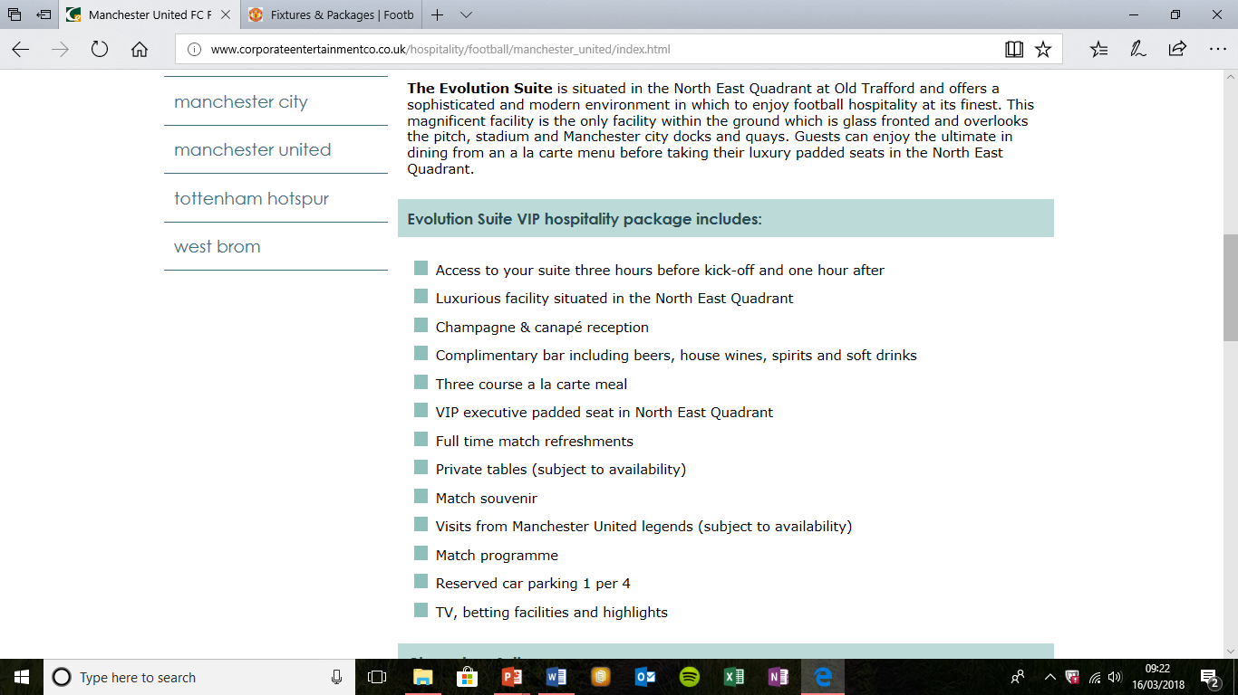
(Appendix 1)
(Appendix 2)
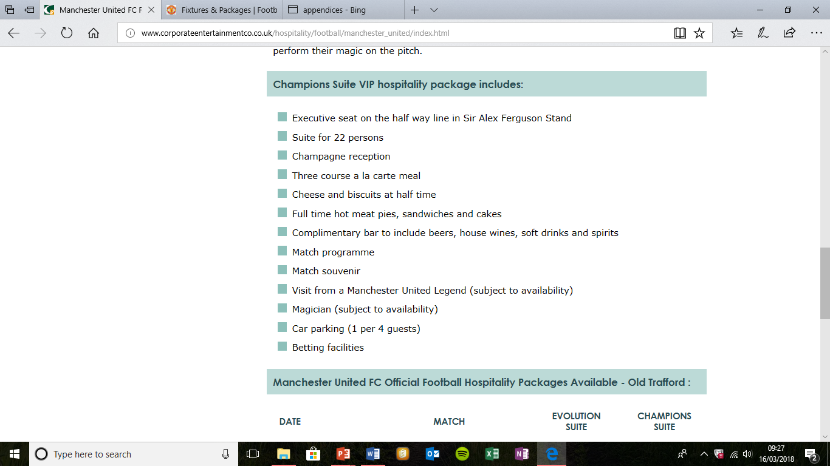

(Appendix 3)
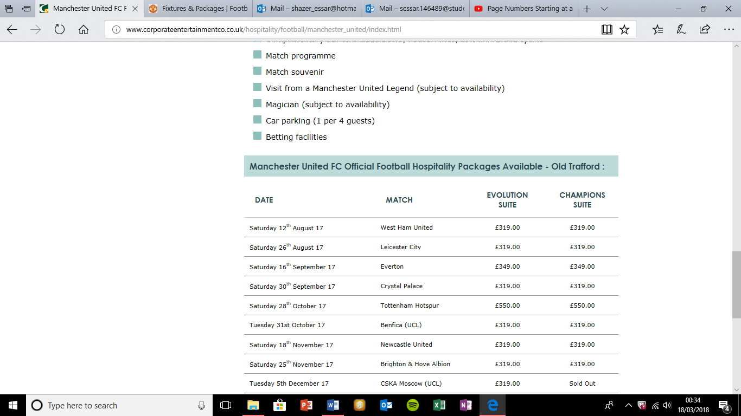
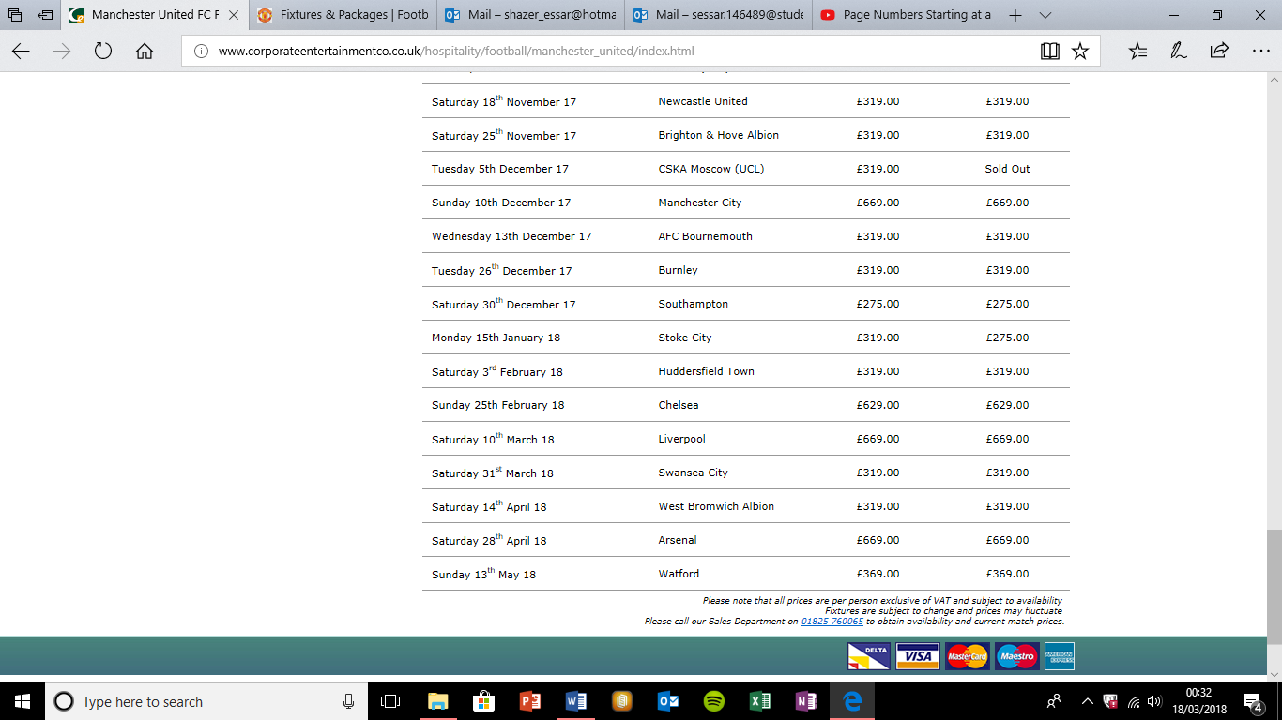

(Appendix 4)
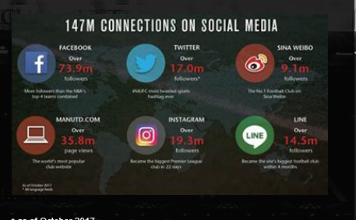

(Appendix 5)

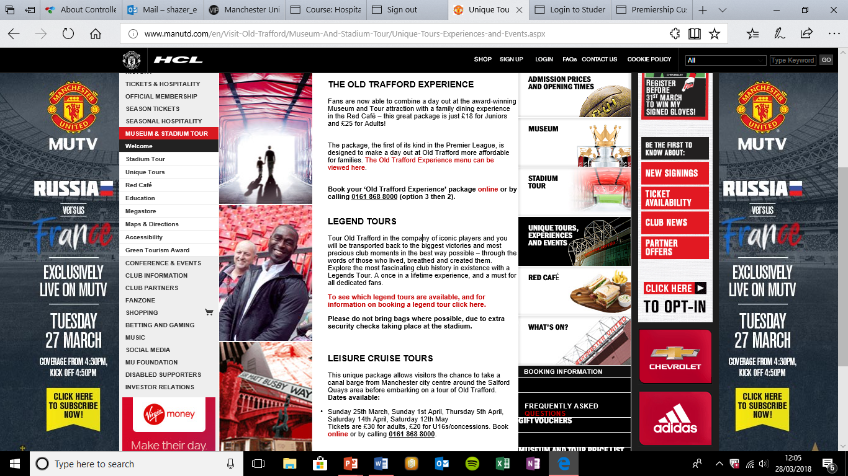

7.0 Acknowledgments
To gather information for the report I got help and from university lecturer, Maria Heffernan, whom helped to compile the report.

8.0 References
Staff, I. (2018). Financial Performance. [online] Investopedia. Available at: https://www.investopedia.com/terms/f/financialperformance.asp#ixzz5AsVfRqIo [Accessed 23 Mar. 2018].
Study.com. (2018). What are Physical Resources in Business? - Video & Lesson Transcript | Study.com. [online] Available at: https://study.com/academy/lesson/what-are-physical-resources-in-business.html [Accessed 23 Mar. 2018].
BusinessDictionary.com. (2018). When was the last time you said this?. [online] Available at: http://www.businessdictionary.com/definition/human-resources.html [Accessed 23 Mar. 2018].
Stadiumguide.com. (2018). Old Trafford - Manchester United - Manchester - The Stadium Guide. [online] Available at: http://www.stadiumguide.com/oldtrafford/ [Accessed 03 Mar. 2018].
Ir.manutd.com. (2018). History. [online] Available at: http://ir.manutd.com/company-information/history.aspx [Accessed 03 Mar. 2018].
Brief, ©. (2018). What is Hospitality Management? Definition and meaning. [online] Mbabrief.com. Available at: http://www.mbabrief.com/what_is_hospitality_management.asp [Accessed 03 Mar. 2018].
Corporateentertainmentco.co.uk. (2018). Manchester United FC Football Hospitality Old Trafford - Corporate Entertainment Company. [online] Available at: http://www.corporateentertainmentco.co.uk/hospitality/football/manchester_united/index.html [Accessed 03 Mar. 2018].
Ir.manutd.com. (2018). Business Strategy. [online] Available at: http://ir.manutd.com/company-information/business-strategy.aspx [Accessed 03 Mar. 2018].
Manutd.com. (2018). Official Manchester United Club Partners - Official Manchester United Website. [online] Available at: http://www.manutd.com/en/Partners.aspx [Accessed 09 Mar. 2018].
Manutd.com. (2018). Match Day Hospitality All Roles - Official Manchester United Website. [online] Available at: http://www.manutd.com/en/Club/Jobs/Matchday-and-Events/Match-Day-Hospitality-All-Roles.aspx [Accessed 10 Mar. 2018].
Controlledsolutionsgroup.com. (2018). Steward Training | Event Steward Training | CSG. [online] Available at: https://controlledsolutionsgroup.com/steward-training/ [Accessed 10 Mar. 2018].
Controlledsolutionsgroup.com. (2018). About Controlled Solutions Group | CSG. [online] Available at: https://controlledsolutionsgroup.com/about-us/ [Accessed 10 Mar. 2018].
Tlfresearch.com. (2018). Manchester United FC | TLF Research UK Based Customer Experience Consultancy. [online] Available at: https://www.tlfresearch.com/case-study-manchester-united-fc/ [Accessed 23 Mar. 2018].
Puckett, J. (2018). Benefits and Importance of Performance Management. [online] TechnologyAdvice. Available at: http://technologyadvice.com/blog/human-resources/importance-of-performance-management/ [Accessed 23 Mar. 2018].
News.bbc.co.uk. (2018). BBC Sport - Football - Football clubs 'pay lip service' to customer care. [online] Available at: http://news.bbc.co.uk/sport1/hi/football/9424828.stm [Accessed 26 Mar. 2018].
Huddled. (2018). Premiership Customer Service from Manchester United FC - Huddled. [online] Available at: https://huddled.co.uk/2013/07/premiership-customer-service-from-manchester-united-fc/https://huddled.co.uk/2013/07/premiership-customer-service-from-manchester-united-fc/ [Accessed 26 Mar. 2018].
Manutd.com. (2018). Unique Tours, Experiences and Events - Official Manchester United Website. [online] Available at: http://www.manutd.com/en/Visit-Old-Trafford/Museum-And-Stadium-Tour/Unique-Tours-Experiences-and-Events.aspx [Accessed 28 Mar. 2018].
9.0 Bibliography
PowerPoint, Hospitality Management, Lecture 1, Mullins (2013)
PowerPoint, Hospitality Management, Lecture 3, Slide 6, Michael Eisner Walt Disney (2002)

