`
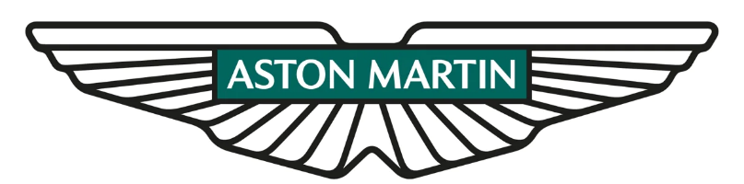


Manufacturing Systems and Simulation
ACMA 6002

Applying Lean Techniques

BEng Manufacturing Systems

Chris Beddoe (2114310)
Date: 20th June 2024
ACMA6002 Manufacturing Systems & Simulation
Applying Lean Techniques

Chris Beddoe
University of Wales Trinity Saint David
20th June 2024

Executive Summary

This report explores the application of lean manufacturing principles to the production of Aston Martin centre consoles at the St Athan plant.
The report begins by identifying the company's background and project scope, emphasising the need for continuous improvement in a competitive automotive industry. Lean manufacturing techniques, derived from the Toyota Production System, aim to eliminate waste and improve value delivery. This includes tools such as 5S methodology, Kaizen, and Kanban systems.
An analysis of the nine wastes of lean manufacturing revealed significant inefficiencies in the current process assembling and movement of centre console parts. The report details how these wastes can be addressed to streamline operations and enhance productivity.
The analysis of customer value emphasises the importance of product quality, functionality, aesthetics, and overall brand experience in creating value for Aston Martin customers. Aligning the production process with these factors involves stringent quality control, process optimisation, and sustainable practices.
Implementing these improvements involves initial costs and potential disruptions. However, the long-term benefits of enhanced efficiency, reduced waste, and improved product quality justify these investments. Addressing challenges through strategic planning, effective training, and continuous communication will ensure successful adoption of lean practices, reinforcing Aston Martin's commitment to luxury and excellence.
The report concludes that embracing lean manufacturing principles will not only enhance operational performance but also uphold the luxury and precision synonymous with the Aston Martin brand, ensuring continued customer satisfaction and competitive advantage in the luxury automotive market.

Table of Contents

Executive Summary 1
1.0 Introduction 1
1.1 Company background 1
1.2 Project scope 1
2.0 Define 2
2.1 Identification of Potential Wastes 3
2.1.1 Movement / Transport 3
2.1.2 Waiting / Overproduction 3
2.1.3 Defects 4
2.1.4 Skills 4
2.1.5 Motion 5
3.0 Analysis of Customer Value in the Production of Aston Martin Centre Consoles 5
3.1 Product Quality 5
3.2. Functionality 5
3.3. Aesthetics 6
3.4 Brand experience 6
3.5 Aligning the Production Process with Customer Value 6
4.0 Improvements 7
4.1 Movement / Transport 7
4.2 Waiting / Overproduction 8
4.3 Defects 9
4.4 Skills 10
4.5 Motion 11
5.0 Conclusion 11
6.0 Bibliography 14
7.0 Appendix 15

Introduction

Company background

Founded in 1913 by Lionel Martin and Robert Bamford, Aston Martin is a British luxury car manufacturer known for its high-performance and elegant design. Iconic for its association with the James Bond franchise, the brand epitomises British engineering excellence. Despite financial challenges and multiple ownership changes, Aston Martin has consistently produced admired luxury sports cars. The St Athan plant in Wales, pivotal for DBX 707 production, showcases Aston Martin's commitment to innovation, luxury, and performance. Today, the company blends advanced engineering with bespoke craftsmanship, maintaining its status as a leading luxury sports car manufacturer.

Project scope

In the highly competitive automotive industry, continuous improvement of manufacturing processes is essential to maintain a leading market position and ensure business is sustainable. The Aston Martin plant at St Athan, renowned for producing the DBX 707, solidifies the Aston Martins commitment to luxury and high-performance vehicles. To uphold these standards, the application of lean manufacturing techniques is crucial. Lean principles, which stem from the Toyota Production System, provide a systematic approach to eliminate waste and enhance value delivery to customers.
Implementing lean manufacturing involves the deployment of various tools and techniques tailored to specific organisational needs. These may include 5S methodology, which focuses on workplace organisation and cleanliness, Kaizen for continuous improvements. Kanban systems can be used for efficient inventory management, and visual management methods to enhance communication and transparency (Chiarini, 2012).
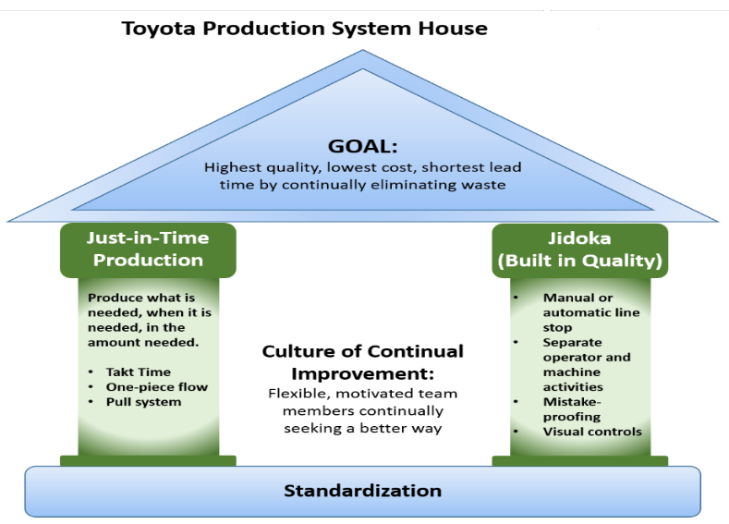
Figure 1: Toyota Production System House, EPA.gov(2023)
This report undertakes a comprehensive analysis of a specific part of the Aston Martin manufacturing process at Aston Martin St Athan. It focuses on identifying all the potential current wastes, analysing value from the customer's perspective, and evaluating strategies to streamline operations. Additionally, the report considers potential challenges in implementing these improvements and assesses associated costs. By applying lean techniques, the aim is to optimise production efficiency, reduce costs, and sustain the superior quality synonymous with Aston Martin.

2.0 Define

In response to the supply chain disruption caused by World Class Manufacturing (WCM) being unable to continue providing essential parts for Aston Martin centre consoles at volume, Aston Martin has decided to internalise the production of these components in the medium term. This lean project will focus on evaluating a new in-plant process for painting and assembling the centre consoles. The primary objective is to identify and eliminate various forms of waste within the new production process, ensuring that it meets Aston Martin's high standards of efficiency and quality. By adopting lean principles, this project aims to streamline operations, minimise costs, and enhance overall productivity while maintaining the luxury and precision associated with the Aston Martin brand.

2.1 Identification of Potential Wastes

2.1.1 Movement / Transport

At present, raw parts for the centre consoles are transported daily from WCM in Essex to Aston Martin in St Athan for painting, inspection, and assembly. The painted and inspected parts are then transferred from the paint plant to the WCM assembly line in St Athan. Following assembly, the parts are transported from St Athan to Aston Martin in Wellesbourne, where they are compiled into assembly kits and subsequently distributed via lorry to the Gaydon and St Athan plants. Parts destined for assembly at Gaydon travel a total of 337 miles before assembly, while those destined for assembly at St Athan travel a total of 448 miles. See appendix figure 5 and 6 for reference.
Transportation can introduce several forms of waste, particularly if deemed excessive transportation. In the process studied, the parts undergo multiple relocations before reaching their final assembly destination, which according to Liker(2003) unnecessarily increases lead times, fuel costs, and the risk of damage during transit. Current rejects due to transit damage sits at 20 percent in Gaydon and just 4 percent in St Athan. This supports the argument that transportation does indeed increase the risk of damage to parts as stated by Womack & Jones(2003).

2.1.2 Waiting / Overproduction

Currently, there is no planned internal logistics structure for inventory arrival. This lack of planning results in significant waiting times for parts upon batch arrival, leading to overproduction when parts do arrive. As a result, waiting for parts represents a waste of resources, as labour costs are incurred without value-added assembly taking place.
Overproduction occurs as when the parts are received, they are all assembled, but not immediately needed for processing. According to Shingo (1988), overproduction is one of the wastes in lean manufacturing, as it ties up capital in unnecessary inventory and increases storage costs. Implementing a just-in-time (JIT) inventory system can help mitigate these issues by ensuring that parts arrive precisely when needed for assembly, reducing waiting times and the risk of overproduction (Ohno, 1988).

2.1.3 Defects

Now at Aston Martin there are multiple handling stages from painting to kitting increase the potential for defects in Aston Martin's centre consoles. Each transfer of parts, including transportation, introduces opportunities for scratches, dents, or other damage, which can compromise the final product quality. According to Shingo (1988), defects are a significant source of waste in manufacturing processes, as they require rework, repairs, or even complete replacement of faulty parts. Removing unnecessary transportation and movement, implementing robust quality control measures, and reducing the number of handling stages could possibly help mitigate these risks and improve product quality.

2.1.4 Skills

The new assembly process at Aston Martin utilises skilled automotive contract labour to perform tasks that are relatively simple. The assembly tasks do not require a high level of skill, although the technicians would have to practice precision and adhere to quality standards. As highlighted by Baudin (2002), developing a skilled workforce capable of handling complex assembly tasks is crucial for achieving operational excellence and maintaining product quality standards in automotive manufacturing. But having overly skilled labour is also a waste, as they often command a higher premium, and their skills could be put to better use elsewhere in the business.

2.1.5 Motion

The current layout of the WCM production facility is required to be assessed. If considered suboptimal, removal of movement waste during the assembly process could be introduced. Poorly planned workstation layouts and inadequate ergonomic considerations could also contribute to unnecessary motion and handling leading to increased production time and introduce opportunities for error. According to Shook and Rother (2009), reducing unnecessary motion is fundamental to lean manufacturing principles, as it minimises wasted time and effort while enhancing overall workflow efficiency.

3.0 Analysis of Customer Value in the Production of Aston Martin Centre Consoles

From the customer's perspective, value is created through a combination of product quality, functionality, aesthetics, and the overall experience associated with owning and using an Aston Martin vehicle. In relation to the production of centre consoles, the following factors are considered critical in creating value.

3.1 Product Quality

Customers expect high-quality, precision-crafted components that reflects the luxury associated with the Aston Martin brand. Any flaws or defects in the centre console can significantly detract from the perceived value of the vehicle. The centre console must be durable and reliable, providing a seamless and long-lasting experience. Any issues with the console could impact customer satisfaction and brand reputation (Liker, 2003).

3.2. Functionality

The centre console should be designed for intuitive and effortless use. This includes the placement of controls, the responsiveness of buttons, and the overall ergonomics. Incorporating advanced technology and innovative features into the centre console can enhance the driving experience, providing added value to customers (Womack & Jones, 2003).

3.3. Aesthetics

The visual appeal of the centre console is crucial. Customers expect a sleek, stylish design that complements the interior of the vehicle. High-quality materials and finishes contribute to the luxurious feel of the car.
Offering customisation options, such as different materials, colours, and finishes, allows customers to personalise their vehicles, again adding to the perceived value.

3.4 Brand experience

The overall experience of owning an Aston Martin, from the purchasing process to after-sales service, adds to the value. Ensuring that every interaction with the brand reinforces its reputation for excellence is vital. Attention to detail in every aspect of the centre console's production and assembly reflects the brand's commitment to quality and enhances customer satisfaction.

3.5 Aligning the Production Process with Customer Value

To align the production process with these value-creating factors, this project will focus on the following improvements:
Quality Control: Implement stringent quality control measures at each stage of production to ensure the highest standards of craftsmanship and durability.
Process Optimisation: Streamline processes to reduce defects and rework, ensuring that every centre console meets the precise specifications and quality expectations of the customer (Shingo, 1988).
Sustainability: Consider environmental impacts and strive for sustainable practices in production, which can enhance the brand’s value proposition to environmentally conscious customers.

4.0 Improvements

4.1 Movement / Transport
To address movement and transport inefficiencies, it is essential to analyse the current movement of parts and identify opportunities to reduce or eliminate unnecessary transportation. Workflow mapping is a tool that can be used to visualise the current transportation process whereby potential excess movement can be identified and removed.
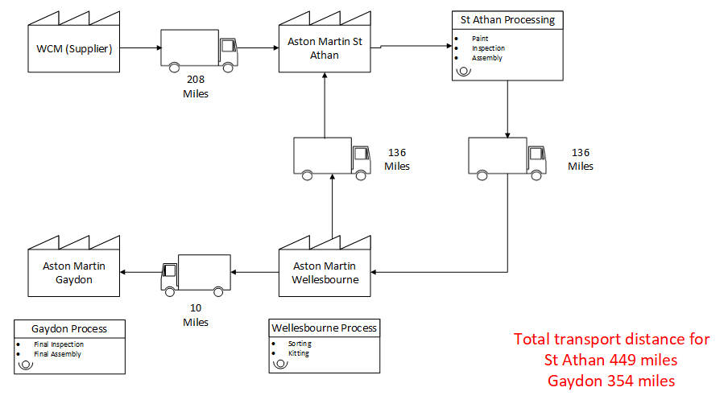
Figure 2 – Current transport workflow map (Chris Beddoe, 2004)
By streamlining the movement process, Aston Martin could enhance operational efficiency and reduce associated costs and risks. To achieve this, consideration should be made for centralisation of production. Instead of sending parts to Wellesbourne for final distribution, a central processing and kitting hub could be set up at St Athan. St Athan would then handle all stages of painting, inspection, assembly, and final distribution in assembly kits. This would reduce the transportation distance of parts finally assembled at St Athan from 449 miles to 208 miles, a reduction of over 53%. Using as the average UK road haulage cost is £1.50 a mile (Road Haulage Services, 2024) this would result in a monetary saving of around £90,000 annually and would reduce the risk of damage.
Reducing transportation is not the only way to limit transport damage. Hanlon, et al. (1998) argue that modern packaging technologies have significantly improved the protection of parts during transportation. Enhanced packaging materials and methods can mitigate the risk of damage, even with extended transport distances.
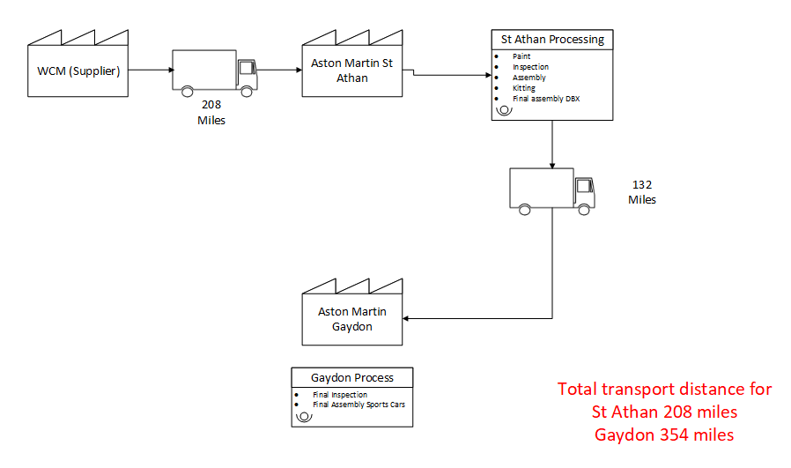
Figure 3 – Proposed improved transport workflow map (Chris Beddoe, 2024)
An internal study was carried out by Aston Martin in 2023 which concluded that the total cost of setting up a kitting hub at St Athan would be around £42,500. Due to numerous factors, including reduced requirement of transport vehicles and drivers, reduction in kitting boxes needed, it would result in an overall year on year net saving of over £1M, with an estimated reduction in annual carbon footprint of 2100 tonnes. See appendix, figure 7 for presentation slide.

4.2 Waiting / Overproduction
To tackle waiting and overproduction, several strategic improvements can be suggested. A comprehensive internal logistics plan could be introduced to schedule inventory arrival. Mapping out the supply chain would assist in recognising and address potential bottlenecks, reducing waiting times and ensuring parts are available when needed. Aligning delivery schedules with production needs maintains a smooth workflow, and coordinating with suppliers to deliver parts just in time would prevent excess inventory and minimise overproduction (Heizer & Render, 2013).
Setting clear production targets based on accurate demand forecasts would help manage the production process effectively. These targets should be flexible yet precise to avoid overproduction. This would mean a product pull system would be in place, driven by actual demand rather than forecasts, and would eliminate overproduction. This system would ensure products are produced only when needed, eliminating waste from excess inventory. Techniques like Just-in-Time (JIT) manufacturing promote efficiency and reduce waiting times (Ohno, 1988).
Kanban systems should also be considered. Kanban systems control material flow and reduce excess inventory by visualising the production process and limiting work-in-progress (WIP). Implementing Kanban boards and electronic Kanban systems can enhance transparency and provides real-time insights into production status, enabling better decision-making (Liker, 2003). See appendix, figure 8 for Kanban board example.

4.3 Defects
To minimise defects in the production process, it is essential to streamline the handling process and reduce the number of touchpoints where damage can occur. Simplifying the process flow can significantly decrease the opportunities for parts to be mishandled (Liker, 2003). Implementation of quality control checks at each stage of production would ensure that any defects are caught early, preventing defective components from advancing further down the line and reducing overall waste (Montgomery, 2020). Additionally, training staff on proper handling techniques is crucial for minimising damage during the assembly process. Well-trained employees are more likely to handle parts correctly, thus maintaining the high standards of quality expected in Aston Martin’s production (Slack, et al., 2016). By focusing on these areas, the production process can become more efficient and produce fewer defects, upholding the luxury and precision synonymous with the Aston Martin brand.

4.4 Skills
Developing a comprehensive training program could assist to upskill the new workers efficiently and ensure they are well-prepared for the assembly process. Such training should cover all necessary skills and techniques required for the assembly tasks, focusing on both speed and accuracy (Blanchard & Thacker, 2013). Additionally, utilising less skilled labour for assembly tasks can free up more highly skilled workers to focus on more complex and critical tasks within the business. This could support optimising the workforce and enhancing productivity. Creating standardised work instructions is also crucial for maintaining consistency and quality in assembly. See example created below created for centre stack finisher.
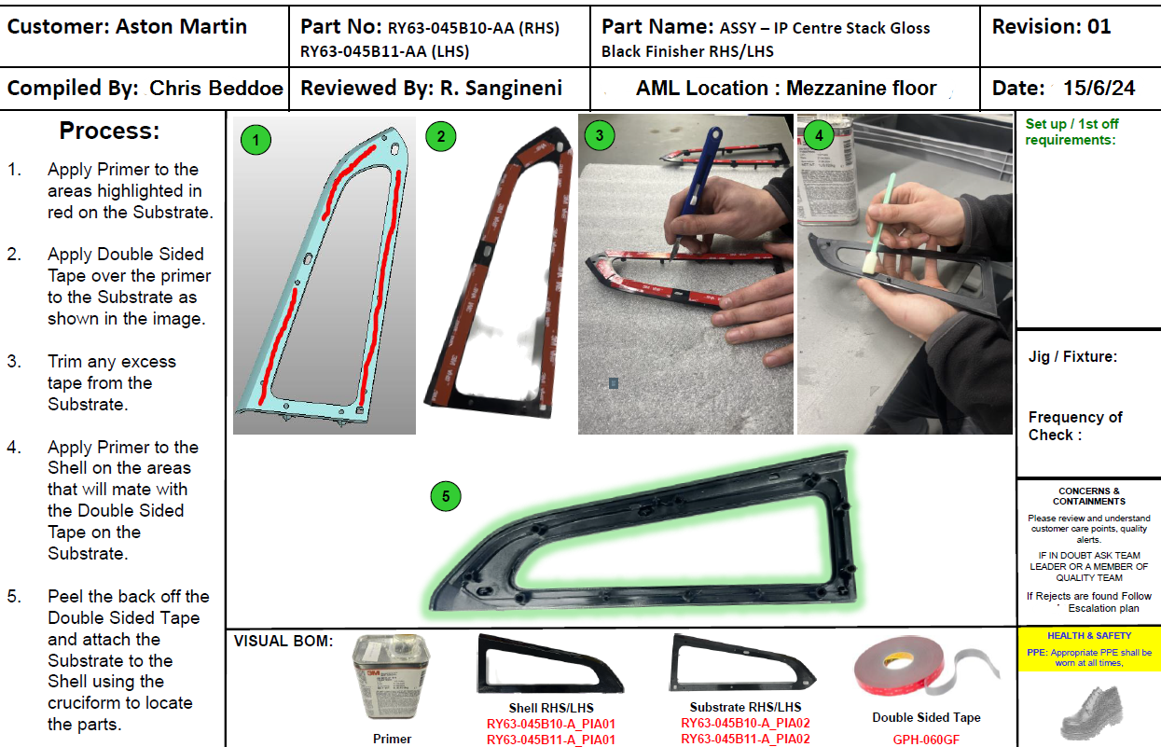
Figure 4 – Example standard work instructions created by Chris Beddoe (2024)
The above instructions are clear, detailed, and should be made accessible to all workers, ensuring that everyone follows the same procedures and standards. Implementing these strategies would ensure a highly skilled and efficient workforce that maintains the company's high standards of quality and luxury.

4.5 Motion

Considerations should be made to redesigning the workspace layout. This could help to minimise unnecessary movement and improve ergonomics, which is crucial for enhancing efficiency and reducing worker fatigue. Having a well organised workspace allows workers to access tools and parts more easily, reducing the time and effort spent on non-value-added activities (Hirano, 1995). Use of value stream mapping can help identify and eliminate these non-value-added activities, streamlining processes and improving overall productivity (Shook & Rother, 2009). Additionally, implementing the 5S methodology (Sort, Set, Shine, Standardise and Sustain) could ensure there is an organised and efficient workspace. The 5S approach ensures that everything is in its place, tools and materials are easily accessible, and the work environment is clean and orderly. All of this contributes to smoother operations and reduced motion waste (Hirano, 1995). By focusing on these improvements, Aston Martin could enhance workflow efficiency, reduce unnecessary movements, and create a more ergonomic and productive work environment on the WCM production process.

5.0 Conclusion

Implementing lean manufacturing principles in the production of Aston Martin centre consoles at the St Athan plant presents significant opportunities for improving efficiency, reducing costs, and enhancing product quality. The identification and elimination of the nine wastes serve as a foundation for streamlining operations and ensuring that the production process aligns with the high standards of the Aston Martin brand.

However, potential challenges and costs associated with these improvements must be considered to ensure successful implementation:

Movement / Transport: The centralisation of production to St Athan aims to reduce transportation costs and carbon footprint. The internal study estimated a setup cost of approximately £42,500 but projected annual savings of over £1M and a reduction in carbon footprint by 2,100 tonnes. The primary challenge is the initial investment and potential resistance to change from staff accustomed to the current workflow. This can be addressed by highlighting the long-term benefits and ensuring a smooth transition through effective change management strategies.

Waiting / Overproduction: Introducing a just-in-time inventory system and Kanban systems will require careful planning and coordination with suppliers to ensure timely delivery of parts. The cost of implementing these systems includes training and potential initial disruptions in production. Overcoming these issues involves robust project management, clear communication with suppliers, and phased implementation to minimise disruptions (Ohno, 1988).

Defects: Enhancing quality control measures and reducing handling stages can decrease defects. The associated costs include investment in quality control technologies and training staff in proper handling techniques. Addressing these challenges involves prioritising quality as a core value, continuous staff training, and integrating automated quality control systems to complement human oversight (Shingo, 1988; Montgomery, 2020).

Skills: Training employees and developing standardised work instructions will require time and resources. The cost of training programs and developing comprehensive instructions must be justified by the resulting improvements in productivity and consistency.

Motion: Redesigning the workspace layout and implementing the 5S methodology involves initial costs in rearranging the workstations and ongoing efforts to maintain the new standards. Potential problems include disruptions during the redesign phase and ensuring continuous adherence to 5S principles. These can be mitigated through planning, involving employees in the redesign process, and establishing a culture of continuous improvement (Hirano, 1995).

In conclusion, while the implementation of lean principles presents upfront costs and potential disruptions, the long-term benefits of enhanced efficiency, reduced waste, and improved product quality justify these investments. Addressing the potential challenges through strategic planning, effective training, and continuous communication will ensure the successful adoption of lean practices.

6.0 Bibliography

Baudin, M., 2002. Lean Assembly: The Nuts and Bolts of Making Assembly Operations Flow. 1st ed. New York: Productivity Press.
Blanchard, N. P. & Thacker, J. W., 2013. Effective Training: Systems, Strategies, and Practices. s.l.:Pearson Education.
Chiarini, A., 2012. Lean Organisation: From the Tools of Toyota Production System to Lean Office. New York: Springer Milan.
Gordon, P. J., 2001. Lean and Green: Profit for Your Workplace and the Environment. s.l.:Berrett-Koehler Publishers.
Hanlon, J. F., Kelsey, R. J. & Forcinio, H., 1998. Handbook of Package Engineering. 3rd ed. s.l.:CRC Press.
Heizer, J. & Render, B., 2013. Operations Management: Sustainability and supply chain management. 11th ed. s.l.:Pearson.
Hirano, H., 1995. 5 Pillars of the Visual Workplace. s.l.:Taylor & Francis.
Liker, J. K., 2003. The Toyota Way: 14 Management Principles From the World's Greatest Manufacturer. s.l.:McGraw Hill Professional.
Montgomery, D. C., 2020. Introduction to Statistical Quality Control. 8th ed. s.l.:John Wiley & Sons.
Ohno, T., 1988. Toyota Production System: Beyond Large-Scale Production. s.l.:Taylor & Francis.
Road Haulage Services, 2024. HAULAGE RATES. [Online]
Available at: https://www.roadhaulageservices.com/haulage-rates/
[Accessed 4 July 2024].
Shingo, S., 1988. Non-Stock Production: The Shingo System of Continuous Improvement. s.l.:Productivity Press.
Shook, J. & Rother, M., 2009. Value-Stream Mapping to create value and eliminate MUDA. 4th ed. s.l.:Lean Enterprise Institute.
Slack, N., Brandon-Jones, A. & Johnston, R., 2016. Operations Management. 8th ed. s.l.:Pearson.
Womack, J. & Jones, D., 2003. Lean Thinking: Banish Waste and Create Wealth in Your Corporation. Second ed. s.l.:Productivity Press.

7.0 Appendix

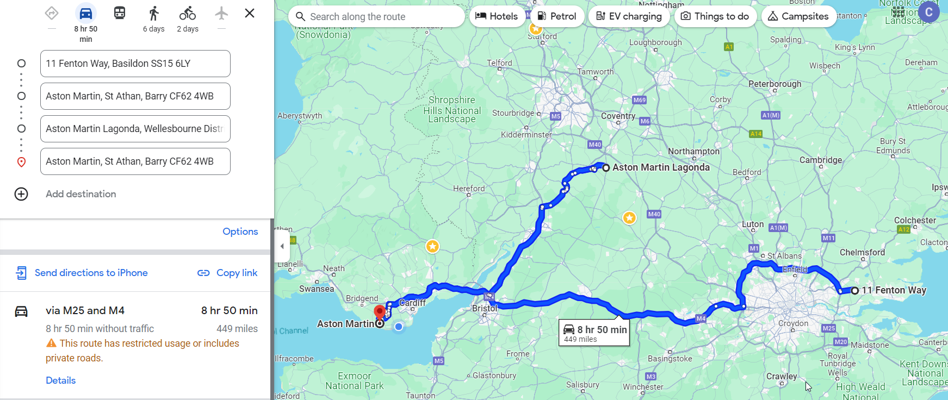
Figure 5 – Google maps to calculate current transportation distance.

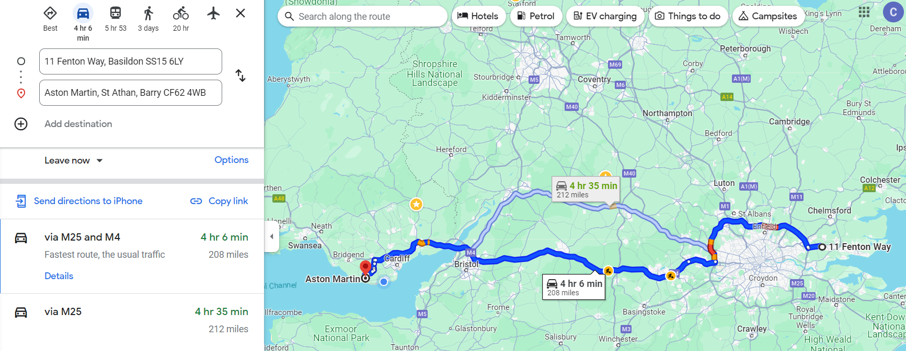
Figure 6 – Google maps to calculate potential lowered transportation distance
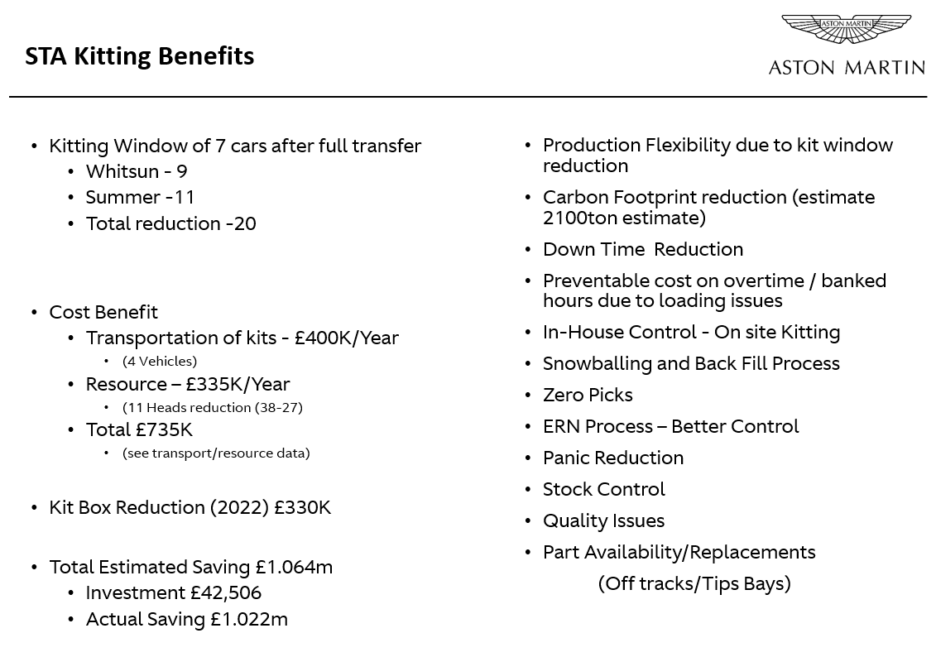
Figure 7 – Presentation for justification of moving all kitting to St Athan

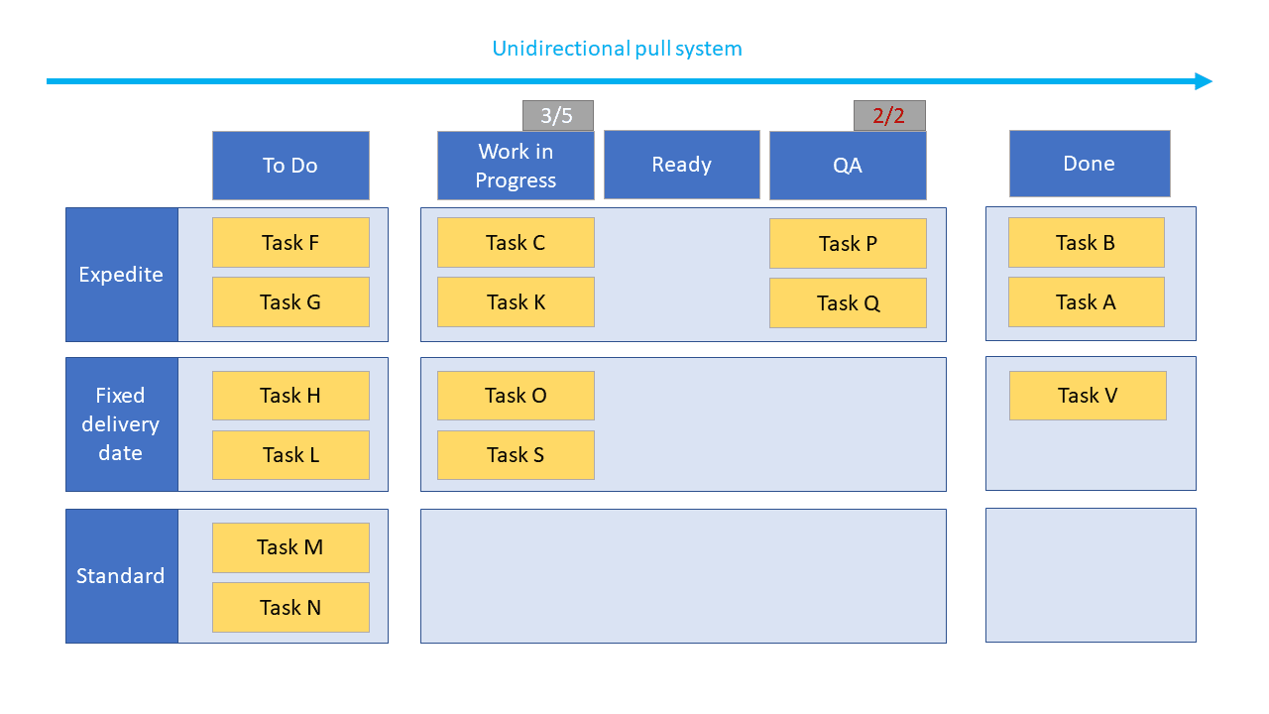
Figure 8 - Example Kanban board (https://teamhood.com/kanban-resources/kanban-pull-system/)

