HND Computing Year 2 Cyber Security Assignment Report
Tutor: Sarah Williams
By James David Joseph Pugh

Table of Contents
List of acronyms 3
Introduction 4
List of Tables and figures 5
Data flow diagrams for chosen BYOD implementation 5
Level 0 5
Level 1 5
Network configuration diagram (applies to the practical application and deployment section of the assignment) 6
User policy 7
1. Initial Brief 7
1.1 Introduction 7
1.2 Scale of policy 7
2. Core User Policy 7
2.1 Permitted Uses of Personal Devices 7
2.2 Costs/Requirements 7
2.3 Unacceptable uses of personal devices 7
2.4 What data will be accessible and retained by devices on our network 8
Chosen Mobile device management software 8
Advantages and Disadvantages of BYOD 10
Advantages 10
Disadvantages 10
Security Policy 11
1. Key requirements 11
2. How the company will deal with device theft or failure along with devices leaving the network. 13
2.1 Theft 13
2.2 Failure 13
2.3 Employee leaving or dismissed from the company 13
Device management policy 13
1. Steps users should take to protect their devices 13
2. How the company will blend the personal and business aspects of Bring Your Own Device 13
3. How the company plans to deal with different brands of devices along with different operating systems. 13
4. How the company plans to deal with the different applications on user devices 14
Conclusion 14

List of acronyms
BYOD – Bring your own device
NCSC- National Cyber Security Centre
DPA – Data Protection Act
MDMS – Mobile Device Management Software
R&D – Research and Development
MAC – Media Access Control
IP – Internet Protocol

Introduction
The following report details the research behind the writer’s approach in developing a complete BYOD framework for Golding-Harvest Ltd. Key areas of this report include user, security, and device management policies. These sections cover issues such as what data different users will have access to while on the network along with how company and employee data will be protected without limiting the flexibility BYOD can offer.

List of Tables and figures

Data flow diagrams for chosen BYOD implementation

Note: If diagrams are unreadable please check the diagram images folder submitted alongside this report for clear versions of these diagrams.

Level 0

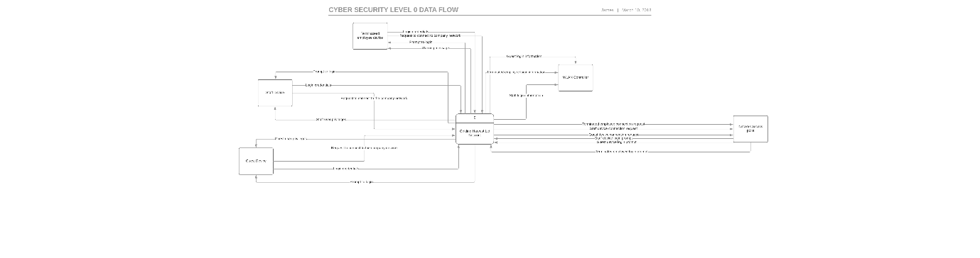

Level 1

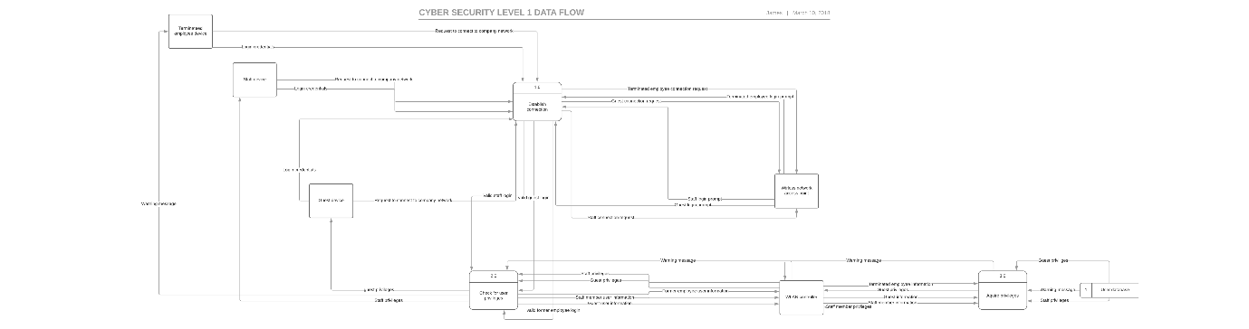

Network configuration diagram (applies to the practical application and deployment section of the assignment)

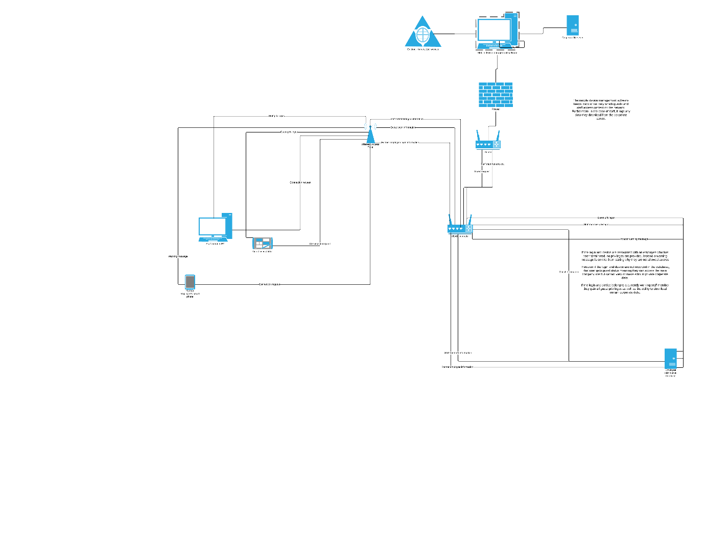

User policy (1)
- Initial Brief

1.1 Introduction
We at Golding-Harvest Ltd, understand that the flexibility of consumer technology is ever increasing. Furthermore, we acknowledge the potential opportunities for both industrial and personal growth, that allowing employees to utilise their personal devices while on our premises could offer.
The goal of this document is to clearly explain to our employee’s key aspects of this policy along with their responsibilities when it comes to protecting both their and our interests/data while using their devices.

1.2 Scale of policy
This policy covers all use of BYOD while on any of our premises and details what use of personal devices is permitted, along with any costs that apply to users taking advantage of BYOD
- Core User Policy
  - Permitted Uses of Personal Devices
- To complete core business tasks that aid the success of the company.
- To communicate with colleagues
- To access web resources through a monitored network.
- To allow emergency contact between employees and their family/fellow colleagues.
- To utilise company software on hardware employees are familiar with.
  - Costs/Requirements
- Employees are required to cover the costs of purchasing any devices they wish to utilise as part of our BYOD network.
- Employees will not be expected to cover any costs associated with installing and maintaining the Mobile Device Management Software (MDM) chosen to complement our implementation of BYOD.
- It is recommended that employees choose a device that operates on one of the following platforms (IOS, Android, Windows, and Samsung).

  - Unacceptable uses of personal devices

- To harass fellow employees or potential clients. The writer assumes that the company has documentation detailing what they consider harassment. However, possible examples may be employees making inappropriate and unwanted sexual advances towards others or employees making racist comments.

- To download/promote extremist content. This content is defined as content designed to disrupt/dismantle a community’s core values along with content that glorifies the physical harm/abuse of individuals of faith groups or minorities. (2)

Possession of this content will result in immediate termination along with potentially being reported to the necessary authorities.

If this were ignored, employees could misinterpret this as the company not highly valuing their safety thus building friction managers and the main workforce. In the long-term this could result in strikes which would decrease productivity, along with harming the company’s media image.

- Any activities associated with pornography.

  - What data will be accessible and retained by devices on our network

The main types of data that will be retained by employee and client devices, are the MAC addresses and private IP addresses they are assigned. This sort of data must be retained, in order for the company network to determine which particular devices to send what data to when data requests are made.

Chosen Mobile device management software

After considering the needs of Golding Harvest Ltd, the writer has chosen to use the MDMS called ManageEngine (3). A key feature of this software, is its compatibility with multiple OS including, Android, IOS, and Windows (3). Thus, high level security will be achievable on a wide range of devices. Perhaps two of the most important features provided, at least in terms of preventing data leaks are device tracking (3) and remote locking (3) as devices can be located easily and made inaccessible to thieves. However, this tracking feature may have privacy implications as employees could feel that their privacy was being compromised as the company would basically be able to track their location whenever the device they use on the company network was in their possession.
These privacy concerns could damage the relationship between the company and its employees as employees may feel that they are simply tools to be taken advantage of and monitored whenever their managers see fit. This poor employer/employee relationship would likely cause a steep decrease in productivity, as employees may become unmotivated due to a sense of felling undervalued and having reduced self-esteem.
Maslow’s Hierarchy of Needs supports this as it places an individual’s need for self-esteem above the need for reaching one’s potential when it comes to being motivated. Meaning, an individual with insufficient self-esteem, won’t be strongly motivated to reach their potential weather that’s referring to their personal life, or at work (4). Because of this, it is recommended that the company focus on the protective benefits these tracking features offer when encouraging employees to utilise BYOD.
Evidence of the privacy concerns associated with BYOD is shown in a 2014 report presented by the security company known as Webroot. (5) In a pool of “2100” surveyed employees, over 50% stated that they were worried about their personal data being viewed by their’ employer. (5) The total employees concerned equates to approximately 1155 employees. This suggests that managing employee privacy is vital consideration that any organisation considering implementing BYOD should be aware of as employees may become uneasy and in turn less mentally sound and productive otherwise
Another feature of the chosen software is partial/full device data wiping. (3) This feature is ideal as without it, Golding-Harvest Ltd could not guarantee that no corporate data would exist on an employee’s device when they left the company.
Catastrophic consequences could come from this oversite, as if an employee became aware of this data and felt vindictive towards the company, they could make this data publicly available. Meaning, that not only could competitors gain access to information such as mining equipment designs, but also any legally questionable activities of Golding-Harvest Ltd could be made public and damage its’ image on social media along with dragging the company into legal disputes.
Thus, this software feature supports the writer’s chosen MDMS as it would protect the company from potential data leakage and extorsion, in addition to legal fees that could cripple it. Furthermore, the ability to wipe data only partially from a device makes this software ideal for blending the business aspect of BYOD with the fact that employees own said devices. However, it is vital that partitioning of corporate and personal data occurs to prevent unintentional data loss.
The chosen software also is provided in a cloud-based version. (6) This is ideal for Golding Harvest Ltd as they predominantly rely on a cloud-based system for their network.
Ultimately, the discussed MDMS has been chosen as it offers robust protection features for both organisations and their employees along with cloud features that suit this company perfectly.

Advantages and Disadvantages of BYOD

Advantages
- Due to familiarity employees have with their own devices, more time is available for work as no training is required to use them. Because of this, companies utilising BYOD should expect a noticeable reduction in their overall costs. This has important implications for productivity, as it means that companies are likely to have greater disposable income that can be used for investing in new technologies to help employees work more productively. For example, a company like Golding Harvest ltd could use these funds to invest in new mining equipment or enhancements such as new drills that are more affective on hard surfaces. Thus, reducing the time needed to complete or acquire mining contracts.

Alternatively, these extra resources could be used to improve the general work environment such as by providing comfortable chairs to sit on or high-quality food if a canteen is on the premises. Through these improvements, it is reasonable to expect an increase in productivity as employees may feel more highly valued and energetic due to a more relaxed environment. A good example of how creating a relaxed work environment can lead to increased productivity and in turn financial success can be seen in Google.

They reward employees with health care provisions and easy access to high quality food. (7) However, despite the inevitable costs of providing these benefits, the company’s annual revenue has always increased since earning less than 1 billion dollars in 2003, to earning just under 110 billion in 2017. (8) Thus, showing that a relaxed work environment can produce significant boosts to productivity and support the financial stability of organisations.

Disadvantages
- Depending on the features available on an employee’s device, they may become distracted engaging in leisure activities such as PC gaming or viewing social media. In contrast, if a company opts for choosing the specific hardware employees will have access to, they won’t have to account for as many differences in available software on similar devices. While this may reduce the overall flexibility of organisation’s system due less verity in the type of hardware and software used, it may be somewhat conducive to productivity as there are fewer dynamic variables that may impact an employee’s willingness or ability to work productively.

- The effectiveness of BYOD is highly dependent on each employee’s available budget. Because, they are solely responsible for purchasing any devices they use as part of their employer’s BYOD policy. Potentially, this could lead to noticeable drops or imbalances in the productivity of individual employees.

This is because an employee may not have the budget needed to purchase more current equipment, and thus need to opt for an outdated device. Thus, productivity inhibitors such as poor system performance or incompatibility with current versions of job related software may appear.

In contrast an equally skilled employee with a more flexible budget is likely to experience a far smother and putative work experience due to hardware advantages such as faster processing speed. Further complications could arise if those using more outdated hardware become aware of this difference in equipment, as they may become less motivated due to feeling inadequate against their wealthier colleagues.

However, if a company purchases the hardware itself, managers can ensure that all devices fit their required role and can compete with hardware used by competitors. Thereby, creating an organisation, whose productivity is more dependent on the skill of its workers rather than differences in hardware capabilities.

- Because employee devices travel between home and the office, opportunities arise for damage or theft to occur. According to the Home Office, approximately 538,000 people experienced mobile phone theft between 2014 and 2015. (9) Assuming 10% were used as part of BYOD that equates to almost 54,000 stolen devices. This would have impacted productivity, as employees involved would have experienced higher stress levels and potentially need to purchase and become familiar with a new device before resuming full productivity. Furthermore, it is likely that the IT departments of affected organisations would become less productive due to spending time assisting employees in finding their lost devices through tracking along with fixing any IT issues resulting from this distraction.

Security Policy
(10)

Key requirements
- Device operating systems must be kept up to date. This is to ensure that employee devices are not susceptible to outdated viruses or malware. Furthermore, by doing this, employees will be ensuring that Golding-Harvest Ltd. network will not be compromised through secondary factors such as code leaks like the recent IOS source code leak

- Utilise a secure password to protect your devices from thieves if your device is stolen or at rest. The NCSC recommends this password mustn’t match a currently used password. (11) Furthermore, employees mustn’t store a text version of this password on any devices they use. This is necessary to prevent the password used being compromised by gaps in the security of unrelated devices.

- These passwords must never be used when securing the device you wish to use. “123456”, “password”, “123456789”, “abc123”. (12) They were found in a Google study to be the most common passwords used on sites where data leaks have occurred with 123456 being linked to over 6 million accounts. (12) If these passwords were used on employee devices, the company could lose millions in legal fees due to competitors getting hold of data such as equipment designs. To further improve device security, it is recommended that passwords include uppercase and lowercase letters along with numbers and symbols.

- If a device is lost, employees should report this to the IT department as we can use tracking to locate it. Knowingly not reporting the loss or theft of a registered device may result in disciplinary action due to the potential for both corporate and personal data loss.

- No copies of client or employee information are a to be produced and stored on employee devices. Furthermore, any copies of corporate data produced must first be approved and destroyed after use. This is necessary to not only prevent possible data leakage as the more copies there are of data, the more likely others can acquire it, but also to comply with legislation such as the UK DPA. (13)

This aspect of our security policy focuses on complying with principle 2 of the DPA which states that data pertaining to specific individuals should not be accessed for non-company specified reasons or for reasons that are illegal. (13)

Failure to comply could cost the company thousands in legal fees. (14) Thus, seriously impacting our ability to compete, due to reduced financial flexibility for things like R&D into new mining equipment or improving the state of our work environment. Furthermore, these legal issues would tarnish our image which could limit the potential for growth due to possible clients not associating with us. In addition, productivity would most likely decrease due to increased stress levels amongst employees, which in turn could result in employees being made redundant due to forced downsizing.

How the company will deal with device theft or failure along with devices leaving the network.

Theft
If a device is stolen, we will use tracking to locate it. However, employees must give consent to device tracking first. Tracking will never be used outside of this context.

2.2 Failure
In this event, employees will need to fill out a small report detailing the cause including photographic evidence of the device. If deemed adequate, we will cover a proportion of the costs for purchasing a new device.

Employee leaving or dismissed from the company
In both these events, all company related data on said employee’s devices will be wiped. Personal data will be partitioned to prevent employees losing it.

Device management policy

Steps users should take to protect their devices
- Don’t root/jailbreak devices.
- Use a protective case to hold devices
- Install malware/virus protection.
- Keep devices near.

How the company will blend the personal and business aspects of Bring Your Own Device
During breaks, employees may use their devices for social media, gaming or listening to music. Equipment such as headphones will be provided. Furthermore, employees will be able to take a bimonthly questionnaire to discuss improvements for our BYOD framework. The company should embrace BYOD’s personal aspects as this may produce happier employees who are more productive and unlikely to harm the company’s interests.

How the company plans to deal with different brands of devices along with different operating systems.
When employees join the company’s BYOD framework, they’ll be asked to fill out a questionnaire detailing which hardware brand they are interested in using along with what OS they are planning to use. The IT department will then send a response detailing whether the proposed brand and operating are support by the chosen MDMS. If they are not supported, employees will be requested to seek an alternative. This is necessary for two main reasons. Firstly, if employees never communicated what brand of hardware or OS they planned to use, the company could not guarantee adequate network security as key features of the chosen MDMS may not be supported.
Secondly, by querying about the employees chosen OS, the company can specify that only currently supported OS are permitted while utilising BYOD. Without taking this precaution, employees’ may choose to use a no longer supported OS such as Windows XP. Due to no longer receiving updates along with being incompatible with company software, using an outdated OS would not only present significant risk to the security of personal and company data, but also would make the used device impractical for achieving required productivity levels.

How the company plans to deal with the different applications on user devices
While on any company premises employees must be aware that any video capture or camera functionality on their devices will be disabled. This is necessary not only to protect our intellectual property, but more importantly, to protect the privacy and identities of our staff and clients.
In addition, the company’s MDMS will be used to blacklist any applications that do not comply with regulations. However, please note that any blacklisted applications will be fully accessible once off the company system.

Conclusion
Overall implementing a BYOD framework presents clear opportunities for Golding-Harvest Ltd to grow both financially and in terms of Productivity. This is a result of a combination of reduced costs due to not having to purchase as much hardware for office use and increased employee motivation because of a strong sense of trust between them and managers. However, it is vital that the company remain aware of the balancing act that is respecting each employee’s private use of their device, and protecting their intellectual properties and general network security.
Final word count 2805

Reference list

- Government of New South Wales. Bring your Own Device (BYOD)
Policy [document on the Internet]. [published 2013 December; cited 2018 Feb 10]. Available from: https://www.finance.nsw.gov.au/ict/sites/default/files/BYOD%20Policy_1.docx

- Canterbury Christ Church University. CCCU. Government Definitions of extremism, radicalisation and terrorism [Internet]. Canterbury: Canterbury Christ Church University; [cited 2018 Feb 11]. Available from: https://www.canterbury.ac.uk/university-solicitors-office/docs/government-definitions-of-extremism-radicalisation-and-terrorism.pdf

- ManageEngine. M. Mobile Device Manager Plus [Internet]. Pleasanton: ZOHO Corp; [cited 2018 Feb 11]. Available from: https://download.manageengine.com/mobile-device-management/data-sheet.pdf

- Highgate Counselling Centre. HCC. CT2 Paper 1 – Maslow Hierarchy of Needs [Internet]. London: Highgate Counselling Centre; [cited 2018 Feb 11] Available from: http://highgatecounselling.org.uk/members/certificate/CT2%20Paper%201.pdf

- Webroot. W. Fixing the Disconnect Between Employer and Employee for BYOD (Bring Your Own Device) [Internet]. Broomfield: Webroot; [cited 2018 Feb 11]. Available from: https://www.webroot.com/shared/pdf/WebrootBYODSecurityReport2014.pdf

- Manageenginecom. Manageenginecom. [Internet]. [cited 2018 Feb 11]. Available from: https://www.manageengine.com/mobile/mobile-device-management/pricing.html

- Baldonado, A.M.B. Workplace Fun: Learning from Google, Southwest Airlines, and Facebook. International Journal of Research in Business Studies and Management.2015;2(12): 16. [cited 2018 Feb 11] Available from: http://www.ijrbsm.org/pdf/v2-i12/2.pdf

- Statistacom. Statista. [Internet]. [cited 2018 Feb 11] Available from: https://www.statista.com/statistics/266206/googles-annual-global-revenue/

- The Behavioural Insights Team Reducing Mobile Phone Theft and Improving Security Paper 2, Home Office. [document on the Internet]. [published 2016 March; cited 2018 Feb 11]. Available from: https://www.gov.uk/government/uploads/system/uploads/attachment_data/file/509846/WEB-6-1946-HO-Reducing_Mobile_Phone_Theft_and_Improving_Security_March_2....pdf

- Sophos. S. Sample Mobile Device Security Policy [Internet]. Oxford: Sophos Ltd: [cited 2018 Feb 11] Available from: https://www.sophos.com/en-us/medialibrary/Gated%20Assets/white%20papers/Sophos-sample-mobile-device-security-policy.pdf

- Ncscgovuk. Ncscgovuk. [Internet]. [cited 2018 Feb 11]. Available from: https://www.ncsc.gov.uk/guidance/password-guidance-simplifying-your-approach

- Google. G. Data Breaches, Phishing, or Malware? Understanding the Risks of Stolen Credentials. [Internet]. [cited 2018 Feb 11]. Available from: https://static.googleusercontent.com/media/research.google.com/en//pubs/archive/46437.pdf

- Legislationgovuk. Legislationgovuk. [Internet]. [cited 2018 Feb 11]. Available from: https://www.legislation.gov.uk/ukpga/1998/29/schedule/1

- Icoorguk. Icoorguk. [Internet]. [cited 2018 Feb 11]. Available from: https://ico.org.uk/about-the-ico/what-we-do/taking-action-data-protection/

marking criteria and Student FEEDBACK
Common Assessment Criteria Applied | Marks available | Marks  awarded
1. Research-informed Literature
Extent of research and/or own reading, selection of credible sources, application of appropriate referencing conventions.
A diverse range of sources used, with appropriate referencing. The use of books and journals would have given you a higher mark, as you have used your research well to support your discussion throughout this report. |  | 9
 | 15 | 9
2. Knowledge and Understanding of Subject
Extent of knowledge and understanding of concepts and underlying principles associated with the discipline.
Throughout document, evidence is available to demonstrate a good understanding of BYOT and relating current legislation and security issues. |  | 8
 | 15 | 8
3. Analysis
Analysis, evaluation and synthesis; logic, argument and judgement; analytical reflection; organisation of ideas and evidence
You have justified decisions made in your MDMS, showing evidence of some logical thinking , however more detail in what features the software has, along with why it was chosen over other available packages, would have strengthened your argument. I would have liked to see more about what features were available within the software and how and why you would deploy them.  Sound understanding of the implications of BYOT are demonstrated in the policy documentation provided, as well as current legislation.  You have considered the impact this may have on the staff very well. |  | 21
 | 40 | 21
4. Practical Application and Deployment
Deployment of methods, materials, tools and techniques; application of concepts; formulation of innovative and creative solutions to solve problems.
You have demonstrated how the network may be configured for this organisation.  This section would have been improved with further discussion on network implementation, to support your diagrams. Little discussion on the network implementation and no argument evident as to why this choice is better than other options available. Much of the written information on the network configuration diagram would have been better placed in the report, rather than on the actual diagram itself. |  | 9
 | 20 | 9
5. Skills for Professional Practice
Attributes in professional practice: individual and collaborative working; deployment of appropriate media; presentation and organisation.
Work is presented well and communicated effectively, although images difficult to view (provided in separate file are much clearer graphics). |  | 5
 | 10 | 5

Assignment Mark (Assessment marks are subject to ratification at the Exam Board. These comments and marks are to give feedback on module work and are for guidance only until they are confirmed. ) | Late Submission Penalties (tick if appropriate) |  | 52%
 | Up to four weeks late |  | 52%
 | First Attempt? |  | 52%

