Information Engineering
Pratical test analysis of System requirements
Correy Heard (1901709)
2020

Context Diagram
This image shows my context diagram made for kids club cymru.
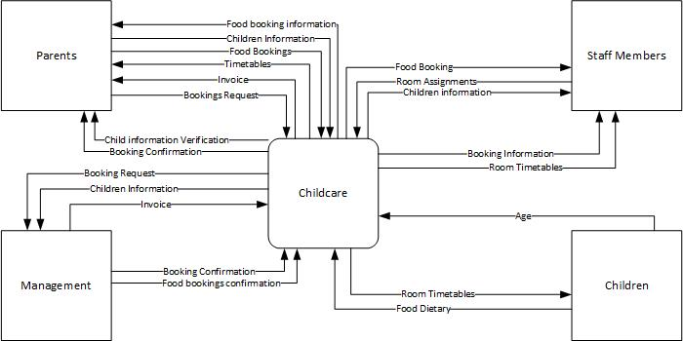

Data flow diagram – Level 0
This image shows my level 0 data flow diagram for the system made for kids club cymru.
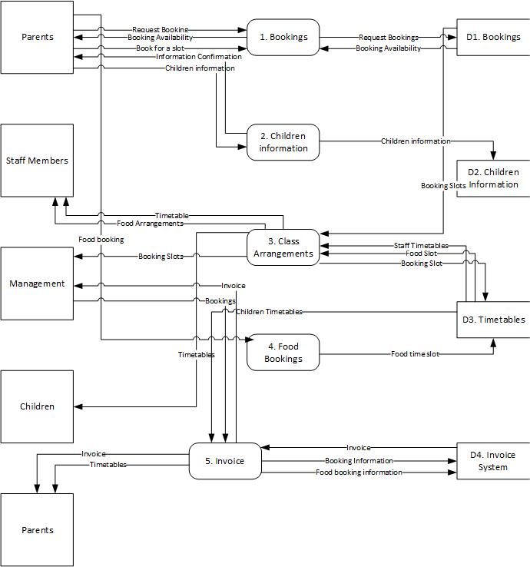

Data flow diagram – Level 1
This image shows a Level 1 data flow diagram on bookings for kids club cymru.
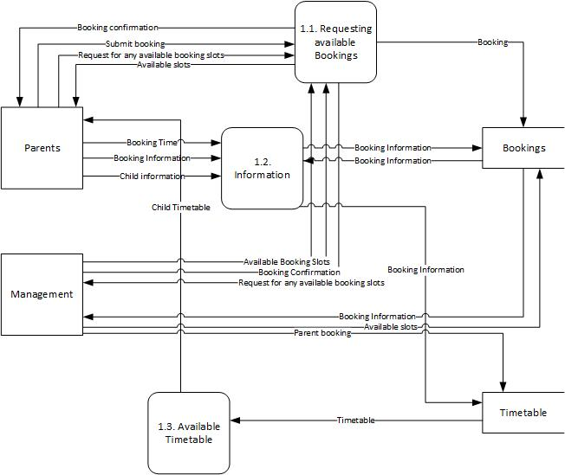

Entity relationship diagram
This diagram shows an Entity relationship diagram for the kids club cymru system.


