Title Page
Student Name: Sonam Akhtar
Student Number: 2439007
Module Number: LCLM4006
Programme: Certificate in Higher Education Business Skills for the Workplace
Title: Enterprise and Entrepreneurship
Lecturer's Name: Dr Chung Lai Johnny Wan
Assignment Title: Business Plan for Love In Eternal Bloom

Executive Summary:
Love in Eternal Bloom is a UK based startup specialising in premium preserved floral arrangements for weddings, anniversaries, corporate gifting, and special occasions on Shopify. These long-lasting flowers retain their beauty for years without water, addressing the growing consumer demand for sustainable, meaningful gifts. The business aims to position itself in the accessible luxury market by offering high-quality preserved roses and eco-friendly packaging.
With steady growth in premium gifting and online retail, Love in Eternal Bloom plans to differentiate itself from established competitors like Endura Roses through competitive pricing, enhanced customisation, and targeted digital marketing. The business will use social media and seasonal promotions to engage customers.
The venture will require an initial capital investment of £10,000 through a government-backed startup loan. With projected monthly sales revenue estimated at approximately £8,500, the objective is to attain financial stability within the first year of operations.

Contents
Title Page 1
Executive Summary: 2
Contents 3
Overview of Love In Eternal Bloom 4
Legal Format and Management Structure of Love In Eternal Bloom 5
Market Research according to PESTEL 6
Marketing Strategies 8
Funding: 9
Reference List: 10
Appendix A 12
Appendix B 14
Appendix C: 15

Overview of Love In Eternal Bloom
Capture the moment and cherish it forever with Love in Eternal Bloom. We provide unique floral gifts for birthdays, anniversaries, weddings, and proposals. Specialising in preserved flowers, we ensure their beauty lasts for years. Our carefully curated selection of preserved roses symbolises lasting emotions, transforming traditional gifts into timeless tokens of love. Love in Eternal Bloom aims to be a respected name in the luxury preserved flower market, where flowers never fade.
Preserved floral arrangements made with plant-based solutions represent a significant advancement in floristry. Unlike traditional bouquets that wilt quickly, these arrangements maintain their vibrant appearance and preserve memories long after the occasion. We offer a unique, long-lasting alternative to conventional floral gifts. According to Deep Market Insights (2025), in 2024, the United Kingdom accounted for about 5.76% of the global preserved flowers market, suggesting that many UK florists are incorporating these durable, sustainable products into their offerings.
As demand for gifting and eco-friendly alternatives grows, many business owners are motivated to adopt more environmentally sustainable practices. According to Mariotti and Glackin (2015) and Schick, Marxen and Freimann (2002), business owners may launch a venture to adopt a more environmentally sustainable approach.
We will initially focus on online platforms such as Shopify and TikTok, offering bespoke, hand-finished arrangements that blend elegance, craftsmanship, and sustainability.

Legal Format and Management Structure of Love In Eternal Bloom
Love in Eternal Bloom will operate as a sole trader. Sole traders are vital to national economies, as highlighted by Makudza, Mandongwe, and Muridzi (2022). I have selected this legal structure due to its low startup costs, which are crucial for any business in its formative stages.
As a sole trader, I will be the sole owner responsible for decision-making, daily operations, and financial management. This structure allows me to maintain complete control over the business's development, ensuring consistent quality and a strong brand identity. Clegg and Barrow (1984) state that being a sole trader allows me to have complete control over the business, enabling me to operate on my own terms. As sales grow, part-time staff will be introduced to support operations, only when revenue allows for expansion.
The sole trader structure provides considerable advantages for startups, such as Love in Eternal Bloom. The Department for Business, Energy & Industrial Strategy (2019) states that in the UK there were about 3.5 million sole traders and 1.9 million limited companies, indicating that sole traders make up the majority of small businesses. This is due to their easy registration and minimal reporting requirements, which reduce administrative burdens.
Sole traders have direct access to after-tax profits, crucial for managing cash flow and reinvesting in growth. I will use digital tools for accounting, inventory management, customer communication, and marketing, enabling Love in Eternal Bloom to operate efficiently and keep costs low in its initial stages.

Market Research according to PESTEL
The UK's preserved flower market is growing, with companies like Endura Roses using Shopify to offer premium arrangements. It is segmented into weddings, corporate gifting, and home décor, allowing for targeted competition and marketing strategies. A PESTEL analysis can help Love in Eternal Bloom identify opportunities and address industry challenges. (refer to Appendix A)
The UK’s political environment supports entrepreneurship and small business development, including initiatives such as startup grants. HM Treasury (2025) reports that the UK government is investing £4 million annually in new enterprise initiatives. My business will assess trade regulations on imports of flowers and preservation materials, as tariffs and supply disruptions can affect costs. Competitors like Endura Roses ensure stable supply chains and compliance.
Economic factors show strong demand for high-quality gifts, but Endura Roses' premium pricing may limit accessibility during economic uncertainty. Love in Eternal Bloom can capture this opportunity by positioning itself as an affordable luxury alternative for price-conscious buyers without sacrificing quality. According to the Office for National Statistics (2026), UK inflation rose to 3.6% in December, the first increase in five months, due to temporary factors. (Refer to Appendix B). Love in Bloom will launch its business in the next few months, taking advantage of the stable 2% inflation rate.
Social trends favour meaningful, personalised gifting experiences. While Endura Roses focuses on timeless elegance, Love in Eternal Bloom can gain a competitive advantage by emphasising emotional storytelling, aligning closely with modern consumer preferences. Farbotko and Head (2013) found that gift-giving enterprises encourage sustainable consumption by focusing on meaningful exchanges that strengthen relationships among friends, family, and partners.
Technological advancements in e-commerce allow companies to sell durable products online efficiently. Love in Eternal Bloom can use TikTok to rapidly build brand awareness and compete with established firms. Domazevich and Feng (2025). TikTok simplifies advertising for small businesses with tools that support budget management and precise audience targeting, leading to positive business outcomes. These features help enhance marketing strategies and improve engagement with target demographics. According to The Guardian (2025), TikTok Shop has rapidly become a key e-commerce platform in the UK, with over 200,000 small and medium-sized enterprises using engaging videos and livestream shopping to connect with consumers and boost online sales.
The business will use a Shopify store as its primary sales channel, benefiting from its secure platform for online transactions, inventory management, and customer engagement. According to Made by Shape (2024), active Shopify stores in the UK increased from approximately 59,450 in 2019 to over 169,000 by 2023, showing a 41% annual growth rate. Customer engagement can be enhanced through email newsletters, SMS campaigns, personalised offers, and seasonal promotions like Valentine’s Day and Mother's Day.
Environmental considerations are becoming increasingly important as consumers seek sustainable alternatives to fresh flowers. By focusing on eco-friendly packaging and responsible sourcing, Love in Eternal Bloom can distinguish itself and attract environmentally conscious customers. Zhuang, Luo, and Riaz (2021) found that in recent decades, environmentally conscious consumers have made significant strides in engaging with and understanding environmental protection issues.
Both Love in Eternal Bloom and its competitors must comply with UK consumer protection laws, e-commerce regulations, and GDPR. According to the GDPR (2016), Article 3 requires that EU personal data comply with the GDPR. Established brands like Endura Roses have strong policies, while Love in Eternal Bloom needs to improve its legal measures to build trust. Investing in cybersecurity is vital for data protection, despite added costs.
In conclusion, while Endura Roses has strong brand recognition and a premium image, market conditions present opportunities for Love in Eternal Bloom to compete through sustainability and accessible pricing.

Marketing Strategies
Love in Eternal Bloom will adopt a multi-channel marketing strategy to boost brand visibility and sales of preserved flowers. We will use Shopify for secure transactions, featuring automated reminders for abandoned carts, loyalty programs, and advanced sales analytics. Our focus on SEO will optimise keywords and improve site structure.
We are targeting UK men aged 30 to 50 in service jobs earning around £30,000, providing high-quality, long-lasting flowers for gifting. Our loyalty program will encourage repeat purchases through points, discounts, and exclusive deals, enhancing customer retention and reducing acquisition costs. Loyalty members will also receive early access to new collections and exclusive offers, setting Love in Eternal Bloom apart from competitors like Endura, which lacks a loyalty program.
Love in Eternal Bloom will leverage TikTok to increase brand awareness of preserved flowers by sharing short videos that highlight product designs and customer experiences. The strategy includes consistent posts, trending hashtags, micro-influencer partnerships, and seasonal ads.
The business will offer premium sustainable floral arrangements under the tagline Where Flowers Never Fade. By focusing on storytelling about craftsmanship, sustainability, and emotional significance, the brand will differentiate itself and enhance its value across channels like Shopify and TikTok.

Funding:
The funding required to launch Love in Eternal Bloom totals £10,000, as outlined in the cash flow statement. (Refer to Appendix C). I will apply for a government startup loan to cover essential costs, including inventory, equipment, marketing, and initial working capital. This support aims to ensure smooth operations in the first month, with projected monthly sales of £8,500.
Love Internal Bloom is an emerging enterprise focused on delivering meaningful products and services while maintaining financial discipline in its start-up phase. Funded by a £10,000 start-up loan, the business has projected monthly expenses of £6,600, which include marketing, utilities, cost of sales, and wages. The first month of sales is estimated at £8,500, indicating short-term financial viability. With careful resource allocation, Love Internal Bloom is positioned to establish a market presence and pursue sustainable growth.
I am dedicating £1,000 to marketing, primarily using TikTok and Google Ads to drive traffic to my Shopify store. This investment aims to attract more customers and build a loyal base across the UK.
As the business grows on Shopify, plans include applying for a Youlend business loan, which allows for repayment based on sales. Iwoca (2024) found that Youlend is a leading UK provider of merchant cash advances, offering revenue-based loans to small businesses through platforms such as Shopify. By leveraging personal savings and government funding, businesses can secure the capital needed to manage inventory and cash flow while minimising financial risks and supporting future growth.

Reference List:
Clegg, G. and Barrow, C. (1984). How to Start and Run Your Own Business. London: Macmillan Education UK, pp. 35–66.
Deep Market Insights (2025) United Kingdom Preserved Flowers Market Size, Share Report By 2033. Available at: https://deepmarketinsights.com/vista/insights/preserved-flowers-market/united-kingdom (Accessed: 1st February 2026).
Department for Business, Energy & Industrial Strategy (BEIS) (2019) Business population estimates for the UK and regions 2019. London: BEIS. Available at: https://www.gov.uk/government/statistics/business-population-estimates-2019 (Accessed: 1st February 2026 ).
Domazevich, D.A.I.N. & Feng, Z.Z., 2025. Why do small brands choose TikTok marketing in the digital age? An in-depth analysis. North American Academic Research, 8(5), pp.416–421. doi:10.5281/zenodo.15627496. (Accessed: 10th February 2026 ).
Farbotko, C. & Head, L., 2013. Gifts, sustainable consumption and giving up green anxieties at Christmas. Geoforum, 50, pp.88–96. https://www.sciencedirect.com/science/article/abs/pii/S0016718513001735 (Accessed: 10th February 2026 ).
GDPR (2016) Regulation (EU) 2016/679 of the European Parliament and of the Council of 27 April 2016 on the protection of natural persons regarding the processing of personal data and on the free movement of such data (Article 3: Territorial scope). Available at: https://gdpr-info.eu/art-3-gdpr. (Accessed: 10 February 2026).
HM Treasury (2025) Entrepreneurship in the UK: Entrepreneurship prospectus, GOV.UK, November. Available at: https://assets.publishing.service.gov.uk/media/6925e64222424e25e6bc31b1/Entrepreneurship_prospectus.pdf (Accessed: 8th February 2026)
Hounslea, K. (2024). Unveiling the Shopify Success Story: A Statistical Analysis of a Global E-Commerce Giant, MadeByShape, 18 January 2024. Available at: https://madebyshape.co.uk/web-design-blog/unveiling-the-shopify-sucess-story-a-statistical-analysis-of-a-global-ecommerce-giant/ (Accessed: 3rd February 2026).
iwoca.co.uk (2024) Youlend Loan: is revenue‑based finance right for your business? Available at: https://www.iwoca.co.uk/lenders/youlend-loan (Accessed: 15 February 2026).
Makudza, F., Mandongwe, L. & Muridzi, G. (2022). Towards Sustainability of Single-Owner Entities: An Examination of Financial Factors That Influence Growth of Sole Proprietorship. Journal of Industrial Distribution & Business, 13(5), pp. 15–26.
Mariotti, S. and Glackin, C. (2015) Entrepreneurship: Starting and Operating a Small Business. Global edition. Harlow: Pearson Education Limited.
Office for National Statistics (2026) Consumer price inflation, UK: December 2025. Available at: https://www.ons.gov.uk/economy/inflationandpriceindices/bulletins/consumerpriceinflation/december2025 (Accessed: 12th February 2026).
Schick, H., Marxen, S. and Freimann, J. (2002) ‘Sustainability issues for start-up entrepreneurs’, Greener Management International, 38, pp. 59–70. Available at: http://www.jstor.org/stable/greemanainte.38.59. (Accessed: 21st January 2026).
The Guardian, 2025. ‘“A gamechanger”: 200,000 UK small businesses sign up to TikTok Shop’, 24 December. Available at: https://www.theguardian.com/technology/2025/dec/24/uk-small-businesses-sign-up-to-tiktok-shop (Accessed 4th February 2026).
Zhuang, W., Luo, X. & Riaz, M.U. (2021) ‘On the factors influencing green purchase intention: A meta-analysis approach’, Frontiers in Psychology, 12, Art. 644020. doi: 10.3389/fpsyg.2021.644020. (Accessed: 10th February 2026 ).

Appendix A
PESTEL Factor | Key Issues | Opportunities | Implications
Political | - Importing Regulations.  - Trade policies. | - Source locally.  - Promote eco-friendliness.  - Government start-up support. | - Traffic and customs delay. Any changes could disrupt the supply chain.
Economic | - Inflation  - Exchange rates.  - Money Supply | - Will see strong demand for premium gifting if the economy grows. | - Spending may be reduced if the economy does not grow.
Social | - Demand for long-lasting gifts.  - Sustainability | - Preserved flowers meet customers' sustainability needs. | - More costly to stay eco-friendly.
Technological | - Social Media Marketing  - Websites | - Websites allow you to reach more customers.  - Social media helps promote visually. | - Requires an ongoing budget for social advertising.
Environmental | - Sustainability concerns  - Climate change affects rose growth. | - Preserved flowers are a sustainable alternative. | - Rising costs to stay sustainable.
Legal | - Employment Law.  - Consumer protection laws.  - Advertising standards. | - Compliance builds customer trust and strengthens brand reputation. | - Failure to comply could result in fines, legal disputes, or reputational damage.

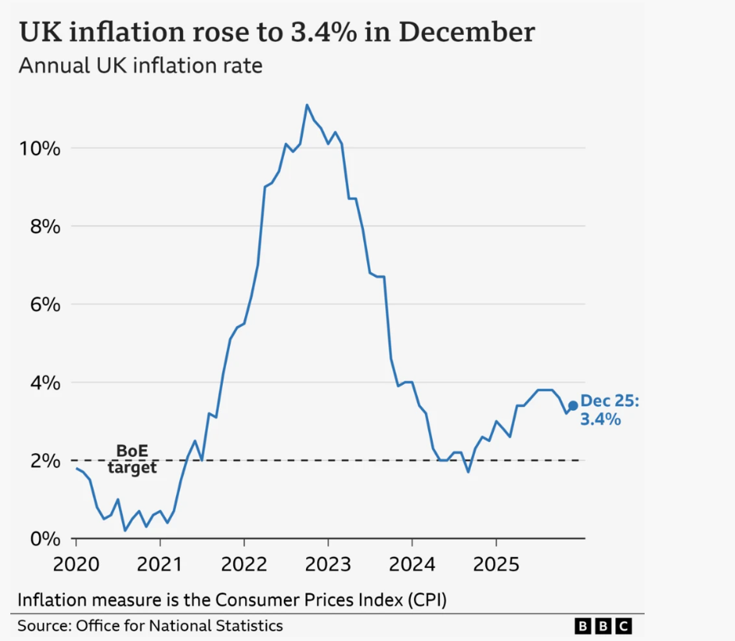
Appendix B

This graph shows the trend of Inflation in the UK

Appendix C:
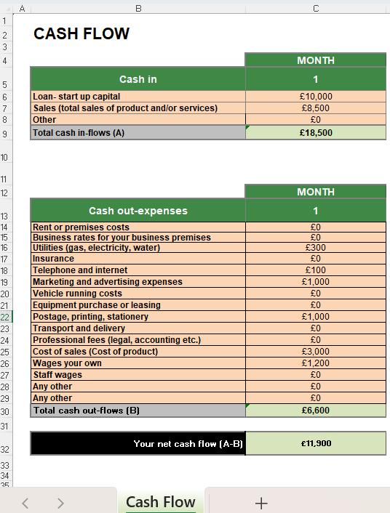
This is the Cash flow for 1 Month.

