

Wireless Networks and Simulation

Design and Evaluation of Wireless Sensor Networks

Dr. Carlene Campbell

Elliot Barnett
BSc Computer Networks and Security

Table of Contents
Part A -Research 3
The Function of modulation 3
Computer network simulation 3
Principles and concepts of network simulation 3
Fundamentals of QAM 3
Advantages of QAM 3
Disadvantages of QAM 4
Implementation of QAM 4
Simulations 4
Part B – Experiment 4
Research 7
Long-range networking 7
LoRa 7
LoRa1 7
Short-range networking 7
WLAN 7
ZigBee 7
Wi-Fi 8
Satellite 8
Cellular 8
Security Technologies 8
Motion Sensors 8
CCTV cameras 9
Wi-Fi Concealed Detection Device 9
Design 1 Farm 10
Design 2 Smart city 11
References 12

Task 1

Part A -Research

The Function of modulation
Modulation takes place in all sorts of commination from networks to radio waves. The function of modulation that converts data in radio waves and then attaches the radio waves into an electric signal [1]. There are several different types of modulation, some of the types of modulation include QAM modulation, QPSK modulation, and BPSK modulation. This report will be focusing on QAM modulation.

Computer network simulation

Principles and concepts of network simulation
The principle of a computer network simulation is to precisely design and run a real-time scenario in a lab environment. The environment would be in perfect condition unless different factors of the environment were changed before running the simulation. The simulation will allow users to evaluate and improve different concepts that have been created without testing them either with mathematics or physically with the live kit. Even though some network simulations are not going to be the same as live because the simulation is in a lab environment, the simulation will give a base understanding and outcome to the concept that is trialed on the simulation [2].

Fundamentals of QAM
QAM stands for quadrature amplitude modulation. It is a modulation technique used to achieve high levels of spectrum usage with high efficiency. QAM comes in either a digital form or an analogue form. The analogue form of QAM is used for televisions where the different channels in QAM allow the different colours to be sent and displayed on televisions. Analogue signals in QAM allow multiple different signals to travel through a carrier. Digital signals in QAM are very useful in situations where high speeds are needed. It is used to transmit radio transmissions to radio communication systems. Digital QAM has a lot of faster speeds than other modulation techniques such as phase and amplitude modulation [3]. The different types of QAM include QAM, 16QAM, 64QAM, and 256QAM, these different types, maps carrier to hold 4 bits for 16QAM, 6 bits for 64QAM, and 8 bits for 256QAM. With the increase in bites, there are more symbols used which means that the symbol rate will keep increasing the higher the ‘x’ QAM [4].

Advantages of QAM
There is a number of different advantages for QAM, the list of advantages includes:
- QAM uses multiple signals that only go through one carrier.
- A different version of QAM such as 64QAM to 256QAM there is double the rate of speed of each symbol, for example, the number of symbols in 64QAM would be 64 and the number of symbols in 256QAM would be 256. This means that the rate of speed for 256QAM would be double the speed of 64QAM [5].
- QAM helps build high data rate speeds than other modulation techniques and is used in current cellular networks around the world [6].

Disadvantages of QAM
There are a couple of disadvantages to QAM, below is a list of disadvantages of QAM modulation:
- QAM uses high data rates to transmit data over networks. Due to the high rates of data the receiver of the data must use a high amount of SNR (signal to noise ratio) to decode the data. With the high SNR, there is a faster data rate taking place but fewer retransmissions of data [7].
- A linear amplifier is needed to send a transmission of a QAM modulation. The amplifier uses a lot of power with processing the signals [8].

Implementation of QAM
QAM is used in a variety of different applications, one of the main uses of QAM is through cellular networking such as LTE phone networks. QAM allows a fast speed of transmission over LTE networks. QAM is also used in the communication of televisions, it uses several signals and sends those signals into one carrier. This allows more data to be transferred to televisions and the data normally consists of colour and different chrome features that help display a picture on the television [9].

Simulations
Using simulations over other methods is getting more popular for businesses every year. Simulations allow businesses to simulate a modulation technique on their network without the need of buying more equipment and testbeds to measure if the new modulation technique works or not. Simulations can be running several times and are users can change different factors such as noise or distance in the network with just a click of the button, whereas physically building and testing the modulation method would cost the business a lot of money and time. Simulations also have that underlying safety factor of if something goes wrong then the problem can be found, and the simulation can be altered and restarted very easily and quickly. If the testing goes wrong on a live network, then there is a risk of the whole network going down and the problem will take time to find. On the other hand, simulations are not all good when it comes to representing real-life environmental factors such as the natural elements (wind, rain, snow, and sun) [10].

Part B – Experiment
Below is an experiment that was set up to determine how 16QAM will get affected by the use of adding more noise over a network. The experiments were set up in a lab environment, the lab environment is in perfect conditions and may not represent real-life situations. The experiment will give a base knowledge on how the data is represented at the beginning of the experiment and how it is represented at the end of the experiment with the noise increased after every simulation. Below is an image of the model that was designed to perform the modulation tests.
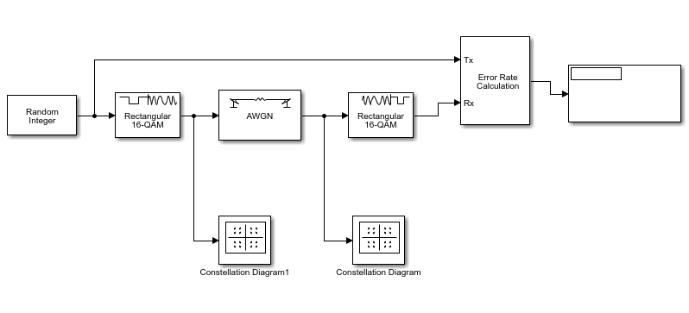

1st simulation
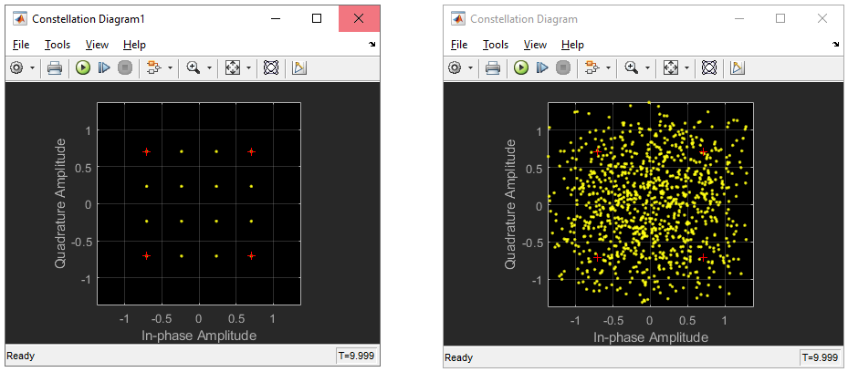
The first simulation was completed using completed and the results are shown above. As you can see the constellation diagram shows that the bits that were sent across the network are scattered across the frames without any form of structure forming. In this simulation, the Eb/No was set to 1 and the Bit error rate that was produced was 0.61%.
14th simulation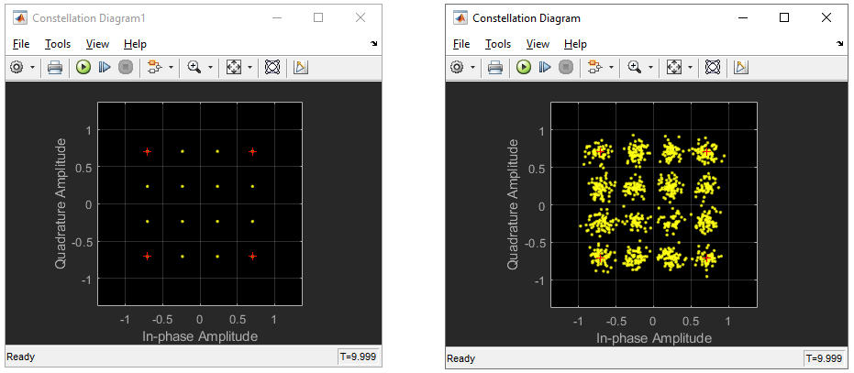

The 14th simulation was the last simulation run. The simulation was stopped at 14 due to the BER (Bit error rate) being 0. As you can see from the constellation diagram that bits that were sent over the network stayed in the frame that they were sent in. The Eb/No that was used in this simulation was 13.
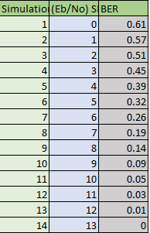
Below is a chart and a table that was created to display the results for all the simulations run. As you can see there is a trend in the graph, as the level of EB/No was increased the BER decreased. This shows that the experiment relates to the research produced and that QAM transmits data efficiently and precisely with the increase in noise over the network.

Task 2

Research

Long-range networking

LoRa
With the increase in IoT devices in homes across the world, there is a need for a base network that will allow IoT devices to speak to one another or the internet. LoRa is a solution to this problem, it’s a long-range modulation technique that allows devices to send a signal over a wireless signal over long distances with little power [11]. LoRa uses the LoRaWAN protocol to send and receive data from devices that far away, for example, a farm covers a vast amount of land and to monitor the security of the farm there must be the use of LoRa and LoRaWAN to send and receive data from CCTV cameras located in different locations around the farm. LoRaWAN uses lower frequencies when transmitting signals to increase the range capability of those signals, it operates similar to WIFI in which it will use the 5GHz and 2.4Gz bands [12].

LoRa1
LoRa1 also known as FP-ATR-LORA1 is a package that allows users to read data from security devices such as motions sensors or to retrieve a geographical position on someone or something using the global navigation satellite system. The package uses the infrastructure of the LoRa to receive data from devices from long distance and creates low power operating modes to save battery. The package is very useful for motion sensors due to the ease of receiving data while not using a lot of battery power. It is also capable of being implemented onto a wide variety of different microcontroller unit due to the use of STM3Cube [13].

Short-range networking

WLAN
A WLAN (Wireless Local Area Network) is a wireless network that consists of wireless devices connecting to access points in a network to get access to the internet or the network. This sort of network is very popular in current home networks across the world and it works well with wireless IoT devices. WLAN covers a wide area of protocols from 802.11a to 802.11ax. WLAN supports wireless band types like 2.4Gz and 5gz with the protocols 802.11a covering the 5Gz band covering the short-range, high bandwidth connections, and the 802.11b protocol covering the 2.4GZ bands for longer distance, low bandwidth connections. 802.11ax is the newest protocol to be used in a WLAN, this protocol supports both 2.4Gz and 5Gz bands and uses a the 1024-QAM modulation scheme to double the bandwidth of the other 802.11 protocols. The WLAN infrastructure supports Adhoc links, this is very useful for devices such as a fire alarm and fire sprinkler to be directly connected. This prevents any delay or connection failure when the fire alarm goes off and the fire sprinkler turns on.

ZigBee
Zigbee is a wireless networking technology that is similar to communication standards like Bluetooth and other short-range wireless standards. Zigbee comes under the 802.15.4 standard and has used a low amount of power and has a communicates data at a lower rate than other wireless technologies [14]. The technology is best used on sensors and other low powered devices that require not a lot of power to operate, but the sensors will be limited by the range of 75-100 meters [15]. Zigbee works four of the OSI (Open Systems Interconnection) layers, the two main layers are the application layer and the networking layer. ZigBee also works on IEEE 802.15.4 standard layers as well, the MAC (Medium Access Control) and the physical layer [14].

Wi-Fi
Wi-Fi is one of the most common wireless networking technologies that allow a variety of different IoT devices to connect in a wireless network (WLAN). The wireless technology uses radio signals to allow the combination of devices between a wireless hub or wireless access point to the network. The radio signals that are produced by Wi-Fi enabled devices are short-ranged and struggle to travel through walls, that is why there are Wi-Fi dead spots around homes and buildings [16]. Wi-Fi is built to carry different wireless frequencies, there are two bands than Wi-Fi can use to send and receive data over a wireless network, these include the 5gz and 2.4Gz bands. The 5Gz band allows high bandwidth that can reach up to speeds of 1300mbps but has a range of receiving and sending data. The 2.4 GHz band has a smaller bandwidth than the 5Gz with a speed of up to 600mbps, but the 2.4 GHz band has a longer range than the 5gz band. The speed and distance of the bands also depend on the router that sends and receives the wireless signals [17].

Satellite
Satellite communication consists of two different factors, a ground signal transmitting device and the satellite that either sends the signal back to the sender or rebounds the signal to another receiver on the ground, these transmitter/receiver devices include radio towers and satellite dishes. The satellite transmits signals back the earth by the use of antennas and transponders that is located on the satellite, the transponder sends and receives radio signals that are sent by transmitting devices on earth. The satellite uses solar panels located on the wings of the satellite to produce its power [18].

Cellular
Cellular networks are networks that are comprised of radio towers and relay nodes that have radio antennas that transmit communication and roaming data from one device to another. The device that uses cellular networking includes mobile phones, smartphones, or dial-up [19]. The base stations used to transmit and receive data use limited power and cover a large distance. They are very efficient at using the same frequency without causing interference to the signal, they can do this due to the limited amount of power that they use allowing them to reuse the same frequency. There are four different generations of mobile networks this includes, 2G,3G,4G, and 5G. 2G is the first generation of cellular networks and 5G being the latest. 2G had a speed of up to 300kbits/s whereas the newest 5G network can have speeds of up to 1Gbps [20].

Security Technologies

Motion Sensors
Motion sensors are used for the detection of motion in certain places. They are mostly used for security measures but are also used for other instances as well such as a wildlife motion detector. Motion sensors are ideal for placing around a certain perimeter of the area and use a low amount of power for longer battery life. There are a couple of different types of motion sensors that are used for a wide area of things. These types include passive infrared sensors, dual technology motions sensors, and area reflective sensors. The passive infrared sensor detects the temperature of a person and the movement of the temperature. The dual technology motions sensor uses infrared but has a passive and an active interface, both of these interfaces must trigger an alarm to go off. A reflective sensor is where a sensor sends rays of infrared to an object through an LED, this can be used as a measurement because the sensor measures the distance be reflecting off the object and determines whether it is in a certain area. There is also a feature on motion sensors that makes them wireless, the sensor would connect to either a wireless router or access point for a user to have a software on their computer to monitor the sensor [21].

CCTV cameras
The CCTV camera is one of the most common and useful measures of monitoring and recording the security of buildings, houses, etc. The cameras help monitor and secure most businesses and homes around the world. Different types of CCTV cameras are used for different purposes some of these types include the Day/Night CCTV camera, Dome camera, and the bullet camera. The Day/night camera is very useful to have in homes to secure their property 24/7, it would allow monitoring and recording in the day and the night with infrared technology. The Dome camera is used in businesses and shops due to the 360-degree control of the camera, it’s very useful to have a clear vision of all the shop. Lastly, the bullet CCTV camera is a camera that has a very useful outdoor use, it is protected by a shell that protects the camera from the natural elements such as rain, snow, and hail. The camera also has a long viewing distance [22].

Wi-Fi Concealed Detection Device
With the increase in gun and other weapons crime around the world, there is a need for a weapons detection system. The Wi-Fi concealed detection device is a system that is designed for places where gun crime is popular. The system is cheap to build can consists of two stations that can be set up very easily. The system uses the local Wi-Fi to detect whether some have a concealed weapon or not. The system uses the OFDM configuration which helps extract data on the different Wi-Fi channels and with the channels data the system can determine whether a concealed weapon is on a person. It can detect the weapon by analysing of the signal that is reflected off the material, for example, metal or liquid [23].

Design 1 Farm
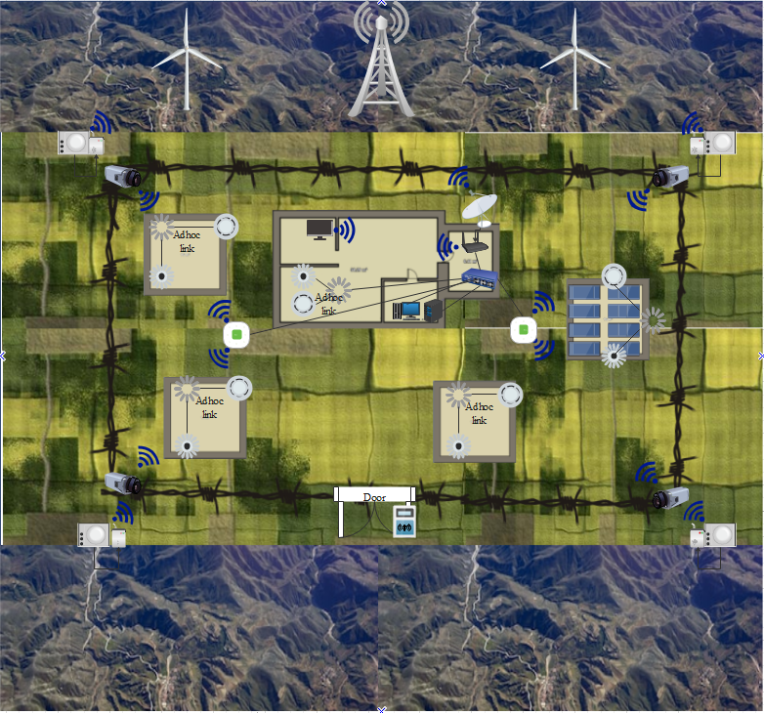
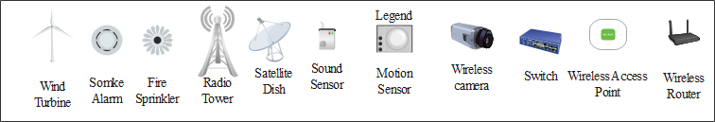

Design one was created to help farmers in the Caribbean islands from the theft and crime of their crops and livestock. From the design above there are several different security measures in place to prevent and stop people from stealing the livestock and crops and the connectivity of the farm. Below is a list of all the different features in the design and why they are implemented.
- Wind turbine. The wind turbine is a very useful way of gaining efficient and environment-friendly electricity. This wind turbine will help power the farm and the security measures around the fields. Due to the assumption that solar panels will be too expensive, they will be optional as the wind turbine alone should be able to power the farm quite easily.
- Smoke alarm and Fire Sprinkler. This security measure was put in place to help reduce the risk of a fire breaking out on the crops or livestock. The smoke alarm and the fire sprinkler are set up using an Adhoc connection, this is to directly connect these two devices to prevent the devices from failing if the network is down.
- Radio tower. The radio tower is in place to help get the farm connected to the world and the tower is also used for connecting the motion sensors to the network using the Lora1 package to enable make the sensors power effective. The radio tower is also placed on the mountains surrounding the farm to help get a better connection. The nearest police stations will have a direct connection to the CCTV cameras located around the farm through the connection of the radio tower.
- Satellite dish. The satellite dish is used to connect the farms' wireless and wired network to the radio tower, which will then enable connectivity.
- Sound Sensor and Motion sensors. These two devices are set up around the perimeter of the farms’ barbed fence. This will then detect any movement of people or animals outside the farms’ perimeter. These devices are connected directly to the radio tower using a Lora1 connection package.
- Wireless camera. The wireless cameras are specifically designed to work in the day and night. The camera’s use thermal imaging to help allow them to see in the night. These cameras are set up and directly connected to the wireless access points around the farm.
- Switch and the access points. The switch and the access points are set up in positions where they are in a good range for the devices that need to connect to them.
- Wireless router. The wireless router is used to connect the wireless network in the farms’ house. This router is then directly connected to the satellite dish.
- The wireless devices in the network will also run the latest 802.11ax protocol to enable the fastest and efficient connectivity throughout the farm.

Design 2 Smart city
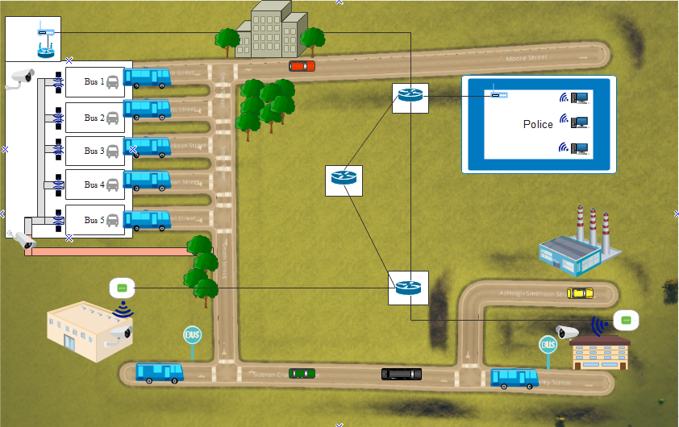
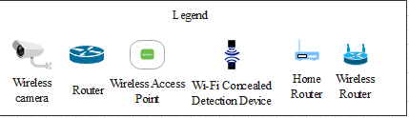
Above is the design for the smart city where the crime rate for weapons is increasing and needs to be stopped. Below is a list of the security measures in place and how they will be connected.
- Wireless camera. The wireless camera type is the bullet CCTV camera. This will enable the camera to see long distances and detect any threats that are coming into the bus station.
- Wi-Fi Concealed Detection Device. The Wi-Fi Concealed Detection Device is a device that will detect any sort of weapon or liquid that is on a person that walks through the sensors. The device is connected to the wireless router that advertises a Wi-Fi connection for the device to use. They are placed in front of the waiting area for the bus and will stop people with weapons from entering the waiting room or onto the buses.
- The routers that connect the access points and the bus station network are set up in a redundancy structure to prevent the network from going down if one of the routers fails.

References

[1] | M. Rouse, “Modulation,” Search Networking, [Online]. Available: https://searchnetworking.techtarget.com/definition/modulation.
[2] | Nurul I. Sarkar, “Simulation of Computer Networks: Simulators, Methodologies and Recommendations,” ICITA, 2008.
[3] | “What is QAM: quadrature amplitude modulation,” Electronicnotes, [Online]. Available: https://www.electronics-notes.com/articles/radio/modulation/quadrature-amplitude-modulation-what-is-qam-basics.php.
[4] | “1.7 Quadrature amplitude modulation (QAM),” The open university, [Online]. Available: https://www.open.edu/openlearn/science-maths-technology/exploring-communications-technology/content-section-1.7.
[5] | “Advantages of QAM | Disadvantages of QAM | 16QAM,64QAM,256QAM,” RF Wireless World, [Online]. Available: https://www.rfwireless-world.com/Terminology/Advantages-and-Disadvantages-of-QAM-types.html.
[6] | “QAM,” 4G LTE Mall, [Online]. Available: https://www.4gltemall.com/blog/qam-2/.
[7] | “How to: Define Minimum SNR Values for Signal Coverage,” Wireless nets, [Online]. Available: http://www.wireless-nets.com/resources/tutorials/define_SNR_values.html.
[8] | “Advantages of QAM | Disadvantages of QAM | 16QAM,64QAM,256QAM,” RF Wireless World, [Online]. Available: https://www.rfwireless-world.com/Terminology/Advantages-and-Disadvantages-of-QAM-types.html.
[9] | “QAM Formats: 8-QAM, 16-QAM, 32-QAM, 64-QAM, 128-QAM, 256-QAM,” Electronics Notes, [Online]. Available: https://www.electronics-notes.com/articles/radio/modulation/quadrature-amplitude-modulation-types-8qam-16qam-32qam-64qam-128qam-256qam.php.
[10] | “Computer simulation,” BBC bitesize, [Online]. Available: https://www.bbc.co.uk/bitesize/guides/zvxp34j/revision/3.
[11] | Semtech, “Semtech,” [Online]. Available: https://www.semtech.com/lora/what-is-lora.
[12] | “The things network,” [Online]. Available: https://www.thethingsnetwork.org/docs/lorawan/regional-parameters.html.
[13] | “Life.Augmented,” [Online]. Available: https://www.st.com/en/embedded-software/fp-atr-lora1.html.
[14] | “Electrical Technology,” [Online]. Available: https://www.electricaltechnology.org/2017/09/zigbee-technology-wireless-networking-system.html.
[15] | “ZigBee Alliance,” [Online]. Available: https://zigbeealliance.org/solution/zigbee/.
[16] | “What is Wi-Fi? Explained in simple terms,” 3G, [Online]. Available: https://3g.co.uk/guides/what-is-wi-fi-explained-in-simple-terms.
[17] | S. Albano, “WiFi frequency bands: 2.4 GHz and 5 GHz,” Minim, 1 April 2019. [Online]. Available: https://www.minim.co/blog/wifi-frequency-bands-2.4-ghz-and-5-ghz.
[18] | V. Labrador, “Britannica,” [Online]. Available: https://www.britannica.com/technology/satellite-communication.
[19] | “Cellular Network,” ScienceDirect, [Online]. Available: https://www.sciencedirect.com/topics/computer-science/cellular-network.
[20] | “In-Depth Analysis of What is Cellular Data & How it Works?,” CellularNews.com, [Online]. Available: https://cellularnews.com/now-you-know/in-depth-analysis-of-what-is-cellular-data-how-it-works/.
[21] | “The Role of Motion Sensors in Your Home Security,” Safewise, [Online]. Available: https://www.safewise.com/resources/motion-sensor-guide/.
[22] | “What Are the Different Types of CCTV Camera?,” Caught on Camera, [Online]. Available: https://www.caughtoncamera.net/news/different-types-of-cctv/#question_4.
[23] | “Detect Concealed Weapons With New WiFi-Based Technology,” Blue Line, [Online]. Available: https://cdn.annexbusinessmedia.com/BL/eBlast/2019/09/11/mail2.html.

