

Name: Yasmin Daley
Student ID: 2525258
Module Code: LCHS4003
Module: Introduction to Health and Social Care
Lecturer: Dr Helen Parsons

Submitted on: 07/06/2026
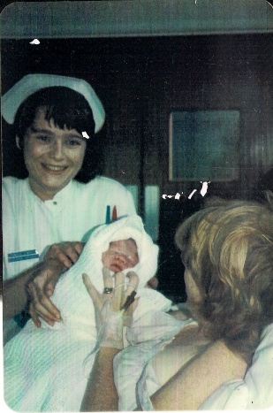
Midwifery
This Photo by Unknown Author is licensed under CC BY
in 2025 an action plan was launched, which set out to prioritise and work across three areas, which are black maternal health, uk wide maternity review work and the supportive actions to help midwives deliver highest standards of care. This plan is a ‘detailed action plan outlining its ongoing work to ensure safe, equitable and person-centred maternity care and education across the UK.’ (nursing & midwifery council, 2025)
Your midwife is there to provide support during your pregnancy, labour, childbirth, and in those first few days or weeks after your baby is born (what does a midwife do? 2024). Midwives are there for pregnant women and their families, in the uk the nhs provides this service.
You receive care from a midwife at home in midwifery unit or birth centre or a hospital. Wherever you choose, the place should feel right for you. You can change your mind at any point in your pregnancy. (NHS,2024)
‘Almost £35 million will be invested to improve maternity safety across England with the recruitment of additional midwives and the expansion of specialist training to thousands of extra healthcare workers.’ (GOV UK, 2024)
One of the oldest professions, dating back to ancient times, midwives were varied as they were often untrained and unqualified.
The 1902 landmark led to the creation of the Central Midwives Board and regulated midwifery practice and formalised education in England and Wales, later followed by the 1915 Midwives Act (Scotland) and the 1918 Midwives Act (Ireland). (royal college of midwives, 2022)
They improve birth outcomes, it doesn’t just end after delivery they provide postpartum support as they maintain relationships throughout the weeks after birth, ‘’offering guidance on feeding recovery and emotional adjustments’’. (Why Are Midwives Important for Mothers and Babies?, 2026)

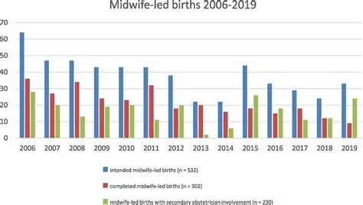
Staffing shortages is an issue within the service as it allows for an unsafe service which allows improper care to patients which may see a decrease safely delivered births or improper care throughout pregnancies. due to shortages the remaining staff will be working additional hours with a survey from the Royal College of Midwives (RCM) has revealed that midwives across England work around 100,000* extra unpaid hours a week to keep maternity services safe. (royal college of midwives, 2024)
Midwives will be experiencing high level of stress, anxiety or depression because of this. This leads to staff not being able to complete their jobs to the highest of expectations, this also leads to staff having time off work due to the workloads they are experiencing, this is supported by evidence showing from surveys that ‘The Royal College of Midwives’ surveys have shown that 45% of midwives report burnout often or always, and only 16% feel there are enough staff to do their job properly.’ (royal college of midwives, 2025)

A residential care home provides twenty-four-hour personal care to the service user. residential care is often well suited to people who need extra support and can no longer manage alone at home, this is often because of ‘frailty, falls risk, or worsening cognition’ (Residential care homes explained 2026). In the uk the average fee in ’2025-2026 is roughly £1,160 per week’ (Residential care homes explained 2026), but many homes are accepting of self-funding and council funded residents.
HISTORY
The history of care homes begins in 936, where the first known house called then an almshouse was built in York. ‘Almshouses were religious places and their aim was to nurture the soul as well as the body. Residents were known as Bedesmen and Bedeswomen. They would have to live under a strict regime of prayer and worship as part of their care.’ Munson (2025, Paragraph 3)
FUNCTION
The primary function of these residential homes is personal care; this means assisting residents with washing dressing managing medication. Social outings and events, this enables the residents to have more social interaction with family, community and other residents which then enhances their emotional and physical well-being. The residential homes should provide comfortable and private accommodation for each resident which should have private facilities such as en suits, also should have communal areas such as a lounge or dinning area for socialising within the home. Residential homes also should offer regular health check up with doctors and nurses or with whatever medical professionals a resident may need, also medication reviews should be done regularly or as and when needed this ensures that correct medication and dosages are being always given.
CHALLENGES
In residential homes staff shortages are one of the biggest issues ‘According to the latest Care Quality Commission (CQC) report, vacancies in the sector continue to rise, putting the quality of care at risk.’ (The future of care homes in England: Challenges and solutions in 2024, 2024). Working long hours, along side low wages it leading to many staff feeling burnt out and this leads to staff resigning from there roles, this then leads to impact residents as they may not receive the highest quality of care and the other staff remaining as it creates and increase in workload which some staff members may not be able to handle. To improve this the working conditions could be improved such as raising wages gives an incentive for more people to apply for jobs in residential care, also improved technology such as instead of paperwork it could be digitalized which enables current staff members and easier and reduced workload.
Residential homes are also facing economic issues due to the cost of living rising in England. ‘Inflation has driven up the prices of food, energy, and other essential supplies, forcing many facilities to adjust their prices or, in the worst cases, shut down​.’ (The future of care homes in England: Challenges and solutions in 2024, 2024). This affects residents as they may not receive the nutrients they need which can affect their wellbeing or supplies such as body wash for personal care or incontinent pads which then affects the resident as they basic needs are then not being met. In the worst case a residential home shutting down affects the residents as they may be moved into a home which doesn’t facilitate their needs and for staff this then leads to a loss of job, which then affects there own personal well-being. To improve this financial support from governments such as providing subsides which then ensures that residential homes can continue to operate as normal without compromising the quality of care provided.

Reference list
what does a midwife do (2024) Available at: https://www.pampers.co.uk/pregnancy/giving-birth/article/what-do-midwives-do-their-role-training-and-more (Accessed: 07 June 2026).
NHS (2024) where to give birth: the options. Available at: https://www.nhs.uk/pregnancy/labour-and-birth/where-to-give-birth-the-options/ (Accessed: 07 June 2026).
Why Are Midwives Important for Mothers and Babies? (2026) Available at: https://scienceinsights.org/why-are-midwives-important-for-mothers-and-babies/ (Accessed: 07 June 2026.
GOV UK (2024) £35 million investment to boost maternity safety Publisher or Available at: https://www.gov.uk/government/news/35-million-investment-to-boost-maternity-safety (Accessed: 07 June 2026).
royal college of midwives (2022) 120 years of the Midwives Act in England and Wales. Available at: https://rcm.org.uk/blog/2022/07/120-years-of-the-midwives-act-in-england-and-wales/ (Accessed: 07 June 2026).
nursing & midwifery council (2025) NMC’s midwifery action plan. Available at: https://www.nmc.org.uk/news/news-and-updates/nmcs-midwifery-action-plan/ (Accessed: 07 June 2026).
royal college of midwives (2024) Midwives give 100,000 hours of free labour to the NHS per week to keep England’s maternity services safe says RCM. Available at:’’ https://rcm.org.uk/media-releases/2024/06/midwives-give-100000-hours-of-free-labour-to-the-nhs-per-week-to-keep-englands-maternity-services-safe-says-rcm/ (Accessed: 07 June 2026).
royal college of midwives (2025) RCM highlights midwives are ‘exhausted, overstretched and burnt out’. Available at: https://rcm.org.uk/news/2025/12/rcm-highlights-midwives-are-exhausted-overstretched-and-burnt-out/ (Accessed: 07 June 2026).
residential care homes explained (2026) Available at: https://care-guide.co.uk/care-options/residential-care (Accessed: 07 June 2026).
residential care homes explained (2026) Available at: https://care-guide.co.uk/care-options/residential-care (Accessed: 07 June 2026).
Munson, S (20 November 2025) a history of care homes Available at: https://www.carehome.co.uk/advice/a-history-of-care-homes (Accessed: 07 June 2026).
The future of care homes in England: Challenges and solutions in 2024 (2024) Available at: https://www.seniorhomeplus.co.uk/blog/active-well-being/the-future-care-homes-england-challenges-and-solutions-2024 (Accessed: 07 June 2026).
The future of care homes in England: Challenges and solutions in 2024 (2024) Available at: https://www.seniorhomeplus.co.uk/blog/active-well-being/the-future-care-homes-england-challenges-and-solutions-2024( Accessed: 07 June 2026).

