Kamila Khalid – 1809606

BA Leadership and Management

Module: BMSW5104 - Project Planning and Management in workplace

Assignment: Project Planning and Management

in workplace

Lecturer: Paul Ranson

Due: 27 November 2020

TABLE OF CONTENTS

Contents Page No.

- Introduction 2
- Vintners Antiques 2
Fig.1 – Staff 3
Fig 2 – Steering Group 4
- Critical Assessment of the Risks Associated with the Project 4
Fig. 3 Table of Risks 5
Fig. 4 – Analytic Hierarchy Process (AHP) 6
- Project Management Tools and Techniques Used Case Study 6
  - The Iron Triangle 6
Fig. 5 – The Iron Triangle 7
  - User Stories 7
Fig. 6 – Chevron Technique 8
  - Project Costs and Time Estimation 8
Fig. 7 – Product Project Technique 9
  - Delphi Technique 9
  - Gantt Chart 10
Fig. 8 – Online Gantt Chart 10
Fig. 9 – Excel Gantt Chart 11
- Communicating Project Plan to Stakeholders 11
Fig. 10 – Project Cycle 12
- Personal Reflection on Managing the Project with Future Recommendation and Self-Development Plan 13
Fig 11. Self-Development Plan 13

- Introduction
This report is for Vintners Techniques and the management of their move from a retail shop to a warehouse. The report starts off with a description of the organisation and its staff members. The second part of the report provides a critical analysis of the risks associated with the project and identifying risks right at the outset of a project. The report then describes various project management tools and techniques used throughout the management of this project which include The Iron Triangle, User Stories, Chevron technique, Delphi technique, Product Project technique and Gantt Chart.
The report discusses how the project plan will be communicated to the stakeholders using various methods such as face to face meetings or via online tools such as Teams and PowerPoint presentations. Finally the report highlights recommendations for future project planning and self-development plan.

Vintners Antiques
Vintners Antiques is a family run business based in Shirley who specialise in antiques. They currently own a shop in Shirley and have recently come into some inheritance and want to refurbish an old derelict warehouse they own in Sparkhill in order to set up a stock and repair station and run as an online business. They have four members of staff consisting of an account manager, antiques dealer, customer service person and a warehouse and repairs person.
Details of each person’s job descriptions are below.

Fig. 1 - Staff

The new warehouse will need to have an office space, space for packing items. Omar will require space to do repairs. In addition the existing stock in Shirley will need to be moved across to the warehouse.
In order for the project to run smoothly a steering group will need to be set up as detailed in the diagram below which consists of sponsor, who is the person responsible for delivering the project and made up of various stakeholders such as financial specialist, user specialist and development specialist.

Fig. 2 – Steering Group

According to Roberts (2011) the success of the project lies with the steering group by ensuring that the expectations set by the business for the project are met appropriately.
- Critical Assessment of the Risks Associated with the Project
Rostami and Oduoza (2017) state that failure in identifying and assessment of risks can have a critical impact on the outcome of a project as it leads to the inadequacy in the management of risks. To identify risks you need to ask what can go wrong or what can prevent you from achieving the goal?
Heagney (2016) suggests to do a risk analysis on the following elements:
- The schedule
- The budget
- Project quality
- Customer satisfaction
It is important that the entire team gets involved to identify threats and what can go wrong. (ibid) Furthermore the risks are categorised in order of likelihood of it actually occurring from high (H), medium (M) to low (L) risk. Also if the risk turns into a reality the question needs to be asked about what negative impact it will have on the project, again categorised into high, medium and low impact.
Some of the risks that Vintners can face are outlined in the table below:

Fig. 3 Table of Risks
Risk Identified | Probability | Negative Impact
Issue with suppliers | M | H
Bad weather | H | L
Loss or damage of items while moving | M | H
Data security issues | M | H
Breakdown of vehicle | L | H

One method of gathering information to identify risks is by gathering user stories. Although user stories are to identify requirements by stakeholders they can also be useful in identifying potential risks. User stories are explained further under management tools and techniques section.
Mustafa and Al-Bahar (1991) found the Analytic Hierarchy Process (AHP) to be another method to analyse and assess risks in projects at the early stages. The AHP is a structured technique to analyse and organise complex decisions. It was developed by Thomas L Saaty in the 1970s (Bruce et al, 1989). A bit like the User Stories and the Chevron technique which are more modern techniques, the AHP also uses the method where problems are presented to decision makers which are then put into a hierarchical order to manage.
Below is an example of the AHP.

Fig. 4 - AHP
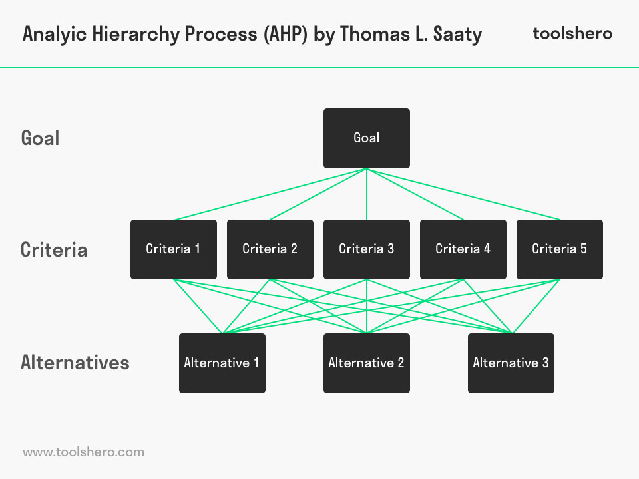
(Source: Mulder, 2017)
This method can help to highlight risks and the alternatives involved should one course of action present a greater threat than another.

- Project Management Tools and Techniques Used Case Study
A variety of project management tools and techniques have been used to assist with the management of the project for Vintners Antiques which are detailed below.

4.1 The Iron Triangle
The Iron Triangle is used to understand success in projects. It is also sometimes known as the Triple Constraint or Project Management Triangle as described by Pollack (2018).

Fig. 5 – The Iron Triangle

(Source: Author)
The criteria in the Iron Triangle measured the success of the project. For example scope or the quality can be impacted by the cost. If the budget is tight the quality may also suffer. Time constraints can also be affected if there is not enough budget to get enough people in to do the work. Each criteria of the triangle will have an impact on the other.

4.2 User Stories
User stories is a technique used to help identify problems which will help define the project. User stories can be written by various stakeholders depending on the project. In the case of Vintners it is likely to be the staff who will write the user stories. Lucassen (2016) states that a simple method of using user stories is by having a template, for example, as a warehouse operative (role) I need a forklift truck (want) to help with the lifting of heavy items (benefit).
Once all user stories have been identified they are then put into a priority order. For this project we can use Heagney’s Chevron Technique which prioritises things into three categories, Must Have, Want to Have and Nice to have.
Below is a diagram of the Chevron technique for Vintners Antiques where the problem is relocation of premises.

Fig. 6 – Chevron Technique

Heagney suggests to complete all of the Musts and as many of the others as possible for the project to be successful.

4.3 Project Costs and Time Estimation
Roberts (2011) describes estimation as an educated guess as it is impossible to know in advance exactly how much a project will cost or how long it will take. One technique Roberts introduced is Product Project Technique in which the project is split into two dimensions, the size and complexity. The question asked is how complex is the task at hand, and this is categorised into high, medium or low levels. The next question to consider is what size the project is, whether it is small, medium or large. Below is an example of how time estimation is given using the Product Project Technique.

Fig. 7 – Product Project Technique
Complexity  Size | Low | Medium | High
Small | 1 | 3 | 5
Medium | 4 | 8 | 11
Large | 7 | 12 | 19

The numbers represent the number of days it would take to complete the project. For example, to install a repair station at the warehouse is quite a large task with medium complexity, this would give you an estimate of 12 days to complete, or if there was a small task such as installing signs which is of low complexity, this is likely to take only one day.
Hajialinajar et al (2019) considered estimation of time in completing a project as one of the important issues and having high accuracy in estimation will have a significant effect on the evaluation of the cost of a project.

4.4 Delphi Technique
In 1950 an organisation called RAND corporation decided to use the name Delphi which originated from Ancient Greece for a process they used to “obtain the most reliable consensus of opinion of a group of experts.” (Linstone, 1985)
In the case of Vintners an example can be used to gain an estimate cost for installing electricity. You would invite a few electricians and get quotes from all of them. You would then add up all the quotes and divide the total by the total number of individuals who gave the quote to come up with an average which would give you the estimate for that particular task.

4.5 Gantt Chart
Gantt Chart shows the length of a project and whether certain projects are dependent on others before they can be completed. The Gantt chart also shows who is responsible for a task and the start date. The Gantt was conceptualised by Henry L Gantt in 1920. The Chart was later implemented by Wallace Clark throughout Europe in the 1930s in various public and private sector organisations in 12 different nations according to Wren (2015). The idea is to take all the stories and put them into one pool. Below is an example of a Gantt Chart that can be used for Vintners Antiques project.
There are many ways of producing a Gantt Chart using online tools such Asana as shown below or using an Excel spreadsheet.

Fig. 8 – Online Gantt Chart
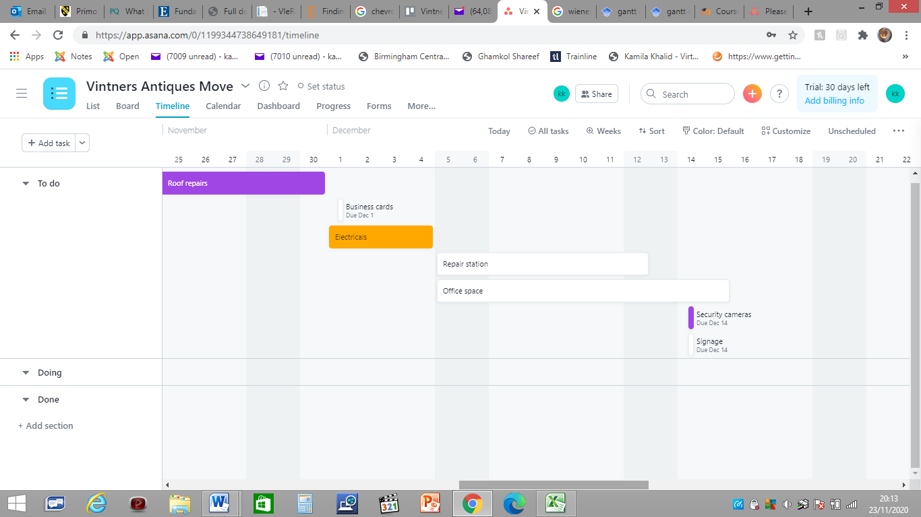
In the Gantt Chart above it can be seen that all projects are yet to be completed and timelines have been set for each project. It also shows dates upon which projects are to be completed, however once the project begins due to circumstances the completion dates may change and so if a task is dependent upon a previous task to be completed, for example, roof repairs may need to be completed before the electricals, but there has been a hold up due to bad weather, the electric job will have to be delayed.
Below is another example of a Gantt Chart producing using Excel which gives the same information as above but in a slightly different format.

Fig. 9 – Excel Gantt Chart
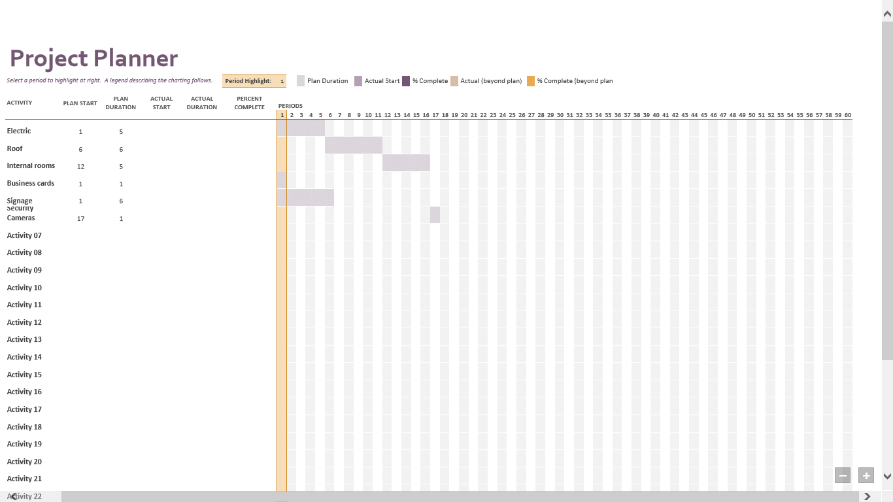

- Communicating Project Plan to Stakeholders
The role of the project manager is to do the project plan and then delegate the jobs to the relevant people working on the project. The project cycle is a way of showing constant cycle of the project plan. Below is a diagram of Roberts (2011) project cycle.

Fig. 10 – Project Cycle

A meeting will then need to be arranged with the steering group to explain what was done yesterday, what you are doing today and what is blocking you. In order to get the most of the meeting it is good to do a stand-up meeting where an individual is asked to stand up and answer what they did yesterday, what they are doing today and what is blocking them, the meeting should not take more than one minute to answer each question. The Gantt Chart is an efficient method of communicating progress of a project.
In recent times as face to face meetings are restricted, other means of communication have had to take precedence such as virtual meetings using Microsoft Teams or Zoom or Skype. For these meetings to be effective using tools such as PowerPoint are useful.
Nissi. and Lehtinen (2016)in their study found that PowerPoint presentations provide an arena for assembling and sharing information by way of a collaborative knowledge production. PowerPoint is a very effective way of communicating with other team members so long as the presentation is kept short and to the point. It is easy to lose the attention of the audience giving long presentations that can go off track at times.

6. Personal Reflection on Managing the Project with Future Recommendation and Self-Development Plan
I found User Stories to be a very effective way of gathering information and understanding problems that people may face. Using tools such as Trello have helped me to understand how this can be used for other projects and to group issues and put them in a priority order using the Chevron technique. I also learned how to create a Gantt Chart using an online tool as well as using Excel. The Gantt shows the progress of the project and shows when to make changes and is the critical path analysis in a project.
For future recommendations I would use the techniques I have learnt to plan projects especially as a director of an organisation in which we have lots of projects to plan throughout the year to run sports activities, the methods and techniques learnt in this module will help us to run our projects more efficiently.

Fig 11. Self-Development Plan
Goals  What I need to improve | Actions  What actions will be taken | Assessment  Who will monitor progress and how often | Completion  Measure success
Project Management Skills | Attend course such as PRINCE2 | Course provider monthly | Successfully completing course
Presentation Skills | Do more presentations face to face or online | Directors to provide feedback every three months | Feedback will determine success of presentation skills

This self-development plan is based on my role as a director and the areas that I can improve on using the techniques learned within this module.

REFERENCE LIST/Bibliography

Asana (2020) Available at: https://app.asana.com/0/1199344738649181/timeline. (Accessed 23 November 2020)
Bruce L. Golden, Edward A. Wasil, Patrick T. Harker (1989). Applications of the Analytic Hierarchy Process: A Categorized, Annotated Bibliography (p37-58)
Hajialinajar, M. T, Rahimi, H, Mosavi, M. R, & Afandak, B. (n.d). (2019). Estimation of Project Completion Time Using Wiener Random Process and Bayesian Structure Based on Expert's Point of View, 395-402.
Heagney, J. (2016). Fundamentals of project management (Fifth ed.).
Linstone, H.A., (1985). The delphi technique. In Environmental impact assessment, technology assessment, and risk analysis (pp. 621-649). Springer, Berlin, Heidelberg.
Lucassen, G., Dalpiaz, F., van der Werf, J.M.E. and Brinkkemper, S., (2016, March). The use and effectiveness of user stories in practice. In International working conference on requirements engineering: Foundation for software quality (pp. 205-222). Springer, Cham.
Mulder, P. (2017). Analytic Hierarchy Process. Available at: https://www.toolshero.com/decision-making/analytic-hierarchy-process. (Accessed 24 November 2020)
Mustafa, M.A. and Al-Bahar, J.F., (1991). Project risk assessment using the analytic hierarchy process. IEEE transactions on engineering management, 38(1), pp.46-52.
Pollack, Julien. (2018). What is the Iron Triangle, and how has it changed? International Journal of Managing Projects in Business, 11(2), 527-548.
Nissi, R. and Lehtinen, E., (2016). Negotiation of expertise and multifunctionality: PowerPoint presentations as interactional activity types in workplace meetings. Language & Communication, 48, pp.1-17.
Roberts, P. (2011). Effective project management (Business Success). London; Philadelphia: Kogan Page. (p. 35)
Rostami, A. and Oduoza, C.F., (2017). Key risks in construction projects in Italy: contractors’ perspective. Engineering, Construction and Architectural Management.
Wren, Daniel A. (n.d. (2015). Implementing the Gantt Chart in Europe and Britain: The Contributions of Wallace Clark, 309-327.

