Certificate of Higher Education Skills for the Workplace

Effective Team Working and Communication

Executive Summary
This report has explained the benefits of effective teamwork in care home X and discussed both Tuckman Team model and the Belbin team roles. Recommendations have also been given as to how care home X can encourage teamwork.

Table of Contents
Executive Summary 2
Introduction 4
Team working overview 4
Tuckman Team Model 5
Belbin Team Roles 7
Action Oriented Roles 7
People Oriented Roles 8
Thought Oriented Roles 9
Benefits of effective team working 10
Effect of ineffective team working 10
Conclusion 11
Recommendations 11
References 12

Introduction
Service user safety is enhanced by effective communication and collaboration. To accomplish desired results, teamwork necessitates collaboration, cooperation, and interaction among team members. Effective collaboration has been demonstrated to fulfil team goals efficiently and effectively, with fewer mistakes, in businesses with a high level of risk, such as the health and social care industry (Wheelan, 2016). This report will explain the benefits of effective teamwork in care home X and discuss both Tuckman Team model and the Belbin team roles. Recommendations will also be given as to how care home X can encourage teamwork.

Team working overview
A team is a kind of corporate grouping of individuals made up of members who are interdependent on one another, work toward similar goals, and share shared accomplishments. The team is a group of people who operate collaboratively to accomplish a common goal. At the care home environment, teamwork is essential for providing service users with constant, quality care. Majority of staff at care homes rely on each other to accomplish their tasks well; the stronger a team works collaboratively, the greater the outcomes they accomplish (Tyler, and Parker, 2011).

Effective teamwork is critical to the success of any organization. There are numerous advantages to cooperation, the most notable of which is an improvement in staff productivity. Establishing a successful team in a company like Care Home X may appear to be a basic and easy activity, but it is challenging to perform and put into action. Organizational members want to engage in the system and see the fantastic results that can be achieved by acting collaboratively rather than alone, and therefore it is up to the leader to instil and maintain motivation (Wheelan, 2016).

Tuckman Team Model
Dr. Bruce Tuckman created the Tuckman model of team building in 1965. He discovered four phases of team growth while studying teams at Harvard University: forming, storming, norming, and performing. The group exhibits particular behaviors in each step to help identify where they may be in the paradigm. The framework's four phases are still extensively utilized to comprehend group cohesiveness. The model may be used by group leaders in care home X to help their teams develop and increase performance. Since Agile teams are self-guiding, this paradigm can also be beneficial to them. Every stage of this model has its own set of features which will be explained below according to Morgan, (2020).;
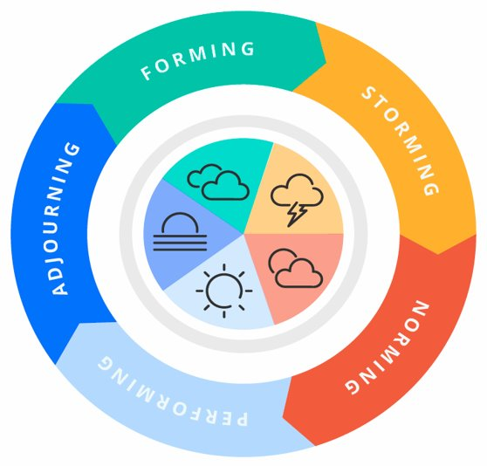
Forming
When new individuals join a current organization or team, they enter this phase. People are still understanding their positions on the team at this time. Individuals attempt to figure out what they have to do in order to be successful. It might take several months for staff at care facility x to become familiar with each other. It also might take a bit of time until the team receives their first productivity evaluation from somebody who is familiar enough with them to provide comments.
Storming
People start to consider themselves as members of a group. They may, however, dispute one another and the group leader on what the group is doing and how tasks ought to be accomplished at this level. As the title suggests, this stage is marked by confrontation and conflict as disagreements emerge. This stage in a care home x could lead to a loss of productivity or commitment on the present
Norming
The group starts to work together around similar goals once everyone feels more comfortable. Individuals get acquainted with the abilities and flaws of others and learn how to exploit them to their advantage. Since everybody knows their position on the team, there should be less disputes amongst colleagues at this time.
Performing
Ultimately, after everyone has mastered how to work together successfully, the team will function stronger than it has ever done previously. Everybody works together to achieve common goals in a seamless and effective manner. If nobody complains about collaborating with the other members of the team, the team understands they're ready to go on to the next level.

Belbin Team Roles
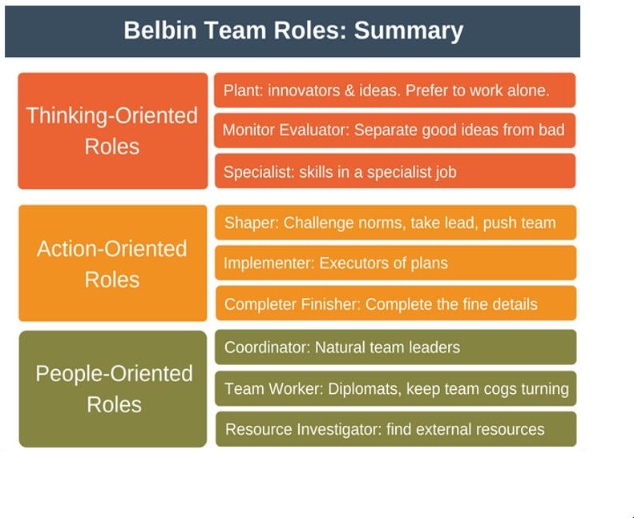
The Belbin Team Roles according to Belbin, (2012) help managers and supervisors at care home X establish effective groups that capitalize on unique team members' talents. A well-balanced team with similar traits has a higher chance of achieving its objectives than an unbalanced team with similar traits. The Belbin Team Roles may be used by group leaders and team development professionals to create more equally balanced groups. Group leaders may establish effective groups that collaborate instead of competing by knowing how the nine Belbin Team Roles "fit together."

Action Oriented Roles
Shaper- Shapers are the people that drive the team forward, ensuring that tasks are performed before deadline and that objectives are reached. Shapers are high-energy, goal-oriented individuals who desire to motivate their co-workers and discover creative solutions to issues. The Shaper's daring and inventive technique ensures that the team remains on schedule and maintains its focus and excitement.
Strengths: Energetic, determined, brave, ambitious, and flourish under pressure. Individuals are motivated and courageous enough to take on difficulties front on.
Weaknesses: Is prone to instigation and has a difficult time dealing with those who are less motivated. It is possible to insult and damage people's sentiments at times.
Implementer- People who implement are the ones who get things done. Implementers are the most likely to put concepts and thoughts into action. They are task-oriented and goal-oriented persons who excel at establishing and enacting business strategies.
Practicality and dependability are two of the implementers strengths. Implementers convert thoughts into realities and organize work so that the team can do projects in a timely manner.
The following are some of the flaws: Having a difficult time embracing fresh concepts and working habits.
Completer/Finisher- Completer-Finishers are in charge of guaranteeing that the tasks assigned to the group are finished to the highest possible standard. They are conscientious and have excellent analytical abilities. They concentrate on the tiniest details in their quest for perfection. Those members of the team that are most worried about meeting goals are known as Complete-Finishers. Workmates characterize Complete-Finishers as overachievers who are neat and meticulous yet hesitant to outsource.
Strengths: Orderly, diligent, and optimists. Complete-Finishers set a high bar for themselves and encourage their members of the team to achieve exact same thing.
Weaknesses: prone to worry excessively.

People Oriented Roles
Coordinator- Coordinators take on the conventional position of group leader and concentrate on the team's goals. They take charge of leading and managing the group. Individuals that fill this job are invested in their coworkers and can see the importance that each individual brings to the company. They are composed, assured, and pleasant, and they understand how to assist others in reaching their maximum capacity.
Peaceful, patient, and true leaders are some of their strengths. Have a good outlook on work and are always looking for ways to get the best out of their coworkers.
Weaknesses: If they delegate too much individual accountability, their co-workers can perceive them as deceptive.
Team Worker- These people are pleasant to work with, polite, and keen to ensure that everybody on the group gets along. It is the most sophisticated and sensitive function. They are regularly called upon to act as team intermediaries. Members of the team strive to avoid conflict and prioritize the team's well-being above their own. Due to their caring and understanding approach, te team worker is well-liked by their employees.
Diplomatic, compassionate, collaborative, and observant are some of her strengths. Good communicators who seek to avoid team disagreement and tension.
Flaws: Indecisive under stress and averse to confrontations.
Resource Investigator- Resource investigators are innovative and inquisitive by nature. They're always on the hunt for innovative ways to do things. People that work in this role try to look into other options, make connections, and advocate for the team. They are outgoing and sociable people that like working with others. Because they are bold and outspoken, people are typically open to Resource Investigators and their perspectives.
Strengths: Passionate and confident. Interested in trying out new ways of doing things. Exceptional at making and maintaining connections.
Flaws: These individuals are prone to losing interest fast and are frequently overconfident.

Thought Oriented Roles
Plant- The Plant is recognized for coming up with innovative ideas and solutions to problems, and they are skilled at dealing with problems in unexpected ways. They come up with new and innovative ideas when offered the chance to deliberate about how to overcome difficult problems. Because their ideas are usually unconventional, they might be unrealistic. They're also terrible communicators who choose to work alone.
Strengths: People who are creative, inventive, and free-thinking who can tackle complicated and difficult issues.
Flaws: Have trouble dealing with criticism, are shy, realistic, and frequently too busy to communicate properly. Plants may be tough to work with as well.
Monitor Evaluator- The Plant is recognized for generating innovative approaches and solutions to problems, and they are skilled at dealing with problems in unexpected ways. Because their ideas are usually unconventional, they might be unrealistic. They're also terrible communicators who choose to work alone.
Strengths: Analytical and strategic. They have a keen sense of reasoning and are well-equipped to make objective judgments.
Weaknesses: Can be too critical, emotionless, and aloof, and can maintain intellectual thinking for too long.
Specialist- Specialists bring to the group a high level of expertise in a particular field. They are proud of their abilities, knowledge, and skills, and they strive hard to maintain their professional status. The group's professionals, specialists' major job is to provide technical assistance to members as well as service users.
Strengths: They have an unfathomable amount of information concerning their profession. Specialists are the experts. They are committed and extremely skilled.
Allowable flaws: Concentrate on the details. They frequently confine their contributions to their field of specialization, and often lack many of their colleagues' social interaction abilities.

Benefits of effective team working
Teamwork is the most effective way to provide excellent health and social care. Care professionals at care home X who work together as a team can be more sensitive to adjustments as they arise. In a solid group, trust grows, giving partners more confidence in their ability to carry out their responsibilities in an emergency. When health-care professionals work together, service users are better pleased with their treatment. Groups that are heavily involved in treatment planning and provision of services are more productive and make better use of resources. Service users who seek solutions and recovery put a lot of pressure on the professionals in care home X. Active teamwork practices in a care facility enhance employee productivity and, as a result, minimize burnout. When service users are part of the care team, they are happier with their care and are more likely to follow recommendations given to them by their GP.

Effect of ineffective team working
Poor work performance is defined as an employee's performance falling short of his or her goals or expectations. In any team, poor teamwork may be a huge energy drain. However, it might be especially difficult to build the team beyond the start-up phase.

Conclusion
At the care home environment, teamwork is essential for providing service users with constant, quality care. Majority of staff at care homes rely on each other to accomplish their tasks well; the stronger a team works collaboratively, the greater the outcomes they accomplish. Dr. Bruce Tuckman discovered four phases of team growth while studying teams at Harvard University: forming, storming, norming, and performing. The framework's four phases are still extensively utilized to comprehend group cohesiveness. The Belbin Team Roles help managers and supervisors at care home X establish effective groups that capitalize on unique team members' talents. Service users who seek solutions and recovery put a lot of pressure on the professionals in care home X. Active teamwork practices in a care facility enhance employee productivity and, as a result, minimize burnout but poor teamwork may be a huge energy drain.

Recommendations
Care home X should encourage teamwork by:
- Making a point of emphasizing the significance of teamwork
- Teaching teamwork skills
- Creating cohesive groups by usin team-building exercises.
- Making the workload fair and the objectives absolutely clear.
- Considering who will play what position in the organization.
- Requesting interim reports and comments on the group process.
- Keeping record of the contributions of individual members of the team.

References
Belbin, R.M., 2012. Team roles at work. Routledge.
Morgan, P., 2020. The Business Student′ s Guide to Study and Employability. Sage.
Tyler, D.A. and Parker, V.A., 2011. Nursing home culture, teamwork, and culture change. Journal of research in Nursing, 16(1), pp.37-49.
Wheelan, S.A., 2016. Creating effective teams: A guide for members and leaders. Sage.

