Name: Sarah Ashton. Student number: 2117732. October 2022.

BMPF 7005: Undertaking research in the workplace (Level 7, 15 Credits )

Critically evaluate a selective range of methodological approaches appropriate for research in work based settings, with due consideration to research ethics and insider research issues.

Introduction

A research design emerges from how we perceive reality and knowledge and the approach used to interpret and organise data (Wisker, 2018). During this study, I aim to critically evaluate various methodological approaches which could be potentially viable for future research projects in my field of vocal pedagogy as a singing teacher. To begin this process I will need to explore my ontological and epistemological position and the paradigm which adheres to my worldview. From this understanding I will then examine possible methodological approaches and research methods appropriate to my work-based setting, with due consideration to the importance of research ethics and insider research issues.

Ontology and Epistemology

Ontology and epistemology ask philosophical questions about research and form the foundation on which a research paradigm is built (Wisker, 2018). These philosophical viewpoints will influence methodological choices and how knowledge is gained and organised (Gray, 2004; Wisker, 2018; Newbury, 2014).

Ontology is the study of the nature of existence and structure of reality, asking questions from the philosophical nominal-realist debate such as whether reality is external to the subject, created by the subject or created by the subject as a result of the outside world (Wisker, 2018; Al-Saadi, 2014; Cohen, Manion and Morrison 2018).

Epistemology is the philosophical study of knowledge which hopes to answer the questions of what we know, how we know it and whether the knowledge is reliable (Wisker, 2018; Al-Saadi, 2014).

A researcher’s ontological viewpoint will likely determine the way they view knowledge and which research questions they will ask (Costley, Elliot and Gibbs, 2010; Guba and Lincoln, 1994). There are two major epistemological and ontological assumptions ‘objectivism/positivism ’ and ’constructivism/interpretivism ’ (as shown in Fig.1).

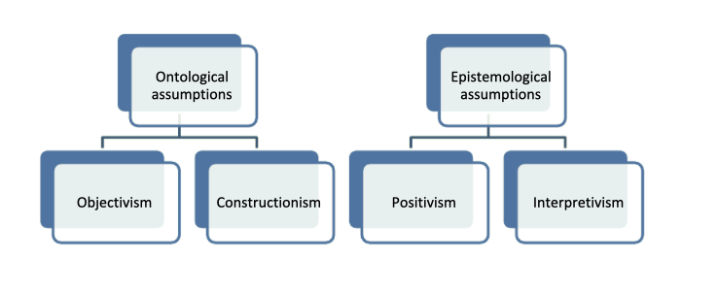
Fig 1: Ontological and Epistemological assumptions (Al-Saadi, 2014).

Objectivists/positivists believe in a single true reality which exists beyond the conscious mind, this leads to the pursuit of an objective truth and an unbiased objective researcher.(Guba and Lincoln, 1994) (Gray, 2004).

In Constructivism/Interpretivism reality is seen as being constructed in people’s minds and being changeable (Gray, 2004). In the pursuit of knowledge, the aim is to understand the multiple truths/realities of subjects rather than proving a hypothesis based on one truth (Guba and Lincoln,1994; Gray, 2004).

From my perspective there exists a definitive reality of what is happening physically to the vocal mechanism when utilising certain vocal techniques, suggesting a position of objectivism. However, each student will interpret sensations and vocal techniques differently and their realities will evolve and change over time as they gain more experience and knowledge (Miller,1996; Guba and Lincoln, 1994). This leads to the philosophical position of constructivism due to the view of multiple realities which can shift and knowledge as something which can be interpreted and influenced (Wisker, 2018; Guba and Lincoln, 1994). My future research will therefore aim to understand the various realities my students experience and the possible methods available to aid their development, rather than proving a hypothesis.

Research Paradigms

A paradigm is the philosophical intent and motivation in undertaking a research study and is based upon the researcher’s ontological and epistemological views (MacKenzie and Knipe, 2006). A Paradigm also provides a framework of a shared belief system which will determine which research methods are relevant for a study (MacKenzie and Knipe, 2006; Guba and Lincoln, 1994; Kankum, 2019). There can be multiple successful ways of producing high-quality research therefore it is of high importance for a researcher to recognise their bias and philosophical viewpoints in order to make an informed decision (Mirriam and Tisdell, 2016; Kaushik and Walsh, 2019).

Positivism
Positivists have the ontological standpoint of reality being what we can observe and measure scientifically through quantitative research (MacKenzie and Knipe, 2006; Gray, D 2004). Positivism aims to verify a hypothesis through observation and experimentation by an objective researcher and focuses on facts which can be proven by data and research methods, these may include experiments, scales, tests, trials and surveys (MacKenzie and Knipe, 2006; Costley, Elliot and Gibbs, 2010; Manion et al. 2018). Positivist research offers the appeal of a definitive answer, however, it is unable to successfully measure the complexity of human nature (Manion et al, 2018). This implies researchers of this paradigm would find the analysis of interactions between a singing teacher and student difficult as human nature is elusive and sensations of vocal technique subjective (Manion et al, 2018).

Post-positivism
Post-positivism evolved from the limitations and constraints of positivism which could not meet the requirements of social science research (Panhwar et al, 2017). It embraces the scientific method of an objective reality but accepts there are multiple ways of observing that same reality and views knowledge as probabilistic (Manion et al, 2018). Post-positivists focus on testing hypotheses rather than proving them and methodological approaches may include qualitative methods in addition to quantitative (Costley, Elliot and Gibbs, 2010). This flexibility of methods may reduce bias due to the subject being observed from multiple perspectives. (Panhwar et al, 2017).

Constructivist/Interpretive
Constructivism/Interpretivism is based on the belief of multiple realities which are created by individuals, possibly conflicting and subject to change as subjects become more informed (Houghton et al. 2012). Within this paradigm, there is an emphasis on acknowledging research bias, an important consideration for insider-researcher projects within education due to the influence of the relationship between student and teacher (Houghton et al. 2012; Costley, Elliot and Gibbs, 2010). Constructivism uses qualitative data and employs research methods such as interviews, observations, dialogue, hermeneutics, document reviews and visual data analysis (MacKenzie and Knipe, 2006; Costley, Elliot and Gibbs, 2010; MacKenzie and Knipe, 2006).

Critical theory
Critical theory is underpinned by Marxism and has the underlying aim of challenging injustice and emancipating the disempowered (Asghar, 2013; Manion et al, 2018). Critical theorists have the viewpoint of reality being shaped by social and cultural values and knowledge as being shaped by society and power dynamics, resulting in a need for careful investigation (Costley, Elliot and Gibbs, 2010). Within critical theory, the researcher aims to transform in contrast to positivism and constructivism which aim to observe and understand (Asghar, 2013; Manion et al, 2018; Mirriam and Tisdell,2016). Qualitative, quantitative and mixed methods are all appropriate as critical theory accommodates any methodology which will be beneficial in creating social change (Asghar, 2013; Costley, Elliot and Gibbs, 2010; Manion et al, 2018). Critics of Critical theory suggest that without empirical verification it can become contemplative and hypothetical and therefore unable to achieve real change in society (Manion et al, 2018).

Pragmatism
Pragmatism is based on human experience rather than metaphysical discussions on the concept of reality (Morgan, 2014; Pabel et al 2021). The researcher should adopt the philosophical view and utilise research methods which best fit the investigation and is therefore associated with mixed method research due to its adaptability in context to what is being researched (Vibha and Walsh, 2019). This flexible and action-led approach could prove beneficial in the multi-disciplinary field of vocal pedagogy, however, critics of pragmatism suggest that a problem-solving approach limits the researcher’s ability to identify ingrained social issues and see the bigger picture (Kaushick and Walsh, 2019; Pabel et al 2021).

Methodological approach
Three main research methods exist; qualitative research which is associated with the constructivist paradigm, quantitative which is associated with the positivist paradigm and mixed method research which combines aspects from both qualitative and quantitative (MacKenzie and Knipe, 2006).

Quantitative research is associated with the ontological view of one observable reality and is associated with the philosophies of positivism, realism and logical empiricism (Newbry,2014; Mirriam and Tisdell,2016). The data should be collected using a deductive approach, be reliable and replicable, and the researcher an objective observer who is uninfluenced by social and economic bias (Laverty, 2003). Quantitative research is structured and pre-determined and the sampling size may be representational and large (Hughes, Tight and Blaxter, 2010; Mirriam and Tisdell,2016). Data is collected using tools such as scales, surveys and computers, and is presented precisely and numerically (Newbry, 2014; Mirriam and Tisdell,2016).

Qualitative research is associated with the worldview of multiple realities and is dependent on a subject’s knowledge and experience (Mirriam and Tisdell,2016). Influenced by the philosophies of constructivism, phenomenology and symbolic interactionism, qualitative researchers study how people place meaning and interpret an experience (Laverty, 2003) (Mirriam and Tisdell,2016). Qualitative researchers are descriptive and investigate with the aim of understanding, words are used as data and theories are explored using an inductive approach (Hoepfl, 1997; Mirriam and Tisdell,2016). Within qualitative research reports, there is often a presence of voice in the text rather than the researcher reporting as an objective observer (Mirriam and Tisdell,2016; Hoepfl,1997). However, bias will need to be acknowledged to ensure the reader is aware of influence during the collection and analysis of data (Mirriam and Tisdell,2016). When designing a qualitative research study it is difficult to plan exactly which research methods will be used due to its evolving nature, however, often multiple methods are utilised and the judgement of the usefulness of data is left to the decision of the reader and researcher (Hoepfl, 1997). Research methods may include sampling, interviews, focus groups and observations which can be coded to help simplify and standardise data for analytical purposes. Coding can be done by replacing characteristics or categories with numbers (Blaxter, Hughes and Tight, 2010; Hoepfl, 1997) .

Commonly associated with the pragmatist paradigm Mixed method research uses both qualitative and quantitative data to answer a research question (Robinson et al. 2011). Guba and Lincoln (1994) state however that it is not only the pragmatist paradigm which coheres with mixed methods research and all paradigms can utilise both qualitative and quantitative methods if appropriate to the study and the researcher possess the adequate skill. Mixed method research has a dual objective of understanding the subject’s constructed worldview through qualitative data whilst also being able to come to a definitive conclusion using statistical quantitative data (Robinson et al. 2011). It has also been identified as being beneficial for educational research and in producing more complex and definitive results (MacKenzie and Knipe, 2006; Morgan,2007; Robinson et al. 2011).

I can deduce the methodological approach most suited for my future research projects would be qualitative due to its exploratory nature and focus on understanding. Mirriam and Tisdell (2016) state that when researching within the social sciences qualitative research is the ideal option as it results in a deeper understanding of the participant’s perspective, asks researchable questions and gives the best opportunity for the development of practice. Ragan in her 2018 research on vocal cool downs also notes it is difficult to objectively quantify the result of vocal techniques due to the variants in the subjects’ daily lives such as hydration and sleep. Additionally, qualitative research due to its focus on interviews and observations, aligns with the practical restraints I will face such as the limited resources and funding available to conduct the research, and the small group of subjects in my work-based setting appropriate for study. The use of small sampling sizes may however result in deeper insight and detailed study rather than large random sampling sizes often used in statistical research which may miss complex social dynamics (Gill, Teasure and Chadwick, 2008; Hoepfl, 1997; Mirriam and Tisdell,2016). Qualitative research may also be useful for generating ideas and investigating variables before using conclusive statistical analysis in future research projects (Fern, 1982; Hoepfl, 1997).

Methodologies
A Methodology is the overarching rationale behind a piece of research and ensures the design is reliable and adheres to the aims and objectives of the study (Harrison, 2020). Methodologies also aid the researcher in deciding how and why data is collected and how it is analysed (Harrison, 2020).

Hermeneutic phenomenology
Phenomenology focuses on finding the pure meaning in phenomena and a phenomenological researcher aims to consciously describe an event and find the core meaning of an individual’s experience (Kafle, 2011). Modern Phenomenology was founded by the German philosopher Husserl (1859-1938) who was frustrated by the application of scientific research to psychology which ignored the perceptions of human beings (Laverty, 2003; Kakkori, 2009). Husserl proposed bracketing out personal bias and the outer world to see the essence of phenomena clearly (Laverty, 2003; Kakkori, 2009).

Hermeneutics shares its lexical root with Hermes the messenger god who had the responsibility of delivering and interpreting messages (Bynum and Varpio, 2018). Hermeneutics is the study of the process of the interpretation of a text in order to understand an experience through a philosophical perspective (Bynum and Varpio, 2018; Laverty 2003; Kakkori 2009). Gadamer (1900-2002) known as the founder of Hermeneutic philosophy saw this as a cyclic self-reflective process of reading, reflecting, writing and interpreting (Kakkori 2009; Laverty 2003; Crowther et al, 2016). Through these stages of study patterns should be revealed, and the bridging of the participant’s and researcher’s experience (Kakkori 2009; Laverty 2003; Crowther et al, 2016).

Founded from the writings of Heidegger (1889-1976) Hermeneutic phenomenology aims to interpret descriptions given by subjects and uncover the core meaning and context, whilst accepting there will never be an objective truth due to the impossibility of being separate from our own bias (Bynum and Varpio, 2018; Kafle, 2011; Laverty 2003; Crowther et al, 2016). Hermeneutic phenomenology has the possibility of being a successful research design for vocal research projects as it adheres to an interpretive approach and aims to uncover the true meaning behind experiences which could aid in understanding students’ issues and learning processes. Hermeneutic phenomenology encourages researchers to openly reflect upon and share their subjectivity which as a singer myself with existing bias, expertise and experience is very applicable. (Bynum and Varpio, 2018). Hermeneutic phenomenology is not a fixed methodology but evolves and changes which may cause difficulty due to a lack of practical and structured guidelines (Alsaigh and Coyne, 2021; Laverty, 2003). However, this lack of structure allows the researcher to embrace working with data in creative ways and their thinking of phenomena to evolve (Crowther et al, 2016).

Action research
Action research(AR) is commonly used within education and is a cyclic, collaborative and systematic process which through planning, observing and reflecting aims to empower researchers and create positive change (See Fig 2) (Manion, Morrison and Cohen, 2018; Hine, 2013). AR is popular within the field of education as it helps researchers develop new knowledge specifically related to their workplace and bridges the gap between research and practice (Manion, Morrison and Cohen, 2018; Hine, 2013). In AR, subjects do not exist and research is carried out by participants and co-researchers, the view of action research as collaborative comes from the ideological viewpoint of those who are involved/affected by the research must be part of its design (Manion, Morrison and Cohen 2018; Gray, 2004). As an individual singing teacher/researcher these considerations could be restricting, undermine my objectivity and it may be potentially difficult to manage a range of interests (Elliot, Gibbs and Costley, 2010). However, Manion, Morrison and Cohen (2018) state AR can be utilised by an individual researcher successfully if the researcher is also an active participant in the research. This relates to the teacher-as-researcher movement inspired by Schön’s (1992) reflection-in-action professional practice theory. Within this theory the practitioner interprets a situation with the view to improve it and learns through investigation (Costello, 2011; Manion, Morrison and Cohen, 2018).

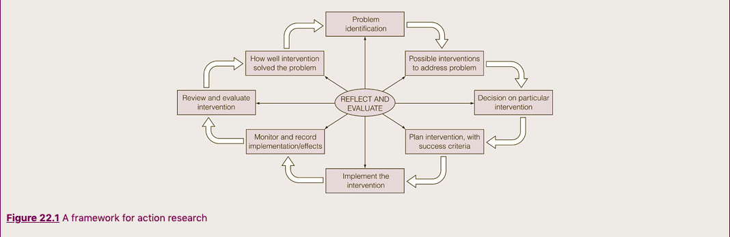
Fig 2: Framework for conventional cyclic of the AR approach (Manion, Morrison and Cohen, 2018)

Due to its focused design AR has gained popularity in small-scale educational studies where the practitioner has often identified an area which needs improvement and could be appropriate for part-time students engaging in a work-based project, such as myself, as it is effective, time efficient and provides a structured framework (Bell, 2017; Hughes, Tight and Blaxter, 2010; Rowley, 2003).

Ethnography
Ethnography emerged from the fieldwork of anthropologists in the early 1900s and its practices have been adopted successfully in fields such as psychology, medicine, social work and education (Herrman, 1989; Harrison, 2018; Hoey,2014; Elliot, Gibbs and Costley,2010). Rather than setting out to prove a hypothesis an ethnographic researcher aims to understand people in their environments, not only describing an event but explaining how an event represents cultural norms (Hoey,2014; Scott et al.2008). This understanding emerges after close inspection of several sources of data, and whilst ethnography is a flexible methodology these will often include diaries, observation and interviews (Hoey,2014). During participant observation the researcher dualistically becomes a participant/observer and interviews are often informal and conversational, however, they may also use more formal and in-depth interviews. (Scott et.al, 2008; Hoey,2014; Harrison, 2018). Field notes are kept continuously throughout the whole process and through an inductive process key issues and themes emerge (Hoey,2014; Harrison, 2018; Scott et.al, 2008). Critics of Ethnography warn representation needs to be addressed as although the researcher may have in-depth information about one particular group we will not know if this information is typical or representational of other similar groups (Bell,2018). An example of this is a choir culture and ability in one school could be extremely different to another school. Ethnographic research is shaped by the researcher’s voice and can be seen as being created from the mixing of both the ethnographer and participants’ realities (Hoey,2014). Improvisation is an important part of ethnographic research, however, this does not mean there is a lack of structure as it is imperative for the researcher to adapt and change within the framework of the objectives and aims of the research (Harrison, 2018).

Bell (2018) suggests ethnographic research is too time-consuming for smaller research projects, however, Harrison(2020) states that based on the setting, researcher’s skill and nature of research, the time needed in the setting may vary, however, she does agree with Bell(2018) that the longer a researcher is in the field the more accustomed people are to their presence and therefore more relaxed and authentic. Elliot, Gibbs and Costley (2010) also suggest that ethnography may be successful in a setting where the researcher already is an active participant, which is ideal for the educational setting where a teacher is often a participant/researcher. In my work-based setting as a vocal teacher with a time-limited research project ‘focused ethnography’ may be a more appropriate choice of research design as it is data intensive and focuses on a particular question from the start (Dewilde, 2019).

Experimental and quasi-experimental research
Within experimental research the researcher aims to test whether a specific treatment influences a result, for example, using specific vocal warm-ups with one group (the treatment group) and not with another (the control group) to assess if they can have a positive impact on vocal performance (Jopling, 2019; O’Dwyer and Bernauer, 2016;Gray,2004;Creswell,2014) (Please See Fig.3. for a breakdown of the Experimental process). Experimental research concludes if something works but qualitative data may explain why it works (Jopling, 2019). Experimental research may therefore be relevant when there is already a large body of knowledge concerning the problem or a qualitative inquiry has already been made (O’Dwyer and Bernauer, 2016). In true experimental research participants are chosen at random however in educational settings such as vocal teaching this may be impossible and a quasi-experimental design which selects participants may be appropriate (O’Dwyer and Bernauer, 2016). In experimental research the researcher has to be aware of confounding variables which could possibly affect results and take these into account in analysis, such as the time of day, hydration levels and experience of students (Blaxter, Hughes and Tight, 2010).

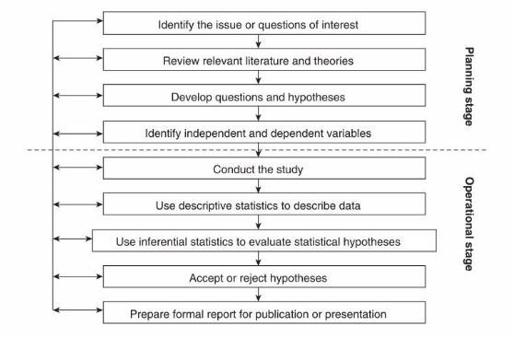
Fig.3: Breakdown of Experimental research design process (Gray, 2004) .

Research methods

Observation
Observation allows the researcher to collect in situ data abundant in cultural context using a cyclic and reflective emergent research design, rather than receiving it from second-hand accounts or interviews where participants may perceive an event differently from how it occurred (Cohen, Manion and Morrison 2018; Bell, 2018; McKechnie, 2008). The researcher has the opportunity to observe everyday behaviours/routines which otherwise may be taken for granted, however not all phenomena are as clearly observed such as a subject’s cognitive process (Given, 2008; Manion, Morrison and Cohen, 2018). Observation can also be approached in various ways and there are several considerations before beginning research (see fig. 3) (Cohen, Manion and Morrison 2018). Observers can interpret the same event differently and an observational researcher, especially an individual observer, would need to be aware of their bias and take steps to reduce it, such as writing reflective journals, peer de-briefing and triangulation (McKechnie, 2008; Manion, Morrison and Cohen, 2018; Bell, 2018). It is worth noting that observations are not always able to transfer into other environments and to achieve reliability several settings would need to be observed (McKechnie, 2008). Due to the longer length of time needed for successful unstructured observation, researchers engaging in short-term projects may find a structured observation where an objective has already been decided upon would be more appropriate (Bell, 2018). McKechnie (2008) celebrates qualitative observation as an ideal tool for exploring and proving both new ideas and existing theories and an especially strong research method when combined with additional methods such as interviews.

Fig 4: Types of observations (Cohen, Manion and Morrison 2018).
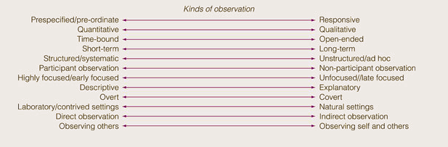

Interviews and focus groups
Interviewing has become one of the most widespread qualitative research methods in the social sciences (Brinkmann,2008). Individual interviews allow voices who hold a different opinion to the group norm to be heard and may be better suited if the research is of a sensitive nature (Kitzinger, 1995; Gill et al. 2008). Individual Interviews also allow a participant who already has knowledge of a subject to offer more in-depth answers (Kitzinger,1995; Gill et al. 2008). There are three fundamental ways to conduct interviews; structured, semi-structured and unstructured (Gill et al. 2008). Structured interviews ask predetermined questions, these are easier to administer but only allow for limited participant responses and do not encourage follow-up questions or conversation. In contrast, unstructured interviews ask open-ended questions which allow for in-depth answers but can also be very long, difficult to manage, and find participants for (Gill et al. 2008). Semi-structured interviews are the most popular type in qualitative research as they consist of key questions but also allow the interviewer to ask more in-depth questions if applicable (Gill et al. 2008; Brinkmann,2008).

Focus groups use group communication and interaction to produce data, allowing the researcher to know and understand what participants think, and why/how they have reached their conclusions (Kitzinger, 1995). Focus groups are a flexible and common qualitative method which can be used to identify questionnaire items, generate hypotheses, feedback data to participants, explore opinions, and clarify or challenge data collected via other methods (Fern, 1982; Gill et al. 2008). The benefits of focus groups rather than one-to-one interviews are they often allow the researcher to access interpersonal relationships which can highlight group norms and allow participants who would be intimidated by a formal individual interview to take part (Kitzinger, 1995).

Questionnaires
Questionnaires ask participants to answer a set of identical questions for data analysis and are a well-established research method within education (Bartram, 2019; Gray, 2004). They are low-cost, time-efficient, can assure respondents anonymity and reduce the effect of the personal interaction with a researcher (Bartram, 2019; Gray, 2004;Denscombe, 2003 ). They can however have a poor response rate, not allow the researcher to check the validity of answers and pre-coded questions may increase bias towards the researcher’s perspective (Descombe, 2003). There are a number of ways to structure questions in a questionnaire (See fig.5) and it is important they are structured in response to the objective of the research (Gray,2004; Newby, 2014). Closed questions would be suitable for large scale research which aims to explore relationships between variables and collect quantitative data, however, they only provide surface level answers and would not be appropriate for small-scale descriptive research (Bartum, 2019; Gray, 2004). If the answers are lengthy and detailed coding answers in advance would help speed up data input (Blaxter, Hughes and Tight, 2010). When creating questionnaires it is important to avoid leading questions, ambiguity and assumptions (Bell, 2018).

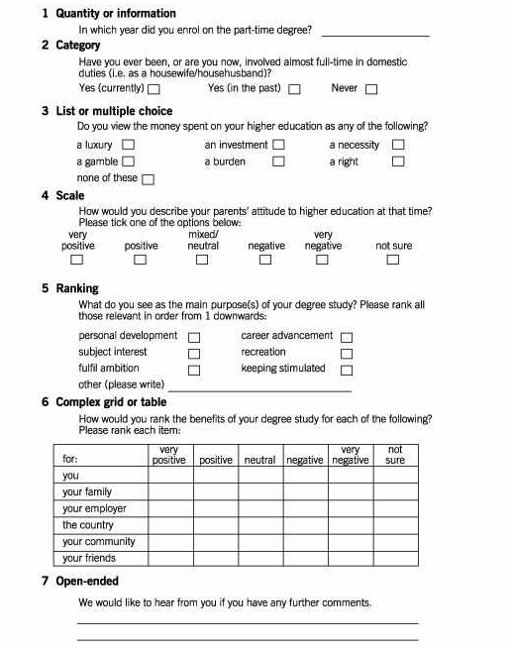
Fig.5: Types of questions (Blaxter, Hughes and Tight, 2010).

Ethics
Ethics are guiding principles which help us decide what is right or wrong and it is paramount that research abides by guidelines set by the relevant professional body to protect both participants and researchers (Bell, 2018; Blaxter, 2010). Considerations of potential ethical issues are an integral part of a research study and researchers have a responsibility that no harm physically, emotionally or lawfully comes to the participants and they have their privacy and rights protected at all times (Hughes, Tight and Blaxter,2010; Guba and Lincoln,1989). Written informed consent from subjects is crucial and ensures a clear understanding between researcher and subject of what is being promised in regards to confidentiality and anonymity (Bell,2018; Gray,2004).

Additional areas to be dutiful in ensuring informed consent include:
- Clear understanding of the study objective and who is involved in the study.
- The type of data is being gathered and how will it be stored and processed.
- Time required by the participant.
- Understanding participation and answering of questions are voluntary (Gray,2004; Elliot, Gibbs and Costley,2010; Bell,2018).

Guba and Lincoln (1989) suggest that a constructivist ontological approach lends itself to good ethical practices as there is no desire to use deception to find one single truth and prevent ambiguity, Constructivists also aim to build a trusting relationship with their participants recognising their own bias in contrast to a positivist unbiased observer.

Insider research
An Insider researcher studies and challenges current practices within their work-based setting to develop knowledge and improve outcomes (Costley,2006). They are also often passionate about and will directly benefit from their research and are therefore determined to overcome adversities (Saidin and Yaacob, 2016). Insider researchers often have a knowledge of a group’s culture and are able to interact naturally with participants, however, this can lead to a lack of objectivity and assumptions based on previous knowledge and experience (Breen, 2007). Familiarity can have big benefits in work-based research, such as more willing, helpful and trusting participants (Herrman,1989). However, it can also be problematic if participants presume a researcher already knows the answer to their questions, divulge too much sensitive information, feel pressured to participate or do not take the research/researcher seriously (Saidin and Yaacob, 2016; Breen, 2007; Herrman, 1989) . Whilst students may benefit from being involved in research and developing reflecting learning skills some students may refrain from an honest account of learning progress and withhold information for fear of being judged (Herrman, 1989). It is also worth noting the researcher’s own familiarity with a setting may cause blindness to the obvious and a failure to report accurately (Herrman, 1989; Saidin and Yaacob, 2016). There are serious risks involved in insider research such as the loss of friends or a job if a community disagree with the researcher’s version of reality or the research reveals something potentially damaging about an organisation (Herrman, 1989).

Conclusion
Creating a methodological approach for a work-based setting requires more than solely selecting methods which resonate with the personal viewpoint of the researcher, it is also based on elements such as time frame, resources, setting, research experience, and the objective of the research (Elliot, Gibbs and Costley, 2010). Exploring the philosophical foundations of research has been eye-opening and I have gained new insights into the world of research. The paradigm of constructivism resonates with me due to its focus on understanding the multiple ways of viewing a phenomena which from my perspective within the subjective nature of vocal pedagogy is necessary. The methodology Action Research would be a suitable framework for my future research project due to its straightforward structure which would be reassuring as a first-time researcher with a limited time frame. Reflective qualitative research methods such as interviews, observation and focus groups allow a deep understanding of participants’ realities, for common themes to emerge, and from a limited resource and funding perspective be possible and easy to manage within my setting. However, dependent on the research aim quantitative methods such as experiments may provide a definitive conclusion after initial qualitative research has been conducted. As an insider researcher, I aim through my research to enhance practices in my workplace however I must achieve full informed consent from all participants and have an awareness of the effect of familiarity and bias on my data.

Word count = 4,811

References

Al-Saadi, H. (2014) ‘Demystifying Ontology and Epistemology in research methods’, Unpublished PhD paper, Available at: https://www.academia.edu/26531411/Demystifying_Ontology_and_Epistemology_in_research_methods(Accessed 08/08/2022).

Alsaigh, R. and Coyne, I. (2021) ‘Doing a Hermeneutic Phenomenology Research underpinned by Gadamer’s Philosophy: A Framework to Facilitate Data Analysis'. International Journal of Qualitative Methods, 20(6). pp 17-20.

Asghar, J. (2013) ‘Critical paradigm : A Preamble for novice researchers’, Life science journal, 10 (4), pp. 3121-3127.

Bartram, B. (2019) ‘Using quantitative data’ in Lambert, M. and Belliappa, J. (ed.) Practical research methods in education : an early researcher’s critical guide, Routledge.

Blaxter, L. Hughes, C. Tight, M. (2010) How to research, Berkshire: Open University press.

Breen, L (2007) ‘The researcher ‘in the middle’ : Negotiating insider/outsider dichotomy’, The Australian community psychologist. 19(1). pp. 163-174.

Brinkmann,S, (2008) ‘Interviewing’ in Given,L (ed.) The Sage encyclopedia of qualitative research methods. London: SAGE Ltd.

Bynum, W. and Varpio, L. (2018) ‘When I say … hermeneutic phenomenology’. Medical Education, 52(3). pp 252–253.

Cohen, L. Manion, L. and Morrison, K. (2018) Research methods in education (8th ed.). London: Routledge.

Costello. (2011) Effective action research developing reflective thinking and practice (2nd ed.). London: Continuum International Publishing Group.

Costley,C. (2006) Practitioner-led enquiry as development of professional practice, Academia, Middlesex University.

Creswell, J, W. (2014) Research Design: Qualitative, Quantitative and mixed method approaches, London: Sage Publications LTD.

Crowther, S. et al. (2017). ‘Crafting Stories in Hermeneutic Phenomenology Research: A Methodological Device’. Qualitative Health Research, 27(6), pp. 826–835.

Crowther, S. and Thomson, G. (2020) ‘From Description to Interpretive Leap: Using Philosophical Notions to Unpack and Surface Meaning in Hermeneutic Phenomenology Research’. International Journal of Qualitative Methods, 19.

Denscombe, M. (2003)The Good Research Guide: for small scale social research projects (2nd ed) Maidenhead: Open University Press.

Dewilde, J. (2019) ‘Ethnography’ in Lambert,M. and Belliappa,J. (ed.) Practical research methods in education : an early researcher’s critical guide Routledge.

Elliot, G. Costley, C. Gibbs, P. (2010) Doing work based research: Approaches to enquiry for inside researcher, London: Sage Publications LTD.

Fern,E. (1982) ‘The use of focus groups for idea generation: the effects of group size, acquaintanceship, and moderator on response quantity and quality’, Journal of Marketing research, 19 (1). pp. 1-13.

Gill, P. et al. (2008) ‘Methods of data collection in qualitative research: Interviews and focus groups’, British Dental Journal, 204(6). pp. 291-295.

Guba, E.and Lincoln, Y. (1989) ‘Ethics: The Failures of Positivist Science’, Review of higher education, 12(3). pp. 221-240.

Guba, E.and Lincoln, Y. (1994) ‘Competing paradigms in qualitative research'. In Denzin,N and Lincoln,Y (Eds.), Handbook of qualitative research (pp. 105–117). Sage Publications, Inc.

Harrison. (2018). Ethnography. New York: Oxford University Press.

Herrman,A. (1989) ‘The participant observer as “insider” researching your own classroom', Annual meeting of the conference on college composition and communication, 16-18 March, Seattle, WA. Available at URL:https://files.eric.ed.gov/fulltext/ED303835.pdf (Accessed 01/08/2022).

Hine,G. (2013) ‘The importance of action research in teacher education programs.’ Issues in Educational Research, 23(2), pp. 151-164.

Hoepfl, M. (1997) ‘Choosing qualitative research: A primer for technology education researchers’, Journal of technology education, 9(1). pp. 47-63.

Hoey,B. (2014) ‘A simple introduction to the practice of ethnography and guide to ethnographic field notes.’ Marshall University.

Houghton,C. Hunter, A. and Meskell, P. (2012) ‘Linking aims, paradigm and method in nursing research,’ Nurse Researcher, 20(2). pp. 34–39.

Jopling, M. (2019) ‘Using quantitative data’ in Lambert,M. and Belliappa,J. (ed.) Practical research methods in education : an early researcher’s critical guide, Routledge.

Kafle, P, N (2011) ‘Hermeneutic phenomological research method, simplified', Bodhi: An interdisciplinary journal. 5. pp. 181-200.

Kakkori,L. (2009) ‘Hermeneutics and phenomenology problems when applying Hermeneutic phenomenological method in educational qualitative research.' Paideusis. 18(2). pp. 19-27.

Kankam, P. (2019). ‘The use of paradigms in information research’. Library & Information Science Research, 41(2), pp. 85–92.

Kaushik,V., and Walsh, A. (2019). 'Pragmatism as a Research Paradigm and Its Implications for Social Work Research'. Social Sciences (Basel). 8(9), pp. 255.

Kitzinger, J. (1995) ‘Introducing focus groups.’ BMJ, 311. pp. 299-311.

Laverty, S. (2003) ‘Hermeneutic Phenomenology: A comparison historical and methodological considerations.’ International journal of qualitative methods. 2(3). pp.21-35.

Leavy, P. (2020) The Oxford handbook of qualitative research (Leavy, Ed.; Second edition.). Oxford University Press.

MacKenzie, N. and Knipe, S. (2006) ‘Research dilemmas, methods and methodology’, Issues in educational research, 16(2). pp.193-205.

Mckechnie, L. (2008) ‘Observational research’ in Given,L (ed.) The Sage encyclopedia of qualitative research methods. London: SAGE Ltd.

Miller, R. (1996) On the Art of Singing, New York: Oxford University Press.

Mirriam,S. and Tisdell,E. (2016) Qualitative research: A guide to design and implementation (4th ed.) San Fransico CA : Jossey Bass.

Morgan,D. (2014). 'Pragmatism as a Paradigm for Social Research’. Qualitative Inquiry, 20(8), pp.1045–1053.

Newby, P. (2014). Research methods for education (2nd ed). London: Routledge.

O’Dwyer, & Bernauer, J. A. (2016). Quantitative research for the qualitative researcher, SAGE.

Panhwar,A. Ansari, S. and Shah, A. (2017) ‘Post-positivism: an effective paradigm for social and educational research’. International Research Journal of Arts & Humanities, 45(45). pp. 253–259.

Ragan, K. (2018) ‘The Efficacy of vocal cool-down exercises,’ Journal of singing, 74(5), pp.521-526.

Reeves,S. Kuper,A. and Hodges,D. (2008) ‘Qualitative Research: Qualitative Research Methodologies: Ethnography’. BMJ (Online), 337(7668), pp 512–514.

Robinson, L. et al. (2011) ‘Mixed Methods Data Collection in Dementia Research: A “Progressive Engagement” Approach.’ Journal of mixed methods research. 5 (4), pp.330-344.

Rowley,J. (2003) ‘Action research: an approach to student work-based learning’. Education + Training. 45(3). pp.131-138.

Saidin,K. and Yaacob,A, (2016) ‘Insider researchers: Challengers and opportunities.’ Proceeding of ICECRS, 1. pp.848-854.

Schön, D. (1992) The Reflective Practitioner, London: Routledge.

Turyahikayo, E. (2021) ‘Philosophical paradigms as the bases for knowledge management research and practice’. Knowledge Management & e-Learning, 13(2). pp. 209–224.

Wisker, G. (2018) The undergraduate research handbook, Bloomsbury Publishing.

