LEVEL 5 ASSESSMENT SPECIFICATION

Student name: | Roxana Andreea Tiris | Student ID number: | 1912306
Programme: | BSc Health and Social Care
Module: | Changemakers: Creativity and Value Creation
Module code: | BMHP5014_BIRM | Contribution to Overall Module Assessment (%): | 50%  (part 2 of 2)
Lecturer: | Dr Azora Hurd | Internal Verifier: | Dr Mark Gallagher-Read

Demonstrate knowledge and critical understanding of innovation, creativity and enterprising mindset, recognizing the values and the contribution creativity makes to the common good
You may be an entrepreneur while still focusing on linear thinking. Existing goods and services are often the ideal starting point for new companies. However, for a variety of reasons, the importance of creativity & lateral thinking in the study of entrepreneurship has been elevated in many current situations (Lockwood, 2010). Increased global rivalry, rapid technological progress, and the intricacy of commerce and communication networks are all contributing factors. These aspects assist to explain not just why entrepreneurial circles value creativity but also why creativity should be stressed. Today's product designers are expected to do much more than merely push goods and innovations forward along a predetermined route; they are expected to go beyond that. Entrepreneurs of the next generation are expected to pave the way for innovative new goods, services, and processes.
Everywhere we look, we may find examples of creative thought and expression. Fine art and poetry, as well as street art and viral films, are just some of the ways in which new forms of expression may be found in the world. In the real world, the scope of what might be considered creative is enormous. When individuals are trying to find a solution to a problem, huge or little, realistic or impractical, it is everywhere..
Innovation
An innovation is a modification made to an existing service that enhances the value of the original product or service. Peter Drucker, a management theorist and author, believes that innovation is a reaction to both internal and external market developments. Entrepreneurship psychologist Peter Drucker argues that innovation must have a goal. 12 Both lateral and linear thinking strategies may be used by businesses and other organizations to come up with new ideas. To put it another way, not all of an idea's potential is based on originality alone. What matters more to a company when it comes to innovation is how well the new product performs than how creative it is. Table 4.3 presents Drucker's seven categories for classifying the sources of innovation. It is possible for businesses and people to be innovative by concentrating on and growing their own creativity. It is important for businesses and people to keep an eye out for new ways to improve.
Many Drucker's sources may be seen in one innovation: cashier kiosks at fast-food restaurants. One of the first fast food chains to introduce self-service kiosks was McDonald's. Operational efficiency (doing more with less) have always been a priority for the organization (Penaluna, 2009). Fast food giant McDonald's has been installing self-service cashier stations in its restaurants in response to changing consumer habits and demographic shifts as well as operational requirements.
Tony Ulwick, a well-known innovation specialist, focuses on determining how customers would perceive the product's quality and worth. As long as the metrics that consumers use to evaluate goods are taken into consideration throughout the product development process, it is possible to create products that are more suited to satisfying the demands of customers after they are released into the market. Drucker's assertion that innovation is a reaction to market shifts is very much in line with this approach. Customers should be considered early inside the development process, according to Ulwick.
ENTREPRENEUR IN ACTION
Pioneering Innovation in the Personal Care Industry
Benjamin Stern comes up with a novel way to revolutionise the personal care sector in his 9th biology class. Individual cleaning items (soap and shampoo) would be free of harsh chemicals and sulphates while also producing no waste from empty bottles, according to his visions. Nohbo Drops are water-soluble personal cleaning solutions invented by him. It wasn't hard for Stern to get the money he needed for the product's development from friends and family, as well as from his college savings (Vuong, 2016). In 2016, he went on Shark Tank and was backed by investor Mark Cuban with his new invention. In order to perfect the product, Stern created a research team and acquired a patent. On the corporate website, the items are now accessible.
When it develops a new product or service based on previous work. A pioneering example of innovation is Pokémon GO. Gaming-related firms were catching up to Nintendo in terms of innovation. To stay true to their main business, the corporation came up with a new path for the gaming sector. As among the most popular mobile games ever, Pokémon GO has become a household name across the globe. As with any new idea, not all pioneering innovations result in a completely new product for customers and clients (Nicolaides, 2011). If an entrepreneur is in the process of creating an innovation, he or she is likely to look at the current products and services their company offers, as well as the new methods and systems being introduced inside the marketplace or in linked marketplaces, and keep an eye on research and innovation in universities and other companies.
Invention
Beyond innovation, inventions take things to a new level of capacity. It is not uncommon for new inventions to merge numerous different ideas into one. Although it is true that creativity is a prerequisite for invention, it extends much beyond just coming up with fresh concepts or ways of thinking. Inventions are made by inventors. Creating a product or service that consumers and users see as innovative might be critical for certain business owners, since innovative products and services have the potential to open up new markets. As long as the firm behind the innovation can weave a compelling storey about how it will shape the company's future, its true ingenuity will be well-known in the marketplace.
Furthermore, real inventions may have a profound effect on society and culture. A new innovation may have a significant impact on the way institutions operate at the societal level. Desktop computers, for example, made accountancy and word processing accessible to practically everyone in the business. The impacts rippled out to the business workforce's education and training institutions. Soon after the widespread use of desktop computers, employees were required to write reports, conduct financial calculations, and create visually attractive presentations. Almost everyone who wanted to work in the corporate world had to specialise in some way, such as a typewriter, bookkeeper, or corporate copywriter. It wasn't long before colleges and high schools realised that kids of all ability levels needed to learn how to use computers. These new capabilities have enhanced profitability and efficiency, but they have also made the ordinary professional's work more difficult.
It's rare for a successful invention to include elements that are both well-known and novel at the same time. Because of the familiarity with the idea or particular characteristics of the product or service, the pace of adoption may be expedited with this combination. As an example, the "videophone" was first proposed in the late 1800s, and it has been around ever since. In the 1920s, AT&T made a significant effort to develop videophones. However, the device was not widely adopted because to a lack of comfort with the concept of conversing with another person through a screen. There were further issues such as cultural conventions, size of a machine, and cost to consider. Until the early 2000s, the innovation remained mostly unknown in the marketplace. 24 Using the term "black box," we mean a system in which tasks are carried out in an obscure and ambiguous way, with a series of coincidental events linking them in an unexpectedly advantageous way (Barrett, 2013). To illustrate, consider the odor-eliminating chemical combination Febreeze. A product called Febreeze was unintentionally created by chemical engineers working on another project when someone observed that the project they were working on eradicated smells. This new product became a commercial success and was named after the company's chemical engineers.
Since innovations and inventors don't always follow the same route, it's difficult to define the process of invention. In many cases, the road might go many different ways, include several individuals, and include multiple restarts. When an innovator and his or her team build their own procedures and products, they will be influenced substantially by the area in which they operate. With four billion-dollar firms under his belt, Elon Musk is well-known. PayPal's, Solar City's, SpaceX's, and Tesla's development procedures were all quite different; nevertheless, Musk did describe a six-step decision-making process:
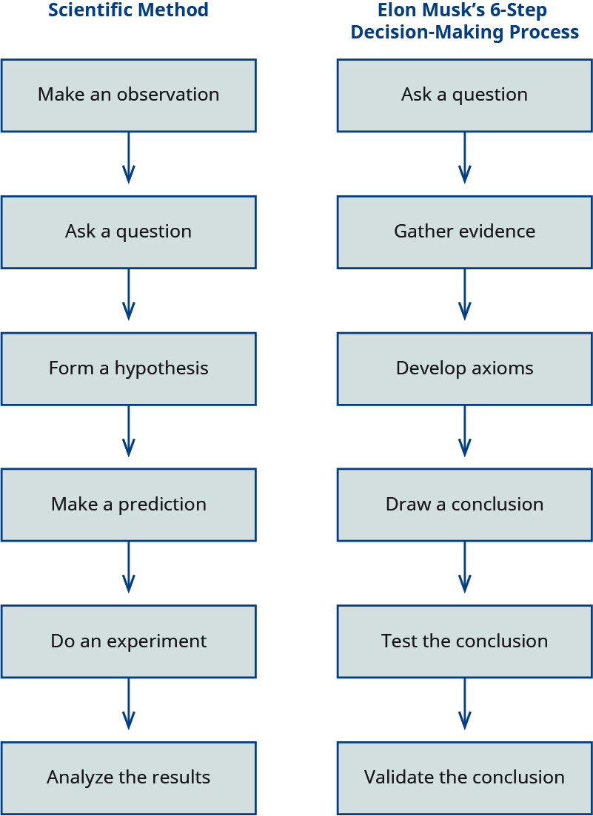
Figure 4.8 According to Elon Musk, he uses a six-step decision-making process that he likens to the scientific process. Copyright Rice College, OpenStax, and OpenStax are licenced under the Creative Commons Attribution 4.0 International License.
Economists believe that economic factors may explain innovation processes. There was a time when it wasn't this way. Inventions were mostly ignored in economic theory before to 1940. After Ww2, most of the developed world's economy was in need of repair (Neneh, 2012). The creation of new technologies was accelerating, as was the amount of money spent on R&D. Entrepreneurs and economists understood that customer demand might affect which ideas take off at a particular moment. 27 In spite of this, innovators face an adoption curve. 28
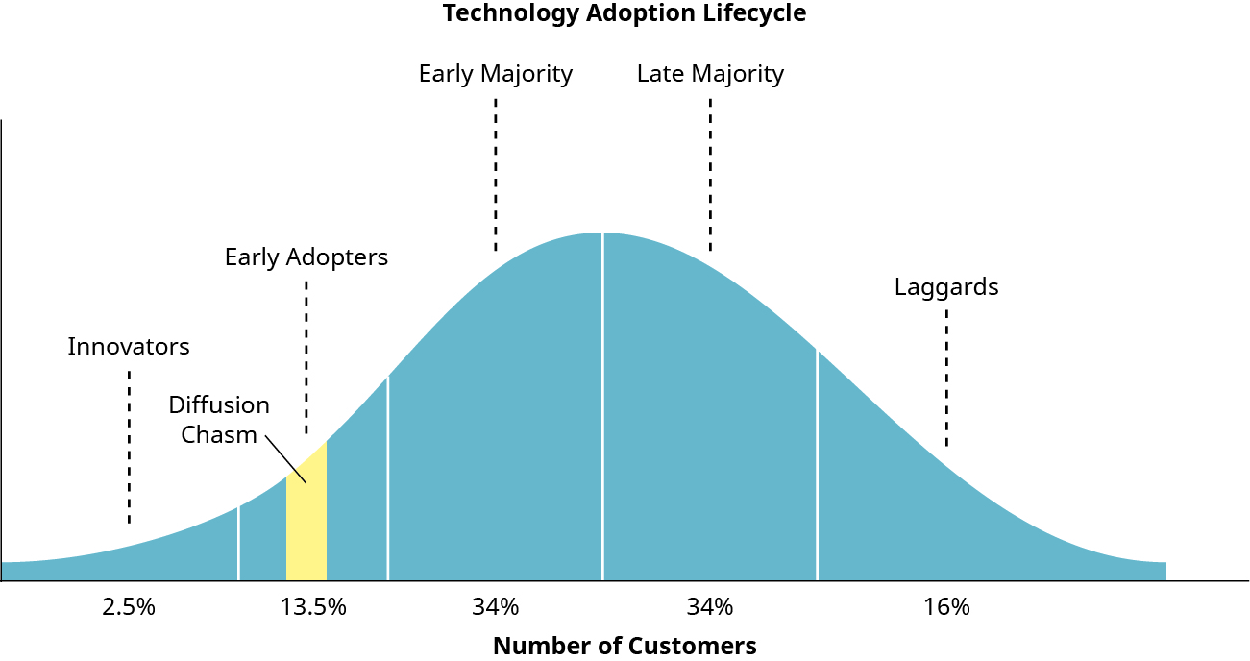
Figure 4.9 According to Everett Rogers' study, the diffusion curve depicts the lifespan of adoption. Early adoption is when the diffusion chasm occurs and OpenStax are licenced under the Creative Commons Attribution 4.0 International License.

Conceive, articulate and apply creative thinking within a work-based or academic context to develop novel solutions and/or value creation.
Modern firms, even the most popular ones to work for, are said to place a great importance on innovative and creative thinking. How can you be innovative without making a fool of yourself, seeming foolish, or just restating what others said a thousand times over? (Jonathan, 2008). I've spoken to a lot of entrepreneurs over the previous several years and learned a lot about how they come up with new ideas. The following are six methods for enhancing your personal creativity and innovation abilities:

Create your own “Three Ifs”
Many successful innovators start with an existing product and then ask provocative questions to reshape its basic notion in order to create something entirely new. The Smartphone was not an initial inspiration for Steve Jobs. What can we do to make it even better or perhaps the greatest, using an already existing mobile phone? (Lockwood, 2010). The truth is that innovation does not have a set formula; instead, it is a process that each individual should tailor to his or her own unique interests, experience level, and working environment. However, I normally encourage my pupils to develop their creativity around three "ifs," namely:
- The object/system/social interaction, etc., would be affected if I were to modify it.
- If I were to utilize this item in 10 years, what would I modify or improve?
- If I had a million dollars to enhance it, what would I do?
These questions, if utilized effectively, may assist you in developing new ways of thinking. To hone these skills, it's helpful to use the "three ifs" strategy (or come up with your own set of questions) on a variety of subjects. Also, new ideas are certain to emerge.
Let's take a bicycle and think about it and then ask the three if questions to come up with a fresh notion. Students initially opposed and expressed skepticism about the plan. At some point during the brainstorming, they came up with a slew of fresh and innovative ideas. My students' teams received multiple monetary prizes for implementing their unique ideas in minor course assignments.

Practice dreaming
Most people believe that having a high IQ or having an apple drop on your head would automatically lead to innovative thinking; however this isn't always the case. It's all about frequently exercising your imagination, honing your observational skills, and daydreaming, no matter how large or tiny your goals are. As easy as it seems, this essential component is frequently absent from our daily lives in this day of information explosion and hyper-charged metropolitan living (Penaluna, 2009). For too many of us, the most innovative notion we can come up with it at the end of the day is simply to sit down in front of the television or computer and watch a movie or play a game. Is this familiar to you? Apply the "three ifs" technique to everything and everything you can think of, whether it's job or play. This can help you develop the habit of allowing yourself time to daydream, which is critical for innovative problem solving and creative thinking.

Make time for cohesive creative thinking
Every book on creativity stresses the significance of setting aside a certain amount of time each day for the purpose of brainstorming and developing new ideas. For instance, Google mandates that its employees spend at least 20% of their time on new ideas or initiatives. When we turn up ready to create, though, new ideas frequently fail to spring out of the ground like popcorn. The deadlock is caused by two factors. Dreaming and focusing on a single thought are the two things we don't do enough of (Vuong, 2016). Hence, schedule time – it may be an hour daily or weekly – to practise creative thinking on a particular item as the next guideline of creative thinking. Many years ago, a coworker informed me that he was thinking about the future of mobile phones while he was a college student. His articles on this issue were well praised in college, and he went on to have a high-paying job building applications for smart phones that appeal to "millennials" after graduation.

References:
- Lockwood, T. (2010). Design thinking: Integrating innovation, customer experience, and brand value. Simon and Schuster.
- Penaluna, A., & Penaluna, K. (2009). Creativity in business/business in creativity: transdisciplinary curricula as an enabling strategy in enterprise education. Industry and Higher Education, 23(3), 209-219.
- Vuong, Q. H. (2016). Global Mindset as the Integration of Emerging Socio-Cultural Values Through Mindsponge Processes: A Transition Economy Perspective 1. In Global Mindsets (pp. 109-126). Routledge.
- Barrett, R. (2013). Liberating the corporate soul. Routledge.
- Nicolaides, A. (2011). Entrepreneurship-the role of higher education in South Africa. Educational research, 2(4), 1043-1050.
- Neneh, N. B. (2012). An exploratory study on entrepreneurial mindset in the small and medium enterprise (SME) sector: A South African perspective on fostering small and medium enterprise (SME) success. African Journal of Business Management, 6(9), 3364-3372.
- Jonathan, P. (Ed.). (2008). Local Economic and Employment Development (LEED) Entrepreneurship and Higher Education (No. 18). OECD Publishing.
- Lockwood, T. (2010). Design thinking: Integrating innovation, customer experience, and brand value. Simon and Schuster.
- Penaluna, A., & Penaluna, K. (2009). Creativity in business/business in creativity: transdisciplinary curricula as an enabling strategy in enterprise education. Industry and Higher Education, 23(3), 209-219.
- Vuong, Q. H. (2016). Global Mindset as the Integration of Emerging Socio-Cultural Values Through Mindsponge Processes: A Transition Economy Perspective 1. In Global Mindsets (pp. 109-126). Routledge.

